Supplementary Information

Organically Surface Engineered Mesoporous Silica Nanoparticles Control the Release of Quercetin by pH Stimuli

Ozi Adi Saputra^{1,2,3,4}, Windy Ayu Lestari¹, Viardi Kurniasyah⁵, Witri Wahyu Lestari⁵, Takashi Sugiura⁶, Rino Rakhmata Mukti⁷, Ronny Martien⁸, Fajar Rakhman Wibowo^{5,}*

¹ Master Program of Chemistry, Faculty of Mathematics and Natural Sciences, Universitas Sebelas Maret, Jl. Ir. Sutami 36A, Surakarta, 57126, Indonesia.
² Department of Chemical Engineering, Collage of Engineering, National Taiwan University, No. 1, Section 4, Roosevelt Rd, Da’an District, Taipei, 10617, Taiwan (Republic of China).
³ Institute of Chemistry, Academia Sinica, No. 128, Section 2, Academia Rd, Nangang District, Taipei, 11529, Taiwan (Republic of China)
⁴ Sustainable Chemical Science and Technology, Taiwan International Graduate Program, Academia Sinica, No. 128, Sec. 2, Academia Rd, Nangang District, Taipei, 11529, Taiwan (Republic of China).
⁵ Chemistry Department, Faculty of Mathematics and Natural Sciences, Universitas Sebelas Maret, Jl Ir. Sutami 36A, Surakarta, 57126, Indonesia
⁶ Department of Chemistry and Biomolecular Science, Faculty of Engineering, Gifu University, Gifu, 501-1193, Japan.
⁷ Division of Inorganic and Physical Chemistry, and Research Center for Nanosciences and Nanotechnology, Institut Teknologi Bandung, Jl. Ganesha no. 10 Bandung, 40132, Indonesia.
⁸ Faculty of Pharmacy, Universitas Gadjah Mada, Sekip Utara, Yogyakarta, 55281, Indonesia.
*Corresponding Email: fajarrakhman@staff.uns.ac.id

Figures captions
Figure S1. Optimized structure and MEP of (a) quercetin and (b) AmEA moiety
Figure S2. Model DFT interaction of quercetin and AmEA moiety on the carboxylic group sites.
Figure S3. Model DFT interaction of quercetin and AmEA moiety on the amines group sites.

Table captions
Table S1. Bond length, bond angle, bond energy and interaction energy of AmEA-quercetin complexes.

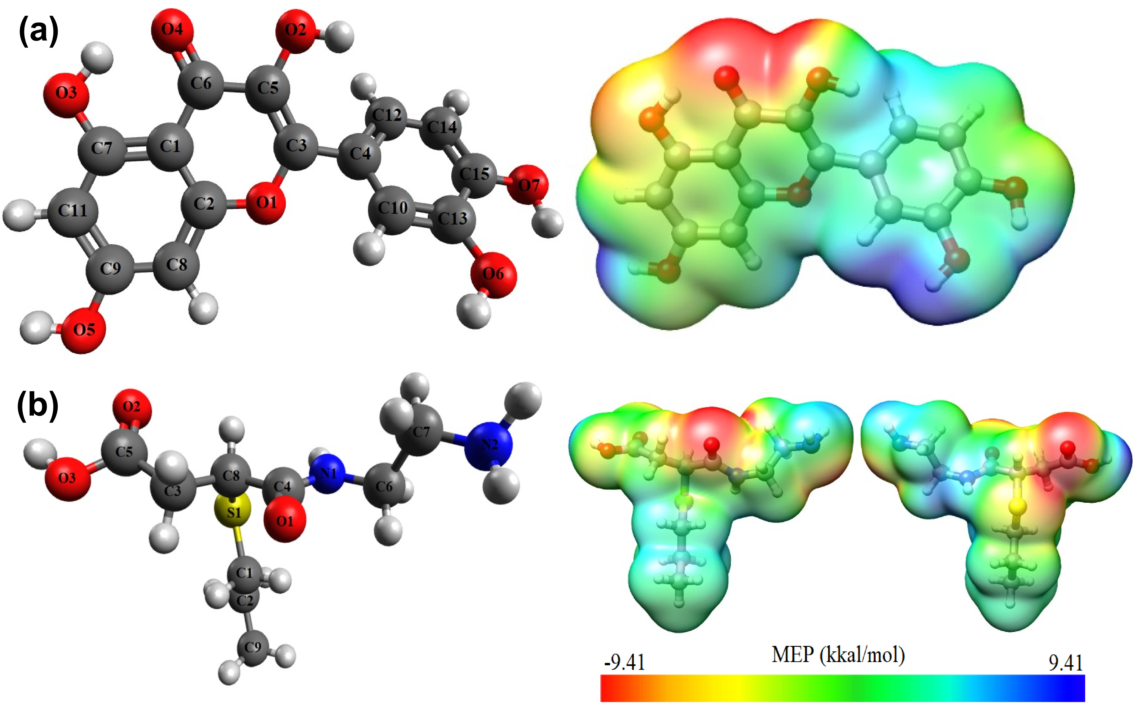
Figure S1. Optimized structure and MEP of (a) quercetin and (b) AmEA moiety

Figure S2. Model DFT interaction of quercetin and AmEA moiety on the carboxylic group sites.

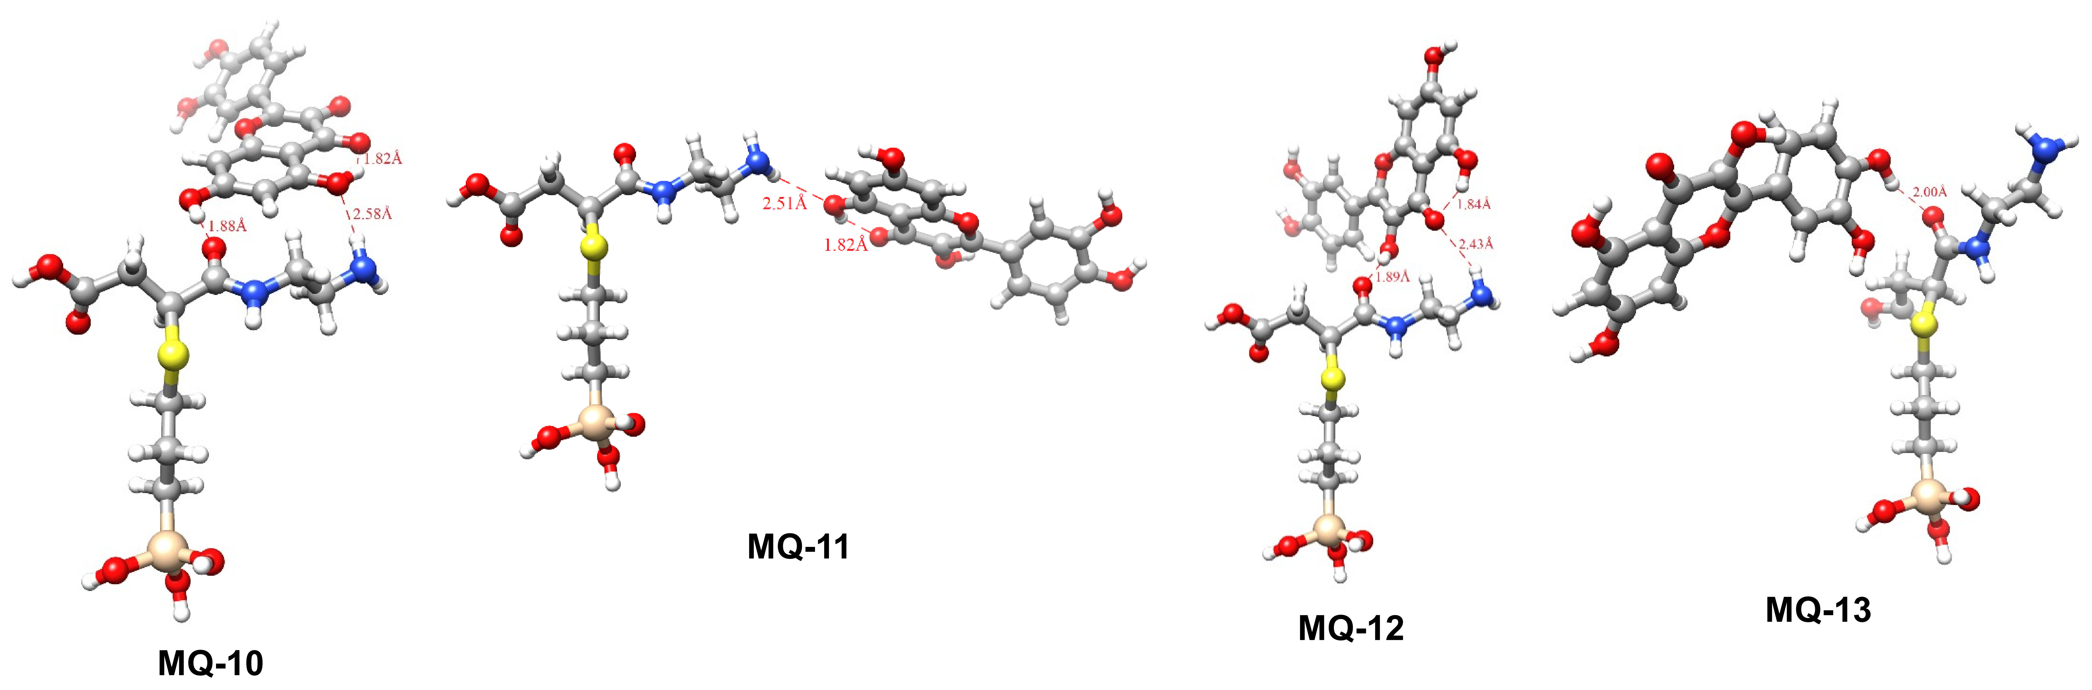
Figure S3. Model DFT interaction of quercetin and AmEA moiety on the amines group sites.

Table S1. Bond length, bond angle, bond energy and interaction energy of AmEA-quercetin complexes.
Structure code | Interaction* | Bond length  (Å) | Hydrogen bond angle, q  (°) | Bond Energy**  (Kcal mol⁻¹) | Interaction Energy***  (Kcal mol⁻¹)
MQ-1 | (M) C5=O2 --- (Q) H–O6 | 1.95027 | 166.84 | -8.6530 | -10.6882
MQ-2 | (M) C5=O2 --- (Q) H–O7 | 2.16423 | 135.88 | -7.0363 | -9.3282
MQ-2 | (M) O3−H --- (Q) O7–H | 2.02021 | 153.69 | -7.0363 | -9.3282
MQ-3 | (M) C5=O2 --- (Q) H–O7 | 1.90208 | 173.58 | -16.5026 | -21.1266
MQ-3 | (M) O3−H --- (Q) O6–H | 1.94661 | 166.87 | -16.5026 | -21.1266
MQ-4 | (M) O3−H --- (Q) C6=O4 | 1.82906 | 171.77 | -15.0594 | -22.8447
MQ-4 | (M) C5=O2 --- (Q) H–O2 | 1.89217 | 152.26 | -15.0594 | -22.8447
MQ-5 | (M) O3−H --- (Q) C6=O4 | 1.83209 | 172.77 | -16.4388 | -22.8038
MQ-5 | (M) C5=O2 --- (Q) H–O2 | 1.90163 | 151.83 | -16.4388 | -22.8038
MQ-6 | (M) C5=O2 --- (Q) H–O5 | 1.97541 | 147.11 | -6.5885 | -9.7464
MQ-6 | (M) O3−H --- (Q) O5–H | 2.14159 | 151.36 | -6.5885 | -9.7464
MQ-7 | (M) O3−H --- (Q) C6=O4 | 1.90742 | 164.27 | -8.2048 | -10.6550
MQ-8 | (M) O3−H --- (Q) O3−H | 1.97784 | 165.61 | -5.1311 | -7.2914
MQ-9 | (M) O3−H --- (Q) O3−H | 1.98028 | 169.99 | -5.8883 | -9.6227
MQ-9 | (M) C5=O2 --- (Q) H–C11 | 2.39124 | 160.69 | -5.8883 | -9.6227
MQ-10 | (M) N2−H --- (Q) O3−H | 2.57974 | 162.26 | -10.7010 | -12.7760
MQ-10 | (M) C4=O1 --- (Q) H–O5 | 1.88407 | 174.28 | -10.7010 | -12.7760
MQ-11 | (M) N2−H --- (Q) O3−H | 2.50543 | 152.72 | -3.8102 | -5.6205
MQ-12 | (M) N2−H --- (Q) O4–C6 | 2.43082 | 146.85 | -13.4215 | -16.4992
MQ-12 | (M) C4=O1 --- (Q) H–O2 | 1.88302 | 142.03 | -13.4215 | -16.4992
MQ-13 | (M) C4=O1 --- (Q) H–O7 | 1.99769 | 160.43 | -4.9113 | -7.2306
* M and Q indicate chemical groups on surface moieties and quercetin, respectively.
** Bond energy was calculated based on HF method.
*** Interaction energy was calculated based on DFT method.

