Supplementary Data:
Supplementary Figure.1: The extracellular Fe²⁺ ion in the culture medium was chelated using the 2bpy compound in 1:3 ratio and showed no significant difference in the bacterial colony count under Fe²⁺ ion chelated condition. This result suggests that free Fe²⁺ ion (without chelators) promotes the bacterial colony formation and Fe²⁺ ion with 2bpy chelator does not promote the bacterial colony formation.

Supplementary Figure.2: Under the niche concentrations of FeSO₄, the E. coli cells reduce the extracellular Fe²⁺ ion concentration from ∼150 to ∼147 μM, E. faecalis cells reduce the extracellular Fe²⁺ ion concentration from ∼200 to ∼195 μM, and dual-species reduce the extracellular Fe²⁺ ion concentration from ∼200 to ∼193 μM.

Supplementary Figure.3: The planktonic cells, E. coli was incubated in the culture medium supplemented with ∼ 150 μM of FeSO₄ (initial Concentration) and after overnight the incubation the extracellular Fe²⁺ ion concentration was reduced to ∼ 147 μM (final Concentration), which was observed in AAS. Similarly, the E. faecalis and dual-species cultures incubated overnight in culture media containing ∼ 150 μM of FeSO₄ (initial Concentration) were reduced to ∼195 and ∼193 μM, respectively. This reduction in the extracellular Fe²⁺ ion concentration during the bacterial growth signifies that the bacterial cells uptake the extracellular Fe²⁺ ion for their growth and development.
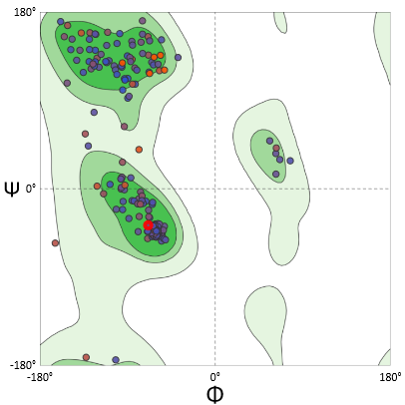
Supplementary Figure.4: Ramachandran plot for FeoB protein model shown that 99% of the amino acid residues lies within out-layer region which signifies that protein modeled with the Van Der Waals force with no steric hindrance on parallel/antiparallel β-sheets and left/right-handed α-helix.

