Humic substances from composted fennel residues control the inflammation induced by H. pylori infection in AGS cells.

Mariavittoria Verrillo^{1,2}, Paola Cuomo^{2*}, Angela Michela Immacolata Montone³, Davide Savy², Riccardo Spaccini ^{1,2}, Rosanna Capparelli^{1,2*}, Alessandro Piccolo^{1,2}

- Centro Interdipartimentale di Ricerca per la Risonanza Magnetica Nucleare per l’Ambiente, l’Agroalimentare, ed i Nuovi Materiali (CERMANU), University of Naples “Federico II”, Via Università 100, 80055 Portici, Italy

- Department of Agricultural Sciences, University of Naples “Federico II”, Via Università 100, 80055 Portici, Italy

- Department of Food Inspection, Istituto Zooprofilattico Sperimentale del Mezzogiorno, Via Salute 2, 80055 Portici, Italy

Corresponding Authors*: capparel@unina.it; paola.cuomo@unina.it

HS-FEN
RTª | Compound | Origin^{b}
7.01 | phenol | phenol
7.24 | methoxy benzene | P1 Lig
8.4 | 1-ethenyl-4 CH3O-benzene | P3 Lig
8.61 | 1,2-di-CH3O benzene | G1 Lig
8.95 | dimethoxy benzene | carbohydrate
9.74 | m/z 128 | N
9.88 | N derivate | N
10.03 | N derivate | N
10.39 | 3,4-dimethoxy toluene | G2 Lig
10.7 | 2,6-dimethoxy phenol | carbohydrate
11.07 | Benzaldehyde methoxy | P4 Lig
11.28 | 1-methyl-1H-indole | N
12.31 | 1,2,3-tri-CH3O benzene | S1 Lig
12.56 | 1-(4-methoxyphenolonyl)-ethanonel) | P5 Lig
12.87 | m/z 128 | N
13.23 | m/z 98 | N
13.56 | dimethoxy phenol | carbohydrate
13.9 | 4-ethenyl-1,2-dimethoxy-benzene | G3 Lig
14.02 | 1,2,4-trimethoxy benzene | carbohydrate
14.2 | benzoic acid 4-methoxy methyl ester | P6 Lig
14.49 | 2-Propenoic acid, 3-phenolonyl methyl ester (e) | lipid
14.8 | 1,2,3-methoxy 5-methyl benzene | S2 Lig
15.35 | m/z 128 | N
15.61 | m/z 128 | N
15.95 | 1,3-diidro-1-metil-2H-indol-2-one | N
16.1 | 5-metossi-2-metil-1H-indole | N
16.37 | N derivative | N
17.25 | 3,4-dimethoxy-benzaldehyde | G4 Lig
17.59 | 1,2-dimethoxy-4-(1-propenyl) benzene | G21 Lig
18 | 2,5-dimethoxy-N,N-dimethylbenzylamine | G7 -G8 Lig
18.49 | benzenepropanoic acid, 4-methoxy, methyl ester | P12 Lig
18.58 | 1,2,3,4-tetramethoxy benzene | carbohydrate
19.59 | 1-(3,4-dimethoxyphenolonyl)-ethanone | G5 Lig
20.35 | 3,4-dimethoxy-methyl ester benzoic acid | G6 Lig
20.53 | 3,4,5-trimethoxy benzaldehyde | S4 Lig
21 | m/z 98 | N
21.22 | cis-1-methoxy-2-(3,4-dimethoxyphenolonyl) ethylene | G7 Lig
21.56 | trans-1-methoxy-2-(3,4-dimethoxyphenolonyl) ethylene | G8 Lig
21.77 | trans-1-methoxy-1-(3,4-dimethoxyphenolonyl)-1-propene | G11 Lig
22.61 | 2-propenoic acid, 3-(4-methoxyphenolonyl)-methyl ester | P18 Lig
22.61 | 1-(3,4,5-trimethoxyphenolonyl)-ethanone | S5 Lig
23.76 | benzoic acid, 3,4,5-trimethoxy-methyl ester | S6 Lig
24.25 | trans-3-methoxy-1-(3,4-dimethoxyphenolonyl)-1-propene | G13 Lig
25.14 | cis-1-(3,4,5-trimethoxyphenolonyl)-2-methoxy ethylene | S7 Lig
25.43 | C15 iso FAME (C14, 13-methyl, FAME) | mic
25.49 | 1-(3,4-di-CH3O phenolonyl)-1,2,3-tri CH3O propane (three/erythro) | G14 Lig
25.64 | C15 ante iso FAME (C14, 12 methyl, FAME) | mic
25.64 | trans-1-(3,4,5-trimethoxyphenolonyl)-2-methyl ethylene | S8 Lig
25.84 | 1,2,3-trimethoxy-1-(3,4-dimethoxyphenolonyl) propane (threetoheritro) | G15 mic
26.13 | cis-1-(3,4,5-trimethoxyphenolonyl)-1-methoxy-1-propene | S10 Lig
27.76 | cis-1-(3,4,5-trimethoxyphenolonyl)-1,3-dimethoxy-1-propene | G16 Lig
27.98 | propenoic acid trans-3-(3,4-di-CH3O phenolonyl)-3CH3O | G18 Lig
28.21 | 1,2,3-trimethoxy-1-(3,4,5-trimethoxyphenolonyl) propane (three/peritre) | S14 Lig
28.32 | C16:1 FAME | mic
28.48 | 1,2,3-trimethoxy-1-(3,4,5-trimethoxyphenolonyl) propane (three parts per liter) | S15 Lig
28.88 | C16 FAME | lipid
28.98 | cis-1-(3,4,5-trimethoxyphenolonyl)-1,3-dimethoxy-prop-1-ene | S16 Lig
30.29 | trans-2-propenoic acid-3-(3,4,5-trimethoxyphenolinyl)-methyl ester | S18 Lig
30.37 | C17 FAME iso (C16, 15 methyl, FAME) | mic
30.56 | C17 ante iso FAME (C16, 14 methyl, FAME) | mic
31.1 | cis-1-(3,4,5-trimethoxyphenolonyl)-1,3-dimethoxy-prop-1-ene | S16gLig
32.9 | C18:1 FAME | lipid
33.04 | C18:1 FAME | lipid
33.53 | C18 FAME | lipid
33.76 | podocarp-7-en 3-one dimethyl isomer | lipid
34.02 | podocarp-7-en 3-one dimethyl isomer | lipid
36.69 | sterol | sterol
37.82 | C20 FAME | lipid
37.98 | N derivate | N
39.16 | N derivate | N
39.92 | N derivate | N
40.05 | sterol | sterol
41.79 | C22 FAME | lipid
43.66 | C23 FAME | lipid
45 | 3,3',4,4'-tetramethoxystilbene | aromatic
45.48 | C24 FAME | lipid
46.84 | squalene | sterol
47.22 | C26-Ome | alcohol
47.6 | aromatic | aromatic
48.38 | alkane | alkane
48.93 | C26 FAME | lipid
49.43 | C24, 24-CH3O, FAME | lipid
50.54 | C28-CH3O | alcohol
52.17 | C28 FAME | lipid
54.42 | sterol | sterol
55.25 | C30 FAME | lipid

Table S1. List of the main products released by the thermochemolysis from humic substances from fennel (HS-FEN).
ª RT retention time (min)
^{b} FAME fatty acid methyl ester; Lg lignin: P phydroxyphenyl, G guayacil, S syringyl; Lip: plant lipids; ME methyl ester; Mic microbial origin; N: nitrogen derivative

GENE | FORWARD PRIMER | REVERSE PRIMER
GAPDH (Glyceraldehyde 3-Phosphate Dehydrogenase) | CCTCTGACTTCAACAGCGACAC | CACCACCCTGTTGCTGTAGCCA
SOD2 (Superoxide Dismutase 2) | CTGATTTGGACAAGCAGCAA | CTGGACAAACCTCAGCCCTA
OPA1 (Optic Atrophy Protein 1) | GCCGGAAGTGTAGTTACCTG | AGGTGGTCTCTGTGGGTTGT

Table S2: Primers used for qRT-PCR.

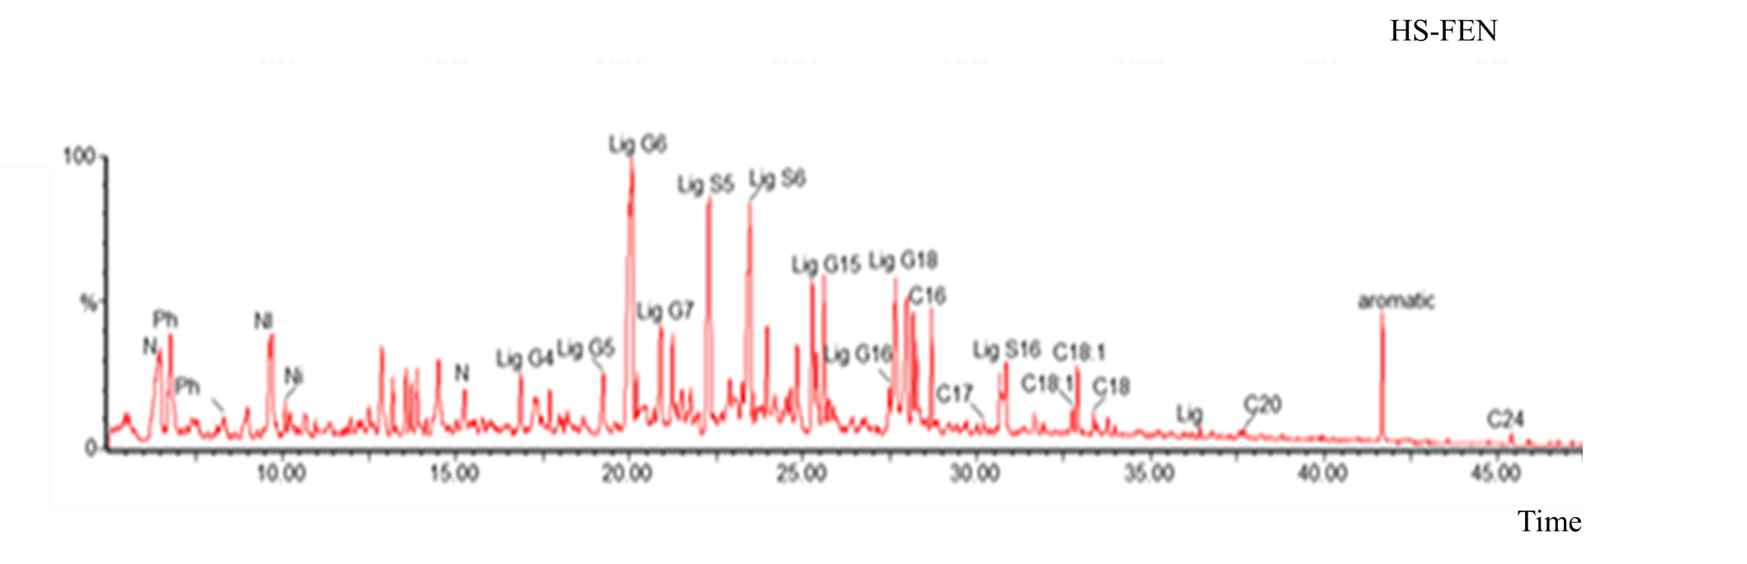Figure S1: Total ion chromatograms of thermochemolysis products of HS-FEN.

