Supplementary Information
An Enduring In vitro Wound Healing Phase Recipient by Bioactive Glass-Graphene Oxide Nanocomposites
N. Manjubaashini¹, T. Daniel Thangadurai², Senthilarasu Sundaram^{3*}, Anurag Roy⁴, S. Balakumar^{1*}
¹National Centre for Nanoscience and Nanotechnology, University of Madras, Chennai-600 025, India.
²Department of Chemistry, KPR Institute of Engineering and Technology, Coimbatore-641 407, India.
³Electrical and Electronics Engineering, School of Engineering and the Built Environment, Edinburgh Napier University, Edinburgh, EH10 5DT, U.K.
⁴Environment and Sustainable Institute, University of Exeter, Penryn Campus, Cornwall TR10 9FE, UK.
Corresponding Authors Email. Id: balasuga@yahoo.com (Dr. S.B); S.Sundaram@napier.ac.uk (Dr. S.S).

1. Materials and Methods
TEOS (Si(OC₂H₅)₄) TCL, orthophosphoric acid (H₃PO₄) Merck, calcium nitrate tetrahydrate (Ca (NO₃)₂.4H₂O), sodium hydroxide (NaOH), sulphuric acid (H₂SO₄), hydrochloric acid (HCL), and sodium nitrate (NaNO₃) SRL, hydrogen peroxide (H₂O₂) Merck, potassium permanganate (KMnO₄) SRL, graphite (Sigma), Cell-Line L929 mouse fibroblast cells, NCCS Pune. XRD (X-Pert Pro PANalytical, Netherlands), HRTEM (Jeol/JEM 2100, Japan), SEM (Hitachi S-3400N, Japan), XPS (Physical Electronics), FTIR (SHIMADZU (Miracle 10, US), RAMAN (WiTec alpha 300, Germany), TGA (NETZSCH STA 2500, Germany), UV-Visible Spectroscopy (LAB MAN LMSP-UV1200, India), Hardness (Wilson-Wolpert, Canada), ICP-OES (Perkin Elmer Optima 5300DV, USA), ELISA Plate Analyser (ROBONIK).
1.1 Preparation of 45S5 Bioglass (45S5 BG). The 45S5 BG was synthesized by the sol-gel method with a composition of 46.1 % SiO₂, 26.9 % CaO, 24.4 % Na₂O, and 2.6 P₂O₅ precursors with the stoichiometry of 11.4795 ml TEOS, 1.74 ml H₃PO₄, 6.24 g of CaNO_{3,} and 13.842 g of NaNO₃ (C. Ashok raja et al., 2018 and A. Kumar et al., 2017). All the precursors were prepared with DD water (double-distilled). TEOS+HNO₃ was first dissolved in a suspension of ethanol and DD water (1:2) and held under constant stirring. The suspension is allowed to form gel while it has reached a clear solution. After the gel was formed, H₃PO₄ was added dropwise to the agitated solution until it gets completely dissolved, and subsequently, the gelation process was allowed for another 12 h. The CaNO₃ was then added drop by drop and left to age till 36 h at 80 °C. The samples were also dried for 24 h in a hot air oven at 100 ºC. The as-prepared samples were calcined for 3 h at 800 °C (heating rate 5 °C/min) to achieve phase formation without residues and were designated as BG. Similarly, the 45S5 bioglass was made without sodium and is termed BG (Na-free) with a similar synthesis process.
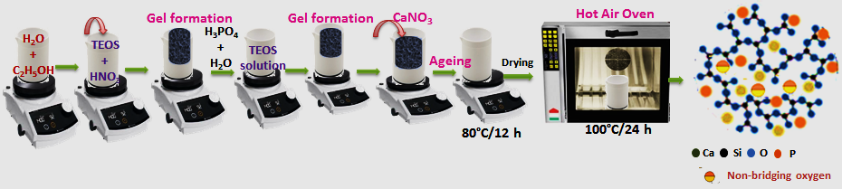
Figure. S1. Preparation of 45S5 BG by Sol-gel Method.

1.2 Synthesis of Graphene Oxide (GO). The improved hammers approach was used to synthesize the GO samples. To avoid environmental concerns, the revised hammers process uses orthophosphoric acid instead of sodium nitrate, which is non-toxic and produces high-quality GO sheets (HuitaoYu, 2016 and Zineb Benzait et al., 2021). Typically, 2.0 g graphite powder was added to 100 mL of saturated H₂SO₄ and stirred. Then, drop by drop, H₃PO₄ was added to the aforementioned solution. The H₂SO₄:H₃PO₄ ratio was calculated to be 100:1. The KMnO₄ (6.0 g) was progressively added for exploitation while stirring continuously with a cold bath. The diluted liquid became brown after complete exfoliation, indicating hydrolysis and absolute exfoliation of intercalated graphite oxide. The brown suspension was then turned black with the addition of H₂O₂ to remove the remaining oxidants. Finally, to neutralize the pH and eliminate excess residuals, the resulting solution was washed numerous times with HCL and DD water. The washed and filtered samples were dried for 24 h at 100 °C.
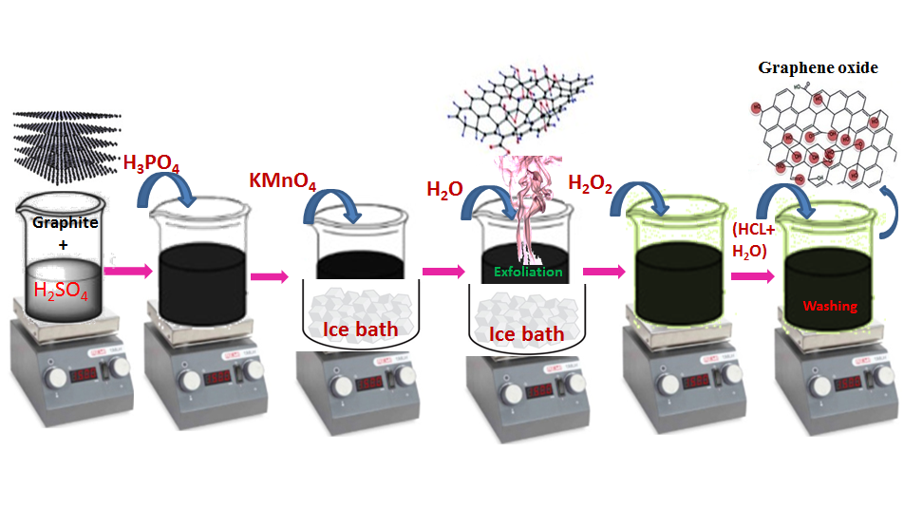
Figure. S2. Preparation of GO by Improved Hammers Method.
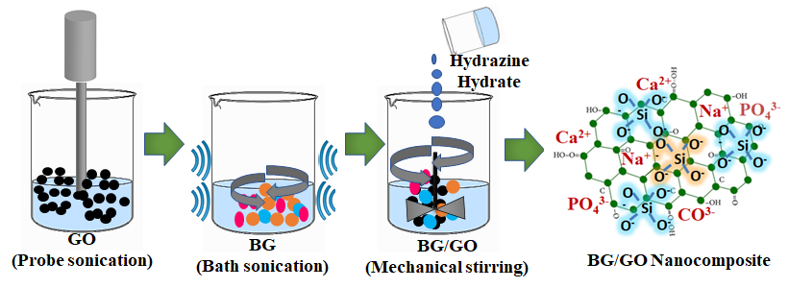
Figure S3. Schematic representation of the preparation of BG/GO nanocomposites.

1.3 In vitro Biomineralization Assay. Hank's balanced salt solution was employed as the simulated body fluid (SBF) solution in this investigation. Na⁺ 213.0 mM, K⁺ 7.5 mM, Mg²⁺ 2.25 mM, Ca²⁺ 3.75 mM, Cl⁻ 221.7 mM, HCO₃⁻ 6.3 mM, HPO₄²⁻ 1.5 mM, SO₄²⁻ 0.75 mM are the components of SBF. The BG(Na), BG, GO and BG(Na)/GO, BG/GO nanocomposite pellets were incubated at 37 °C for up to 28 days in 10 mL SBF (pH 7.4) in 15 mL falcon tubes (Hongyan Liu, 2014). The submerged samples were washed extensively with DD water and dried at 100 ºC under a vacuum. XRD, FTIR, Raman, and SEM investigations were carried out to examine the development of apatite layer formation on composites surfaces.

1.4 In vitro Biocompatibility Assay. Healthy volunteers provided the appropriate amount of blood, which was then mixed with 1.6 g/L EDTA (Ethylenediaminetetraacetic acid) to avoid coagulation. The blood was then centrifuged at 4 °C for 10 minutes at 2000 rpm. Phosphate buffer saline (PBS) was used to wash the collected erythrocytes (RBCs). The RBCs were then resuspended in a suitable amount of PBS (pH 7.4). The positive control comprises 950 μL of DD water and 50 μL of blood, whereas the negative control has 950 μL of PBS and 50 μL of blood. A calculated number of samples were placed in a vial containing 1 ml of re-suspended RBCs and incubated for 1 h at 37 °C with gentle shaking. The vials were then centrifuged for 10 minutes at 2000 rpm, and the supernatant was collected. Finally, using a UV-Visible Spectrophotometer, the absorbance was measured at 540 nm. The following equation was used to compute the percentage of hemolysis;

1.5 In vitro Cytotoxicity and Cell Proliferation MTT Assay-Direct Method. A direct MTT test was used to investigate the cytotoxicity of BG and GO. The fibroblast L929 cells were grown in Dulbecco's Modified Eagle's medium (DMEM), which included 10% fetal bovine serum (FBS) and 1% penicillin-streptomycin (Rugia Abu A.M.M.A. Alhassan, 2020). The cells (1×10⁵ per well) were planted in 24-well plates and incubated at 37 ºC with 5% CO₂. The cells were treated with various concentrations of all samples (0, 0.5, 2.5, 5.0, 7.5, 10.0 μM) for 24 and 48 h to assess the cytotoxicity based on the concentration of the samples. The mitochondrial enzyme decrease was achieved by adding 5 mg/mL of Methyl thiazolyl diphenyl tetrazolium bromide (MTT) to the samples and incubating them for 4 h. Following the incubation period, 1 mL of dimethyl sulfoxide (DMSO) was added to each well to dissolve the formazan crystals (S. Chitra, 2020). Using an ELISA reader, the absorbance at 570 nm was measured with DMSO as a control. The concentration necessary for a 50 percent inhibition (IC₅₀) was found by measurements. An inverted phase-contrast microscope was also used to view the morphology of the cells. The percentage of viable cells was computed using the formula;

Cell viability (%) = (Corrected abs. of sample/corrected abs. of control) × 100

1.6 Apoptosis Assay. The development of apoptosis is a key element of wound healing since it influences cell function as well as cytocompatibility. Exponentially developed L929 cells were planted in 48-well plates with a cell density of 50,000 cells per well for apoptosis tests. The cell lines were grown at 37 ºC with 5% CO₂ in Minimum Essential Medium Eagle (MEM) containing 10% FBS and a Penicillin (100 U/mL) - Streptomycin (100 g/mL) antibiotic solution (G Zhang, 1997). The cells were cultured with samples (0.1 mg/ml) at varying concentrations (0, 5, 25, 50, 75, 100 μL) for 24 and 48 h at 37 °C after the medium was withdrawn and rinsed with PBS buffer for the experimental groups. After alcoholic cell fixation, the cells were stained with 50 μL of double dye (Acridine orange/Ethidium bromide) and 10 μL of a medium, which was allowed to bind for 10 minutes before the media was withdrawn (Shreyasi Majumdar, 2021). A fluorescence microscope was used to capture the fluorescence pictures in the UV-region, blue channel.

1.7 Wound Healing (Scratch Assay). For cell migration studies, the scratch assay was developed. The fibroblast L929 cells were cultured in DMEM with 10% FBS supplemented. After the cells had grown to roughly 80% confluence in a 24-well tissue culture plate for 24 h, a slight scratch was formed on the monolayer of the cells using a fresh 1 mL pipette tip across the well. Scratched wells were gently washed to remove the detached cells (Syed Raza ur Rehman, 2019). The BG(Na), BG, GO and BG(Na)/GO, BG/GO nanocomposites were added to the wells (0.1 mg/mL), and the cells were left to heal for the period allotted. In addition, using an inverted phase-contrast microscope, time-dependent pictures were acquired. Finally, using the method below, the wound contraction % was computed.
$$\left[\text{\% Wound Contraction}= \frac{\text{Wound }\text{area}\text{ at initial hours - Wound area at final hour}}{\text{Wound Area at }\text{initial}\text{ hour }}×100\right]$$
To compare the means of more than two groups, statistical analysis was performed using the standard one-way analysis of variance with the following significant levels: *( P ≤ 0.05), **( P ≤ 0.01), ***( P ≤ 0.001), and ****( P ≤ 0.0001).
1.8 Antioxidant activity. Generally, the scavenging activity of antioxidants is measured using 1,1-diphenyl-2-picrylhydrazyl (DPPH), a synthetic nitrogen-centered free radical, that accepts electrons or hydrogen radicals from antioxidants to form a stable molecule. The free radical scavenging activity of nanocomposites was assessed by using the DPPH assay. The BG (Na-free), BG, GO, BG (Na-free)/GO, and BG/GO were immersed in 2 mL of methanol solution overnight. Then, 2.5 mL of DPPH radical solution (concentration of 0.04 mg/mL) was added to 0.5 mL of methanol solution and the sample. After 30 minutes of incubation in the dark at 37 °C, the absorbance was measured using UV–Visible spectroscopy at 517 nm. The blank and control solutions were methanol and DPPH, respectively. The following equation was used to compute DPPH radical scavenging activity (Irem Unalan et al., 2021).

DPPH radical scavenging activity (%) = Absorbance of control-Absorbance of sample
× 100
Absorbance of control
2. Result and Discussion
2.1 Elemental Analysis
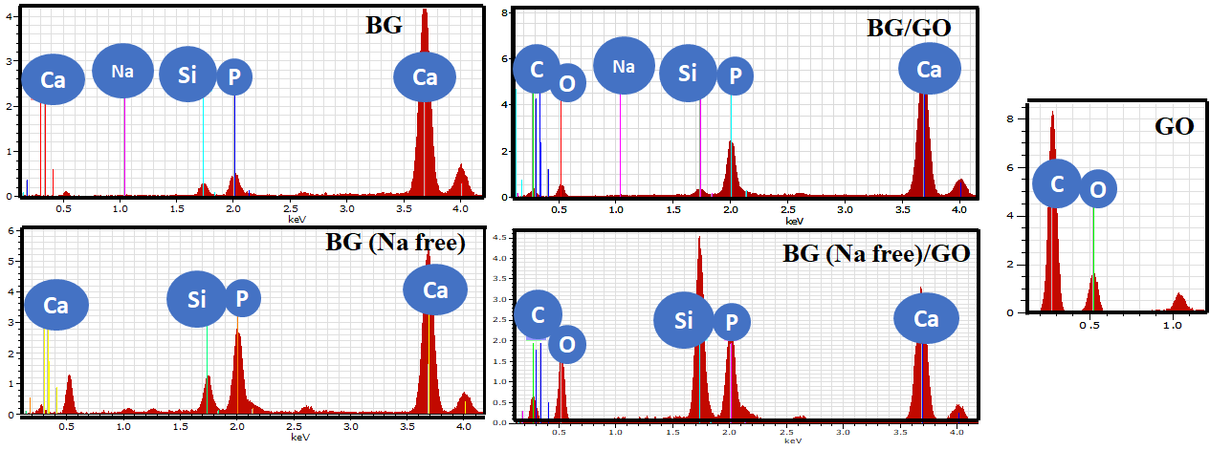
Figure. S4. EDAX spectrum of BG, BG (Na-free), GO and BG/GO, BG (Na-free)/GO nanocomposites after mineralization (28th day).
2.2 Ca/P ratio analysis
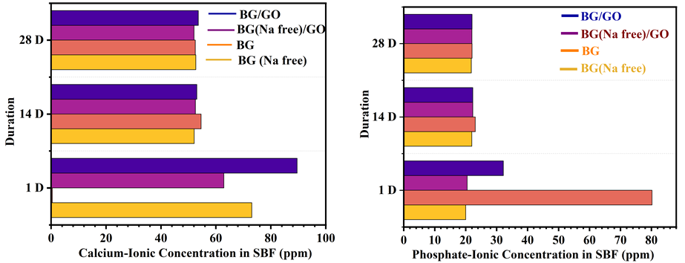
Figure S5. Determination of Ca and P concentration in SBF for different immersion days.
2.3 Hemoclot Assay
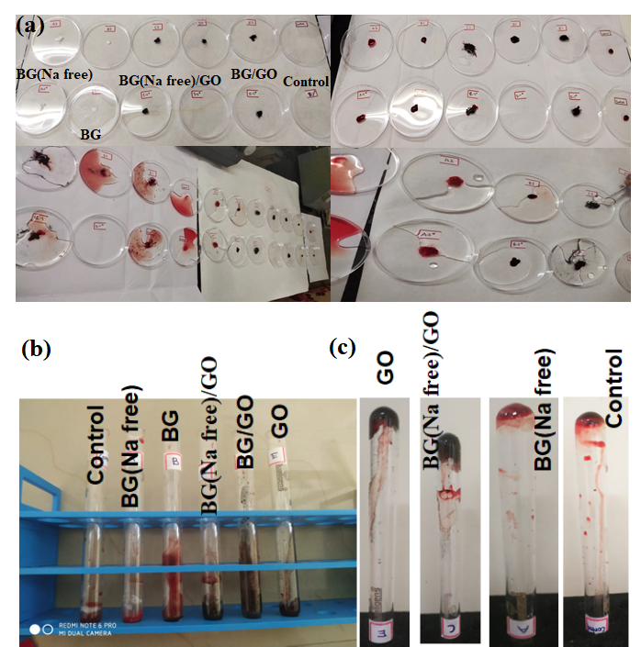
Figure. S6. (a) The whole blood interaction with samples, clot formation was disturbed by adding distilled water, (b) Le & white Method samples along with blood kept in a water bath at 37 °C for clot formation, (d) clot formation was confirmed by tilting the test tubes.
2.4 Contact angle measurement
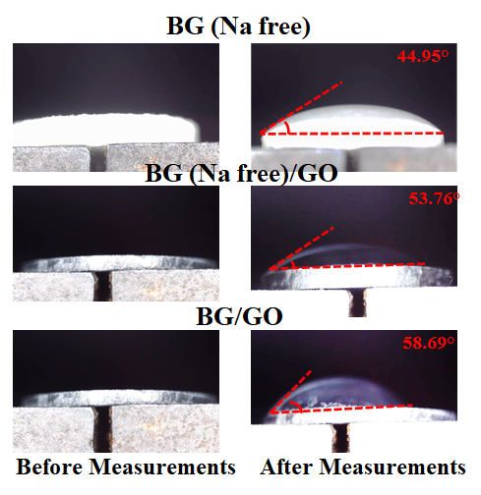
Figure. S7. Contact angle measurement of BG (Na-free), BG (Na-free)/(GO), and BG/GO.

3. Physiochemical Analysis
3.1 Thermal Studies. Before annealing, the BG and BG (Na-free) samples were subjected to TG/DTA analyses are presented in Fig. S9 in which at each interval, the kind of response and quantity of weight loss was displayed. The endothermic peak in BG is associated with a peak at 135 ºC and the elimination of H₂O molecules, while the TG curve reveals an 11.26 % weight loss at 200 ºC. At 567 and 306 ºC, the second weight loss endothermic peak of 18.98 % occurs, further increasing the destruction of organic molecules. Similarly, from 134 to 570 ºC, the BG (Na-free) displays a total weight loss of 37.7 %, with DTA maxima at 194, 300, and 570 ºC determining the endothermic process.
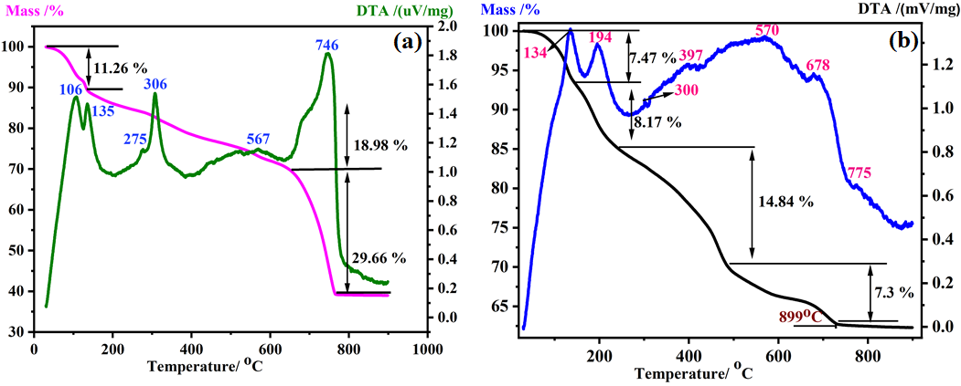
Figure S8. TG and DTA results of (a) BG, and (b) BG (Na-free) before annealing.
3.2 XRD Analysis
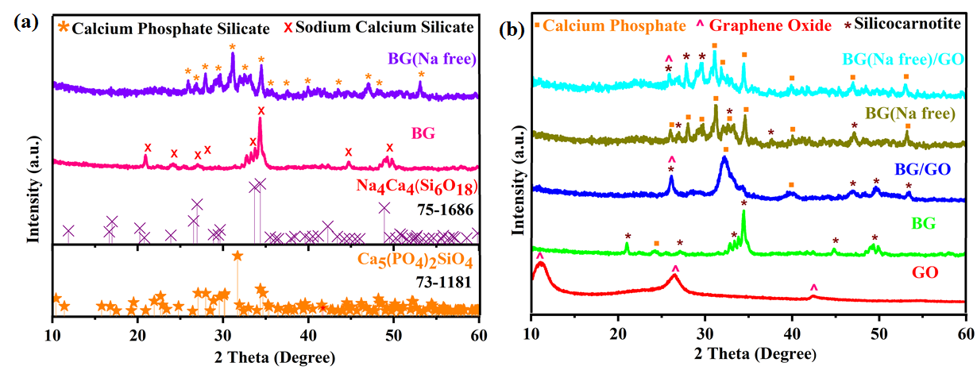
Figure S9. XRD patterns for (a) BG and BG (Na-free), (b) BG, BG (Na-free), GO and BG/GO, BG (Na-free)/GO nanocomposites.
3.3 SEM Analysis
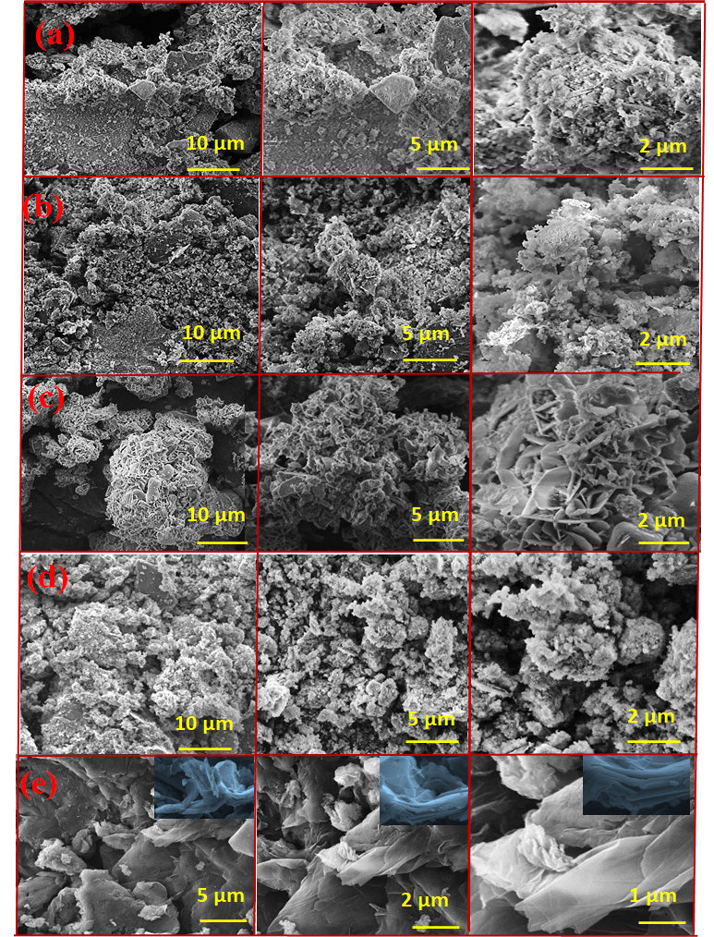
Figure S10. SEM images of (a) BG, (b) BG/GO, (c) BG (Na-free), (d) BG (Na-free)/GO, and (e) GO nanocomposites.
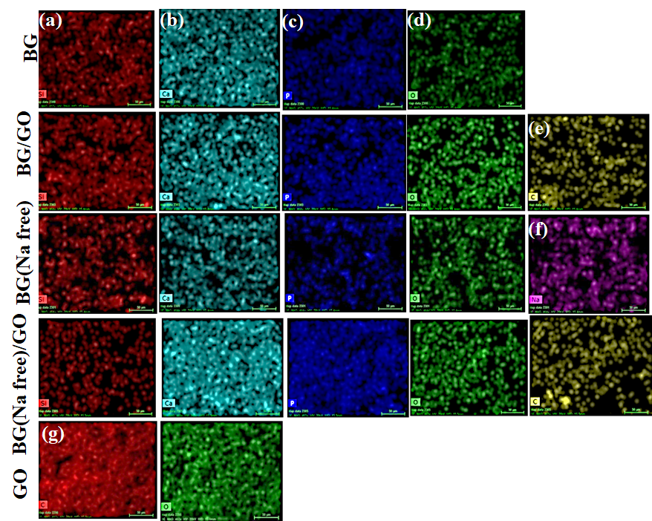
Figure. S11. Elemental mapping of BG, BG (Na-free), GO and BG/GO, BG (Na-free)/GO nanocomposites. (a) Si, (b) Ca, (c) P, (d) O, (f) Na, (e & g) C.
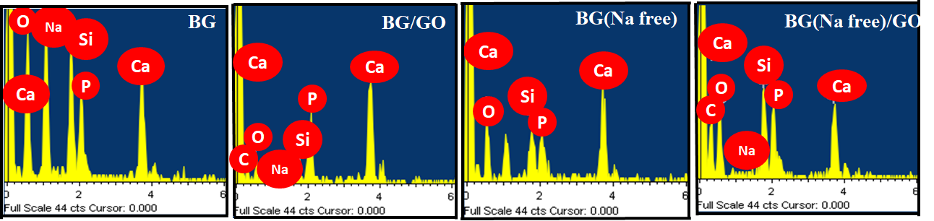
Figure. S12. EDAX spectrum of BG, BG (Na-free) and BG/GO, BG (Na-free)/GO nanocomposites before mineralization.
Table S1. Elemental Quantification of BG, BG (Na-free) and BG/GO, BG (Na-free)/GO nanocomposite.
Elements | Atomic (%)  (Before Mineralization) |  |  |  | Atomic (%)  (After Mineralization)
Elements | BG | BG/GO | BG  (Na-free) | BG (Na-free)/GO | BG | BG/GO | BG (Na-free) | BG (Na-free)/GO | GO
Si | 7.81 | 1.84 | 5.88 | 3.78 | 3.57 | 0.70 | 11.36 | 6.53
Ca | 6.09 | 14.91 | 10.72 | 3.91 | 87.35 | 17.95 | 60.59 | 5.39
P | 4.93 | 6.94 | 4.98 | 3.28 | 7.78 | 6.49 | 28.05 | 3.93
C | - | 41.05 | - | 46.26 | - | 28.50 | - | 34.81 | 72.86
O | 63.97 | 34.57 | 78.41 | 42.82 | - | 45.92 | - | 49.33 | 27.14
Na | 17.20 | 0.69 | - | -0.06 | 1.30 | - | - | -
3.4 HRTEM Imaging
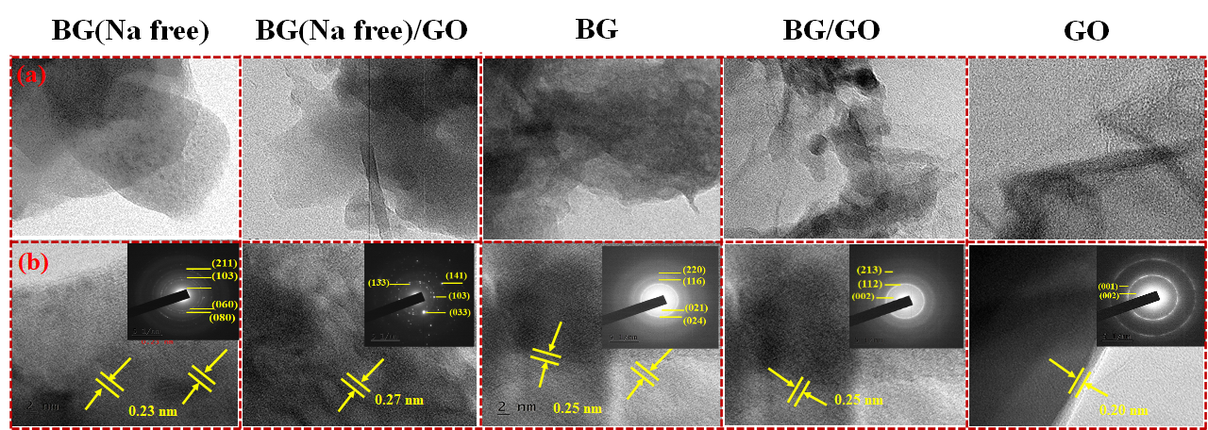
Figure S13. HRTEM images of the BG, BG (Na-free), GO, and BG/Na, BG (Na-free)/GO nanocomposites (a) corresponding cross-sectional profile (b) and SAED pattern (inset). Sheet separation is shown by the arrows. Scale bar: (a, b) 200 - 2 nm.

3.5 XPS Spectra determination
Table S2. Determination of elemental peaks from XPS spectra.
Peaks | Binding  Energy (eV) | Chemical Bond | Peaks | Binding Energy (eV) | Chemical Bond
Si 2p | 104.67 | SiO₂ | C 1s | 286.92 | C-O
Si 2p | 101.53 | Si₃N₄ |  | 285.65 | C-OH
Si 2p | 101.3 | Si 2p_{3/2} |  | 284.77 | Sp² C
P 2p | 134.6 | P 2p_{3/2} | O 1s | 532.7 | O-Si
P 2p | 133.1 | PO₃ |  | 531.3 | O-C
P 2p | 131.79 | P-C |  | 535.6 | Si-O-Si
P 2p | 1073.4 | Na⁺ |  | 532.82 | BO (Bridging Oxygen)
Ca 2p | 350.97 | Ca 2p_{1/2} |  | 532.93 | C=O, C-O-C
Ca 2p | 348.2 | CaCO₃ |  | 532.7 | O-Si
Ca 2p | 347.15 | Ca(PO₄)₂ | Na 1s | 1072 | Na-O, Na-O-Si
Ca 2p | 347 | Ca 2p_{3/2} | Na 1s | 1072 | Na-O, Na-O-Si
C 1s | 290 | C=O | Na 1s | 1072 | Na-O, Na-O-Si
C 1s | 286.4 | C-O-C | Na 1s | 1072 | Na-O, Na-O-Si
C 1s | 284.7 | C-C | Na 1s | 1072 | Na-O, Na-O-Si

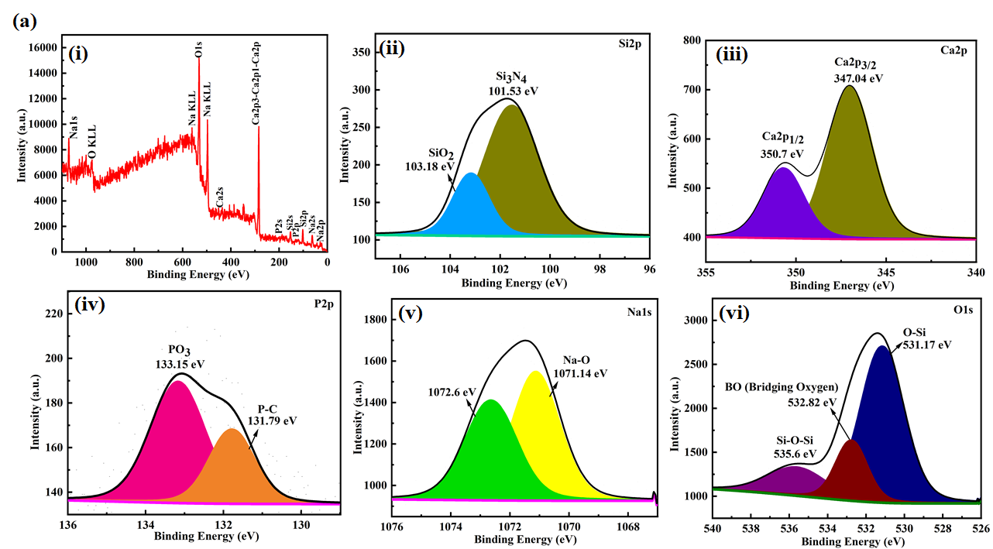
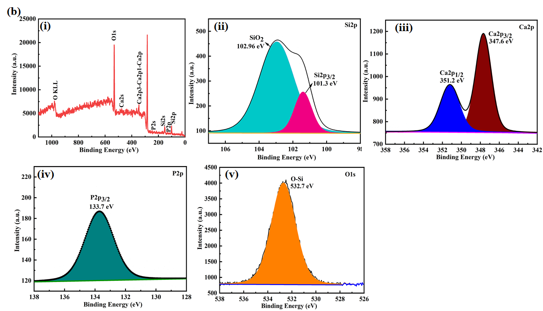
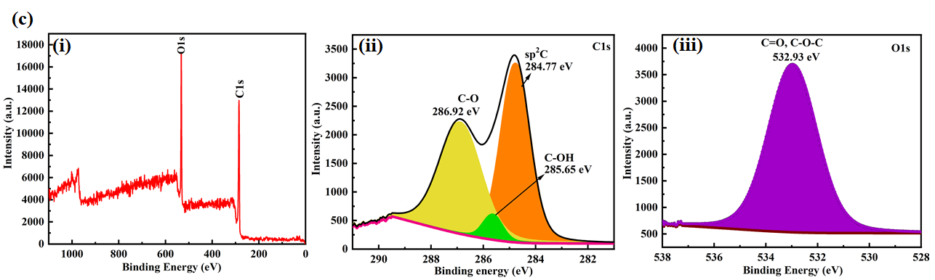
Figure. S14. XPS spectra of (a) BG, (b) BG (Na-free), (c) GO; Survey spectrum and high-resolution spectrum of Si 2p, Ca 2p, P 2p, Na 1s, C1s, and O1s.
3.6 Raman Spectra analysis

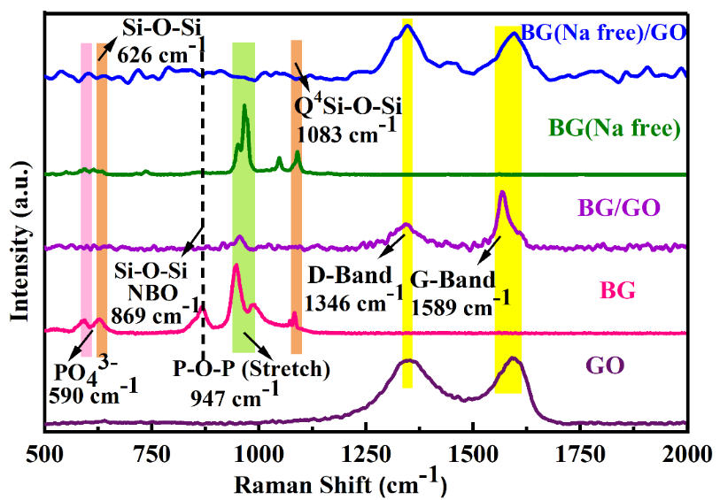
Samples | Before | D band  (cm⁻¹) | G band  (cm⁻¹) | I_{D}/I_{G} | D´ band  (cm⁻¹) | G´ band  (cm⁻¹) | I´_{D}/I´_{G}
GO | Before | 1346 | 1591 | 0.90 | - | - | -
GO | 1st Day | 1328 | 1577 | 0.97 | 2687 | 2898 | 1.01
GO | 14th Day | 1357 | 1599 | 0.98 | 2713 | 2936 | 0.98
GO | 28th Day | 1357 | 1581 | 1.00 | 2700 | 2919 | 1.00
BG/GO | Before | 1344 | 1569 | 0.45
 | 1st Day | - | - | - | - | - | -
 | 14th Day | 1349 | 1578 | 1.03 | 2454 | 2714 | 0.89
 | 28th Day | 1352 | 1576 | 1.02 | 2710 | 2946 | 1.05
BG (Na-free)/GO | Before | 1346 | 1594 | 1.14 | - | - | -
Samples | Before | D band  (cm⁻¹) | G band  (cm⁻¹) | I_{D}/I_{G} | D´ band  (cm⁻¹) | G´ band  (cm⁻¹) | I´_{D}/I´_{G}
GO | Before | 1346 | 1591 | 0.90 | - | - | -
GO | 1st Day | 1328 | 1577 | 0.97 | 2687 | 2898 | 1.01
GO | 14th Day | 1357 | 1599 | 0.98 | 2713 | 2936 | 0.98
GO | 28th Day | 1357 | 1581 | 1.00 | 2700 | 2919 | 1.00
BG/GO | Before | 1344 | 1569 | 0.45
 | 1st Day | - | - | - | - | - | -
 | 14th Day | 1349 | 1578 | 1.03 | 2454 | 2714 | 0.89
 | 28th Day | 1352 | 1576 | 1.02 | 2710 | 2946 | 1.05
BG (Na-free)/GO | Before | 1346 | 1594 | 1.14 | - | - | -
Figure S15. Raman spectra of BG, BG (Na-free), GO, and BG/GO, BG (Na-free)/GO nanocomposites.

Table S3. Peak parameters derived from Raman spectra.
3.7 FTIR Analysis
Table. S4. Determination of functional groups from FTIR spectra after mineralization.
Sample |  | After Mineralization  (Wavenumber cm⁻¹) |  |  | Functional Group | Ref
Sample | Before | (1st D) | (14th D) | (28th D)
GO | 3452 | 3738 | 3975 | 3775 | Free OH group | YouningGonga, 2015
GO | 3452 | 2927 | 3975 | 2919 | C-H bending | Luis C. Mendes, 2012
BG | 1445 | 1515 | 1492 | 1514 | C-H, C-O stretching,  Residual Carbonate group | MehradMehdipour, 2012
BG | 517 | 571 | 597 | -  - | P-O bending (crystal) | J. Faure, 2015
BG | 453 | 449 | 465 | -  - | Si-O-Si bending | Vikash Kumar Vyas, 2016
BG/GO | 1063 | 1026 | 1026 | 1032 | Si-O-Si anti-symmetric stretching | P. Bargavi, 2018
BG (Na-free) | 738 | - | - |  | SiO₄, PO₄³⁻ | Xuan Vuong Bui, 2019
BG (Na-free)/GO | - |  |  | 810 | Si-O-Si symmetric stretching | Ta Anh Tuan, 2021
BG (Na-free)/GO | - | 679 | 602 | 622 | P-O bending (amorphous) | Wei Li, 2015& Ena A. Aguilar-Reyes, 2017
BG (Na-free)/GO | - |  |  | 1527 | N-H bending, C-N stretching (in-plane) | NaziaBano, 2019

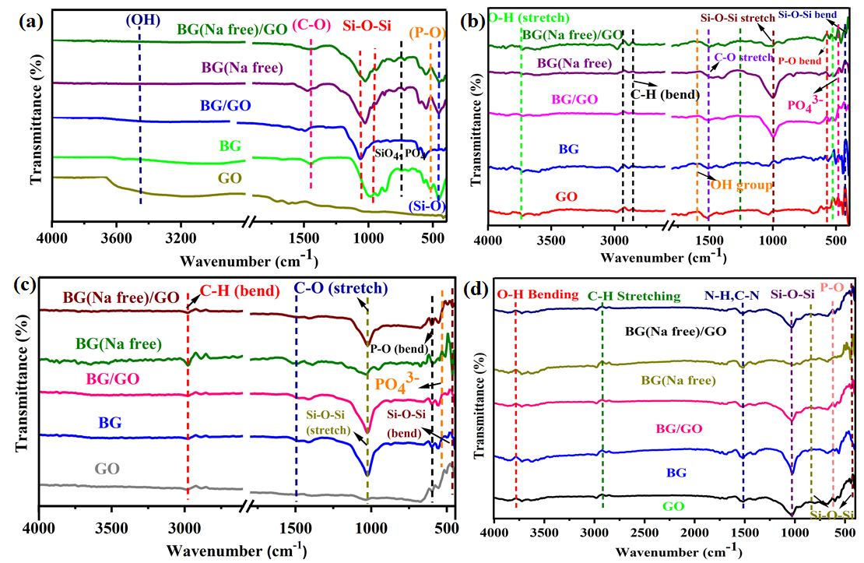
Figure S16. FTIR band position of BG, BG (Na-free), GO and BG/GO, BG (Na-free)/GO nanocomposites; (a) Before Mineralization; After Mineralization (c) 1st day, (d) 14th day, (e) 28th day.
3.8 Mechanical Stability Analysis
The microhardness test was obtained at room temperature with an applied load of 0.3Kgf and a dwell time of 10s. All the samples are indicated with error bars and denote a decrease in hardness when load increases. Compared to pure 45S5 BG and GO, the nanocomposites show a linear increase in hardness due to the microstructure of the GO.
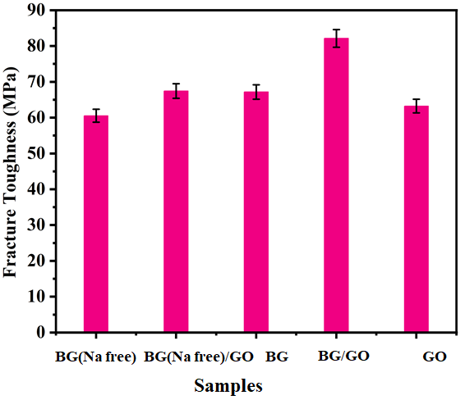
Figure. S17. Vickers hardness measurements for BG, BG (Na-free), GO and BG/GO, BG (Na-free)/GO nanocomposites.
References
- Ashok Raja, C.; Balakumar, S.; Bargavi, P.; Rajashree, P.; Anandkumar, B.; George, R. P.; Kamachi Mudali, U. Decoration of 1-D nano bioactive glass on reduced graphene oxide sheets: Strategies and in vitro bioactivity studies. Mater Sci Eng C Mater Biol Appl. 2018, 90, 85-94. DOI: 10.1016/j.msec.2018.04.040.
- Kumar, A.; Sevi, M.; Aditya, A.; Boccaccini. Mesoporous 45S5 bioactive glass: Synthesis, in vitro dissolution and biomineralization behavior. J. Mater. Chem. B 2017, 5, 8786-8798. DOI: 10.1039/C7TB01738C.
- Yu, H.; Zhang, B.; Bulin, C.; Li, R.; Xing, R. High-efficient Synthesis of Graphene Oxide Based on Improved Hummers Method. Scientific Reports 2016, 6, 36143. DOI: 10.1038/srep36143.
- Zineb, B.; Pengwan, C.; Levent, T. Enhanced synthesis method of graphene oxide. Nanoscale Adv. 2021, 3, 223-230. DOI: 10.1039/D0NA00706D.
- Liu, H.; Cheng, J.; Chen, F.; Bai, D.; Shao, C.; Wang, J.; Xi, P.; Zeng, Z. Gelatin functionalized graphene oxide for mineralization of hydroxyapatite: biomimetic and in vitro evaluation. Nanoscale 2014, 6, 5315-5322. DOI: 10.1039/C4NR00355A.
- Rugia Abu, A.M.M.A.; Alhassan. Investigating the role of mineralization of bioactive glass in wound healing using a cellular 3D collagen matrix, Thesis, McGill University, 2020.
- Zhang, G.; Gurtu, V.; Kain, S. R.; Yan, G. Early detection of apoptosis using a fluorescent conjugate of annexin V. Biotechniques. 1997, 23(3), 525-531. DOI: 10.2144/97233pf01.
- Majumdar, S.; Hira, S. K.; Tripathi, H.; Sampath Kumar, A.; Pratim Manna, P.; Singh, S. P. Sairam Krishnamurthy, Synthesis and characterization of barium-doped bioactive glass with potential anti-inflammatory activity. Ceramics International, 2021, 47, 7143-7158. DOI: 10.1016/j.ceramint.2020.11.068.
- Raza ur Rehman, S.; Augustine, R.; Ali Zahid, A.; Ahmed, R.; Tariq, M.; Hasan, A. Reduced Graphene Oxide Incorporated GelMA Hydrogel Promotes Angiogenesis For Wound Healing Applications. Int J Nanomedicine. 2019, 14, 9603–9617. DOI: 10.2147/IJN.S218120.
- Irem, U.; Tim.; FBenedikt, S.; Andrea, B.; Aldo R. Boccaccini. Antibacterial and antioxidant activity of cinnamon essential oil-laden 45S5 bioactive glass/soy protein composite scaffolds for the treatment of bone infections and oxidative stress. Materials Science & Engineering C 2021, 128, 112320. DOI: 10.1016/j.msec.2021.112320.
- Youning, G.; Delong, L.; Qiang, F.; Chunxu P. Influence of graphene microstructures on electrochemical performance for supercapacitors. Progress in Natural Science: Materials International 2015, 25, 379-385. DOI: 10.1016/j.pnsc.2015.10.004.
- Xuan Vuong Bui and Tan Hiep Dang. Bioactive glass 58S prepared using an innovation sol-gel process. Processing and Application of Ceramics 2019, 13, 98–103. DOI: 10.2298/PAC1901098B.
- Vikash, K V.; Sampath Kumar, A.; Akher, A.; Sunil Prasad.; Pradeep, S.; Sarada Prasanna, M.; Md Ershad.; Saryoo Prasad, S.; Ram, P. Assessment of nickel oxide substituted bioactive glass-ceramic on in vitro bioactivity and mechanical properties. Bol. Soc. Esp. Cerám. Vidr. 2016, 55, 228-238. DOI:10.1016/j.bsecv.2016.09.005.
- Wei, L.; Hui, W.; Yaping, D.; Ellen C. Scheithauer.; Ourania-MentiGoudouri.; Alina Gru¨newald.; Rainer Detsch.; Seema Agarwal.; Aldo R. Boccaccini. Antibacterial 45S5 sbased scaffolds reinforced with genipin cross-linked gelatin for bone tissue engineering. J. Mater. Chem. B 2015, 3, 3367-3378. DOI: 10.1039/C5TB00044K.
- Luis C. Mendes.; Geysy L. Ribeiro.; Raphaella C. Marques. In Situ Hydroxyapatite Synthesis: Influence of Collagen on Its Structural and Morphological Characteristic. Materials Sciences and Applications 2012, 3, 580-586. DOI: :10.4236/msa.2012.38083.
- Ta Anh Tuan.; Elena V. Guseva.; Nguyen Anh Tien.; Ho Tan Dat.; Bui Xuan Vuong. Simple and Acid-Free Hydrothermal Synthesis of Bioactive Glass 58SiO₂-33CaO-9P₂O₅ (wt%). Crystals 2021, 11, 283. DOI: 10.3390/cryst11030283.
- Ena A. Aguilar-Reyes.; Carlos A. León-Patiño.; Esmeralda Villicaña-Molina.; Víctor I. Macías-Andrésa.; Louis-Philippe Lefebvre. Processing and in vitro bioactivity of high-strength 45S5 glass-ceramic scaffolds for bone regeneration. Ceramics International 2017, 43, 6868-6875. DOI: 10.1016/j.ceramint.2017.02.107.
- Faure, J.; Drevet, R.; Lemelle, A.; Ben Jaber, N.; Tara, A.; El Btaouri, H.; Benhayoune, H. A new sol-gel synthesis of 45S5 bioactive glass using an organic acid as catalyst. Materials Science and Engineering C 2015, 47, 407-412. DOI: 10.1016/j.msec.2014.11.045.
- Mehrad Mehdipour.; Abdollah Afshar.; Milad Mohebali. Electrophoretic deposition of bioactive glass coating on 316L stainless steel and electrochemical behavior study. Applied Surface Science 2012, 258, 9832–9839. DOI:10.1016/j.apsusc.2012.06.038.
- Bargavi, P.; Chitra, S.; Durgalakshmi, D.; Rajashree, P.; Balakumar, S. Effect of Titania Concentration in Bioglass/TiO₂ Nanostructures and Its In Vitro Biological Property Assessment. J. Nanosci. Nanotechnol 2018, 18, 4746-4754. DOI: 10.1166/jnn.2018.15340.
- Nazia, B.; Suzi Salwah, J.; Hatijah, B.; Sharifah, A.; Dagaci Muhammad, Z. XRD and FTIR Study of A&B Type Carbonated Hydroxyapatite Extracted from Bovine Bone. AIP Conference Proceedings 2019, 2068, 020100. DOI: 10.1063/1.5089399.

