Supplementary Appendix
Inclusion Criteria:
- Patients 18 years of age and above
- Patients giving consent for participating in the study and willing to follow up at 3 months
- Patients diagnosed with symptomatic ischemic stroke due to extracranial internal carotid artery atherosclerotic disease
- Patients undergoing carotid artery re-vascularization (carotid artery stenting and carotid end- arterectomy) for symptomatic carotid artery stenosis.
Exclusion criteria:
- Patients less than 18 years of age
- Patients or their caretakers not willing to give consent
- Patients with intracerebral haemorrhage
- Patients with any other sort of cerebro-vascular co-morbidities viz aneurysm,SAH(sub-arachnoid hemorrhage), ICSOL(intracranial space occupying lesions),vasculitis.
- Patients with visual loss or visual impairment, media opacities preventing high-quality imaging, vitreoretinal disease particularly central retinal artery occlusion and central retinal vein occlusion ,clinically evident diabetic retinopathy or status post vitreoretinal surgery.
- Hypertensive retinopathy more than Grade 2
- Patients who are terminally ill and are on life support measures.

Modified Rankin Score (mRS)
Modified Rankin Score, is a clinician – reported measure of global disability, which is widely used to evaluate stroke patient outcomes and as an end point in major clinical trials involving stroke patients.^{39,40} mRS is graded as follows:
mRS 0: No symptoms at all
mRS 1: No significant disability: despite symptoms, able to carry out all usual
duties and activities
mRS 2: Slight disability: unable to perform all previous activities but able to look
after own affairs without assistance
mRS 3: Moderate disability: requiring some help but able to walk
without assistance
mRS 4: Moderately severe disability: unable to walk without assistance and unable
to attend to own bodily needs without assistance
mRS 5: Severe disability: bedridden, incontinent and requiring constant nursing
care and attention
mRS 6: Death

Acquisition of OCTA images
(Representative images shown in Figure 3 and 4)
OCTA scans were performed using Spectral Domain Cirrus HD-OCT Model 5000 (Carl Zeiss, Meditec, Inc, 5160 Hacienda Drive, Dublin, CA 94568 USA).
2 areas of the retina were scanned
A. 3 mm by 3mm scan, centred at macula
B. 4.5 mm by 4.5mm scan, centred on optic disc
A. Analysis at the Macula
1) At the superficial level – was done by the automated machine provided software and segregated into the following segments:
a. Superficial, Vessel density, in mm/mm2
i. Central(fovea)
ii. Inner (parafovea)
iii. Full (whole en face)
b. Superficial, Perfusion Density, in %
i. Central(fovea)
ii. Inner (parafovea)
iii. Full (whole en face)
2) At the Deep level – was done by ImageJ software as described below.
B. Analysis at the disc
1) Radial Peripapillary Capillary/ONH perfusion in %
2) Radial Peripapillary Capillary/ONH Flux Index

ImageJ analysis
The computer algorithms provided automated data for the superficial vessel density and blood flow (perfusion) and also perfusion at the RPC layer of ONH. However, the OCTA technology used for this study (version mentioned above) did not have the software for automated image data segregation and value generation. The Deep OCTA image obtained were analysed using the ImageJ software to obtain the vessel density of the Deep layer at the macula.
ImageJ is a based image processing program developed at the National Institutes of Health and the Laboratory for Optical and Computational Instrumentation (LOCI, University of Wisconsin). ImageJ software has been pioneers as open tools for the analysis of scientific images.⁴⁴
ImageJ can be run as an online applet, a downloadable application, or on any computer with a Java 5 or later virtual machine. ImageJ can display, edit, analyze, process, save, and print 8-bit color and grayscale, 16-bit integer, and 32-bit floating point images. It can read many image file formats including TIFF, PNG, GIF, JPEG, BMP, DICOM, and FITS, as well as raw formats.⁴⁵
For the purpose of this study Image J software was downloaded from the National Institute of Health (National Centre for Biotechnology Information). The software is available for free download at this website:https://imagej.nih.gov/ij/download.html).⁴⁶ The 8 bit images were analyzed using the JPEG format. The detailed procedure used to analyze the images is shown in the flowchart below.( Flowchart 1).⁴⁴

Flowchart 1 depicting the procedure used for deep OCTA analysis using ImageJ software
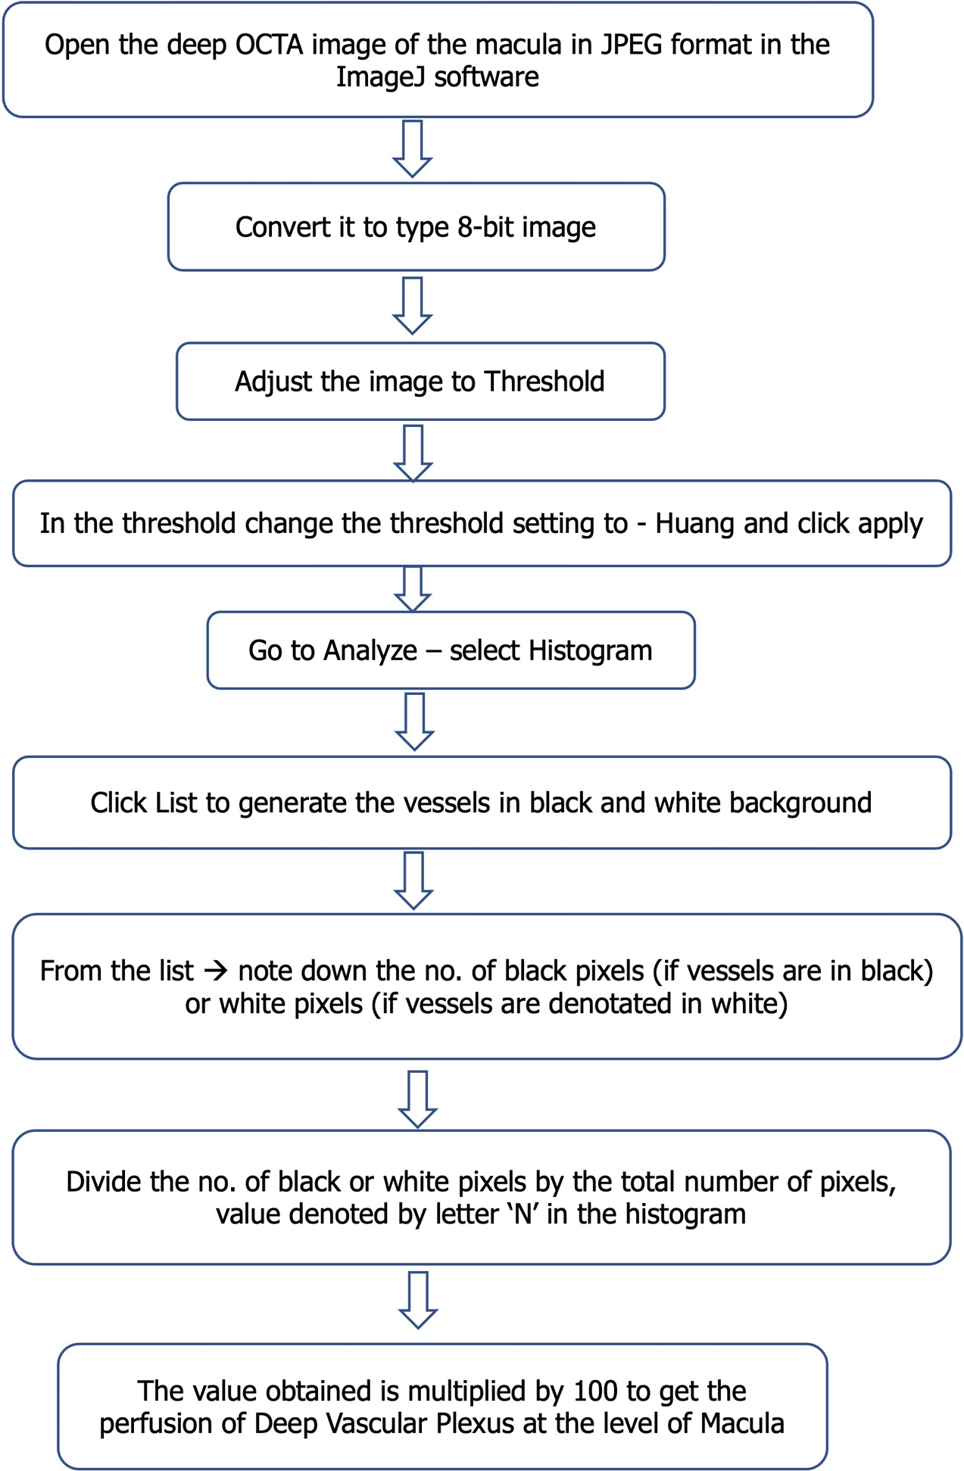
Legends for supplementary figures
Figure S1 showing images acquired from a representative case (case arm) in the present study.
Axial MRI brain images showing DWI (Diffusion weighted) restriction in the right ACA, MCA watershed region, centrum semiovale (a) with corresponding hypointensity in the ADC sequence of MRI (b). FLAIR hyperintensity is also seen in the same territory, suggestive of an acute infract in the right MCA (c), ACA watershed territory (yellow arrows). MIP (maximum intensity projection) image of the Computed Tomography Angiography of the arch of aorta, the neck vessels and the Circle of Willis showing long segment occlusion of cervical and petrous part of right ICA (d, yellow arrow) with recanalization of cavernous and clinoid part of ICA and MCA, suggestive of Extracranial Carotid Artery Atherosclerotic disease (ECAD).
Figure e – l showing OCTA angiograms of the same patient. Figure e showing superficial vessel density at the level of macula and automatically segregated into three regions by the software, central ( fovea), inner (parafovea) and full (whole in face) ( highlighted in the figure by yellow squares). The values against these three parameters were noted down to analyze the results. Figure f showing superficial perfusion density at the level of macula and automatically, segregated into three regions by the software, central ( fovea), inner (parafovea) and full (whole in face) ( highlighted in the figure by yellow squares). Figure g - is the deep vessel density at the level of macula, which was processed by the imageJ software to obtain the vessel density. Figure h showing Radial peri-pappilary capillary perfusion Density (RPCPD) at the Optic Nerve Head ( ONH), which the software automatically computes values for perfusion density in percentage and Flux index in ratio. The images from e – h are for the ipsilateral eye, eye on the side of stroke, in this case right side, denoted by OD in the images. Figure i -l shows the same OCTA images acquired for the contralateral eye.
Figure S2 showing images acquired from a control subject (control arm) in the present study.
Figure a –d showing doppler ultrasound of bilateral carotid arteries. Figure a and c showing right and left carotid bulb, respectively, showing normal diameter of these vessels and without any intraluminal plaque or stenosis (yellow arrows). Figure b and c showing normal velocity and normal spectral waveforms of the bilateral internal carotid arteries for the right side and left side respectively, without any evidence of stenosis (yellow arrows).
Figure e – l showing OCTA angiograms of the same patient. Figure e showing superficial vessel density at the level of macula and automatically segregated into three regions by the software, central ( fovea), inner (parafovea) and full (whole in face) ( highlighted in the figure by yellow squares). The values against these three parameters were noted down to analyze the results. Figure f superficial perfusion density at the level of macula and automatically segregated into three regions by the software, central ( fovea), inner (parafovea) and full (whole in face) ( highlighted in the figure by yellow squares). Figure g is the deep vessel density at the level of macula, which was processed by the imageJ software to obtain the vessel density. Figure h showing RPCPD at the Optic Nerve Head (ONH), which the software automatically computes values for perfusion density in percentage and Flux index in ratio. Figure i- l showing the same OCTA parameters acquired for the opposite eye.
Figure S3 showing the schematic representation of recruitment of cases (flowchart 3a on the left) and controls (flowchart 3b on the right) for the present study.

Figure S4 showing comparison between OCTA findings of the contralateral eye and various outcome measures

Figure S4 showing distribution of spearman coefficient and p- value of the comparison of OCTA parameters of the contralateral eye with NIHSS at the time of admission, mRS at discharge, mRS at 3 months of stroke onset and change in mRS. [x-axis denotes the outcome measures(mentioned vertically) compared with the various OCTA findings (mentioned horizontally) , y axis denoted the spearman corelation coefficient, rs (in orange colour) and p value (in blue colour)].

