SUPPLEMENTARY MATERIAL
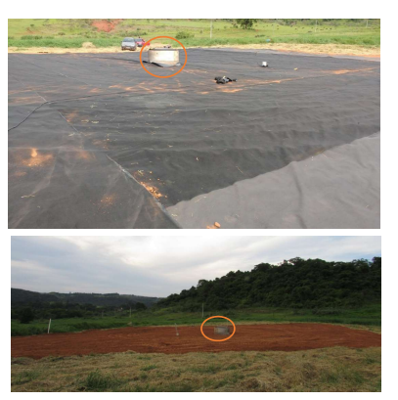
Fig. 1_{SM}. Detail of capping layers constructed in the study area. Geomembrane (above) and regularization soil layer (below)

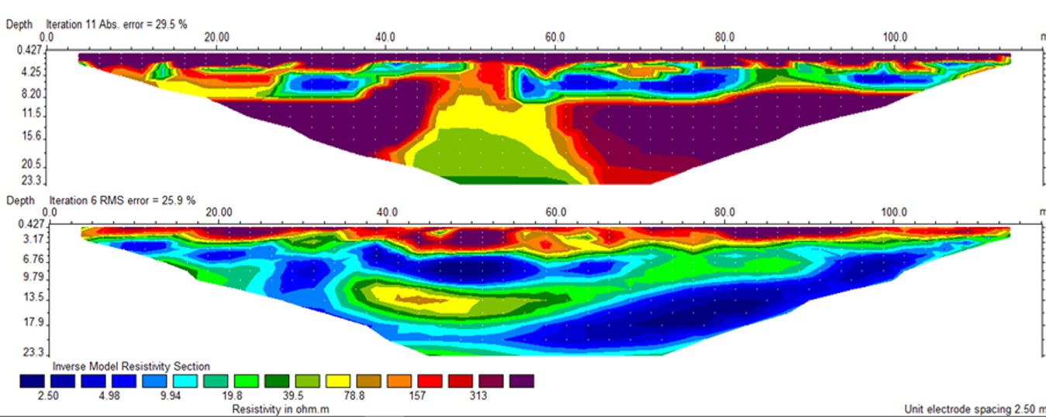
Fig. 2_{SM}. Resistivity profiles for Line 5, in July 2018 (above) and February 2020 (below).

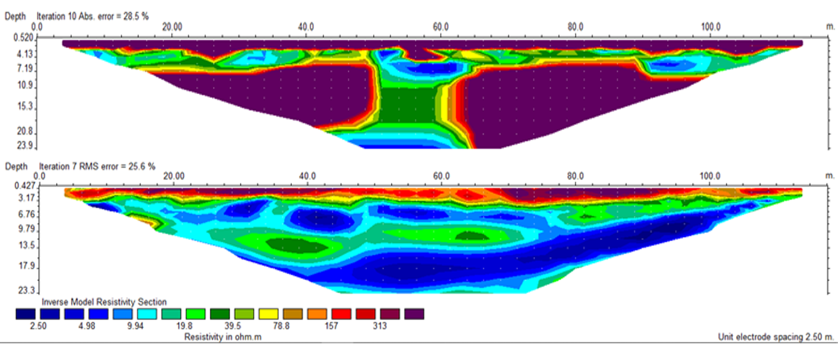Fig. 3_{SM}. Resistivity profiles for Line 6, in July 2018 (above) and February 2020 (below).

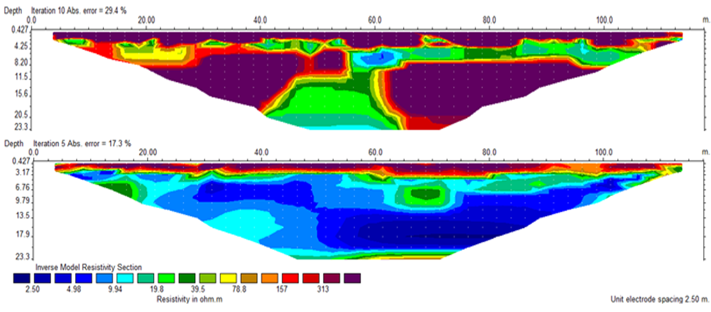Fig. 4_{SM}. Resistivity profiles for Line 7, in July 2018 (above) and February 2020 (below).

