Supplemental Figure
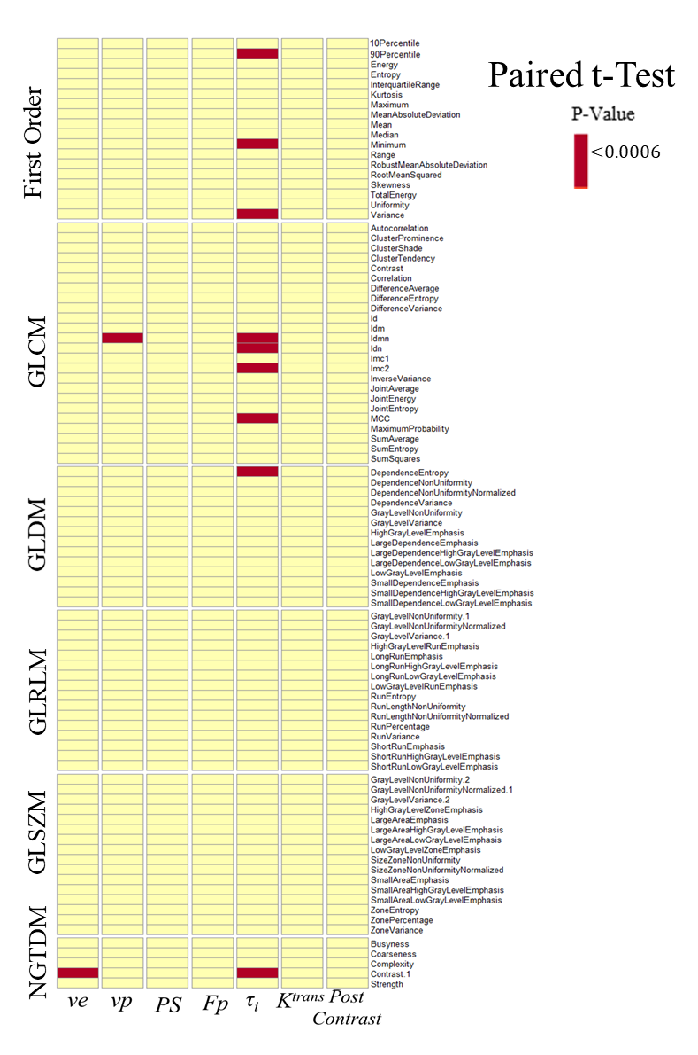
Supplementary Figure S1. Heatmap of the radiomics features with significant difference (p < 0.0006, depicted in red) between the control and treated cohorts. Among the 93 histogram and texture features extracted from the parameter maps, 9 τ_{i} features and one feature for v_{e} and v_{p} maps were found to be significantly different.

