Supplementary Material (Plant and Soil)

Salinity mediates the effects of groundwater and seasonal streamflow on the symbiotic nitrogen fixation of a dryland phreatophyte

Meimei Li ^{1, 2, 3, 4, 5}, Matthew D. Petrie ⁵, Hao Chen ^{3*}, Fanjiang Zeng ^{1, 2, 4*}, Zeeshan Ahmed ^{1, 2, 4}, Xibin Sun³

¹ State Key Laboratory of Desert and Oasis Ecology, Xinjiang Institute of Ecology and Geography, Chinese Academy of Sciences, Urumqi 830011, China.
² Xinjiang key laboratory of Desert Plant Roots Ecology and Vegetation Restoration, Xinjiang Institute of Ecology and Geography, Chinese Academy of Sciences, Urumqi 830011, China.
³ State Key Laboratory of Biocontrol, School of Ecology, Sun Yat-sen University, Shenzhen 518107, China.
⁴ Cele National Station of Observation and Research for Desert-Grassland Ecosystems, Qira 848300, China.
⁵ School of Life Sciences, University of Nevada Las Vegas, Las Vegas, NV 89154 USA.

*Corresponding to:
Hao Chen
No.66, Gongchang Road, Guangming District, Shenzhen 518107, Guangdong, China
E-mail: chenhao27@mail.sysu.edu.cn

Fanjiang Zeng
818 South Beijing Road, Urumqi 830011, Xinjiang, China.
E-mail: zengfj@ms.xjb.ac.cn

Table S1 The concentrations of NH₄-N, Ca²⁺, HCO₃⁻, SOC, and pH in the water-saturated soil for Transect A (sampling locations a₁-a₁₄) and Transect B (b₁-b₉).
No. plot | NH₄-N | Ca²⁺ | HCO₃⁻ | SOC | pH (1:5)
No. plot | mg/kg
a1 | 11.52 ± 0.42 | 77.87 ± 24.31 | 88.59 ± 4.79 | 0.68 ± 0.06 | 8.06 ± 0.09
a2 | 10.98 ± 0.30 | 89.55 ± 24.31 | 95.78 ± 8.19 | 0.83 ± 0.03 | 8.15 ± 0.23
a3 | 12.22 ± 0.24 | 73.98 ± 17.84 | 98.55 ± 21.05 | 0.77 ± 0.05 | 8.25 ± 0.02
a4 | 13.54 ± 0.32 | 63.23 ± 16.65 | 110.73 ± 27.05 | 0.72 ± 0.07 | 7.74 ± 0.08
a5 | 13.43 ± 0.44 | 78.65 ± 14.07 | 98.55 ± 8.19 | 0.79 ± 0.09 | 8.17 ± 0.20
a6 | 11.97 ± 0.40 | 76.63 ± 7.05 | 117.93 ± 2.87 | 0.80 ± 0.05 | 8.04 ± 0.37
a7 | 11.91 ± 0.26 | 97.34 ± 24.31 | 112.39 ± 4.17 | 0.69 ± 0.06 | 7.61 ± 0.18
a8 | 12.56 ± 0.52 | 81.77 ± 20.23 | 115.16 ± 14.32 | 0.84 ± 0.06 | 7.75 ± 0.47
a9 | 12.78 ± 0.64 | 66.19 ± 6.74 | 100.21 ± 6.71 | 0.70 ± 0.09 | 7.59 ± 0.41
a10 | 13.08 ± 0.26 | 55.72 ± 26.61 | 126.50 ± 13.64 | 0.77 ± 0.03 | 8.33 ± 0.05
a11 | 12.73 ± 0.65 | 77.87 ± 17.84 | 91.91 ± 9.14 | 0.67 ± 0.13 | 7.55 ± 0.01
a12 | 12.83 ± 0.52 | 152.79 ± 16.82 | 94.12 ± 6.91 | 0.76 ± 0.06 | 7.81 ± 0.41
a13 | 11.97 ± 0.57 | 104.81 ± 20.51 | 93.02 ± 14.19 | 0.86 ± 0.02 | 8.06 ± 0.29
a14 | 13.03 ± 0.29 | 87.22 ± 21.2 | 96.89 ± 2.53 | 0.76 ± 0.08 | 7.80 ± 0.39
b1 | 11.66 ± 0.75 | 59.96 ± 30.49 | 107.96 ± 14.38 | 0.74 ± 0.17 | 7.69 ± 0.11
b2 | 12.42 ± 0.47 | 72.42 ± 18.54 | 96.89 ± 4.79 | 0.72 ± 0.05 | 7.90 ± 0.29
b3 | 13.02 ± 1.44 | 79.43 ± 15.31 | 115.16 ± 8.52 | 0.70 ± 0.06 | 8.24 ± 0.02
b4 | 12.85 ± 1.61 | 84.10 ± 15.32 | 107.96 ± 10.37 | 0.79 ± 0.07 | 8.20 ± 0.06
b5 | 13.08 ± 0.26 | 55.72 ± 26.61 | 126.50 ± 13.64 | 0.77 ± 0.03 | 8.33 ± 0.05
b6 | 11.91 ± 1.04 | 22.33 ± 8.38 | 152.33 ± 10.01 | 0.78 ± 0.10 | 8.47 ± 0.17
b7 | 12.59 ± 0.48 | 29.66 ± 11.71 | 157.66 ± 24.01 | 0.79 ± 0.11 | 8.19 ± 0.16
b8 | 12.76 ± 1.72 | 109.02 ± 7.74 | 119.04 ± 4.79 | 0.82 ± 0.07 | 7.69 ± 0.11
b9 | 12.52 ± 1.47 | 81.89 ± 22.50 | 101.29 ± 13.19 | 0.77 ± 0.08 | 7.90 ± 0.19

Table S2 Shrub height and coverage of A. sparsifolia vegetation in upland (plot a₁), lowland (plot a₁₄), and riparian (plot b₁) locations.
Location | Upland | Lowland | Riparian
Height (cm) | 91.0 ± 9.53 | 91.3 ± 4.04 | 90.6 ± 13.57
Coverage (%) | 28.5 ± 4.98 | 29.7 ± 5.35 | 25.5 ± 7.84

Table S3 Salt (NaCl) and available nutrients dissolved in groundwater (sampling location b₁) and Qira River during summer (June-August).
Water source | Units | NaCl | NO₃-N | NH₄-N | Available_P
Groundwater | mg/L | 153.92 ± 11.64 | 6.68 ± 0.93 | 11.66 ± 0.75 | 0.87 ± 0.15
Stream water | mg/L | 28.66 ± 2.51 | 6.12 ± 0.11 | 1.41 ± 0.16 | 0.86 ± 0.07

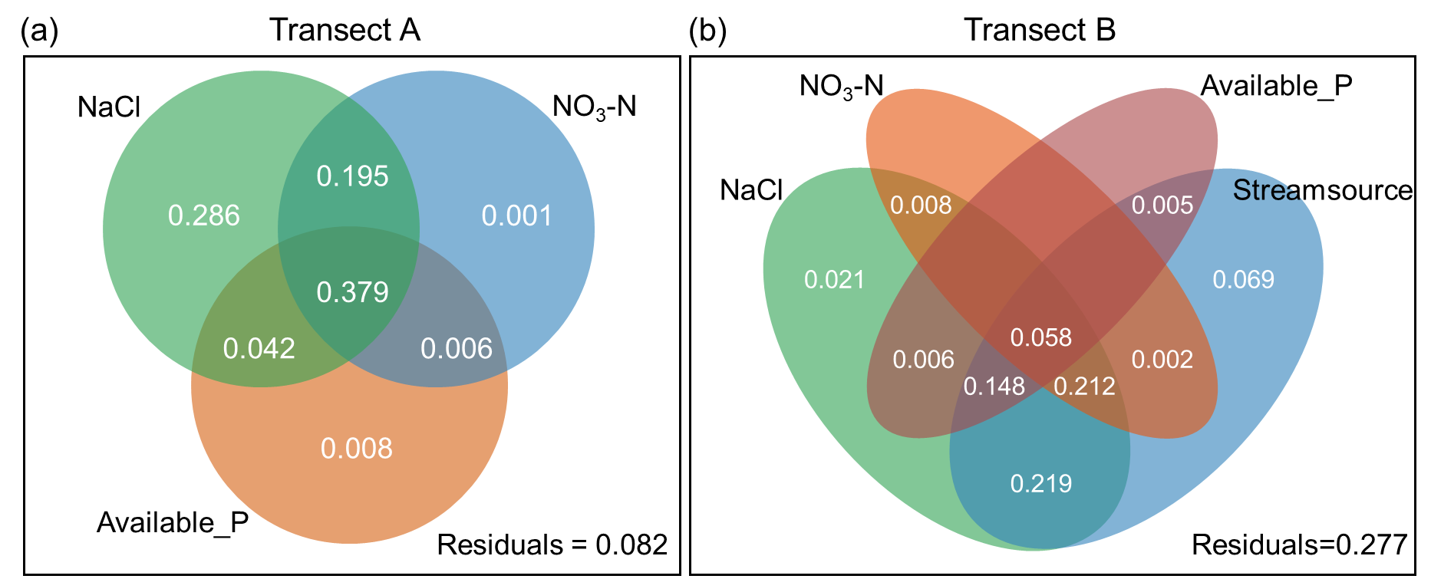
Fig.S1 Variance decomposition analysis of main factors influencing the nitrogen fixation of A. sparsifolia across Transect A (Panel a) and Transect B (Panel b).

