Supplementary Information

Table S1. Clinicopathologic characteristics of SMARCA4-WT (wild-type)
and SMARCA4-R1157W mutant in CRC patients.
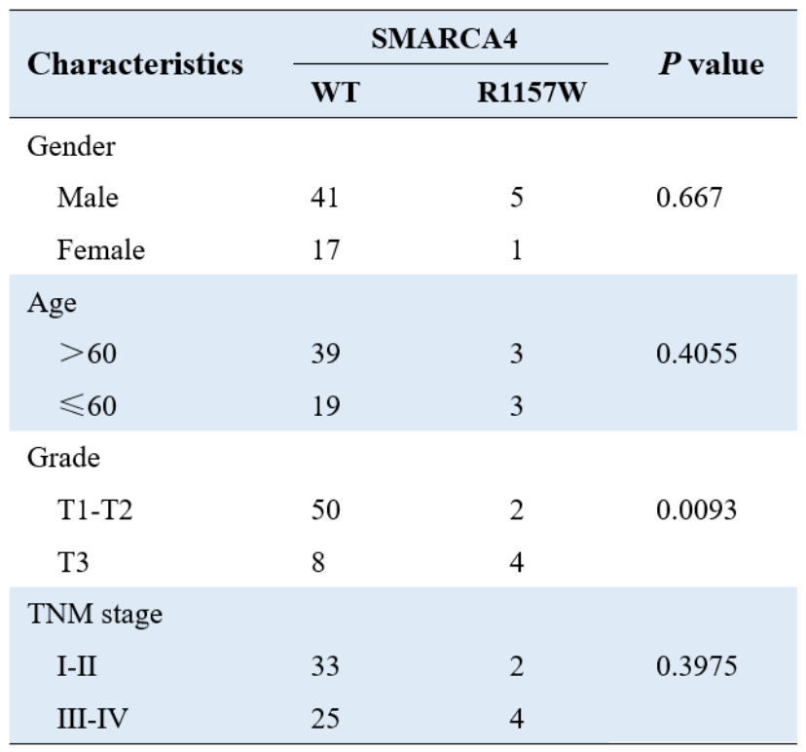
Analysis of pathological parameters in patients with CRC. Six samples with SMARCA4-R1157W mutation were identified in 64 CRC samples by direct sequencing. According to the TNM staging criteria set by the American Joint Committee on Cancer (AJCC), patient information was classified by gender, age, grade, and stage. P values were derived using Fisher’s exact test to compare values for the two parameters in each category. [Grade T1-T2: the cancer has grown into submucosa (T1) or muscularis propria (T2). Grade T3: the cancer has spread into subserosa. Stage I-II: the cancer has spread to surrounding tissues, but not to lymph nodes. Stage III-IV: the cancer has spread to lymph nodes and is more likely to spread to distant sites such as liver, lung, peritoneum, or ovaries].

Table S2. Primers for RT-PCR
Gene names | Sequence (5’-3’)
SMARCA4-F  SMARCA4-R  EGFR-F  EGFR-R  TNS4-F  TNS4-R  GAPDH-F  GAPDH-R | GACCAGCACTCCCAAGGTTAC  CTGGCCCGGAAGACATCTG  AGGCACGAGTAACAAGCTCAC  ATGAGGACATAACCAGCCACC  AGGACACCAGAACTCCGTTCA  TCTCGGGTGATGTTTGGCTTA  GAAGGTGAAGGTCGGAG  GAAGATGGTGATGGGATTTC

Table S3. Primers for ChIP
Gene names | Sequence (5’-3’)
EGFR-ChIP-F  EGFR-ChIP-R  TNS4-ChIP-F  TNS4-ChIP-R | CTCCTCAGGGCACCCGCTC  CCAGGCGGCGGAGGAGGGATC  CACTGGCATCCTGCTTTGTCAAG  GTTCCTGCTTGGGCTTCTCGTG

Table S4. Primers for DNase I chromatin accessibility analysis
Gene names | Sequence (5’-3’)
EGFR-F (promoter)  EGFR-R (promoter)  EGFR-F (gene body)  EGFR-R (gene body)  TNS4-F (promoter)  TNS4 -R (promoter)  TNS4 -F (gene body)  TNS4-R (gene body) | CTCCTCAGGGCACCCGCTC  CCAGGCGGCGGAGGAGGGATC  GCCTTGACTGAGGACAGCAT  CCTTACGCCCTTCACTGTGT  CACTGGCATCCTGCTTTGTCAAG  GTTCCTGCTTGGGCTTCTCGTG  GAGAGACACGAAGCAGCAGT  CCAGTCTTGGAGAAGCCACC

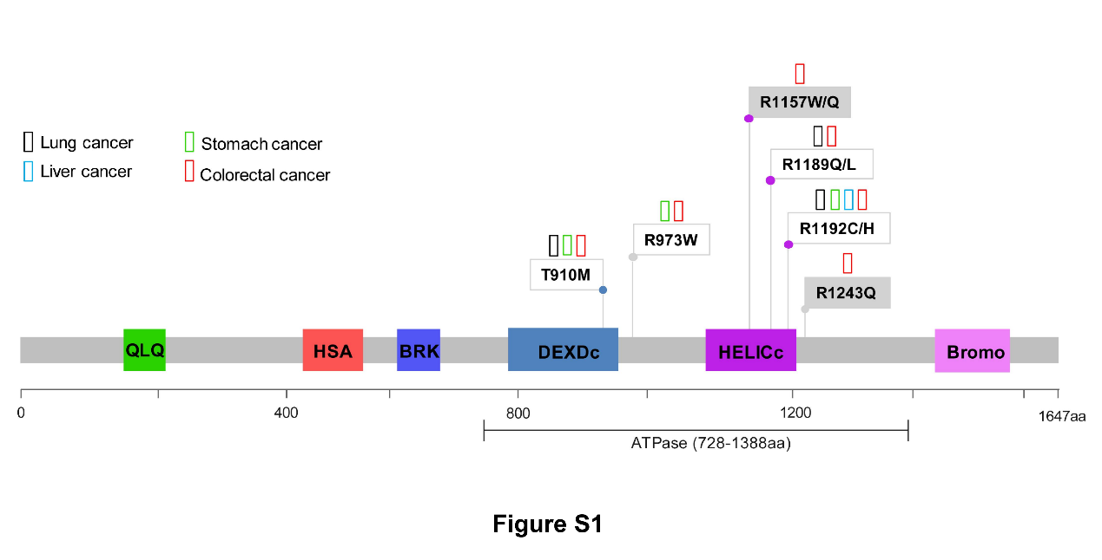
Figure S1. SMARCA4 ATPase domain harbors specific genomic mutations in CRC. Mutations of SMARCA4 in lung, liver, stomach, and colorectal cancers were analyzed in the cBioPortal database.

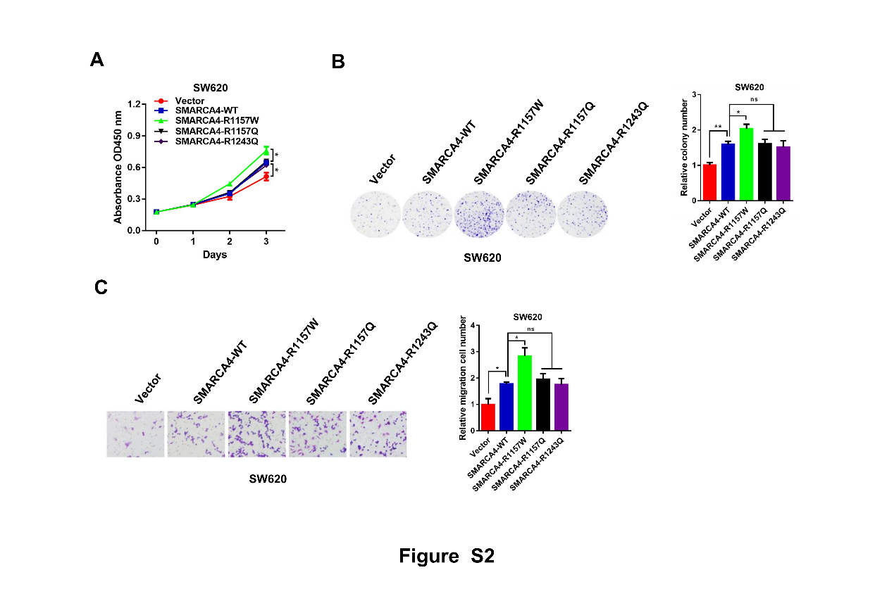
Figure S2. The SMARCA4-R1157W mutant promotes the growth of SW620 cells. A, Proliferation of SW620 cells transfected with SMARCA4 overexpression plasmids (SMARCA4-WT, SMARCA4-R1157W, SMARCA4-R1157Q, or SMARCA4-R1243Q) or vector plasmids. Values at the indicated time points represent mean ± SD from three independent tests. **P < 0.01. B, Colony formation assay of SW620 cells transfected with SMARCA4 overexpression plasmids as in (A). Representative images (left panel) and quantitative analyses of the colony formation (right panel) are shown. *P < 0.05. C, Migration assays of SW620 cells transfected with SMARCA4 overexpression plasmids as in (A). The numbers of migrated cells were quantified by counting the numbers of cells in entire fields at ×200 magnification. Representative images (left panel) and quantitative analyses of the migrated cells (right panel) are shown. *P < 0.05, **P < 0.01.

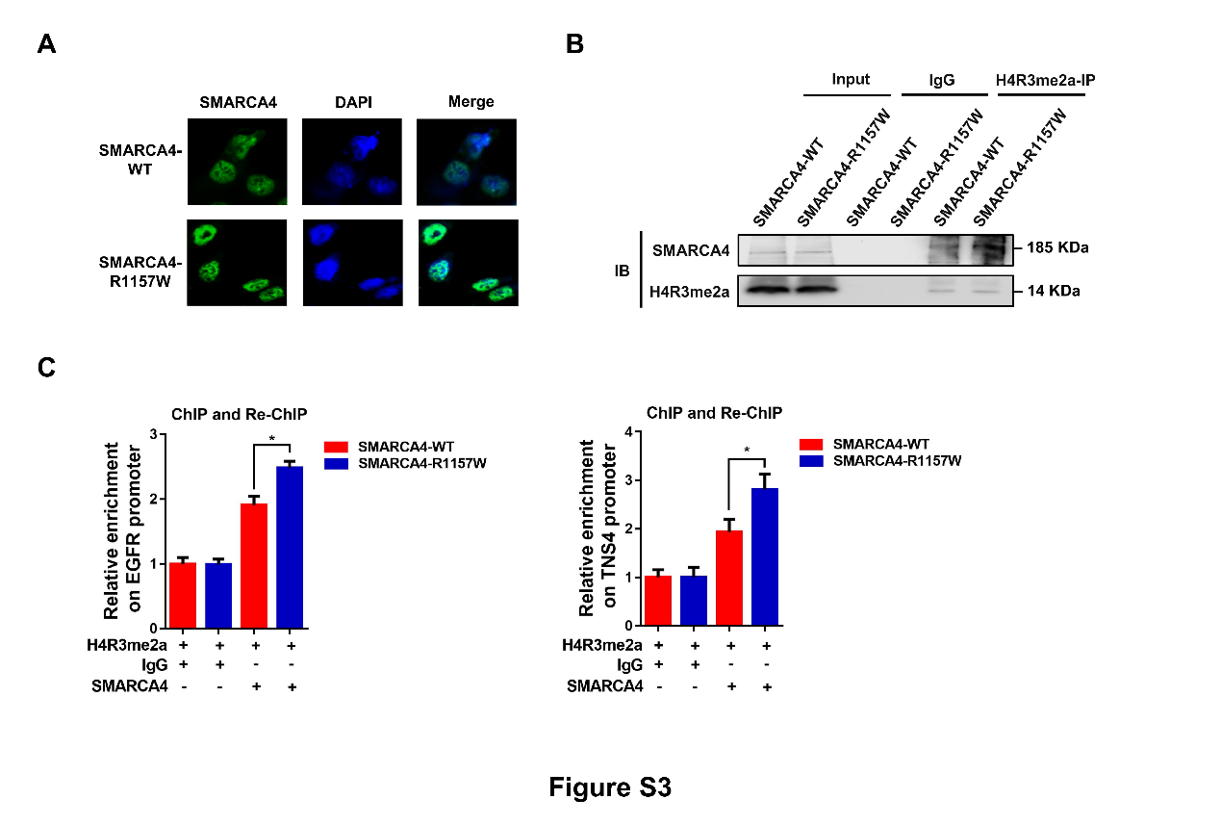
Figure S3. The SMARCA4-R1157W mutation enhances its binding to H4R3me2a. A, Immunofluorescence assay was performed in HCT116 cells after transfection with SMARCA4-WT or SMARCA4-R1157W plasmids; rabbit anti-SMARCA4 antibody (green), DAPI (blue). B, Coimmunoprecipitation assay with lysates prepared from SMARCA4-KO HCT116 cells after transfection with SMARCA4-WT or -R1157W mutant plasmids. Anti-H4R3me2a antibody was used for immunoprecipitation, and precipitates were blotted with the indicated antibody. IgG serves as a negative control. C, ChIP-reChIP analysis of chromatin from SMARCA4-KO HCT116 cells after transfection with SMARCA4-WT or R1157W mutant plasmids. The first antibody (H4R3me2a) and second antibody (SMARCA4) used in the reChIP are shown below the bar plot. The amount recovered from the reChIP was determined by qPCR and is shown as values relative to IgG. *P < 0.05.

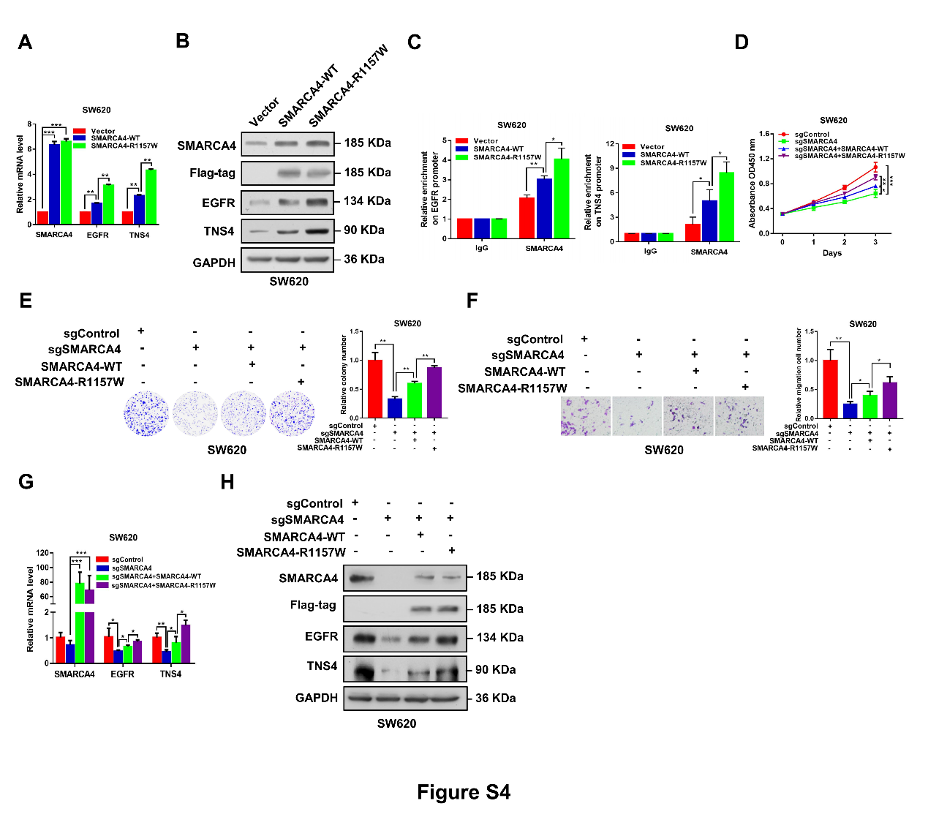
Figure S4. The SMARCA4-R1157W mutant reinforces expression of EGFR and TNS4 in SW620 cells. A, Quantitative real-time PCR analysis of SMARCA4, EGFR, and TNS4 mRNA levels normalized to GAPDH in SW620 cells transfected with SMARCA4-WT or R1157W overexpression plasmids. **P < 0.01, ***P < 0.001. B, Western blot analysis of indicated proteins in SW620 cells transfected with SMARCA4-WT or SMARCA4-R1157W overexpression plasmids. GAPDH served as a loading control. C, ChIP analysis of SMARCA4-WT and SMARCA4-R1157W binding to the EGFR and TNS4 promoter in SW620 cells. *P < 0.05, **P < 0.01. D-F, CRISPR/Cas9 was used to knockout SMARCA4 in SW620 cells, and SMARCA4-WT or SMARCA4-R1157W plasmids were transfected into SMARCA4-KO cells. CCK-8 assay (D) was used to detect proliferation of cells in each group. Colony formation assay (E) was used to detect the clonogenesis of cells in each group. Migration assay (F) was used to detect migration of cells in each group. *P < 0.05, **P < 0.01, ***P < 0.001. G, Quantitative real-time PCR analysis of SMARCA4, EGFR, and TNS4 mRNA levels normalized to GAPDH in SMARCA4-KO SW620 cells transfected with SMARCA4-WT or SMARCA4-R1157W plasmids. *P < 0.05, **P < 0.01, ***P < 0.001. H, Western blot analysis of indicated proteins in SMARCA4-KO SW620 cells transfected with SMARCA4-WT or SMARCA4-R1157W plasmids. GAPDH served as a loading control.

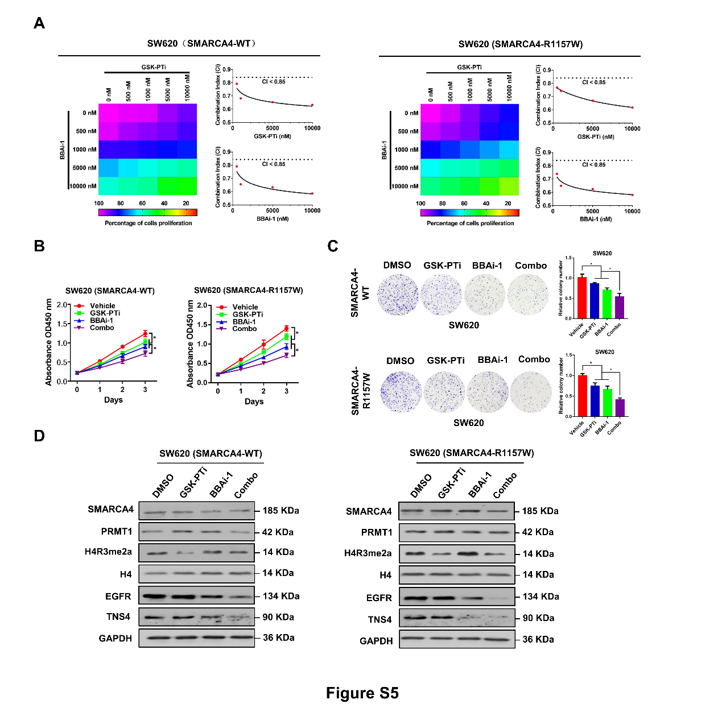
Figure S5. Synergistic effect of combined treatment with GSK-PTi and BBAi-1 in SMARCA4-R1157W SW620 cells. A, Drug dose-response matrix for growth inhibition of SMARCA4-WT or -R1157W SW620 cells following 7-day culture with GSK-PTi plus BBAi-1. Color gradation indicates percent viability at the indicated dose combination. Combination index (CI) plots for 5 μM BBAi-1 or 5 μM GSK-PTi with graded doses of GSK-PTi (top) or BBAi-1 (bottom) in SMARCA4-WT or -R1157W SW620 cells. B and C, CCK8 (B) and colony formation (C) assay were performed to evaluate the effect of the combination treatment with 5 μM GSK-PTi and 5 μM BBAi-1 on cell proliferation of SMARCA4-WT or -R1157W SW620 cells. *P < 0.05. D, Western blot analysis of indicated proteins in SMARCA4-WT or -R1157W SW620 cells following treatment with 5 μM GSK-PTi or 5 μM BBAi-1. Histone H4 and GAPDH were used as loading control.

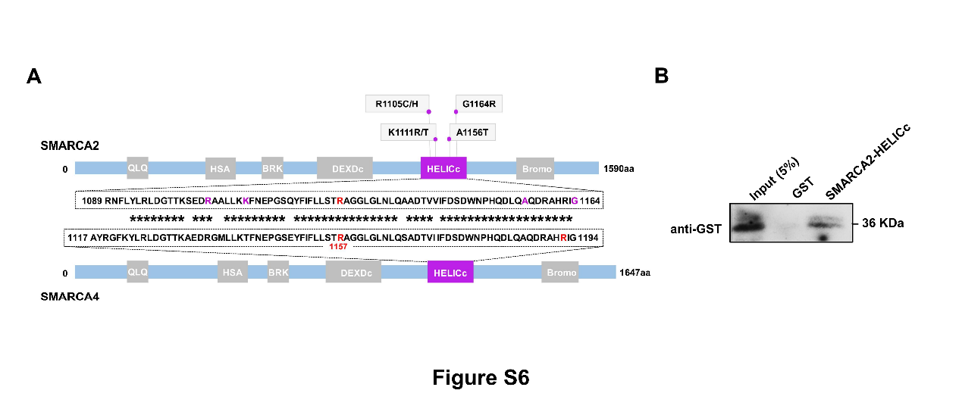
Figure S6. The binding of SMARCA2 HELICc domain to H4R3me2a. A, Comparison of the amino acid sequences of SMARCA2 and SMARCA4 HELICc domain and their mutations in CRC. B, Peptide pulldown assays to detect the interaction between H4R3me2a peptide and SMARCA2 HELICc domain protein as a GST fusion protein. GST was used as a negative control.

