Supplementary Information: Three-dimensional strain imaging of irradiated chromium using multi-reflection Bragg coherent diffraction
Ericmoore Jossou*ª, Tadesse A. Assefa^{b}, Ana F. Suzana^{c}, Longlong Wu^{c}, Colleen Campbell^{d},
Ross Harder^{e}, Wonsuk Cha^{e}, Kim Kisslinger^{f}, Cheng Sun^{g}, Jian Gan^{g}, Lynne Eckerª, Ian K. Robinson^{c}, Simerjeet K. Gill*ª
ªNuclear Science and Technology Department, Brookhaven National Laboratory, Upton, NY 11973, USA
^{b}Stanford Institute for Materials and Energy Sciences, SLAC National Accelerator Laboratory, Menlo Park, CA, USA
^{c}Condensed Matter Physics and Materials Science Department, Brookhaven National Laboratory, Upton, NY, 11973 USA
^{d}Department of Nuclear Science & Engineering, Massachusetts Institute of Technology, Cambridge, MA, USA
^{e}Advanced Photon Source, Argonne National Laboratory, Lemont, IL, USA
^{f} Center for Functional Nanomaterials, Brookhaven National Laboratory, Upton, NY, 11973, USA
^{g}Idaho National Laboratory, Idaho Falls ID 83415, USA
* Corresponding author E-mail address: ejossou@bnl.gov (Ericmoore Jossou)
* Corresponding author E-mail address: gills@bnl.gov (Simerjeet K. Gill)
I. Phasing of BCDI data
The reconstruction process of a 3D coherent X-ray diffraction (CXD) patterns was performed in stages, using the output from the previous stage to seed the next phasing stage. Initially, CXD patterns were padded to a size of 256×256×256 voxels (zero padded to 256 pixels in the third direction).
1. Each reconstruction was seeded with a random guess. The well-defined shapes and edges of the sample help to render the diffraction patterns invertible, which also allows us to use fixed box-shaped support to assist the phasing algorithms¹. A guided phasing approach with 40 individuals and 4 generations was used with a geometric average breeding mode². 620 iterations were used in each generation, alternating between a block of 20 error reduction (ER) and 180 hybrid input–output (HIO) iterations, with β = 0.9. This was followed by 20 ER iterations to return the final object. The shrinkwrap algorithm with a threshold of 0.15 was used to update the real-space support every iteration. The σ for the Gaussian kernel shrinkwrap smoothing for each generation was 1.5³. The best reconstruction was determined using a sharpness criterion, as it is the most appropriate metric for crystals containing defects⁴. The two worst reconstructions were removed after each generation.
2. The reconstruction was seeded with the output from step 1. This stage was identical to stage 1, except now we account for the longitudinal and transverse partial coherence using a mutual coherence function (MCF)⁵. Starting from the 50th iteration, the MCF was updated every 50 iterations using 20 iterations of the Richardson–Lucy deconvolution algorithm⁶.
3. The reconstruction was seeded with the output from step 2. This step was identical to step 2, except now we use a guided algorithm with 10 individuals and 4 generations. For each generation and population, a block of 20 ER and 180 HIO iterations, with β = 0.9, was repeated 5 times, followed by 500 ER iterations. The final 50 iterates were averaged to produce the final image. The spatial resolution of the reconstruction was estimated using the spherically averaged phase retrieval transfer function (PRTF)⁷. The average 3D spatial resolution was ~31 nm.
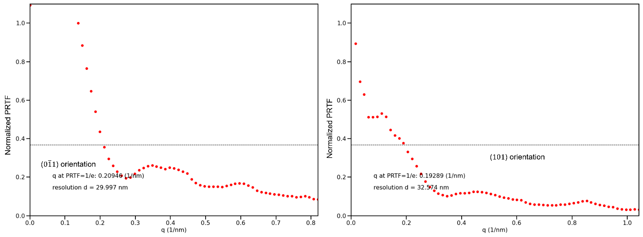
Figure S1. Estimation of resolution using phase-retrieval transfer function. Phase retrieval transfer function (PRTF) for the reconstructed image.
II. Supplementary Movie
Lattice strain and rotation movie showing the slice-by-slice data recovered from multi-reflection Bragg coherent diffraction imaging (BCDI) parallel to the vertical plane (black dash line- described in Figure 5 of the main text). Shown are the six strain tensor components (upper right triangle and diagonal) alongside the three rotation tensor elements (bottom left triangle). The lattice swelling resulting from the implantation is most evident in the $ε_{zz}$ component. Heterogeneity of the strain within the implanted layer indicates damage induced evolution of the microstructure (particularly visible in the $ε_{xx}$,$ε_{yy}$and $ε_{zz}$ components). There is evidence of dislocation loops as shown by the phase jumps in the strain data.

References
1. Fienup, J. R. Reconstruction of a complex-valued object from the modulus of its Fourier transform using a support constraint. J. Opt. Soc. Am. A vol. 4 (1987).
2. Chen, C. C., Miao, J., Wang, C. W. & Lee, T. K. Application of optimization technique to noncrystalline x-ray diffraction microscopy: Guided hybrid input-output method. Physical Review B - Condensed Matter and Materials Physics 76, (2007).
3. Marchesini, S. et al. X-ray image reconstruction from a diffraction pattern alone. Physical Review B - Condensed Matter and Materials Physics 68, (2003).
4. Ulvestad, A. et al. Identifying Defects with Guided Algorithms in Bragg Coherent Diffractive Imaging. Scientific Reports 7, (2017).
5. Clark, J. N., Huang, X., Harder, R. & Robinson, I. K. High-resolution three-dimensional partially coherent diffraction imaging. Nature Communications 3, (2012).
6. Richardson, W. H. Bayesian-Based Iterative Method of Image Restoration*.
7. Abuin, M. et al. Coherent X-ray Imaging of CO-Adsorption-Induced Structural Changes in Pt Nanoparticles: Implications for Catalysis. ACS Applied Nano Materials 2, 4818–4824 (2019).

