Supplementary information for

Nicotine consumption rate through wastewater-based epidemiology: A systematic review, meta-analysis and probabilistic risk assessment

Anvar Asadiª, Yadolah Fakhri^{b}, Yahya Salimi^{c}, Nebile Daglioglu^{d}, Mina Tahmasebifard^{e}, Maryam Aghajarinezhad^{e}
ªDepartment of Environmental Health Engineering, School of Public Health, Kermanshah University of Medical Sciences, Kermanshah, Iran (anvarasadi@sbmu.ac.ir)
^{b}Food Health Research Center, Hormozgan University of Medical Sciences, Bandar Abbas, Iran
^{c}Department of Epidemiology, School of Public Health, Kermanshah University of Medical Sciences, Kermanshah, Iran
^{d}Department of Forensic Medicine, Faculty of Medicine, University of Cukurova, Adana, Turkey
^{e}Students Research Committee, Department of Environmental Health Engineering, Kermanshah University of Medical Sciences, Kermanshah, Iran

Table S1 Main characteristics of studies included in our study
NO. | Country of study | Year of measuring  Table S1 continue... | Population served by WWTP(s) | Number of Samplings | Mean ± SD of nicotine consumption rate (mg/inh./day) | Mean of MOE of measurement | P-95% of MOE | Ref.
1ª | Australia | 2012 | 110000 | 249^{b} | 0.420 ± 0.167^{c} | 350 | 969 | (Zheng et al., 2020b)
2 | Australia | 2013 | 110000 | 249^{b} | 0.489 ± 0.147 | 290 | 785 | (Zheng et al., 2020b)
3 | Australia | 2014 | 110000 | 249^{b} | 0.601 ± 0.095 | 231 | 595 | (Zheng et al., 2020b)
4 | Australia | 2015 | 110000 | 249^{b} | 0.580 ± 0.077 | 238 | 606 | (Zheng et al., 2020b)
5 | Australia | 2016 | 110000 | 249^{b} | 0.582 ± 0.106 | 243 | 631 | (Zheng et al., 2020b)
6 | Australia | 2017 | 110000 | 249^{b} | 0.504 ± 0.086 | 277 | 719 | (Zheng et al., 2020b)
7 | Australia | 2015 | 100000 | 42 | 1.768 ± 0.460 | 82 | 219 | (Zheng et al., 2020a)
8 | Australia | 2014-2015 | 24000000 | 140 | 1.430 ± 1.160 | 128 | 433 | (Lai et al., 2018)
9 |  |  |  |  | 1.950 ± 0.940 | 85 | 247 | (Lai et al., 2018)
10 |  |  |  |  | 1.620 ± 0.760 | 93 | 266 | (Lai et al., 2018)
11 |  |  |  |  | 1.960 ± 1.230 | 83 | 259 | (Lai et al., 2018)
12 |  |  |  |  | 1.210 ± 0.780 | 136 | 424 | (Lai et al., 2018)
13 |  |  |  |  | 0.750 ± 0.460 | 219 | 674 | (Lai et al., 2018)
14 |  |  |  |  | 0.790 ± 0.690 | 247 | 856 | (Lai et al., 2018)
15 |  |  |  |  | 2.380 ± 1.090 | 63 | 182 | (Lai et al., 2018)
16 |  |  |  |  | 1.900 ± 0.720 | 76 | 212 | (Lai et al., 2018)
17 |  |  |  |  | 1.850 ± 0.710 | 84 | 236 | (Lai et al., 2018)
18 |  |  |  |  | 2.010 ± 0.860 | 81 | 231 | (Lai et al., 2018)
19 |  |  |  |  | 1.650 ± 0.630 | 94 | 266 | (Lai et al., 2018)
20 |  |  |  |  | 1.430 ± 0.590 | 111 | 316 | (Lai et al., 2018)
21 |  |  |  |  | 2.680 ± 1.050 | 55 | 154 | (Lai et al., 2018)
22 |  |  |  |  | 3.020 ± 1.270 | 53 | 154 | (Lai et al., 2018)
23 | Australia | 2010 | 110000 | 291 | 3.489 ± 1.256 | 41 | 112 | (Mackie et al., 2019)
24 | Australia | 2011 | 110000 | 291 | 3.084 ± 1.110 | 47 | 128 | (Mackie et al., 2019)
25 | Australia | 2012 | 110000 | 291 | 2.849 ± 1.025 | 50 | 139 | (Mackie et al., 2019)
26 | Australia | 2013 | 110000 | 291 | 3.095 ± 1.114 | 47 | 128 | (Mackie et al., 2019)
27 | Australia | 2014 | 110000 | 291 | 2.896 ± 1.047 | 54 | 150 | (Mackie et al., 2019)
28 | Australia | 2015 | 110000 | 291 | 2.763 ± 0.995 | 55 | 154 | (Mackie et al., 2019)
29 | Australia | 2016 | 110000 | 291 | 2.733 ± 0.984 | 53 | 144 | (Mackie et al., 2019)
30 | Australia | 2017 | 110000 | 291 | 2.545 ± 0.916 | 61 | 168 | (Mackie et al., 2019)
31 | Belgium | 2014 | 30600 | 56 | 5.499 ± 0.674 | 26 | 64 | (van Wel et al., 2016)
32 | Belgium  (Brussels) | 2015 | 950000 | 56 | 3.100 ± 0.744 | 47 | 126 | (Baz-Lomba et al., 2016)
33 | China  (Dalian) | 2015 | 2200000 | 154 | 1.923 ± 1.079 | 84 | 250 | (Wang et al., 2016)
34 | China  (Jilin province) | 2016 | 3973900 | 20 | 2.390 ± 1.470 | 69 | 209 | (Zheng et al., 2017)
35 | China | 2014 | 26760000 | 98 | 1.600 ± 0.900 | 114 | 335 | (Gao et al., 2020)
36 | China | 2016 | 19150000 | 98 | 1.900 ± 1.100 | 85 | 256 | (Gao et al., 2020)
37 | China | 2018 & 2019 | 135910000 | 81 | 0.733 ± 0.391 | 215 | 629 | (Shao et al., 2021)
38 | Czech Republic  (Prague) | 2014 | 2326000 | 49 | 4.300 ± 0.376 | 32 | 80 | (Mackuľak et al., 2015)
39 | Czech Republic  (České Budějovice) | 2014 | 2326000 | 49 | 3.600 ± 0.212 | 38 | 96 | (Mackuľak et al., 2015)
40 | Denmark (Copenhagen) | 2015 | 530000 | 56 | 1.300 ± 0.360 | 114 | 310 | (Baz-Lomba et al., 2016)
41 | UK  (Bristol) | 2015 | 890000 | 56 | 2.040 ± 0.586 | 73 | 198 | (Baz-Lomba et al., 2016)
42 | Italy  (Milan) | 2012 | 5638114 | 56 | 1.946 ± 0.218 | 71 | 183 | (Castiglioni et al., 2015)
43 | Italy  (Como) | 2012 | 5638114 | 56 | 2.668 ± 0.564 | 54 | 143 | (Castiglioni et al., 2015)
44 | Italy  (Bologna) | 2012 | 5638114 | 56 | 2.109 ± 0.197 | 65 | 168 | (Castiglioni et al., 2015)
45 | Italy  (Turin) | 2012 | 5638114 | 56 | 3.503 ± 0.289 | 39 | 101 | (Castiglioni et al., 2015)
46 | Italy  (Rome) | 2012 | 5638114 | 56 | 2.983 ± 1.421 | 51 | 148 | (Castiglioni et al., 2015)
47 | Italy  (Naples) | 2012 | 5638114 | 56 | 4.015 ± 0.428 | 34 | 88 | (Castiglioni et al., 2015)
48 | Italy  (Bari) | 2012 | 5638114 | 56 | 3.207 ± 0.128 | 43 | 109 | (Castiglioni et al., 2015)
49 | Italy  (Palermo) | 2012 | 5638114 | 56 | 3.800 ± 0.297 | 36 | 99 | (Castiglioni et al., 2015)
50 | Italy | 2012 | 6312144 | 163 | 2.565 ± 0.540 | 56 | 149 | (Senta et al., 2015)
51 |  |  |  |  | 2.020 ± 0.675 | 76 | 210 | (Senta et al., 2015)
52 |  |  |  |  | 3.105 ± 0.810 | 47 | 128 | (Senta et al., 2015)
53 | Italy  (Milan) | 2015 | 1120000 | 56 | 1.500 ± 0.360 | 96 | 258 | (Baz-Lomba et al., 2016)
54 | Italy | 2013-2014 | 6514773 | 168 | 2.832 ± 0.574 | 50 | 134 | (Gracia-Lor et al., 2020)
55 |  |  |  |  | 2.105 ± 1.097 | 75 | 224 | (Gracia-Lor et al., 2020)
56 |  |  |  |  | 3.147 ± 0.997 | 48 | 134 | (Gracia-Lor et al., 2020)
57 | Netherlands  (Utrecht) | 2015 | 300000 | 56 | 1.300 ± 0.312 | 112 | 296 | (Baz-Lomba et al., 2016)
58 | Norway  (Oslo) | 2015 | 580000 | 56 | 4.000 ± 0.960 | 36 | 95 | (Baz-Lomba et al., 2016)
59 | Portugal | 2011 | 756000 | 8 | 5.860 ± 3.511 | 28 | 82 | (Lopes et al., 2014)
60 | Slovakia  (Bratislava) | 2014 | 2326000 | 49 | 4.200 ± 0.677 | 34 | 87 | (Mackuľak et al., 2015)
61 | Slovakia  (Petržalka) | 2014 | 2326000 | 49 | 5.100 ± 2.400 | 30 | 88 | (Mackuľak et al., 2015)
62 | Slovakia  (Košice) | 2014 | 2326000 | 49 | 2.400 ± 1.942 | 76 | 266 | (Mackuľak et al., 2015)
63 | Slovakia  (Nitra) | 2014 | 2326000 | 49 | 8.00 ± 1.699 | 18 | 47 | (Mackuľak et al., 2015)
64 | Slovakia  (Piešťany) | 2014 | 2326000 | 49 | 2.200 ± 1.963 | 88 | 313 | (Mackuľak et al., 2015)
65 | Spain | 2012 | 130000 | 21 | 1.685 ± 0.501 | 87 | 235 | (Rodríguez-Álvarez et al., 2014)
66 | Spain | 2013 | 130000 | 21 | 1.928 ± 0.579 | 76 | 204 | (Rodríguez-Álvarez et al., 2014)
67 | Spain | 2014 | 130000 | 21 | 1.400 ± 0.129 | 98 | 245 | (Rodríguez-Álvarez et al., 2014)
68 | Spain  (Castellon) | 2015 | 180000 | 51 | 3.100 ± 0.744 | 46 | 122 | (Baz-Lomba et al., 2016)
69 | Switzerland | 2007 | 535700 | 10 | 2.817 ± 1.192 | 52 | 148 | (Buerge et al., 2008)
70 | Switzerland  (Zurich) | 2015 | 410000 | 56 | 3.600 ± 0.864 | 40 | 106 | (Baz-Lomba et al., 2016)
71 | Turkey | 2019 | 20000000 | 392 | 5.508 ± 1.078 | 27 | 68 | (Asicioglu et al., 2021)
72 | Turkey  (Adana) | 2019 | 15070337 | 308 | 2.912 ± 1.437 | 55 | 159 | (Yavuz Guzel et al., 2021)
73 | Turkey  (Ankara) | 2019 | 15070337 | 308 | 2.740 ± 0.625 | 54 | 140 | (Yavuz Guzel et al., 2021)
74 | Turkey  (DiyarbakIr) | 2019 | 15070337 | 308 | 2.755 ± 1.529 | 70 | 218 | (Yavuz Guzel et al., 2021)
75 | Turkey  (Erzurun) | 2019 | 15070337 | 308 | 2.764 ± 1.211 | 60 | 168 | (Yavuz Guzel et al., 2021)
76 | Turkey  (Gaziantep) | 2019 | 15070337 | 308 | 3.647 ± 1.601 | 42 | 119 | (Yavuz Guzel et al., 2021)
77 | Turkey  (Kayseri) | 2019 | 15070337 | 308 | 4.282 ± 1.332 | 34 | 91 | (Yavuz Guzel et al., 2021)
78 | Turkey  (Konya) | 2019 | 15070337 | 308 | 3.276 ± 1.219 | 115 | 284 | (Yavuz Guzel et al., 2021)
79 | Turkey  (Mersin) | 2019 | 15070337 | 308 | 3.884 ± 1.082 | 39 | 105 | (Yavuz Guzel et al., 2021)
80 | Turkey  (Sanliurfa) | 2019 | 15070337 | 308 | 2.116 ± 1.287 | 79 | 244 | (Yavuz Guzel et al., 2021)
81 | Turkey  (Trabzon) | 2019 | 15070337 | 308 | 0.098 ± 0.394 | 10094 | 84127 | (Yavuz Guzel et al., 2021)
82 | Turkey  (van) | 2019 | 15070337 | 308 | 1.877 ± 1.315 | 119 | 387 | (Yavuz Guzel et al., 2021)
83 | USA | 2015-2016 | 222000 | 231 | 2.700 ± 0.600 | 53 | 141 | (Chen et al., 2019)
84 |  |  |  |  | 2.400 ± 1.200 | 65 | 190 | (Chen et al., 2019)
85 |  |  |  |  | 2.640 ± 0.500 | 53 | 141 | (Chen et al., 2019)
86 | Vietnam | 2017 | 545830 | 10 | 1.100 ± 0.260 | 133 | 345 | (Nguyen et al., 2018)
87 |  |  |  |  | 1.300 ± 0.250 | 109 | 279 | (Nguyen et al., 2018)
ªThis column represent the number of nicotine measurement in each articles (either during years’ period in a location(s) (city) or different cities in a year(s))
^{b}Number of wastewater samples collected form studied WWTP(s)
^{c}Mean ± deviation of daily nicotine consumption rate (calculated from back calculation of Ets. concentration in wastewater).

Table S1 continue...

Table S2 The number of studies in countries based on classification of mean MOE
Country | Number of location/measurements | Risk (MOE <100) | Public health risk (MOE 100-10000)
Australia | 30 | 21 | 9
Belgium | 2 | 2 | 0
China | 5 | 4 | 1
Czech Republic | 2 | 2 | 0
Denmark | 1 | 0 | 1
UK | 1 | 1 | 0
Italy | 15 | 15 | 0
Netherland | 1 | 0 | 1
Norway | 1 | 1 | 0
Portugal | 1 | 1 | 0
Slovakia | 5 | 5 | 0
Spain | 4 | 4 | 0
Switzerland | 2 | 2 | 0
Turkey | 12 | 10 | 2
USA | 3 | 3 | 0
Viet Nam | 2 | 0 | 2

Australia1  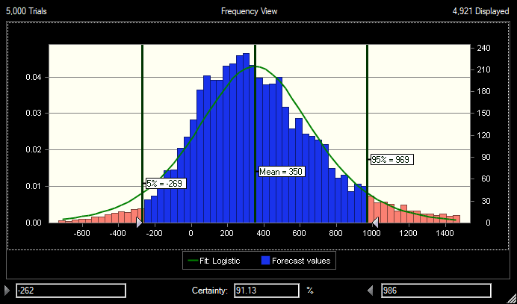 | Australia2  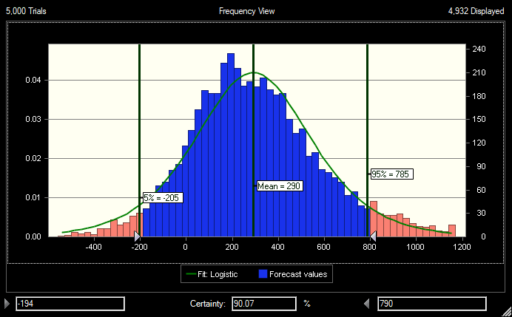
Australia3  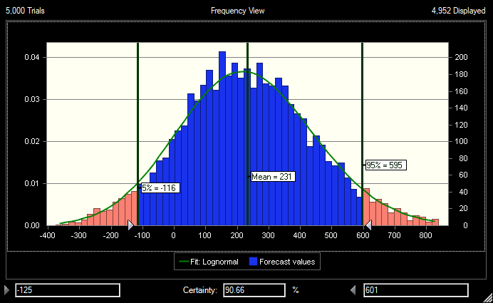 | Australia4  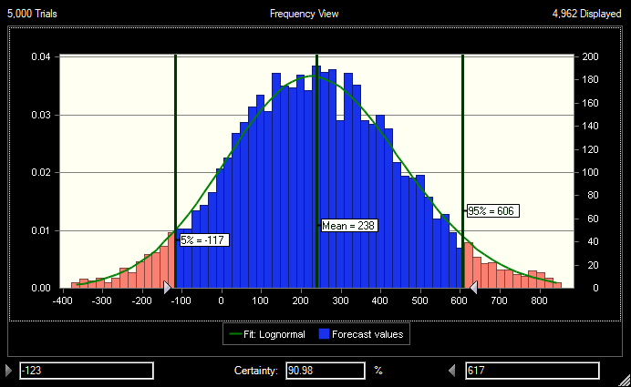
Australia5  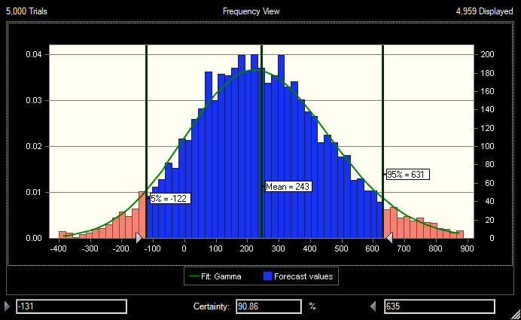 | Australia6  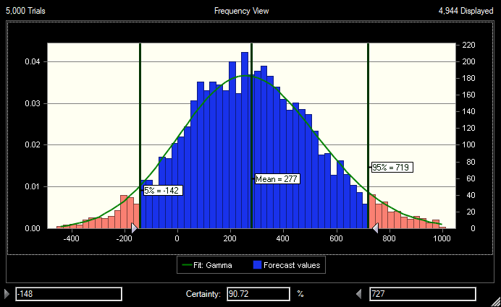
Australia7  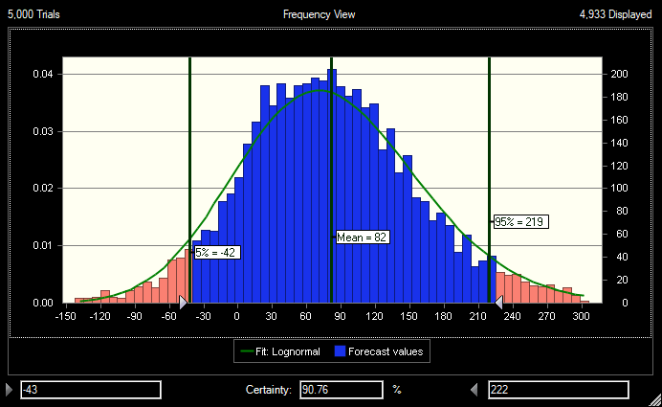 | Australia8  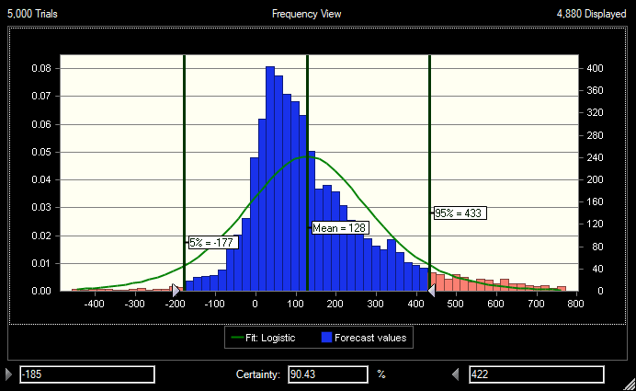
Australia9  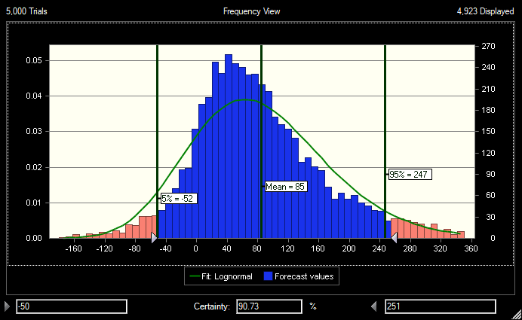 | Australia10  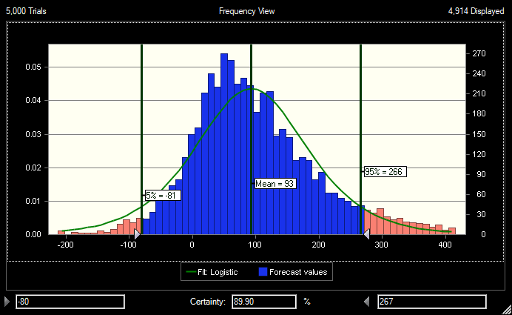
Australia11  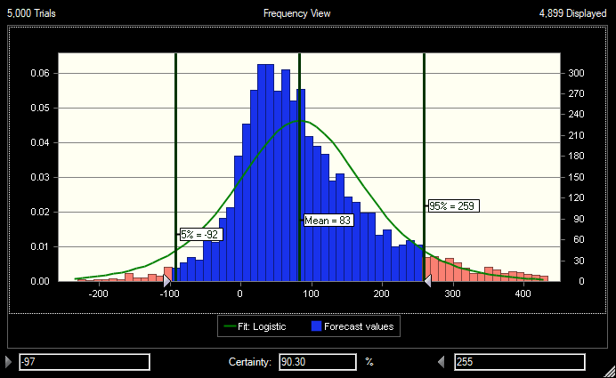 | Australia12  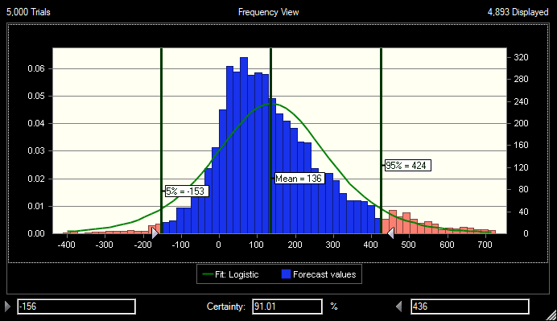

Australia13  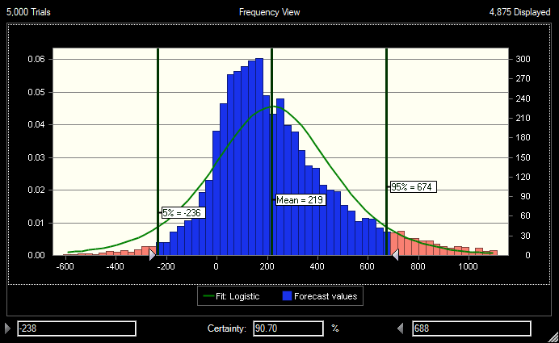 | Australia 14  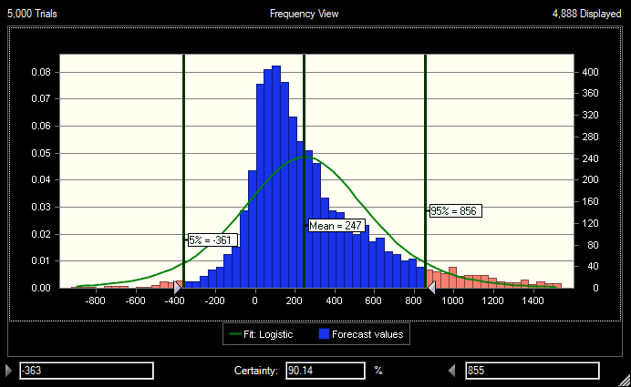
Australia 15  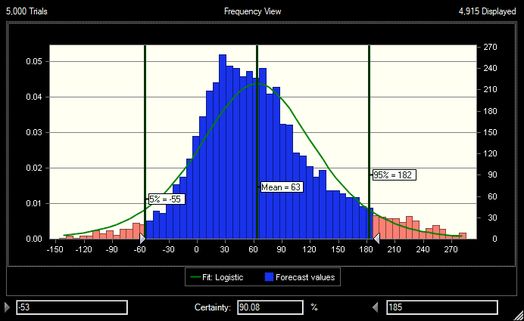 | Australia 16  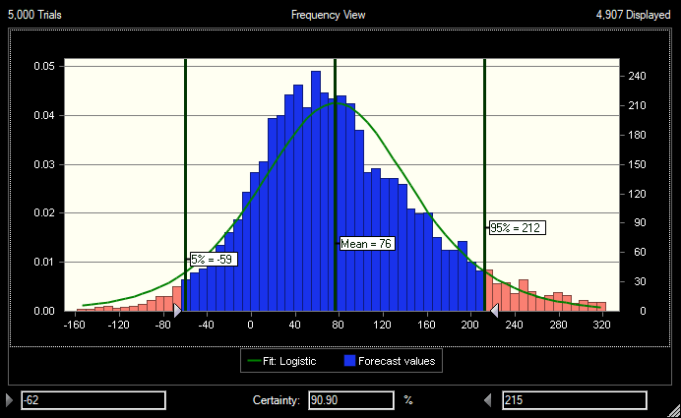
Australia 17  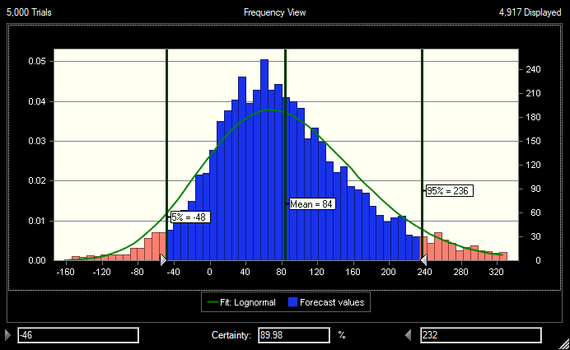 | Australia 18  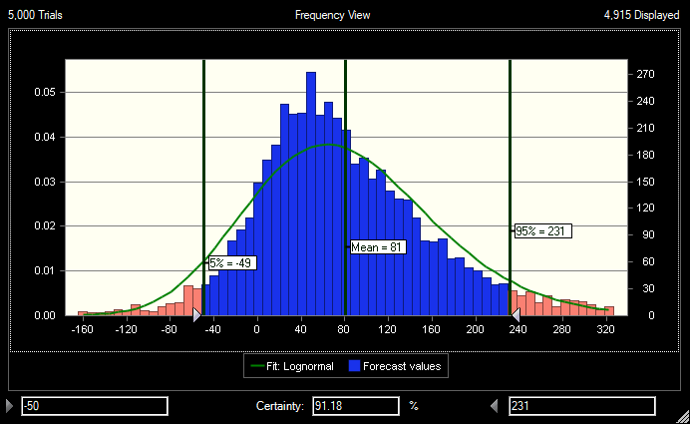

Australia19  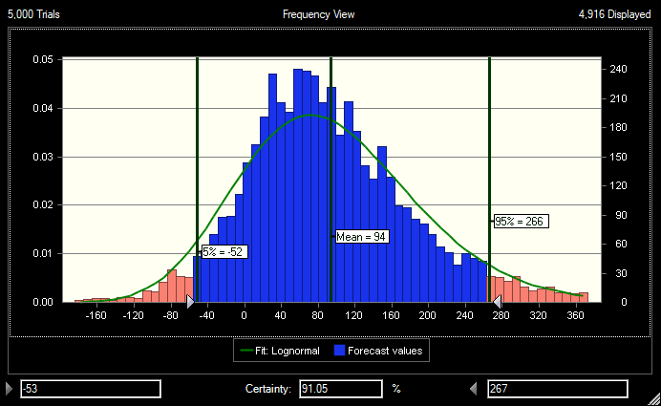 | Australia 20  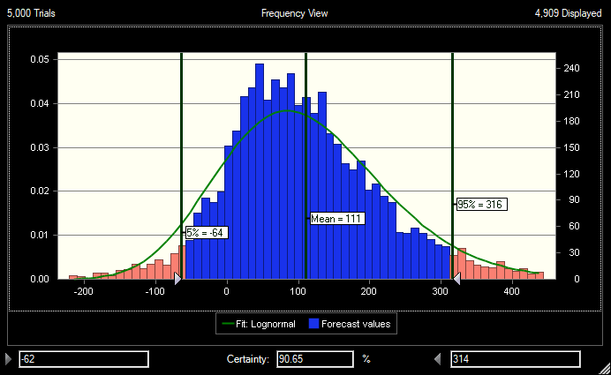
Australia 21  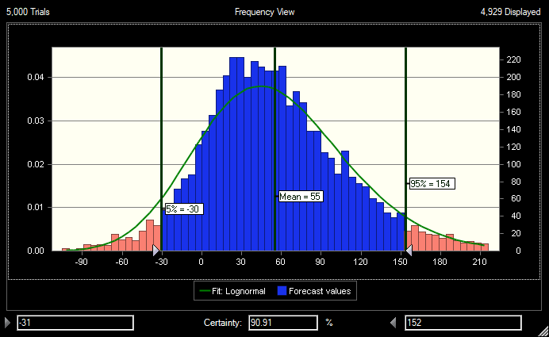 | Australia 22  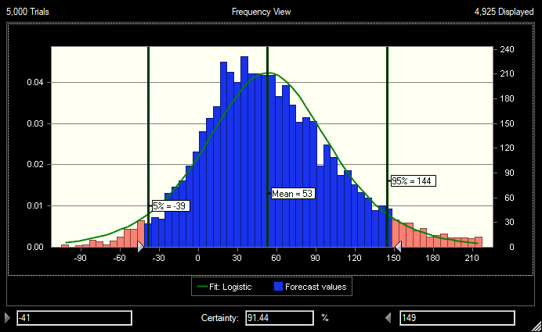
Australia23  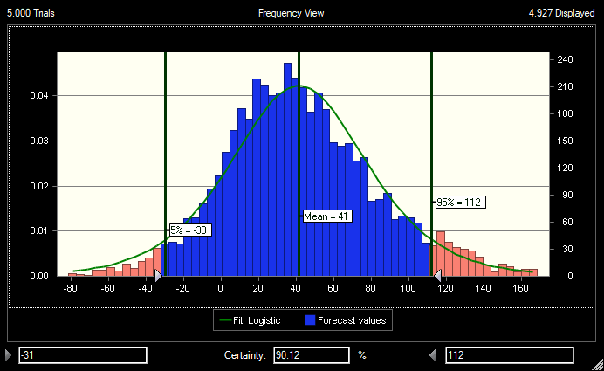 | Australia24  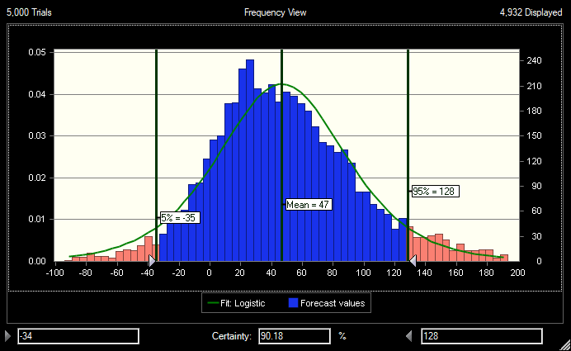

Australia 25  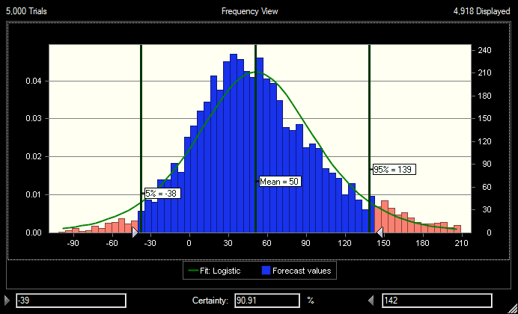 | Australia 26
Australia 27  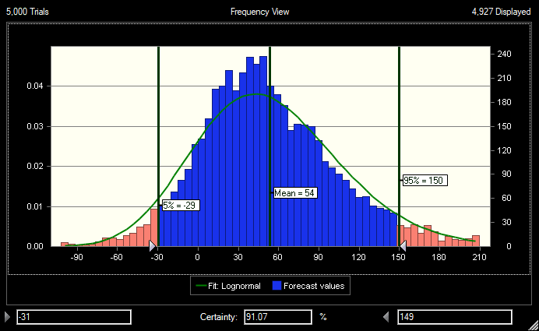 | Australia 28
Australia 29 | Australia 30  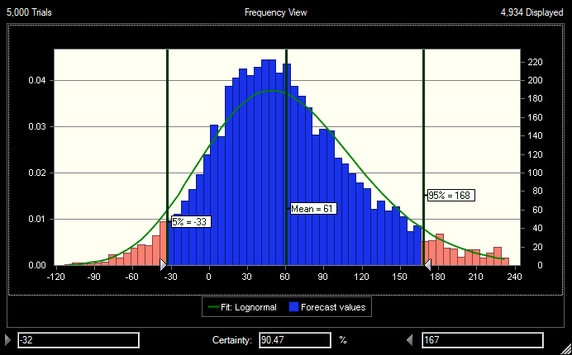

Belgium31  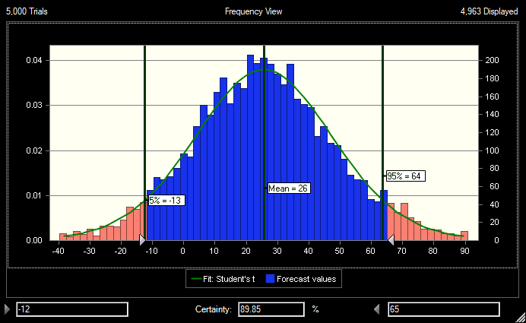 | Belgium32  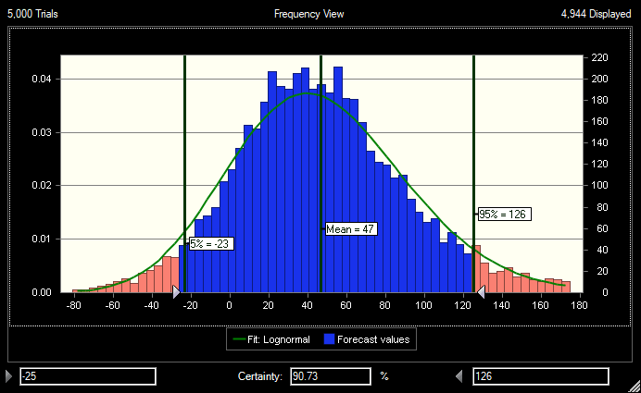
China33  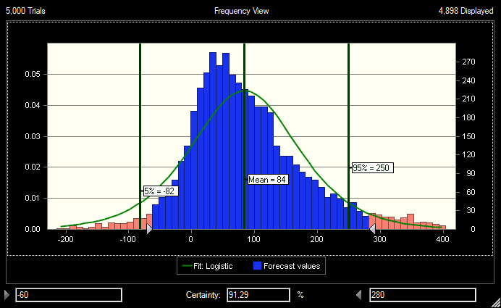 | China34  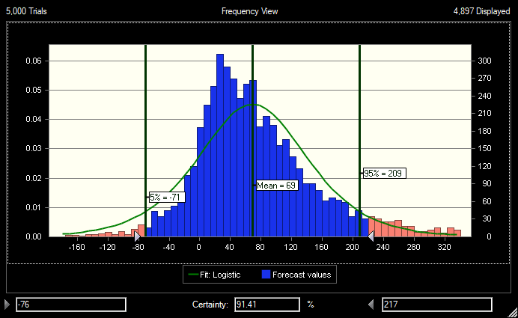
China35  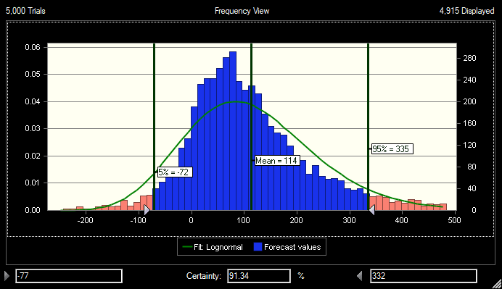 | China36  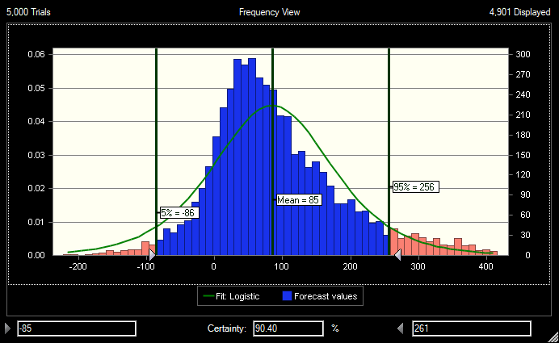

China37  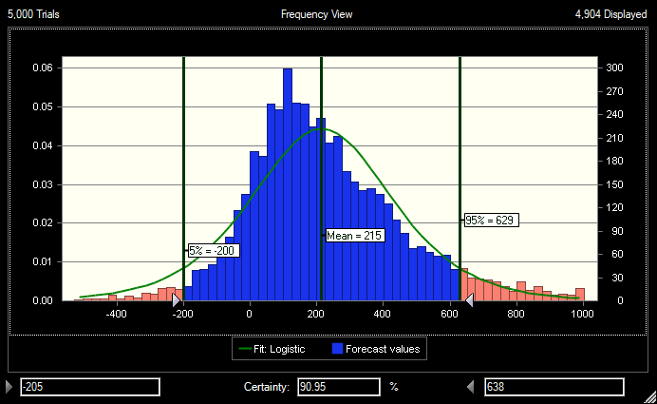 | Czech Republic38  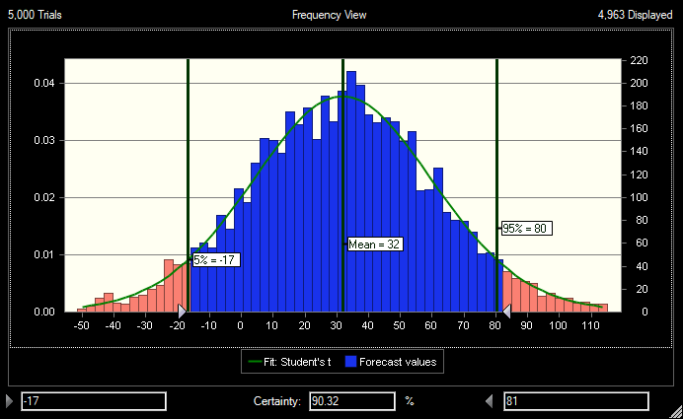
Czech Republic39  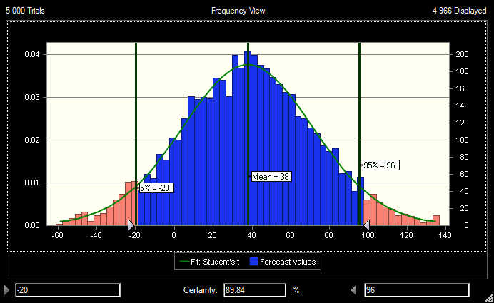 | Denmark 40  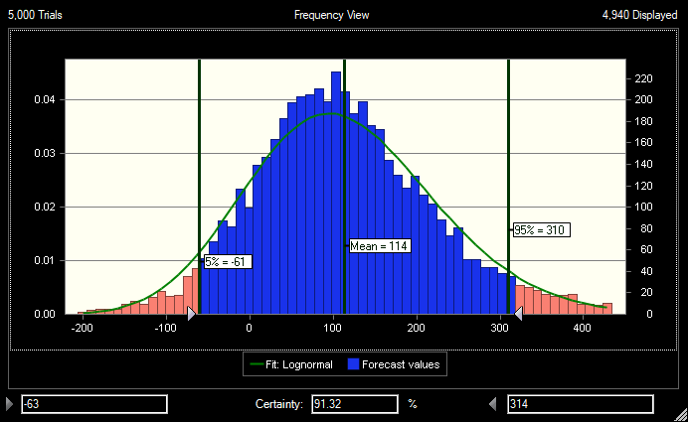
England 41  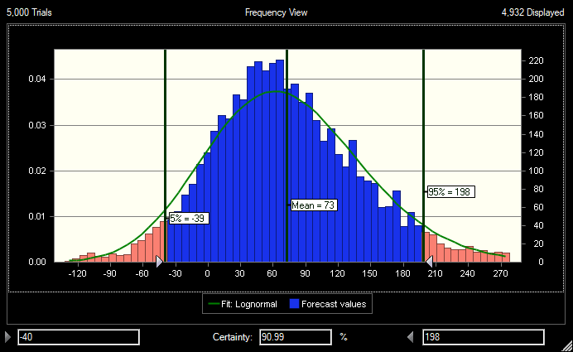 | Italy 42  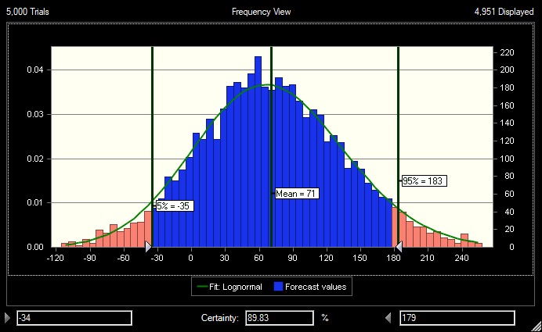

Italy 43  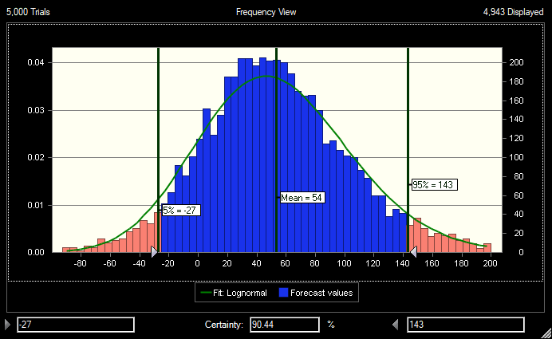 | Italy 44  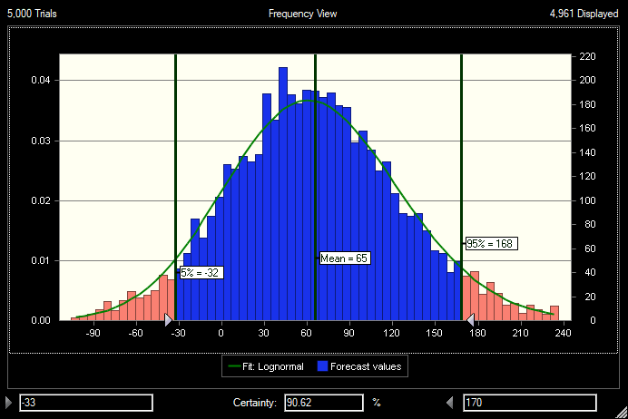
Italy 45  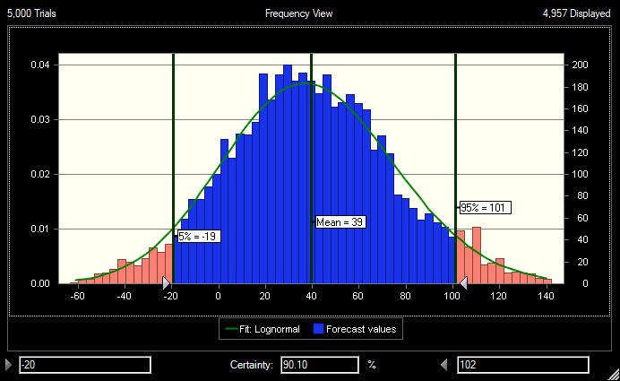 | Italy 46  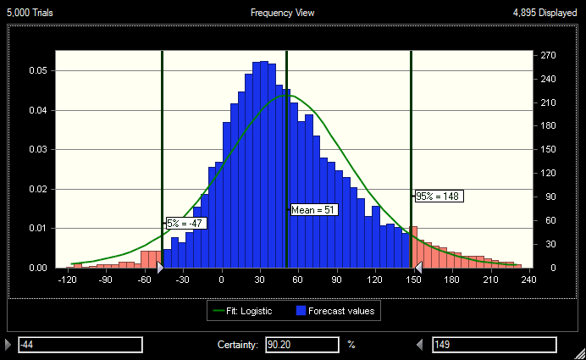
Italy 47  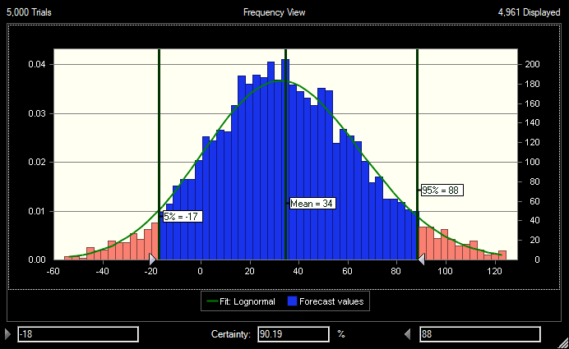 | Italy 48  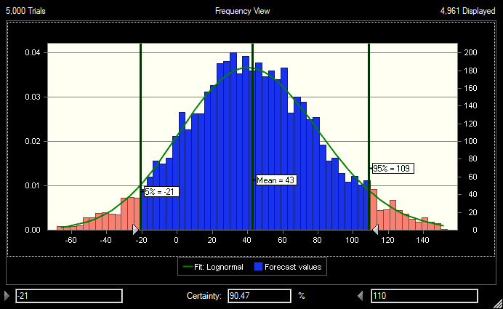

Italy 49  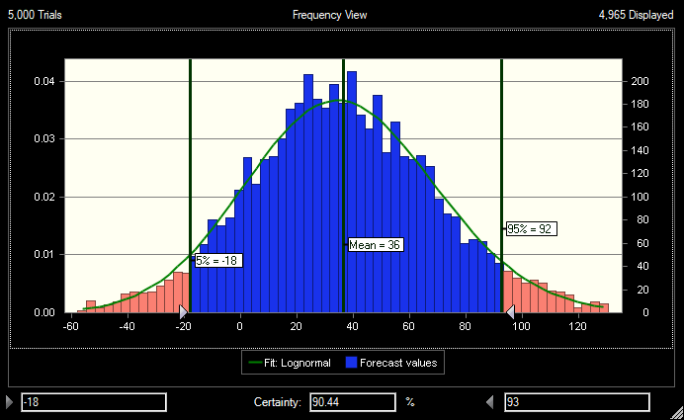 | Italy50  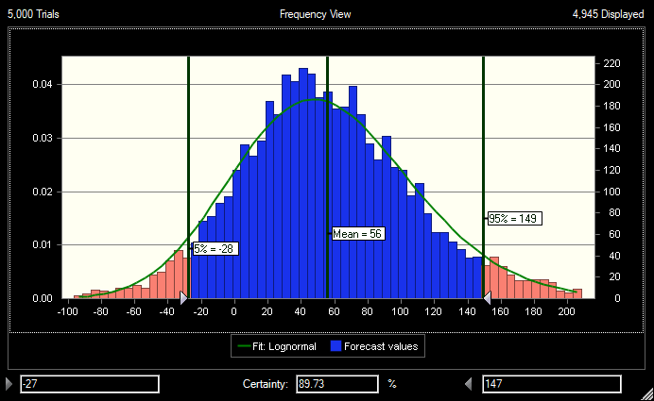
Italy 51  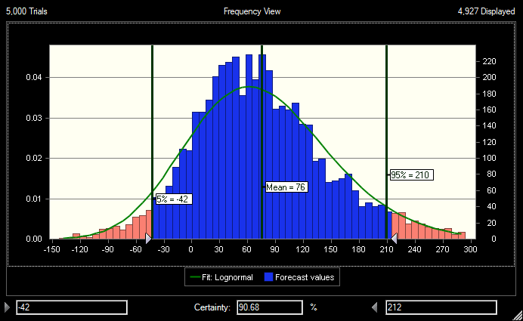 | Italy 52  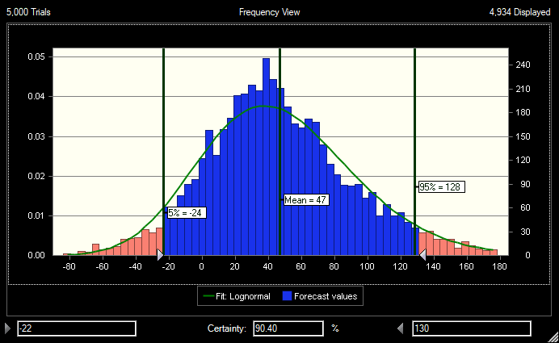
Italy 53  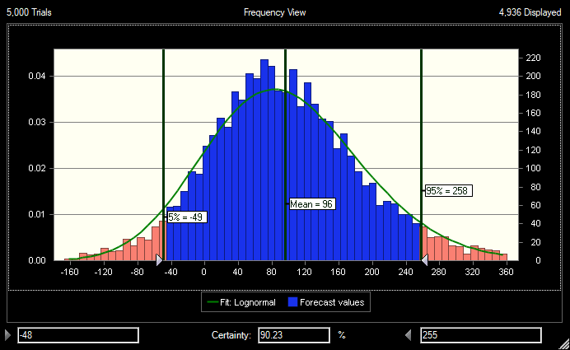 | Italy 54  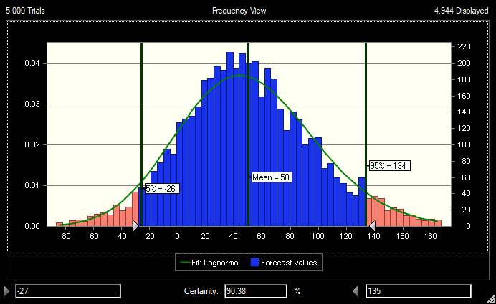

Italy 55  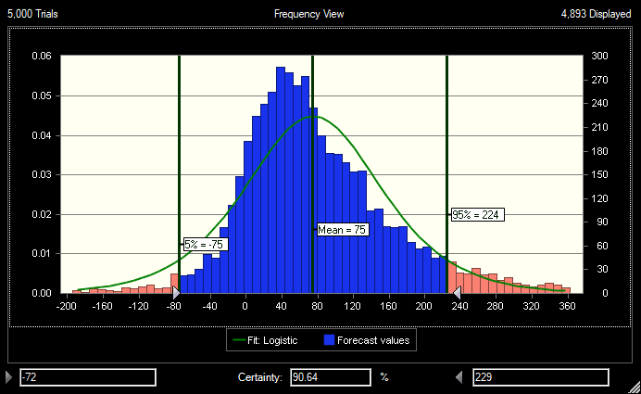 | Italy 56  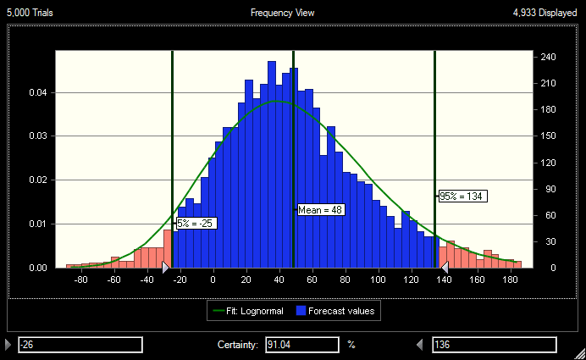
Netherland 57  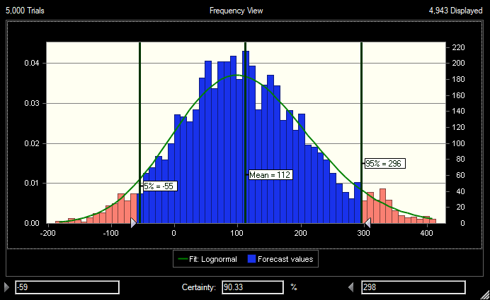 | Norway 58  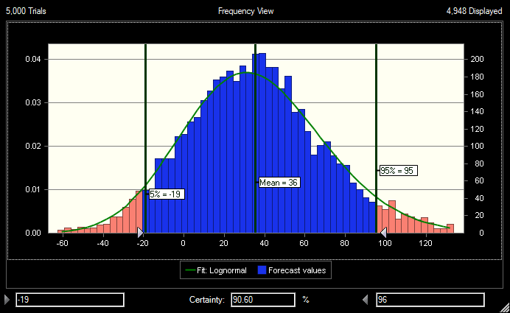
Portugal59  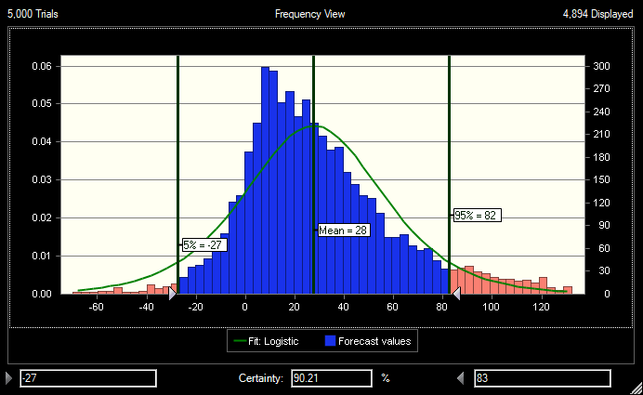 | Slovakia 60  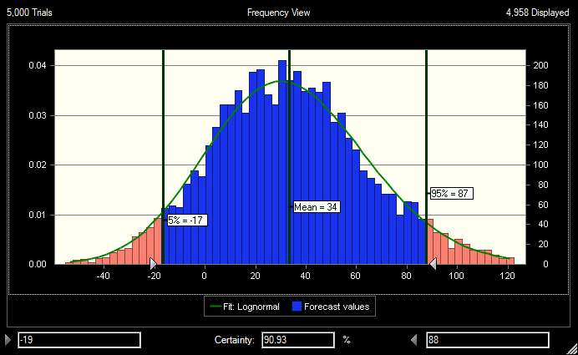

Slovakia 61  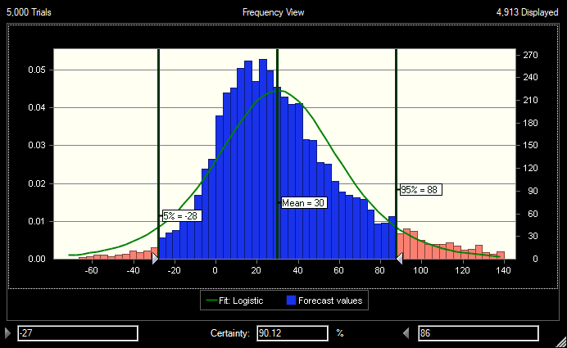 | Slovakia 62  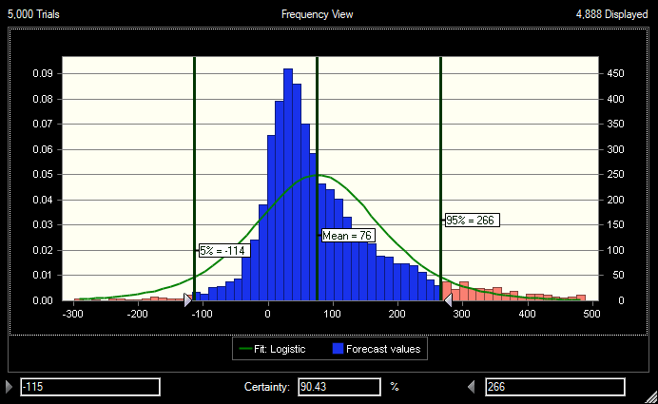
Slovakia 63  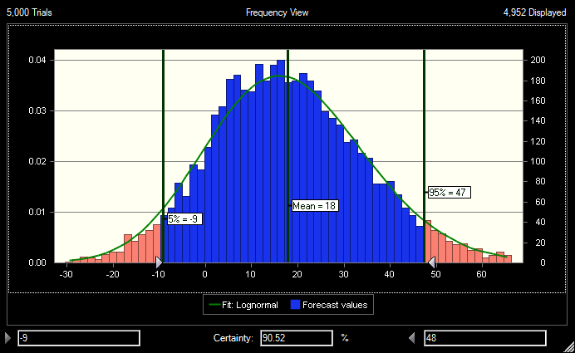 | Slovakia 64  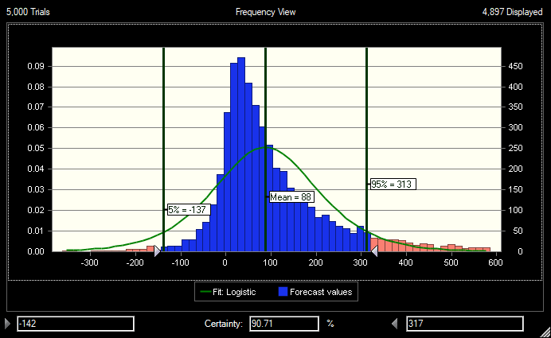
Spain 65  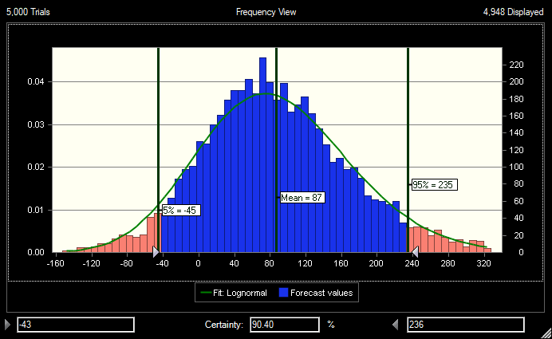 | Spain 66  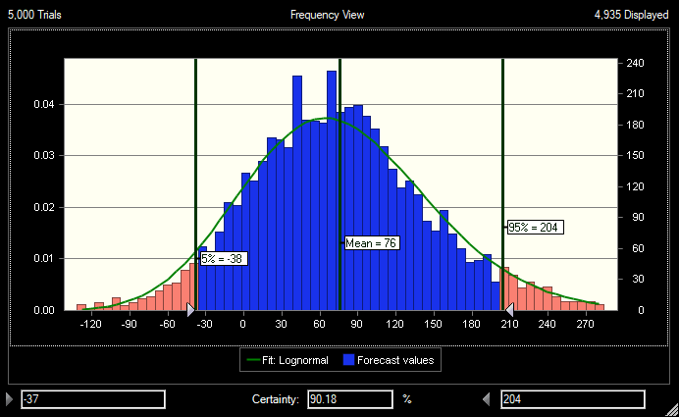

Spain 67  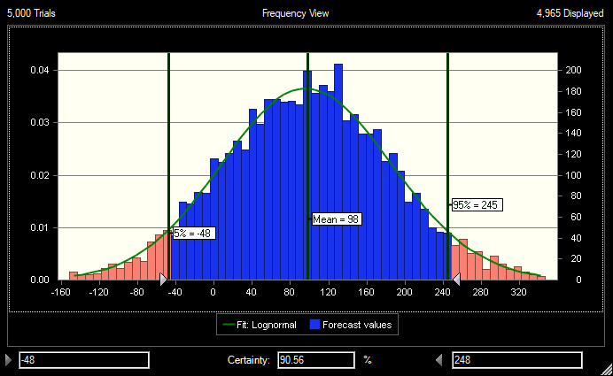 | Spain 68  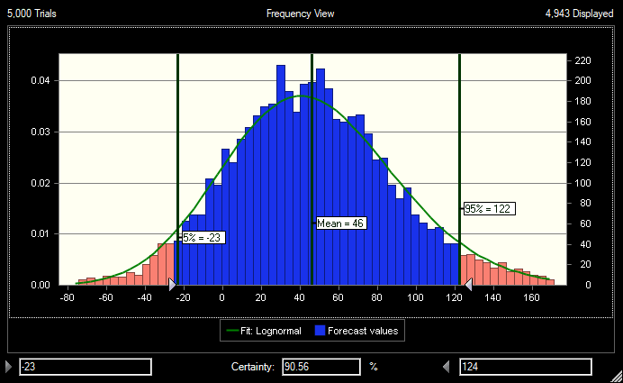
Switzerland 69  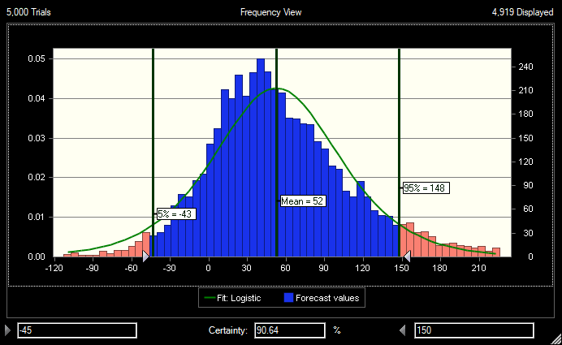 | Switzerland 70  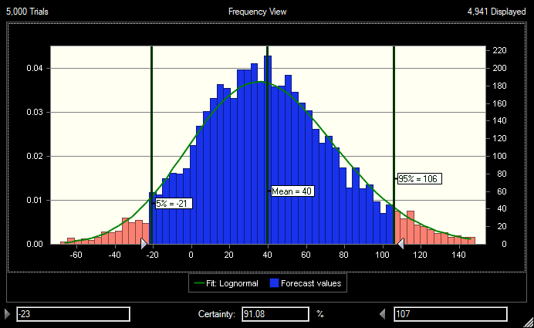
Turkey 71  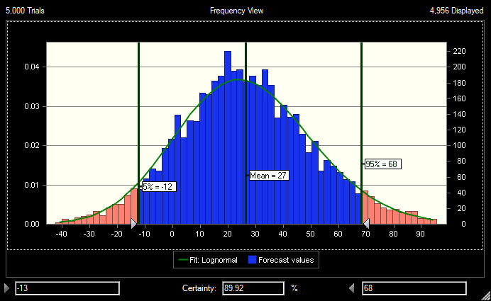 | Turkey 72  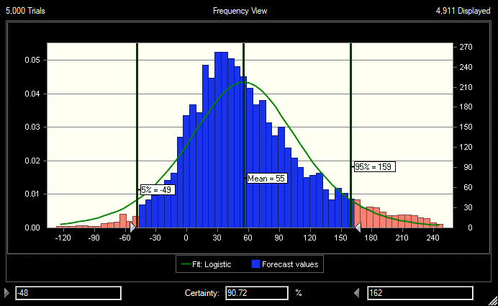

Turkey 73  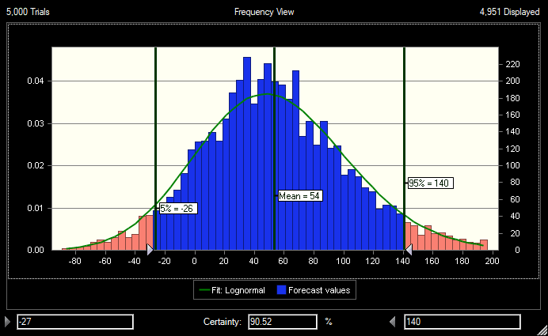 | Turkey 74  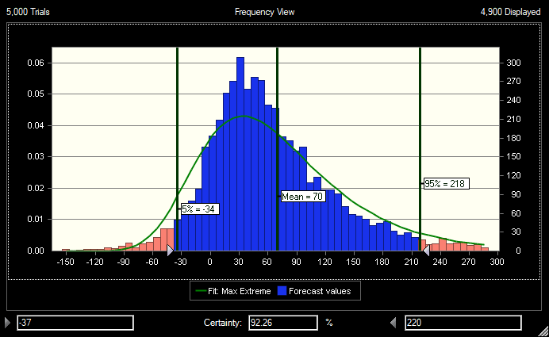
Turkey 75  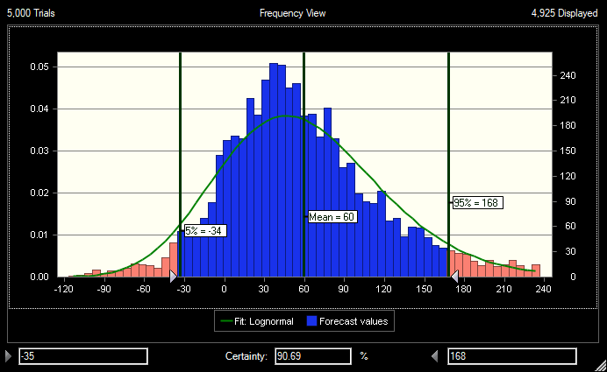 | Turkey 76  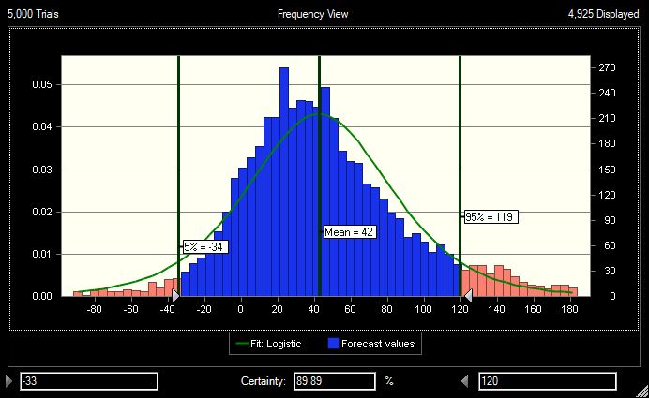
Turkey 77  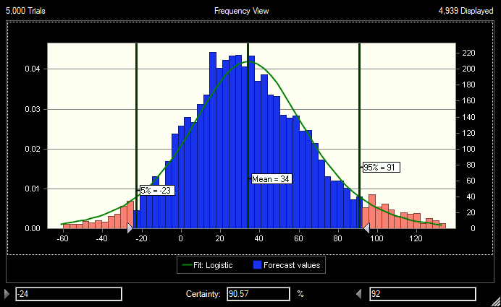 | Turkey 76  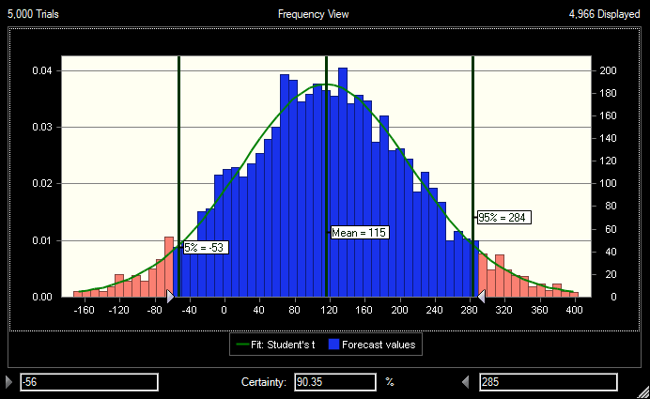

Turkey 79  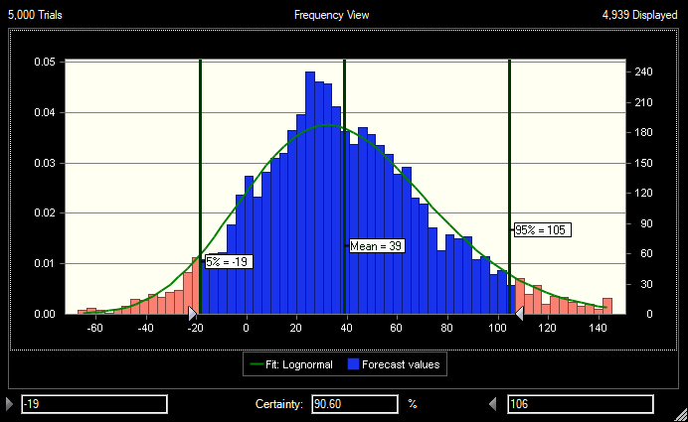 | Turkey 80  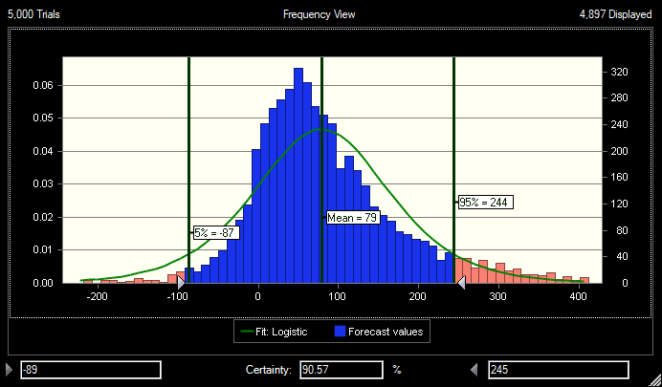
Turkey 81  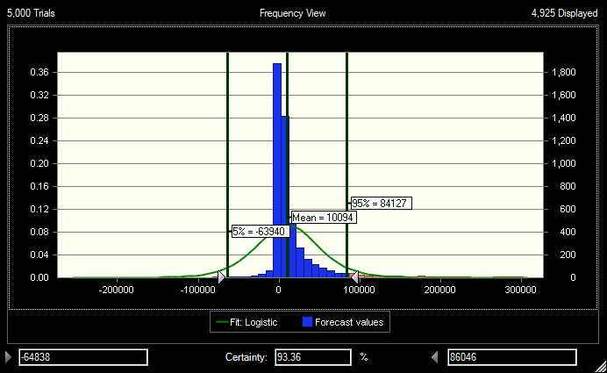 | Turkey 82  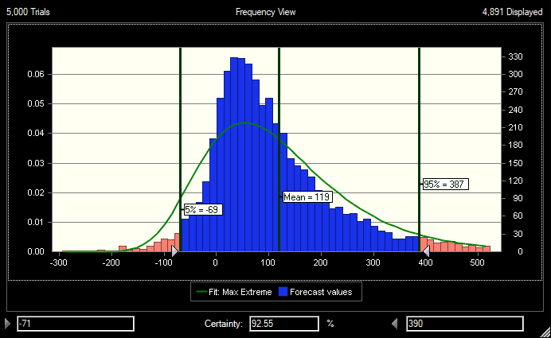
USA83  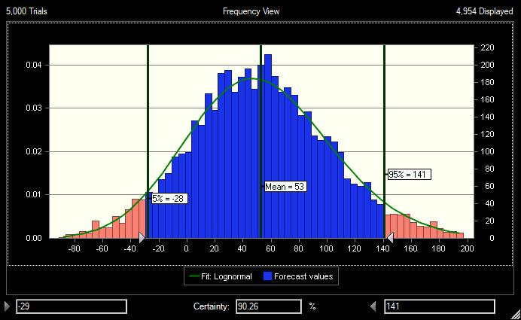 | USA84  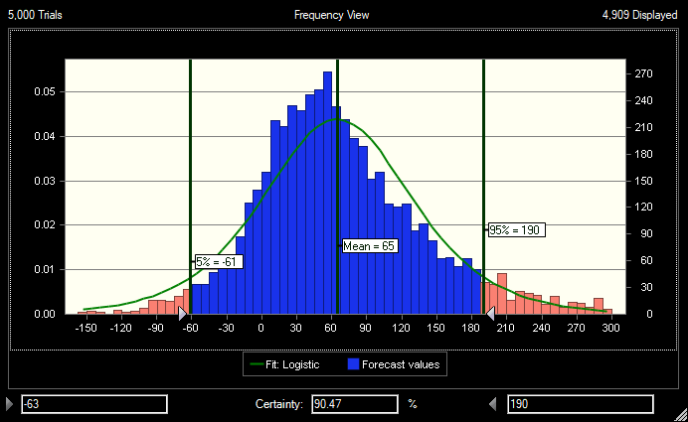

USA 85  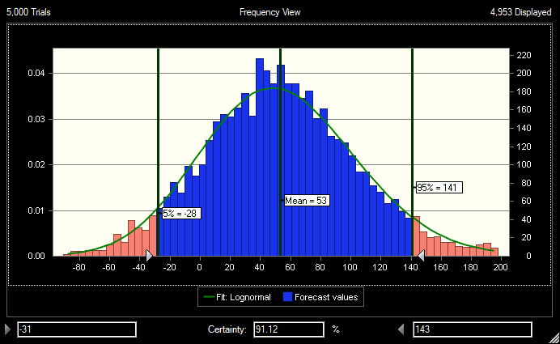 | Viet Nam 86  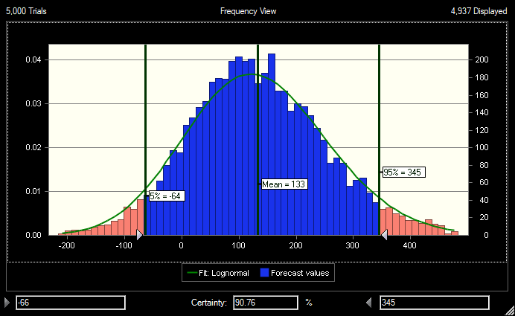
Viet Nam 87
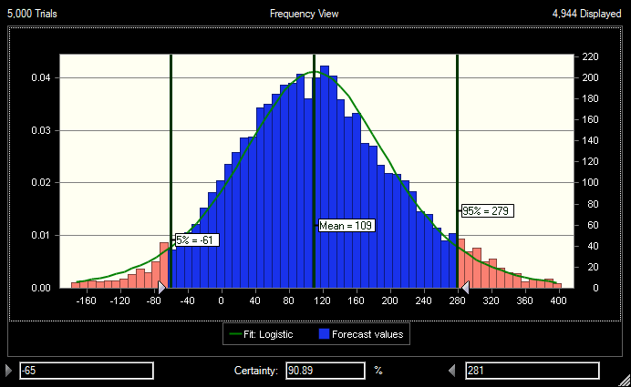

Fig. S1 Tornado plots showing the mean and 95th percentile of MOE for daily nicotine consumption based on wastewater analysis in measurements of each study for the sensitivity analysis (the central vertical line denotes the mean MOE; left and right vertical lines are one standard deviation; the number above each Fig. correspond to first column of Table S1)

Reference:
Asicioglu F, Kuloglu Genc M, Tekin Bulbul T, Yayla M, Simsek SZ, Adioren C, et al. Investigation of temporal illicit drugs, alcohol and tobacco trends in Istanbul city: Wastewater analysis of 14 treatment plants. Water Res 2021; 190: 116729.
Baz-Lomba JA, Salvatore S, Gracia-Lor E, Bade R, Castiglioni S, Castrignanò E, et al. Comparison of pharmaceutical, illicit drug, alcohol, nicotine and caffeine levels in wastewater with sale, seizure and consumption data for 8 European cities. BMC Public Health 2016; 16: 1035.
Buerge IJ, Kahle M, Buser HR, Müller MD, Poiger T. Nicotine derivatives in wastewater and surface waters: application as chemical markers for domestic wastewater. Environ Sci Technol 2008; 42: 6354-60.
Castiglioni S, Senta I, Borsotti A, Davoli E, Zuccato E. A novel approach for monitoring tobacco use in local communities by wastewater analysis. Tob Control 2015; 24: 38-42.
Chen J, Venkatesan AK, Halden RU. Alcohol and nicotine consumption trends in three U.S. communities determined by wastewater-based epidemiology. Sci Total Environ 2019; 656: 174-183.
Gao J, Zheng Q, Lai FY, Gartner C, Du P, Ren Y, et al. Using wastewater-based epidemiology to estimate consumption of alcohol and nicotine in major cities of China in 2014 and 2016. Environ Int 2020; 136: 105492.
Gracia-Lor E, Rousis NI, Zuccato E, Castiglioni S. Monitoring caffeine and nicotine use in a nationwide study in Italy using wastewater-based epidemiology. Sci Total Environ 2020; 747: 141331.
Lai FY, Gartner C, Hall W, Carter S, O'Brien J, Tscharke BJ, et al. Measuring spatial and temporal trends of nicotine and alcohol consumption in Australia using wastewater-based epidemiology. Addiction 2018; 113: 1127-1136.
Lopes A, Silva N, Bronze MR, Ferreira J, Morais J. Analysis of cocaine and nicotine metabolites in wastewater by liquid chromatography-tandem mass spectrometry. Cross abuse index patterns on a major community. Sci Total Environ 2014; 487: 673-80.
Mackie RS, Tscharke BJ, O'Brien JW, Choi PM, Gartner CE, Thomas KV, et al. Trends in nicotine consumption between 2010 and 2017 in an Australian city using the wastewater-based epidemiology approach. Environ Int 2019; 125: 184-190.
Mackuľak T, Birošová L, Grabic R, Škubák J, Bodík I. National monitoring of nicotine use in Czech and Slovak Republic based on wastewater analysis. Environ Sci Pollut Res Int 2015; 22: 14000-6.
Nguyen HT, Thai PK, Kaserzon SL, O'Brien JW, Eaglesham G, Mueller JF. Assessment of drugs and personal care products biomarkers in the influent and effluent of two wastewater treatment plants in Ho Chi Minh City, Vietnam. Sci Total Environ 2018; 631-632: 469-475.
Rodríguez-Álvarez T, Rodil R, Rico M, Cela R, Quintana JB. Assessment of local tobacco consumption by liquid chromatography-tandem mass spectrometry sewage analysis of nicotine and its metabolites, cotinine and trans-3'-hydroxycotinine, after enzymatic deconjugation. Anal Chem 2014; 86: 10274-81.
Senta I, Gracia-Lor E, Borsotti A, Zuccato E, Castiglioni S. Wastewater analysis to monitor use of caffeine and nicotine and evaluation of their metabolites as biomarkers for population size assessment. Water Res 2015; 74: 23-33.
Shao XT, Cong ZX, Liu SY, Wang Z, Zheng XY, Wang DG. Spatial analysis of metformin use compared with nicotine and caffeine consumption through wastewater-based epidemiology in China. Ecotoxicol Environ Saf 2021; 208: 111623.
van Wel JH, Gracia-Lor E, van Nuijs AL, Kinyua J, Salvatore S, Castiglioni S, et al. Investigation of agreement between wastewater-based epidemiology and survey data on alcohol and nicotine use in a community. Drug Alcohol Depend 2016; 162: 170-5.
Wang DG, Dong QQ, Du J, Yang S, Zhang YJ, Na GS, et al. Using Monte Carlo simulation to assess variability and uncertainty of tobacco consumption in a city by sewage epidemiology. BMJ Open 2016; 6: e010583.
Yavuz Guzel E, Atasoy A, Gören İ E, Daglioglu N. Estimation of alcohol and nicotine consumption in 11 cities of Turkey using wastewater-based epidemiology. Drug Test Anal 2021; 13: 853-861.
Zheng Q, Eaglesham G, Tscharke BJ, O'Brien JW, Li J, Thompson J, et al. Determination of anabasine, anatabine, and nicotine biomarkers in wastewater by enhanced direct injection LC-MS/MS and evaluation of their in-sewer stability. Sci Total Environ 2020a; 743: 140551.
Zheng Q, Gartner C, Tscharke BJ, O'Brien JW, Gao J, Ahmed F, et al. Long-term trends in tobacco use assessed by wastewater-based epidemiology and its relationship with consumption of nicotine containing products. Environ Int 2020b; 145: 106088.
Zheng QD, Lin JG, Pei W, Guo MX, Wang Z, Wang DG. Estimating nicotine consumption in eight cities using sewage epidemiology based on ammonia nitrogen equivalent population. Sci Total Environ 2017; 590-591: 226-232.

Corresponding author. E-mail address: tahmasemina94@gmail.com (M. Tahmasebifard).

