Particulate Oxidative Potential Associated with Fireworks Activity during Diwali at a site in the Indo-Gangetic Plain
Isha Goyal, Puneet Kumar Verma, K. Maharaj Kumari and Anita Lakhani*
Department of Chemistry, Dayalbagh Educational Institute, Dayalbagh, Agra (UP), 282005
E-mail address: anita.lakhani01@gmail.com, anitalakhani@dei.ac.in

2.3. Backward trajectory analysis
The origin and transport pathways of the air masses arriving at the sampling site (27.16°N, 78.08°E) in Agra were characterized by 72-hr backward trajectory modelling with the HYSPLIT model version 4.0 provided by the National Oceanic and Atmospheric Administration (NOAA) Air Resources Laboratory ¹. The input meteorological data with a horizontal resolution of 1°× 1° latitude-longitude and a temporal resolution of 6 hr were acquired from the Global Data Assimilation System (ftp://arlftp.arlhq.noaa.gov/pub/archives/ gdas1). The air mass backward trajectories begin at 12:00 UTC each day during Diwali were calculated with a starting height of 500 AGL. The backward trajectories were plotted a day before Diwali (26/10/2019), Diwali day (27/10/2019) and a day after Diwali (28/10/2019).

List of Figures
Fig. S1. Air mass backward trajectory during Diwali Period

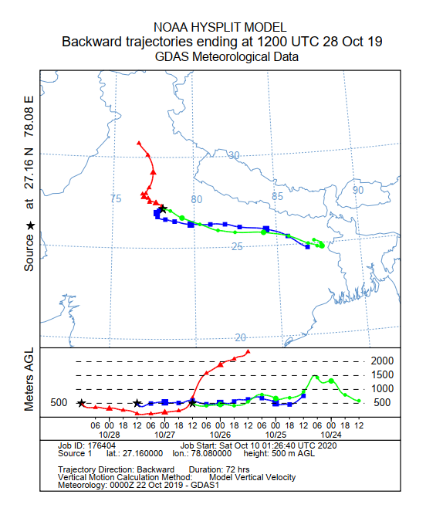
Fig. S1. Air mass backward trajectory during Diwali Period

List of Tables
Table S1. Working parameters of ICP-OES for analysis
TableS2. Detection limits of metals by ICP-OES
Table S3: PM_{2.5} mass concentrations and meteorological parameters during pre-Diwali, Diwali and post-Diwali
Table S4. Pearson correlation coefficients (r) of OPv with mass concentration of PM_{2.5} components

Table S1. Working parameters of ICP-OES for analysis
Parameters |  |  | Value
Plasma flow |  |  | 12.0 l min⁻¹
Nebulizer flow |  |  | 0.7 l min⁻¹
Make up flow |  |  | 0.0 l min⁻¹
Auxiliary flow |  |  | 1.0 l min⁻¹
Pump rate |  |  | 12 rpm
Power |  |  | 1.2 kW
Viewing mode |  |  | Synchronous Vertical  Dual View (SVDV)
Viewing height |  |  | 8.0 mm
Stabilization time |  |  | 15 sec
Uptake delay |  |  | 25 sec
Replicate per scan |  |  | 3

Table S2. Detection limits of metals by ICP-OES
Metal Detection limits |  | ng m⁻³
Al |  | 0.7
Ba |  | 0.2
Cd |  | 1.5
Cr |  | 1.4
Cu |  | 0.3
Mn |  | 1.2
Ni |  | 0.6
Pb |  | 1.3
Se |  | 0.7
V |  | 0.4
Zn |  | 1.9
Ca |  | 0.4
Fe |  | 3.3
K |  | 0.1
Mg |  | 1.7
Na |  | 0.9

Table S3. PM_{2.5} mass concentrations and meteorological parameters during pre-Diwali, Diwali and post-Diwali
Parameters | pre-Diwali |  | Diwali |  | post-Diwali
Parameters | Day | Night | Day | Night | Day | Night
PM_{2.5} | 115± 10 | 152 ± 2 | 279 ± 221.3 | 460 ± 68 | 318 | 280
Pressure (mm Hg) | 747.1 ± 0.1 | 746 ± 0.0 | 746.8 ± 0.1 | 746.0 ± 0.0 | 746.7 ± 0.2 | 746.0 ± 0.0
RH (%) | 41.9 ± 4.0 | 61.9 ± 5.7 | 43.4 ± 1.2 | 59.6 ± 0.8 | 47.4 ± 5.5 | 62.5 ± 3.5
WS (m/s) | 1.2 ± 0.1 | 0.8 ± 0.1 | 1.1 ± 0.6 | 0.7 ± 0.3 | 0.9 ± 0.4 | 0.4 ± 0.1
SR (W/m²) | 353.7 ± 8.7 | 24.9 ± 0.4 | 298.8 ± 58.1 | 23.2 ± 2.5 | 240.6 ± 75.2 | 22.3 ± 1.8
Rainfall (mm) | 0.0 ± 0.0 | 0.0 ± 0.0 | 0.0 ± 0.0 | 0.0 ± 0.0 | 0.0 ± 0.0 | 0.0± 0.0
WD (degree) | S-SW |  | S-SW |  | S-SW

Table S4. Pearson correlation coefficients (r) of OP with mass concentration of PM_{2.5} components
 | Al | Ba | Cd | Cr | Cu | Mn | Ni | Pb | Se | V | Zn | Ca | Fe | K | Mg | Na | PM_{2.5} | OPv | OPm
Al | 1
Ba | -0.06 | 1
Cd | 0.55 | 0.63 | 1
Cr | -0.02 | 0.83* | 0.78* | 1
Cu | 0.31 | 0.74 | 0.75* | 0.81* | 1
Mn | 0.25 | 0.64 | 0.47 | 0.25 | 0.27 | 1
Ni | -0.29 | 0.82* | 0.53 | 0.89* | 0.72* | 0.22 | 1
Pb | 0.99* | -0.07 | 0.49 | -0.09 | 0.25 | 0.31 | -0.34 | 1
Se | 0.36 | 0.90* | 0.78* | 0.74* | 0.80* | 0.7 | 0.6 | 0.36 | 1
V | 0.22 | 0.77* | 0.93* | 0.93* | 0.76* | 0.43 | 0.76* | 0.15 | 0.77 | 1
Zn | 0.76 | 0.48 | 0.78* | 0.41 | 0.55 | 0.61 | 0.17 | 0.76* | 0.78 | 0.59 | 1
Ca | 0.19 | 0.68 | 0.56 | 0.74* | 0.72* | 0.09 | 0.66 | 0.14 | 0.72 | 0.59 | 0.45 | 1
Fe | -0.45 | 0.07 | -0.14 | -0.06 | -0.08 | 0.29 | 0.13 | -0.42 | -0.16 | 0.01 | -0.29 | -0.62 | 1
K | 0.56 | 0.17 | 0.17 | 0.07 | 0.53 | -0.02 | -0.01 | 0.56 | 0.43 | -0.02 | 0.44 | 0.56 | -0.58 | 1
Mg | -0.15 | 0.25 | -0.07 | 0.3 | 0.4 | -0.39 | 0.43 | -0.18 | 0.19 | 0.01 | -0.13 | 0.74* | -0.56 | 0.6 | 1
Na | 0.79 | -0.34 | 0.33 | -0.21 | 0.13 | 0.07 | -0.51 | 0.76* | 0.02 | 0.04 | 0.44 | -0.29 | -0.02 | 0.27 | -0.49 | 1
PM_{2.5} | -0.13 | 0.44 | 0.36 | 0.59 | 0.32 | -0.04 | 0.7 | -0.18 | 0.33 | 0.5 | 0.15 | .716* | -0.38 | -0.01 | 0.54 | -0.6 | 1
OPv | 0.11 | 0.92* | .79* | .89* | .77* | 0.53 | .85* | 0.08 | 0.87* | 0.88* | 0.53 | 0.76* | -0.12 | 0.15 | 0.3 | -0.27 | 0.66 | 1
OPm | 0.07 | 0.7 | 0.6 | 0.6 | 0.54 | 0.57 | 0.7 | 0.07 | 0.63 | 0.66 | 0.29 | 0.49 | 0.09 | -0.02 | 0.17 | -0.26 | 0.57 | 0.85* | 1
* Correlation is significant at the 0.01 level (2-tailed).

