Integrating trait-based movement into mechanistic predictions of thermal performance

Jördis F. Terlau^{1,2}, Ulrich Brose^{1,2}, Ana Carolina Antunes^{1,2}, Emilio Berti^{1,2}, Thomas Boy^{1,2}, Benoit Gauzens^{1,2}, Samraat Pawar³, Malin Pinsky⁴, Remo Ryser^{1,2}, Myriam R. Hirt^{1,2}
- EcoNetLab, German Centre for Integrative Biodiversity Research Halle-Jena-Leipzig, Leipzig, Germany
- Institute of Biodiversity, Friedrich‐Schiller‐University Jena, Jena, Germany
- Department of Life Sciences, Imperial College London, Silwood Park, Ascot, UK
- Department of Ecology, Evolution and Natural Resources, Rutgers University, New Brunswick, NJ, USA

This supplementary document includes:
- Detailed description of the collection and keeping of study organisms, the experimental setup and tracking process
- Supplementary Tables S1-S3: Summary tables of analyzed models
- Supplementary Figures S1-S3
- References

- Supplementary Tables S1-S3: Summary tables of analyzed models
Table S1: Summary table of comparison of the non-unimodal and unimodal regression model. Here c is the temperature response coefficient for species’ random effects, z₀ is the group's average optimal temperature, w the width of the thermal response curve and z the optimal temperature deviation for each species from the group mean.
Model structure | fixed effects | random | BIC
non-unimodal model | temperature, log(body mass) | $c$ (species) | 233.36
unimodal model | temperature, log(body mass), $z_{0}$ and $w$ | $z_{}$(species) | 171.86

Table S2: Summary table of the final unimodal model.
Predictors | Estimates | std. Error | CI | p
intercept | 3.724 | 0.177 | 3.379 – 4.069 | <0.0001
log(body mass) | 0.098 | 0.040 | 0.019 – 0.175 | 0.0175
z₀ | 24.631 | 1.287 | 22.122 – 27.139 | <0.0001
w | 180.369 | 19.139 | 134.779 – 225.960 | <0.0001
Random Effects
N_{species} | 8
Observations | 125

Table S3: Summary table of optimal temperature deviation (z) for each species from the group mean.
Species | z
Anchomenus dorsalis | 0.028
Abax parallelus | 1.306
Carabus granulatus | 0.268
Carabus nemoralis | 3.106
Harpalus affinis | 1.547
Nebria brevicollis | -5.563
Pterostichus cristatus | -1.511
Pterostichus melanarius | 0.818

- Supplementary Figures S1-S3

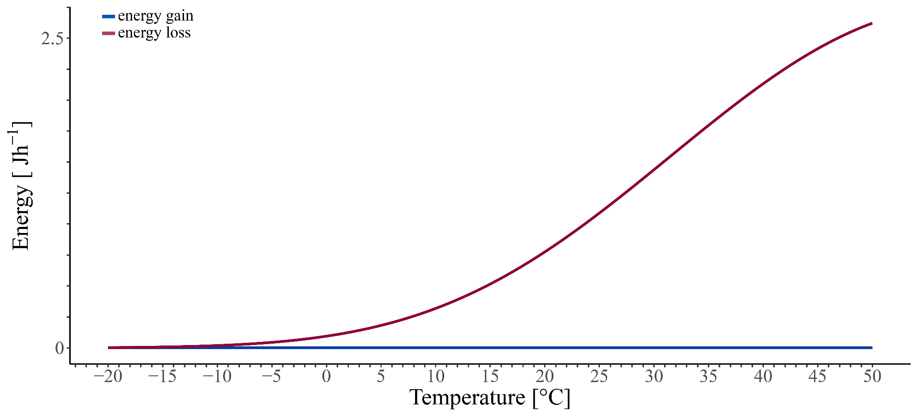
Figure S1: Thermal response of energy use of an exemplary predator without movement. The solid red line indicates the energy loss (field metabolic rate, supplementary equ. S1 and main text equ. 4) and the solid dark blue line energy gain (supplementary equ. S2 and main text equ. 5 and 9-12)

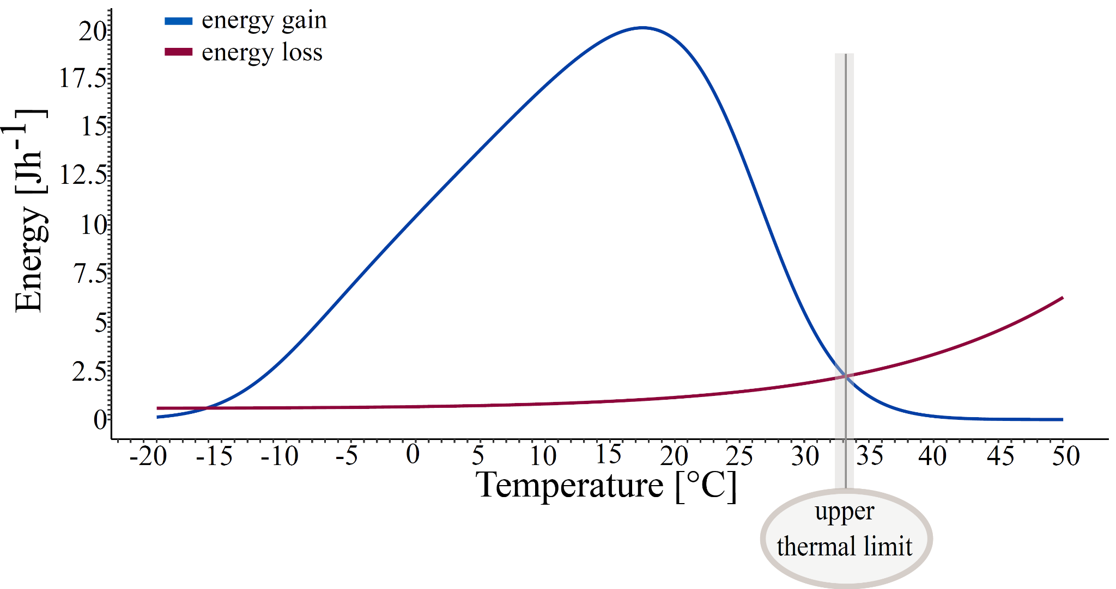
Figure S2: Thermal response of energy use of an exemplary predator based on temperature-independent movement (supplementary equ. S3). The solid red line indicates the energy loss (field metabolic rate, main text equ. 3-4) and the solid dark blue line energy gain (feeding rate, main text equ. 5-12).

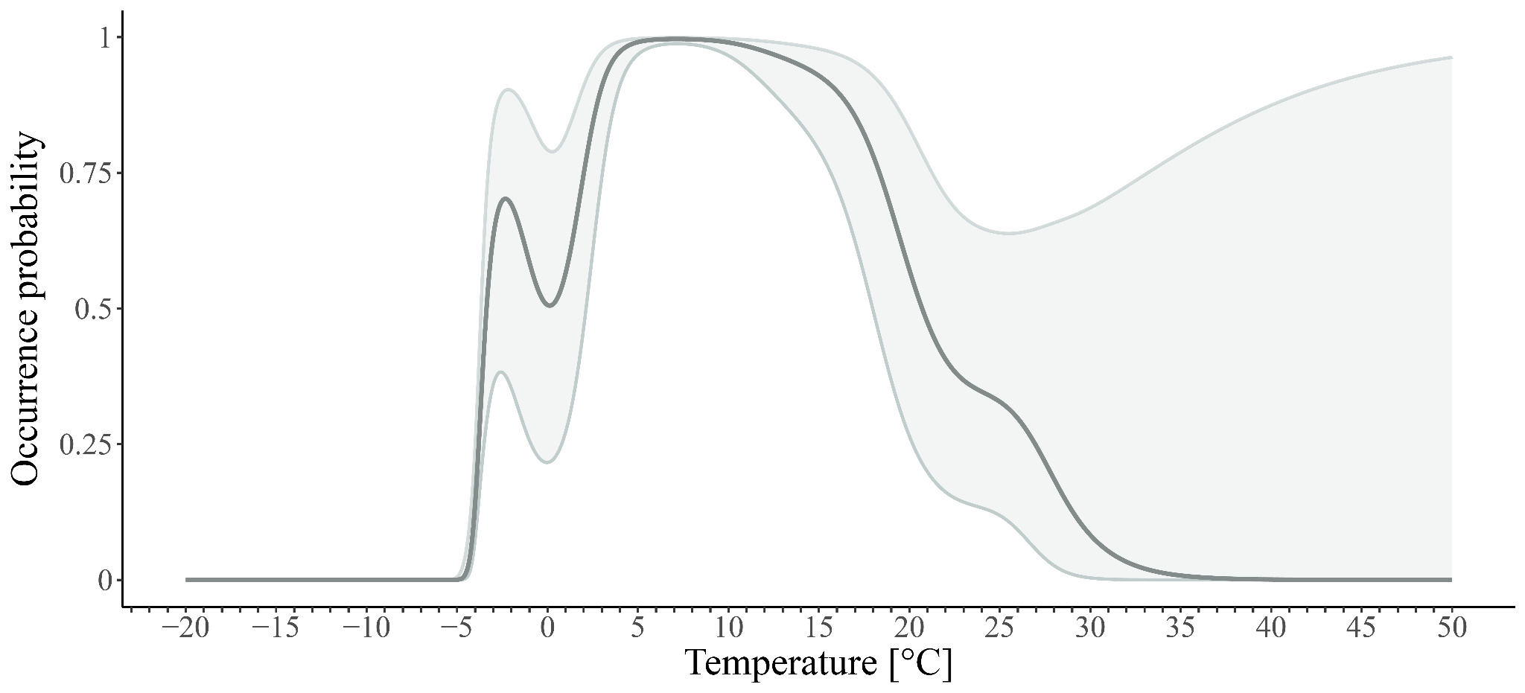
Figure S3: Environmental niche model (generalized additive model, i.e., GAM). Gray shaded areas show the 95% confidence intervals of the GAM.

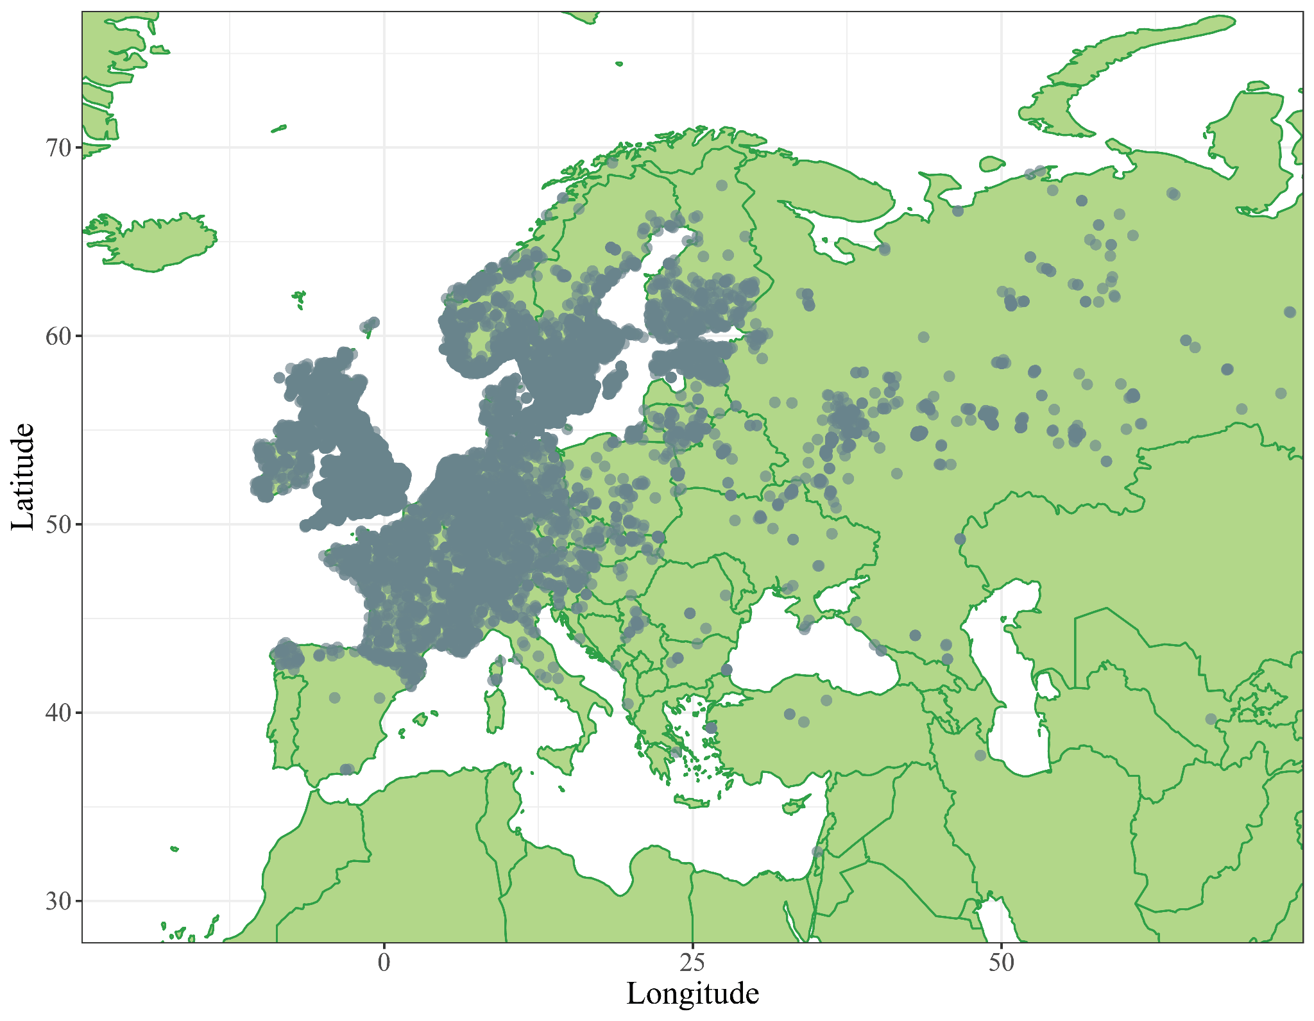
Figure S4: Occurrences of the species used in this study based on GBIF data (GBIF.org, 2021) and the R package maps (Becker et al., 2021).

- References

Becker, R.A. et al. (2021) maps: Draw Geographical Maps. R package version 3.4.0. https://CRAN.R-project.org/package=maps.
GBIF.org (2021) ‘GBIF Occurrence Download (29 July 2021) https://doi.org/10.15468/dl.jgqgg3’. The Global Biodiversity Information Facility. doi:10.15468/DL.JGQGG3.

