Supplementary Information for
A Novel Fluorescent Probe for the Detection of Cyanide Ions in Solutions and Studies on Its Biophysical Interactions with ctDNA and Proteases
Bensu Doyuran¹ . Elmas Gökoğlu^{1,*} . Ayman Zouitini² . Ergin Keleş^{2,3} . Tugba Taskin-Tok^{4,5} . Nurgül Seferoğlu^{3,6}. Zeynel Seferoğlu^{2,3}
¹ Hacettepe University, Department of Chemistry, 06800, Ankara, Turkey
² Gazi University, Department of Chemistry, 06560, Ankara, Turkey
³ Technological Dyes and Materials Application and Research Center (TEBAM), Gazi University, 06560, Ankara, Turkey
⁴ Gaziantep University, Department of Chemistry, 27310, Gaziantep, Turkey
⁵ Gaziantep University, Department of Bioinformatics and Computational Biology, 27310, Gaziantep, Turkey
^{f} Gazi University, Department of Advanced Technology, 06560, Ankara, Turkey

*Corresponding Author: Elmas Gökoğlu, E-Mail: gokoglu@hacettepe.edu.tr

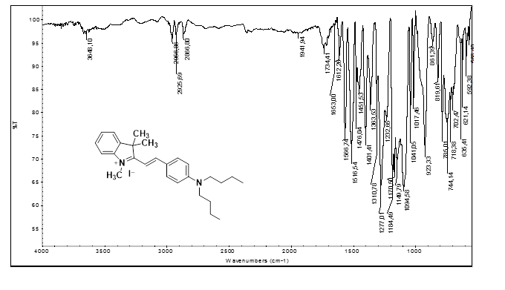
Fig. S1. FTIR spectrum of Ci.

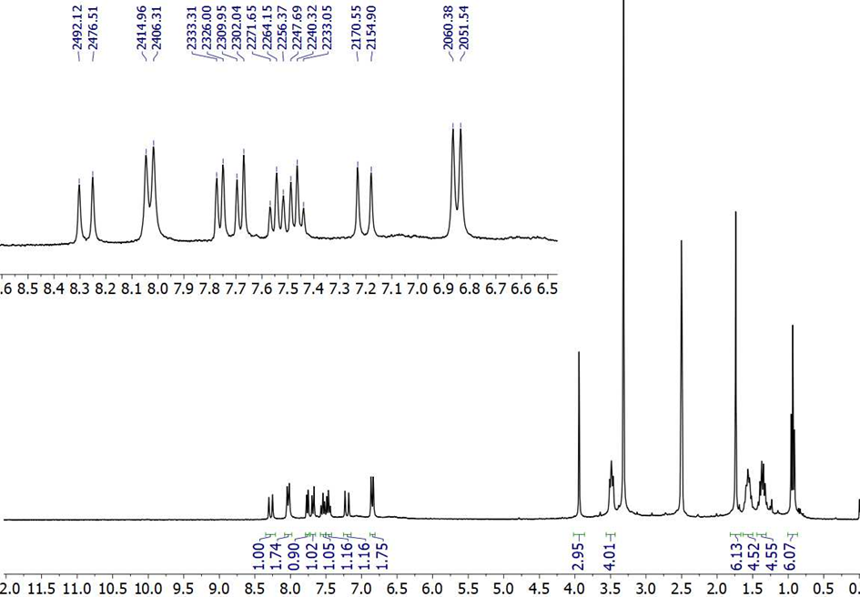
Fig. S2. ¹H NMR spectrum of Ci.

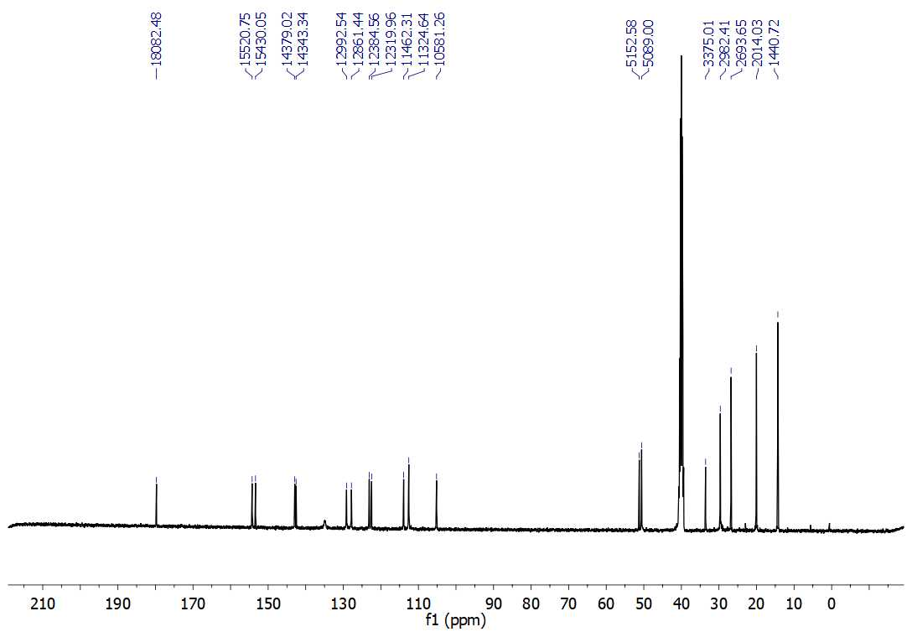

Fig. S3. ¹³C NMR spectrum of Ci.

Fig. S4. HRMS spectrum of Ci.

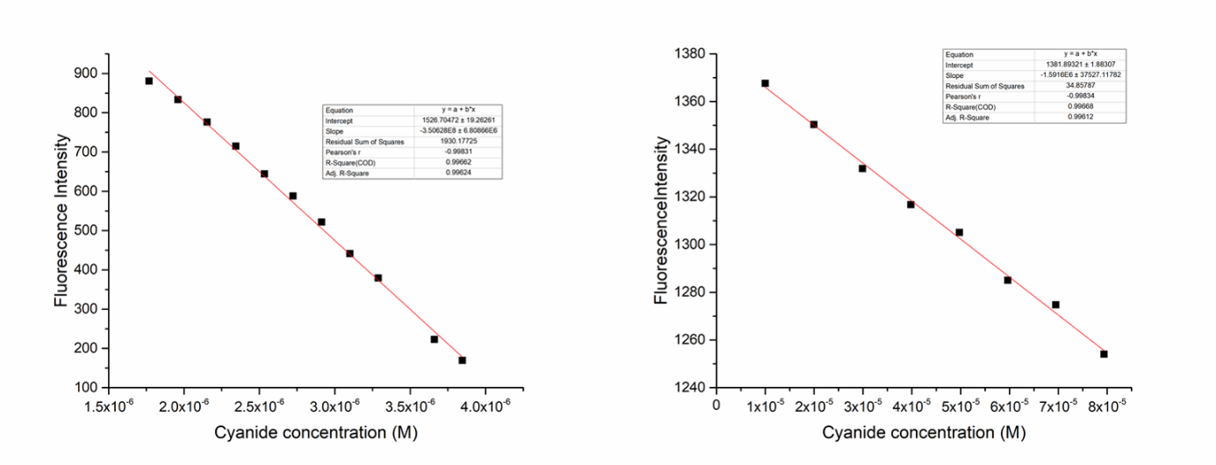
Fig. S5. The linear calibration curve of the fluorescence intensity of Ci in DMSO (left) and in DMSO/H₂O (v/v, 1/99) mixture (right).

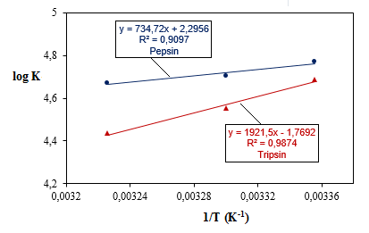
Fig. S6. van’t Hoff graphs of Ci-pepsin and Ci -trypsin systems.

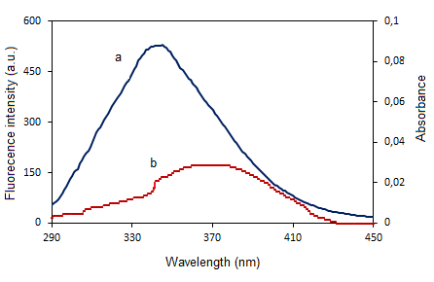
Fig. S7. The overlap of (a) fluorescence spectra of 2.5x10⁻⁶ M pepsin with (b) absorption spectra of 2.5x10⁻⁶ M Ci at pH 2.0.

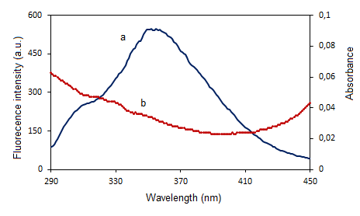
Fig. S8. The overlap of (a) fluorescence spectra of 5.0x10⁻⁶ M trypsin with the (b) absorption spectra of 5.0x10⁻⁶ M Ci at pH 7.4.

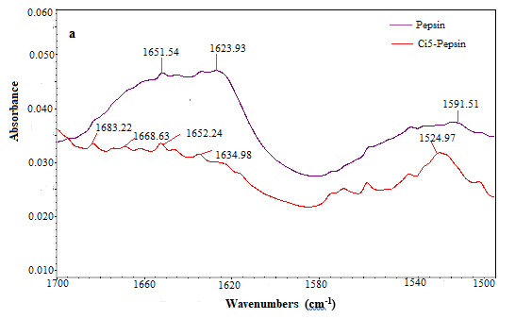

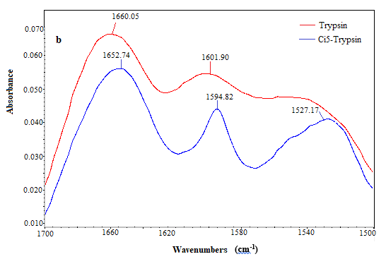
Fig. S9. FTIR results for binding Ci with (a) pepsin and (b) trypsin.

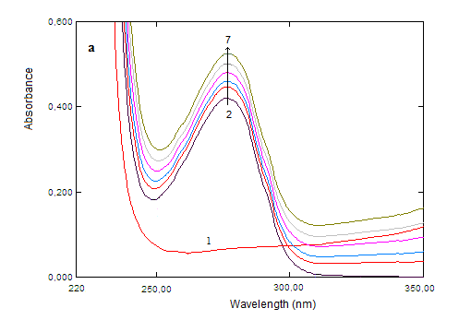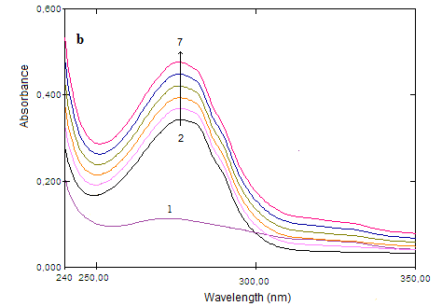

Fig. S10. UV absorption spectra of (a) 1.0x10⁻⁵ M pepsin (spectrum 2) (pH 2.0) and (b) 1.0x10⁻⁵ M trypsin (spectrum 2) (pH 7.4) in the presence of Ci. The spectra show (from 2 to 7) addition increasing amount of compound 2 which are 0.0; 2.38; 4.75; 7.11; 9.46; 11.8 (x10⁻⁶) M. (Each spectrum 1 is free 1.0x10⁻⁵ M of Ci).

Tables

Table S1 Interactions types and distances of optimal mode Ci against pepsin/trypsin and DNA, respectively.

Interactions  Pepsin - Ci | Distance Å | Bonding | Bonding Types | Binding site of target | Binding site of ligand
: Ci:H18 - A:GLU13:OE2 | 2.8826 | Hydrogen Bond | Carbon Hydrogen Bond | A:GLU13:OE2 | : Ci:H18
: Ci:H30 - A:GLY217:O | 2.2910 | Hydrogen Bond | Carbon Hydrogen Bond | A:GLY217:O | : Ci:H30
A:ALA115 - : Ci:C | 4.4937 | Hydrophobic | Alkyl | A:ALA115 | : Ci:C
: Ci:C - A:LEU112 | 4.4119 | Hydrophobic | Alkyl | A:LEU112 | : Ci:C
: Ci:C - A:ILE120 | 5.0609 | Hydrophobic | Alkyl | A:ILE120 | : Ci:C
A:TYR75 - : Ci:C | 4.4006 | Hydrophobic | Pi-Alkyl | A:TYR75 | : Ci:C
A:TYR75 - : Ci:C | 4.8996 | Hydrophobic | Pi-Alkyl | A:TYR75 | : Ci:C
A:PHE111 - : Ci:C | 4.7902 | Hydrophobic | Pi-Alkyl | A:PHE111 | : Ci:C
A:PHE111 - : Ci:C | 4.5950 | Hydrophobic | Pi-Alkyl | A:PHE111 | : Ci:C
A:PHE111 - : Ci:C | 5.4813 | Hydrophobic | Pi-Alkyl | A:PHE111 | : Ci:C
: Ci - A:ILE30 | 5.1453 | Hydrophobic | Pi-Alkyl | A:ILE30 | : Ci
Interactions  Trypsin - Ci | Distance Å | Bonding | Bonding Types | Binding site of target | Binding site of ligand
: Ci:H17 - A:SER195:OG | 2.9345 | Hydrogen Bond | Carbon Hydrogen Bond | A:SER195:OG | : Ci:H17
: Ci:H19 - A:PHE41:O | 2.9952 | Hydrogen Bond | Carbon Hydrogen Bond | A:PHE41:O | : Ci:H19
A:PHE41:HB1 - : Ci | 2.8748 | Hydrophobic | Pi-Sigma | A:PHE41:HB1 | : Ci
A:TYR151 - : Ci | 3.6961 | Hydrophobic | Pi-Pi Stacked | A:TYR151 | : Ci
: Ci:C - A:ILE73 | 4.5948 | Hydrophobic | Alkyl | A:ILE73 | : Ci:C
: Ci:C - A:ILE73 | 4.3520 | Hydrophobic | Alkyl | A:ILE73 | : Ci:C
A:TYR39 - Ci:C | 4.7710 | Hydrophobic | Pi-Alkyl | A:TYR39 | : Ci:C
A:HIS40 - : Ci:C | 4.3921 | Hydrophobic | Pi-Alkyl | A:HIS40 | : Ci:C
Interactions  DNA - Ci | Distance Å | Bonding | Bonding Types | Binding site of target | Binding site of ligand
: Ci:H17 - A:DC9:O2 | 2.4546 | Hydrogen Bond | Carbon Hydrogen Bond | A:DC9:O2 | : Ci:H17
: Ci:H19 - A:DG10:O4' | 2.6986 | Hydrogen Bond | Carbon Hydrogen Bond | A:DG10:O4' | : Ci:H19
: Ci:H30 - A:DC11:O2 | 2.7578 | Hydrogen Bond | Carbon Hydrogen Bond | A:DC11:O2 | : Ci:H30
A:DG10:OP1 - : Ci | 3.9548 | Electrostatic | Pi-Anion | A:DG10:OP1 | : Ci
B:DA18:H4' - : Ci | 2.6712 | Hydrophobic | Pi-Sigma | B:DA18:H4' | : Ci

Table S2 Binding energy, inhibition constant and RMSD data of the Ci against pepsin/trypsin and ctDNA.

Target | Binding Energy  (kcal/mol) | Inhibition Constant, Ki (nM) | RMSD (Å)
Pepsin | -7.50 | 114.93 | 0.0002
Trypsin | -6.90 | 399.21 | 0.0940
ctDNA | -6.80 | 13979 | 0.4260

