What goes in must come out? The metabolic profile of plants and caterpillars, frass, and adults of Asota (Erebidae: Aganainae) feeding on Ficus (Moraceae) in New Guinea

Alyssa M. Fontanilla^{1,2} ☥, Gibson Aubona^{3 ☥}, Mentap Sisol³, Ilari Kuukkanen⁴, Juha-Pekka Salminen⁴, Scott E. Miller⁵, Jeremy D. Holloway⁶, Vojtech Novotny^{1,2}, Martin Volf¹, and Simon T. Segar^{7*}

¹Institute of Entomology, Biology Centre of the Czech Academy of Sciences, České Budějovice, Czech Republic
²Faculty of Science, University of South Bohemia, České Budějovice, Czech Republic
³New Guinea Binatang Research Center, Madang, Papua New Guinea
⁴Natural Chemistry Research Group, Department of Chemistry, University of Turku, Turku, Finland
⁵National Museum of Natural History, Smithsonian Institution, Washington DC, USA
⁶Department of Life Sciences, The Natural History Museum, London, UK
⁷Agriculture and Environment Department, Harper Adams University, Newport, UK
☥ Joint first authors

Corresponding author:
Simon T. Segar
email: ssegar@harper-adams.ac.uk
ORCID: 0000-0001-6621-9409

Supporting Information
Asota taxonomy
Asota eusemioides (Felder) is a widespread species in New Guinea and surrounding islands, formerly identified as Asota versicolor (Fabricius), but now known as eusemioides following Zwier (2009). Asota heliconia (Linnaeus) as currently defined is widespread in Southeast Asia and highly variable in wing pattern, but it includes two clades based on DNA barcodes (Ratnasingham & Hebert, 2013): ABY6186 and ACE4743. Both clades of heliconia are widespread and apparently co-occurring in many localities, although ACE4743 is known from more peripheral localities (e.g. Taiwan, Queensland, Solomon Islands) and appears to be found at higher elevations in New Guinea. Based on DNA barcode data currently available, it appears that all of our lowland rearings (e.g. Weiblen et al., 2006) including those treated here are from ABY6186, while we reared ACE4743 at Mu, Chimbu, at 1800 m (Novotny et al., 2005). DNA barcodes (cytochrome c oxidase I) prepared from single legs using standard Sanger techniques at the Biodiversity Institute of Ontario (Wilson, 2012) for Asota eusemioides and the two clades of heliconia are available in GenBank as accessions KF549915-KF549917, KF549938, KF549947-KF549950, MT256674 and MT256915.
References
Novotny, V., Miller, S. E., Basset, Y., Cizek, L., Darrow, K., Kaupa, B., Kua, J., & Weiblen, G. D. (2005). An altitudinal comparison of caterpillar (Lepidoptera) assemblages on Ficus trees in Papua New Guinea. Journal of Biogeography, 32(8), 1303–1314. https://doi.org/10.1111/j.1365-2699.2005.01225.x
Ratnasingham, S., & Hebert, P. D. N. (2013). A DNA-based registry for all animal species: The Barcode Index Number (BIN) system. PLoS ONE, 8(7), e66213. https://doi.org/10.1371/journal.pone.0066213
Robinson, G. S., Ackery, P. R., Kitching, I., Beccaloni, G., & Hernández, L. (2001). Hostplants of the moth and butterfly caterpillars of the Oriental Region. Natural History Museum.
Weiblen, G. D., Webb, C. O., Novotny, V., Basset, Y., & Miller, S. E. (2006). Phylogenetic dispersion of host use in a tropical insect herbivore community. Ecology, 87(sp7), S62–S75. https://doi.org/10.1890/0012-9658(2006)87[62:PDOHUI]2.0.CO;2
Wilson, J. J. (2012). DNA barcodes for insects. In W. Kress & D. Erickson (Eds.), DNA Barcodes: Methods and Protocols (Vol. 858, pp. 17–46). Humana Press.
Zwier, J. (2009). Asota eusemioides Felder, 1874, a new identity for an old moth “versicolor”, from New Guinea. Suara Serangga Papua, 4(2), 46–51.
Figure Captions
Fig. S1 Host families of Asota moth larvae. All records from the family Moraceae are from the genus Ficus apart from one record on Broussonetia based on the Natural Museum HOSTS database and Robinson et al. (2001).
Fig. S2 Photographs from the field. Top right: A. eusemioides on F. hispidioides, top left: work in the field, bottom left: A. heliconia on F. septica and bottom left: enclosed caterpillars in mesh bags feeding on the experimental trees.
Fig. S3 A boxplot of caterpillar size at each instar for both species involved in the study.

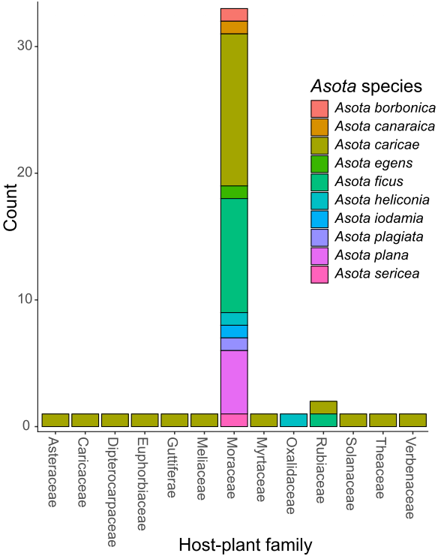

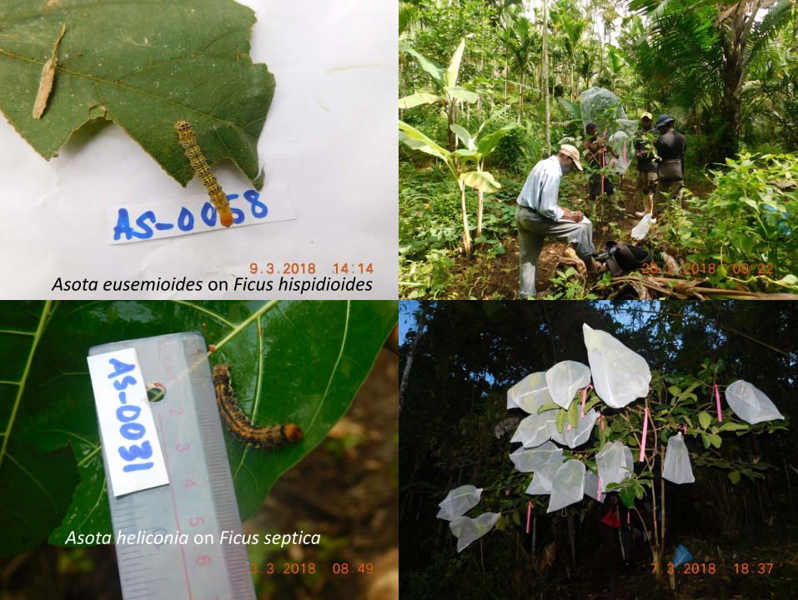

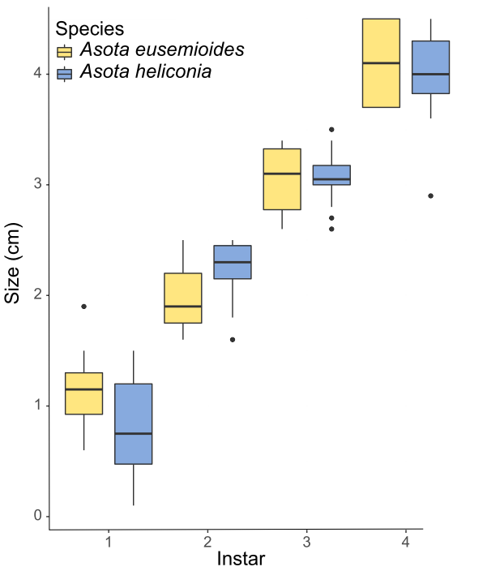

Table S1. Results of zero-inflated LMMs assessing the relationship between individual compound occurrence across tree species and adult tissue type. Numerator degrees of freedom are given. SEP: Ficus septica, HIS: F. hispidioides, PAR: F. pachyrrhachis. Ahel: Asota heliconia, Aeus: A. eusemoides, Cat: caterpillar, Fr: frass and L: leaves.
Compound | Tree Species |  |  |  |  |  | Sample Type
 | Chisq | Df | Pr(>Chisq) | PAR-HIS | SEP-HIS | SEP-PAR | Chisq | Df | Pr(>Chisq) | Ahel - Aeus | Cat - Aeus | Fr - Aeus | L - Aeus | Cat - Ahel | Fr - Ahel | L - Ahel | Fr - Cat | L - Cat | L - Fr
Alkaloid 5 | 21.266 | 2 | 0.000 | 0.722 | 0.001 | < 1e-04 | 657.407 | 4 | <2.2e-16 | < 0.001 | 0.188 | < 0.001 | < 0.001 | < 0.001 | < 0.001 | < 0.001 | < 0.001 | < 0.001 | 0.003
Alkaloid 9 | 0.099 | 2 | 0.952 | 0.950 | 0.976 | 0.996 | 1589.940 | 4 | <2e-16 | 0.933 | 0.664 | < 1e-04 | < 1e-04 | < 1e-04 | 0.992 | < 1e-04 | < 1e-04 | < 1e-04 | 0.001
Alkaloid 16 | 2.453 | 2 | 0.293 | 0.348 | 0.988 | 0.466 | 10243.693 | 4 | <2e-16 | 0.109 | 0.744 | 0.238 | < 0.001 | 0.003 | 0.673 | < 0.001 | 0.130 | < 0.001 | < 0.001
Alkaloid 17 | 296.640 | 2 | <2.2e-16 | < 1e-04 | 0.000 | < 1e-04 | 74.802 | 4 | 2.20E-15 | <0.001 | 0.050 | <0.001 | <0.001 | 0.055 | 0.991 | 0.809 | 0.031 | 0.335 | 0.892
Alkaloid 22 | 202.840 | 2 | <2.2e-16 | < 0.001 | 0.006 | < 0.001 | 256.520 | 4 | <2.2e-16 | <0.001 | <0.001 | <0.001 | <0.001 | 0.007 | 0.369 | <0.001 | <0.001 | <0.001 | 0.017
Alkaloid 24 | 71.998 | 2 | 0.000 | 0.386 | <1e-04 | <1e-04 | 13.562 | 4 | 0.008831 | 0.813 | 0.690 | 0.930 | 0.991 | 0.188 | 0.004 | 1.000 | 0.847 | 0.888 | 0.972
Alkaloid 25 | 130.060 | 2 | <2.2e-16 | <1e-04 | 0.174 | <1e-04 | 238.250 | 4 | <2.2e-16 | 0.194 | <0.001 | <0.001 | <0.001 | 0.122 | <0.001 | <0.001 | 0.023 | <0.001 | 0.077
Alkaloid 27 | 24.382 | 2 | 0.000 | <1e-04 | <1e-04 | 0.996 | 178.698 | 4 | <2.2e-16 | 0.991 | 0.114 | < 0.001 | < 0.001 | 0.061 | < 0.001 | < 0.001 | 0.019 | 0.003 | 0.196
Alkaloid 28 | 13.667 | 2 | 0.001 | 0.017 | 0.597 | <0.001 | 453.957 | 4 | <2.2e-16 | <1e-04 | <1e-04 | 0.935 | <1e-04 | 0.994 | < 0.001 | < 0.001 | < 0.001 | < 0.001 | < 0.001
Alkaloid 30 | 94.338 | 2 | <2.2e-16 | <1e-06 | <1e-06 | <1e-06 | 102.512 | 4 | <2.2e-16 | 1.000 | 1.000 | 0.003 | < 0.001 | 1.000 | < 0.001 | < 0.001 | 0.008 | < 0.001 | < 0.001
Alkaloid 32 | 106.810 | 2 | <2.2e-16 | 0.000 | < 1e-05 | < 1e-05 | 340.250 | 4 | <2.2e-16 | < 0.001 | 0.009 | < 0.001 | 0.001 | < 0.001 | < 0.001 | < 0.001 | < 0.001 | < 0.001 | 0.845
Alkaloid 35 | 91.683 | 2 | <2.2e-16 | 0.253 | <1e-04 | <1e-04 | 570.000 | 4 | <2.2e-16 | 0.502 | 0.068 | < 0.001 | 0.002 | 0.020 | < 0.001 | 0.035 | < 0.001 | 0.303 | 1.000
Alkaloid 36 | 729.320 | 2 | <2.2e-16 | 0.984 | <1e-06 | <1e-06 | 979.060 | 4 | <2.2e-16 | <0.001 | 0.974 | 0.057 | 0.928 | <0.001 | <0.001 | <0.001 | 0.050 | 0.698 | 0.772
Alkaloid 37 | 4.485 | 2 | 0.106 | 0.351 | 0.109 | 0.635 | 20.046 | 4 | 0.0004892 | 0.957 | 0.226 | 0.403 | 0.663 | 0.056 | 0.287 | 0.994 | 0.003 | 0.014 | 0.941
Alkaloid 38 | 4.693 | 2 | 0.096 | 0.973 | 0.146 | 0.101 | 88.210 | 4 | <2e-16 | 0.222 | 0.002 | 0.002 | 0.008 | 0.957 | < 0.001 | < 0.001 | < 0.001 | < 0.001 | 0.963
Alkaloid 41 | 58.739 | 2 | 0.000 | 0.000 | < 1e-04 | < 1e-04 | 29.058 | 4 | 7.61E-06 | 0.971 | 0.956 | 0.030 | < 0.001 | 0.997 | 0.988 | 0.669 | 0.348 | 0.001 | 0.294
Alkaloid 43 | 151.150 | 2 | <2.2e-16 | 0.137 | <1e-04 | <1e-04 | 818.910 | 4 | <2.2e-16 | < 0.001 | < 0.001 | 0.213 | 0.005 | 0.227 | < 0.001 | < 0.001 | < 0.001 | < 0.001 | 0.048

Table S2. Results of zero-inflated LMMs assessing the relationship between individual compound occurrence across tree species and adult body part. Numerator degrees of freedom are given. There was insufficient variation in the data to model the occurrence of compounds A32 and A36 and achieve adequate convergence. Ahel: Asota heliconia and Aeus: A. eusemoides.
Compound | Moth Species |  |  |  | Sample Type
 | Chisq | Df | Pr(>Chisq) | As_hel - As_eus | Chisq | Df | Pr(>Chisq) | Other - Body | Wing - Body | Wing - Other
Alkaloid 27 | 1.356 | 1 | 0.244 | 0.244 | 2.660 | 2 | 0.2645 | 0.231 | 0.823 | 0.739
Alkaloid 37 | 0.146 | 1 | 0.702 | 0.702 | 0.111 | 2 | 0.946 | 1.000 | 0.958 | 0.950

