Phase-Separating Peptides for Direct Cytosolic Delivery and Redox-Activated Release of Macromolecular Therapeutics
-
Extended data figures and tables

Extended Data Table 1. Peptide sequence and their optimum pH to induce LLPS. K^{(SA)} and K^{(SP)} are conjugated side chains with self-immolative moieties attached to the Lys (K) residue, as shown in Extended Data Fig. 12.

Peptide | Sequence | Optimal pH
HBpep | GHGVY GHGVY GHGPY GHGPY GHGLY W | 7.5¹
HBpep-K | GHGVY GHGVY GHGPY K GHGPY GHGLY W | 9.0
HBpep-SA | GHGVY GHGVY GHGPY K^{(SA)} GHGPY GHGLY W | 6.5
HBpep-SP | GHGVY GHGVY GHGPY K^{(SP)} GHGPY GHGLY W | 6.5

Extended Data Fig. 1: 3D confocal microscopy imaging of various cell lines treated with EGFP-loaded HBpep coacervates. (a) T22 cells (a); (b) RPE1 cells; (c) ARN8 cells; and (d) H1299 cells. Green dots show that intracellular delivery of EGFP was achieved, with the droplets remaining stable for multiple days.

Extended Data Fig.2: EGFP delivery into HepG2 cells mediated by HBpep coacervates. (a, b) Fluorescence (a) and brightfield (b) micrographs of HepG2 cells treated with EGFP-loaded HBpep coacervates for 24 hours. (c, d) Fluorescence (c) and optical (d) micrographs of HepG2 cell treated with EGFP-loaded HBpep coacervates for 72 hours.

Extended Data Fig. 3: EGFP delivery into T22 cells mediated by HBpep coacervates. (a) Confocal micrographs of T22 cells treated with EGFP-loaded HBpep coacervates for 7 days. The pseudo color represents the fluorescence signal of EGFP. (b) Optical micrograph of the same cells.
Extended Data Fig. 4: Characterization of modified HBpep coacervates. (a) Particle size of pristine, EGFP-loaded, and mRNA-loaded coacervates measured by DLS. Data are presented as the mean ± SD of n = 3 independent measurements. (b) Fluorescence micrograph of EGFP-loaded HBpep-SP coacervates. (c) Fluorescence micrograph of Cy5-mRNA-loaded HBpep-SP coacervates.

Extended Data Fig. 5: Control group for protein delivery. (a-d) Fluorescence and (e-g) brightfield micrographs of HepG2 cell treated with free EGFP, AF-lysozyme, AF-BSA and R-PE for 24 hours.

Extended Data Fig. 6: Codelivery of EGFP and R-PE by HBpep-SP coacervates. (a) EGFP channel; (b) R-PE channel; and (c) merged micrographs of HepG2 cells treated with EGFP/R-PE co-loaded HBpep-SP coacervates for 24 hours.
Extended Data Fig. 7: Recruitment efficiency of proteins by HBpep-SP coacervates (1 mg/mL), including EGFP, AF-lysozyme, AF-BSA and R-PE (0.1 mg/mL). Data are presented as the mean ± SD of n = 3 independent measurements.

Extended Data Fig. 8: Cytotoxicity of redox-responsive coacervates. (a,b) Relative cell viability of HepG2 (a) and HEK293 (b) treated with HBpep-SA and HBpep-SP coacervates and comparison with commercial transfection reagents including PEI and lipofectamine 2000 and 3000. Data are presented as the mean ± SD of n = 3 independent measurements.
Extended Data Fig. 9: Control group for Cy5-mRNA (EGFP) delivery. (a) FACS of untreated HepG2; (b) FACS of untreated HEK293.

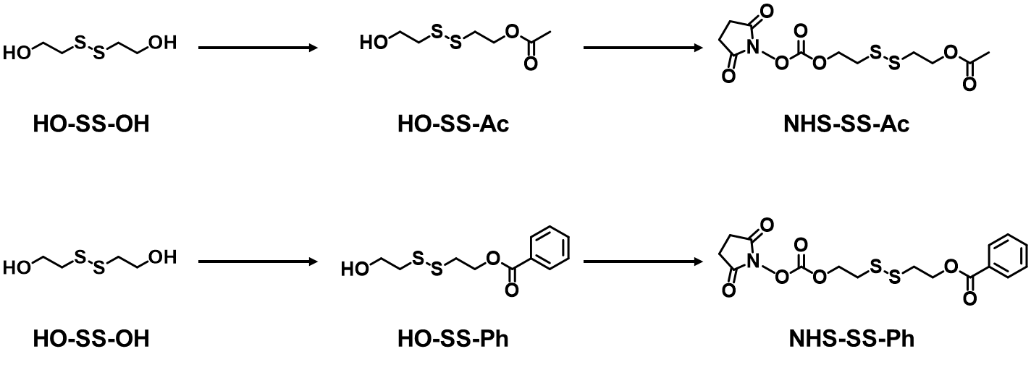
Extended Data Fig. 10: Synthesis routes to produce the self-immolative moieties that are subsequently conjugated to HBpep-K (see Figure 1 of the main text). On top, the end group of the moiety is acetate (labelled as “SA” in the main text) and on bottom the end group of the moiety is benzoate (labelled as “SP” in the main text).

Extended Data Fig. 11: ¹H NMR spectra of synthesized products in CDCl₃. (a) HO-SS-Ac; (b) NHS-SS-Ac; (c) HO-SS-Ph; and (d) NHS-SS-Ph.

Extended Data Fig. 12: MALDI-TOF mass spectra of HBpep and HBpep conjugated peptides. (a) Fmoc-HBpep-K (theoretical MW: 3132.4 Da); (b) HBpep-SA (theoretical MW: 3132.4 Da); and (c) HBpep-SP (theoretical MW: 3194.5 Da).

References
1. Lim, Z.W., Ping, Y. & Miserez, A. Glucose-Responsive Peptide Coacervates with High Encapsulation Efficiency for Controlled Release of Insulin. Bioconjugate Chemistry 29, 2176-2180 (2018).

