Fluorescence resonance energy transfer biosensor based on Nitrogen doped carbon quantum dots and hairpin probe to sensitively detect aflatoxin biosynthesis-related genes aflD in rice
Tao Yu, ^{b} Shuangfeng Peng, ^{b} Qingyue Sun, ª Dezhao Kong, ª Chang Liu, ª Qiaoqiao Shi, ª Yaqi Li^{*,a,c,d,e}, Yong Chen^{*,e}

ª School of Grain Science and Technology, Jiangsu University of Science and Technology, Zhenjiang, 212100, Jiangsu Province, PR China
^{b} School of Environmental and Chemical Engineering, Jiangsu University of Science and Technology, Zhenjiang, 212100, Jiangsu Province, PR China
^{c} Advanced Technology Institute of Suzhou, Suzhou, 215123, Jiangsu Province, PR China
^{d} Institute of Biological Information Processing, Bioelectronics (IBI-3), Forschungszentrum
Jülich GmbH, 52428 Jülich, Germany
^{e} School of Environmental Science and Engineering, Huazhong University of Science and Technology, Wuhan, 430074, Hubei Province, PR China

*Corresponding author E-mail: liyaqi@just.edu.cn (Yaqi Li); ychen@mail.hust.edu.cn (Yong Chen).

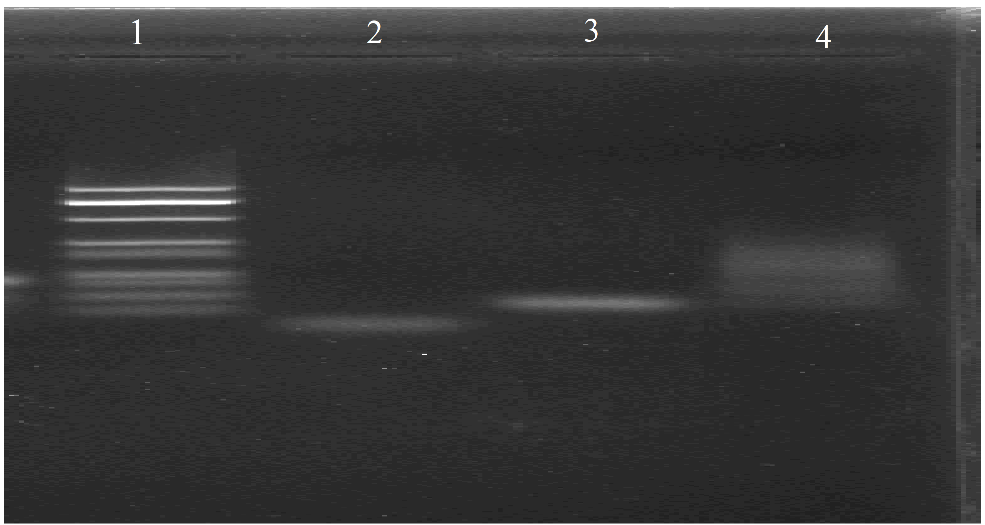
Figure.S1 Agarose gel electrophoresis analysis. (lane 1-4, DNA marker, tDNA, hairpin DNA, tDNA + hairpin DNA).

Table.S1 Comparison of nor-1 gene detection using other methods with the proposed FRET strategy.
Detection method | Linear range (nM) | Limit of dection (nM) | Reference
Piezoelectric assay | 30-110 | 40 | (Sara et al. 2009)
Electrochemical | 1–10000 | 0.55 | (Khavidak et al. 2017)
Fluorescence resonance energy transfer assay | 10-150 | 1.95 | This work

Reference
1. Sara T, Marco M, Barbara S, Gianni B, Quirico M (2009) DNA biosensors for the detection of aflatoxin producing Aspergillus flavus and A. parasiticus. Monatsh. Chem 140: 901-907.
2. Khavidak S, Mazloum-Ardakani S, Khorasgani MR, Emtiazi M, Hosseinzadeh G (2017) Detection of aflD gene in contaminated pistachio with Aspergillus flavus by DNA based electrochemical biosensor. Int J Food Prop 20: 119-130.

