Supplementary Information

The immunodominant protein P116 extracts
cholesterol and other essential lipids

Lasse Sprankel^{1,}*, David Vizarraga^{2,}*, Jesús Martín², Sina Manger¹, Jakob Meier-Credo³, Marina Marcos⁴, Josep Julve⁵, Noemi Rotllan⁵, Margot P. Scheffer¹, Joan Carles Escolà-Gil⁵, Julian Langer³, Jaume Piñol⁴, Ignacio Fita^{2,#} and Achilleas S. Frangakis^{1,#}

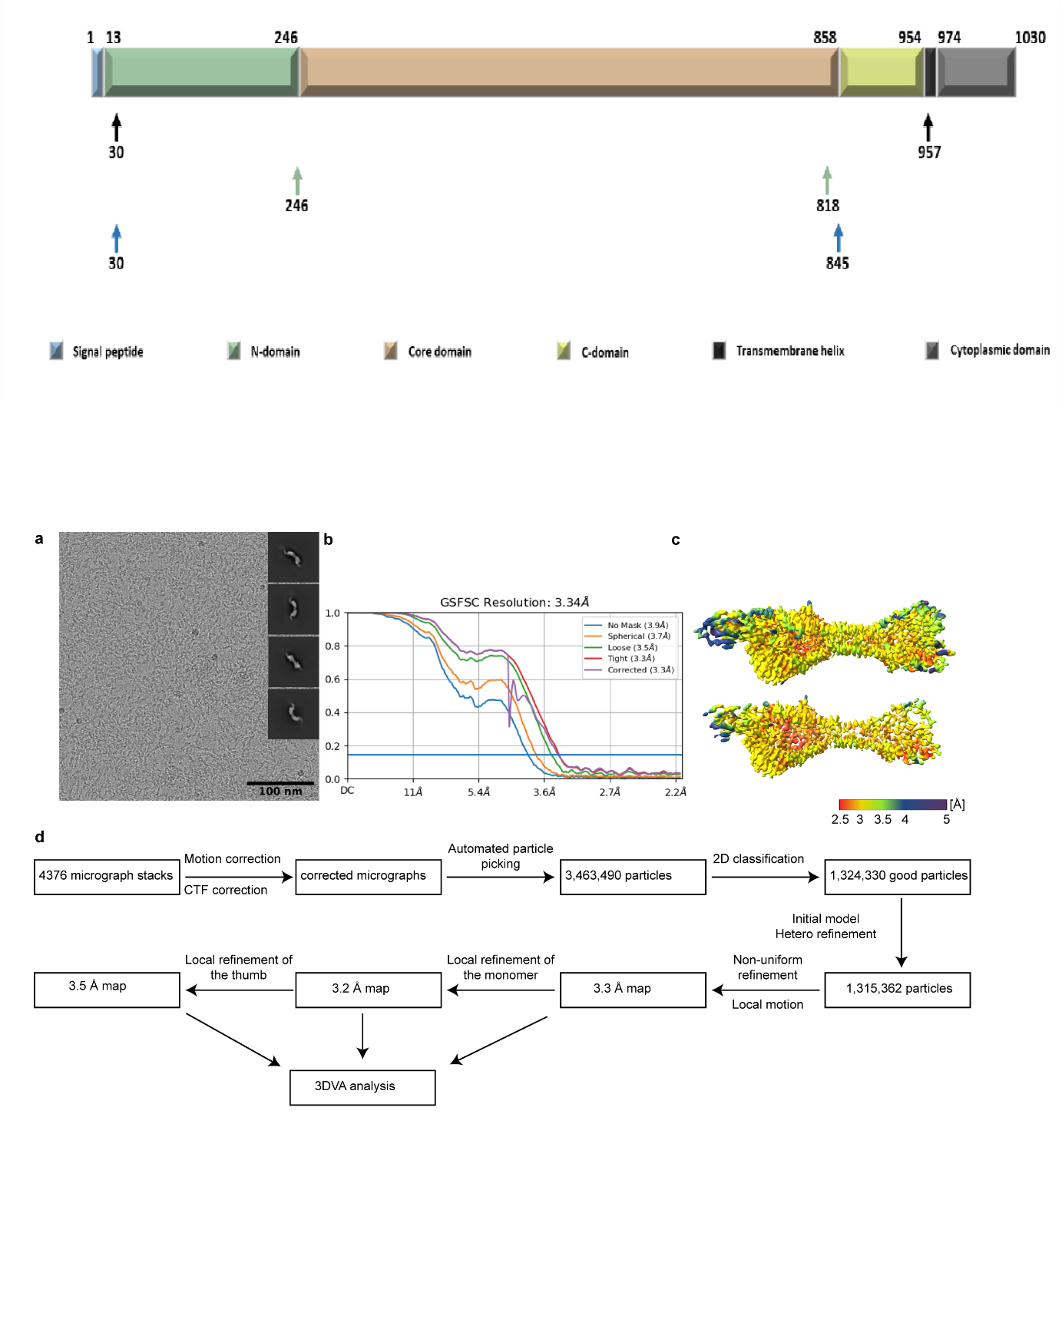

Supplementary Figure 1: P116 constructs.
Overview of the different constructs (30 - 957, 30 – 818, 246 - 845) used for expression. For expression purposes a His-tag (KHHHHH) was added at the C-terminus. For the structural analysis by cryoEM the construct from 30-957 was used.

Supplementary Figure 2: Overview of cryoEM processing of P116. (a) Representative Micrograph and obtained 2D classes used for template picking. (b) Fourier shell correlation of P116 reporting a final resolution of 3.3 Å according to the 0.143 cut-off criteria. (c) Local resolution map of the cryoEM denisty map of P116 ranging from 2.5 to 5 Å. (d) Schematic processing overview for the P116 construct. The processing for P116 empty, P116 refilled and P116 + HDL was carried out in a similar manner.

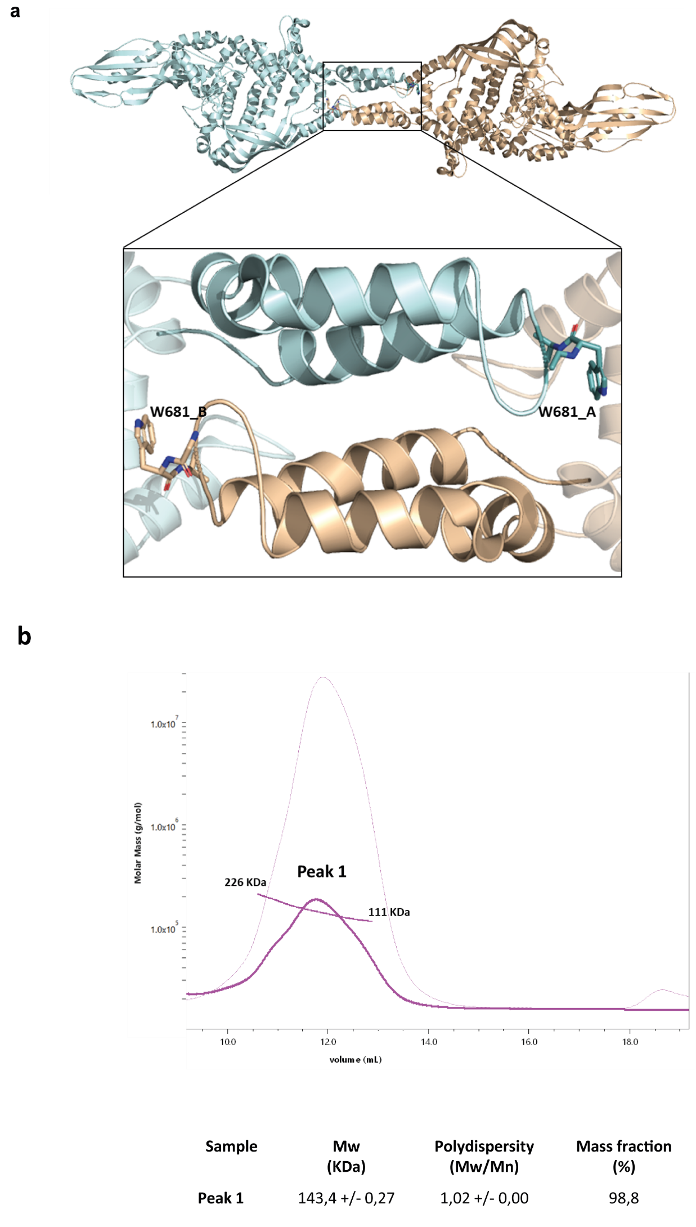

Supplementary Figure 3: Dimerization interface of P116. (a) Detail of the dimerization zone with the two monomers and the TRP-681 residue of both chains contacting the opposite one. (b) SEC-MALS of P116 W681A. The greatest polydispersity of this sample is observed, which oscillates between a very large MW (molecular weight) range, and the clear decrease in size with respect to the WT due to the now predominance of the monomeric state.

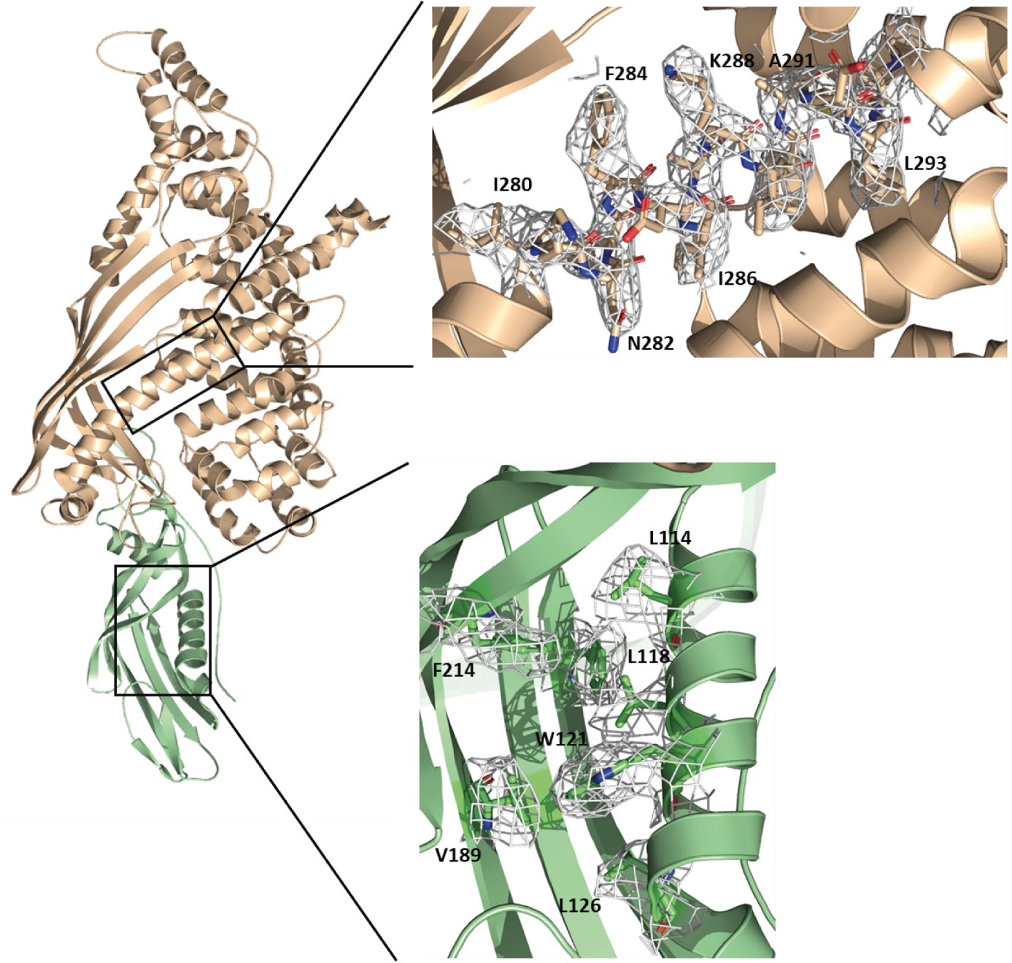

Supplementary Figure 4: Model building of P116. Exemplary superimpositions of the cryoEM density and the PDB model for the core and N-terminal domain.

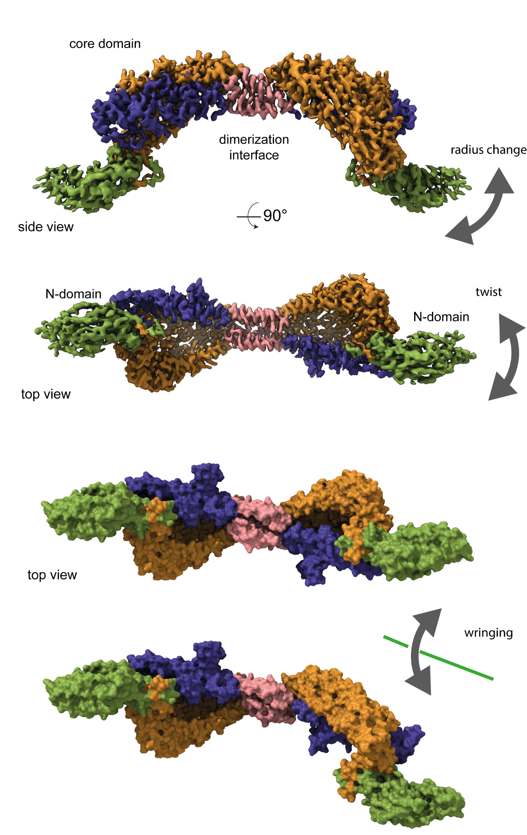

Supplementary Figure 5: Flexibility of P116. CryoEM classes display different flexibility modes.

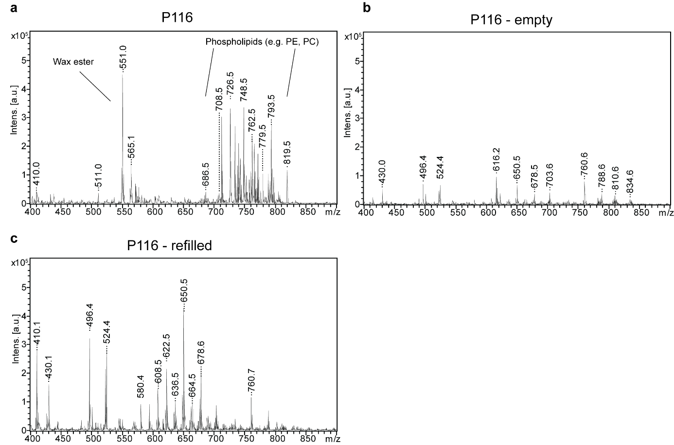

Supplementary Figure 6: MALDI-TOF of P116, P116 empty and P116 refilled (a-c) Individual low molecular weight MALDI-MS spectra of P116, P116-empty and P116-refilled as displayed in in figure 4D.

Supplementary Figure 7: P116 in other Mycoplasma species. (a) Conserved (minimum 55 %) amino acids pointing inwards the hydrophobic cavity. Black indicates amino acids with a hydrophobic character. Red indicates amino acids with a hydrophilic character. Blue indicates amino acids with a negative side chain. Purple indicates amino acids with a positive side chain. Green indicates other amino acids. (b) Predictions of P116 from different Mycoplasma spp. in comparison with the structure resolved with cryoEM. The N-terminal and the core domain have been predicted independently and subsequently fitted in the cryoEM density map of P116. The colouring of the models is identical to the figures 1-4.
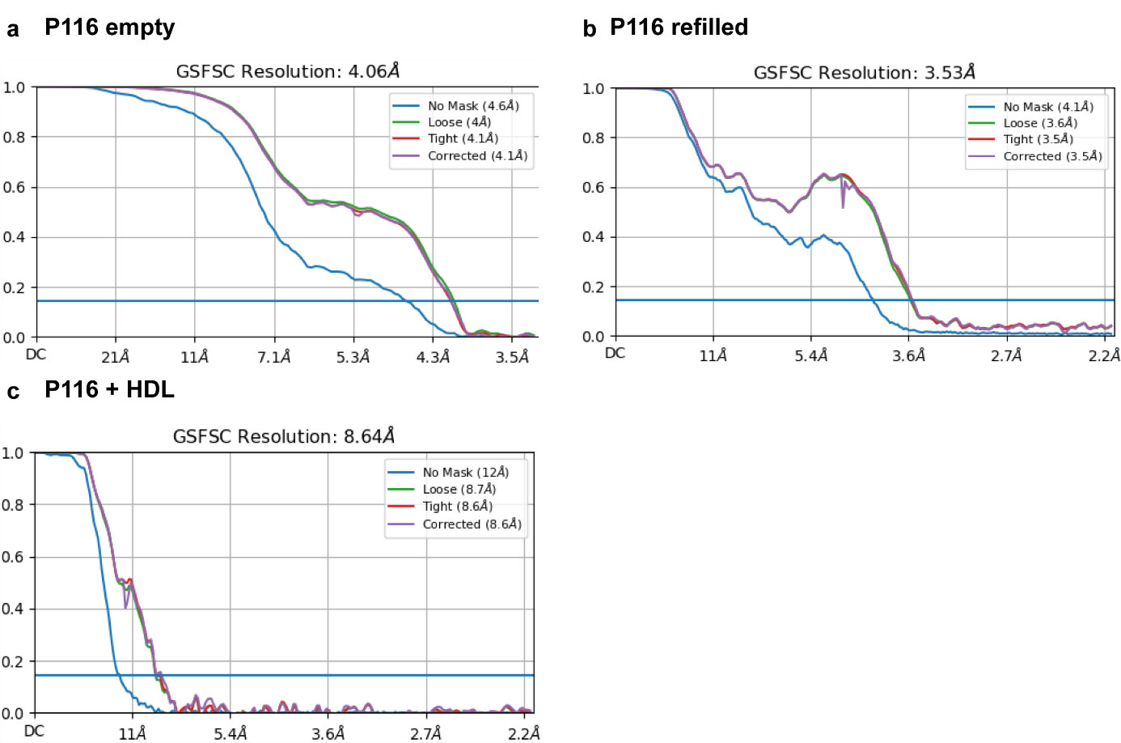

Supplementary Figure 8: Fourier shell correlations of P116 empty, P116 refilled and P116 + HDL. (a) Final reported resolution of P116 empty at 4 Å according to the 0.143 cut-off criteria. (b) Final reported resolution of P116 refilled at 3.5 Å according to the 0.143 cut-off criteria. (c) Final reported resolution of P116 + HDL at 9 Å according to the 0.143 cut-off criteria.

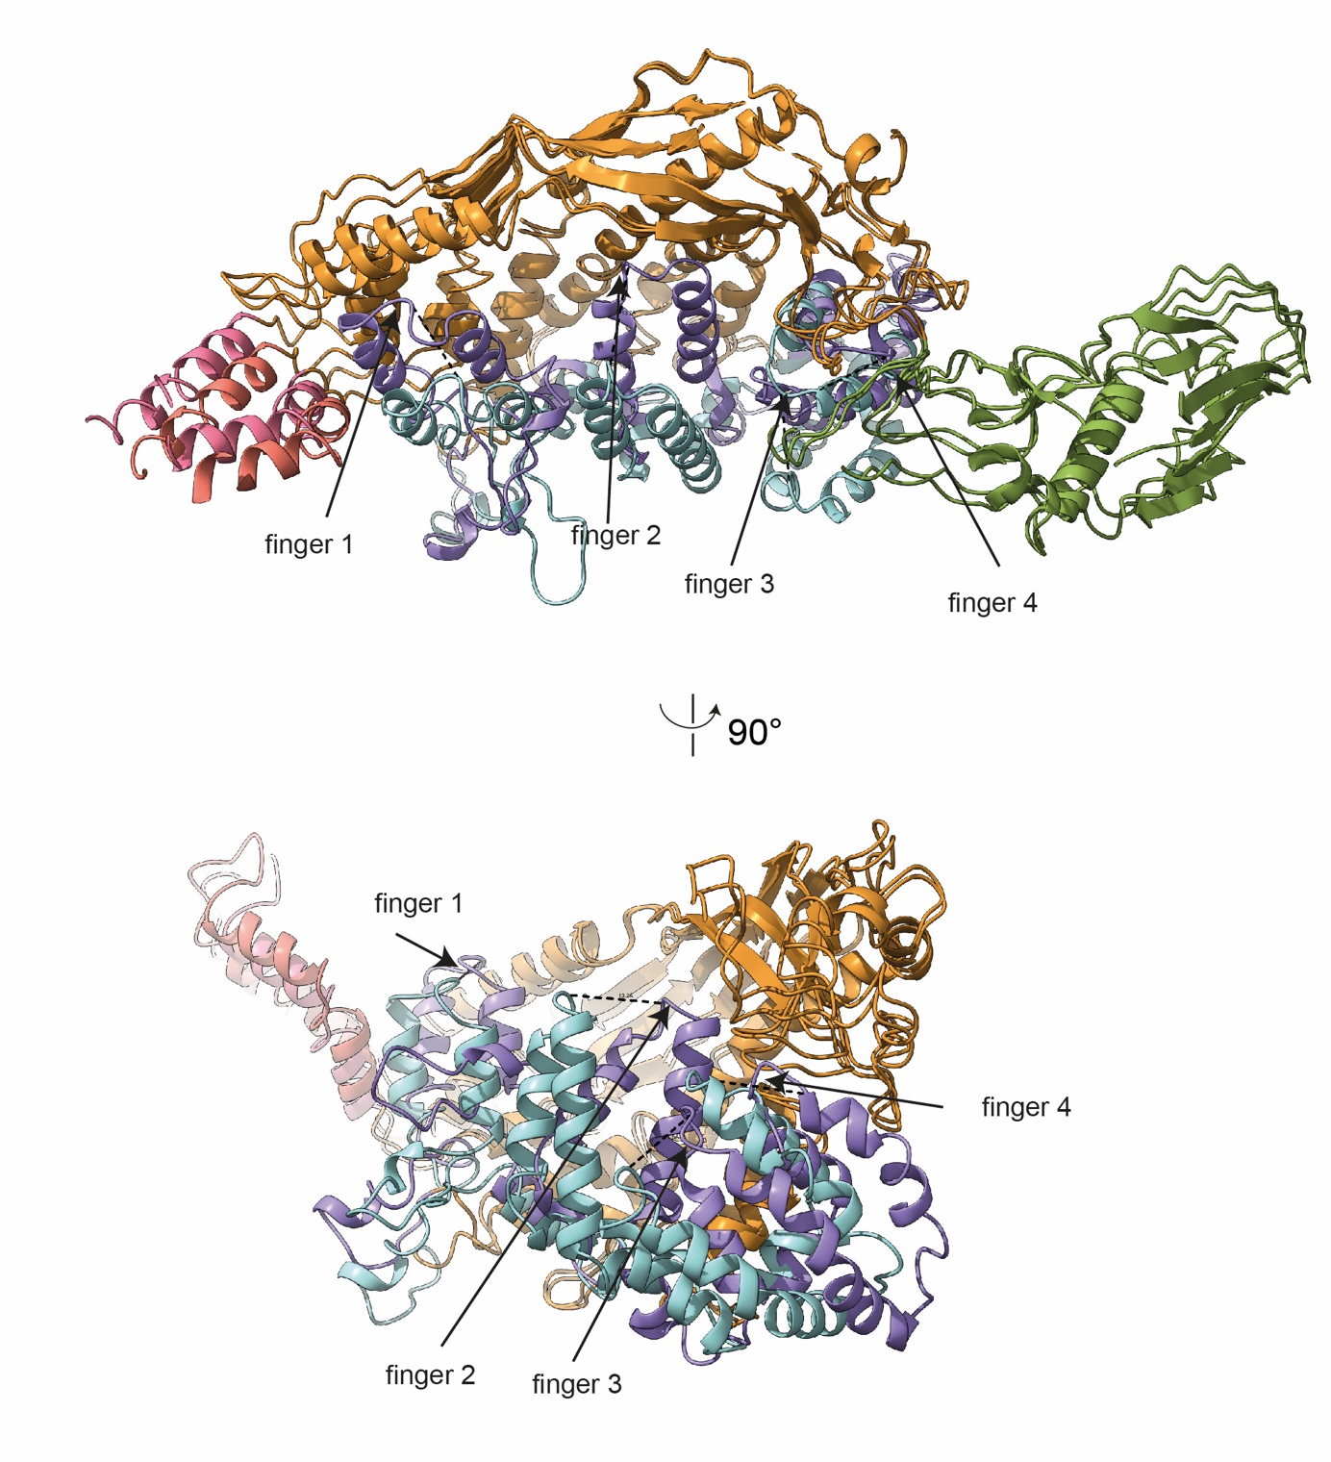

Supplementary Figure 9: Conformational change between P116 and P116 empty.
Superimposition of one subunit of P116 with one subunit of P116 empty. The movement of the fingers 1-4 is indicated by dashed lines. Side view of the ribbon representation of the empty and full P116 shows that the fingers (in purple) have come closer to the core domain, massively reducing the available volume. Their new position is markedly different compared to the full P116 (shown in light blue). Finger 1 moved 8Å sideways and towards the core, finger 2 has moved 13 Å towards the core and Finger 3 has moved 12 Å towards the core.
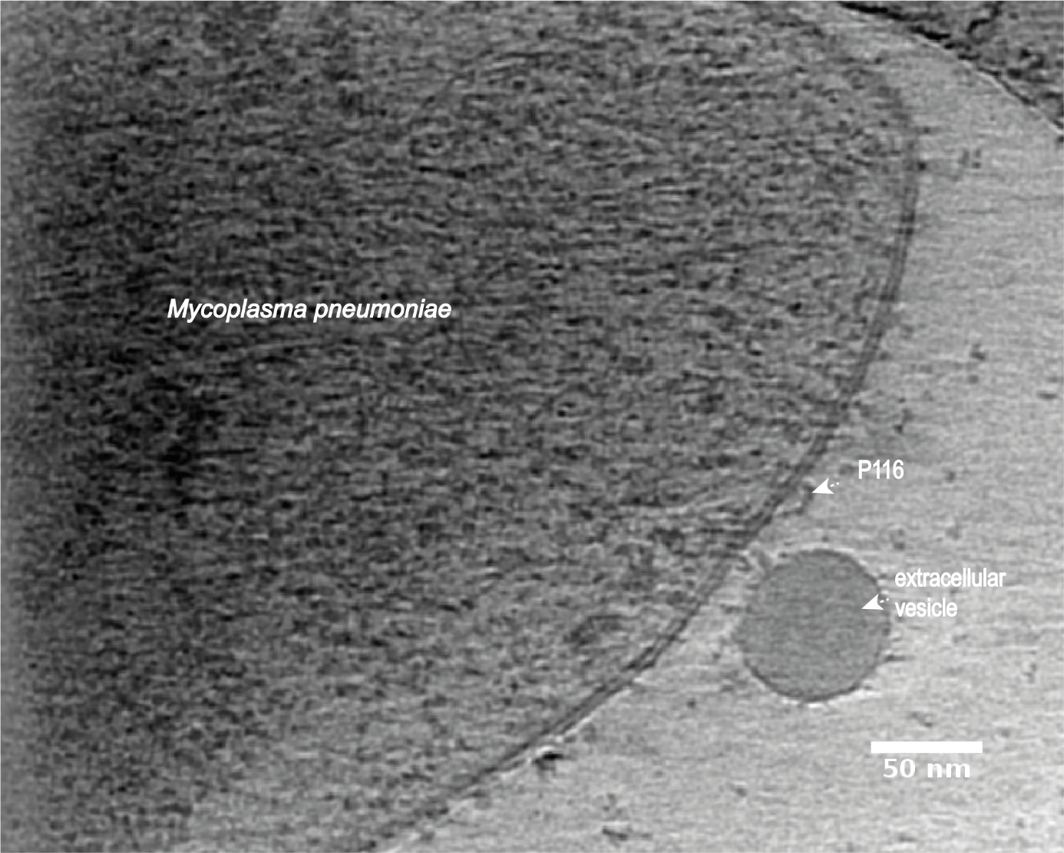

Supplementary Figure 10: Cryo-electron tomogram of a M. pneumoniae cell. Ortho slice of a tomographic reconstruction of a M. pneumoniae cell depicting a possible P116 protein on the surface of the M. pneumoniae membrane. Tomogram was acquired at a defocus of -3 µm.

Supplementary Table I. Number of cell detachments and motility status in microcinematography (MCN) replicates of M. pneumoniae cells before and after adding polyclonal antibodies (PCA) vs P1 and P116. A negative control was performed by incubating cells in the same medium (PBS - 10% FBS) but no antibodies were added. Mean and standard deviation (SD) were computed from the frequencies of detached cells in each replicate.

 |  | Before AS |  |  |  | After AS
PCA | MCN replicate | Total | Non- Motile | Motile |  | Total | Non- Motile | Motile | Detached cells | % Detached cells
P1 | 1 | 46 | 5 | 41 |  | 15 | 11 | 4 | 37 | 90,2
 | 2 | 20 | 1 | 19 |  | 4 | 4 | 0 | 19 | 100,0
 | 3 | 131 | 3 | 128 |  | 31 | 24 | 7 | 121 | 94,5
 | 4 | 15 | 0 | 15 |  | 9 | 9 | 0 | 15 | 100,0
 | 5 | 397 | 9 | 388 |  | 122 | 89 | 33 | 355 | 91,5
 |  |  |  |  |  |  |  |  | Mean | 95,1
 |  |  |  |  |  |  |  |  | SD | 4,6
P116 | 1 | 170 | 5 | 165 |  | 112 | 7 | 105 | 60 | 36,4
 | 2 | 79 | 7 | 72 |  | 45 | 8 | 37 | 35 | 48,6
 | 3 | 51 | 5 | 46 |  | 35 | 5 | 30 | 16 | 34,8
 | 4 | 42 | 5 | 37 |  | 30 | 6 | 24 | 13 | 35,1
 | 5 | 61 | 4 | 57 |  | 31 | 4 | 27 | 30 | 52,6
 |  |  |  |  |  |  |  |  | Mean | 40,2
 |  |  |  |  |  |  |  |  | SD | 6,6
Negative control | 1 | 29 | 4 | 25 |  | 12 | 4 | 8 | 17 | 68,0
Negative control | 2 | 49 | 2 | 47 |  | 31 | 5 | 26 | 21 | 44,7
Negative control | 3 | 32 | 4 | 28 |  | 17 | 4 | 13 | 15 | 53,6
 |  |  |  |  |  |  |  |  | Mean | 53,8
 |  |  |  |  |  |  |  |  | SD | 11,8

Supplementary Table II. CryoEM data collection, refinement and validation statistics

 | P116  EMDB | P116 empty  EMDB | P116 refilled  EMDB | P116 + HDL  EMDB
Data collection
Microscope | FEI Titan Krios | FEI Titan Krios | FEI Titan Krios | FEI Titan Krios
Detector | Gatan K2 Summit | Gatan K3 Summit | Gatan K2 Summit | Gatan K2 Summit
Acquistion Software | SerialEM 3.8 | EPU 2.12 | SerialEM 3.8 | SerialEM 3.8
Magnification | 130,000x | 105,000x | 130,000x | 130,000x
Pixel size (Å) | 1,05 | 0,831 | 1,05 | 1,05
Total electron dose (e⁻/Å²) | 50 | 50 | 50 | 50
Dose rate (Å²/s⁻¹) | 8,2 | 8,2 | 8,2 | 30
Number of frames | 34 | 50 | 29 | -1 to -3.5
Defocus range (µm) | -1 to -3.5 | -1 to -3.5 | -1 to -3.5 | 3114
Micrographs used | 4367 | 15299 | 4019
Processing
Software | cryoSPARC v3.3.2 | cryoSPARC v3.3.2 | cryoSPARC v3.3.2 | cryoSPARC v3.3.2
Motion correction | cryoSPARC v3.3.2 | cryoSPARC v3.3.2 | cryoSPARC v3.3.2 | cryoSPARC v3.3.2
CTF estimation | cryoSPARC v3.3.2 | cryoSPARC v3.3.2 | cryoSPARC v3.3.2 | cryoSPARC v3.3.2
Total extracted particles | 3.463.490 | 4.532.601 | 2.930.863 | 262.981
After 2D classification | 1.324.330 | 1.140.275 | 1.311.526 | 46.277
Number of refined particles | 1.315.362 | 633.322 | 1.311.526 | 46.277
Symmetry | / | / | / | /
Map sharpening B factor | -117 | -105 | -131 | -490
Resolution (Å) FSC 0.143 | 3,3 | 4 | 3,5 | 8.6

Refinement | P116
Initial model used (PDB code) | /
Model resolution (Å)  FSC threshold | 3.2  0.143
Model resolution range (Å) | 2.5-5.0
Map sharpening B factor (Å²) | -94
Model composition  Non-hydrogen atoms  Protein residues  Ligands | 12772  1618  0
B factors (Å²)  Protein  Ligand | 51.22  0
R.m.s. deviations  Bond lengths (Å)  Bond angles (°) | 0.003  0.651
Validation  MolProbity score  Clashscore  Poor rotamers (%) | 2.18  12  0.14
Ramachandran plot  Favored (%)  Allowed (%)  Disallowed (%) | 89.34  10.53  0.13

Supplementary Table III: Identified lipid compounds from of P116, P116-empty, P116-refilled and serum in positive and negative mode as used for heatmap generation.

Supplementary Movie 1: Microcinematography adding P1 polyclonal antibodies. Frames were taken each 0.5 seconds of observation and are showed at 20 frames per second in the movie. The blank frame/s in the first seconds of the movie denote when the polyclonal antibodies were added to cells.

Supplementary Movie 2: Microcinematography adding P1116 polyclonal antibodies. Frames were taken each 0.5 seconds of observation and are showed at 20 frames per second in the movie. The blank frame/s in the first seconds of the movie denote when the polyclonal antibodies were added to cells.

Supplementary Movie 3: Control microcinematography. Frames were taken each 0.5 seconds of observation and are showed at 20 frames per second in the movie.

Supplementary Movie 4: Density map of the P116 homodimer
Rotation along the long axis of the cryoEM density map. The complete extracellular region of the P116 dimer at 3.3 Å resolution, 90 degrees apart. The individual domains can be appreciated: The dimerization interface (shown in pink), the core domains with the four contiguous antiparallel helices (shown in blue) and a β-sheet with five antiparallel strands (shown in orange) as well as the N-terminal domain is shown in green (Color coding is identical to the coloring in the Figures 1 &2).

Supplementary Movie 5: Ribbon model of P116
Ribbon representation of the P116 structure with the same coloring as in Movie 1.

Supplementary Movie 6: Flexibility of P116
Animation of the wringing motion between the monomers as seen after classification of the cryoEM data. In some classes both cavities face the same direction, while in other they face 80 degrees apart. The speed of the movie may be adjusted in order to appreciate the conformational change. The N- terminal domains were computationally removed for the better visualization.

Supplementary Movie 7: Hydrophobicity map of the P116 homodimer
Rotation along the long axis of the hydrophobic map of P116. The huge hydrophobic cavity that is fully accessible to solvent can be appreciated.

Supplementary Movie 8: Crosssection of one P116 monomer
Cross-section of the hydrophobic map of the monomer reveals the positions of the ligands (in red).

Supplementary Movie 9: Ribbon model of a P116 monomer (colors as in Figure 2 & 3) with the unaccounted elongated densities.
Ribbon representation of the monomer with the ligands (in red). The alignment of the ligands along the bridge helix can be seen.

Supplementary Movie 10: Conformational change of P116 top view
Morphing between the ribbon models from P116 and P116 empty. Conformational changes of the P116 shown from the top view. Starting from the structure of the full P116 (open) a morphing is shown towards the structure of the empty P116. The speed of the movie may be adjusted in order to appreciate the conformational change.

Supplementary Movie 11: Conformational change of P116 distal view
Morphing between the ribbon models from P116 and P116 empty. Conformational changes of the P116 shown from an arbitrary view. The movement of the four fingers (in blue) towards the core domain (in orange) can be appreciated. The speed of the movie may be adjusted in order to appreciate the conformational change.

Supplementary Movie 12: Conformational change of P116 distal view with ligands
Morphing between the ribbon models from P116 and P116 empty. Similar view as in movie 8, only the ligands (in red) present. In the closed conformation the 4 fingers (in blue) clash with the ligands.

