Quantifying the Fragmentation of Polypropylene upon Exposure to Accelerated Weathering

Nora Meides,^{1,}† Anika Mauel,^{2,}† Teresa Menzel,³ Volker Altstaedt,³ Holger Ruckdäschel,³ Jürgen Senker,^{2,*} Peter Strohriegl^{1,*}

¹ Department of Macromolecular Chemistry I, University of Bayreuth, Universitätsstraße 30, 95447 Bayreuth, Germany
² Department of Inorganic Chemistry III, University of Bayreuth, Universitätsstraße 30, 95447 Bayreuth, Germany
³ Department of Polymer Engineering, University of Bayreuth, Universitätsstraße 30, 95447 Bayreuth, Germany

†These authors contributed equally to this work and share first authorship
*Corresponding author: peter.strohriegl@uni-bayreuth.de
List of Figures
Figure S1. Global horizontal irradiation for Europe and for Germany in kWh/m² for 2019. Source: SOLARGIS.
Figure S2. Q-SUN daylight-Q filter compared to direct sunlight. Modified from Q-Lab Corporation, 2014, Technical Bulletin LX-5060, A Choice of Filters for Q-Sun Xenon Test Chambers.
Figure S3. (A) MALDI spectrum of the first processing stabilizer in PP HP526 J. The three prominent peaks could be assigned to the oxidized species of Irgafos® 168 (Schwarzinger et al., 2012). (B) Chemical structure of Irgafos® 168 (Tris(2,4-di-tert-butylphenyl)phosphite) and (C) Tris(2,4-di-tert-butylphenyl)phosphate) together with m/z values from the literature.
Figure S4. (A) MALDI-TOF-MS spectrum of the second processing stabilizer in PP HP526 J. The prominent peaks are identical to those arising from Irganox® 1010 reference material, treated with simulated solar radiation in THF for 100 h in (B).
Figure S5. Comparison of ¹H (A), ¹³C (B), and ³¹P (C) NMR spectra of the first extracted additive, tris(2,4-di-tert-butylphenyl)-phosphate and Irgafos® 168 as well as of the second extracted additive, Irganox® 1010 and oxidised Irganox® 1010. The ¹H and ¹³C spectra were normalised to the proton and carbon resonances of tert-butyl groups and the ³¹P spectra to the highest peak.
Figure S6. Above: Scheme for the photooxidative degradation of PP explaining the formation of hydroperoxides, alcohols, ketones, olefins and carboxylic acids. Below: Reactions of the radical scavenger Irgafos® 168 with reactive hydroperoxides and peroxy- and alkoxy radicals. The reactive intermediates marked in red (above) are deactivated by the phosphite Irgafos® 168 which itself is oxidized to the phosphate (Maier and Schiller, 2016).
Figure S7. Average particle size distributions for (A) PP with stabilizer and (B) PP particles without stabilizer.
Figure S8. Molecular weight distributions in g/mol of (A) PP with stabilizer and (B) PP without stabilizer for exposure time intervals from 0 h to 3200 h.
Figure S9. DSC measurements. Heat flow in W/g vs. temperature in °C for (A) PP particles with stabilizer and (B) PP particles without stabilizer.
Figure S10. ¹³C CP MAS NMR spectrum of the PP particles with stabilizer prior to weathering with signal assignment. In the enlarged PP spectra (blue and orange rectangle) the differences of the resonances of the amorphous (signal a1 and b1) and crystalline (signal a2 and b2) phase become visible (Hronský et al., 2014).
Figure S11. ¹³C CP MAS NMR spectra of the PP particles with (A) and without (B) stabilizer for 0, 400 and 3200 h weathering time. Upon irradiation, a shift of signal intensity from the amorphous phase resonances (30 ppm, 48 ppm) to the crystalline phase resonances (28 ppm, 46 ppm) is observed (Hronský et al., 2014). The spectra are normalised to the integral of the backbone signal (35-20 ppm and 55-35 ppm).
Figure S12. SEM images of PP with stabilizer after irradiation for different time intervals.
Figure S13. SEM images of PP without stabilizer after irradiation for different time intervals.
List of Tables
Table S1. Calculation of total irradiance in the Q-SUN Xe-3 chamber.
Table S2. Average particle sizes in µm for PP samples with and without stabilizer at exposure times from 0 h to 3200 h. Values display the average of three measurements.
Table S3. Number-average (M_{n}), weight-average (M_{w}), peak (M_{p}) molecular weights in g/mol, and dispersity (Ð) values for PP samples with and without stabilizer for different exposure times.
Table S4. Crystallinity and melting temperature measurements for PP with stabilizer and PP without stabilizer.
Table S5. Correction factors for PP with and without stabilizer determined with quantitative multi-CP spectra of the respective 3200 h weathered sample. Used to calibrate the defect intensities in the CP spectra (Meides et al., 2021).
Experimental Section
Materials and Methods
Accelerated Weathering

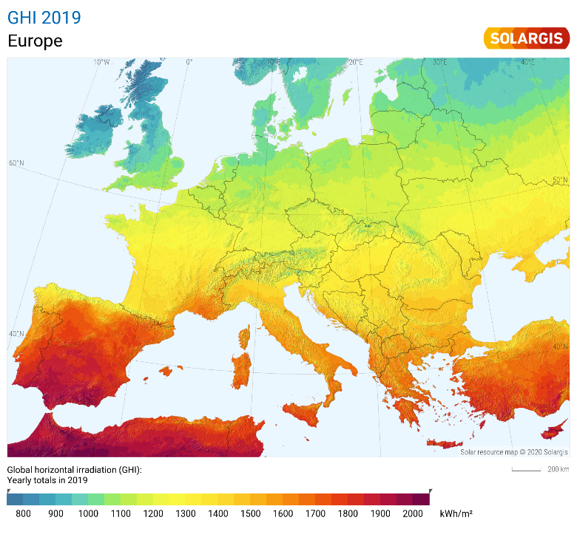 | 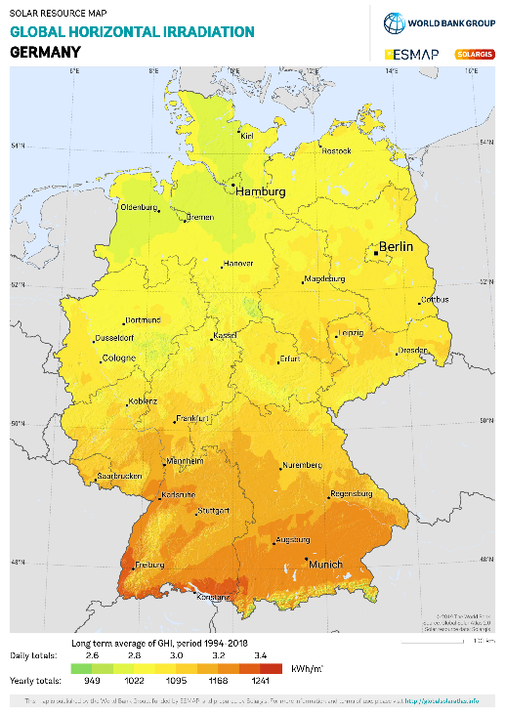
Figure S1. Global horizontal irradiation for Europe and for Germany in kWh/m² for 2019. Source: SOLARGIS.

Table S1. Calculation of total irradiance in the Q-SUN Xe-3 chamber.
Calculation of total irradiance in Q-SUN Xe-3 chamber
Lamp settings^{*1} | 60 | W/m²
Calculation factor*² | 9.9
Total irradiance in Q-SUN Xe-3 chamber | 594 | W/m²
Acceleration factor of Q-SUN Xe-3 chamber compared to Central Europe
Solar irradiance per year*³ | 1000 | kWh/m²
Hours per year | 8765 | h
Solar irradiance | 114 | W/m²
Acceleration factor of Q-SUN Xe-3 chamber*⁴ | 5.21 | -
*¹measured in the wavelength interval from 300 to 400 nm
*² calculation factor converting the irradiance from 300 to 400 nm to the whole emission range of the Xenon lamp (300 – 800 nm). Extracted from Q-Sun Irradiance Conversion Sheet provided by Q-Lab Germany
*³value was derived from Figure S1 for the longitude of Central Europe
*⁴this value was calculated by division of the total irradiance in the Q-Sun Xe-3 chamber (594 W/m²) by the solar irradiance determined for Central Europe (114 W/m²)

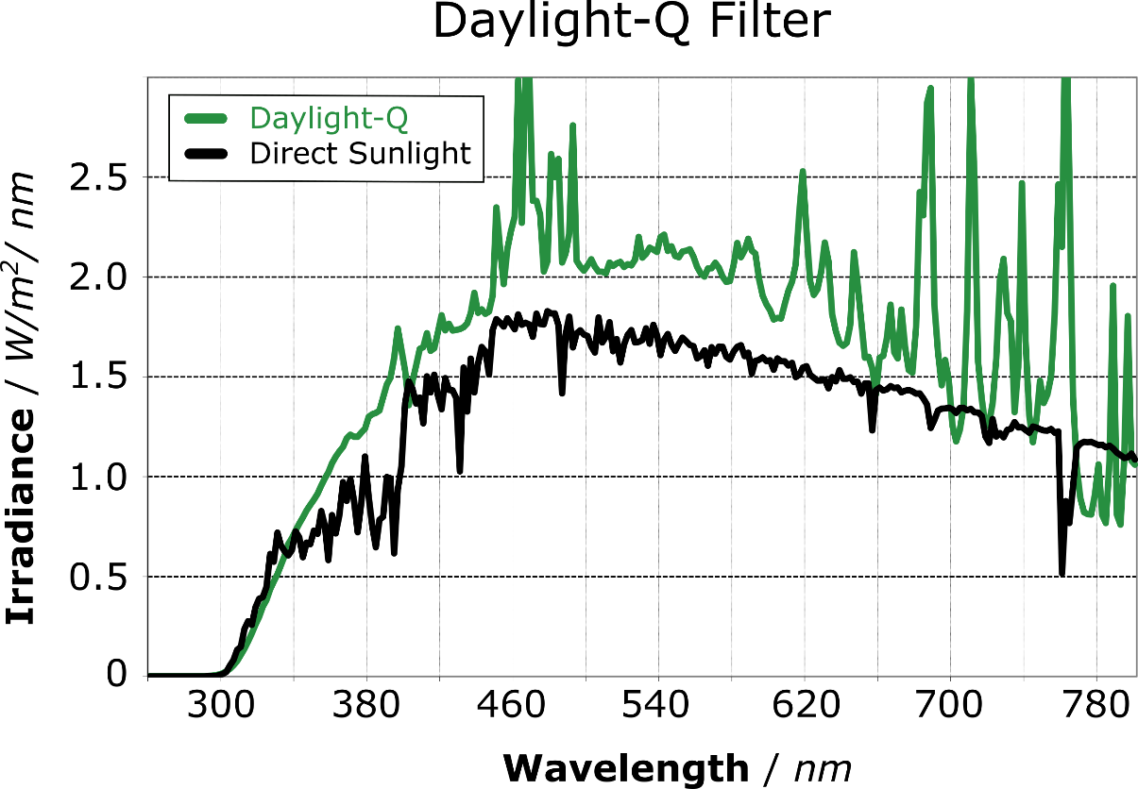
Figure S2. Q-SUN daylight-Q filter compared to direct sunlight. Modified from Q-Lab Corporation, 2014, Technical Bulletin LX-5060, A Choice of Filters for Q-Sun Xenon Test Chambers.

Results
Identification of the Processing Stabilizer via MALDI-TOF Mass Spectrometry
A | 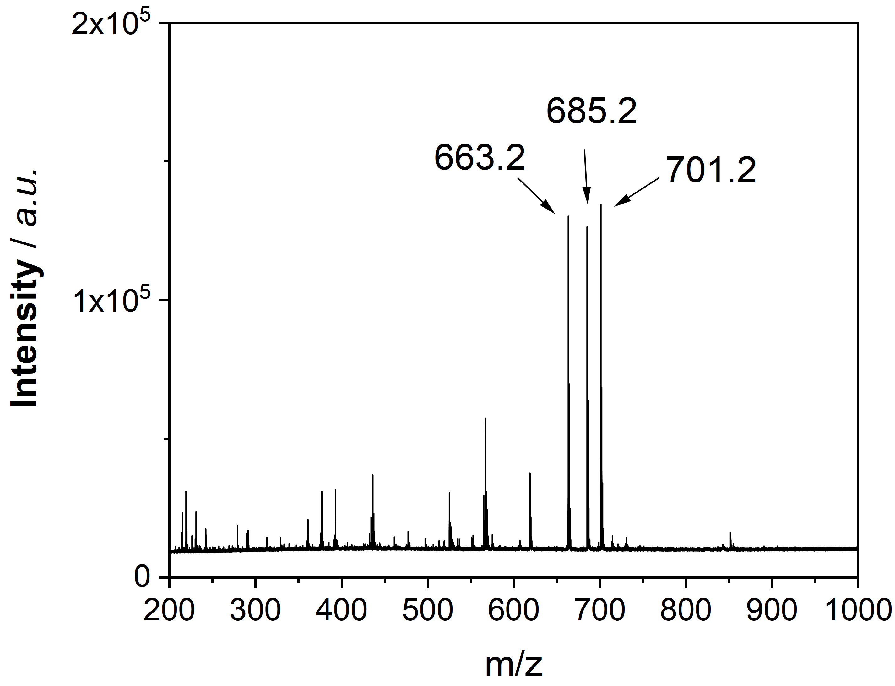
B | Tris(2,4-di-tert-butylphenyl)phosphite  Irgafos® 168  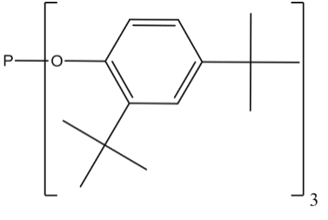C₄₂H₆₄O₃P | C | Tris(2,4-di-tert-butylphenyl)phosphate  Irgafos® 168, oxidized form  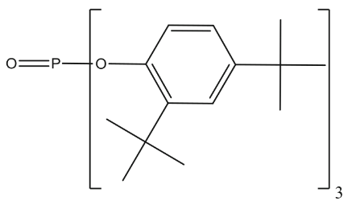C₄₂H₆₄O₄P
 | m/z = 647.5 [M+H]⁺ (Fouyer et al., 2012; Schwarzinger et al., 2012) |  | m/z = 663.5 [M+H]⁺ (Fouyer et al., 2012; Schwarzinger et al., 2012)  m/z = 685.4 [M+Na]⁺ (Schwarzinger et al., 2012)  m/z = 701.4 [M+K]⁺ (Schwarzinger et al., 2012)
Figure S3. (A) MALDI spectrum of the first processing stabilizer in PP HP526 J. The three prominent peaks could be assigned to the oxidized species of Irgafos® 168 (Schwarzinger et al., 2012). (B) Chemical structure of Irgafos® 168 (Tris(2,4-di-tert-butylphenyl)phosphite) and (C) Tris(2,4-di-tert-butylphenyl)phosphate) together with m/z values from the literature.

A | 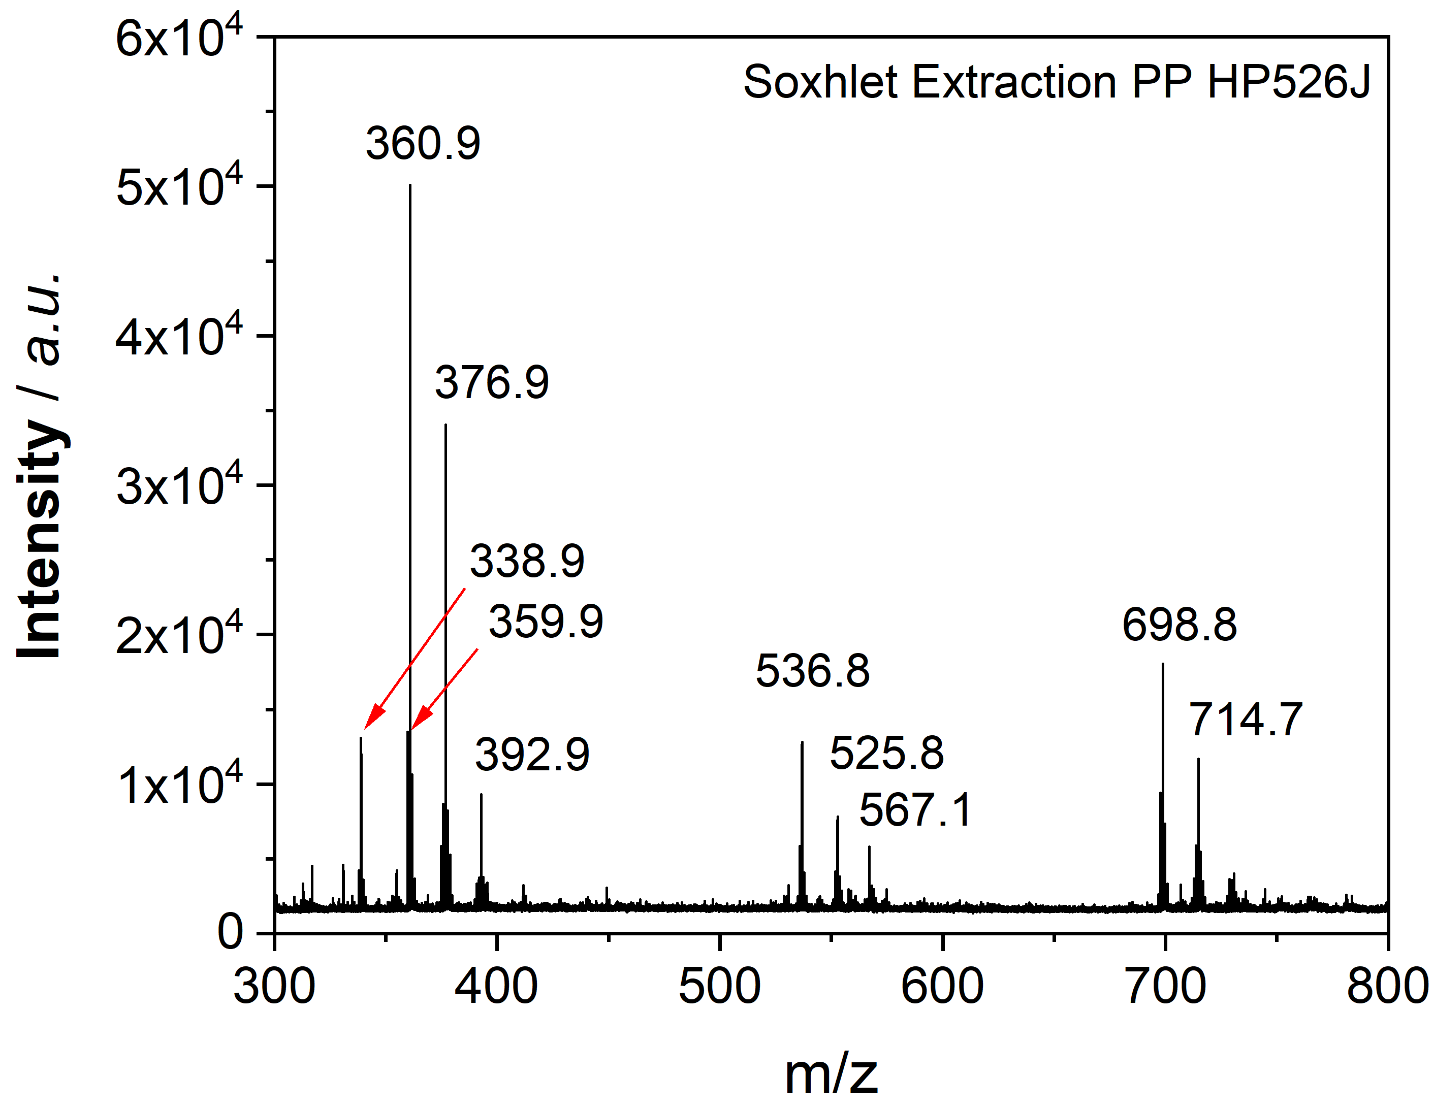
B | 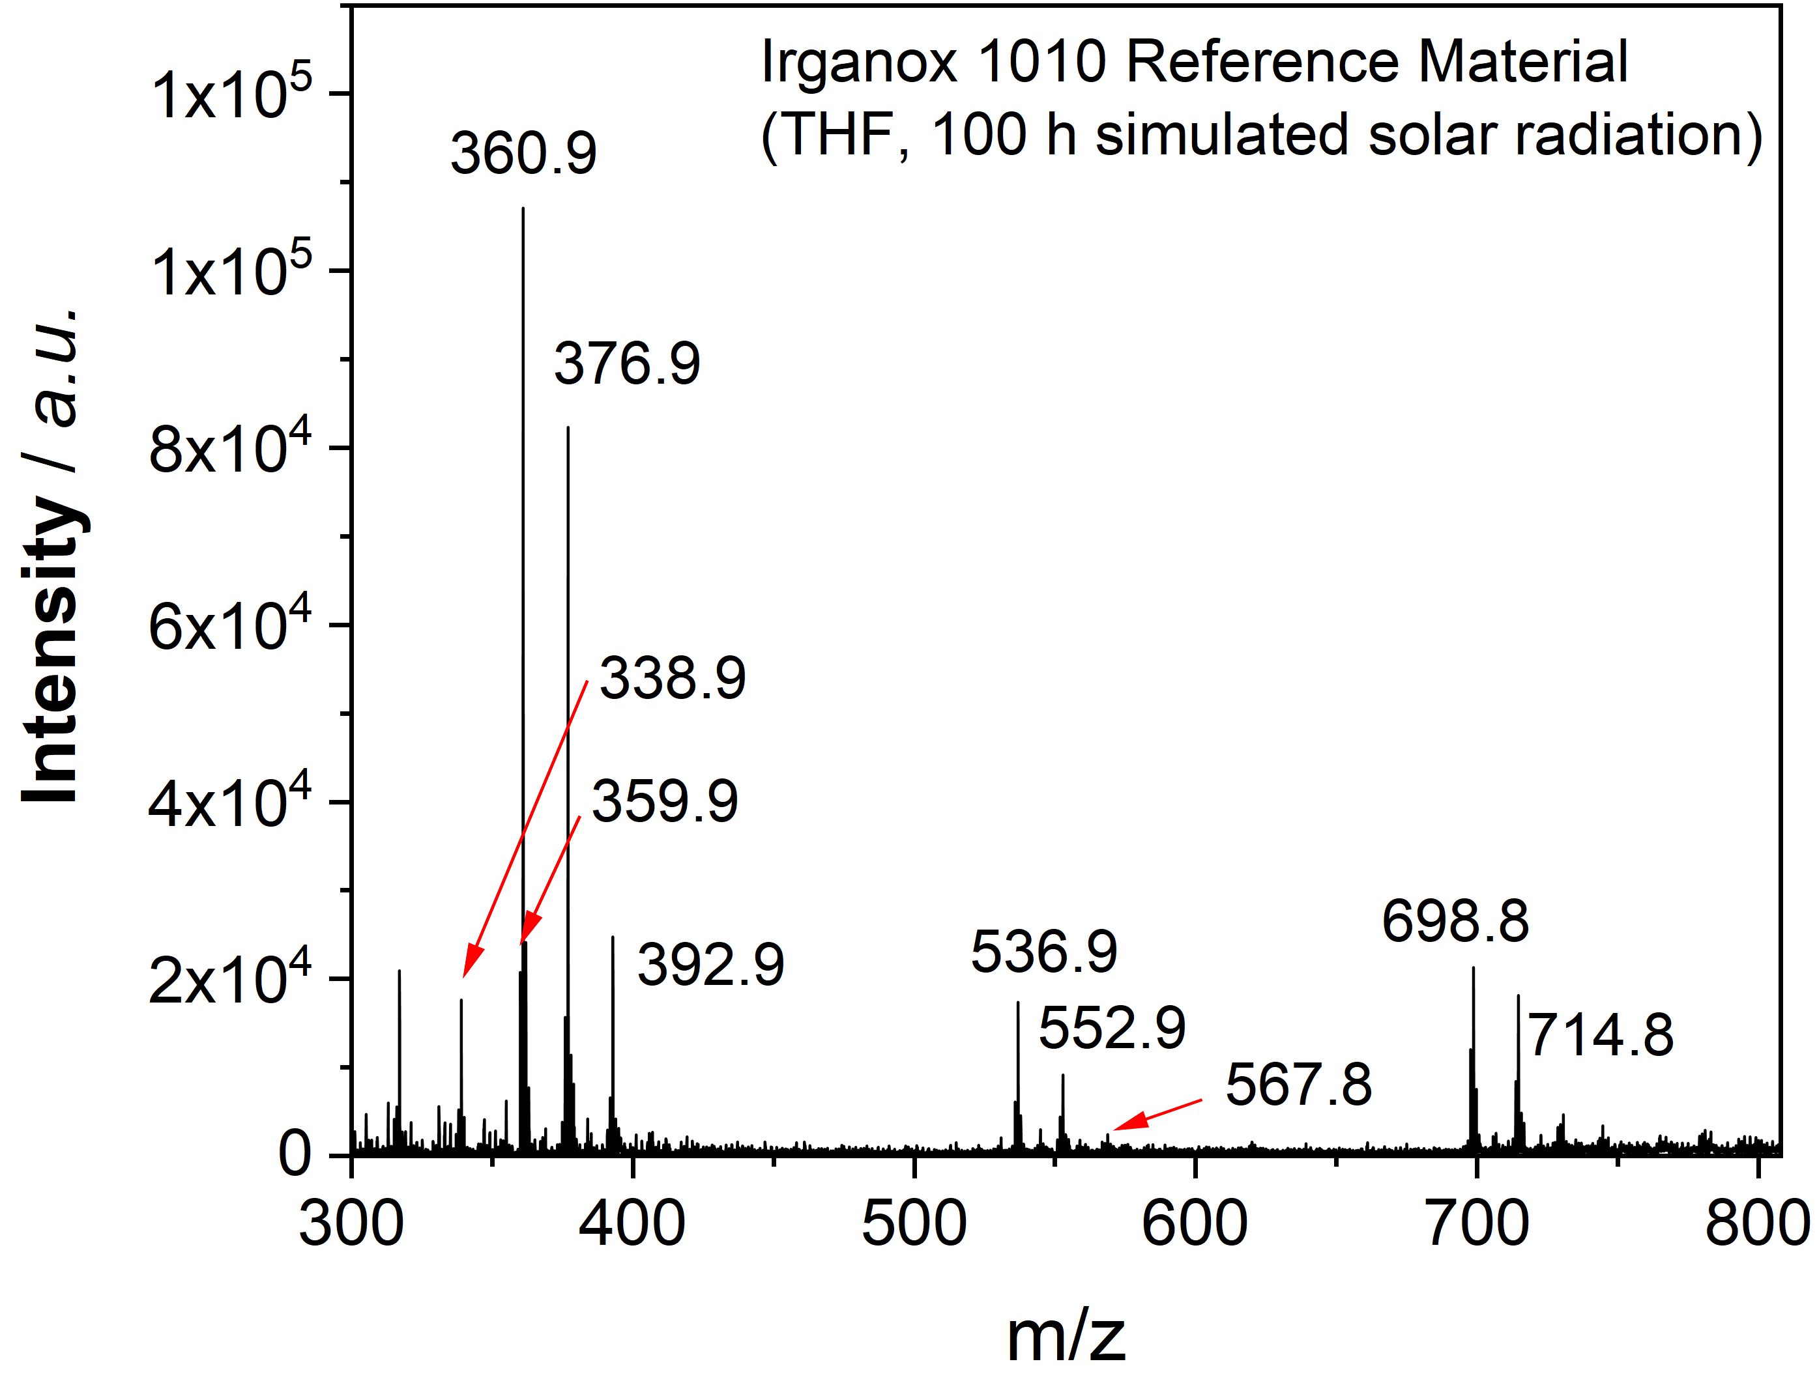
C
Figure S4. (A) MALDI-TOF-MS spectrum of the second processing stabilizer in PP HP526 J. The prominent peaks are identical to those arising from Irganox® 1010 reference material, treated with simulated solar radiation in THF for 100 h in (B).

Identification of the processing stabilizers via ¹H, ¹³C and ³¹P liquid-state NMR spectroscopy
A | 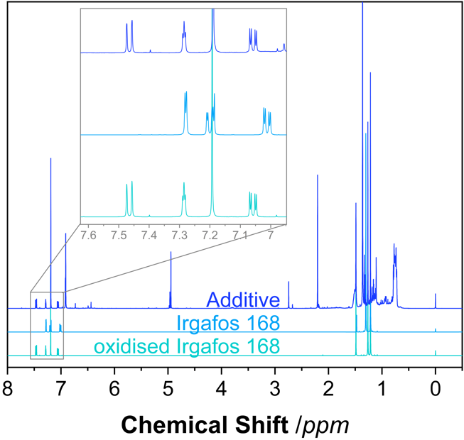 | D
B | 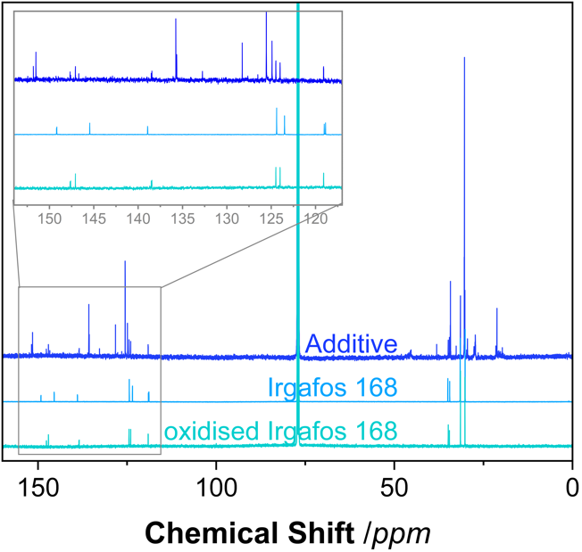 | E
C | 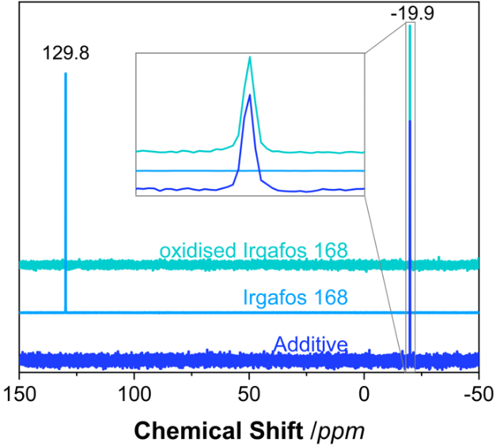
Figure S5. Comparison of ¹H (A), ¹³C (B), and ³¹P (C) NMR spectra of the first extracted additive, tris(2,4-di-tert-butylphenyl)-phosphate and Irgafos® 168 as well as ¹H (D), ¹³C (E) spectra of the second extracted additive, Irganox® 1010 and Irganox® 1010 reference material, treated with simulated solar radiation in THF for 100 h. The ¹H and ¹³C spectra were normalised to the proton and carbon resonances of tert-butyl groups and the ³¹P spectra to the highest peak.

Degradation Mechanisms
Figure S6. Above: Scheme for the photooxidative degradation of PP explaining the formation of hydroperoxides, alcohols, ketones, olefins and carboxylic acids. Below: Reactions of the radical scavenger Irgafos® 168 with reactive hydroperoxides and peroxy- and alkoxy radicals. The reactive intermediates marked in red (above) are deactivated by the phosphite Irgafos® 168 which itself is oxidized to the phosphate (Maier and Schiller, 2016).

Average Particle Size and Particle Size Distributions
Table S2. Average particle sizes in µm for PP samples with and without stabilizer at exposure times from 0 h to 3200 h. Values display the average of three measurements.
 | With Stabilizer |  |  |  |  | Without Stabilizer
Exposure Time | Average Particle Size | Particle Volume | DMP Quantity | Surface Area | Total Surface Area (Quantity*Surface) | Average Particle Size
hours | µm | µm³ | counts | µm² | µm² | µm
0 | 192.4 | 3705973 |  | 115812 |  | 119.4
24 | 197.0 |  |  |  |  | 119.7
50 | 189.9 |  |  |  |  | 121.6
100 | 197.5 |  |  |  |  | 108.8
150 | 199.7 |  |  |  |  | -
200 | 200.1 |  |  |  |  | 85.4
250 | 197.4 |  |  |  |  | -
300 | 193.4 |  |  |  |  | -
350 | 187.0 |  |  |  |  | -
400 | 148.1 |  |  |  |  | 53.6
450 | 98.5 |  |  |  |  | -
500 | 68.2 |  |  |  |  | -
550 | 51.8 |  |  |  |  | -
600 | 41.3 |  |  |  |  | 31.4
800 | 16.5 |  |  |  |  | 22.2
1200 | 9.4 |  |  |  |  | 13.4
1600 | 5.6 |  |  |  |  | 8.6
2000 | 4.2 |  |  |  |  | 6.6
2400 | 4.1 |  |  |  |  | 5.8
2800 | 4.2 |  |  |  |  | 4.9
3200 | 4.1 | 36 | 102696 | 53 | 10^9 | 5.1

A | 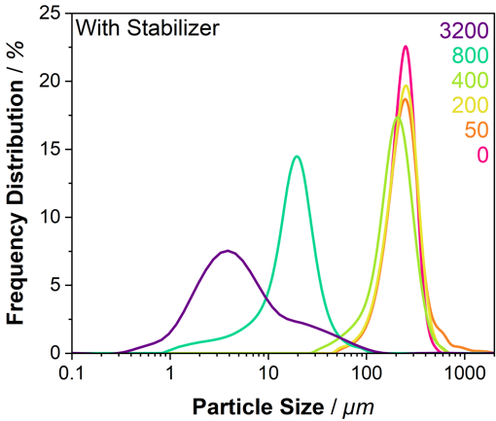 | B | 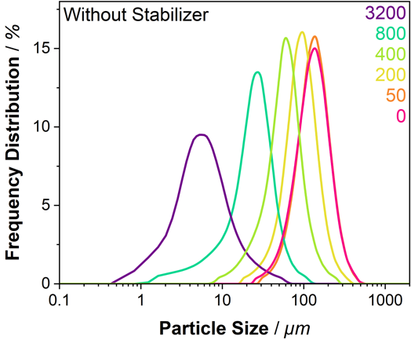
Figure S7. Average particle size distributions for (A) PP with stabilizer and (B) PP particles without stabilizer.

Molecular Weight Data
Table S3. Number-average (M_{n}), weight-average (M_{w}), peak (M_{p}) molecular weights in g/mol, and dispersity (Ð) values for PP samples with and without stabilizer for different exposure times.
 | PP with stabilizer |  |  |  | PP without stabilizer
Exposure Time | M_{n} | M_{w} | M_{p} | Ð | M_{n} | M_{w} | M_{p} | Ð
hours | g/mol | g/mol | g/mol |  | g/mol | g/mol | g/mol
0 | 68300 | 795800 | 342000 | 11.7 | 68800 | 532000 | 256700 | 7.7
24 | - | - | - | - | 53500 | 293700 | 174000 | 5.5
50 | 75000 | 739700 | 328200 | 9.9 | 13000 | 47700 | 41300 | 3.7
100 | 63400 | 698600 | 296200 | 11.0 | 5400 | 17200 | 13700 | 3.2
150 | 44900 | 731200 | 328200 | 16.3 | - | - | - | -
200 | 35100 | 669100 | 296200 | 19.1 | 3300 | 8800 | 7500 | 2.7
250 | 64600 | 661800 | 296200 | 10.2 | - | - | - | -
300 | 30000 | 162700 | 93900 | 5.4 | - | - | - | -
350 | 10400 | 40300 | 31500 | 3.9 | - | - | - | -
400 | 5000 | 16100 | 10900 | 3.2 | 2100 | 4500 | 4000 | 2.1
450 | 3500 | 9300 | 7600 | 2.7 | - | - | - | -
500 | 3000 | 6500 | 4100 | 2.2 | - | - | - | -
550 | 2500 | 5000 | 3800 | 2.0 | - | - | - | -
600 | 2400 | 4400 | 3700 | 1.9 | 1800 | 3400 | 2000 | 1.9
800 | 1900 | 3500 | 2200 | 1.8 | 1500 | 2700 | 1900 | 1.8
1200 | 1600 | 2600 | 1900 | 1.7 | 1200 | 2000 | 1600 | 1.7
1600 | 1300 | 2200 | 1700 | 1.6 | 1100 | 1700 | 1500 | 1.6
2000 | 1300 | 1900 | 1600 | 1.5 | 1000 | 1500 | 1300 | 1.6
2400 | 1100 | 1700 | 1500 | 1.6 | 800 | 1400 | 1200 | 1.7
2800 | 900 | 1600 | 1300 | 1.7 | 800 | 1200 | 1200 | 1.7
3200 | 1000 | 1500 | 1300 | 1.6 | 700 | 1200 | 1000 | 1.7

A | 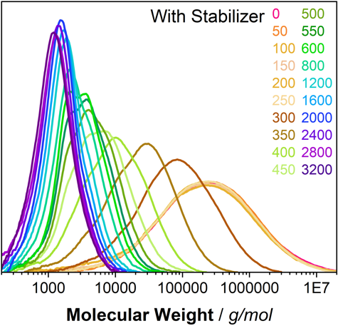 | B | 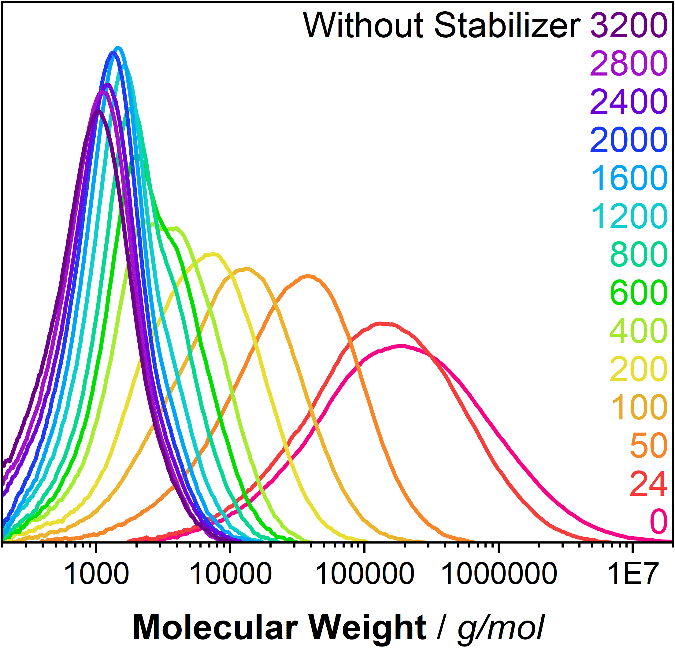
Figure S8. Molecular weight distributions in g/mol of (A) PP with stabilizer and (B) PP without stabilizer for exposure time intervals from 0 h to 3200 h.
Crystallinity and Melting Temperature
Table S4. Crystallinity and melting temperature measurements for PP with stabilizer and PP without stabilizer.
 | PP with stabilizer |  | PP without Stabilizer
Exposure Time | Crystallinity ꭓc | Melting Temp. T_{m} | Crystallinity ꭓc | Melting Temp. T_{m}
hours | % | °C | % | °C
0 | 52.1 | 164.8 | 45.1 | 164.7
24 | 49.7 | 164.6 | 52.5 | 164.8
50 | 49.6 | 164.4 | 54.0 | 163.6
100 | 48.0 | 164.7 | 52.7 | 157.7
200 | 51.0 | 164.6 | 61.6 | 152.6
350 | 48.7 | 162.4 | - | -
400 | 64.6 | 156.1 | 61.3 | 150.0
600 | 65.7 | 148.5 | 58.4 | 147.2
800 | 67.7 | 145.8 | 63.4 | 145.0
1200 | 63.0 | 142.2 | 61.0 | 143.0
1600 | 62.2 | 137.8 | 58.8 | 141.0
2000 | 59.50 | 135.8 | 57.1 | 136.1
2400 | 57.9 | 130.9 | 59.8 | 133.4
2800 | 48.0 | 122.9 | 57.8 | 131.2
3200 | 51.3 | 119.5 | 63.0 | 125.3

A | 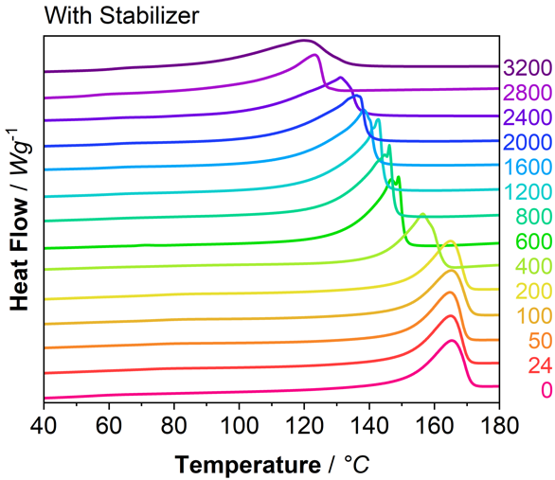 | B | 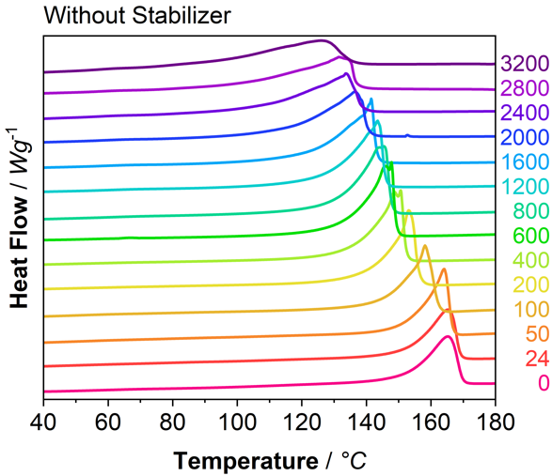
Figure S9. DSC measurements. Heat flow in W/g vs. temperature in °C for (A) PP particles with stabilizer and (B) PP particles without stabilizer.

Evaluation of Crystallinity via ¹³C CP MAS NMR Spectroscopy
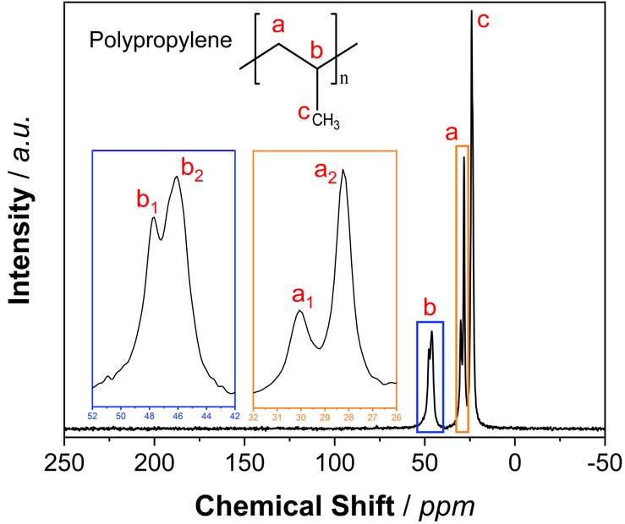

Figure S10. ¹³C CP MAS NMR spectrum of the PP particles with stabilizer prior to weathering with signal assignment. In the enlarged PP spectra (blue and orange rectangle) the differences of the resonances of the amorphous (signal a1 and b1) and crystalline (signal a2 and b2) phase become visible (Hronský et al., 2014).

A | 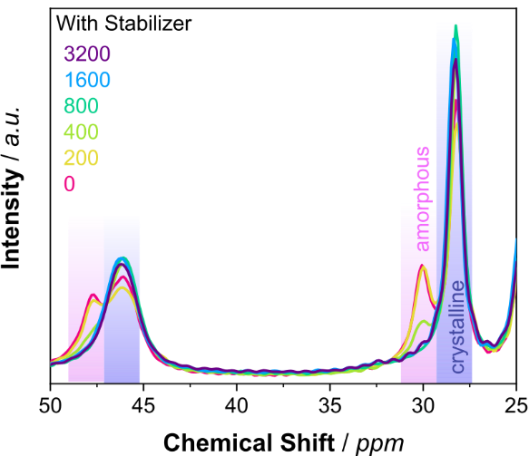 | B | 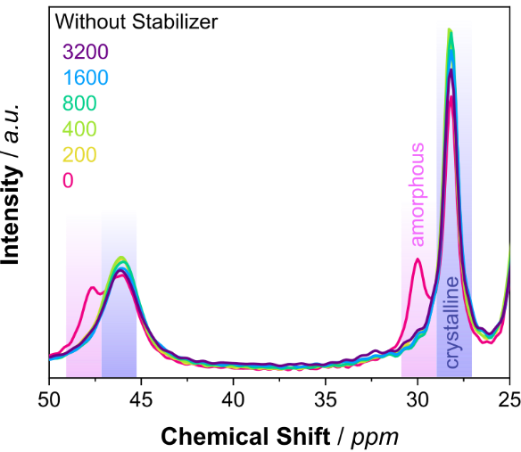
Figure S11. ¹³C CP MAS NMR spectra of the PP particles with (A) and without (B) stabilizer for 0, 400 and 3200 h weathering time. Upon irradiation, a shift of signal intensity from the amorphous phase resonances (30 ppm, 48 ppm) to the crystalline phase resonances (28 ppm, 46 ppm) is observed (Hronský et al., 2014). The spectra are normalised to the integral of the backbone signal (35-20 ppm and 55-35 ppm).

Calculation of Defect Proportions via ¹³C CP MAS NMR Spectroscopy
Table S5. Correction factors for PP with and without stabilizer determined with quantitative multi-CP spectra of the respective 3200 h weathered sample. Used to calibrate the defect intensities in the CP spectra (Meides et al., 2021).
Functional Group | PP with stabilizer | PP without stabilizer
Functional Group | c_{i} 3200 h | c_{i} 3200 h
Ketone | 0.49 | 0.50
Carboxylic acid | 0.85 | 0.84
Peroxide | 0.76 | 0.74
Alcohol | 0.80 | 0.77

ρ_{ru} = [1 – (3 ∙ I_{ketone}) – (2 ∙ I_{COOH}) – (3 ∙ I_{POOH}) – (3 ∙ I_{OH})] / 3 (Eq. 1)
with: ρ_{ru} proportion of propylene RUs relative to the proportion of defects
I_{ketone} relative intensity of the ketone resonance
I_{COOH} relative intensity of the carboxylic acid resonance
I_{POOH} relative intensity of the peroxide resonance
I_{OH} relative intensity of the alcohol resonance.

Since the ratio of the different groups is I_{ketone} : I_{COOH} : I_{POOH} : I_{OH} : p_{ru}, the absolute proportions of the carbonyl groups (ap_{ketone}), carboxy groups (ap_{COOH}), peroxy groups (ap_{POOH}) and hydroxy groups (ap_{POH}) can be calculated once ρ_{ru} is known:
ap_{ketone} = I_{ketone} /(p_{ru} + I_{ketone} + I_{COOH} + I_{POOH} + I_{OH}) (Eq. 2)
ap_{COOH} = I_{COOH} /(p_{ru} + I_{ketone} + I_{COOH} + I_{POOH} + I_{OH}) (Eq. 3)
ap_{POOH} = I_{POOH} /(p_{ru} + I_{ketone} + I_{COOH} + I_{POOH} + I_{OH}) (Eq. 4)
ap_{OH} = I_{OH} /(p_{ru} + I_{ketone} + I_{COOH} + I_{POOH} + I_{OH}) (Eq. 5)
SEM Images
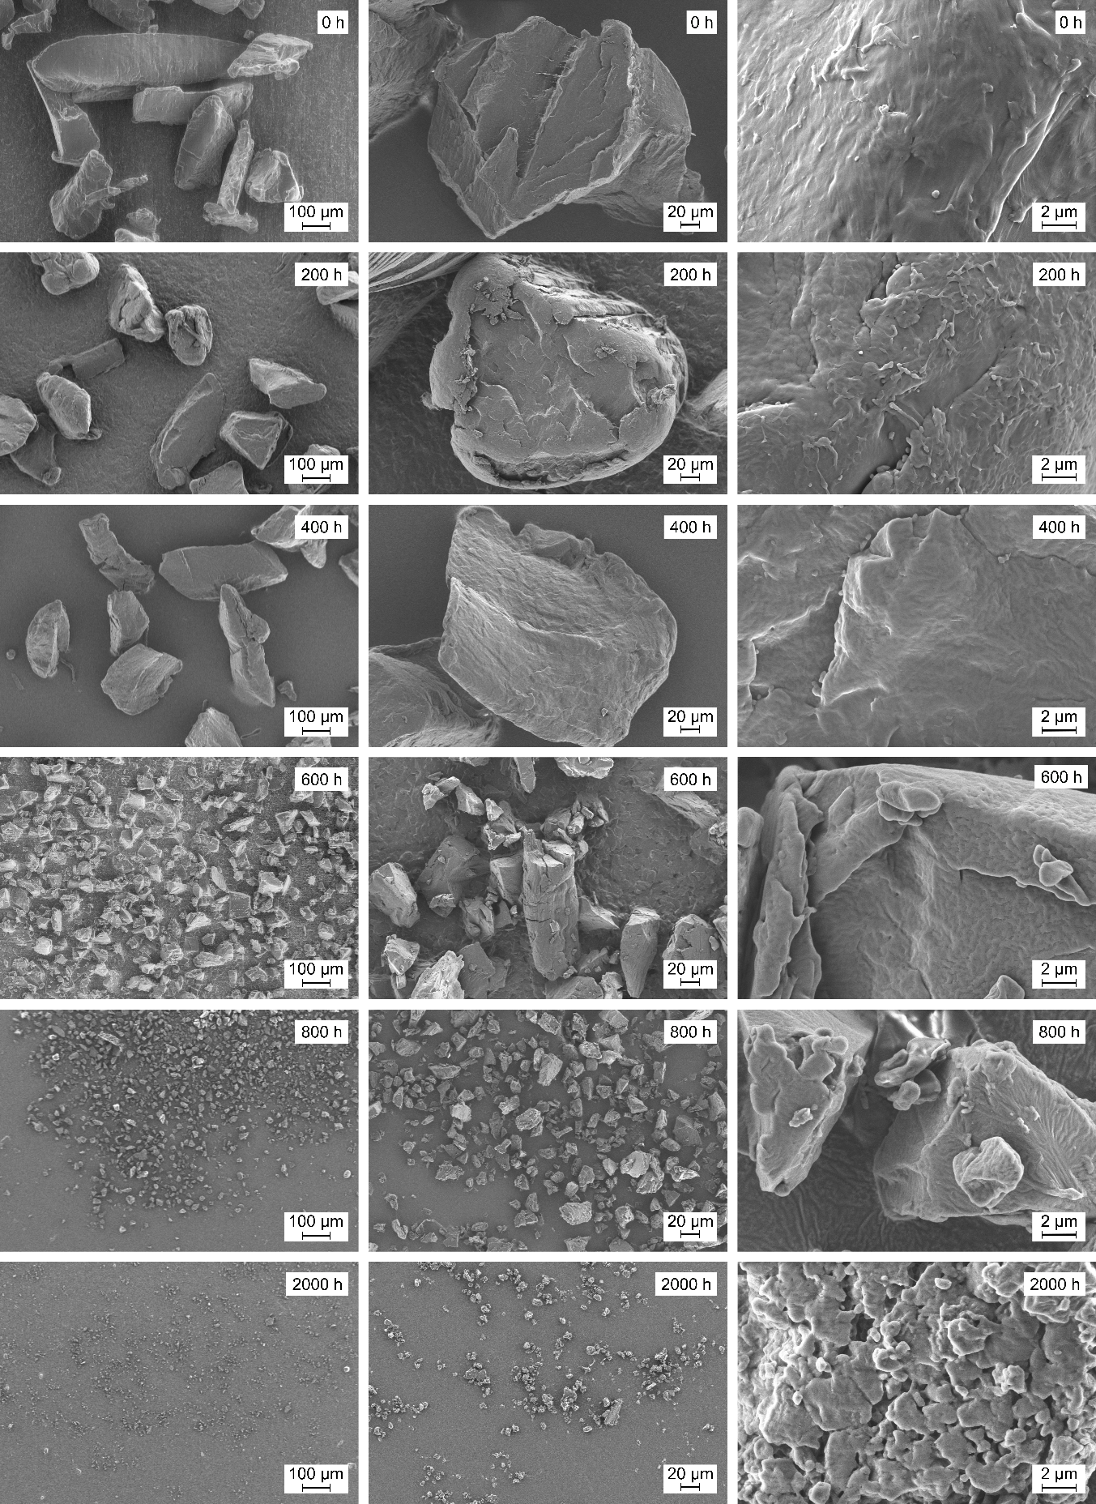
Figure S12. SEM images of PP with stabilizer after irradiation for different time intervals.

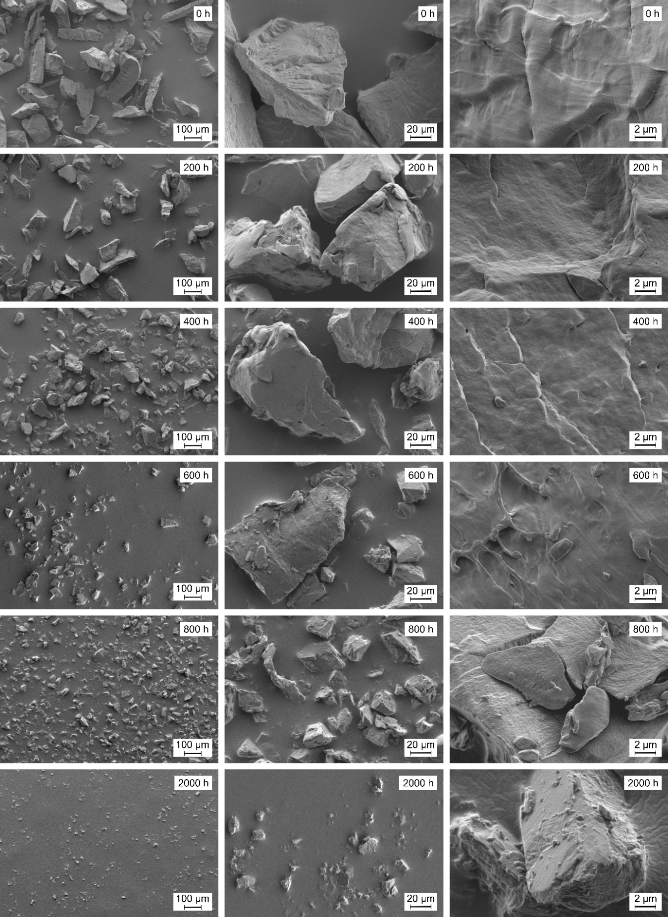
Figure S13. SEM images of PP without stabilizer after irradiation for different time intervals.

Supplementary References
Fouyer K, Lavastre O, Rondeau D. Direct monitoring of the role played by a stabilizer in a solid sample of polymer using direct analysis in real time mass spectrometry: the case of Irgafos 168 in polyethylene. Analytical chemistry 2012;84(20):8642–9.
Hronský V, Koval'aková M, Vrábel P, Uhrínová M, Olčák D. Estimation of the Degree of Crystallinity of Partially Crystalline Polypropylenes Using 13 C NMR. Acta Physica Polonica, A 2014;125(6).
Maier R-D, Schiller M. Handbuch Kunststoff Additive: Carl Hanser Verlag GmbH Co KG; 2016.
Meides N, Menzel T, Poetzschner B, Löder MGJ, Mansfeld U, Strohriegl P et al. Reconstructing the Environmental Degradation of Polystyrene by Accelerated Weathering. Environmental Science & Technology 55 2021(12):7930–8. 10.1021/acs.est.0c07718.
Schwarzinger C, Gabriel S, Beißmann S, Buchberger W. Quantitative Analysis of Polymer Additives with MALDI-TOF MS Using an Internal Standard Approach. Journal of the American Society for Mass Spectrometry 2012;23(6):1120–5.

