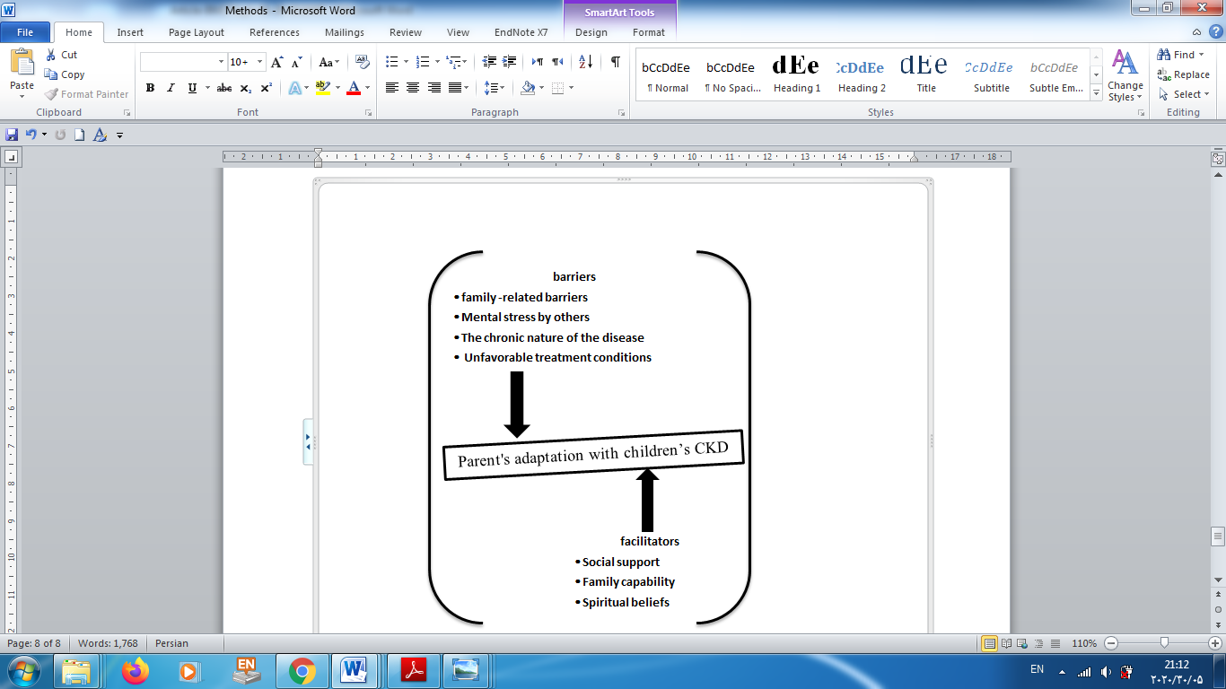

Schematic model of factors influencing parents’ adaptation

Schematic model of factors influencing parents’ adaptation

