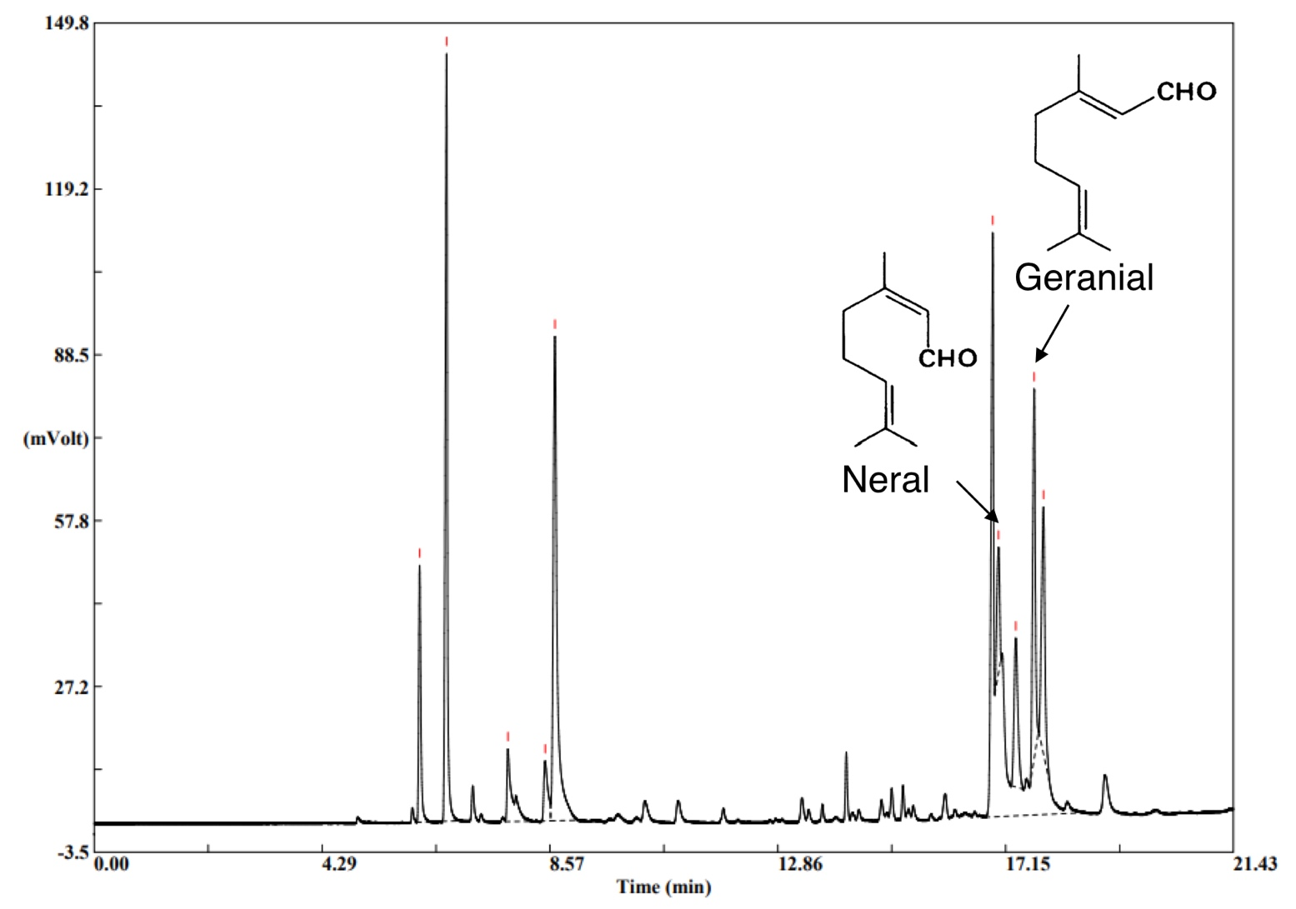
Supplementary Fig. 1| Gas chromatography chromatogram of ginger essential oil (GEO) showed citral was the major compound. The GC demonstrated that citral comprised a mixture of the two geometric isomers geranial and neral. Citral was the main component of GEO; approximately 31% of it comprised 18.8% neral and 12.2% geranial isomers.

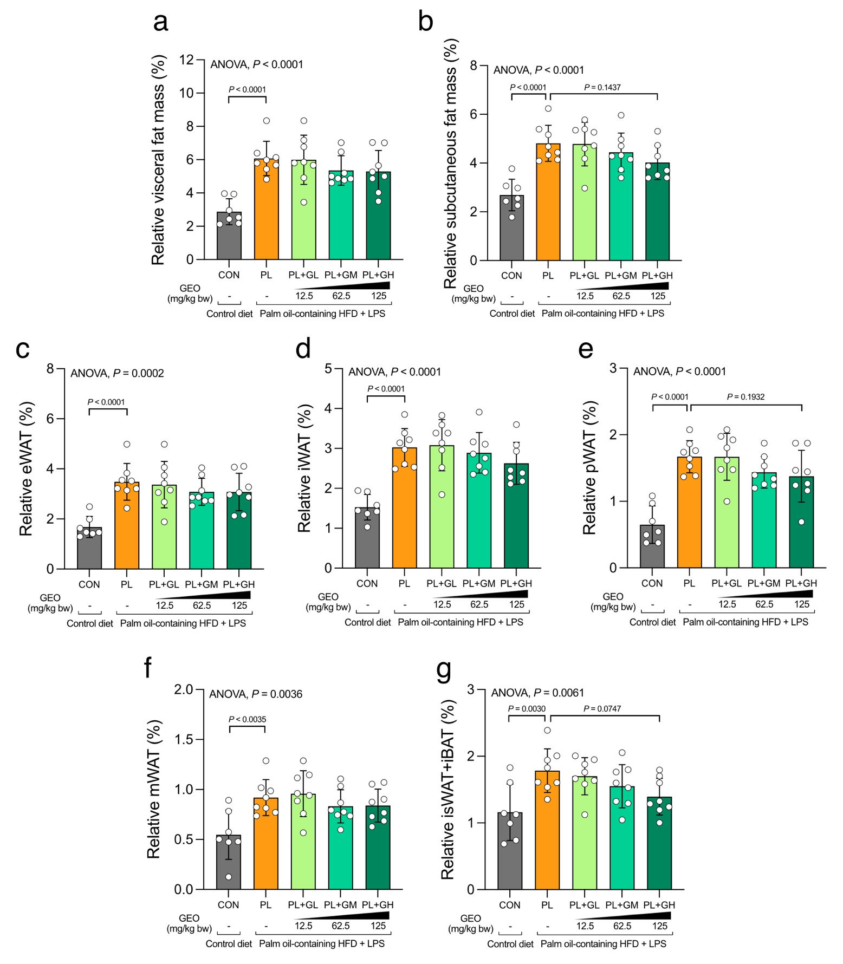
Supplementary Fig. 2| Effect of PL and supplementation with GEO on relative fat mass. Relative (a) visceral, (b) subcutaneous, (c) epididymal white adipose tissue (WAT) (eWAT), (d) inguinal WAT (iWAT), (e) perirenal WAT (pWAT), (f) mesenteric WAT (mWAT), and (g) inguinal subcutaneous white adipose tissue (isWAT) and interscapular brown adipose tissue (iBAT) in C57BL/6 mice, which were treated with either control or a palm oil-containing HFD with LPS i.p. (PL) with or without ginger essential oil (GEO) (12.5 (GL), 62.5 (GM), and 125 (GH) mg/kg bw) supplementation by daily oral gavage for 12 weeks. Each value was expressed as the mean ± SD (n = 7–8). Statistical analyses were performed by a one-way ANOVA with Dunnett's multiple comparison test for comparing group means against the PL group.

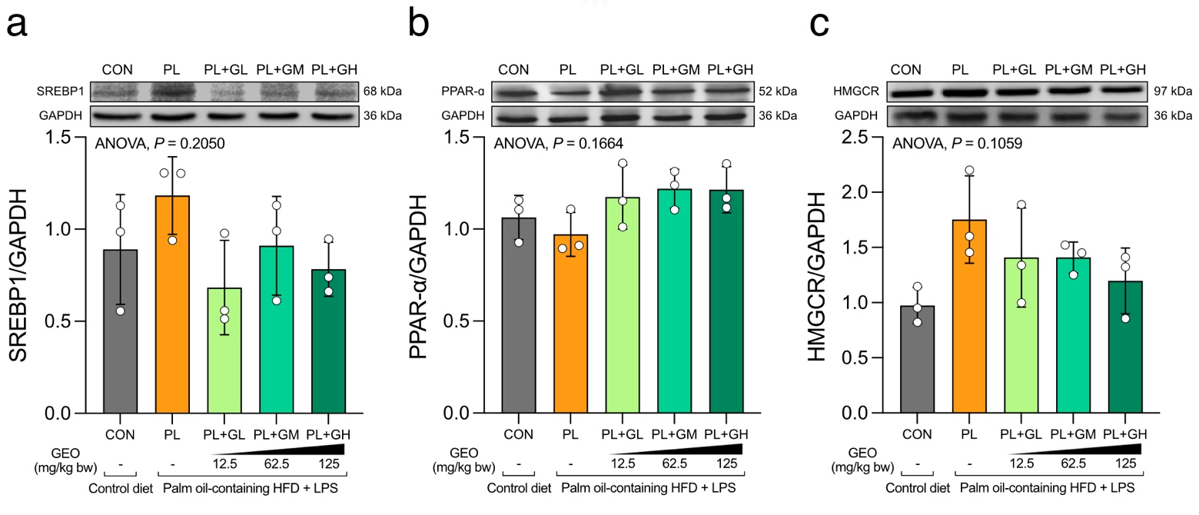
Supplementary Fig. 3| GEO tended to modulate fatty acid synthesis and β-oxidation related proteins. (a) SREBP1, (b) PPAR-ɑ, and (c) HMGCR protein expression in the livers of C57BL/6 mice, which were treated with either control or a palm oil-containing HFD with LPS i.p. (PL) with or without ginger essential oil (GEO) (12.5 (GL), 62.5 (GM), and 125 (GH) mg/kg bw) supplementation by daily oral gavage for 12 weeks. Each value was expressed as the mean ± SD (n = 3). Statistical analyses were performed by a one-way ANOVA with Dunnett's multiple comparison test for comparing group means against the PL group.

