Table 2: The main bioactive compounds of A. trajani extract were detected by GC/MS.
Chemical compound | Area Sum % | M. formula | M. wt. | Chemical structure
Furan, 3,3'-dithiobis[2-methyl- | 81.3 | C₁₀H₁₀O₂S₂ | 226.315 | 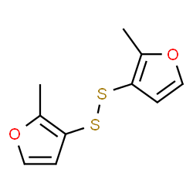
Furfuryl sulfide | 3.12 | C₁₀H₁₀O₂S | 194.250 | 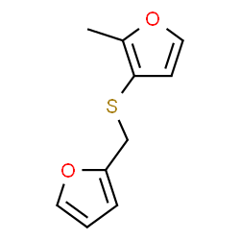
Thiophene, 2-formyl-2,3-dihydro- | 1.75 | C₅H₆O_{S} | 114.166 | 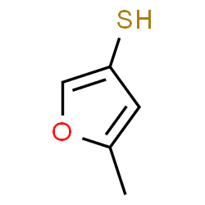
Palmitic acid | 2.5 | C₁₆H₃₂O₂ | 256.424 | 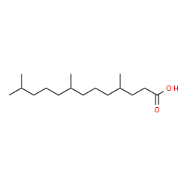
Linoleic acid | 1.25 | C₂₁H₃₈O₂Si | 350.6107 | 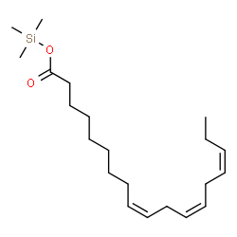
Oleic Acid | 6.01 | C₁₈H₃₄O₂ | 282.461 | 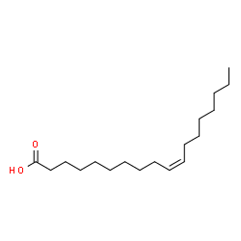
Stearic acid | 1.71 | C₁₈H₃₆O₂ | 284.477 | 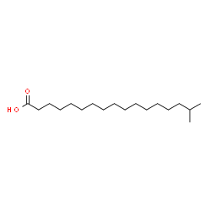
2H-Imidazole-2-thione, 1,3-dihydro-1-methyl- | 0.92 | C₄H₆N₂S | 114.169 | 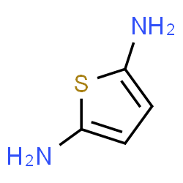
Note: All names were checked using NIST Chemistry WebBook, SRD 69

