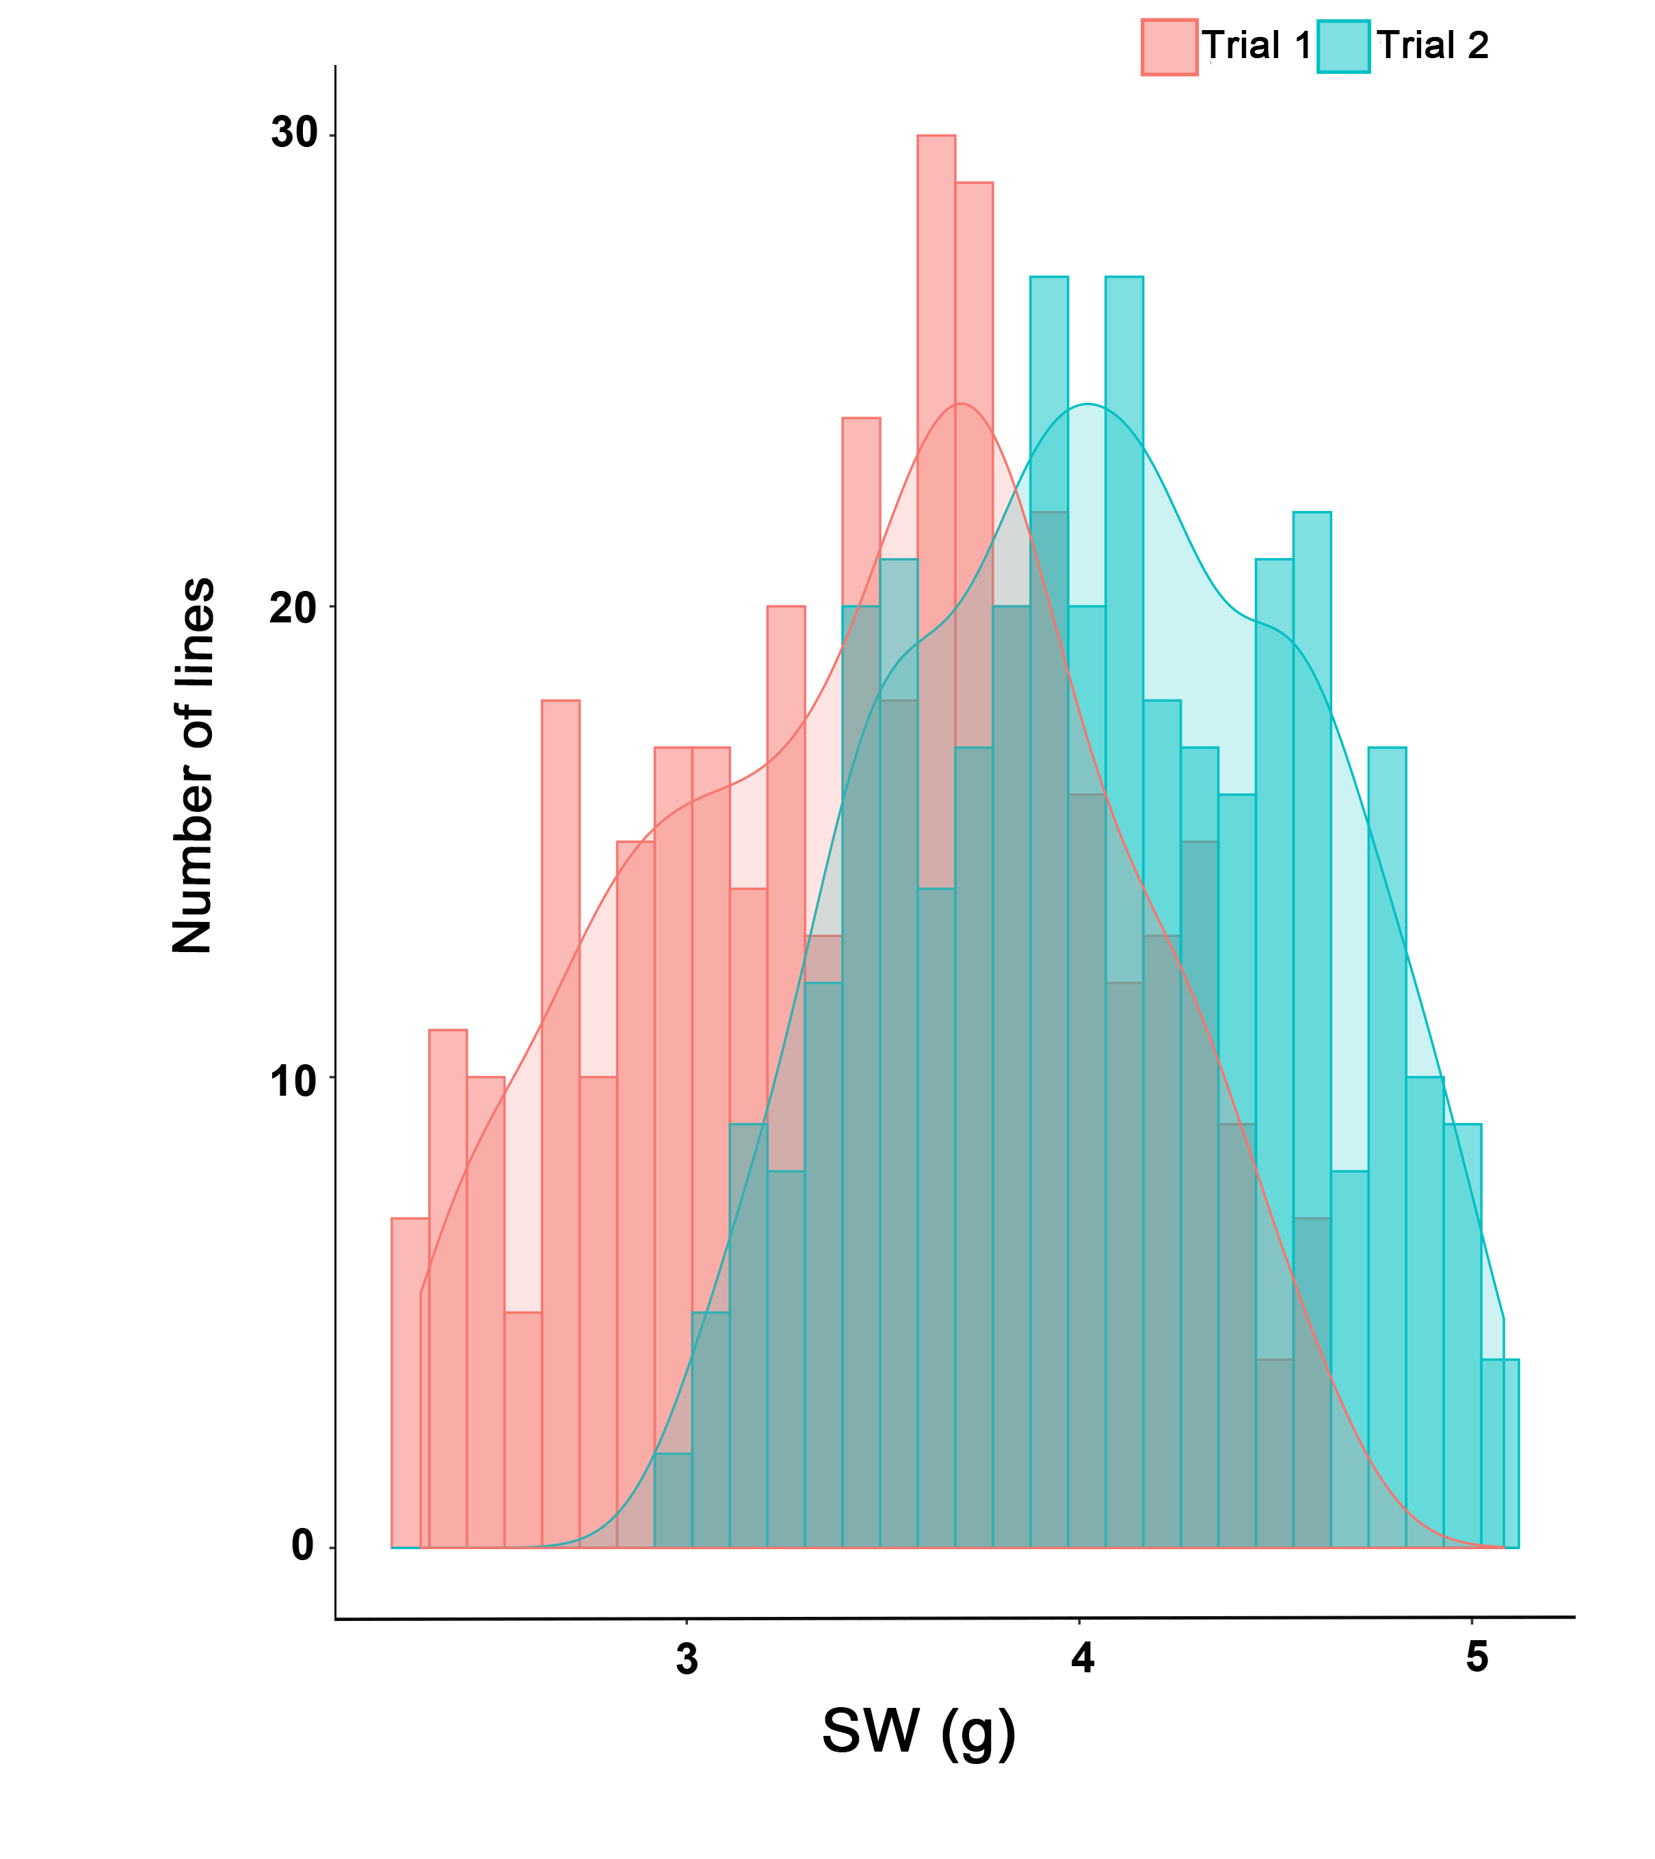
Fig S1. Frequency distribution of SW of an association panel of B. napus in Trial 1 and Trial 2. SW, 1000-seed weight.

