Supplementary Figures
Supplementary Figure 1. The schematic molten-alkali mechanochemical reaction for synthesizing IrO₂NR.
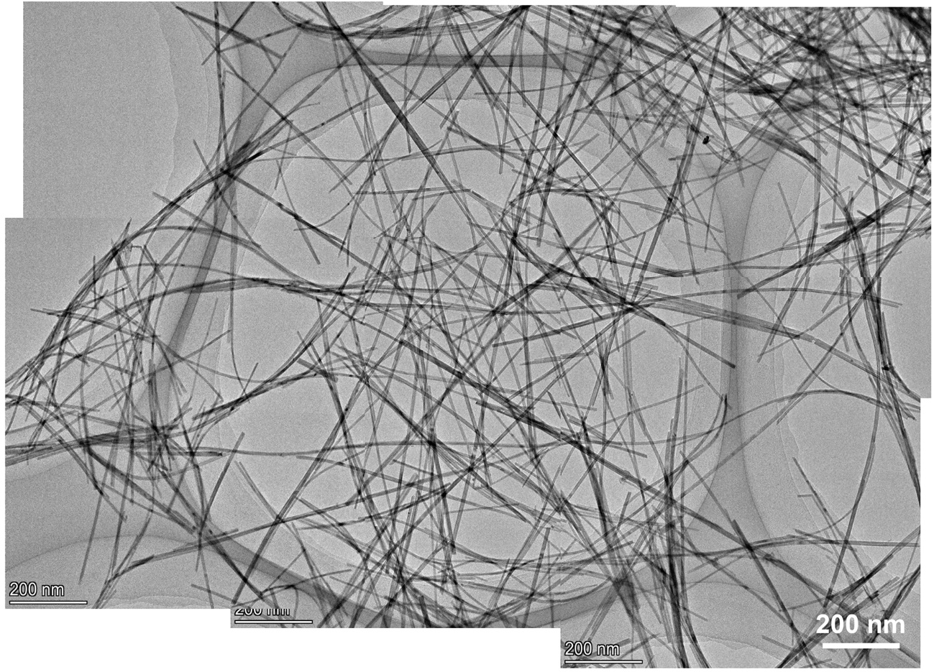
Supplementary Figure 2. TEM image of IrO₂NR.

Supplementary Figure 3. Statistics histogram showing the width of IrO₂NR. The width values are obtained by 500 nanoribbons.
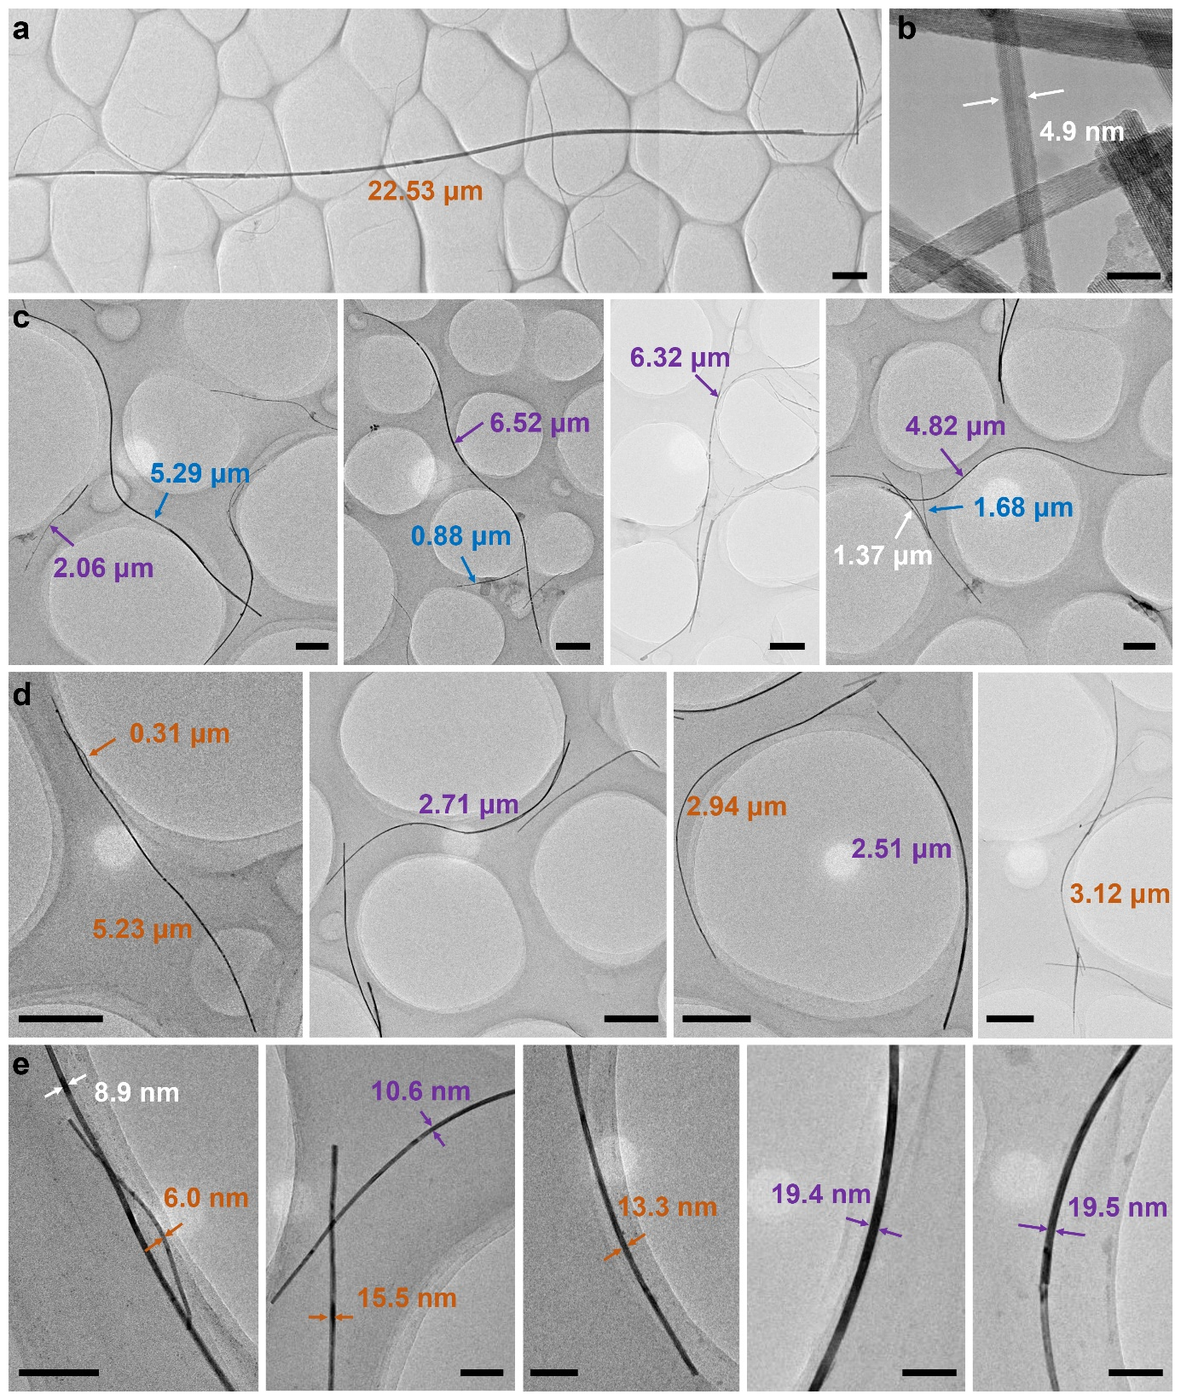
Supplementary Figure 4. Gallery of IrO₂NR. (a) Typical image of a long IrO₂NR. Figure bar, 1 μm; insert bar, 100 nm. (b) Typical image of a thin IrO₂NR. Figure bar, 10 nm. (c) and (d) IrO₂NR of different lengths. Figure bar, 500 nm. (e) Micrographs of IrO₂NR with different widths. Figure bar, 100 nm.

Supplementary Figure 5. Thickness of IrO₂NR. (a) AFM image and (b-d) the corresponding height profiles showing the thickness of the IrO₂NR.
Supplementary Figure 6. Chemical composition analysis of IrO₂NR. (a) TEM-EDS spectrum of IrO₂NR holding on a Cu grid. (b) HAADF-STEM image and corresponding elemental EDS mapping image showing the distributions of (c) O and (d) Ir elements.

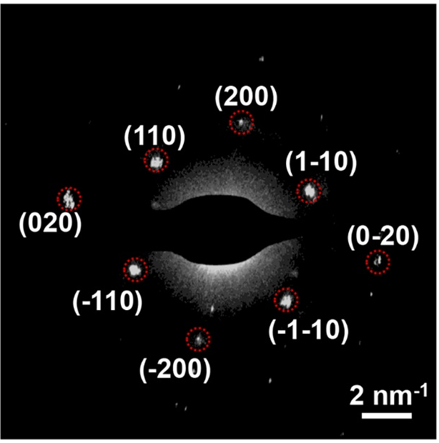
Supplementary Figure 7. SAED pattern of IrO₂NR from the [001] direction.

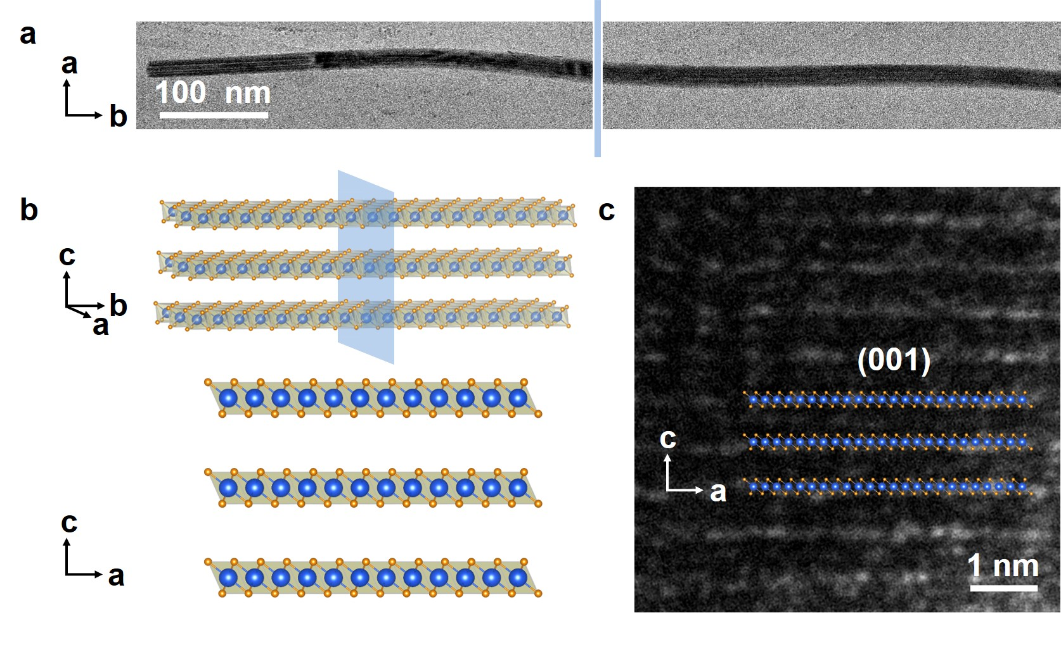
Supplementary Figure 8. (a) and (b) Schematic showing that the IrO₂NR was embedded in epoxy resin and sliced into pieces to observe the cross section. (c) HRTEM image of the cross section for IrO₂NR showing the (001) plane with distance of 0.69 nm.

Supplementary Figure 9. The simulated and tested XRD patterns of IrO₂NR.

Supplementary Figure 10. Characterization of the initial slurry before washing by water. (a) XRD pattern and (b) TEM image.

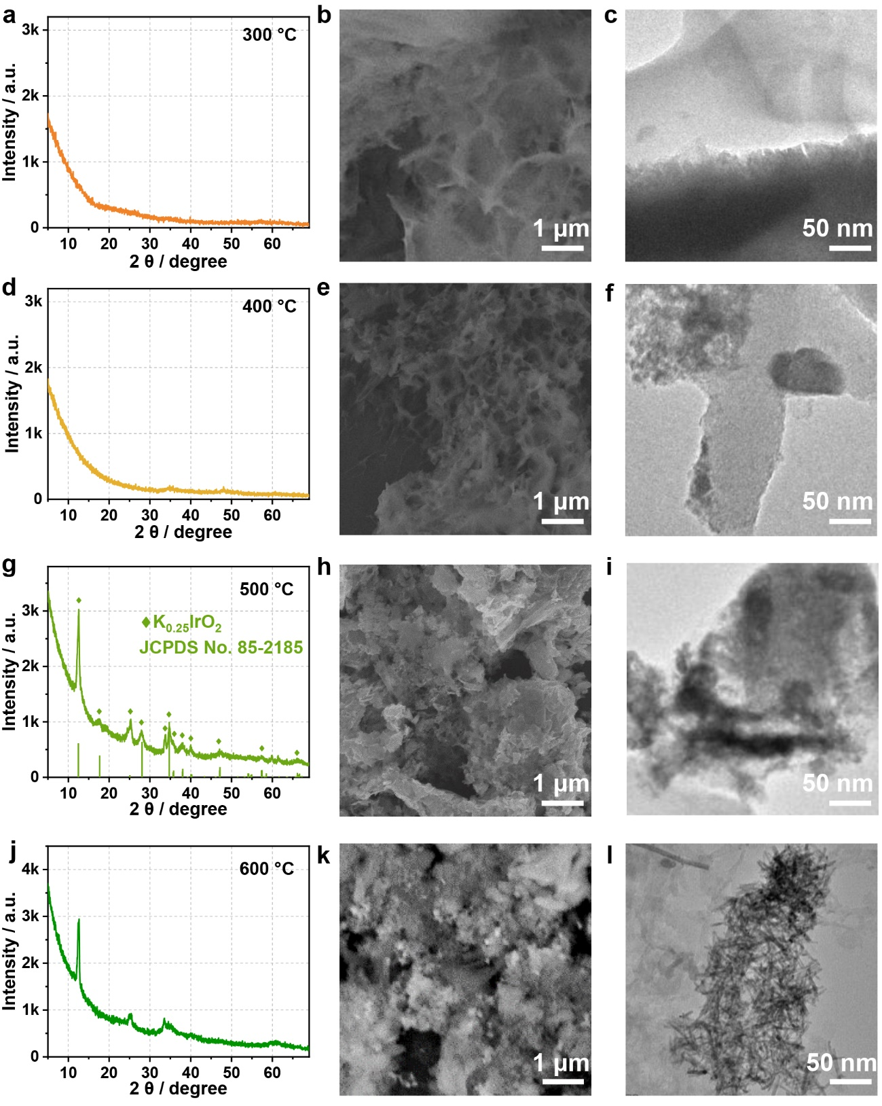
Supplementary Figure 11. The phase and morphology of samples at different reaction temperatures. (a) XRD pattern, (b) SEM image and (c) TEM image of sample annealed at 300 °C. (d) XRD pattern, (e) SEM image and (f) TEM image of sample annealed at 400 °C. (g) XRD pattern, indexed as K_{0.25}IrO₂; (h) SEM image and (i) TEM image of sample annealed at 500 °C. (j) XRD pattern, (k) SEM image and (l) TEM image of sample annealed at 600 °C.

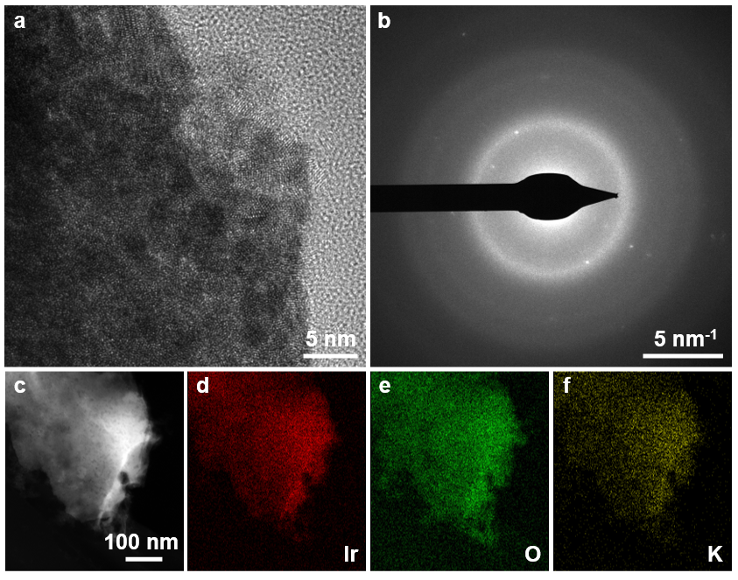
Supplementary Figure S12. Chemical composition analysis of K_{0.25}IrO₂ obtained at reaction temperatures of 500 °C. (a) HRTEM image, (b) SAED, (c) HAADF-STEM image and corresponding elemental EDS mapping image showing the distributions of (d) Ir, (e) O, and (f) K elements.

Supplementary Figure 13. The comparison experiments showing the important role of the alkaline condition. (a) XRD pattern of sample by calcining K_{0.25}IrO₂ at 700 °C for 2 h without KOH, which is indexed as Rutile IrO₂. (b) TEM image of the above mentioned Rutile IrO₂. (c) XRD pattern of the sample that calcined the mixture of K_{0.25}IrO₂ and KOH at 700 °C for 2 h, where the layered structure appears. (d) TEM image of the above mentioned sample.
Supplementary Figure 14. XPS spectra. (a) Full spectra; (b) Ir 4f peaks and (c) O 1s peaks for IrO₂NR, K_{0.25}IrO₂, C-IrO₂ and C-Ir/C. The O 1s for C-Ir/C may come from the adsorbed oxygen species with carbon materials.
Supplementary Figure 15. XAS analysis of IrO₂NR, K_{0.25}IrO₂, C-IrO₂, and Ir foil. (a) XANES spectra for IrO₂NR, K_{0.25}IrO₂, C-IrO₂ and Ir foil. (b) The first derivative of normalized intensity for IrO₂NR, K_{0.25}IrO₂ and C-IrO₂ in (a). (c) FT-EXAFS spectra for IrO₂NR, K_{0.25}IrO₂, C-IrO₂ and Ir foil. (d) The imaginary parts of IrO₂NR, K_{0.25}IrO₂, C-IrO₂, and Ir foil.

Supplementary Figure 16. The phase, morphology and formation mechanism of samples calcined at temperature of 800 °C. (a) XRD pattern of IrO₂NS and IrO₂NR; (b) SEM image of IrO₂NS; (c) and (d) TEM image of IrO₂NS, most of the sample showing nanosheet structure with several nanoribbons in it. (e) HRTEM image, and (f) SAED pattern of IrO₂NS; (g) Schematic diagram illustrating the structure evolution of IrO₂NR to IrO₂NS.
Supplementary Figure 17. Calibration of the saturated calomel electrode (SCE). Calibration of the SCE electrode with respect to reversible hydrogen electrode (RHE) in 0.5 M H₂SO₄ electrolytes bubbled with pure hydrogen gas at room temperature. Scan rate: 1 mV s⁻¹.

Supplementary Figure 18. XRD patterns of commercial samples. (a) C-IrO₂ and (b) C-Ir/C.
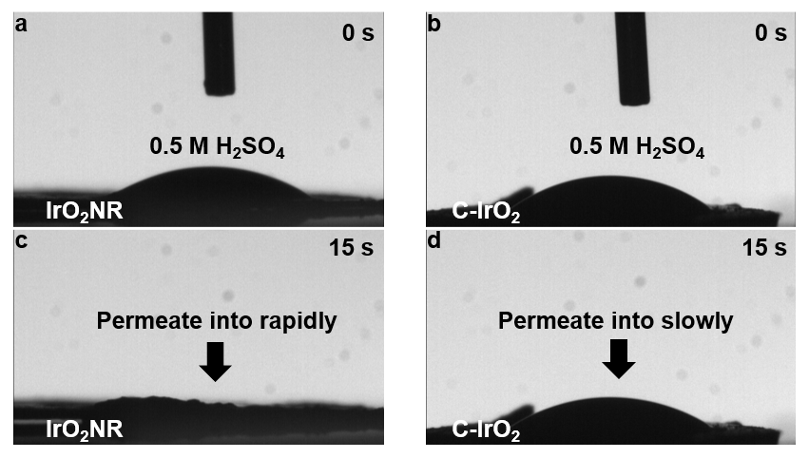
Supplementary Figure 19. The contact angles at different time. H₂SO₄ (0.5 M) droplet on IrO₂NR tablet at (a) 0 s and (c) 15 s. H₂SO₄ (0.5 M) droplet on C-IrO₂ tablet at (b) 0 s and (d) 15 s. The H₂SO₄ permeate into the IrO₂NR more rapidly than that into C-IrO₂.

Supplementary Figure 20. OER performance of samples obtained at different reaction steps. (a) The LSV curves, and (b) histograms showing the overpotentials of corresponding samples in 0.5 M H₂SO₄.

Supplementary Figure 21. Tafel plots and corresponding Tafel slopes of IrO₂NR, IrO₂NS, C-IrO₂, and C-Ir/C.

Supplementary Figure 22. BET surface area measurements. N₂ adsorption-desorption isotherms obtained for (a) IrO₂NR; (b) IrO₂NS; (c) C-IrO₂; and (d) C-Ir/C.

Supplementary Figure 23. ECSA measurements. The CV curves of (a) IrO₂NR; (b) IrO₂NS; (c) C-IrO₂; and (d) C-Ir/C in 0.1 M HClO₄ electrolyte containing 1 mM mercury nitrate at the scan rate of 100 mV s⁻¹.

Supplementary Figure 24. Gas chromatograph data of the produced oxygen by IrO₂NR at different reaction time at a current density of 20 mA cm_{geo}⁻². (a) 30 min; (b) 60 min; (c) 90 min; and (d) 120 min.

Supplementary Figure 25. Stability tests for IrO₂NR. (a) Chronopotentiometric curves of IrO₂NR at a constant current density of 10, 50 and 100 mA cm⁻²; and (b) S-numbers of IrO₂NR at different current densities and different applied potentials (averaged over 3 measurements).

Supplementary Figure 26. S-number values of IrO₂NR compared with other reported iridium-based OER catalysts.

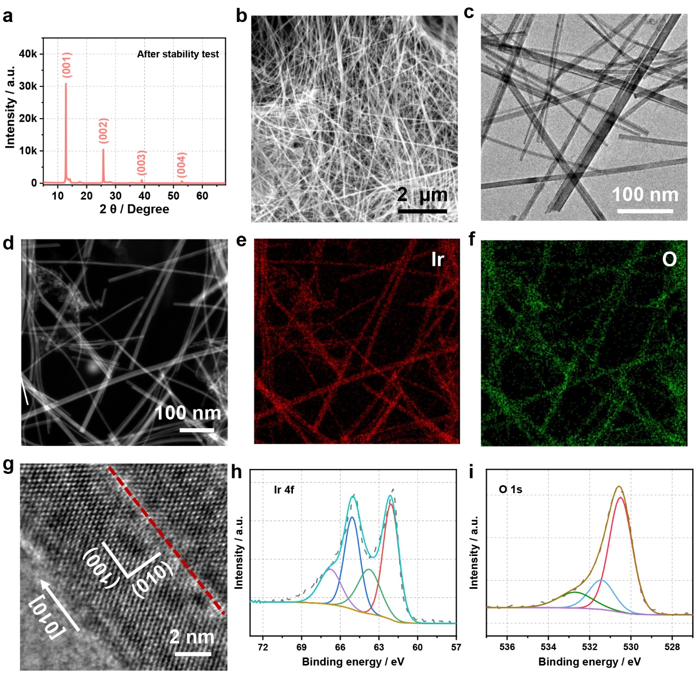
Supplementary Figure 27. Structure of IrO₂NR after long stability test with the constant current density of 10 mA cm⁻² in 0.5 M H₂SO₄ electrolyte. (a) XRD pattern showing the maintained layered structure of IrO₂NR. (b) SEM image, (c) TEM image, (d) HAADF-STEM image and corresponding elemental EDS mapping image showing the distribution of (e) Ir and (f) O elements. The IrO₂NR are uniformly dispersed without aggregation or morphology change after undergoing the long-term OER. (g) HRTEM image showing clearly the regular atomic arrangement. The XPS spectra of (h) Ir 4f peak and (i) O 1s peak. The valence state of Ir keeps almost constant with the original IrO₂NR.

Supplementary Figure 28. Thickness of IrO₂NR after stability test. (a) AFM image and (b-d) the corresponding height profiles showing the thickness of the IrO₂NR.
Supplementary Figure 29. The diagrams of the unit cell of IrO₂NR viewed from different sides. (a) unit cell viewed from a direction, and (b) unit cell viewed from c direction.

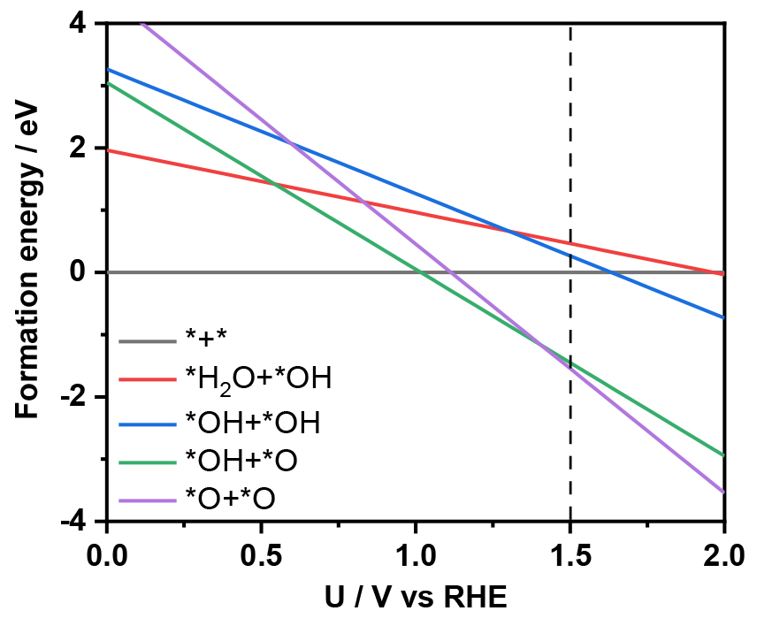
Supplementary Figure 30. Theoretical Pourbaix diagram of IrO₂NR (010) surface.

Supplementary Figure 31. Comparison of d-orbital distribution of Ir atoms for the (a) *, (b) *OH, (c) *O and (d) *OOH in IrO₂NR (red curve) and Rutile IrO₂ (blue curve).

Supplementary Fig. 32. Comparisons of projected crystal orbital Hamilton population of the Ir-O bonds in IrO₂NR (left) and Rutile IrO₂ (right).

Supplementary Tables
Supplementary Table 1. Crystallographic information for IrO₂NR and C-IrO₂.
Material | Crystal system | Bravais lattice | Unit-cell dimension | Space group
IrO₂NR | Monoclinic | C-centered | a = 4.43 ± 0.01 Å, b = 3.14 ± 0.02 Å, c = 6.95 ± 0.03 Å; α = β = γ = 90° | C2/m (12)
C-IrO₂ | Tetragonal | Primitive | a = b = 4.498 Å, c = 3.154 Å; α = β = γ = 90°  α = β = γ = 90° | P4₂/mnm (136)

Supplementary Table 2. The BET areas and ECSAs of IrO₂NR, C-IrO₂ and C-Ir/C.
Material | IrO₂NR | IrO₂NS | C-IrO₂ | C-Ir/C
BET area / m² g⁻¹ | 47.3 | 22.0 | 11.8 | 397.6
ECSA / m² g⁻¹ | 31.3 | 21.6 | 15.5 | 16.3

Supplementary Table 3. OER activities of IrO₂NR, C-IrO₂ and C-Ir/C tested at 1.5 V vs RHE.
Material | IrO₂NR | IrO₂NS | C-IrO₂ | C-Ir/C
Overpotential @ 10 mA cm_{geo}⁻² / mV | 205 | 235 | 303 | 322
Tafel slope / mV dec⁻¹ | 46.2 | 54.2 | 61.2 | 97.3
Geometric activity / mA cm_{geo}⁻² | 456.8 | 57.4 | 2.6 | 2.2
Mass activity /  mA mg_{Ir}⁻¹ | 2354.5 | 295.9 | 13.4 | 48.6
Specific activity /  mA cm_{BET}⁻² | 4.27 | 1.15 | 0.1 | 0.01
Specific activity /  mA cm_{ECSA}⁻² | 6.45 | 1.17 | 0.07 | 0.3
TOF_{BET} / s_{BET}⁻¹ | 9.27 | 3.10 | 0.15 | 0.01
TOF_{ECSA} / s_{ECSA}⁻¹ | 14.01 | 3.07 | 0.12 | 0.3

Supplementary Table 4. Comparison of overpotential, Tafel slope and TOF of IrO₂NR with previously reported Ir-based catalysts.
Catalyst | Electrolyte | η@10 mA cm_{geo}^{‒2} / mV | Tafel slope / mV dec⁻¹ | Potential at 1 mA cm_{BET}⁻²/ V | Mass activity  / mA mg_{Ir}⁻¹ @ Potential vs RHE | TOF/ s^{‒1} @ Potential vs RHE | Ref
IrO₂NR | 0.5 M H₂SO₄ | 205 | 46.2 | 1.48 | 2354.5@1.50 V | 9.27@1.50 Vª  14.01@1.50 V^{b} | This work
3%IrO₂@BCNT | 0.5 M H₂SO₄ | 291 | 52 | / | / | / | S1
H-Ti@IrOx | 0.5 M H₂SO₄ | 277 | 29 | 1.58 V@ 0.04 mA cm_{ECSA}⁻² | 1500@1.58 V | / | S2
IrRu@Te | 0.5 M H₂SO₄ | 220 | 35 | / | 590@1.50 V | / | S3
RuIrO_{x} | 0.5 M H₂SO₄ | 233 | 42 | / | / | / | S4
Rh₂₂Ir₇₈/VXC | 0.5 M H₂SO₄ | 292 | 101 | / | 1174@1.53 V | 5.095@1.53 V^{b} | S5
Li-IrO_{x} | 0.5 M H₂SO₄ | 300 | 39 | 1.55 | 1000@1.575 V | 0.31@1.53 Vª | S6
IrO_{x} on IrCo | 0.5 M H₂SO₄ | 247 | 49 | / | / | / | S7
IrO₂/GCN | 0.5 M H₂SO₄ | 278 | 57 | / | 1280@1.60 V | 0.175@1.60 V^{d} | S8
Ru@IrOx | 0.5 M H₂SO₄ | 282 | 69.1 | / | 644.8@1.56 V | / | S9
Ir nanosheets | 0.5 M H₂SO₄ | 240 | 49 | / | 260@1.50 V | / | S10
6H-SrIrO₃ | 0.5 M H₂SO₄ | 248 | / | 1.55 | 75@1.525 V | / | S11
Ir/GF | 0.5 M H₂SO₄ | 290 | 46 | / | 200@1.62 V | / | S12
IrO₂/CNT | 0.5 M H₂SO₄ | 293 | 67 | / | 11.2@1.53 V | / | S13
IrCoNi/CFP | 0.5 M H₂SO₄ | 303 | 54 | / | 750@1.53 V | 0.26@1.53 Vª | S14
IrO₂-RuO₂@Ru | 0.5 M H₂SO₄ | 281 | 53.1 | / | / | 0.039@1.55 V^{d} | S15
IrO_{x}-Ir | 0.5 M H₂SO₄ | 290 | ~44 | / | 100@1.53 V | ~1.1@1.53 V^{b} | S16
IrO_{x}/SrIrO₃ | 0.5 M H₂SO₄ | 270 | / | 1.47 | / | / | S17
IrNiO_{x} | 0.5 M H₂SO₄ | / | / | / | 676@1.53 V | / | S18
La₂LiIrO₆ | 0.5 M H₂SO₄ | / | / | / | ~13@1.50 V | / | S19
1T-IrO₂ | 0.5 M H₂SO₄ | 235 | 49 | / | 152@1.50 V | 2.0@1.50 V^{b} | S20
ultrathin iridium nanosheets | 0.5 M H₂SO₄ | 328 | 45.4 | / | 209@1.53 V | / | S21
S-doped M-SrIrO₃ nanosheets | 0.5 M H₂SO₄ | 228 | 58.4 | / | 41.5@1.55 V | / | S22
Ir nanosheets | 0.5 M H₂SO₄ | 254 | 72.5 | / | 1200@1.55 V | 0.25@1.56 V^{c} | S23
Mesoporous IrOx  nanosheets | 0.5 M H₂SO₄ | ~250 | 47 | / | ~1300@1.55 V | / | S24
IrO₂ nanoneedles | 1M H₂SO₄ | 313 | 57 | 1.55 V@0.03 mA cm_{ECSA}⁻² | 51.6@1.55 V | / | S25
Ir  nanodendrites | 0.05 M H₂SO₄ | 400 | 56 | 1.57 | 100@1.52V | / | S26
3R-IrO₂ | 0.1 M HClO₄ | 188 | 52 | / | 690.4@1.50 V | 5.7@1.50 V^{b} | S27
SrCo_{0.9}Ir_{0.1}O_{3-δ} | 0.1 M HClO₄ | ~290 | / | 1.56 V@10 mA cm_{BET}⁻² | / | 2.56@1.50 Vª | S28
IrNiCu double-layered  nanoframe | 0.1 M HClO₄ | ~303 | 48 | / | 120@1.50 V | / | S29
Y₂Ir₂O₇ | 0.1 M HClO₄ | / | 50 | / | 100@1.54 V | / | S30
H_{3.6}IrO₄·3.7H₂O | 0.1 M HClO₄ | / | / | 1.51 | / | / | S31
npIrx-NS | 0.1 M HClO₄ | ~300 | ~54 | / | / | / | S32
Amorphous Ir nanosheets | 0.1 M HClO₄ | 255 | 40 | / | 221.8 @1.53 V | 0.16@1.53 V^{c} | S33
ª based on the surface number sites calculated on BET
^{b} based on the moles of surface metal atoms on ECSA
^{c} based on the total number sites of mass
^{d} based on the moles of surface metal atoms in mol

Supplementary Table 5. comparison of BET, ECSA and specific activity of IrO₂NR with previously reported Ir-based catalysts.
Catalyst | BET /  m² g⁻¹ | Specific activity  based on BET / mA cm_{BET}⁻² | ECSA /  m² g⁻¹ | Specific activity  based on ECSA / mA cm_{ECSA}⁻² | Ref
IrO₂NR | 47.3 | 1@1.48 V vs RHE  4.3@1.50 V vs RHE | 31.3 | 1@1.47 V vs RHE  6.4@1.50 V vs RHE | This work
H-Ti@IrOx | / | / | / | 0.04@1.58 V vs RHE | S2
Li-IrO_{x} | 27 | 1@1.55 V vs RHE | / | ~1@1.53 V vs RHE | S6
6H-SrIrO₃ | 0.3 | ~0.03@1.48 V vs RHE | / | / | S11
1T-IrO₂ | 21.9 | ~1.3@1.55 V vs RHE | 15.4 | ~1.8@1.55 V vs RHE | S20
IrO₂ nanoneedles | 196.5 | 0.031@1.55 V vs RHE | 205.1 | 0.03@1.55 V vs RHE | S25
Ir  nanodendrites | 39.2 | 1@1.57 V vs RHE | / | / | S26
3R-IrO₂ | 14.8 | ~4.2@1.5 V vs RHE | 14.0 | ~4.21@1.5 V vs RHE | S27
SrCo_{0.9}Ir_{0.1}O_{3-δ} | 0.175 | ~1@1.48 V vs RHE | / | / | S28
H_{3.6}IrO₄·3.7H₂O | 4.01 | 1@1.51 V vs RHE | / | / | S31

Supplementary Table 6. ICP-MS results of IrO₂NR under different current densities and potentials for 3600 s.
 | Current density / mA cm⁻² |  |  |  | Potential / V vs. RHE
 | 10 | 20 | 50 | 100 | 1.40 | 1.45 | 1.50 | 1.55
Concentration of Ir (ppb) | 0.107 | 0.255 | 0.616 | 1.378 | 0.009 | 0.067 | 0.362 | 1.128
nO2 (μmol) | 94.2 | 186.6 | 467.0 | 948.8 | 7.1 | 47.9 | 258.4 | 689.1
S-number | 1605016 | 1334671 | 1382921 | 1255874 | 1628672 | 1385454 | 1369837 | 1172582

Supplementary References
S1. Liu, N., Duan, Z. Y., Zhang, Q. Q. & Guan, J. Q. Insights into active species of ultrafine iridium oxide nanoparticle electrocatalysts in hydrogen/oxygen evolution reactions. Chem. Eng. J. 419, 129567 (2021).
S2. Yu, Z. P. et al. Ultrafine oxygen-defective iridium oxide nanoclusters for efficient and durable water oxidation at high current densities in acidic media. J. Mater. Chem. A 8, 24743-24751 (2020).
S3. Xu, J. Y. et al. Strong electronic coupling between ultrafine iridium-ruthenium nanoclusters and conductive, acid-stable tellurium nanoparticle support for efficient and durable oxygen evolution in acidic and neutral media. ACS Catal. 10, 3571-3579 (2020).
S4. Zhuang, Z. et al. Three-dimensional open nano-netcage electrocatalysts for efficient pH-universal overall water splitting. Nat. Commun. 10, 4875 (2019).
S5. Guo, H. Y. et al. Rational design of rhodium-iridium alloy nanoparticles as highly active catalysts for acidic oxygen evolution. ACS Nano 13, 13225-13234 (2019).
S6. Gao, J. J. et al. Breaking long-range order in iridium oxide by alkali ion for efficient water oxidation. J. Am. Chem. Soc. 141, 3014-3023 (2019).
S7. Meng, G. et al. Strain regulation to optimize the acidic water oxidation performance of atomic-layer IrO_{x}. Adv. Mater. 31, 1903616 (2019).
S8. Chen, J. Y. et al. Low-coordinate iridium oxide confined on graphitic carbon nitride for highly efficient oxygen evolution. Angew. Chem. Int. Ed. 58, 12540-12544 (2019).
S9. Shan, J. Q. et al. Charge-redistribution-enhanced nanocrystalline Ru@IrO_{x} electrocatalysts for oxygen evolution in acidic media. Chem 5, 445-459 (2019).
S10. Jiang, B. et al. Mesoporous metallic iridium nanosheets. J. Am. Chem. Soc. 140, 12434-12441 (2018).
S11. Yang, L. et al. Efficient oxygen evolution electrocatalysis in acid by a perovskite with face-sharing IrO₆ octahedral dimers. Nat. Commun. 9, 5236 (2018).
S12. Zhang, J. et al. Iridium nanoparticles anchored on 3D graphite foam as a bifunctional electrocatalyst for excellent overall water splitting in acidic solution. Nano Energy 40, 27-33 (2017).
S13. Guan, J. Q., Li, D., Si, R., Miao, S., Zhang, F. X. & Li, C. Synthesis and demonstration of subnanometric iridium oxide as highly efficient and robust water oxidation catalyst. ACS Catal. 7, 5983-5986 (2017).
S14. Feng, J. R. et al. Iridium-based multimetallic porous hollow nanocrystals for efficient overall-water-splitting catalysis. Adv. Mater. 29, 1703798 (2017).
S15. Li, G. Q., Li, S. T., Ge, J. J., Liu, C. P. & Xing, W. Discontinuously covered IrO₂-RuO₂@Ru electrocatalysts for the oxygen evolution reaction: how high activity and long-term durability can be simultaneously realized in the synergistic and hybrid nano-structure. J. Mater. Chem. A 5, 17221-17229 (2017).
S16. Lettenmeier, P. et al. Nanosized IrO_{x}-Ir catalyst with relevant activity for anodes of proton exchange membrane electrolysis produced by a cost-effective procedure. Angew. Chem. Int. Ed. 55, 742-746 (2016).
S17. Seitz, L. C. et al. A highly active and stable IrO_{x}/SrIrO₃ catalyst for the oxygen evolution reaction. Science 353, 1011-1014 (2016).
S18. Nong, H. N. et al. A unique oxygen ligand environment facilitates water oxidation in hole-doped IrNiO_{x} core-shell electrocatalysts. Nat. Catal. 1, 841-851 (2018).
S19. Grimaud, A. et al. Activation of surface oxygen sites on an iridium-based model catalyst for the oxygen evolution reaction. Nat. Energy 2, 16189 (2017).
S20. Dang, Q. et al. Iridium metallene oxide for acidic oxygen evolution catalysis. Nat. Commun. 12, 6007 (2021).
S21. Cheng, Z. F.; Huang, B. L.; Pi, Y. C.; Li, L. G.; Shao, Q.; Huang, X. Q. Partially hydroxylated ultrathin iridium nanosheets as efficient electrocatalysts for water splitting. Natl. Sci. Rev. 7, 1340-1348 (2020).
S22. You, M. S. et al. Electronic tuning of SrIrO₃ perovskite nanosheets by sulfur incorporation to induce highly efficient and long-lasting oxygen evolution in acidic media. Appl. Catal. B: Environ. 298, 120562 (2021).
S23. Xie, Y. H.; Long, X.; Li, X. W.; Chang, C. F.; Qu, K. G. & Yang, Z. H. The template synthesis of ultrathin metallic Ir nanosheets as a robust electrocatalyst for acidic water splitting. Chem. Commun. 57, 8620-8623 (2021).
S24. Jiang, B. et al. Efficient oxygen evolution on mesoporous IrOx nanosheets. Catal. Sci. Technol. 9, 3697-3702 (2019).
S25. Lim, J. et al. Ultrathin IrO₂ nanoneedles for electrochemical water oxidation. Adv. Funct. Mater. 28, 1704796 (2018).
S26. Oh, H. S.; Nong, H. N.; Reier, T.; Gliech, M.; Strasser, P., Oxide-supported Ir nanodendrites with high activity and durability for the oxygen evolution reaction in acid PEM water electrolyzers. Chem.Sci. 6, 3321-3328 (2015).
S27. Fan, Z. L. et al. Extraordinary acidic oxygen evolution on new phase 3R-iridium oxide. Joule 5, 3221-3234 (2021).
S28. Chen, Y. et al. Exceptionally active iridium evolved from a pseudocubic perovskite for oxygen evolution in acid. Nat. Commun. 10, 572 (2019).
S29. Park, J. et al. Iridium-based multimetallic nanoframe@nanoframe structure: an efficient and robust electrocatalyst toward oxygen evolution reaction. ACS Nano 11, 5500-5509 (2017).
S30. Lebedev, D. et al. Highly active and stable iridium pyrochlores for oxygen evolution reaction. Chem. Mater. 29, 5182-5191 (2017).
S31. Zhang, R. H. et al. First example of protonation of ruddlesden−popper Sr₂IrO₄: a route to enhanced water oxidation catalysts. Chem. Mater. 32, 3499-3509 (2020).
S32. Chatterjee, S. et al. Nanoporous iridium nanosheets for polymer electrolyte membrane electrolysis. Adv. Energy Mater. 11, 2101438 (2021).
S33. Wu, G. et al. A general synthesis approach for amorphous noble metal nanosheets. Nat. Commun. 10, 4855 (2019).

