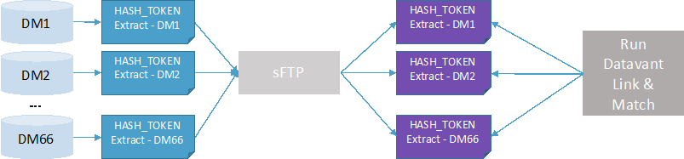
Figure 1: Data flow for the HASH_TOKEN extract. For this study, the number of contributing DataMarts (DMs) is four. A secure file transfer protocol (sFTP) hosted by PopMedNet was used to transfer data to PCORnet Coordinating Center staff from DCRI.

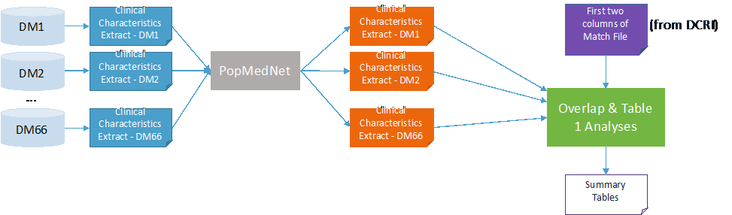

Figure 2: Data flow for the Demographic query. For this study, the number of contributing DataMarts (DMs) is four. A secure file transfer protocol (sFTP) hosted by PopMedNet was used to transfer data to PCORnet Coordinating Center staff from HPHCI.

DMID_PATID | TOKEN_1 | TOKEN_2 | TOKEN_N
CXYYY_0001 | U3FA3JF39# | 2A93A-A3A93Y | 3Q695U3AFD
CXYYY_0002 | AFENAKUT3HO9T | #TJ(G#AGEGAL# | 64GJ(G#AT*Y
CXYYY_0003 | %#(#JOYG#O | #$QJ(#PYMhlh | #TMPOYQ#e3qta

Table 1: Illustration of the content of the HASH_TOKEN extract. There is one row per patient. DMID_PATID corresponds to the ID of the contributing DataMart and PATID corresponds to a pseudoidentifier used to link across all information belonging to a patient within the DataMart’s CDM.

MATCH_ID | DMID_PATID | TOKEN_1 | TOKEN_2 | TOKEN_N
0 | C1AAA_0001 | U3FA3JF39# | 2A93A-A3A93Y | 3Q695U3AFD
1 | C1AAA_0002 | AFENAKUT3HO9T |  | 64GJ(G#AT*Y
1 | C2BBB_045 | AFENAKUT3HO9T | #TJ(G#AGEGAL# | 64GJ(G#AT*Y
2 | C3CCC_0100 | J39ANG((#%3Q6Q | AT93G3(2-A0-AT3 | A%)`E@2D@at
2 | C5EEE_4190 |  | AT93G3(2-A0-AT3 | A%)`E@2D@at
Table 2: Example of matching output. MATCH_ID is used to denote patients that match across DMs. Each MATCH_ID corresponds to a unique patient. DMID_PATID is the internal DM identifier (but does not contain patient identifiers). The TOKEN columns are populated with encrypted hash tokens. MATCH_ID and DMID_PATID are needed to perform the overlap analysis and generate the de-duplicated patient demographic characteristics table.

