Supplemental materials: What are birds looking at? A large-scale motion-capture system reveals the visual attention of freely-behaving pigeons

Table S1. Summary of our statistical approach.
Test | Response | Fixed factor (Number of levels) | Random factor (Number of levels) | Model type
Differential use of visual field regions | Mean proportion of time per nonempty bin (logit-transformed) | Visual field region (5) | Subject (20), Presentation condition (6) | LMM
Differential use of visual field regions | Intersaccadic interval (sec) | Visual field region (5) | Subject (20), Presentation condition (6) | LMM
Effect of distance on the use of foveal and lower-frontal regions | Number of frames in which the visual target was hit/missed | Distance bin (16), Visual field region (2) | Subject (20) | Binomial GLMM
Laterality of foveal use in response to different object types | Laterality score | Object type (3) | Subject (20) | Repeated measures ANOVA

*LMM – Linear Mixed Model, GLMM, Generalized Linear Mixed Model, ANOVA, Analysis of Variance

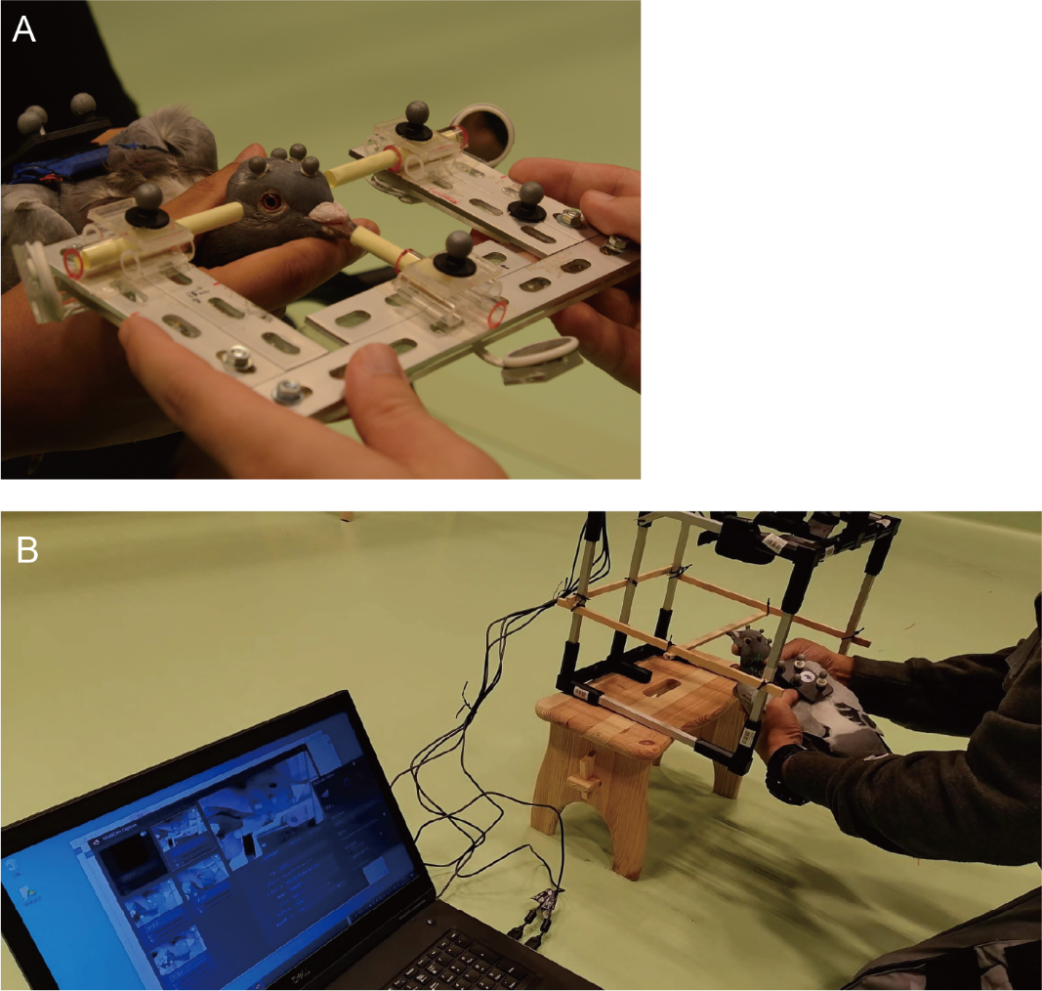
Figure S1. Two head calibration methods in this study. A. Calibration grid with mo-cap markers. B. Multi-camera calibration volume.

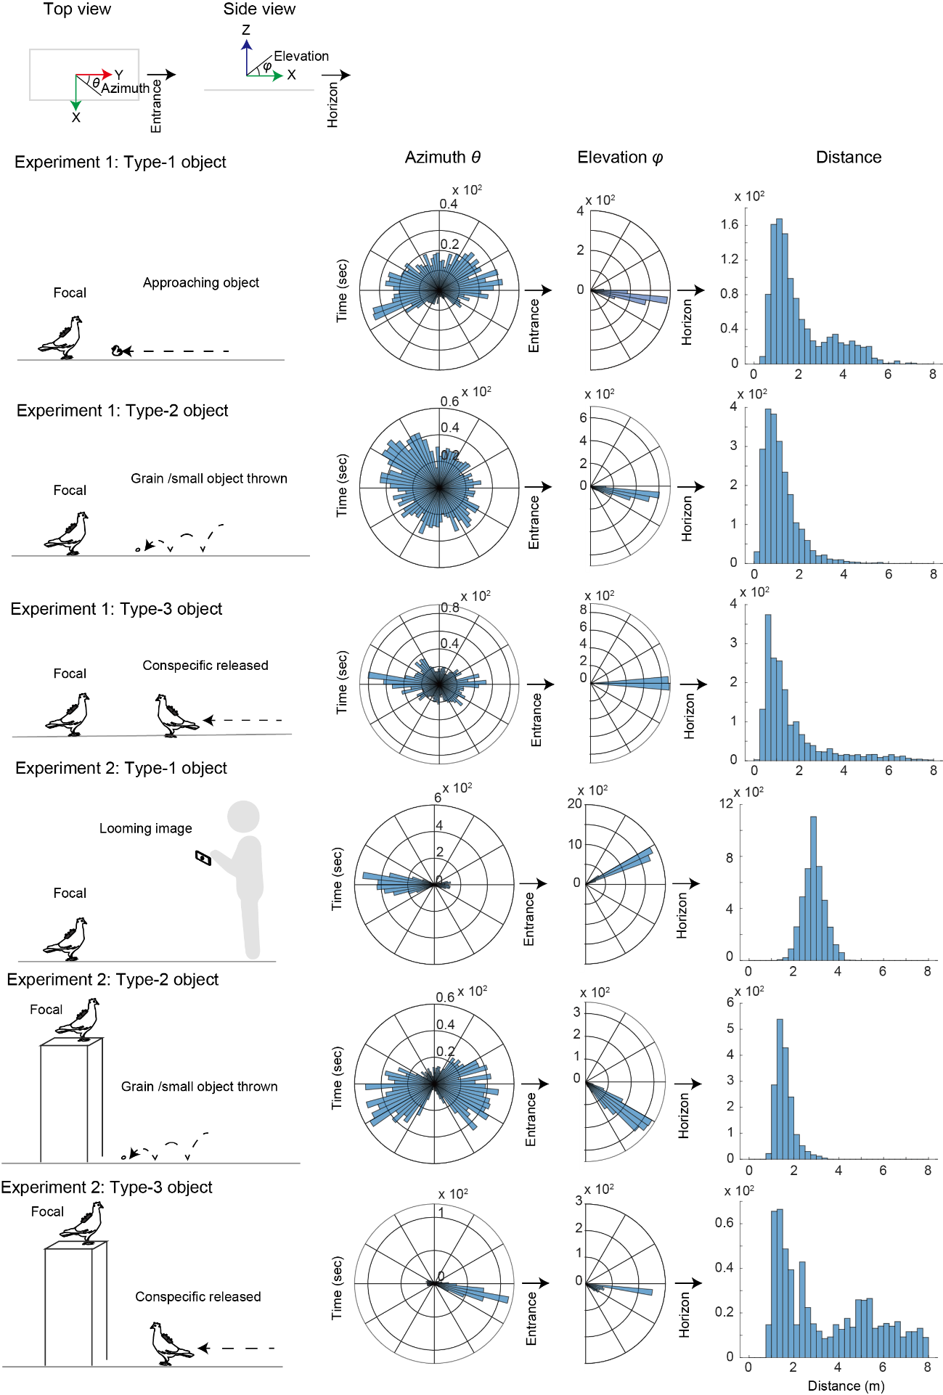
Figure S2. Distribution of the presented visual targets in the motion-capture room across the two experiments. The Polar coordinates of visual targets were shown as the azimuth, elevation, and distance in the coordinate system with its origin located at the focal pigeon’s head (the center of the two eyes), its Z-axis oriented to the zenith, and its Y-axis oriented to the entrance of the mo-cap room and the horizon.

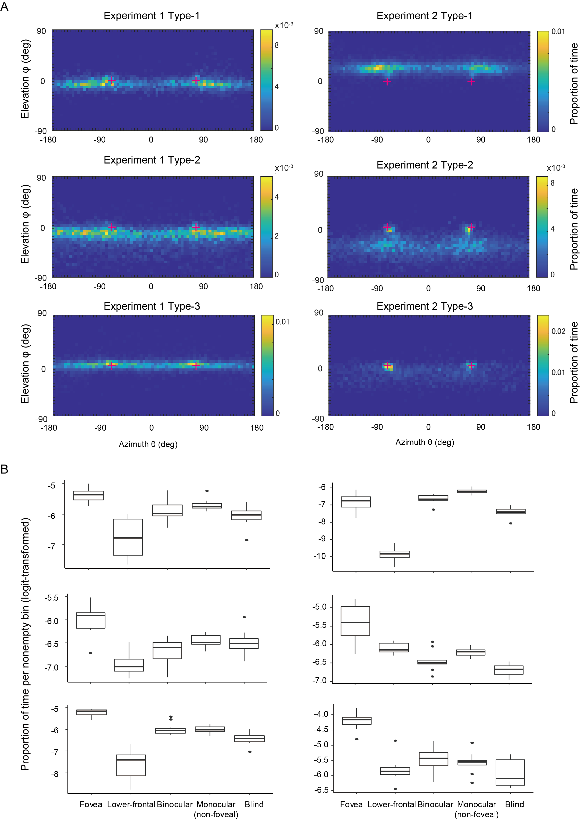
Figure S3. A. The distribution of visual targets in pigeons’ visual field in each experiment per object type. Each bin was sized 5° x 5° and indicate the proportion of time during which visual targets were observed in this bin. Also shown is the combined map for all experiments. The cross marks indicate the location of foveas in the visual fields (at an azimuth of ±75° and an elevation of 0°). B. Proportion of time during which visual targets were observed in each non-empty bin of each visual field region (logit-transformed), separated for each experiment and object type. Box plots show the median, interquartile range (IQR), and 1.5 × IQR with outliers plotted individually.

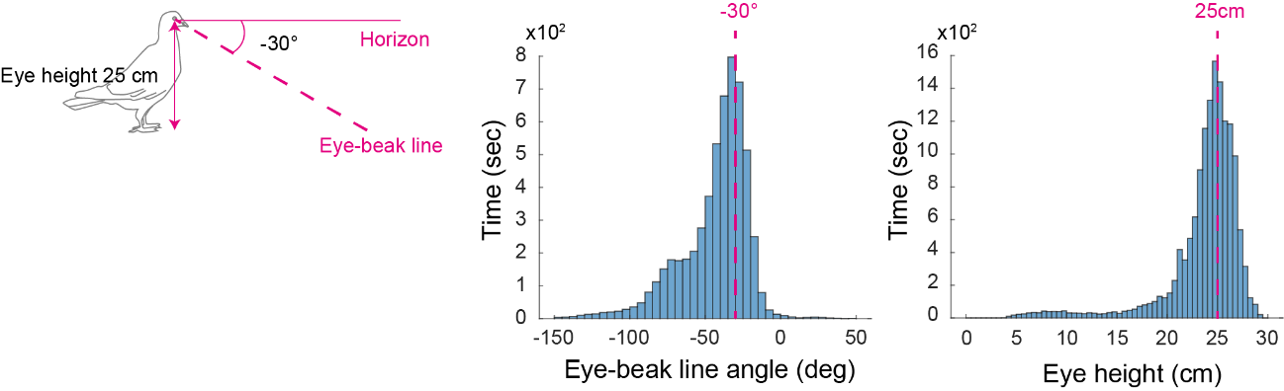
Figure S4. Frequency of the elevation angle of the beak (per 5° bin) in the head-centric coordinate system and the eye height from the ground (the midpoint of the two eyes; the origin of the head-centric coordinate system). The latter data included only the moments when the birds were on the ground (0 cm) but not on the table (73 cm). We derived these data from Experiment 2 because the calibration method used in Experiment 2 identified the eye centers and beak tip more directly than that used in Experiment 1.

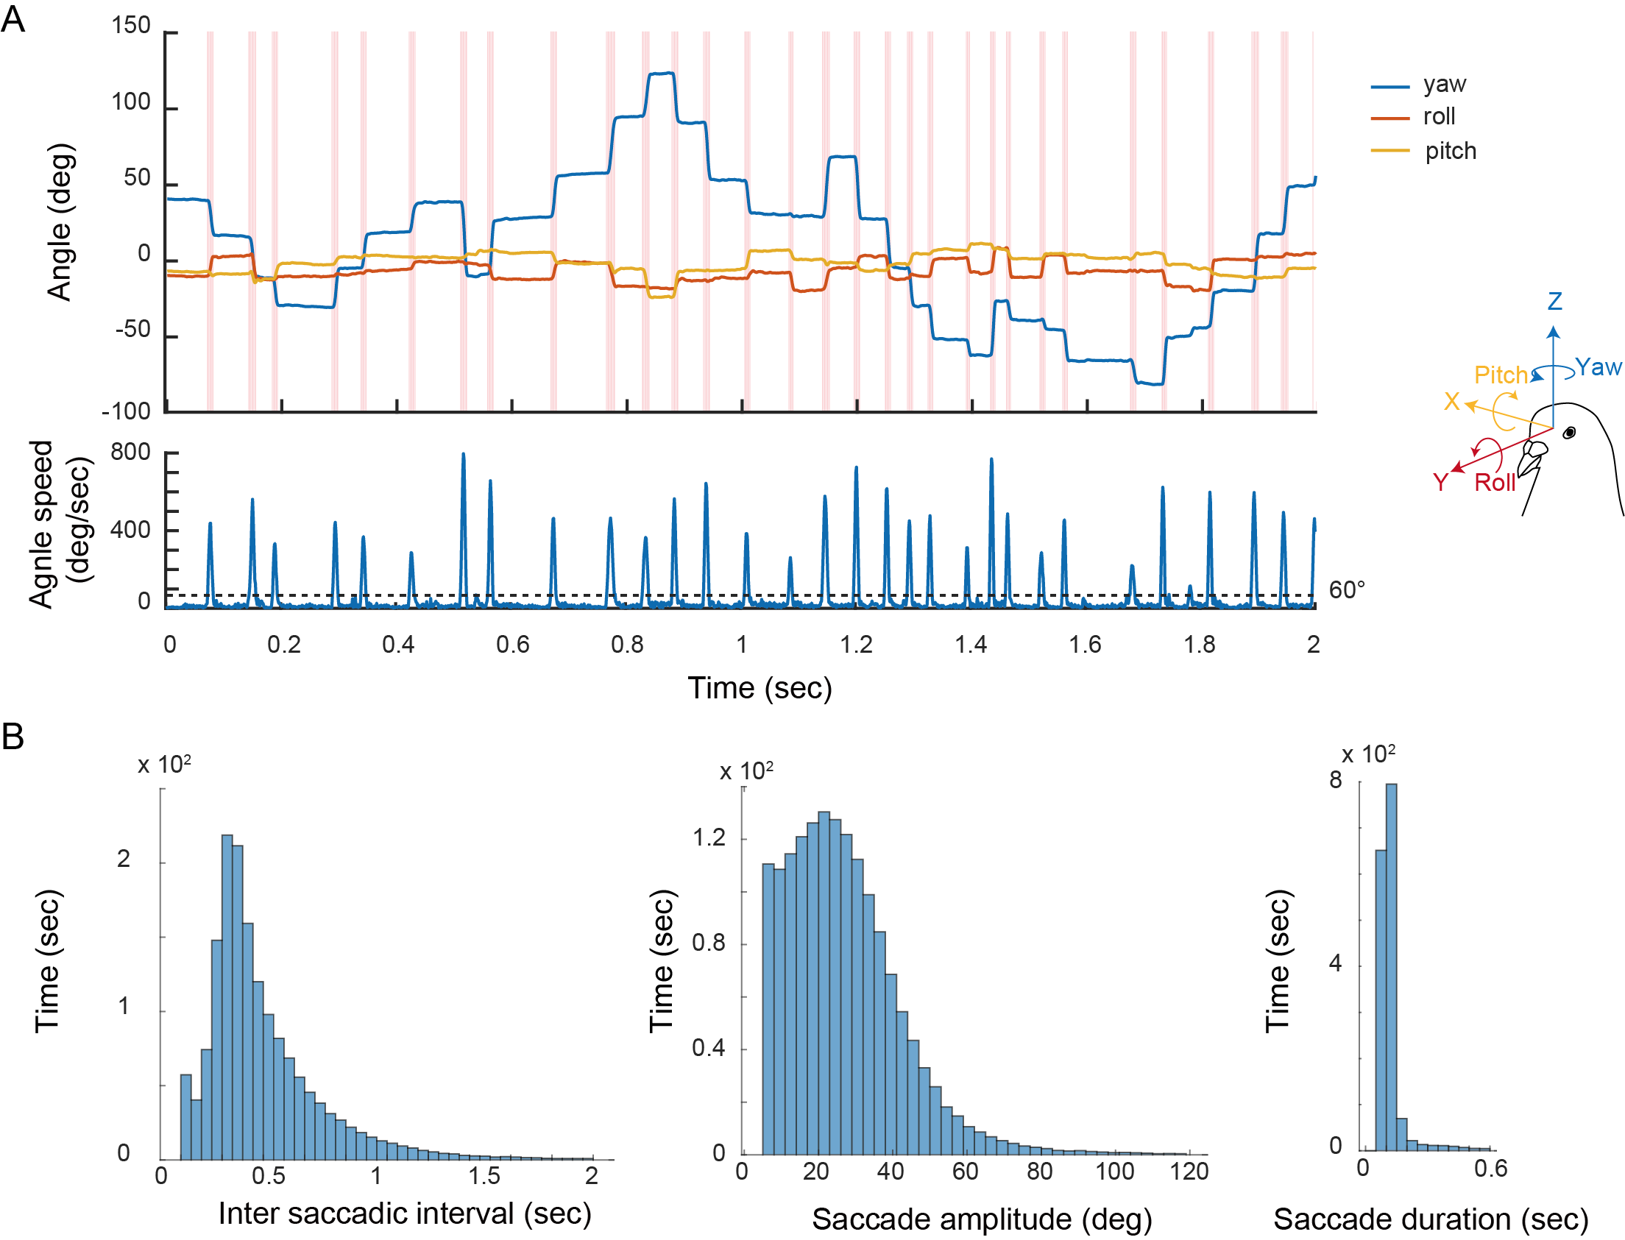
Figure S5. A. Example of head movement in yaw, roll, and pitch. Saccades were highlighted in magenta. The axial angle speeds are shown in the bottom panel. B. Histograms of intersaccadic interval (sec), saccade amplitude (deg), and saccade duration (sec).

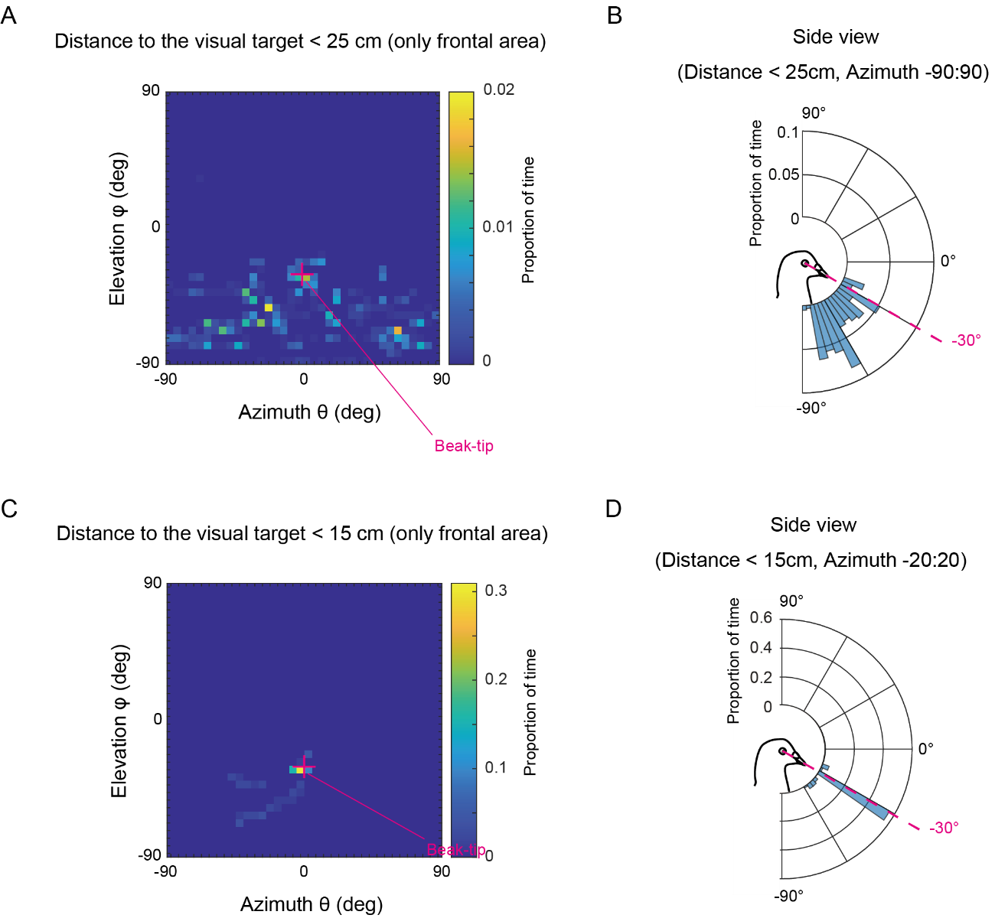
Figure S6. A. The distribution of visual targets (the proportion of time during which visual targets were observed in each 5°x5° bin) when the visual targets were in front of the pigeons’ heads (at the azimuth from -90° to 90°) and closer than 25 cm (when the pigeons slightly lowered their head) in Experiment 1 presenting Type-2 targets (food-related stimuli). The cross mark indicates the coordinate of the beak tip. B. The same data in a Polar histogram (the side view). C. Identical to A except that the visual targets were closer than 15 cm (when the pigeons were prepared to peck it). D. The same data in a Polar histogram (the side view), while restricting (for the visualization purpose) the distribution to a range including the azimuth from -20° to 20°.

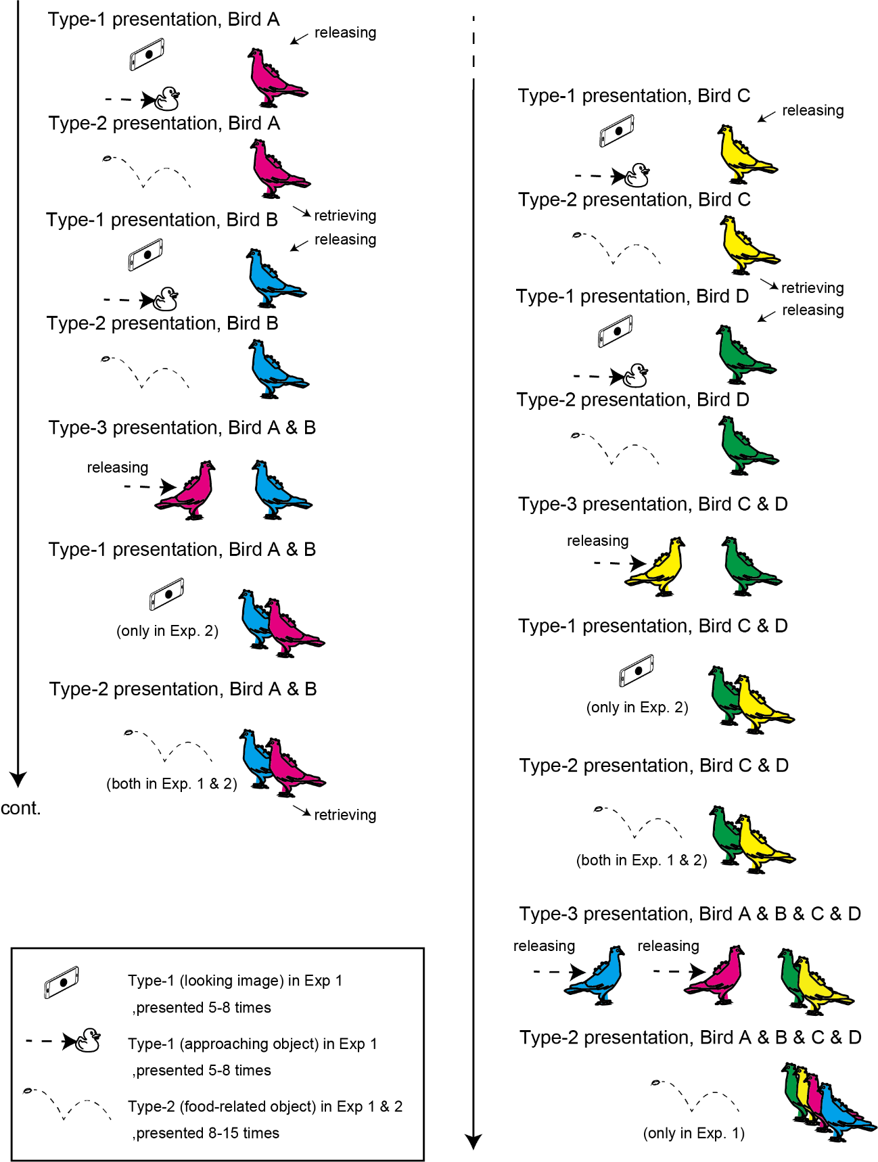
Figure S7. The procedure of testing birds each day. One bird (Bird A) was released into the mo-cap room and presented with Type-1 targets 5-8 times and then with Type-2 targets 8-15 times. Bird A was then retrieved (and kept in a carrier box) and then another bird (Bird B) was released. Type-1 and Type-2 targets were presented to Bird A and B (the same number of times). Type-1 targets were presented to these two birds only in Experiment 2 (due to the time constraints within a day). Bird A was then released and let freely interact with Bird B for longer than 30 seconds. Type-1 and Type-2 targets were presented to both Bird A and B (the same number of times). Both birds were then retrieved (and kept in a carrier box). The same procedures were repeated with another two birds (Bird C and D). Bird A (or B) was released and let freely interact with Bird C and D for longer than 30 seconds, and then Bird B (or A) was released and let freely interact with Birds A (or B), C, and D for the same amount of time. Finally, Type-2 targets were presented to all four birds (the same number of times) but only in Experiment 1 (due to the time constraints each day).

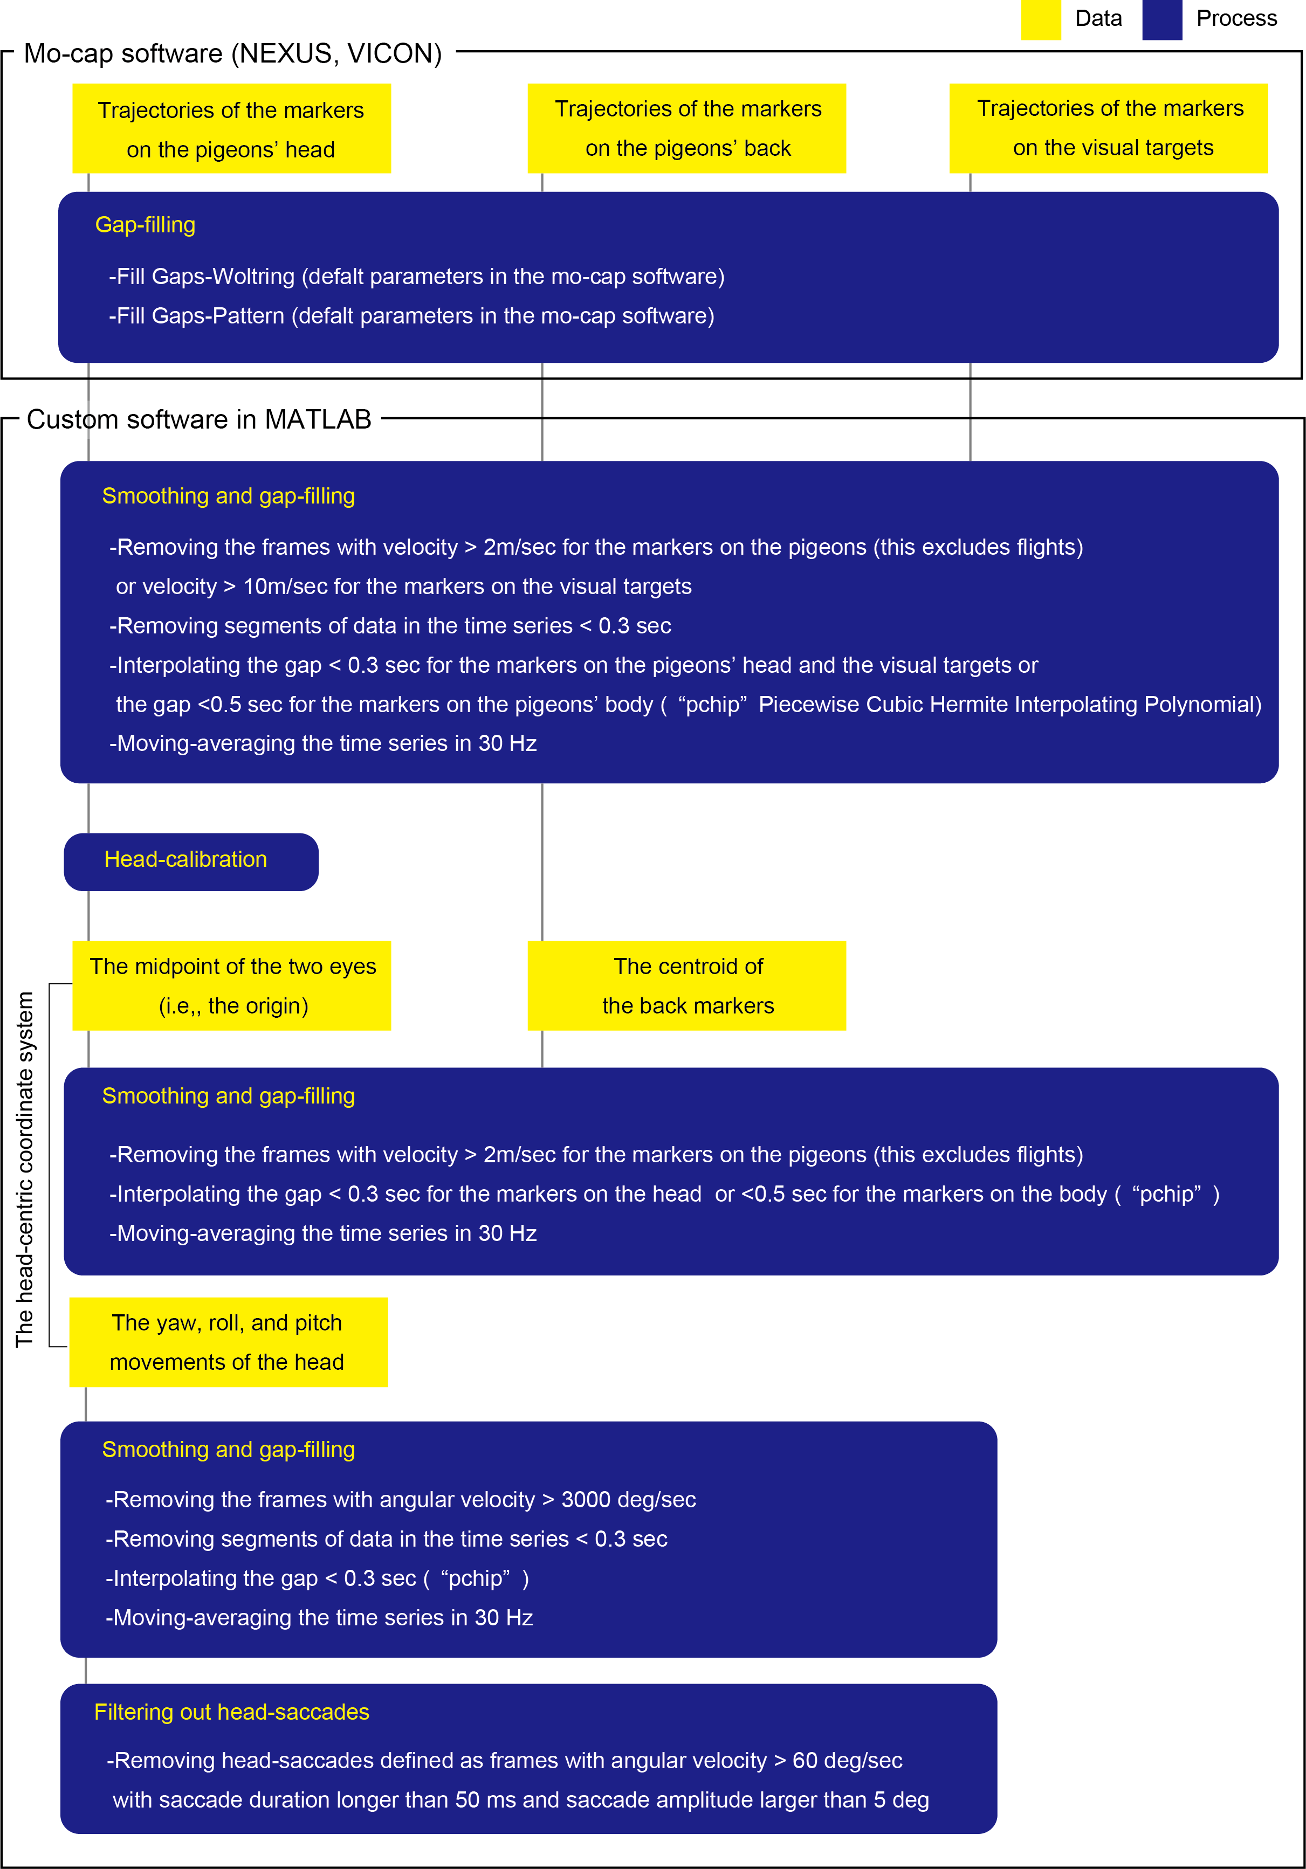
Figure S8. The data-filtering procedure. Trajectories of markers were first gap-filled in the motion-capture software and then cleaned, again gap-filled, and smoothed in the custom software. These trajectories were then converted to the centroids and coordinate system and further cleaned, gap-filled, and smoothed in the custom software. Finally, head saccades were filtered out from the yaw, roll, and pitch movements of the head.

Video S1. Examples of experimental recordings with reconstructed “gaze”. https://youtu.be/jlTCNdSN75M

