STRUCTURAL CHEMISTRY
Supplementary file
On
Structurally Modulated D-π-D- A_{(Semiconductor)} Anchoring Dyes to Enhance the Tunable NLO Response: A DFT/TDDFT Quest For New Photovoltaic Materials
Abrar U. Hassan,^{*1} Sajjad H. Sumrra¹, Muhammad Zubair¹, Ghulam Mustafa¹, Muhammad F. Nazar², Muhammad N. Zafar¹
¹Department of Chemistry, University of Gujrat, Gujrat 50700, Pakistan
²Department of Chemistry, Division of Science and Technology, University of Education, Lahore, Multan Campus 60700, Pakistan
Email: hassanabrar2016@gmail.com

Table S1. Structural parameters of Ref-D
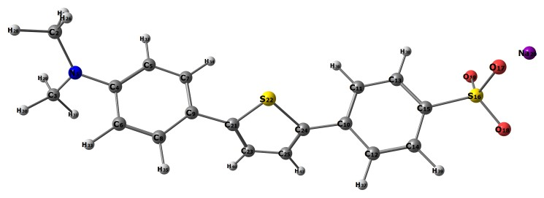
 | Bond Lengths (A) |  | Bond Angles (°)
R(1-2) |  | 1.52 |  | A(2-1-3) | 117.3
R(1-3) |  | 1.51 |  | A(2-1-4) | 121.5
R(1-4) |  | 1.46 |  | A(1-2-26) | 111.9
R(2-26) |  | 1.11 |  | A(1-2-27) | 110.8
R(2-27) |  | 1.12 |  | A(1-2-28) | 112.9
R(2-28) |  | 1.12 |  | A(3-1-4) | 121.1
R(3-29) |  | 1.11 |  | A(1-3-29) | 112.9
R(3-30) |  | 1.11 |  | A(1-3-30) | 110.1
R(3-31) |  | 1.12 |  | A(1-3-31) | 112.2
R(4-5) |  | 1.40 |  | A(1-4-5) | 119.9
R(4-6) |  | 1.40 |  | A(1-4-6) | 120.9
R(5-7) |  | 1.40 |  | A(26-2-27) | 108.0
R(5-32) |  | 1.13 |  | A(26-2-28) | 104.6
R(6-8) |  | 1.41 |  | A(27-2-28) | 108.2
R(6-33) |  | 1.13 |  | A(29-3-30) | 108.2
R(7-9) |  | 1.39 |  | A(29-3-31) | 104.5
R(7-34) |  | 1.13 |  | A(30-3-31) | 108.5
R(8-9) |  | 1.39 |  | A(5-4-6) | 119.2
R(8-35) |  | 1.13 |  | A(4-5-7) | 120.2
R(9-21) |  | 1.50 |  | A(4-5-32) | 119.7
R(10-11) |  | 1.40 |  | A(4-6-8) | 120.5
R(14-39) |  | 1.12 |  | A(7-9-21) | 117.2
R(15-16) |  | 1.77 |  | A(9-8-35) | 118.7
R(16-17) |  | 1.44 |  | A(8-9-21) | 122.6
R(16-18) |  | 1.44 |  | A(9-21-22) | 121.0
R(16-19) |  | 1.66 |  | A(9-21-23) | 126.5
R(21-22) |  | 1.81 |  | A(11-10-12) | 119.9
R(21-23) |  | 1.39 |  | A(11-10-24) | 117.0
R(25-41) |  | 1.12 |  | A(10-12-37) | 118.7
 |  |  |  | A(12-14-15) | 120.2
 |  |  |  | A(12-14-39) | 120.9
 |  |  |  | A(15-13-38) | 118.3
 |  |  |  | A(13-15-14) | 119.7
 |  |  |  | A(13-15-16) | 117.6
 |  |  |  | A(15-14-39) | 118.9
 |  |  |  | A(14-15-16) | 122.7
 |  |  |  | A(15-16-17) | 109.1
 |  |  |  | A(15-16-18) | 113.1
 |  |  |  | A(15-16-19) | 109.5
 |  |  |  | A(17-16-18) | 108.3
 |  |  |  | A(17-16-19) | 109.5
 |  |  |  | A(18-16-19) | 107.2
 |  |  |  | A(22-21-23) | 112.4
 |  |  |  | A(21-22-24) | 88.0
 |  |  |  | A(21-23-25) | 113.7
 |  |  |  | A(21-23-40) | 122.3
 |  |  |  | A(22-24-25) | 112.2
 |  |  |  | A(25-23-40) | 124.0
 |  |  |  | A(23-25-24) | 113.7
 |  |  |  | A(23-25-41) | 123.7
 |  |  |  | A(24-25-41) | 122.7
Table S2. Structural parameters of dye D-1
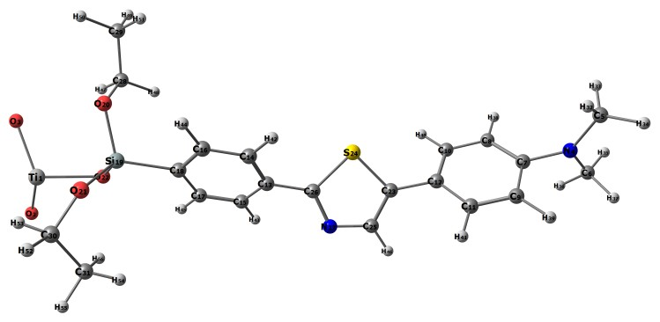
 | Bond Lengths (A) |  | Bond Angles (°)
R(1-2) |  | 2.07 |  | A(2-1-3) | 109.8
R(1-3) |  | 2.07 |  | A(2-1-22) | 108.9
R(1-22) |  | 2.07 |  | A(3-1-22) | 112.3
R(4-5) |  | 1.49 |  | A(1-22-19) | 114.9
R(4-6) |  | 1.49 |  | A(5-4-6) | 122.5
R(4-7) |  | 1.49 |  | A(5-4-7) | 118.1
R(5-32) |  | 1.12 |  | A(4-5-32) | 112.8
R(5-33) |  | 1.11 |  | A(4-5-33) | 109.1
R(5-34) |  | 1.11 |  | A(4-5-34) | 112.3
R(6-35) |  | 1.12 |  | A(6-4-7) | 119.4
R(6-36) |  | 1.12 |  | A(4-6-35) | 112.0
R(6-37) |  | 1.12 |  | A(4-6-36) | 111.6
R(7-8) |  | 1.40 |  | A(4-6-37) | 110.8
R(7-9) |  | 1.39 |  | A(4-7-8) | 120.0
R(8-10) |  | 1.40 |  | A(4-7-9) | 119.7
R(8-38) |  | 1.13 |  | A(32-5-33) | 108.0
R(9-11) |  | 1.40 |  | A(32-5-34) | 105.4
R(9-39) |  | 1.13 |  | A(33-5-34) | 109.1
R(10-12) |  | 1.39 |  | A(35-6-36) | 107.0
R(10-40) |  | 1.13 |  | A(35-6-37) | 107.4
R(11-12) |  | 1.40 |  | A(36-6-37) | 107.9
R(11-41) |  | 1.13 |  | A(8-7-9) | 120.3
R(12-23) |  | 1.51 |  | A(7-8-10) | 119.9
R(13-14) |  | 1.40 |  | A(7-8-38) | 118.9
R(13-15) |  | 1.40 |  | A(7-9-11) | 119.8
R(13-26) |  | 1.52 |  | A(7-9-39) | 118.8
R(14-16) |  | 1.40 |  | A(10-8-38) | 121.2
R(14-42) |  | 1.13 |  | A(8-10-12) | 119.9
R(15-17) |  | 1.41 |  | A(8-10-40) | 121.5
R(15-43) |  | 1.13 |  | A(11-9-39) | 121.4
R(16-18) |  | 1.39 |  | A(9-11-12) | 120.0
R(16-44) |  | 1.12 |  | A(9-11-41) | 121.0
R(17-18) |  | 1.39 |  | A(12-10-40) | 118.7
R(17-45) |  | 1.12 |  | A(10-12-11) | 120.1
R(23-24) |  | 1.81 |  | A(14-13-26) | 119.1
R(23-25) |  | 1.39 |  | A(13-14-16) | 120.1
R(24-26) |  | 1.81 |  | A(13-14-42) | 119.2
R(25-27) |  | 1.39 |  | A(15-13-26) | 121.4
R(25-46) |  | 1.11 |  | A(13-15-17) | 120.0
R(26-27) |  | 1.39 |  | A(13-15-43) | 119.1
R(28-29) |  | 1.58 |  | A(13-26-24) | 123.6
R(28-47) |  | 1.13 |  | A(13-26-27) | 124.6
R(28-48) |  | 1.13 |  | A(16-14-42) | 120.7
R(29-49) |  | 1.12 |  | A(14-16-18) | 120.3
R(29-50) |  | 1.12 |  | A(14-16-44) | 121.8
R(29-51) |  | 1.12 |  | A(17-15-43) | 120.9
R(30-31) |  | 1.58 |  | A(15-17-18) | 120.1
R(30-52) |  | 1.13 |  | A(15-17-45) | 121.6
R(30-53) |  | 1.13 |  | A(18-16-44) | 117.9
R(31-54) |  | 1.12 |  | A(16-18-17) | 119.9
R(31-55) |  | 1.13 |  | A(16-18-19) | 118.3
R(31-56) |  | 1.12 |  | A(18-17-45) | 118.3
 |  |  |  | A(17-18-19) | 121.7
 |  |  |  | A(18-19-20) | 109.4
 |  |  |  | A(18-19-21) | 105.8
 |  |  |  | A(18-19-22) | 111.5
 |  |  |  | A(23-25-46) | 123.4
 |  |  |  | A(24-26-27) | 111.8
 |  |  |  | A(27-25-46) | 121.9
 |  |  |  | A(25-27-26) | 113.8
 |  |  |  | A(29-28-47) | 112.5
 |  |  |  | A(29-28-48) | 113.0
 |  |  |  | A(28-29-49) | 114.0
 |  |  |  | A(28-29-50) | 112.1
 |  |  |  | A(28-29-51) | 112.5
 |  |  |  | A(47-28-48) | 106.0
 |  |  |  | A(49-29-50) | 106.8
 |  |  |  | A(49-29-51) | 104.8
 |  |  |  | A(50-29-51) | 106.1
 |  |  |  | A(31-30-52) | 112.4
 |  |  |  | A(31-30-53) | 113.3
 |  |  |  | A(30-31-54) | 112.2
 |  |  |  | A(30-31-55) | 113.0
 |  |  |  | A(30-31-56) | 113.8
 |  |  |  | A(52-30-53) | 105.7
 |  |  |  | A(54-31-55) | 107.1
 |  |  |  | A(54-31-56) | 104.5
 |  |  |  | A(55-31-56) | 105.5
Table S3. Structural parameters of dye D-2
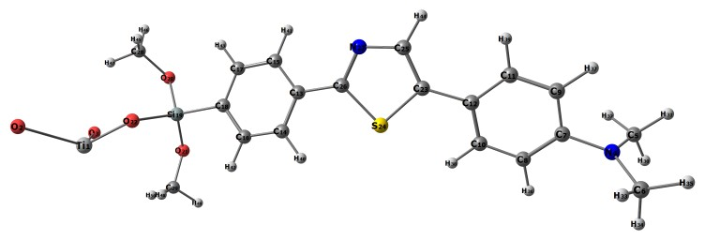
 | Bond Lengths (A) |  | Bond Angles (°)
R(1-2) |  | 2.07 |  | A(2-1-3) | 110.1
R(1-3) |  | 2.07 |  | A(2-1-22) | 110.5
R(1-22) |  | 2.07 |  | A(3-1-22) | 112.7
R(4-5) |  | 1.49 |  | A(1-22-19) | 112.4
R(4-6) |  | 1.49 |  | A(5-4-6) | 122.8
R(4-7) |  | 1.49 |  | A(5-4-7) | 119.7
R(5-30) |  | 1.11 |  | A(4-5-30) | 111.3
R(5-31) |  | 1.11 |  | A(4-5-31) | 110.2
R(5-32) |  | 1.12 |  | A(4-5-32) | 112.8
R(6-33) |  | 1.12 |  | A(6-4-7) | 117.4
R(6-34) |  | 1.11 |  | A(4-6-33) | 112.9
R(6-35) |  | 1.11 |  | A(4-6-34) | 109.8
R(7-8) |  | 1.39 |  | A(4-6-35) | 112.2
R(7-9) |  | 1.39 |  | A(4-7-8) | 120.0
R(8-10) |  | 1.40 |  | A(4-7-9) | 120.2
R(8-36) |  | 1.13 |  | A(30-5-31) | 108.9
R(9-11) |  | 1.40 |  | A(30-5-32) | 106.1
R(9-37) |  | 1.13 |  | A(31-5-32) | 107.5
R(10-12) |  | 1.41 |  | A(33-6-34) | 107.7
R(10-38) |  | 1.12 |  | A(33-6-35) | 105.2
R(11-12) |  | 1.41 |  | A(34-6-35) | 108.8
R(11-39) |  | 1.11 |  | A(8-7-9) | 119.8
R(12-23) |  | 1.57 |  | A(7-8-10) | 120.0
R(13-14) |  | 1.40 |  | A(7-8-36) | 118.4
R(13-15) |  | 1.40 |  | A(7-9-11) | 120.3
R(13-26) |  | 1.52 |  | A(7-9-37) | 118.0
R(14-16) |  | 1.40 |  | A(10-8-36) | 121.6
R(14-40) |  | 1.13 |  | A(8-10-12) | 121.3
R(15-17) |  | 1.41 |  | A(8-10-38) | 119.3
R(15-41) |  | 1.13 |  | A(11-9-37) | 121.7
R(16-18) |  | 1.39 |  | A(9-11-12) | 120.9
R(16-42) |  | 1.12 |  | A(9-11-39) | 118.7
R(17-18) |  | 1.39 |  | A(12-10-38) | 119.4
R(17-43) |  | 1.12 |  | A(10-12-11) | 117.7
R(18-19) |  | 1.90 |  | A(10-12-23) | 118.3
R(19-20) |  | 1.79 |  | A(12-11-39) | 120.4
R(19-21) |  | 1.79 |  | A(11-12-23) | 124.0
R(19-22) |  | 1.78 |  | A(12-23-24) | 120.8
R(20-28) |  | 1.43 |  | A(12-23-25) | 130.7
R(21-29) |  | 1.43 |  | A(14-13-15) | 119.3
R(23-24) |  | 1.82 |  | A(14-13-26) | 119.9
R(23-25) |  | 1.40 |  | A(13-14-16) | 120.2
R(24-26) |  | 1.81 |  | A(13-14-40) | 119.1
R(25-27) |  | 1.39 |  | A(15-13-26) | 120.8
R(25-44) |  | 1.11 |  | A(13-15-17) | 120.0
R(26-27) |  | 1.38 |  | A(13-15-41) | 119.3
R(28-45) |  | 1.11 |  | A(13-26-24) | 123.9
R(28-46) |  | 1.11 |  | A(13-26-27) | 125.5
R(28-47) |  | 1.11 |  | A(16-14-40) | 120.8
R(29-48) |  | 1.11 |  | A(14-16-18) | 120.8
R(29-49) |  | 1.11 |  | A(14-16-42) | 121.2
 |  |  |  | A(18-17-43) | 118.3
 |  |  |  | A(17-18-19) | 121.1
 |  |  |  | A(18-19-20) | 110.4
 |  |  |  | A(18-19-21) | 111.3
 |  |  |  | A(18-19-22) | 109.6
 |  |  |  | A(20-19-21) | 103.5
 |  |  |  | A(20-19-22) | 109.5
 |  |  |  | A(19-20-28) | 118.8
 |  |  |  | A(21-19-22) | 112.4
 |  |  |  | A(19-21-29) | 122.3
 |  |  |  | A(20-28-45) | 112.3
 |  |  |  | A(20-28-46) | 107.8
 |  |  |  | A(20-28-47) | 110.8
 |  |  |  | A(21-29-48) | 114.1
 |  |  |  | A(21-29-49) | 108.3
 |  |  |  | A(21-29-50) | 109.0
 |  |  |  | A(24-23-25) | 108.5
 |  |  |  | A(23-24-26) | 90.5
 |  |  |  | A(23-25-27) | 115.9
 |  |  |  | A(23-25-44) | 126.1
 |  |  |  | A(24-26-27) | 110.6
 |  |  |  | A(27-25-44) | 118.0
 |  |  |  | A(25-27-26) | 114.5
 |  |  |  | A(45-28-46) | 109.1
 |  |  |  | A(45-28-47) | 107.9
 |  |  |  | A(46-28-47) | 108.8
 |  |  |  | A(48-29-49) | 109.4
 |  |  |  | A(48-29-50) | 107.4
 |  |  |  | A(49-29-50) | 108.6

Table S4. Structural parameters of dye D-3
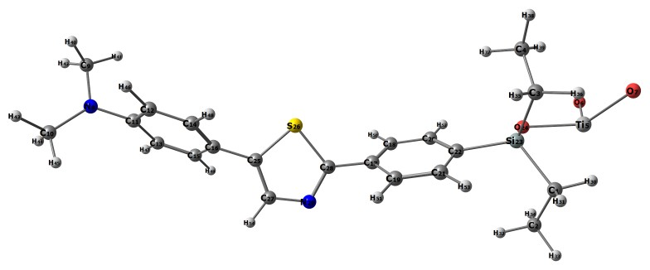
 | Bond Lengths (A) |  | Bond Angles (°)
R(1-2) |  | 1.62 |  | A(2-1-23) | 110.8
R(1-23) |  | 1.89 |  | A(2-1-30) | 112.2
R(1-30) |  | 1.13 |  | A(2-1-31) | 112.9
R(1-31) |  | 1.12 |  | A(1-2-32) | 112.2
R(2-32) |  | 1.12 |  | A(1-2-33) | 112.9
R(2-33) |  | 1.12 |  | A(1-2-34) | 112.0
R(2-34) |  | 1.12 |  | A(23-1-30) | 106.7
R(3-4) |  | 1.63 |  | A(23-1-31) | 109.0
R(3-23) |  | 1.89 |  | A(1-23-3) | 111.4
R(3-35) |  | 1.13 |  | A(1-23-22) | 112.5
R(3-36) |  | 1.13 |  | A(1-23-24) | 107.1
R(4-37) |  | 1.12 |  | A(30-1-31) | 104.8
R(4-38) |  | 1.13 |  | A(32-2-33) | 107.1
R(4-39) |  | 1.12 |  | A(32-2-34) | 105.1
R(5-6) |  | 2.07 |  | A(33-2-34) | 107.1
R(5-7) |  | 2.07 |  | A(4-3-23) | 111.5
R(5-24) |  | 2.07 |  | A(4-3-35) | 111.9
R(8-9) |  | 1.49 |  | A(4-3-36) | 112.2
R(8-10) |  | 1.49 |  | A(3-4-37) | 111.5
R(8-11) |  | 1.49 |  | A(3-4-38) | 113.1
R(9-40) |  | 1.11 |  | A(3-4-39) | 112.6
R(9-41) |  | 1.11 |  | A(23-3-35) | 106.4
R(9-42) |  | 1.11 |  | A(23-3-36) | 108.8
R(10-43) |  | 1.11 |  | A(3-23-22) | 106.3
R(10-44) |  | 1.11 |  | A(3-23-24) | 108.8
R(10-45) |  | 1.12 |  | A(35-3-36) | 105.7
R(11-12) |  | 1.39 |  | A(37-4-38) | 107.3
R(11-13) |  | 1.40 |  | A(37-4-39) | 105.1
R(12-14) |  | 1.40 |  | A(38-4-39) | 106.7
R(12-46) |  | 1.13 |  | A(6-5-7) | 109.9
R(13-15) |  | 1.40 |  | A(6-5-24) | 108.8
R(13-47) |  | 1.13 |  | A(7-5-24) | 113.0
R(14-16) |  | 1.40 |  | A(5-24-23) | 113.9
R(14-48) |  | 1.13 |  | A(9-8-10) | 122.0
R(19-51) |  | 1.13 |  | A(8-11-13) | 119.7
R(20-22) |  | 1.40 |  | A(40-9-41) | 107.9
R(20-52) |  | 1.12 |  | A(40-9-42) | 107.1
R(21-22) |  | 1.39 |  | A(41-9-42) | 107.1
R(21-53) |  | 1.12 |  | A(43-10-44) | 109.3
R(22-23) |  | 1.90 |  | A(43-10-45) | 105.5
R(23-24) |  | 1.78 |  | A(44-10-45) | 107.4
R(25-26) |  | 1.81 |  | A(12-11-13) | 120.0
R(25-27) |  | 1.39 |  | A(11-12-14) | 119.8
R(26-28) |  | 1.81 |  | A(11-12-46) | 119.1
R(27-29) |  | 1.39 |  | A(11-13-15) | 120.3
R(27-54) |  | 1.11 |  | A(11-13-47) | 118.7
R(28-29) |  | 1.38 |  | A(14-12-46) | 121.1
 |  |  |  | A(12-14-16) | 120.3
 |  |  |  | A(12-14-48) | 121.1
 |  |  |  | A(15-13-47) | 121.1
 |  |  |  | A(13-15-16) | 119.6
 |  |  |  | A(13-15-49) | 121.5
 |  |  |  | A(16-14-48) | 118.6
 |  |  |  | A(14-16-15) | 120.1
 |  |  |  | A(14-16-25) | 117.9
 |  |  |  | A(16-15-49) | 118.9
 |  |  |  | A(15-16-25) | 122.0
 |  |  |  | A(16-25-26) | 121.5
 |  |  |  | A(16-25-27) | 126.6
 |  |  |  | A(18-17-19) | 120.0
 |  |  |  | A(18-17-28) | 121.7
 |  |  |  | A(17-18-20) | 119.8
 |  |  |  | A(17-18-50) | 118.6
 |  |  |  | A(21-19-51) | 121.2
 |  |  |  | A(19-21-22) | 120.6
 |  |  |  | A(19-21-53) | 120.7
 |  |  |  | A(22-20-52) | 118.4
 |  |  |  | A(20-22-21) | 119.3
 |  |  |  | A(20-22-23) | 121.0
 |  |  |  | A(22-21-53) | 118.7
 |  |  |  | A(21-22-23) | 119.7
 |  |  |  | A(22-23-24) | 110.7
 |  |  |  | A(26-25-27) | 111.8
 |  |  |  | A(25-26-28) | 87.7
 |  |  |  | A(25-27-29) | 114.6
 |  |  |  | A(25-27-54) | 123.5
 |  |  |  | A(26-28-29) | 112.9
 |  |  |  | A(29-27-54) | 121.9
 |  |  |  | A(27-29-28) | 113.1

Table S5. Structural parameters of dye D-4
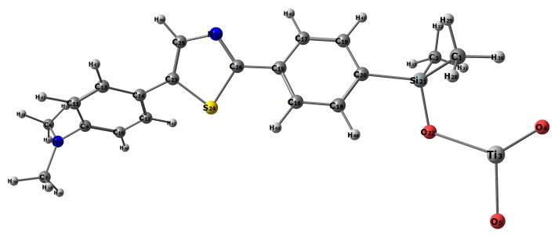
 | Bond Lengths (A) |  | Bond Angles (°)
R(1-21) |  | 1.88 |  | A(21-1-28) | 110.8
R(1-28) |  | 1.11 |  | A(21-1-29) | 108.6
R(1-29) |  | 1.11 |  | A(21-1-30) | 111.2
R(1-30) |  | 1.11 |  | A(1-21-2) | 110.8
R(2-21) |  | 1.88 |  | A(1-21-20) | 108.6
R(2-31) |  | 1.11 |  | A(1-21-22) | 110.3
R(2-32) |  | 1.11 |  | A(28-1-29) | 109.0
R(2-33) |  | 1.11 |  | A(28-1-30) | 108.2
R(3-4) |  | 2.07 |  | A(29-1-30) | 109.0
R(3-5) |  | 2.07 |  | A(21-2-31) | 110.9
R(3-22) |  | 2.07 |  | A(21-2-32) | 110.1
R(6-7) |  | 1.49 |  | A(21-2-33) | 110.8
R(6-8) |  | 1.49 |  | A(2-21-20) | 112.5
R(6-9) |  | 1.49 |  | A(2-21-22) | 106.3
R(7-34) |  | 1.12 |  | A(31-2-32) | 107.9
R(7-35) |  | 1.11 |  | A(31-2-33) | 107.8
R(7-36) |  | 1.11 |  | A(32-2-33) | 109.4
R(8-37) |  | 1.11 |  | A(4-3-5) | 110.5
R(8-38) |  | 1.11 |  | A(4-3-22) | 110.9
R(8-39) |  | 1.11 |  | A(5-3-22) | 108.7
R(9-10) |  | 1.40 |  | A(3-22-21) | 113.5
R(9-11) |  | 1.40 |  | A(7-6-8) | 122.5
R(10-12) |  | 1.40 |  | A(7-6-9) | 118.2
R(10-40) |  | 1.13 |  | A(6-7-34) | 112.7
R(11-13) |  | 1.40 |  | A(6-7-35) | 109.8
R(11-41) |  | 1.13 |  | A(6-7-36) | 111.8
R(12-14) |  | 1.40 |  | A(8-6-9) | 118.9
R(12-42) |  | 1.13 |  | A(6-8-37) | 112.2
R(13-14) |  | 1.40 |  | A(6-8-38) | 109.4
R(13-43) |  | 1.13 |  | A(6-8-39) | 112.6
R(14-23) |  | 1.51 |  | A(6-9-10) | 120.0
R(15-16) |  | 1.40 |  | A(6-9-11) | 119.6
R(15-17) |  | 1.40 |  | A(34-7-35) | 107.8
R(15-26) |  | 1.51 |  | A(34-7-36) | 105.6
R(16-18) |  | 1.40 |  | A(35-7-36) | 108.9
R(16-44) |  | 1.13 |  | A(37-8-38) | 108.8
R(19-20) |  | 1.39 |  | A(9-10-40) | 119.1
R(19-47) |  | 1.12 |  | A(9-11-13) | 120.0
R(20-21) |  | 1.90 |  | A(9-11-41) | 118.7
R(21-22) |  | 1.78 |  | A(12-10-40) | 121.3
R(23-24) |  | 1.81 |  | A(10-12-14) | 120.1
R(23-25) |  | 1.39 |  | A(10-12-42) | 120.9
R(24-26) |  | 1.81 |  | A(13-11-41) | 121.3
R(25-27) |  | 1.39 |  | A(11-13-14) | 119.7
R(25-48) |  | 1.11 |  | A(11-13-43) | 121.0
R(26-27) |  | 1.39 |  | A(14-12-42) | 119.0
 |  |  |  | A(12-14-13) | 120.2
 |  |  |  | A(12-14-23) | 117.9
 |  |  |  | A(14-13-43) | 119.3
 |  |  |  | A(13-14-23) | 121.9
 |  |  |  | A(14-23-24) | 120.1
 |  |  |  | A(14-23-25) | 128.4
 |  |  |  | A(16-15-17) | 119.6
 |  |  |  | A(16-15-26) | 119.3
 |  |  |  | A(15-16-18) | 120.0
 |  |  |  | A(15-16-44) | 119.4
 |  |  |  | A(17-15-26) | 121.1
 |  |  |  | A(15-17-19) | 120.0
 |  |  |  | A(15-17-45) | 119.2
 |  |  |  | A(15-26-24) | 121.6
 |  |  |  | A(15-26-27) | 126.5
 |  |  |  | A(18-16-44) | 120.6
 |  |  |  | A(16-18-20) | 120.5
 |  |  |  | A(16-18-46) | 121.2
 |  |  |  | A(19-17-45) | 120.9
 |  |  |  | A(17-19-20) | 120.3
 |  |  |  | A(17-19-47) | 121.2
 |  |  |  | A(20-18-46) | 118.3
 |  |  |  | A(18-20-19) | 119.6
 |  |  |  | A(18-20-21) | 118.9
 |  |  |  | A(20-19-47) | 118.6
 |  |  |  | A(19-20-21) | 121.6
 |  |  |  | A(20-21-22) | 108.4
 |  |  |  | A(24-23-25) | 111.5
 |  |  |  | A(23-24-26) | 88.5
 |  |  |  | A(23-25-27) | 114.5
 |  |  |  | A(23-25-48) | 123.8
 |  |  |  | A(24-26-27) | 111.9
 |  |  |  | A(27-25-48) | 121.7
 |  |  |  | A(25-27-26) | 113.6
Table S6. Structural parameters of dye D-5
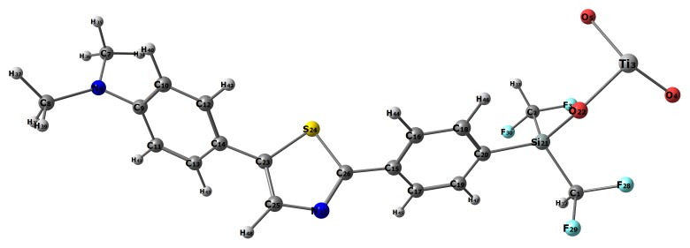
 | Bond Lengths (A) |  | Bond Angles (°)
R(1-21) |  | 1.88 |  | A(21-1-28) | 110.8
R(1-28) |  | 1.42 |  | A(21-1-29) | 108.9
R(1-29) |  | 1.42 |  | A(21-1-32) | 111.3
R(1-32) |  | 1.11 |  | A(1-21-2) | 111.0
R(2-21) |  | 1.88 |  | A(1-21-20) | 112.5
R(2-30) |  | 1.42 |  | A(1-21-22) | 106.2
R(2-31) |  | 1.42 |  | A(28-1-29) | 108.5
R(2-33) |  | 1.11 |  | A(28-1-32) | 107.1
R(3-4) |  | 2.07 |  | A(29-1-32) | 110.2
R(3-5) |  | 2.07 |  | A(21-2-30) | 111.4
R(3-22) |  | 2.07 |  | A(21-2-31) | 110.0
R(6-7) |  | 1.49 |  | A(21-2-33) | 109.6
R(6-8) |  | 1.49 |  | A(2-21-20) | 106.7
R(6-9) |  | 1.49 |  | A(2-21-22) | 110.9
R(7-34) |  | 1.12 |  | A(30-2-31) | 108.3
R(7-35) |  | 1.12 |  | A(30-2-33) | 107.5
R(7-36) |  | 1.11 |  | A(31-2-33) | 110.1
R(8-37) |  | 1.11 |  | A(4-3-5) | 111.3
R(8-38) |  | 1.11 |  | A(4-3-22) | 113.0
R(8-39) |  | 1.11 |  | A(5-3-22) | 112.0
R(9-10) |  | 1.39 |  | A(3-22-21) | 116.7
R(9-11) |  | 1.40 |  | A(7-6-8) | 122.2
R(10-12) |  | 1.40 |  | A(7-6-9) | 118.6
R(10-40) |  | 1.13 |  | A(6-7-34) | 112.5
R(11-13) |  | 1.41 |  | A(6-7-35) | 110.2
R(11-41) |  | 1.13 |  | A(6-7-36) | 111.8
R(12-14) |  | 1.40 |  | A(8-6-9) | 118.6
R(12-42) |  | 1.13 |  | A(6-8-37) | 112.2
R(13-14) |  | 1.39 |  | A(6-8-38) | 109.3
R(13-43) |  | 1.13 |  | A(6-8-39) | 112.8
R(14-23) |  | 1.51 |  | A(6-9-10) | 120.1
R(15-16) |  | 1.39 |  | A(6-9-11) | 120.0
R(15-17) |  | 1.39 |  | A(34-7-35) | 107.9
R(15-26) |  | 1.49 |  | A(34-7-36) | 105.7
R(16-18) |  | 1.40 |  | A(35-7-36) | 108.5
R(16-44) |  | 1.13 |  | A(37-8-38) | 108.9
R(17-19) |  | 1.41 |  | A(37-8-39) | 105.5
R(17-45) |  | 1.13 |  | A(38-8-39) | 107.9
R(18-20) |  | 1.39 |  | A(10-9-11) | 120.0
R(18-46) |  | 1.12 |  | A(9-10-12) | 119.8
R(19-20) |  | 1.39 |  | A(9-10-40) | 119.2
R(19-47) |  | 1.12 |  | A(9-11-13) | 120.2
R(20-21) |  | 1.89 |  | A(9-11-41) | 118.6
R(21-22) |  | 1.78 |  | A(12-10-40) | 121.0
R(23-24) |  | 1.81 |  | A(10-12-14) | 120.2
R(23-25) |  | 1.39 |  | A(10-12-42) | 121.1
R(24-26) |  | 1.81 |  | A(13-11-41) | 121.1
R(25-27) |  | 1.39 |  | A(11-13-14) | 119.5
R(25-48) |  | 1.11 |  | A(11-13-43) | 121.5
R(26-27) |  | 1.39 |  | A(14-12-42) | 118.7
 |  |  |  | A(12-14-13) | 120.2
 |  |  |  | A(12-14-23) | 117.5
 |  |  |  | A(14-13-43) | 118.9
 |  |  |  | A(17-15-26) | 122.5
 |  |  |  | A(15-17-19) | 119.5
 |  |  |  | A(15-17-45) | 118.7
 |  |  |  | A(15-26-24) | 120.2
 |  |  |  | A(15-26-27) | 126.5
 |  |  |  | A(18-16-44) | 121.1
 |  |  |  | A(16-18-20) | 120.3
 |  |  |  | A(16-18-46) | 121.0
 |  |  |  | A(19-17-45) | 121.8
 |  |  |  | A(17-19-20) | 120.4
 |  |  |  | A(17-19-47) | 121.3
 |  |  |  | A(20-18-46) | 118.7
 |  |  |  | A(18-20-19) | 119.6
 |  |  |  | A(18-20-21) | 119.4
 |  |  |  | A(20-19-47) | 118.3
 |  |  |  | A(19-20-21) | 121.0
 |  |  |  | A(20-21-22) | 109.5
 |  |  |  | A(24-23-25) | 112.1
 |  |  |  | A(23-24-26) | 87.5
 |  |  |  | A(23-25-27) | 114.5
 |  |  |  | A(23-25-48) | 123.5
 |  |  |  | A(24-26-27) | 113.2
 |  |  |  | A(27-25-48) | 122.0
 |  |  |  | A(25-27-26) | 112.7

Table S7. NBO analysis of Ref-D
Donor (i) | Type | Acceptor (j) | Type | E⁽²⁾ | E(j)E(i) (au) | F_{i,j} (au)
Ti1-O2 | π | Ti1-O3 | π* | 1.35 | 0.60 | 0.036
Ti1-O2 | π | Ti1-O22 | π* | 1.21 | 0.59 | 0.034
Ti1-O3 | π | Ti1-O2 | π* | 1.31 | 0.60 | 0.035
Ti1-O3 | π | Ti1-O22 | π* | 1.17 | 0.59 | 0.033
Ti1-O22 | π | Ti1-O2 | π* | 1.36 | 0.62 | 0.037
Ti1-O22 | π | Ti1-O3 | π* | 1.22 | 0.62 | 0.035
Ti1-O22 | π | Si19-O20 | π* | 0.54 | 0.54 | 0.022
Ti1-O22 | π | Si19-O21 | π* | 2.50 | 0.53 | 0.047
C7-C9 | π | C8-C10 | π* | 0.37 | 1.17 | 0.026
C7-C9 | π | C8-H38 | π* | 0.96 | 1.02 | 0.040
C7-C9 | π | C9-H39 | π* | 0.33 | 1.02 | 0.023
C7-C9 | π | C11-C12 | π* | 0.42 | 1.18 | 0.028
C7-C9 | π | C11-H41 | π* | 1.00 | 1.02 | 0.040
C8-C10 | π | C7-C9 | π* | 0.36 | 1.18 | 0.026
C8-C10 | π | C8-H38 | π* | 0.38 | 1.02 | 0.025
C8-C10 | π | C10-H40 | π* | 0.37 | 1.01 | 0.024
C11-C12 | π | C7-C9 | π* | 0.41 | 1.18 | 0.028
C11-C12 | π | C8-C10 | π* | 0.38 | 1.17 | 0.027
C11-C12 | π | C9-H39 | π* | 0.98 | 1.02 | 0.040
C11-C12 | π | C10-H40 | π* | 0.98 | 1.02 | 0.040
C11-C12 | π | C11-H41 | π* | 0.36 | 1.02 | 0.024
C11-C12 | π | C12-C23 | π* | 0.37 | 1.04 | 0.025
C11-C12 | π | C23-C25 | π* | 0.69 | 0.68 | 0.029
C11-H41 | π | C7-C9 | π* | 1.05 | 1.06 | 0.042
C11-H41 | π | C9-C11 | π* | 0.45 | 1.05 | 0.028
C11-H41 | π | C9-H39 | π* | 0.42 | 0.90 | 0.025
C11-H41 | π | C10-C12 | π* | 1.10 | 1.06 | 0.043
C11-H41 | π | C11-C12 | π* | 0.44 | 1.05 | 0.027
C11-H41 | π | C12-C23 | π* | 0.55 | 0.91 | 0.028
C12-C23 | π | C8-C10 | π* | 0.99 | 1.12 | 0.042
C12-C23 | π | C9-C11 | π* | 0.93 | 1.12 | 0.041
C12-C23 | π | C10-C12 | π* | 0.36 | 1.12 | 0.026
C12-C23 | π | C10-H40 | π* | 0.38 | 0.96 | 0.024
C12-C23 | π | C11-C12 | π* | 0.43 | 1.12 | 0.028
C12-C23 | π | C11-H41 | π* | 0.37 | 0.96 | 0.024
C12-C23 | π | C23-C25 | π* | 0.52 | 1.12 | 0.030
C12-C23 | π | C25-N27 | π* | 0.88 | 1.04 | 0.038

Table S8. NBO analysis of dye D-1
Donor (i) | Type | Acceptor (j) | Type | E⁽²⁾ | E(j)E(i) (au) | F_{i,j} (au)
C8-C10 | π | C11-C12 | π* | 0.38 | 1.17 | 0.027
C8-C10 | π | C12-C23 | π* | 0.94 | 1.03 | 0.039
C8-H38 | π | C7-C8 | π* | 0.40 | 1.05 | 0.026
C8-H38 | π | C7-C9 | π* | 1.06 | 1.05 | 0.042
C8-H38 | π | C8-C10 | π* | 0.48 | 1.05 | 0.028
C8-H38 | π | C10-C12 | π* | 1.07 | 1.05 | 0.042
C8-H38 | π | C10-H40 | π* | 0.43 | 0.89 | 0.025
C9-C11 | π | C7-C8 | π* | 0.36 | 1.17 | 0.026
C9-C11 | π | C9-H39 | π* | 0.38 | 1.02 | 0.025
C9-C11 | π | C10-C12 | π* | 0.39 | 1.17 | 0.027
C9-C11 | π | C11-H41 | π* | 0.36 | 1.01 | 0.024
C9-C11 | π | C12-C23 | π* | 0.97 | 1.03 | 0.040
C9-C11 | π | C7-C8 | π* | 11.27 | 0.29 | 0.072
C9-C11 | π | C10-C12 | π* | 11.24 | 0.29 | 0.072
C9-H39 | π | C7-C8 | π* | 1.06 | 1.05 | 0.042
C9-H39 | π | C7-C9 | π* | 0.39 | 1.06 | 0.026
C9-H39 | π | C9-C11 | π* | 0.47 | 1.05 | 0.028
C9-H39 | π | C11-C12 | π* | 1.07 | 1.05 | 0.042
C9-H39 | π | C11-H41 | π* | 0.42 | 0.89 | 0.024
C10-C12 | π | C7-C8 | π* | 0.42 | 1.18 | 0.028
C10-C12 | π | C8-H38 | π* | 0.99 | 1.02 | 0.040
C10-C12 | π | C9-C11 | π* | 0.39 | 1.17 | 0.027
C10-C12 | π | C10-H40 | π* | 0.37 | 1.02 | 0.024
C10-C12 | π | C11-H41 | π* | 0.98 | 1.02 | 0.040
C10-C12 | π | C12-C23 | π* | 0.42 | 1.04 | 0.026
C10-C12 | π | C23-C25 | π* | 0.66 | 0.68 | 0.029
C10-C12 | π | C7-C8 | π* | 10.85 | 0.29 | 0.071
C10-C12 | π | C9-C11 | π* | 11.17 | 0.29 | 0.072
C10-C12 | π | C23-C25 | π* | 0.96 | 0.79 | 0.038
C10-C12 | π | C23-C25 | π* | 1.95 | 0.29 | 0.030
C10-H40 | π | C7-C8 | π* | 1.04 | 1.06 | 0.042
C10-H40 | π | C8-C10 | π* | 0.45 | 1.05 | 0.027
C10-H40 | π | C8-H38 | π* | 0.41 | 0.90 | 0.024
C10-H40 | π | C10-C12 | π* | 0.43 | 1.06 | 0.027
C10-H40 | π | C11-C12 | π* | 1.09 | 1.06 | 0.043

Table S9. NBO analysis of dye D-2
Donor (i) | Type | Acceptor (j) | Type | E⁽²⁾ | E(j)E(i) (au) | F_{i,j} (au)
C13-C14 | π | C13-C26 | π* | 0.47 | 1.03 | 0.028
C13-C14 | π | C14-H42 | π* | 0.38 | 1.02 | 0.025
C13-C14 | π | C15-C17 | π* | 0.39 | 1.17 | 0.027
C13-C14 | π | C15-H43 | π* | 0.97 | 1.03 | 0.040
C13-C14 | π | C16-C18 | π* | 0.40 | 1.20 | 0.028
C13-C14 | π | C16-H44 | π* | 1.00 | 1.02 | 0.040
C13-C14 | π | C26-N27 | π* | 0.55 | 1.09 | 0.031
C13-C14 | π | C26-N27 | π* | 0.25 | 0.66 | 0.018
C13-C14 | π | C15-C17 | π* | 10.94 | 0.29 | 0.072
C13-C14 | π | C16-C18 | π* | 10.63 | 0.29 | 0.071
C13-C14 | π | C26-N27 | π* | 0.45 | 0.69 | 0.024
C13-C14 | π | C26-N27 | π* | 5.91 | 0.26 | 0.050
C13-C15 | π | C13-C26 | π* | 0.39 | 1.02 | 0.025
C13-C15 | π | C14-C16 | π* | 0.39 | 1.17 | 0.027
C13-C15 | π | C14-H42 | π* | 1.01 | 1.02 | 0.040
C13-C15 | π | C15-H43 | π* | 0.34 | 1.03 | 0.024
C13-C15 | π | C17-C18 | π* | 0.39 | 1.19 | 0.027
C13-C15 | π | C17-H45 | π* | 0.97 | 1.02 | 0.040
C13-C26 | π | C13-C14 | π* | 0.39 | 1.13 | 0.026
C13-C26 | π | C13-C15 | π* | 0.47 | 1.13 | 0.029
C13-C26 | π | C14-C16 | π* | 0.97 | 1.12 | 0.042
C13-C26 | π | C14-H42 | π* | 0.39 | 0.97 | 0.025
C13-C26 | π | C15-C17 | π* | 0.88 | 1.12 | 0.040
C13-C26 | π | C15-H43 | π* | 0.35 | 0.98 | 0.023
C13-C26 | π | C25-N27 | π* | 0.68 | 1.04 | 0.034
C13-C26 | π | C26-N27 | π* | 0.79 | 1.03 | 0.036
C14-C16 | π | C13-C15 | π* | 0.38 | 1.17 | 0.027

Table S10. NBO analysis of dye D-3
Donor (i) | Type | Acceptor (j) | Type | E⁽²⁾ | E(j)E(i) (au) | F_{i,j} (au)
C14-C16 | π | C13-C26 | π* | 0.94 | 1.02 | 0.039
C14-C16 | π | C14-H42 | π* | 0.34 | 1.01 | 0.023
C14-C16 | π | C16-H44 | π* | 0.37 | 1.02 | 0.024
C14-C16 | π | C17-C18 | π* | 0.40 | 1.19 | 0.027
C14-C16 | π | C18-Si19 | π* | 0.74 | 0.87 | 0.033
C14-H42 | π | C13-C14 | π* | 0.47 | 1.06 | 0.028
C14-H42 | π | C13-C15 | π* | 1.06 | 1.06 | 0.042
C14-H42 | π | C13-C26 | π* | 0.57 | 0.91 | 0.029
C14-H42 | π | C14-C16 | π* | 0.43 | 1.05 | 0.027
C14-H42 | π | C16-C18 | π* | 1.06 | 1.08 | 0.043
C14-H42 | π | C16-H44 | π* | 0.43 | 0.90 | 0.025
C15-C17 | π | C13-C14 | π* | 0.39 | 1.17 | 0.027
C15-C17 | π | C13-C26 | π* | 1.01 | 1.02 | 0.041
C15-C17 | π | C15-H43 | π* | 0.36 | 1.02 | 0.024
C15-C17 | π | C16-C18 | π* | 0.41 | 1.19 | 0.028
C15-C17 | π | C17-H45 | π* | 0.37 | 1.02 | 0.025
C15-C17 | π | C18-Si19 | π* | 0.78 | 0.87 | 0.034
C15-C17 | π | C13-C14 | π* | 11.02 | 0.28 | 0.071
C15-C17 | π | C16-C18 | π* | 11.59 | 0.29 | 0.073
C15-H43 | π | C13-C14 | π* | 1.09 | 1.05 | 0.043
C15-H43 | π | C13-C15 | π* | 0.45 | 1.04 | 0.027
C15-H43 | π | C13-C26 | π* | 0.58 | 0.89 | 0.029
C15-H43 | π | C15-C17 | π* | 0.49 | 1.04 | 0.028
C15-H43 | π | C17-C18 | π* | 1.07 | 1.06 | 0.043
C15-H43 | π | C17-H45 | π* | 0.44 | 0.89 | 0.025

Table S11. NBO analysis of dye D-4
Donor (i) | Type | Acceptor (j) | Type | E⁽²⁾ | E(j)E(i) (au) | F_{i,j} (au)
C16-C18 | π | C14-H42 | π* | 0.99 | 1.02 | 0.040
C16-C18 | π | C15-C17 | π* | 0.41 | 1.17 | 0.028
C16-C18 | π | C16-H44 | π* | 0.34 | 1.02 | 0.024
C16-C18 | π | C17-H45 | π* | 0.99 | 1.02 | 0.040
C16-C18 | π | C18-Si19 | π* | 0.42 | 0.88 | 0.025
C16-C18 | π | C13-C14 | π* | 11.05 | 0.28 | 0.071
C16-C18 | π | C15-C17 | π* | 11.35 | 0.28 | 0.072
C16-H44 | π | C13-C14 | π* | 1.05 | 1.06 | 0.042
C16-H44 | π | C14-C16 | π* | 0.45 | 1.05 | 0.027
C16-H44 | π | C14-H42 | π* | 0.41 | 0.90 | 0.024
C16-H44 | π | C16-C18 | π* | 0.39 | 1.07 | 0.026
C16-H44 | π | C17-C18 | π* | 1.13 | 1.07 | 0.044
C17-C18 | π | C13-C15 | π* | 0.41 | 1.17 | 0.028
C17-C18 | π | C14-C16 | π* | 0.40 | 1.17 | 0.027
C17-C18 | π | C15-H43 | π* | 0.94 | 1.03 | 0.039
C17-C18 | π | C16-H44 | π* | 1.00 | 1.02 | 0.040
C17-C18 | π | C17-H45 | π* | 0.33 | 1.02 | 0.023
C17-C18 | π | C18-Si19 | π* | 0.46 | 0.88 | 0.026
C17-H45 | π | C13-C15 | π* | 1.04 | 1.06 | 0.042
C17-H45 | π | C15-C17 | π* | 0.45 | 1.05 | 0.027
C17-H45 | π | C15-H43 | π* | 0.40 | 0.91 | 0.024
C17-H45 | π | C16-C18 | π* | 1.12 | 1.08 | 0.044
C17-H45 | π | C17-C18 | π* | 0.39 | 1.07 | 0.026
C17-H45 | π | C18-Si19 | π* | 0.25 | 0.76 | 0.018
C18-Si19 | π | C14-C16 | π* | 1.56 | 0.99 | 0.050
C18-Si19 | π | C15-C17 | π* | 1.53 | 0.99 | 0.050
C18-Si19 | π | C16-C18 | π* | 0.85 | 1.01 | 0.038
C18-Si19 | π | C16-H44 | π* | 0.64 | 0.84 | 0.030
C18-Si19 | π | C17-C18 | π* | 0.94 | 1.01 | 0.039
C18-Si19 | π | C17-H45 | π* | 0.61 | 0.84 | 0.029

Table S12. NBO analysis of dye D-5
Donor (i) | Type | Acceptor (j) | Type | E⁽²⁾ | E(j)E(i) (au) | F_{i,j} (au)
C23-S24 | π | C25-N27 | π* | 1.25 | 0.97 | 0.044
C23-S24 | π | C25-H46 | π* | 1.54 | 0.90 | 0.047
C23-S24 | π | C26-N27 | π* | 0.80 | 0.96 | 0.035
C23-C25 | π | C23-S24 | π* | 1.25 | 0.82 | 0.041
C23-C25 | π | S24-C26 | π* | 0.29 | 0.81 | 0.020
C23-C25 | π | C25-N27 | π* | 0.67 | 1.10 | 0.034
C23-C25 | π | C25-H46 | π* | 0.34 | 1.04 | 0.024
C23-C25 | π | C10-C12 | π* | 0.92 | 0.80 | 0.035
C23-C25 | π | C10-C12 | π* | 1.56 | 0.30 | 0.029
C23-C25 | π | C11-C12 | π* | 0.86 | 0.80 | 0.034
C23-C25 | π | C26-N27 | π* | 8.39 | 0.28 | 0.064
S24-C26 | π | C12-C23 | π* | 0.70 | 0.91 | 0.032
S24-C26 | π | C13-C14 | π* | 0.27 | 1.05 | 0.022
S24-C26 | π | C13-C14 | π* | 0.32 | 0.55 | 0.018
S24-C26 | π | C13-C15 | π* | 0.54 | 1.05 | 0.030
S24-C26 | π | C13-C26 | π* | 1.81 | 0.90 | 0.051
S24-C26 | π | C23-C25 | π* | 0.34 | 1.05 | 0.024
S24-C26 | π | C25-N27 | π* | 0.34 | 0.97 | 0.023
S24-C26 | π | C26-N27 | π* | 3.00 | 0.96 | 0.068
C25-N27 | π | C12-C23 | π* | 1.08 | 1.06 | 0.043
C25-N27 | π | C13-C26 | π* | 1.31 | 1.04 | 0.047
C25-N27 | π | C23-S24 | π* | 0.70 | 0.83 | 0.031
C25-N27 | π | S24-C26 | π* | 1.05 | 0.82 | 0.038
C25-N27 | π | C25-H46 | π* | 0.61 | 1.05 | 0.032
C25-N27 | π | C26-N27 | π* | 0.91 | 1.10 | 0.040
C25-H46 | π | C12-C23 | π* | 0.36 | 0.93 | 0.023
C25-H46 | π | C23-S24 | π* | 1.15 | 0.70 | 0.036
C25-H46 | π | C23-C25 | π* | 0.38 | 1.07 | 0.026
C25-H46 | π | C25-N27 | π* | 0.63 | 0.98 | 0.031
C25-H46 | π | C26-N27 | π* | 0.82 | 0.97 | 0.036
C26-N27 | π | C13-C14 | π* | 0.28 | 1.20 | 0.023
C26-N27 | π | C13-C26 | π* | 0.93 | 1.05 | 0.039
C26-N27 | π | C23-S | π* | 0.32 | 0.84 | 0.021
C26-N27 | π | C23-C25 | π* | 0.73 | 1.20 | 0.037
C26-N27 | π | S24-C26 | π* | 1.10 | 0.83 | 0.039
C26-N27 | π | C25-N27 | π* | 0.63 | 1.12 | 0.034
C26-N27 | π | C25-H46 | π* | 1.51 | 1.05 | 0.050
C26-N27 | π | C13-C14 | π* | 0.32 | 0.80 | 0.021
C26-N27 | π | C13-C14 | π* | 3.86 | 0.31 | 0.046
C26-N27 | π | C13-C15 | π* | 0.28 | 0.80 | 0.019
C26-N27 | π | C23-C25 | π* | 9.83 | 0.31 | 0.072
C28-C29 | π | Si19-O20 | π* | 0.67 | 0.70 | 0.028
C28-C29 | π | O20-C28 | π* | 0.35 | 0.85 | 0.022
C28-H47 | π | O20-C28 | π* | 0.69 | 0.83 | 0.030
C28-H47 | π | C28-C29 | π* | 0.26 | 0.83 | 0.019
C28-H47 | π | C29-H51 | π* | 0.84 | 0.89 | 0.035
C28-H48 | π | O20-C28 | π* | 0.95 | 0.83 | 0.036
C28-H48 | π | C29-H50 | π* | 0.81 | 0.90 | 0.034
C29-H49 | π | O20-C28 | π* | 1.16 | 0.82 | 0.039
C29-H49 | π | C28-C29 | π* | 0.34 | 0.82 | 0.021
C29-H50 | π | O20-C28 | π* | 0.31 | 0.81 | 0.020
C29-H50 | π | C28-C29 | π* | 0.26 | 0.82 | 0.019
C29-H50 | π | C28-H48 | π* | 0.81 | 0.85 | 0.033
C29-H51 | π | C28-C29 | π* | 0.27 | 0.82 | 0.019
C29-H51 | π | C28-H47 | π* | 0.78 | 0.86 | 0.033
C30-C31 | π | O21-C30 | π* | 1.28 | 0.85 | 0.042
C30-C31 | π | C30-H53 | π* | 0.33 | 0.89 | 0.022
C30-H52 | π | Si19-O21 | π* | 1.07 | 0.70 | 0.036
C30-H52 | π | C30-C31 | π* | 0.27 | 0.83 | 0.019
C30-H53 | π | Ti1-O22 | π* | 0.42 | 0.79 | 0.023
C30-H53 | π | O21-C30 | π* | 0.84 | 0.84 | 0.034
C30-H53 | π | C30-C31 | π* | 0.39 | 0.84 | 0.023
C30-H53 | π | C31-H54 | π* | 0.74 | 0.92 | 0.033
C31-H54 | π | O21-C30 | π* | 0.38 | 0.81 | 0.022
C31-H54 | π | C30-C31 | π* | 0.27 | 0.81 | 0.019
C31-H54 | π | C30-H53 | π* | 0.88 | 0.85 | 0.035
C31-H55 | π | O21-C30 | π* | 1.18 | 0.81 | 0.039
C31-H55 | π | C30-C31 | π* | 0.30 | 0.81 | 0.020
C31-H56 | π | C30-C31 | π* | 0.37 | 0.81 | 0.022
C31-H56 | π | C30-H52 | π* | 0.72 | 0.86 | 0.032

Table S13. NBO tensor of average polarizability <α>
 | Ref-D | D-1 | D-2 | D-3 | D-4 | D-5
XX | 71.0228 | -191.6356 | -188.8905 | -177.2011 | -176.3311 | -184.5049
YY | -21.6992 | -190.8255 | -165.1422 | -187.4746 | -180.3479 | -187.4942
ZZ | -49.3236 | -193.1090 | -188.5707 | -181.9749 | -164.0286 | -177.5829
XY | -42.8758 | 14.1561 | 15.7587 | 33.9252 | -24.3316 | 3.9310
XZ | 24.7952 | -19.6876 | -6.7151 | -3.9677 | -22.2505 | 17.9813
YZ | -5.6182 | -6.3096 | -4.6335 | 1.2455 | -4.6401 | -15.3838

Table S14. NBO tensor of second order hyper polarizability (β)
 | Ref-D | D-1 | D-2 | D-3 | D-4 | D-5
XXX | 1069.8580 | 300.1037 | 448.3597 | -197.4974 | -325.9283 | 156.6554
YYY | -51.0416 | 19.8061 | -36.5595 | -38.0136 | 3.2614 | 5.3710
ZZZ | 9.8084 | -0.8809 | -1.1210 | -0.3493 | 0.8961 | -1.5376
XYY | 122.6072 | -25.3582 | -111.3951 | 1.4638 | -44.6551 | -53.3472
XXY | -483.7966 | -68.9154 | -123.4803 | 214.4812 | -110.7446 | 43.1365
XXZ | 223.2229 | 196.9839 | 30.1087 | -50.6749 | -154.9022 | -119.2276
XZZ | 28.3640 | -2.4033 | 25.0456 | -22.0891 | 38.5558 | -117.9086
YZZ | -7.4683 | 5.1079 | -10.2307 | 6.3884 | 22.7129 | 24.0788
YYZ | 19.0500 | 9.0733 | 7.0420 | 2.4035 | 3.2736 | 2.0488
XYZ | -54.4386 | 29.7823 | 28.6678 | 9.6253 | -32.7433 | 60.8792

Table S15. NBO tensor of average polarizability (γ)
 | D-1 | D-2 | D-3 | D-4 | D-5
XXXX | -11903.9421 | -39786.6451 | -37336.2147 | -35207.9730 | -36242.6097
YYYY | -1439.6773 | -1973.4944 | -2101.4324 | -2723.6760 | -2782.4025
ZZZZ | -610.8935 | -898.8818 | -1173.4920 | -678.8854 | -1004.4068
XXXY | -4204.1771 | 712.1164 | 2015.2098 | -1050.0125 | 185.7282
XXXZ | 2050.2463 | 68.0146 | 50.9440 | -1295.9649 | 661.9133
YYYX | -403.7013 | 130.9284 | -35.7726 | -215.9456 | 140.1010
YYYZ | -41.2539 | -15.8906 | -17.0424 | -10.1555 | -74.8188
ZZZX | 113.1858 | 3.0526 | -14.0842 | -12.7535 | 73.9958
ZZZY | -19.1668 | -12.6300 | 6.6894 | 0.0535 | -10.9036
XXYY | -3666.1108 | -6068.9405 | -6625.3167 | -6365.1136 | -6321.3026
XXZZ | -4666.9251 | -7010.0253 | -6743.9170 | -5432.4830 | -5871.5626
YYZZ | -336.8802 | -478.3320 | -547.1113 | -528.8105 | -550.0150
XXYZ | -409.0309 | -196.4863 | 199.1858 | -134.9810 | -418.1311
YYXZ | 142.0415 | -49.2126 | 23.9271 | 9.4093 | 109.7293
ZZXY | -66.2997 | 16.7033 | 61.8828 | 108.8315 | -101.1105

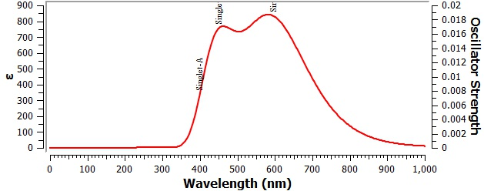

Fig S1. Computed UV spectra of dye Ref-D

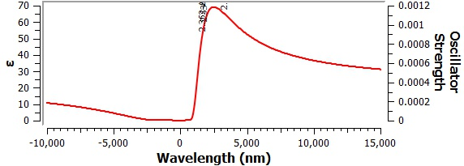
Fig S2. Computed UV spectra of dye D-1

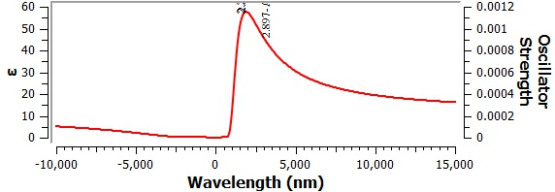
Fig S3. Computed UV spectra of dye D-2

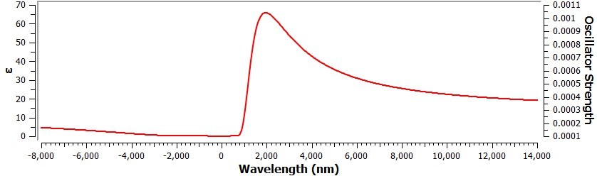 Fig S4. Computed UV spectra of dye D-3

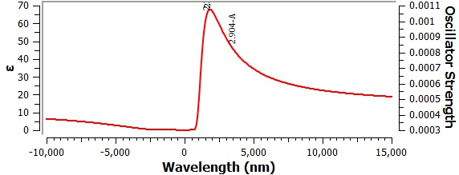

Fig S5. Computed UV spectra of dye D-4

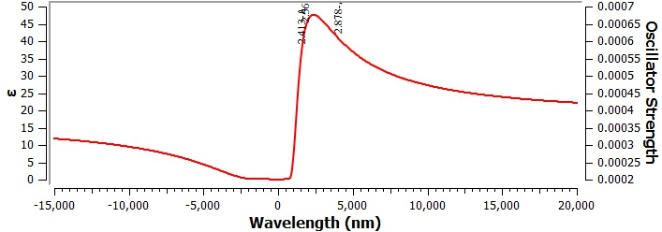
Fig S6. Computed UV spectra of dye D-5

