S1. Toxic unit (TU) values of heavy metals in sediments collected from Old Brahmaputra River, Mymensingh, Bangladesh.

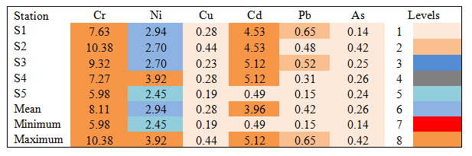
S2. The modified hazard quotient (mHQ) values of heavy metals in sediments collected from Old Brahmaputra River, Mymensingh, Bangladesh.

