SUPPLEMENTARY MATERIAL
Table S1: Geographic coordinates of centroids used for the establishment of 1-km buffer for each ranch. Datum UTM Zone 14,WGS84. Cattle management information and landscape metrics used in stadistical models.
Ranch | Longitude (W) | Latitude (N) | Cattle density | Herbicides | Fertilizers | Macrocyclic lactones | NP.osf | NP.tp | NP.cr | TE.cr | NP.ur
1 | 674341.9876 | 2244491.465 | low | Use | Use | No use | 122 | 295 | 79 | 16470 | 149
2 | 676654.5608 | 2247333.578 | high | No use | Use | Use | 69 | 46 | 95 | 27530 | 86
3 | 675835.0123 | 2249881.52 | high | Use | Use | Use | 44 | 44 | 64 | 16060 | 32
4 | 673403.5395 | 2254303.167 | high | Use | No use | Use | 137 | 286 | 106 | 35490 | 84
5 | 665679.8257 | 2257252.961 | high | No use | Use | No use | 53 | 329 | 253 | 61490 | 187
6 | 669190.4426 | 2258886.568 | high | No use | Use | No use | 28 | 140 | 36 | 13190 | 29
7 | 674720.0072 | 2260237.048 | high | Use | No use | Use | 45 | 162 | 121 | 34730 | 104
8 | 683165.5347 | 2252356.952 | high | Use | No use | Use | 0 | 286 | 176 | 29890 | 55
9 | 686290.4156 | 2251954.784 | low | Use | Use | Use | 13 | 126 | 19 | 4288.35 | 27
10 | 684012.7294 | 2240496.73 | low | No use | No use | Use | 0 | 165 | 7 | 1270.07 | 72
11 | 684282.7813 | 2239105.273 | low | Use | Use | Use | 0 | 74 | 9 | 3660.79 | 74
12 | 680547.1979 | 2264981.891 | high | Use | No use | No use | 55 | 216 | 120 | 24500 | 24
13 | 680883.8224 | 2265432.442 | low | No use | No use | No use | 22 | 36 | 21 | 23339.40 | 3
14 | 680166.7263 | 2269638.986 | low | No use | No use | No use | 27 | 111 | 18 | 9024.97 | 45
15 | 682625.5924 | 2270038.375 | high | Use | No use | Use | 46 | 182 | 43 | 7290 | 62
16 | 682365.5382 | 2270474.2 | high | No use | No use | No use | 44 | 0 | 26 | 8845.66 | 57
17 | 676559.6766 | 2276971.024 | high | Use | Use | Use | 45 | 17 | 34 | 5409.00 | 62
18 | 669024.4384 | 2276356.418 | low | No use | Use | Use | 6 | 60 | 10 | 2435.55 | 45
19 | 668486.8371 | 2270485.302 | low | No use | No use | Use | 29 | 110 | 24 | 10414.57 | 8
20 | 671150.6674 | 2271602.551 | low | Use | No use | Use | 0 | 75 | 7 | 2047.05 | 0
21 | 671094.8402 | 2265799.751 | high | Use | No use | Use | 36 | 116 | 53 | 16047.71 | 32

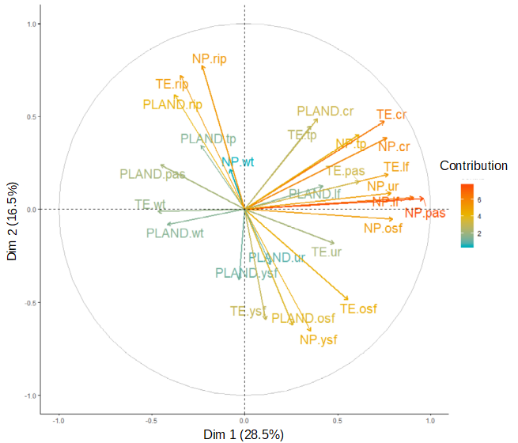

Figure S1. Principal Component Analysis (PCA) of landscape metrics. Colors indicate the degree of contribution of each landscape metric to each dimension, red for high contribution to blue for low contribution. Percentage of landscape (PLAND) of mature secondary forest (PLAND. osf), pastures (PLAND pas), live fences and isolated trees (PLAND. lf), tree plantations (PLAND. tp), crops (PLAND. cr), urban area and nude soil (PLAND. ur), water (PLAND. wt), young secondary forest (PLAND. ysf) and riparian vegetation (PLAND. rip). Number of patches (NP) of old-secondary forest (NP. osf), pastures (NP. pas), live fences and isolated trees (NP. lf), tree plantations (NP. tp), crops (NP. cr), urban area and nude soil (NP. ur), young secondary forest (NP. ysf), riparian vegetation (NP. rip), water (NP. wt). Total edge (TE) of old-secondary forest (TE. osf), pastures (TE. pas), pastures live fences and isolated trees (TE. lf), tree plantations (TE. tp), crops (TE. cr), pastures urban area and total edge of pastures nude soil (TE. ur), young secondary forest (TE. ysf), riparian vegetation TE.rip) and total edge of water (TE.wt).
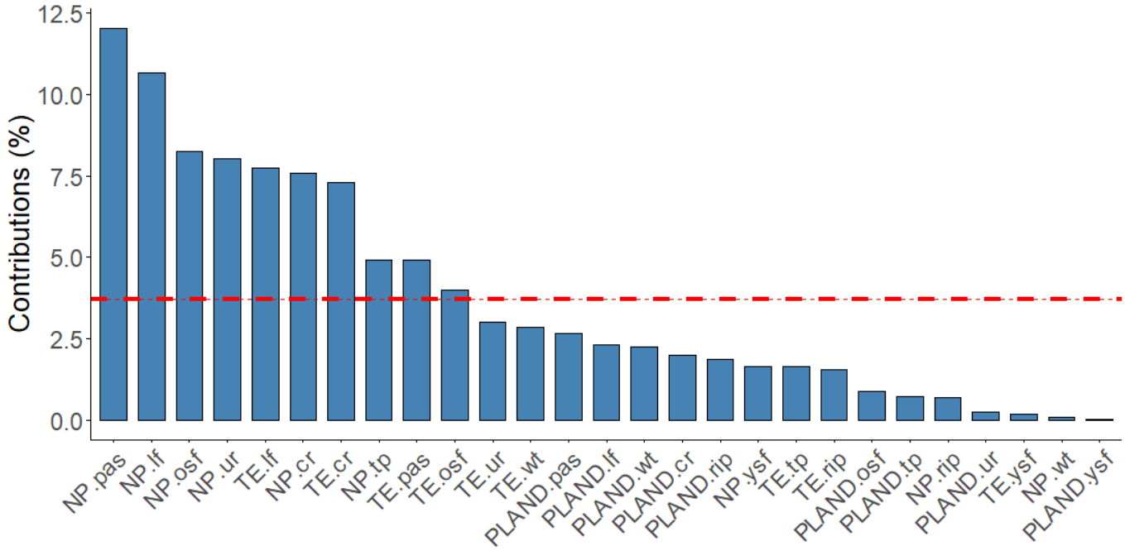

Figure S2. Contribution of landscape metrics to the first dimension of Principal Component Analysis (PCA). If the contribution of the variables were uniform, the expected value would be 1/length(variables) = 1/10 = 10%. For a given component, a variable with a contribution larger than the cut-off of expected average contribution could be considered as important in contributing to the component (Kassambara, 2017). For the analysis, we first identified the metrics above the cutoff of expected average contribution (dashed red line): Number of patches (NP) of pastures (NP. pas), live fences and isolated trees (NP. lf), old- secondary forest (NP. osf), urban area and nude soil (NP. ur), crops (NP. cr), tree plantations (NP. tp), as well as total edge (TE) of live fences and isolated trees (TE. lf), pastures (TE. pas), old secondary forest (TE. osf) and crops (TE. cr).

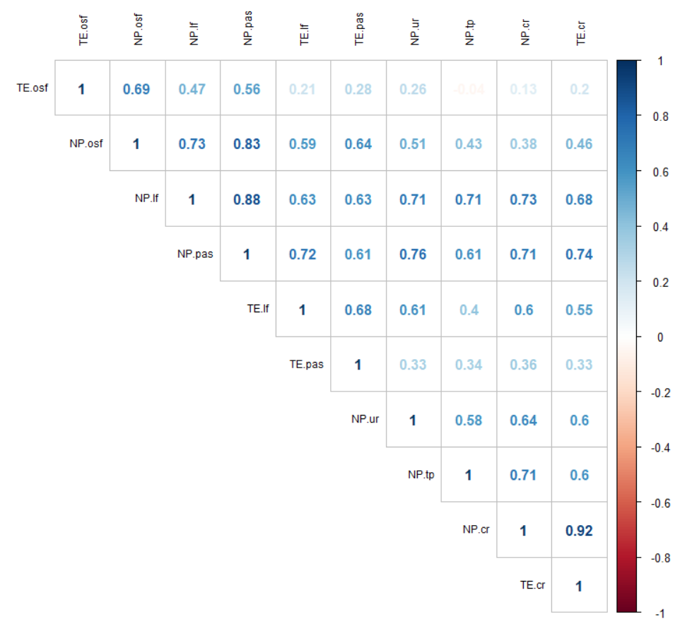

Figure S3. Correlogram of landscape metrics above the cutoff of expected average contribution s to the first dimension of Principal Component Analysis (PCA): Number of patches (NP) of pastures (NP. pas), live fences and isolated trees (NP. lf), old- secondary forest (NP. osf), urban area and nude soil (NP. ur), crops (NP. cr), tree plantations (NP. tp), as well as total edge (TE) of live fences and isolated trees (TE. lf), pastures (TE. pas), old secondary forest (TE. osf) and crops (TE. cr).

Supplementary material S2. Content of the survey instrument: semi-structured interviews delivered in one-on-one with ranch landowners or management. Questions are presented in English and Spanish, in order of administration.



INSTITUTO DE ECOLOGÍA, A. C.
Red de Ecoetología

MANAGEMENT PRACTICES QUESTIONNAIRE

IMPORTANT: THE INFORMATION PROVIDED IS CONFIDENTIAL AND NON-PROFIT MAKING

Date: ___________________________ Interviewer: __________________________________
RANCH INFORMATION
Ranch name: ________________________________________________ Locality: _______________________
Address: ______________________________________________________ Ranch extension: ___________ (ha)
Owner or administrator name: ______________________________________________________age: _________
e-mail/cellphone/telephone number: _______________________________________________________________
Years of ownership: _____________ Number of permanent workers: ____________
RANCH DESCRIPTION
Property regime: (private property) (ejidal) (rented property) (community property)
Of the total ranch surface, how many hectares are cattle pastures? ______ how many divisions do they have? ________
Do yo have a complementary crop(s) for cattle feeding? (Yes) (No) Which?: (Sugar cane) (Corn) (Improved pasture) (Leucaena) (Other) __________
How many hectares does this crop occupies? _________ When do you harvest? ___________________ Do you produce silage? (yes) (No)
How many trees do you have in your property? _______________________________________________________
Where do you have them? (in live fences) (in a woodland) (in forestal crops) (isolated in pastures)
Which of the following materials do you use as posts for your fences? (wood) (concrete) (metal) (live fences)

Do you have any water source in your property? (river) (natural spring) (water well) (watershed) (none)
How would you describe such water source? (clean) (dirty) (always available) (it dries periodically) (it dried a while ago)
Is there a woodland in your property? (Yes) (No) Of how many Ha? ____________________________
LAND MANAGEMENT
When was your land cleared? (_____ years) (doesn´t know or remember) (it was already cleared when I got here)
When as the last time you cleared your land? (_____ years) (doesn´t know or remember) (doesn´t clear anymore)
Do you control weeds manually? (Yes) (No) When? ______________________________
Do you implement pasture burning? (Yes) (No) When? ______________________________
What herbicides do you use for weed control? ___________________________________________________________________________________________
Please mention the dose per hectare of herbicide? ______________
Please mention the number of herbicide applications per year ___________________ Where do you apply it?______________________________
What kind of fertilizer do you apply? (manure) (synthetic fertilizer) (don’t use) (don’t know) (other) __________________
Please mention the number of fertilizer applications per year _________________ If you apply synthetic fertilizer, please mention the product you apply_____________________

Have you notice any changes in the quality of the pasture over the years? If so, please describe it. ____________________________________________________________________________________________________________________________________________________________________________________________________________________________________________________________________________________________________________________________________________________________________________

HERD INFORMATION
Which of the following is the productive purpose of your ranch? (milk) (cow-calf operations) (backgrounding) (dual purpose) (other) ______________
Which breed do you have? ____________________ adults average weigth? ________________
Total head of livestock____________
What kind of cattle management do you use? (Stabled livestock) (extensive) (semi extensive) (Silvopastoral)
What do you use to feed your cattle? (pasture) (chopped pasture) (forage) (silage) (alimento balanceado)
do use any mineral supplement? (yes) (no) Which one? ______________________________
HERD PARASITE CONTROL
Which deworming product do you use for your cattle? ____________________________________________________________
Please mention dose and applying method ____________________
Do you apply it according to which of the following criteria? (age) (symptoms) (by season) (due to recomendations) (does not know)
How long have you been using deworming products on your cattle? (_____ years) (always) (does not know or does not remember) (use discontinued)
How often do you ask for veterinarian advice? (due to serious illness) (Regularly) (sometimes) (never)

INSTITUTO DE ECOLOGÍA, A. C. - Red de Ecoetología

ENCUESTA SOBRE PRÁCTICAS GANADERAS

IMPORTANTE: LA INFORMACIÓN QUE PROPORCIONE ES CONFIDENCIAL SIN FINES DE LUCRO

Fecha de la encuesta _____________________ Nombre del encuestador: ______________________________
DATOS DEL RANCHO
Nombre del rancho: __________________________________________ Municipio: _______________________
Dirección del rancho: ________________________________________ superficie del rancho: ___________ (ha)
Nombre del propietario o responsable: _______________________________________________edad: ______
Correo electrónico y/o celular para recibir información: _____________________________________________________
Años de ser el dueño o responsable del rancho: ________ # de personas de planta que trabajan ahí __________
DESCRIPCIÓN DEL RANCHO
¿Qué superficie del rancho son pastizales para el ganado? _______ ¿está divido en cuántos potreros? _______
¿Qué cultivo de apoyo tiene para alimentar a su ganado? (caña) (maíz) (pasto mejorado) (Leucaena) (otro) _____
¿Cuál es la superficie de ese cultivo? ___________ ¿Cuándo lo cultiva? _____________________ ¿lo ensila? (no) (si)
¿Qué árboles tiene en su rancho? _____________________________________________________________________
¿Dónde tiene esos árboles? (en linderos/cerca) (en monte) (en cultivo forestal) (aislados en potrero) (no tiene)
¿Qué material usa cómo postes? (madera) (cemento) (metal) (árboles o arbustos vivos)
¿Tiene algún cuerpo de agua en su rancho? (rio) (manantial) (pozo) (olla) (colecta agua de lluvia) (ninguno)
¿Cómo está esa fuente de agua? (limpia) (sucia) (siempre disponible) (se seca periódicamente) (ya se secó)
¿Conserva alguna zona con monte en su rancho? (No) (SI) ¿De qué tamaño? ______________________
MANEJO DEL TERRENO
¿Cuándo se inició el desmonte en su terreno? (_____ años) (no sabe o recuerda) (ya estaba así cuando llegó)
¿Cuándo fue la última vez que desmontó su terreno? (_____ años) (no sabe o recuerda) (ya no desmonta)
¿Acostumbra chapear su terreno? (No) (Si) ¿Cuándo? ______________________________
¿Acostumbra quemar el pastizal? (No) (Si) ¿Cuándo? ______________________________
¿Qué productos químicos usa para controlar las malezas? __________________________________________________
¿Cuál es la dosis por hectárea del herbicida? ______________
¿Cuántas veces aplica herbicidas al año? ______________ ¿Dónde lo aplica?___________________________
¿Qué tipo de abono usa en su terreno? (estiércol) (fertilizante) (nada) (no sabe) (otro) __________________
¿Cada cuándo aplica el abono o fertilizante? ______________ Si es fertilizante ¿cuál usa? _________________
¿Qué sustancias utiliza? ___________________________________________________________________________
INFORMACIÓN SOBRE EL GANADO
¿Cuál es el objetivo de su rancho? (leche) (de cría) (engorda) (doble propósito) (otro) ______________
¿Cuál es la raza del ganado? _______________ ¿cuál es el peso promedio de los adultos? ________________
¿Cuántas cabezas vacunAS tiene en total? ____________
¿Qué tipo de manejo realiza? (estabulado) (extensivo) (semi extensivo) (Silvopastoril)
¿Qué utiliza para alimentar al ganado? (pasto) (pasto de corte) (forraje) (ensilados) (alimento balanceado)
¿Utiliza algún suplemento mineral para su ganado? (No) (Si) ¿Cuál? ______________________________
CONTROL DE PARÁSITOS DEL GANADO
¿Qué desparasitantes usa para su ganado ______________________________________________________
¿Cuál es la dosis y vía de aplicación de esos productos? ____________ (intramuscular) (oral) (tópico) (otro)
¿Aplica el producto a su ganado según? (la edad) (los síntomas) (la temporada) (por recomendación) (no sabe)
¿Qué tiempo tiene de usar desparasitantes en su ganado? (_____ años) (siempre) (no sabe o recuerda) (ya no usa)

