Antimicrobial activity of synthesized Graphene Oxide-Selenium nanocomposites: A mechanistic insight
Isha Riyal^{ǂ a}, Ayush Badoni^{ǂ a}, Shubham S. Kaluraª, Kavita Mishraª, Himani Sharma^{b}, Lokesh Gambhir^{c},
Charu Dwivedi^{a*}
ªDepartment of Chemistry, Doon University, Dehradun-248001, India
^{b}Department of Physics, Doon University, Dehradun-248001, India
^{c}SGRR ITS campus, Dehradun-248001, India.
Email address: cdwivedi.ch@doonuniversity.ac.in
Supplementary Information

HRTEM-SAED Analysis
Fig. S1 demonstrated that the structure of GO is polycrystalline based on a set of concentric rings with various radii. The lattice spacings of the (111), (010), (110), (221), and (120) planes of GO are calculated to be 0.2952 nm, 0.2220 nm, 0.1878 nm, 0.1372 nm and 0.1153 nm, respectively, between the various diffraction rings and the diffraction centre (Wang et al. 2015).
S.no. | Label | 1/2r (1/nm) | 1/r (1/nm) | r (nm) | d-spacing (Å) | hkl
1 | Diff on S1. | 6.774 | 3.387 | 0.2952 | 2.952 | (111)
2 | Diff on S1. | 9.007 | 4.5035 | 0.2220 | 2.220 | (010)
3 | Diff on S1. | 10.647 | 5.3235 | 0.1878 | 1.878 | (110)
4 | Diff on S1. | 14.567 | 7.2835 | 0.1372 | 1.372 | (221)
5 | Diff on S1. | 17.344 | 8.672 | 0.1153 | 1.153 | (120)
Table 1: Representing d-spacing and hkl planes of GO

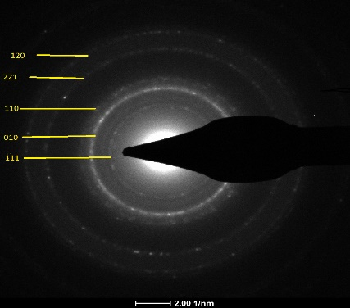
Fig. S1: SAED pattern of GO
XPS Analysis
Fig. S2 (a) and (b) shows the survey scan of GO and GO-Se. It revealed that the indexed peaks correspond to carbon, oxygen and selenium. When compared to O 1s and C 1s of GO, the peak intensities of O 1s and C 1s in the GO-Se sample are weak. This finding demonstrates unequivocally that the development of multilayer graphene oxide networks is replicated by the reductions in oxygen and carbon functional groups in GO-Se (Gao et al. 2009). It has been noted that adding Se to GO has slight impact which is primarily because of interfacial interaction of Se and the C in the GO sheets which is also responsible for no change in chemical state of Se (Thiyagarajan et al. 2018). The elemental profiling of the GO–Se nanocomposite supports the presence of GO and selenium in the prepared nanocomposite.

(b)
(a)

Fig. S2: Representing Survey scan of (a) GO and (b) GO-Se nanocomposite
Antibacterial mechanism
Five groups with different concentrations of the Se in GO-Se nanocomposite were used. Blank representing GO solution, sample A consisting of 80 μl of Se precursor, sample B consisting of 60 μl of Se precursor, sample C consisting of 70 μl of Se precursor, sample D consisting of 80 μl of Se precursor and sample E consisting of 100 μl of Se precursor. It was observed that on increasing the dosage of Se precursor the antibacterial action of GO-Se nanocomposite was increasing.
S.No. | Sample | Se precursor (μl)
1. | Blank | 0
2. | A | 80
3. | B | 60
4. | C | 70
5. | D | 90
6. | E | 100
Table 2: Depicting varying proportion of Se precursor

References
Gao Z, Zhang J, Fu Y, Xu J, Qi D, Xue (2009) Room temperature ferromagnetism of pure ZnO nanoparticles. Appl. Phys. Let. 105:446-449.
http://dx.doi.org/10.1166/nnl.2014.1718
Thiyagarajan K, Muralidharan M, Sivakumar K. (2018) Interfacial ferromagnetism in reduced graphene oxide–ZnO nanocomposites. J Mater Sci Mater Electron 9:7442-52.
https://link.springer.com/article/10.1007/s10854-018-8735-7
Wang L, Kang J, Nam JD, Suhr J, Prasad AK, Advani SG (2015) Composite membrane based on graphene oxide sheets and nafion for polymer electrolyte membrane fuel cells ECS Electrochem Lett 4:F1-F4.
http://dx.doi.org/10.1149/2.0021501eel

