Levels, daily exposures, and health risk assessment of pesticides and toxic metals in fruits of Lycium barbarum L. (Goji berries) from different sources in Ningxia, China
Yahong Zhang¹, Jiaqi Qin², Yan Wang², Tongning Zhou², Ningchuan Feng^{1,3}, Caihong Ma⁴, Meilin Zhu^{2,3*}
¹College of Pharmacy, Ningxia Medical University, Yinchuan 750004, China
²College of Public Health and Management, Ningxia Medical University, Yinchuan 750004, China
³College of Basic Medical Sciences, Ningxia Medical University, Yinchuan 750004, China
⁴College of Resources and Environmental Science, Ningxia University, Yinchuan 750021, China

* Correspondence: Prof. Meilin Zhu, E-mail: jay70281@163.com, Tel: 0951-6980120

List of Supplementary Material
Figure S1 Distribution of various parameters

Figure S2 Forecast result of the toxic metals

Figure S3 Sensitivity result of the toxic metals

Table S1 The operating parameters of GC analysis to detect pyrethroids and organic phosphorus pesticides

Table S2 ICP-OES working parameters

Table S3 The methodological verification of pesticide detection

Table S4 The methodological verification of toxic metal detection

Table S5 The probabilistic distribution of toxic metal contents

Table S6 The probabilistic distribution of exposure factors

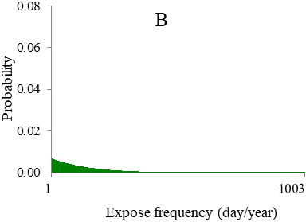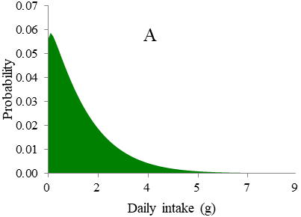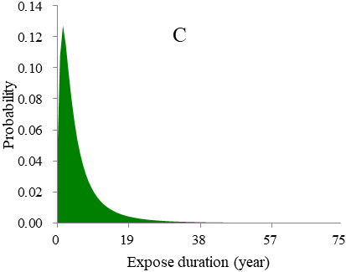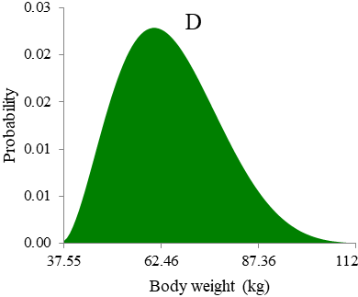

A. Distribution of daily intake (g)
B. Distribution of expose frequency (day/year)
C. Distribution of expose duration (year)
D. Distribution of body weight (kg)
Figure S1 Distribution of various parameters

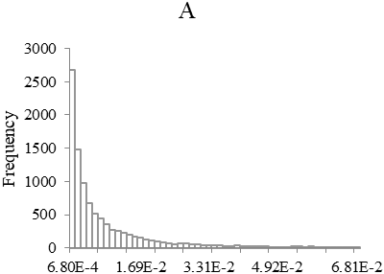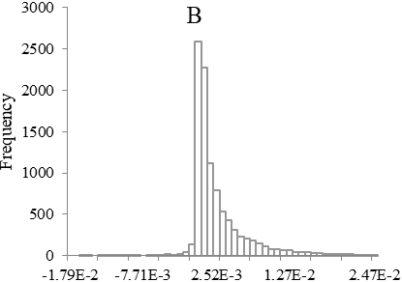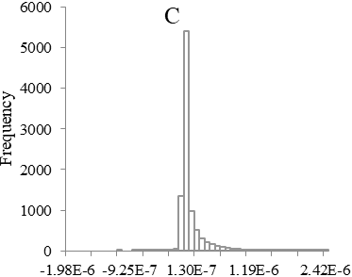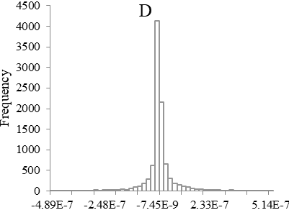

A. Forecast of HI in Goji from plantation
B. Forecast of HI in Goji from supermarket
C. Forecast of R in Goji from plantation
D. Forecast of R in Goji from supermarket
Figure S2 Forecast result of the toxic metals

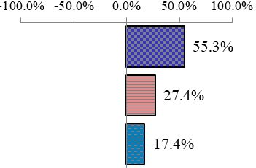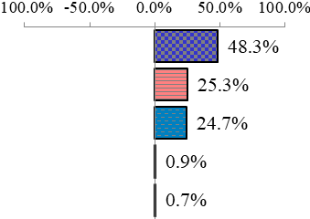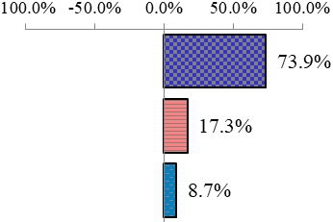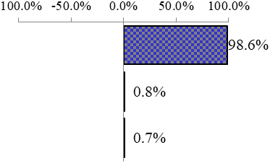
EF

DI

C-As
EF
DI
C-As
C-Cd C-Cu
C-As
EF

DI
C-As
EF
ED
A B
C D

A. Sensitivity result of HI-metals Goji from plantation
B. Sensitivity result of HI-metals Goji from supermarket
C. Sensitivity result of R-As Goji from plantation
D. Sensitivity result of R-As Goji from supermarket
Figure S3 Sensitivity result of the toxic metals

Table S1 The operating parameters of GC analysis to detect pyrethroids and organic phosphorus pesticides
Item | Parameters
 | Pyrethroids pesticides | Organic phosphorus pesticides
Detector | Electron capture detector (ECD) | Flame photometric detector (FPD)
Chromatographic column | HP-5 | HP-5
Carrier gas | N₂ | N₂（9 ml/min）H₂（40 ml/min）  Air (150ml/min)
Injection port temperature | 260℃ | 220℃
Detector temperature | 300℃ | 300℃
Injection volume | 1 µl | 1 µl
Injection method | Split-flow injection (1:5) | No-split-flow injection
Temperature | The initial temperature was 260℃(9min), maintained for 5 min, and then increased to 270℃ with the rate of 2℃/min and maintained for 5 min | The initial temperature was 120℃(9min), and then increased to 240℃ with the rate of 10℃/min and maintained for 2 min

Table S2 ICP-OES working parameters
Parameters | Numerical value
Power (KW) | 1.00
Plasma gas flow (L·min⁻¹) | 15.0
Auxiliary gas flow (L·min⁻¹) | 1.50
Nebulizer pressure (kPa) | 200
One reading time (s) | 5
Pump speed (rpm) | 15
Cleaning time (s) | 10
Condition | All spectral lines

Table S3 The methodological verification of pesticide detection
Pesticides | RT  (min) | Linear regression equations | correlation coefficients | Recovery (%) | RSD (%) | LOD  (µg/g) | LOQ  (µg/g)
dichlorovos | 4.47 | y=4.1824x-0.5483 | 0.9979 | 77.25 | 4.05 | 0.005 | 0.015
omethoate | 7.67 | y=0.1892x-0.0375 | 0.9960 | 86.14 | 5.73 | 0.01 | 0.03
malathion | 11.29 | y=0.3980x-0.0325 | 0.9971 | 92.37 | 3.06 | 0.005 | 0.015
cypermethrin | 8.00 | y=11.068x-0.4788 | 0.9940 | 90.02 | 4.52 | 0.01 | 0.03
fenvalerate | 9.81 | y=4.5172x-0.6651 | 0.9967 | 79.91 | 3.27 | 0.02 | 0.06
deltamethrin | 11.45 | y=8.5566x-2.2726 | 0.9990 | 91.14 | 7.03 | 0.02 | 0.06
RT: retention time
LOD: limit of detection
LOQ: limit of quantitation

Table S4 The methodological verification of toxic metal detection
Element | Linear regression equations | correlation coefficients | Recovery (%) | RSD (%) | LOD  (µg/g) | LOQ  (µg/g)
Pb | y=2055.4x+101.34 | 0.9999 | 6.37 | 6.37 | 0.0024 | 0.0072
Cd | y=33932x+531.04 | 1 | 106 | 9.16 | 0.0702 | 0.2106
Cu | y=16204x+657.2 | 1 | 91 | 1.12 | 0.0093 | 0.0279
Ni | y=6400.1x+273.56 | 1 | 102 | 3.44 | 0.0034 | 0.0102
Zn | y=21018x+1643.1 | 0.9999 | 99 | 5.23 | 0.0021 | 0.0063
As | y=525.5x+3.7121 | 1 | 105 | 5.29 | 0.0075 | 0.0225
LOD: limit of detection
LOQ: limit of quantitation

Table S5 The probabilistic distribution of toxic metal contents
Element | Distribution types
Pb | Beta
Cd | Beta
Cu | Normal
Ni | Maximum extreme value
Zn | Lognormal
As | Beta

Table S6 The probabilistic distribution of exposure factors
Exposure factors | Distribution types | Unit | Value
Daily intake | Beta | g | 1.37
Expose frequency | Geometry | day/year | 145.7
Expose duration | Lognormal | year | 5.93
Body weight | Beta | kg | 64.81

