Supporting information for Electrochemical Characteristics and Capacitive Deionization Performance of Asymmetric Nanoengineered CoFe₂O₄ Carbon Nanomaterials Composite

Hammad Younes*, Md Mahfuzur Rahman², Haiping Hong ¹, Maryam AlNahyan³, and Florent Ravaux³

¹ Department of Electrical Engineering, South Dakota School of Mines and Technology, Rapid City, South Dakota 57701, USA.
²Department of Industrial and Production Engineering, Jashore University of Science and Technology (JUST), Jashore, 7408, Bangladesh.
³ Department of Mechanical Engineering, Khalifa University of Science and Technology, P.O. Box 127788, Abu Dhabi, United Arab Emirates

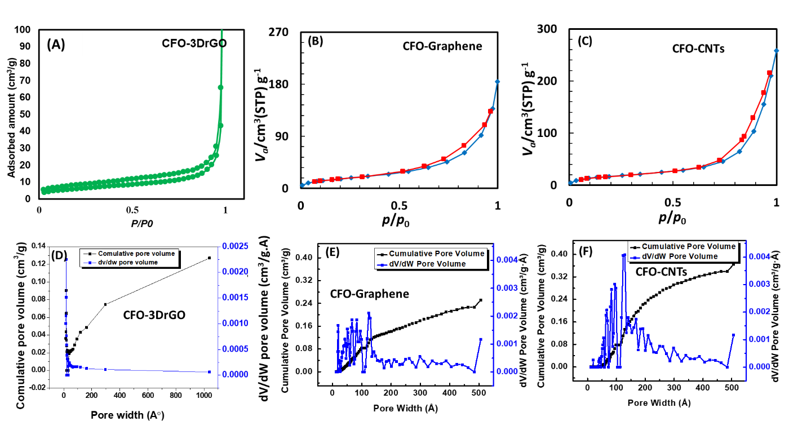
Fig. S1 BET adsorption desorption isotherm of (A) CFO-3DrGO, (B) CFO-Graphene, (C) CFO-CNTs, and Pore size distribution and cumulative pore volume of (D) CFO-3DrGO, (E) CFO-Graphene and (F) CFO-CNTs.

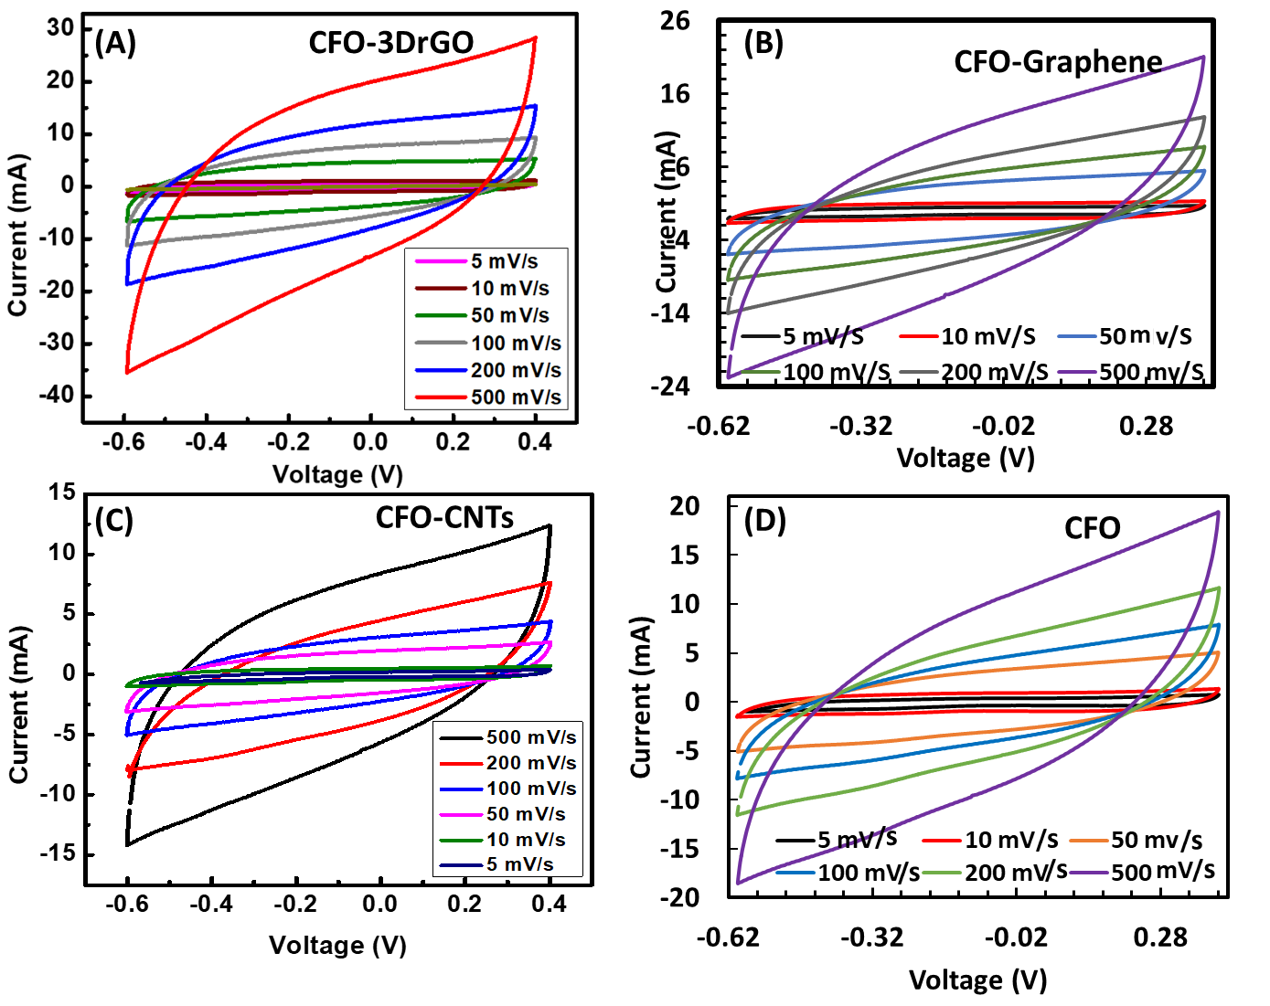
Fig. S2 Cyclic voltammograms (CV) at different scan rate of (A) CFO-3DrGO, (B) CFO-Graphene, (C) CFO-CNTs and (D) CFO only.

