Appendix.

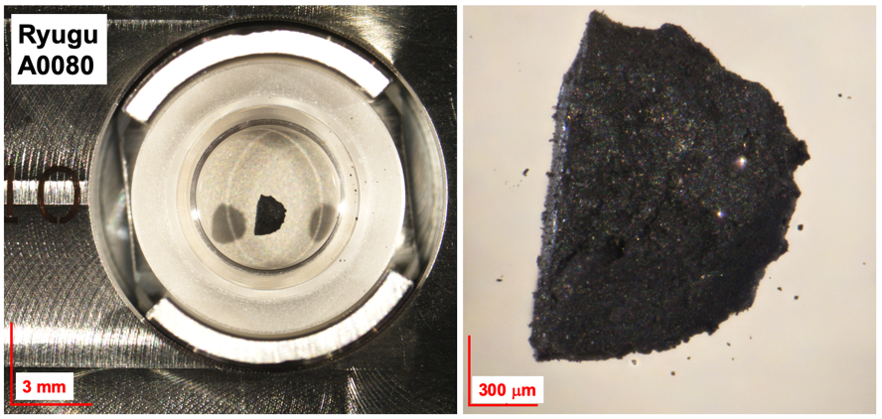

Figure A1.
The photograph of initial sample A0080 (total 1.4 mg) collected from the first touchdown site of asteroid Ryugu. The photos were taken in the clean chamber of the ISAS/JAXA curation facility before the sample distribution. The scale bars were shown in the red lines.

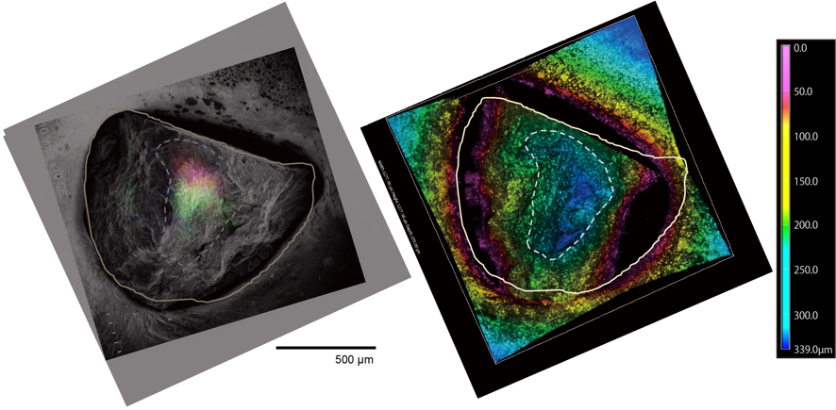
Figure A2.
(Left) Combined image of SE image of A0080 and RGB image of total CHO (red), total CHN (green), and total CHNO compounds. (Right) Topography image obtained from the almost the same area as the SE image. The color bar shows a depth of the sample surface ranged from 0–339 µm. Dotted line shows the highest region on the surface, which is roughly corresponding to the SOM concentrated region identified by DESI-HRMS imaging.

Figure A3.
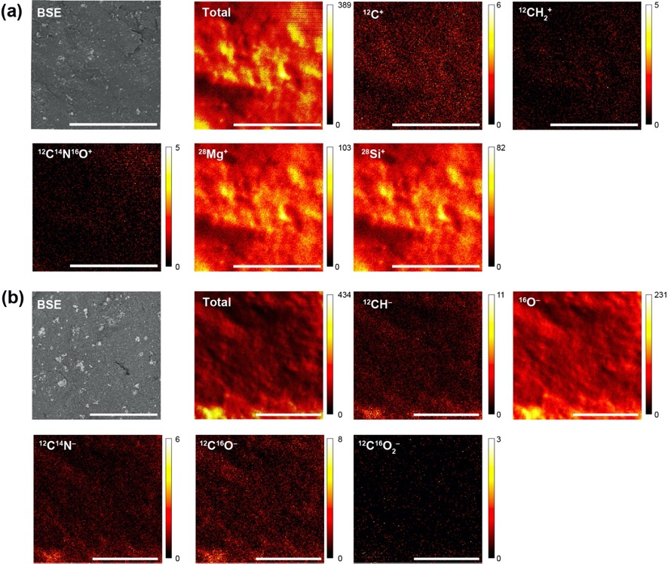
(a) A BSE image and positive secondary ion images obtained by TOF-SIMS from area A shown in Fig. 7. (b) An BSE image and negative secondary ion images obtained by ToF-SIMS from area B shown in Fig. 7. All scale bars show 100 µm. Color bars show ion counts. Note that the positioning of the TOF-SIMS images and BSE image contains a ~ ± 20 µm uncertainty.

