A tiny dataset for Plantorgan hunter Testing
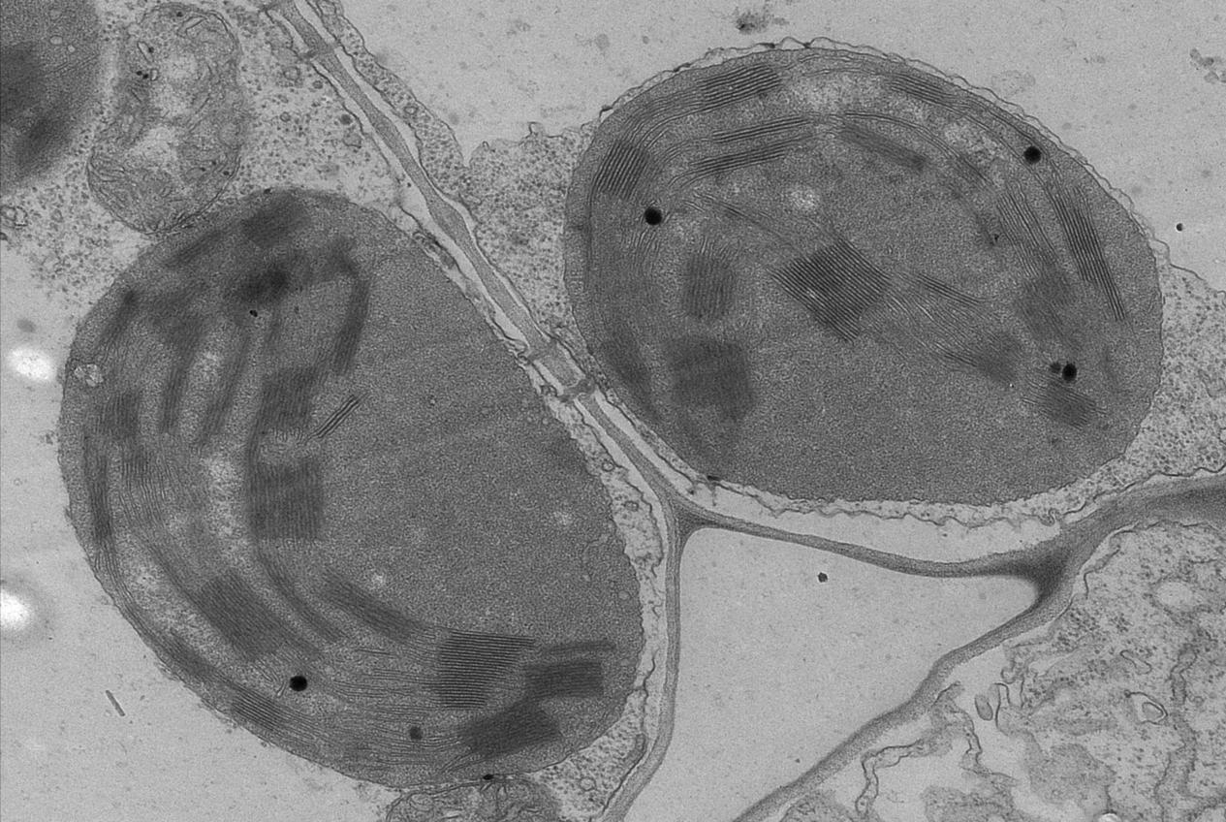
Tiny dataset Fig.1 A TEM image of plant organelles contains mitochondria and chloroplasts, the scale bar of the image is 800nm, and the pixel length of the scale bar is 520pixels.
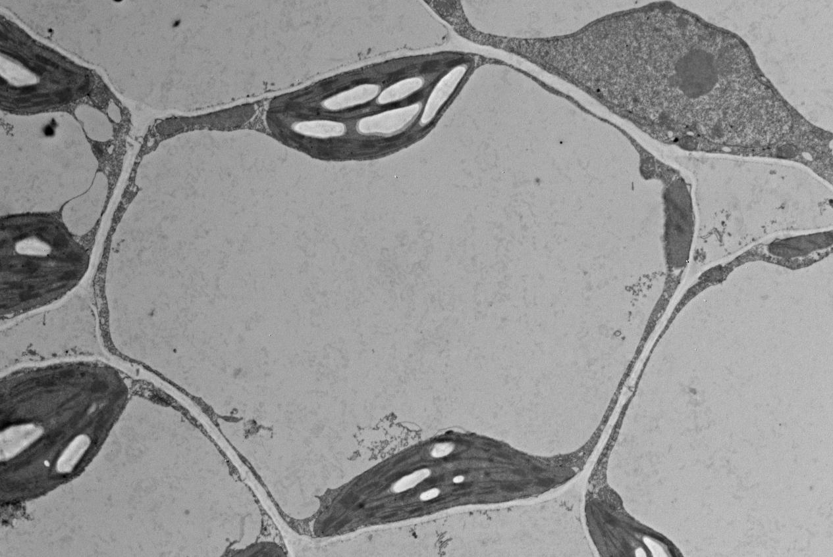
Tiny dataset Fig.2 A TEM image of plant organelles containing mitochondria, chloroplasts, nuclei and vacuoles. The scale bar of the image is 2000nm, and the pixel length of the scale bar is 460pixels
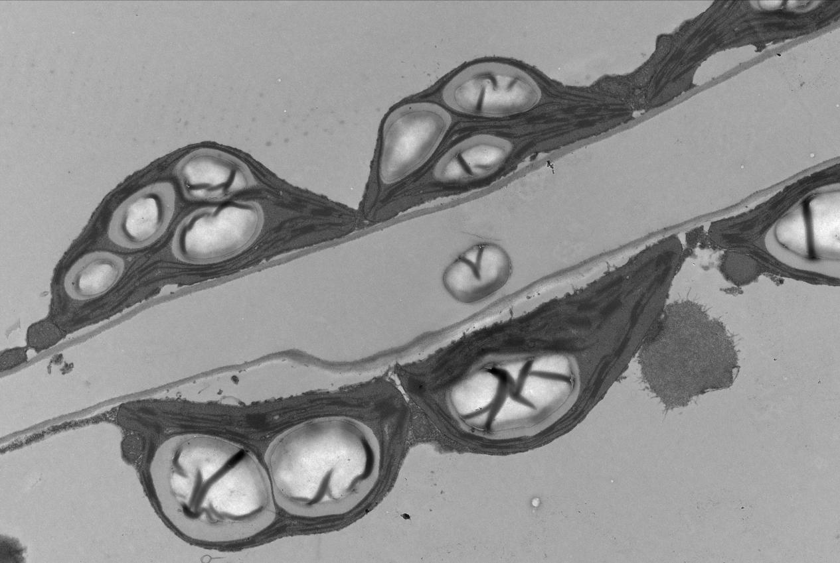
Tiny dataset Fig.3 A TEM image of plant organelles containing mitochondria, chloroplasts and vacuoles. The scale bar of the image is 2000nm, and the pixel length of the scale bar is 520pixels.

