Supplementary Information
Plantorgan hunter: a deep learning-based framework for quantitative profiling plant subcellular morphology

Xuping Feng^{1,3#}, Zeyu Yu^{1,3#}, Huifang^{2,3}, Hangjin Jiang⁴, Guofeng Yang ^{1,3}, Liting Chen⁵, Xinran Zhou⁵, Bing Hu⁶, Chun Qin⁶ , Gang Hu⁶, Guipei Xing⁶, Boxi Zhao⁵, Yongqiang Shi³, Yong He³*, Feng Liu⁵*, Feng Liu⁷, and Bo Han ⁸
¹ The Rural Development Academy &Agricultural Experiment Station, Zhejiang University, Hangzhou 310058, China
² Huzhou Institute of Zhejiang University, Huzhou 313000, Zhejiang, China;
³ College of Biosystems Engineering and Food Science, Zhejiang University, Hangzhou 310058, China;
⁴ Center for Data Science, Zhejiang University, Hangzhou 310058, China;
⁵ College of Life Sciences, Nanjing Agricultural University, Nanjing 210095, P. R. China.
⁶ College of Life Sciences, Biological experiment teaching center, Nanjing Agricultural University, Nanjing 210095, P. R. China.
⁷ School of Mathematics and Statistics, University of Melbourne
⁸ Department of Computer Science, Hong Kong Baptist University
# Xuping Feng and Zeyu Yu contributed equally to this work.
*Correspondence and requests for materials should be addressed to Yong He (yhe@zju.edu.cn) or Feng Liu (liufeng@njau.edu.cn)

Supplementary Fig. 1 Impact of magnification level on the segmentation performance of OrgSegNet for different plant organelles. Segmentation accuracy was evaluated by the F1 score calculated from the overlap between prediction and ground-truth area.

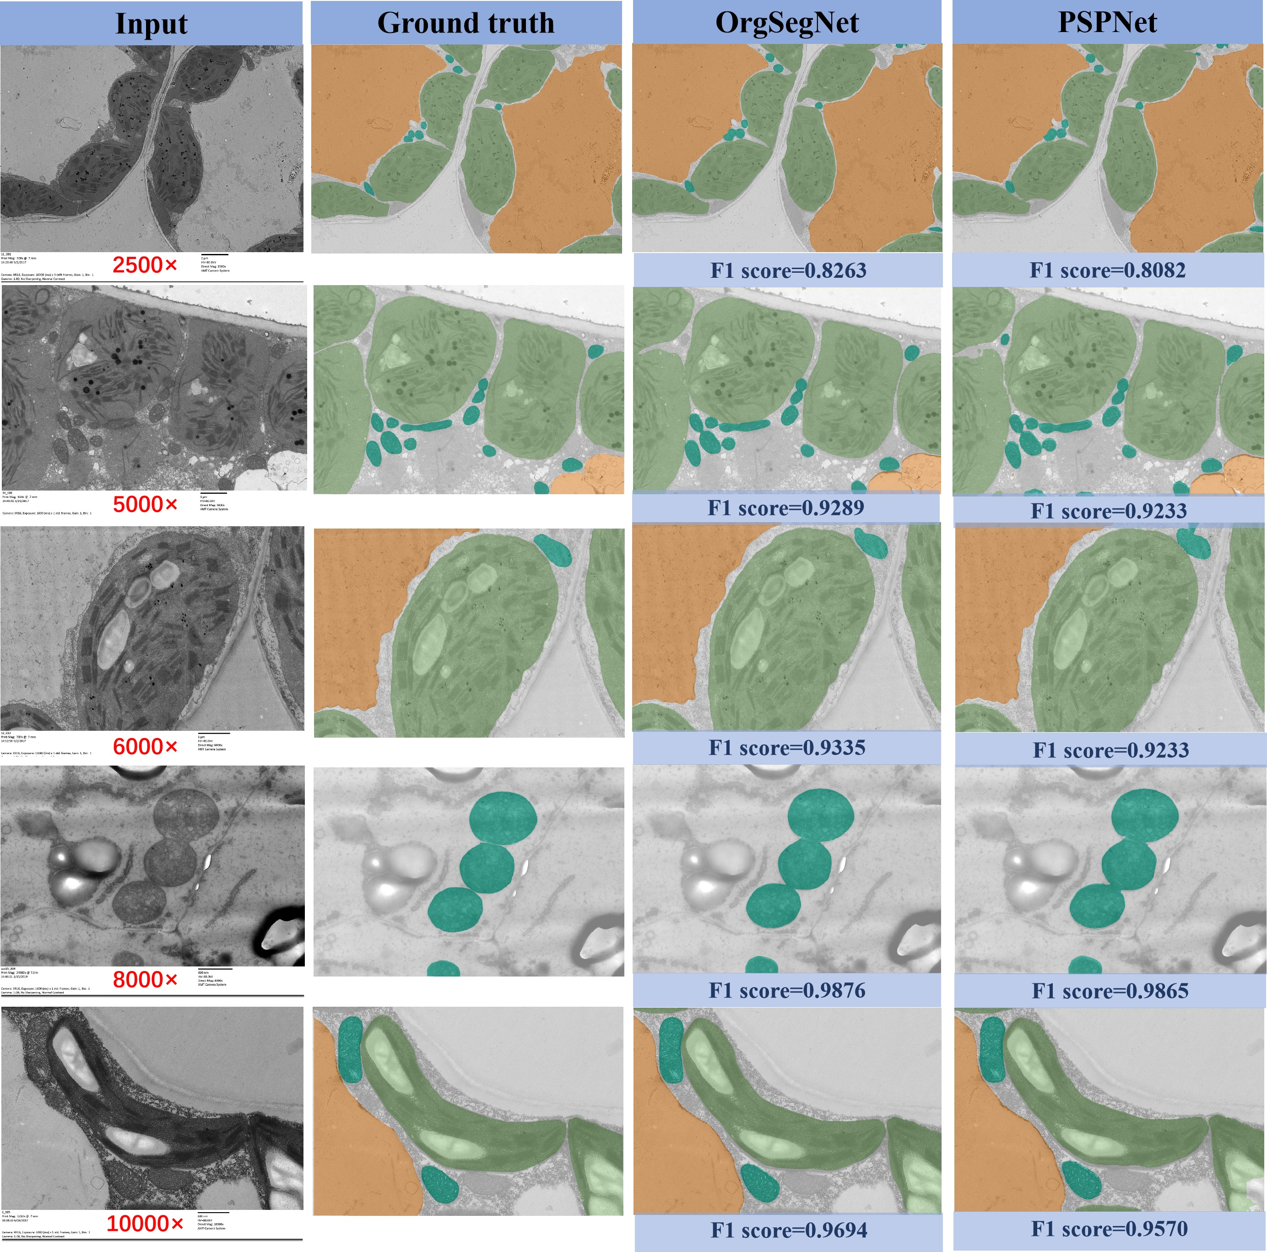
Supplementary Fig. 2 Comparison of the segmentation performance of OrgSegNet and PSPNet for small-sized mitochondria across a range of TEM data under different magnifications. The F1 score is shown for each image. First column: input image; second column: ground-truth; third column: OrgSegNet predicted segmentation; last column: PSPNet predicted segmentation.

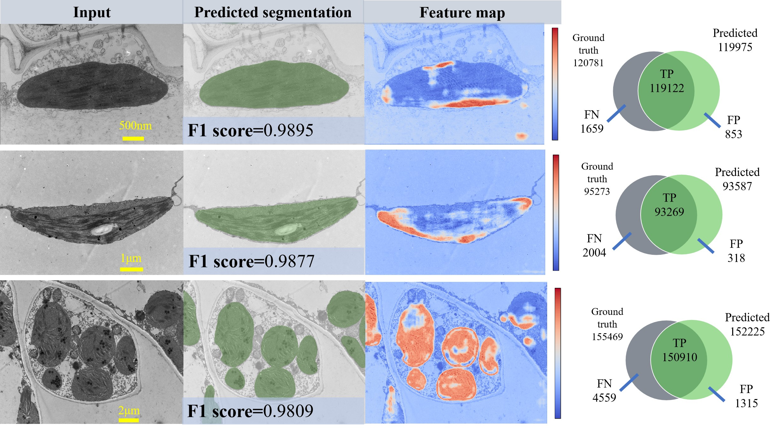
Supplementary Fig. 3 Representative examples of chloroplast segmentation at different magnification levels and their feature maps visualization learned by OrgSegNet. First column, input image; second column, predicted segmentation; third column, feature map; fourth column, venn diagrams showing the performance of OrgSegNet for chloroplast detection as TP, FP and FN for the special images. TP, true positives; FP, false positives; FN, false negatives.

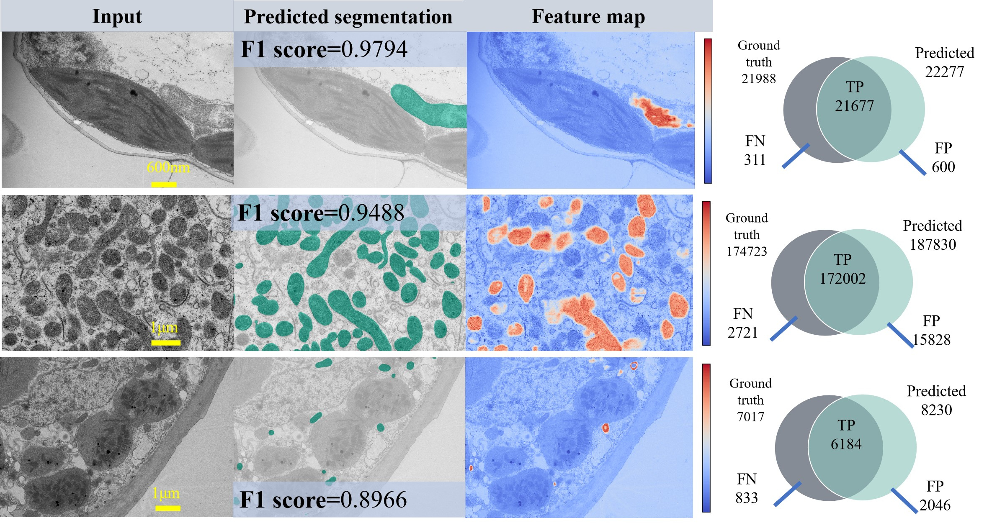
Supplementary Fig. 4 Representative examples of mitochondria segmentation at different magnification levels and their feature maps visualization learned by OrgSegNet. First column, input image; second column, predicted segmentation; third column, feature map; fourth column, venn diagrams showing the performance of OrgSegNet for mitochondria detection as TP, FP and FN for the special images.

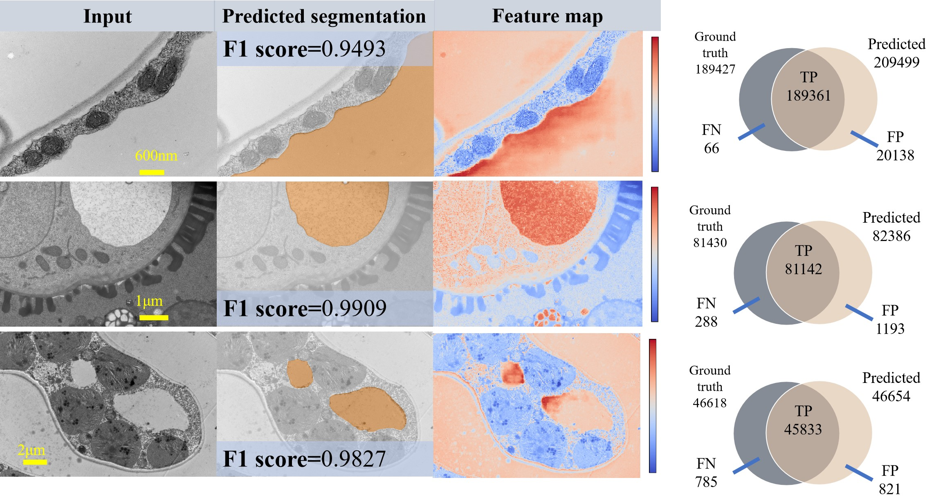
Supplementary Fig. 5 Representative examples of vacuole segmentation at different magnification levels and their feature maps visualization learned by OrgSegNet. First column, input image; second column, predicted segmentation; third column, feature map; fourth column, venn diagrams showing the performance of OrgSegNet for vacuole detection as TP, FP and FN for the special images.

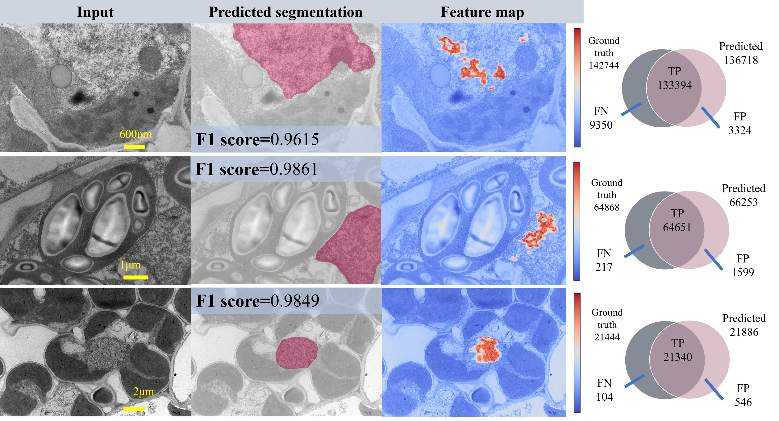
Supplementary Fig. 6 Representative examples of nucleus segmentation at different magnification levels and their feature maps visualization learned by OrgSegNet. First column, input image; second column, predicted segmentation; third column, feature map; column row, venn diagrams showing the performance of OrgSegNet for nucleus detection as TP, FP and FN for the special images.

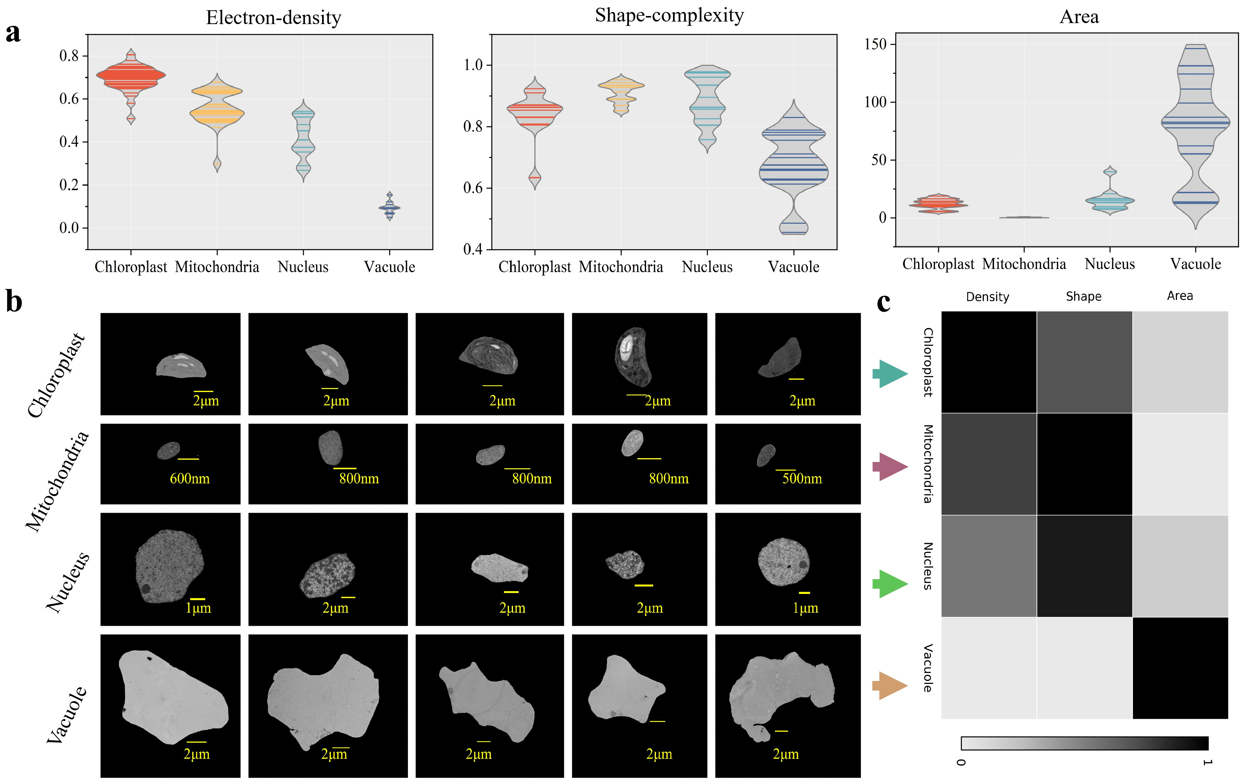
Supplementary Fig. 7 Quantitative evaluation of organelles’s characters related to electron-density, shape-complexity and area. a, Diversity of organelle’s morphological characteristics; b, Representative chloroplast, mitochondria, nucleus, and vacuole images following segmentation; c, Clustering organelles type based on the three morphological metrics.

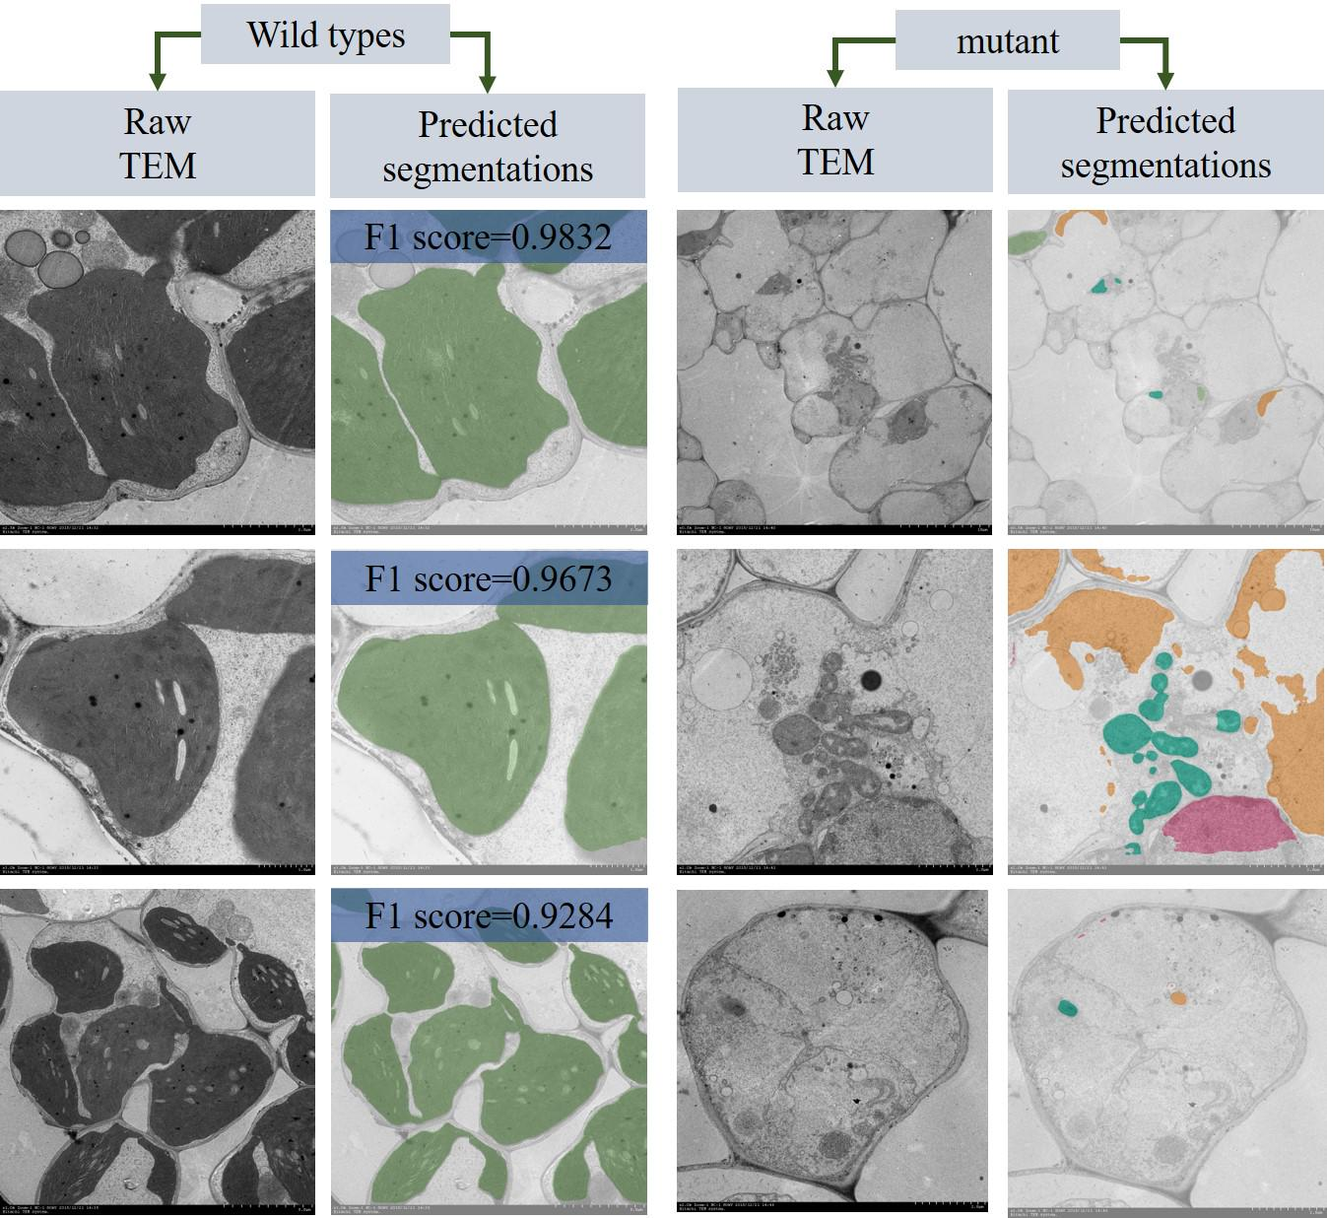
Supplementary Fig. 8 Representative images of OrgSegNet segmentation predictions using images from rice wild type and its mutant under different magnifications. Rice mutant was a thermo-sensitive rice albino leaf mutant induced by ethyl methane sulfonate. F1 score is shown for each image.

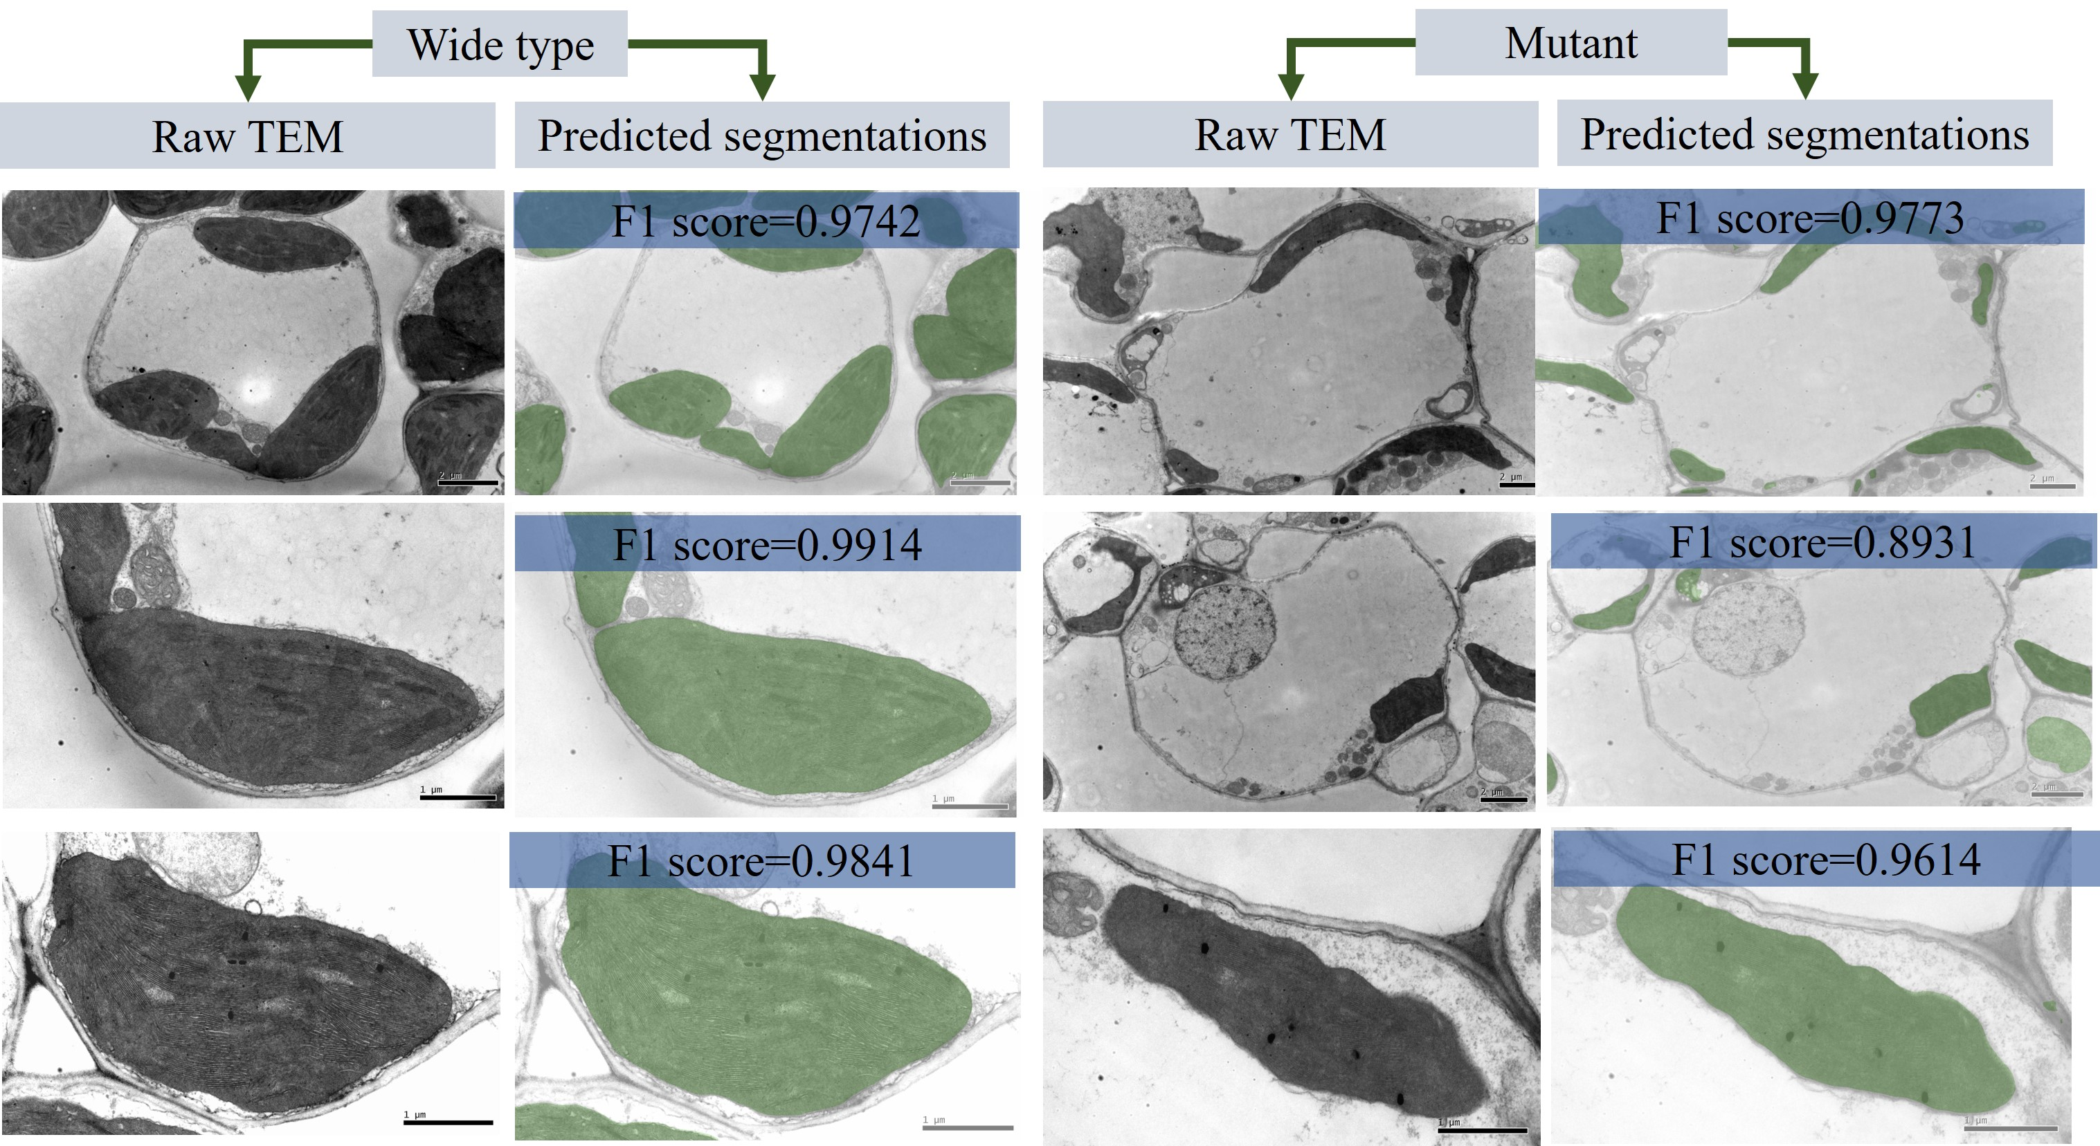
Supplementary Fig. 9 Representative images of OrgSegNet segmentation predictions using images from rice wild type and its ylc1 mutant under different magnifications. Rice mutant had young leaf chlorosis leaf mutant induced ⁶⁰Co-irradiation. F1 score is shown for each image.

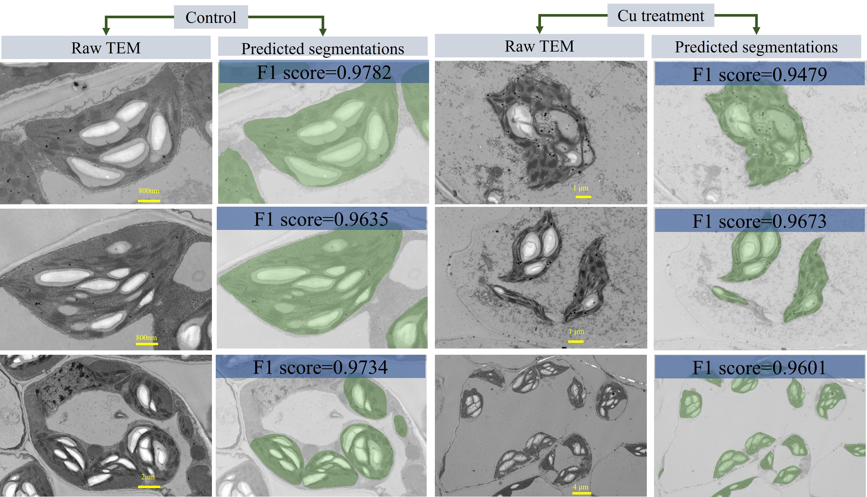
Supplementary Fig. 10 Representative images of OrgSegNet chloroplast segmentation predictions using images from Medicago sativa with and without copper (Cu) treatment. F1 score is shown for each image.

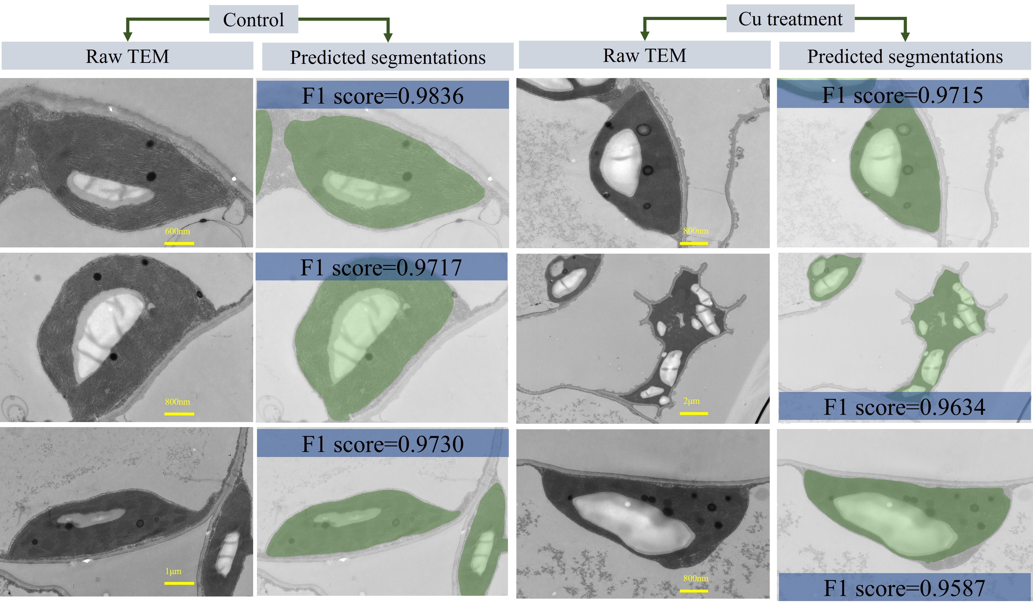
Supplementary Fig. 11 Representative images of OrgSegNet chloroplast segmentation predictions using images from Elsholtzia haichowensis with and without copper (Cu) treatment. F1 score is shown for each image.

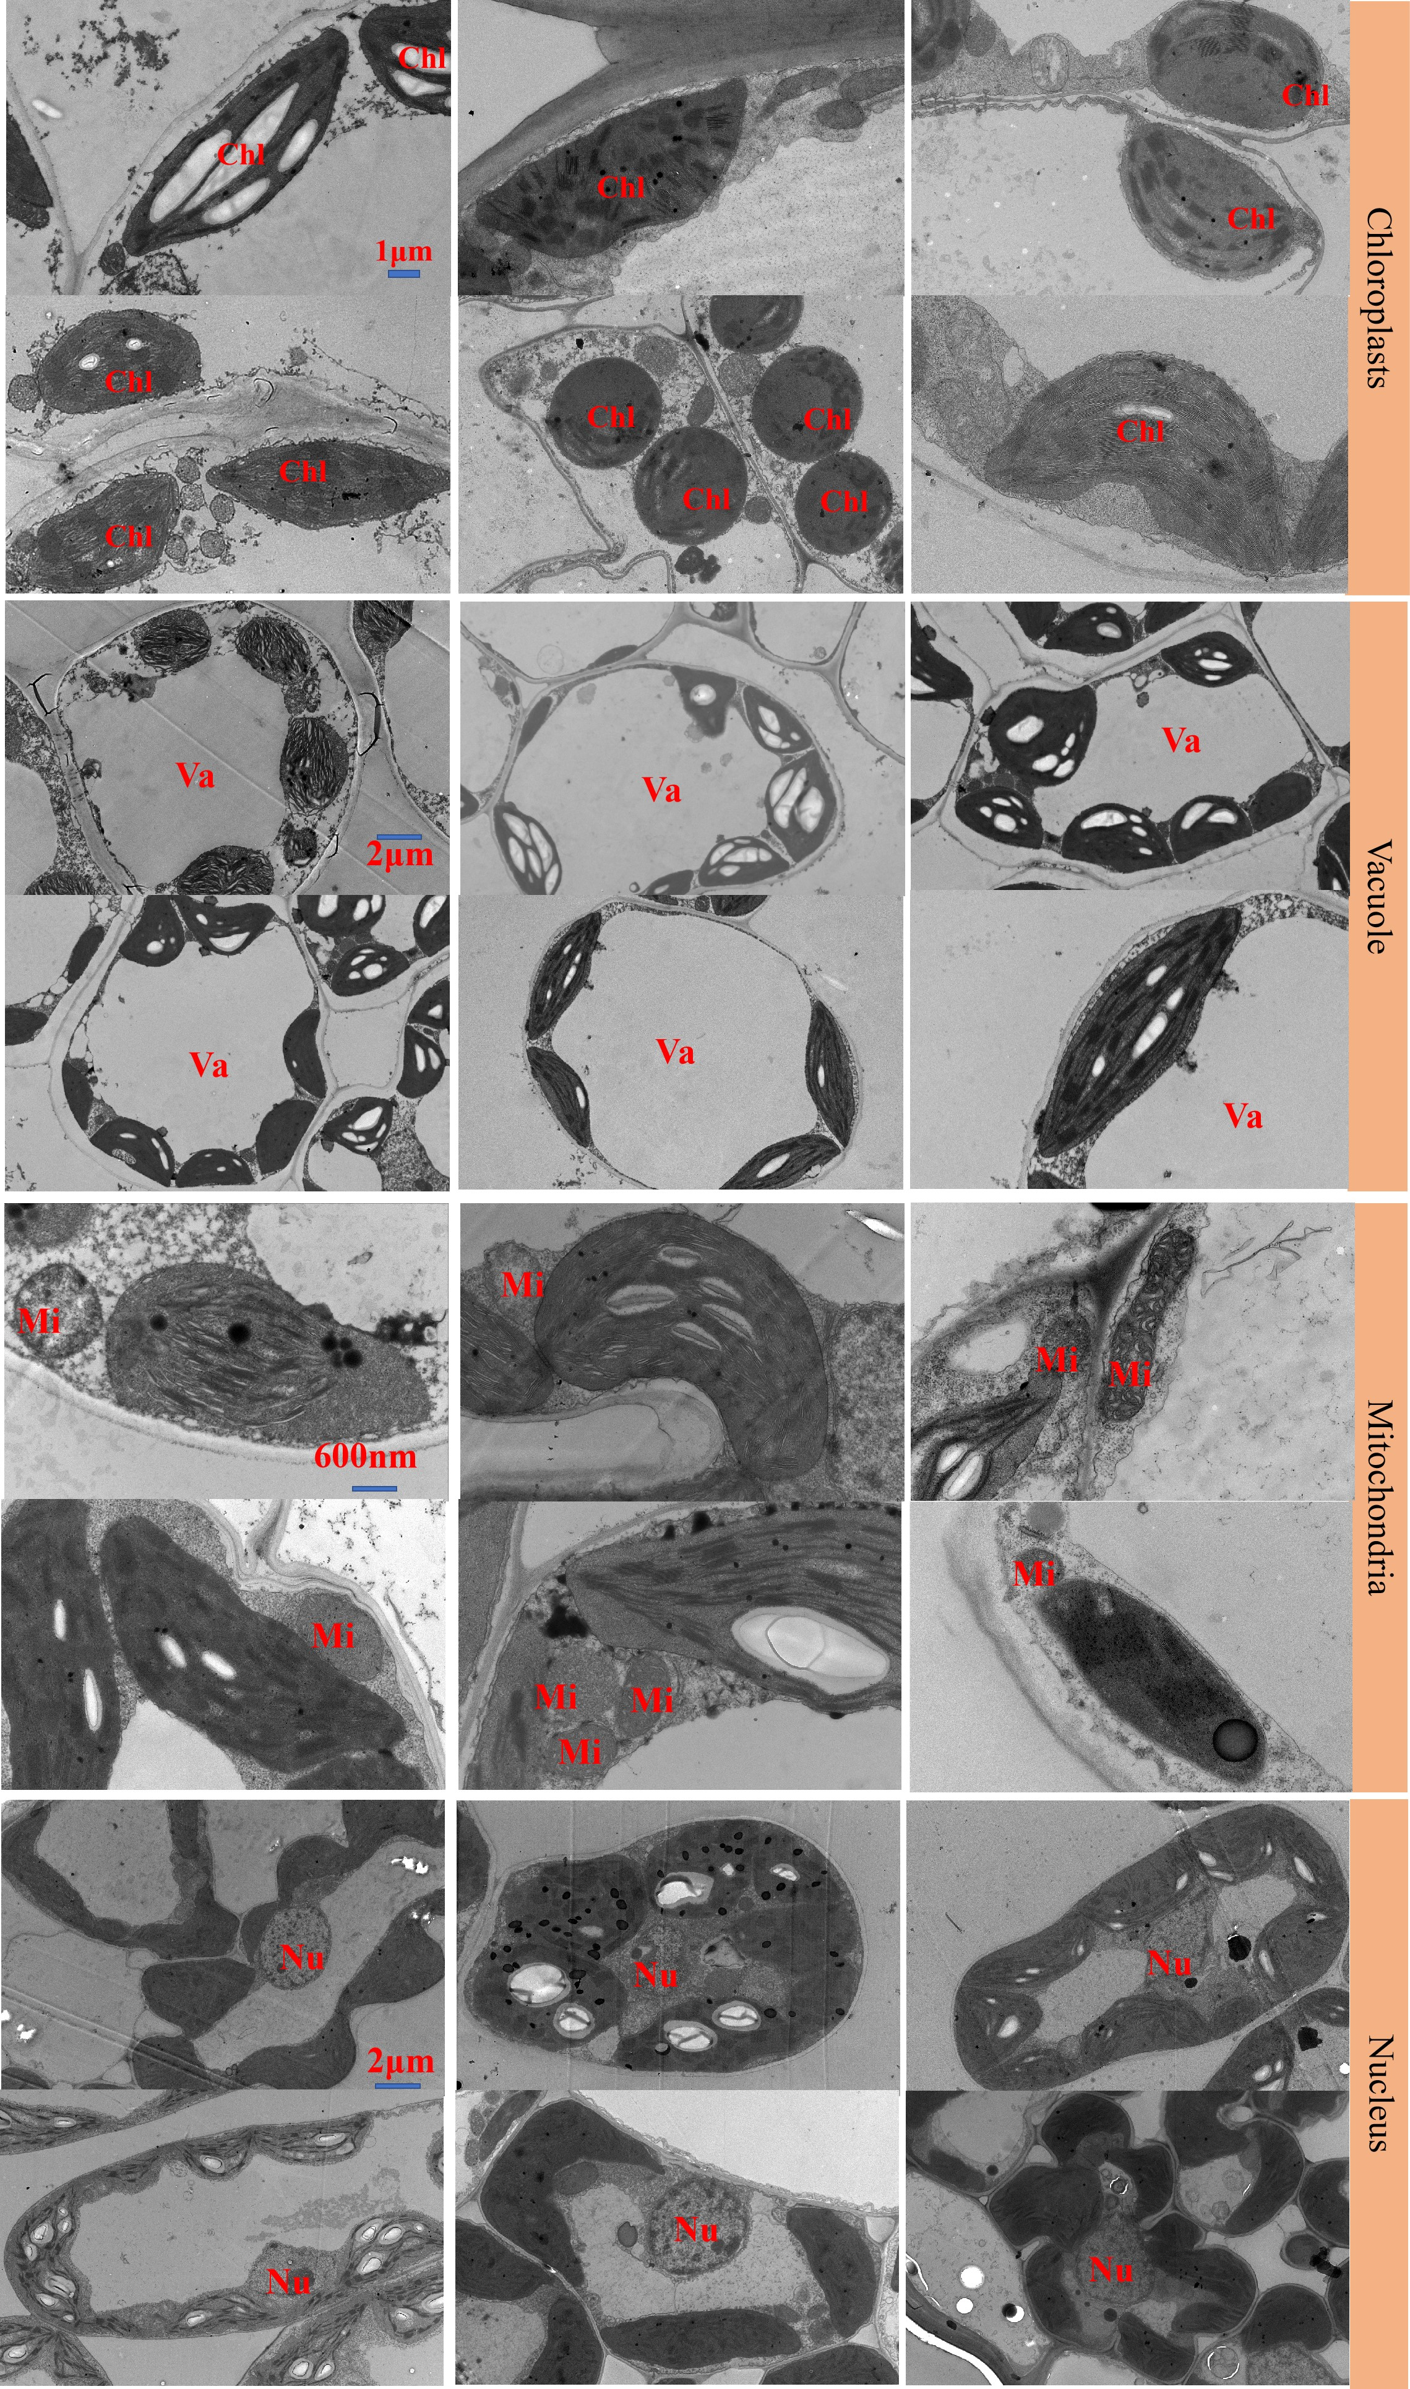
Supplementary Fig. 12 Representative cases of chloroplasts (Chl), mitochondria (Mi), nuclei (Nu), and vacuoles (Va) with diverse morphological characteristics. The same type of organelle shares the same scale bar. The large differences in the cross-section samples of plant leaves under the electron microscope made the shapes of the various organelles in the pictures different, even for the same type of organelle.

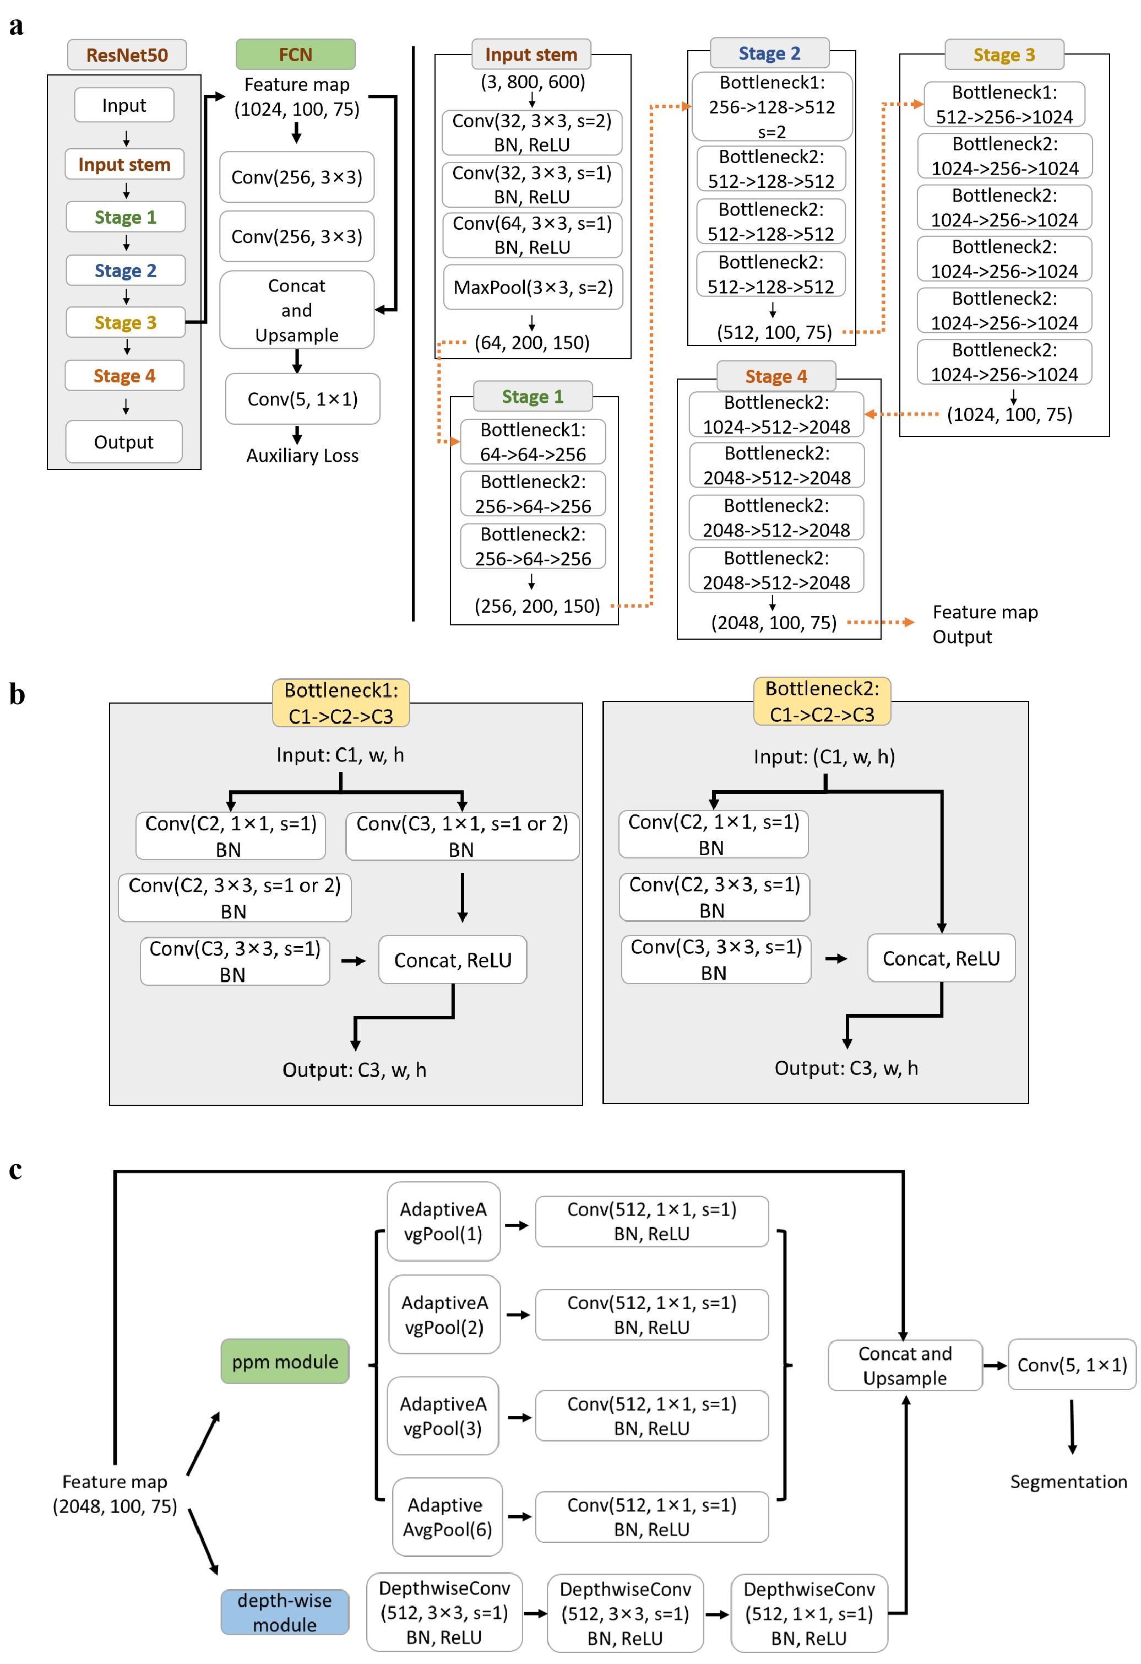
Supplementary Fig. 13 Detailed structure of OrgSegNet.
a, The detailed structure and parameters of ResNet50. BatchNormalization operation and ReLU activation function are added after each convolution layer of ResNet50. In ResNet50, it is mainly divided into 4 stages, which are used to extract the features of each layer. At the end of Stage4, a feature map of size 2048×100×75 is output. The FCN branch module is connected after Stage3, and the auxiliary loss is calculated according to the output of this branch.
b, The detailed structure and parameters of two types of basic residual block. Bottleneck1 allows downsampling with convolution layer with stride 2 instead of Pooling layer. Bottleneck1 is used in Stage 1, 2 and 4 to achieve hierarchical feature extraction of images. Bottleneck2 is a basic residual block used to extract more effective features on the channel.
c, The detailed structure and parameters of decode head. A decode head consists of a ppm module, a depth-wise module and a skip connection. In ppm module, the pool size of AdaptiveAvgPool is 1, 2, 3, 6 respectively. The channels of all the convolution layer is 512, 1/4 of the channels of feature map. In depth-wise module, kernel size of depthwise separable layer is 3×3, 3×3, 1×1 respectively, and BatchNormalization operation and ReLU activation function are added behind. Feature maps from ppm module are merged and upsampled to original feature map size. The original feature maps are merged together with the outputs of the ppm and depth-wise modules through skip connection. The combined feature map outputs the prediction result through a convolution layer with the number of channels equal to the number of classifications.

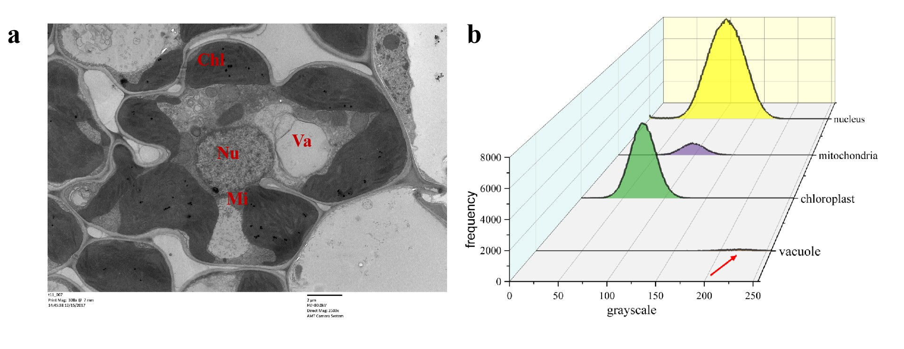
Supplementary Fig. 14 The Gray histogram of each organelle. a, Representative example showing chloroplast (Chl), mitochondria (Mi), nucleus (Nu), and vacuole (Va); b, The overall intensity histogram distributions of the grayscale value of different organelles collected from a.

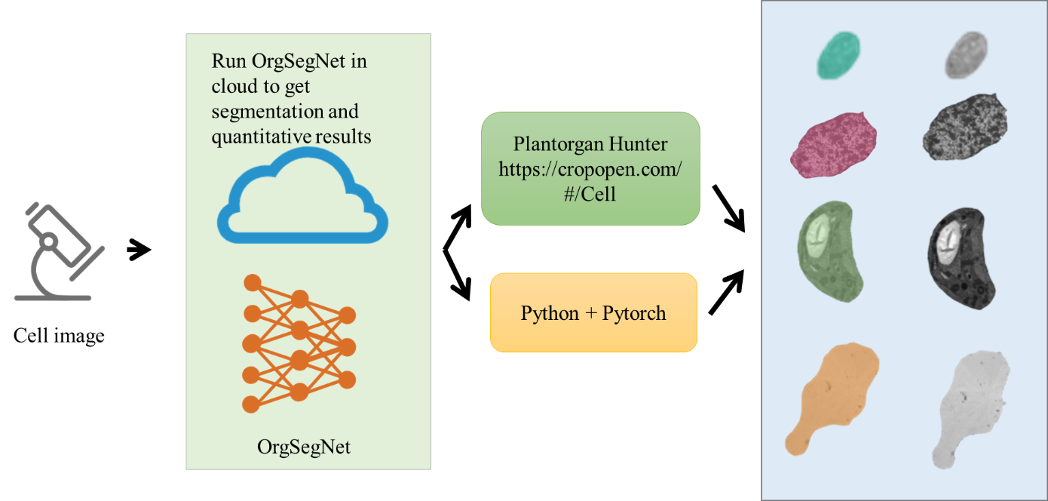
Supplementary Fig. 15 Plantorgan Hunter Portal pipeline including a centralized web server, https://cropopen.com/#/Cell. Users can upload images to be processed on the web page. The server will automatically implement the OrgSegNet process and return the morphological metrics (shape-complexity, electron-density, and area) of each organelle present in TEM through email.

Supplementary Table 1 Comparison of OrgSegNet with previous deep learning algorithms calculated on test data.
Method | mIoU | mACC | OA | Params | FLOPs | Time
DANet | 58.70 | 71.10 | 87.10 | 39.85M | 370G | 74s
PSPU-Net | 70.10 | 85.12 | 87.90 | 29.05M | 367G | 202s
DNLNet | 71.55 | 85.25 | 86.85 | 49.95M | 366G | 82s
PSPNet | 79.60 | 88.70 | 91.60 | 48.96M | 327G | 64s
Swin | 74.54 | 86.12 | 90.67 | 233.85M | 448G | 122s
DeepLabv3+ | 77.00 | 88.30 | 90.10 | 68.21M | 494G | 76s
OrgSegNet | 81.30 | 90.20 | 91.80 | 52.93M | 356G | 67s
mIoU, Mean Intersection over Union; mACC, mean accuracy; OA, overall accuracy; Params, total number of parameters of the model; FLOPs, total number of float-point operations of the model; Time, total time taken by the model to inference on test dataset.

Supplementary Table 2 Comparison of OrgSegNet with PSPNet for segmentation of small mitochondria at different TEM magnifications.
Direct magnification level | Sample ID | OrgSegNet |  |  |  | PSPNet
Direct magnification level | Sample ID | FN | TP | FP | F1 score | FN | TP | FP | F1 score
2500× | C051 | 131 | 3474 | 1329 | 0.8263 | 91 | 3514 | 1657 | 0.8082
5000× | C154 | 462 | 18522 | 2372 | 0.9289 | 281 | 18703 | 2824 | 0.9233
6000× | C137 | 276 | 4981 | 433 | 0.9335 | 302 | 4955 | 815 | 0.8987
8000× | z606 | 635 | 54584 | 726 | 0.9876 | 297 | 43922 | 1203 | 0.9865
10000× | z186 | 275 | 17273 | 814 | 0.9694 | 169 | 17379 | 1392 | 0.9570
TP, true positives; FP, false positive; FN, false negative. Sample ID related to plant organelle dataset available in the Sicence Data Bank repository, https://www.scidb.cn/s/EBvqei.

