Supplemental Information for

Rolling origami of vanadium dioxide nanomembranes for enhanced multi-level solar modulation

Xing Li^{1,2+}, Cuicui Cao^{3,4+}, Chang Liu^{1,2}, Wenhao He⁵, Kaibo Wu^{1,2}, Yang Wang^{1,2}, Borui Xu^{1,2}, Ziao Tian⁶, Enming Song⁷, Jizhai Cui^{1,2}, Gaoshan Huang^{1,2}, Changlin Zheng⁵, Zengfeng Di⁶, Xun Cao^{3,4*}, Yongfeng Mei^{1,2,7*}

1 Department of Materials Science, International Institute of Intelligent Nanorobots and Nanosystems, State Key Laboratory of ASIC and Systems, Fudan University, Shanghai 200433, People’s Republic of China
2 Yiwu Research Institute of Fudan University, Yiwu 322000, Zhejiang, People’s Republic of China
3 State Key Laboratory of High Performance Ceramics and Superfine Microstructure, Shanghai Institute of Ceramics, Chinese Academy of Sciences, Shanghai 200050, People’s Republic of China
4 Center of Materials Science and Optoelectronics Engineering, University of Chinese Academy of Sciences, Beijing 100049, People’s Republic of China.
5 State Key Laboratory of Surface Physics and Department of Physics, Fudan University, Shanghai 200433, People’s Republic of China
6 State Key Laboratory of Functional Materials for Informatics, Shanghai Institute of Microsystem and Information Technology, Chinese Academy of Sciences, Shanghai 200050, People’s Republic of China
7 Shanghai Frontiers Science Research Base of Intelligent Optoelectronics and Perception, Institute of Optoelectronics, Fudan University, Shanghai 200433, People’s Republic of China

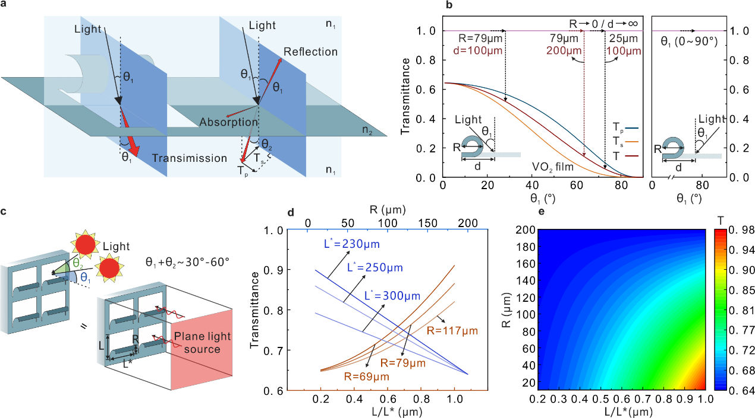
Supplementary Figure 1: Particularity of rolled-up SW to the incident angle of the sun. a, Schematic of rolled-up SW and planar VO₂ NM for light transmission. b, Transmittance of VO₂ SW with incident angle calculation by Fresnel formula. The left part presents the incident direction of sunlight in the same as the rolled-up direction and the right region in the opposite direction. c, Schematic of sunlight incident on the rolled-up SW is equal to plane light incident regardless of the sun's incident angle. d, Transmittance of the rolled-up SW with a single variable (radius, R or periodicity, L/L*). e, Transmittance of rolled-up SW as a function of R (1/$K$) and L/L*. It indicates that the solar modulation of the rolled-up SW is only related to the structure size, and the change of the solar incidence angle has no influence.

Supplementary Figure 2: SEM image of VO₂ NM. The SEM image shows that the surface morphology of the VO₂ NM is flat and the crystal grain size is about 80 nm in uniform distribution, which facilitates uniform transmission of sunlight.

Supplementary Figure 3: STEM images of VO₂ NM at different positions. a, Low-resolution STEM image of VO₂ NMs. b-d, High-resolution STEM image at different positions corresponding to the (a). STEM images of different positions show good crystallinity.

Supplementary Figure 4: XRD patterns of VO₂ NM. a, XRD patterns measured by small-angle synchrotron radiation XRD with different incidence angles (ψ). b-e, Corresponding enlarged spectra show individual VO₂ peaks. With the increase of ψ, the peak intensity of amorphous quartz around 12º decreases, while the characteristic peak intensity of VO₂ increases, and the peak position of VO₂ shifts to a smaller angle. It indicates that the initial internal strain gradient is introduced into the VO₂ NM which can be accurately calculated by a series of formulas (Supplementary Table 1,2 and Note 2).

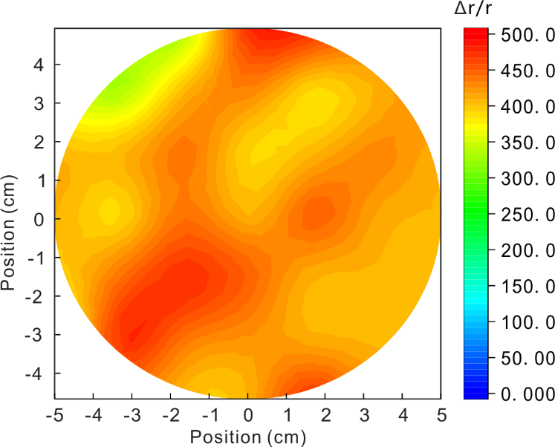
Supplementary Figure 5: Map of 4-inch VO₂ resistivity change ratio. More than 89% of the wafer area have the $∆r/r$>350, demonstrating high yield, good uniformity, and excellent quality of wafer-scale VO₂ NM.

Supplementary Figure 6: In-situ STEM image and corresponding FFT image of VO₂ NM during heating. a, 20 ºC, b, 50 ºC, c, 80 ºC, d, 110 ºC, e, 140 ºC, f, 170 ºC. g, Interplanar spacing ($d$) in two directions changes with temperature. The $d$ of the VO₂ has a regular and obvious change during the heating process, which infer the occurrence of the phase transition and the resulting strain change. Y-direction is corresponding to the [0-12] zone axis, and X-direction represents the [012] zone axis. Here, the value of $d$ shows an obvious sudden change during heating before reaching τ_{c} and tends to a relatively stable value after the phase transition. Since the internal stress existing in the NM will accumulate certain elastic potential energy, the phase transition will destroy the equilibrium state and release the potential energy. After the phase transition, the release of the potential energy will make the lattice structure forms a new equilibrium state and stabilize $d$.

Supplementary Figure 7: Transmittance spectra of the VO₂ NMs with different thicknesses. The 100 nm VO₂ NM has the best solar modulation during phase transition.

Supplementary Figure 8: Shape-deformation of different VO₂ rolled-up microstructures. a-e, Microscope image of different rolled-up VO₂ samples during heating. Rolled-up VO₂ NMs with different growth parameters have different deformabilities.

Supplementary Figure 9: Curvatures of different rolled-up VO₂ samples as a function of temperature. The rolled-up microstructures have a large curvature ($K$) change during the phase transition, and the statistics of the curvature show that the internal stress released by the rolling origami leads to the decrease of the phase transition temperature (τ_{c}).

Supplementary Figure 10: Raman spectra of a rolled-up microstructure measured at different temperatures. The A_{g} peak of VO₂ disappears at 50 °C and appears again while the temperature reduces to 30 °C. The results demonstrate the decrease of τ_{c} in rolled-up microstructures.

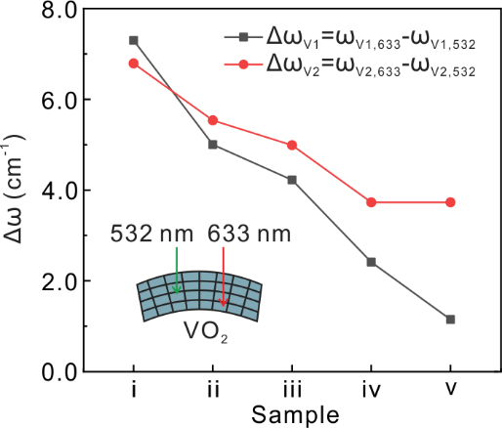
Supplementary Figure 11: Raman peak shifts ($∆ω$) of $ω_{V1}$ and $ω_{V2}$ in rolled-up SW samples obtained with different lasers wavelengths correspond to: ⅰ (350 °C), ⅱ (400 °C), ⅲ (450 °C), ⅳ (500 °C), and ⅴ (550 °C). The shifts of Raman peaks ($∆ω$) excited by different lasers are summarized and both $∆ω_{V1}$ and $∆ω_{V2}$ reduce with increase growth temperature. According to these shifts, the initial strain gradient ($∆ε$) along the radial direction are calculated (supplementary Note S3).

Supplementary Figure 12: Phase diagrams of VO₂. The red line is the strain of the rolled-up VO₂ microstructure. It shows that the calculated strain value and the actual τ_{c} are consistent with the phase diagram data.

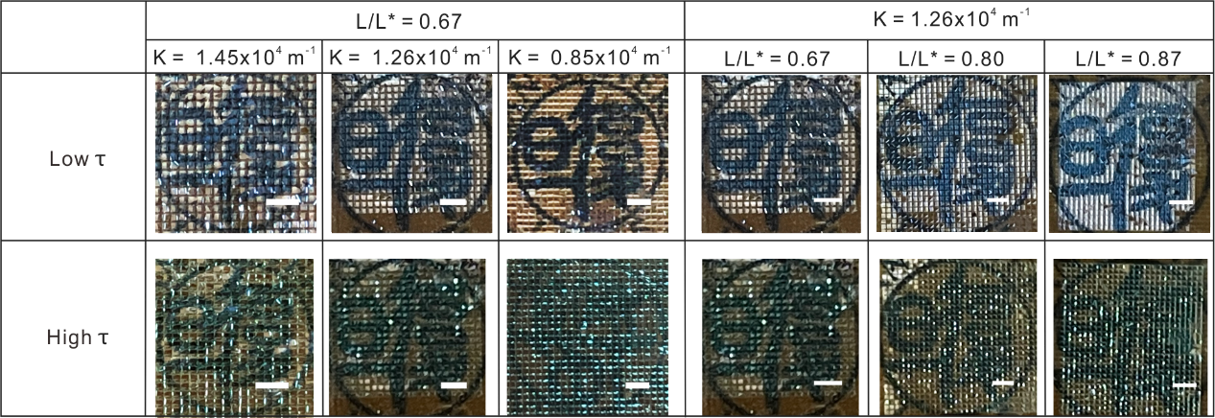
Supplementary Figure 13: Photograph of rolled-up SWs. Scale bar: 1 mm. Structural optimization has an obvious effect on enhancing the light transmittance. Under the condition that the maximum deformation of rolled-up SW is satisfied, the reduction of L/L* can effectively enhance the light transmittance at low τ.

Supplementary Figure 14: Photograph of the “Fudan” badge is observed through the rolled-up SW at different temperatures. The badge is far away from the rolled-up SW. To demonstrate the excellent performance of rolled-up SW with a $K$ of 1.26×10⁴ m⁻¹ and a L/L* of 0.87 in light transmittance, the sample is placed on a heating plate with a small hole and the “Fudan” badge is placed 15 cm away from the sample. In corresponding photos, the sharpness of the badge drops significantly at high τ, while the color and shape of the badge are well displayed at low τ.

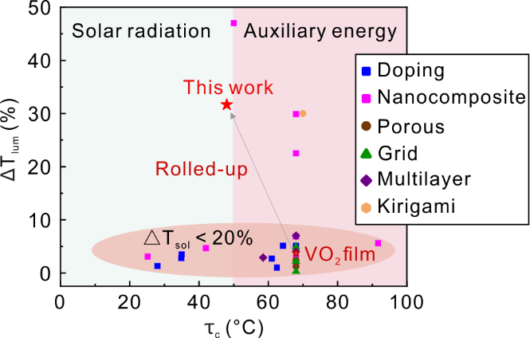
Supplementary Figure 15: Comparison of this work with the best-reported experimental works regarding the ${∆T}_{lum}$ and τ_{c}.¹⁻²⁷ ${∆T}_{lum}$ shows the change of visible light transmission during phase transition, which means visibility change of the outdoor scene. Generally, in order to ensure high transmission, this difference of transmittance should be minimized as much as possible, so that the window’s basic skills can still be maintained based on energy-saving. Here, our rolled-up SW has a great transmittance at low τ and meets the minimum requirements of civil windows for lighting at high τ. The τ_{c} can be reduced to below 50 °C through strain engineering without doping, which provides the possibility for practical applications.

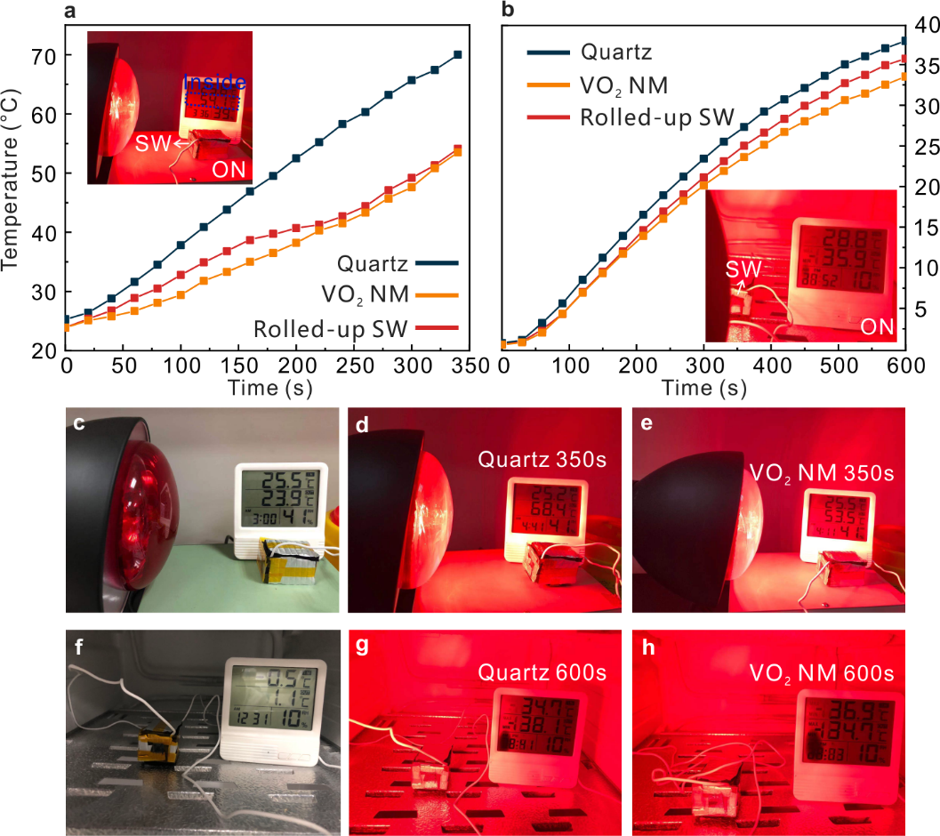
Supplementary Figure 16: Comparison of the in-house temperature changes of different windows. a, In-house temperature dependence on the irradiation time for quartz, VO₂ NM, and the rolled-up SW. The inset shows the temperature sensor connects with the house model and IR light for heating (room temperature is about 25.5 °C). b, In-house temperature dependence on the irradiation time for quartz, VO₂ NM, and the rolled-up SW. The inset shows the temperature sensor connects with the house model and IR light for heating (room temperature is about 0.5 °C). c-e, Photographs of quartz or VO₂ NM-installed house heated by IR light in on or off state (room temperature is about 25.5 °C). f-h, Photographs of quartz or VO₂ NM-installed house heated by IR light in on or off state (room temperature is about 0.5 °C). The house has two layers, the outer layer is glass for support, and the interlayer is an insulating sponge. The heat exchange of the house only depends on the radiation from a hollow that is on the house wall. For the quartz-installed house, the temperature rises to 70 °C in 350 s. However, the rolled-up SW and the VO₂ NM SW reach 51 °C after 350 s due to the phase transition. Interestingly, rolled-up SW has better light transmittance before the phase transition leading to a faster heating rate. When the house is put in the refrigerator and heated by the same heating lamp, the different windows-installed houses’ temperature change trends are similar, and the temperature difference is about 3-4 °C. Compared with the VO₂ NM SW, the rolled-up SW shows a better heat exchange at low τ.

Supplementary Figure 17: Reflectance spectra of rolled-up SW during the phase transition. a, Reflectance spectra of the VO₂ NM and rolled-up SW at different temperatures. It shows the reflectivity of the rolled-up SW ($K$ = 1.26×10⁴ m⁻¹, L/L* = 0.87) and the VO₂ NM SW at different temperatures by Fourier Transform Interferometric Radiometer (FTIR). It can be seen that the reflectivity of rolled-up SW reduces a lot at low τ, and approaches that of the VO₂ NM at high τ. b, Photograph was taken by the camera through a window installed with VO₂ NM SW. Blue thermometers represent low τ and red thermometers represent high τ. The VO₂ NM cover has similarly visible and IR imaging to the rolled-up SW cover at high τ, but it shows a significant difference at low τ.

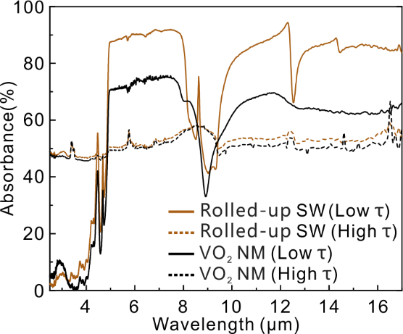
Supplementary Figure 18: Absorption spectra of rolled-up SW during the phase transition. Absorption spectra of VO₂ NM and rolled-up SW at different temperatures. It shows the absorption of the rolled-up SW ($K$ = 1.26×10⁴ m⁻¹, L/L* = 0.87) and the VO₂ NM at different temperatures by FTIR. It can be clearly seen that the absorption of rolled-up SW reduces a lot at low τ, and approaches that of the VO₂ NM at high τ. The wide range of emissivity variation in rolled-up SW can bring great practicality to the field of camouflage coating.

Supplementary Figure 19: Fixed area actuation of rolled-up SW is controlled by the patterned laser for infrared imaging. With a single rolled-up structure as a pixel, a specific laser pattern can realize the intelligent driving of single or multiple pixels. It shows that the rolled-up SW can not only work together in a large array but also can be accurately programmed by an infrared laser.

Supplementary Table 1: 18 XRD peak positions of VO₂ NM with different $ψ$.
$ψ$ (°) | VO₂ (011) | VO₂ (200) | VO₂ (210) | VO₂ (220)
0 | 28.40096 | 37.50716 | 42.63066 | 57.5265
18 | 28.05109 | 36.6826 | 41.77429 | 56.74794
32 | 27.92002 | 36.6826 | 41.77429 | 56.77655
45 | 28.02924 | 36.65977 | 41.77429 | 56.71929
Supplementary Table 2: Contribution of different orientations to the stress of VO₂.
Spacings | K (GPa) | M | σ_{φ} (GPa) | P(k l m)
(0 1 1) | -1.7388 | -0.42247 | 0.73459084 | 0.3164
(2 0 0) | -1.2248 | -0.88122 | 1.07931826 | 0.2083
(2 1 0) | -1.0174 | -0.8503 | 0.86509522 | 0.1721
(2 2 0) | -0.6364 | -0.8113 | 0.51631132 | 0.3032
Supplementary Table 3: The ${∆T}_{sol}$ and $T_{lum}$ of different samples with various $K$ and L/L*.
SW sample  $K$(10⁴ m⁻¹)-L/L* | T_{lum,lt}(%) | T_{lum,ht}(%) | ΔT_{sol}(%)
1.45-0.67 | 59.022 | 46.539 | 20.753
1.26-0.67 | 47.626 | 26.566 | 30.684
0.85-0.67 | 41.824 | 29.991 | 22.927
1.26-0.80 | 53.729 | 28.602 | 35.465
1.26-0.87 | 61.009 | 29.303 | 42.412
0-0 (film) | 23.901 | 20.167 | 12.553
Supplementary Table 4: Comparison of this work with the best-reported experiment works regarding the τ_{c}, ${∆T}_{lum}$, $T_{lum}$, and ${∆T}_{sol}$.
 | τ_{c} | ΔT_{lum} | T_{lum} | ΔT_{sol}
This work | 48 | 31.71 | 61.01 | 42.14
VO₂ film | 68 | 3.74 | 23.90 | 12.55
Doping Mg¹ | 61.05 | 2.7 | 82.1 | 4.8
Doping Sr² | 68 | 5.1 | 54.3 | 5
Doping Sr² | 68 | 4.8 | 50.3 | 6.5
Doping W³ | 28 | 1.3 | 45.1 | 6.9
Doping F⁴ | 34.9 | 2.8 | 48.7 | 10.7
Doping Zr⁵ | 64.3 | 5.1 | 60.4 | 14.1
Doping Ti⁶ | 68 | 6.9 | 53 | 17.2
Doping Tb⁷ | 62.5 | 1 | 65.9 | 4.6
Doping Mg+W¹ | 35 | 3.5 | 81.3 | 4.3
PU⁸ | 91.7 | 5.6 | 45.6 | 22.3
Core-shell  VO₂-@-SiO₂^{9,10} | 68 | 2.9 | 27.8 | 13.6
Core-shell  V_{x}W_{1-X}O₂-@-SiO₂¹¹ | 25.2 | 3.1 | 50.6 | 14.7
VO₂+TiO₂¹² | 68 | 1.5 | 61.2 | 14.6
PNIPAm^{13,14} | 68 | 29.9 | 62.6 | 34.7
HPC¹⁵ | 50 | 47 | 56 | 36
IL-Ni-Cl¹⁶ | 68 | 22.51 | 55.2 | 26.5
CLETS¹⁷ | 68 | 6.9 | 59.2 | 20.8
NLETS¹⁸ | 42 | 4.65 | 71 | 18.2
PVP¹⁹ | 68 | 2.4 | 43.3 | 14.1
Freeze-drying²⁰ | 68 | 1.2 | 50 | 14.7
Electrodeposition²¹ | 68 | 4.9 | 38.4 | 13.9
Mesh printing²² | 68 | 2.2 | 43.3 | 14.9
Nanosphere  Lithography²³ | 68 | 0.3 | 46 | 13.2
CeO₂/VO₂²⁴ | 68 | 7 | 67.5 | 5.4
TEOS/VO₂²⁵ | 68 | 4 | 52.7 | 16.4
TiO₂/VO₂/SiO₂²⁶ | 58.5 | 2.9 | 61.5 | 6.9
LSAR kirigami²⁷ | 70 | 30 | 35.2 | 37.7

Supplementary Note 1: Fresnel equations for sun incident angle study.
The Fresnel equations describe the reflection and transmission of light (or electromagnetic radiation in general) when incident on an interface between different optical media.
$T_{s}=\frac{n_{2}}{n_{1}}t_{s}^{2}$ (1)
$T_{p}=\frac{n_{2}}{n_{1}}t_{p}^{2}$ (2)
$t_{s}=\frac{{2cosθ}_{1}{sinθ}_{2}}{{sin⁡(θ}_{1}+θ_{2})}$ (3)
$t_{p}=\frac{{2cosθ}_{1}{sinθ}_{2}}{{sin⁡(θ}_{1}+θ_{2}){cos⁡(θ}_{1}-θ_{2})}$ (4)
$n_{1}{sinθ}_{1}=n_{2}{sinθ}_{2}$ (5)
In the equations, T_{s} is the amplitude transmission for s polarization and T_{p} is for p polarization. The transmission coefficient t is the ratio of the transmitted wave's complex electric field amplitude to that of the incident wave, for either polarization. The coefficients t is generally different between the s and p polarizations, and even at normal incidence. The $θ_{1}$ is incidence angle and $θ_{2}$ is angle of refraction.

Supplementary Note 2: Calculation of initial strain and phase transition strain of VO₂ NMs.
Supplementary Fig. 4 shows the XRD patterns of VO₂ NMs that are measured by small-angle synchrotron radiation XRD with different incidence angles ($ψ$), and the specific data are recorded in Supplementary Table 1. It presents that the peak position of VO₂ shifts to a smaller angle with increasing $ψ$. So, the stress state of NM can be accurately calculated by a series of formula ²⁸ The residual stress${ σ}_{φ}$ in the NM is
$σ_{φ}=-\frac{E}{2\left(1+ν\right)}cotθ_{0}\frac{π}{180}\frac{∂\left(2θ\right)}{∂\left(\sin^{2}ψ\right)}$. (6)
where $σ_{φ}$ is the stress of a certain crystal orientation ($φ$) at different $ψ$, ν is the Poisson ratio, E is the Young’s modulus of the VO₂ (~140 GPa) and θ is the Bragg angle.
For the sake of clarity, here we define
$K=-\frac{E}{2\left(1+ν\right)}cotθ_{0}$, (7)
and
$M=\frac{∂\left(2θ\right)}{∂\left(\sin^{2}ψ\right)}$. (8)
Thus, we obtain
$σ_{φ}=K×M$. (9)
The XRD scans of polycrystalline VO₂ NMs show the contribution of several orientations, namely (011), (200), (210) and (220). The relative domain population corresponding to the (k l m)-oriented area, which represents the concentration of different orientation, can be represented as follows:²⁹
$P_{\left(k l m\right)}=\frac{I\left(k l m\right)}{\left(I\left(0 1 1\right)+I\left(2 0 0\right)+I\left(2 1 0\right)+I(2 2 0)\right)}$ (10)
where I (k l m) represents the XRD intensity of the (k l m) reflection. The domain population P_{(k l m)} corresponding to (011), (200), (210), and (220) oriented area can therefore be determined by XRD diagrams.
Average stress σ in the NM can thus be calculated by
$σ=\sum_{i=1}^{4}{P_{(k l m)}σ_{φ}^{(k l m)}\left(x\right)}$ (11)
Thus, we propose an approach to determine the residual stress in VO₂ NMs with the help of XRD characterization, and the influence from the substrate temperature can be investigated. Based on the XRD results shown in supplementary Fig. 4, the calculated stress statuses are given in Supplementary Table 2. The average internal stresses σ of VO₂ NMs are calculated to be 0.7627 GPa deposited at 500 ℃. And $∆$ε = $∆$σ/E = 0.7627 GPa/E = 0.5448%.
An account of the relationship between composition, lattice spacing ($d$), and strain has been given in the literature.³⁰ The in-plane strain leads to an expansion of lattice planes along the growth direction. The lattice spacing along that is according to the substrate, $d^{⊥}(y)$, is related to the bulk lattice spacing $d(y)$ of the rutile VO₂. Once the unstrained lattice parameter $a$ of the film is known, the strain in the film parallel and perpendicular to the growth direction can be calculated using
$ε^{⊥}=\frac{d^{⊥}\left(y\right)-d(y)}{d\left(y\right)}$ (12)
$ε^{⫽}=\frac{d^{⫽}\left(x\right)-d(x)}{d\left(x\right)}$ (13)
Here, $d^{⊥}\left(y\right)$ represents the lattice spacing of Y and $d^{⫽}\left(x\right)$ represents the lattice spacing of Y, that is shown in supplementary Fig. 6. Since the strain producing deformation mainly originates from the direction parallel to the growth plane (X direction), the phase transition strain ($∆ε$) can be considered as
$∆ε={ε^{⫽}}_{high τ}-{ε^{⫽}}_{low τ}=\frac{{d^{⫽}\left(x\right)}_{high τ}-{d^{⫽}\left(x\right)}_{low τ}}{d\left(x\right)}$ (14)

Supplementary Note 3: Calculation of strain with different rolled-up SW sample
The relation between the Raman shifts and the initial strain gradient ($∆ε$) generated in rolled-up SW can be expressed as:
$∆ω={-b}_{uni}×∆ε$ (15)
where $∆ω$ represents the Raman peak positions shifts of $ω_{V1}$ and $ω_{V2}$ mode according to the supplementary Fig. 11, and $b_{uni}$ = 791 is the strain-shift coefficient under purely uniaxial stress situations.^{31,32}
To quantitatively describe the radius variation as a function of $∆ε$, we refer to the linear strain theory model used for bilayer systems. According to this theory model, we divide the NM into two regions. The lower VO₂ is a relaxed layer that is close to the interface of the deposited layer, as well as the upper VO₂ region is a strained layer. We assume that the elastic coefficients are equal in the two regions. The $K$ of rolled-up microstructure can be calculated by³³
$K=\frac{6ε\left(1+v\right)d_{strain}d_{relax}}{{\left(d_{strain}+d_{relax}\right)}^{3}}$ (16)
where $ε$ is the strain in the VO₂ NM and the $v$ is the Poisson ratio. The $d_{strain}$ is always equal to 3 nm and the $d_{relax}$ value is 57 nm, 97 nm and 137 nm, respectively.

Supplementary Note 4: Calculation methods of ${∆T}_{sol}$, $T_{lum}$.
Integral visible transmittance (${\overline{T}}_{vis}$)(380-780 nm), near infrared transmittance (${\overline{T}}_{NIR}$) and solar transmittance (${\overline{T}}_{sol}$) (350-2600 nm) are calculated by equations:
${\overline{T}}_{vis}=\int{Φ_{lum}}(λ)τ(λ)d(λ)/\int{Φ_{lum}\left(λ\right)}d(λ)$ (17)
${\overline{T}}_{sol}=\int{Φ_{sol}}(λ)τ(λ)d(λ)/\int{Φ_{sol}\left(λ\right)}d(λ)$ (18)
${\overline{T}}_{NIR}={\overline{T}}_{sol}-{\overline{T}}_{vis}$ (19)
where $Φ_{lum}$(λ) is standard efficiency function for photopic vision, indicating the sensitivity of the human eye to different wavelengths in the visible light region. $Φ_{sol}$($λ$) is the solar irradiance spectrum for an air mass of 1.5, which corresponds to the sun sanding 37° above the horizon. τ(λ) represents the transmittance at wavelength λ. Solar modulation (${∆T}_{sol}$) is an important index to evaluate the thermochromic property of VO₂, which is calculated by:
$∆T_{sol}={\overline{T}}_{sol, low τ}-{\overline{T}}_{sol, high τ}$ (20)
where low τ and high τ represent 20 ℃ and 80 ℃, respectively.

Supplemental references
- Wang, N., Liu, S., Zeng, X.T., Magdassi, S. & Long, Y. Mg/W-codoped vanadium dioxide thin films with enhanced visible transmittance and low phase transition temperature. J. Mater. Chem. C 3, 6771-6777 (2015).
- Dietrich, M.K. et al. Influence of doping with alkaline earth metals on the optical properties of thermochromic VO₂. J. Appl. Phys. 117, 185301 (2015).
- Hu, L., et al. Porous W-doped VO₂ films with simultaneously enhanced visible transparency and thermochromic properties. J. Solgel Sci. Technol 77, 85-93 (2016).
- Dai, L. et al. F-doped VO₂ nanoparticles for thermochromic energy-saving foils with modified color and enhanced solar-heat shielding ability. Phys. Chem. Chem. Phys. 15, 11723-11729 (2013).
- Shen, N. et al. The synthesis and performance of Zr-doped and W-Zr-codoped VO₂ nanoparticles and derived flexible foils. J. Mater. Chem. A 2, 15087-15093 (2014).
- Chen, S. et al. The visible transmittance and solar modulation ability of VO₂ flexible foils simultaneously improved by Ti doping: An optimization and first principle study. Phys. Chem. Chem. Phys. 15, 17537-17543 (2013).
- Wang, N. et al. Terbium-doped VO₂ thin films: Reduced phase transition temperature and largely enhanced luminous transmittance. Langmuir 32, 759-764 (2016).
- Chen, Z. et al. Fine crystalline VO₂ nanoparticles: Synthesis, abnormal phase transition temperatures and excellent optical properties of a derived VO₂ nanocomposite foil. J. Mater. Chem. A 2, 2718-2727 (2014).
- Gao, Y. et al. Enhanced chemical stability of VO₂ nanoparticles by the formation of SiO₂/VO₂ core/shell structures and the application to transparent and flexible VO₂-based composite foils with excellent thermochromic properties for solar heat control. Energy Environ. Sci. 5, 6104-6110 (2012).
- Zhou, Y. et al. Surface plasmon resonance induced excellent solar control for VO₂@SiO₂ nanorods-based thermochromic foils. Nanoscale 5, 9208-9213 (2013).
- Zhu, J. et al. Vanadium dioxide nanoparticle-based thermochromic smart coating: High luminous transmittance, excellent solar regulation efficiency, and near room temperature phase transition. ACS Appl. Mater. Interfaces 7, 27796-27803 (2015).
- Chen, Z., Cao, C., Chen, S., Luo, H. & Gao, Y. Crystallised mesoporous TiO₂(A)- VO₂(M/R) nanocomposite films with self-cleaning and excellent thermochromic properties. J. Mater. Chem. A 2, 11874-11884 (2014).
- Zhou, Y., Cai, Y.F., Hu, X. & Long, Y. Temperature-responsive hydrogel with ultra- large solar modulation and high luminous transmission for ‘‘smart window’’ applications. J. Mater. Chem. A 2, 13550-13555 (2014).
- Zhou, Y., Cai, Y.F., Hu, X. & Long, Y. VO₂/hydrogel hybrid nanothermochromic material with ultra-high solar modulation and luminous transmission. J. Mater. Chem. A 3, 1121-1126 (2015).
- Yang, Y.S., Zhou, Y., Chiang, F. & Long, Y. Tungsten doped VO₂/microgels hybrid thermochromic material and its smart window application. RSC Adv. 7, 7758-7762 (2017).
- Zhu, J. et al. Composite film of vanadium dioxide nanoparticles and ionic liquid-nickel-chlorine complexes with excellent visible thermochromic performance. ACS Appl. Mater. Interfaces 8, 29742-29748 (2016).
- Zhu, J. et al. Solar-thermochromism of a hybrid film of VO₂ nanoparticles and CoII-Br-TMP complexes. RSC Adv. 6, 67396-67399 (2016).
- Zhu, J. et al. Hybrid films of VO₂ nanoparticles and a nickel (II)-based ligand exchange thermochromic system: Excellent optical performance with a temperature responsive color change. New J. Chem. 41, 830-835 (2017).
- Kang, L. et al. Nanoporous thermochromic VO₂ films with low optical constants, enhanced luminous transmittance and thermochromic properties. ACS Appl. Mater. Interfaces 3, 135-138 (2011).
- Cao, X. et al. Nanoporous thermochromic VO₂(M) thin films: Controlled porosity, largely enhanced luminous transmittance and solar modulating ability. Langmuir 30, 1710-1715 (2014).
- Liu, C., Long, Y., Magdassi, S. & Mandler, D. Ionic strength induced electrodeposition: A universal approach for nanomaterial deposition at selective areas. Nanoscale 9, 485-490 (2017).
- Lu, Q. et al. Periodic micro-patterned VO₂ thermochromic films by mesh printing. J. Mater. Chem. C 4, 8385-8391 (2016).
- Ke, Y. et al. Controllable fabrication of two-dimensional patterned VO₂ nanoparticle, nanodome, and nanonet arrays with tunable temperature-dependent localized surface plasmon resonance. ACS Nano 11, 7542-7551 (2017).
- Koo, H. et al. The effect of CeO₂ antireflection layer on the optical properties of thermochromic VO₂ film for smart window system. J. Mater. Eng. Perform 23, 402-407 (2014).
- Liu, C. et al. Index-tunable anti-reflection coatings: Maximizing solar modulation ability for vanadium dioxide-based smart thermochromic glazing. J. Alloys Compd. 731, 1197-1207 (2018).
- Chen, Z. et al. VO₂- based double-layered films for smart windows: Optical design, all-solution preparation and improved properties. Sol. Energy Mater. Sol. Cells 95, 2677-2684 (2011).
- Ke, Y. et al. Adaptive thermochromic windows from active plasmonic elastomers. Joule 3, 858-871 (2019).
- Zheng, X., Li, J. & Zhou, Y. X-ray diffraction measurement of residual stress in PZT thin films prepared by pulsed laser deposition. Acta Materialia 52, 3313-3322 (2004).
- Sakashita, Y., Ono, T., Segawa, H., Tominaga, K. & Okada, M. Preparation and electrical properties of MOCVD-deposited PZT thin films. J. Appl. Phys. 69, 8352 (1991).
- Rosenauer, A. et al. Transmission Electron Microscopy of Semiconductor Nanostructures: Analysis of Composition and Strain State. In Springer Tracts in Modern Physics 182, 57-84 (2003).
- Süess, M.J. et al. Analysis of enhanced light emission from highly strained germanium microbridges. Nat. Photonics 7, 466-472 (2013).
- Atkin, J.M. et al. Strain and temperature dependence of the insulating phases of VO₂ near the metal-insulator transition. Phys. Rev. B 85, 020101 (2012).
- Songmuang, R., Deneke, C. & Schmidt, O.G. Rolled-up micro- and nanotubes from single-material thin films. Appl. Phys. Lett. 89, 223109 (2006).

