Supplementary information

Electrospun P3HT/PVDF-HFP Semiconductive Nanofibers for Triboelectric Nanogenerators

Meng-Fang Lin*, Gang-Wei Zhang, Jia-Xian Li, Xin-Xain Wu, Yu-Ching Huang *

Department of Materials Engineering, Ming Chi University of Technology, New Taipei City, Taiwan
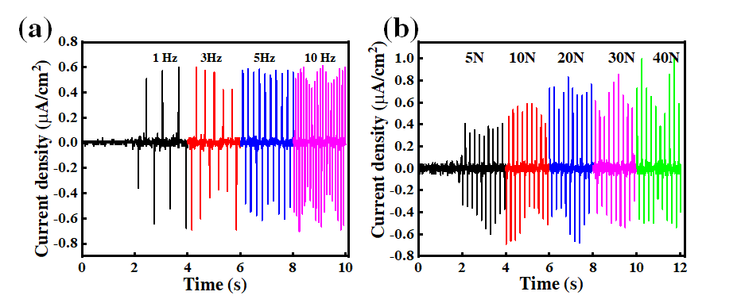
Fig. S1 Electrical output current density of the P3HT/PVDF-HFP nanofibers measured with respect to (a) frequency and (b) mechanical force.
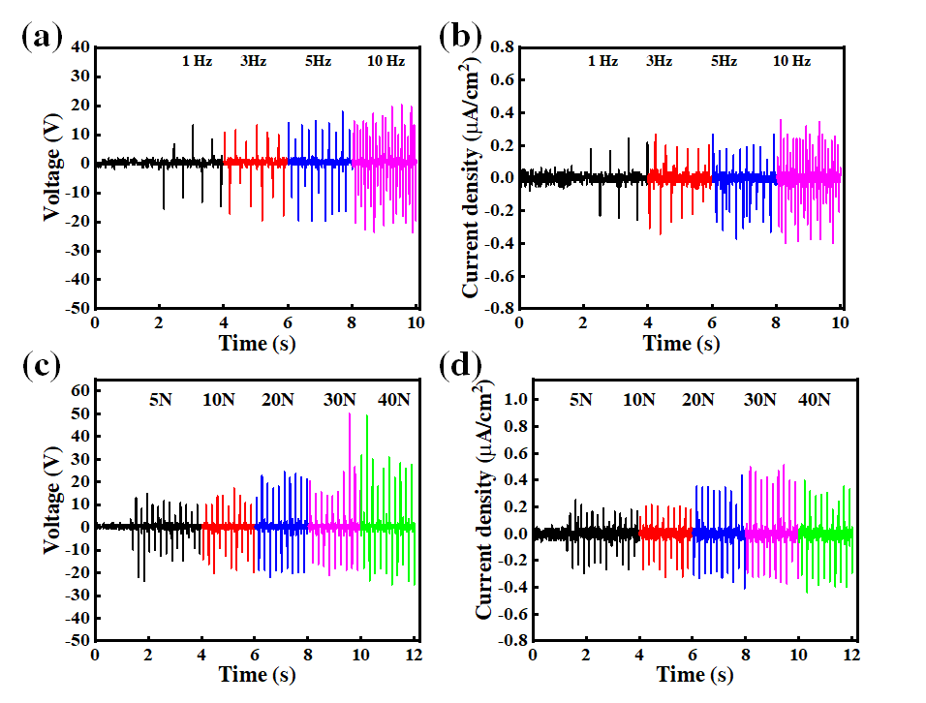
Fig. S2 (a, c) Output voltages and (b, d) current densities of the TENG composed of electrospun PVDF-HFP nanofibers, measured (a, b) under the same mechanical force (10 N) at frequencies (f) of 1, 3, 5, and 10 Hz and (c, d) under the same frequency (5 Hz) at mechanical forces of 5, 10, 20, 30, and 40 N.
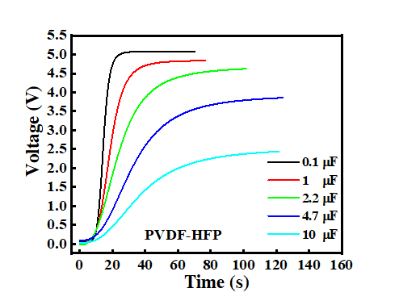
Fig. S3 (a) Capacitor charging of the PVDF-HFP nanofiber TENG at various capacitances.
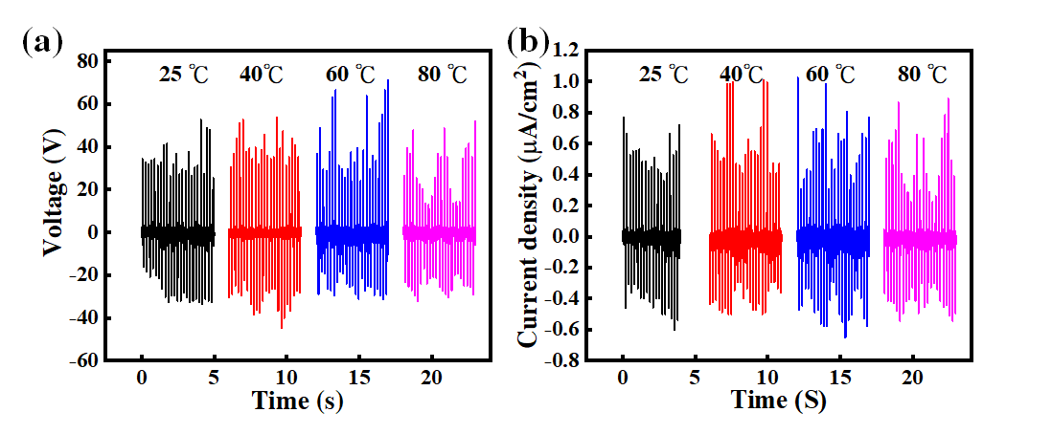
Fig. S4 (a) Voltage and (b) current outputs of the P3HT/PVDF-HFP nanofiber TENG, measured at various temperatures.

Movie S1. LED bulb array and a digital watch could be powered by the TENG containing the P3HT/PVDF-HFP nanofiber mats

