Supplementary material to:

Growth dynamics and amorphous-to-crystalline phase transformation in natural nacre
  - L.M. Otter^{1*}, K. Eder², M.R. Kilburn³, L. Yang², P. O’Reilly⁴, D.B. Nowak⁴, J.M. Cairney², D.E. Jacob¹
  - ¹Research School of Earth Sciences, Australian National University, Canberra, ACT 2601, Australia
  - ²Australian Centre for Microscopy and Microanalysis, The University of Sydney, Sydney, NSW 2006, Australia
  - ³Centre for Microscopy Characterisation and Analysis, University of Western Australia, Perth, WA 6009, Australia
  - ⁴Molecular Vista Inc., 6840 Via Del Oro, Suite 110, San Jose, CA 95119, USA
  - *Correspondence and requests for materials should be addressed to LMO: email: Laura.Otter@anu.edu.au

Data collection
Supplementary Table 1: Summary of data obtained from studied samples.
Analytical approach: | # Specimen: | Comments:
Sr labelling of live mussels | 50 shells from 2 groups (see methods) | Total number of samples from aquaculture experiments
BSE imaging | 19 shells, >5 BSE images/specimen | Survey of a subset of shells
NanoSIMS mapping | 8 shells, > 4 maps per specimen | Survey of a subset of shells
APT reconstructions | 1 shell, 8 tips from 2 liftouts | Final data collection using specimen with highest growth rates for best resolution (specimen ID ‘M2S2’)
PiFM maps | 1 shell, 3 maps in different areas
Quantitative EDS maps | 1 shell, 1 map

Quantitative SEM-EDS mapping
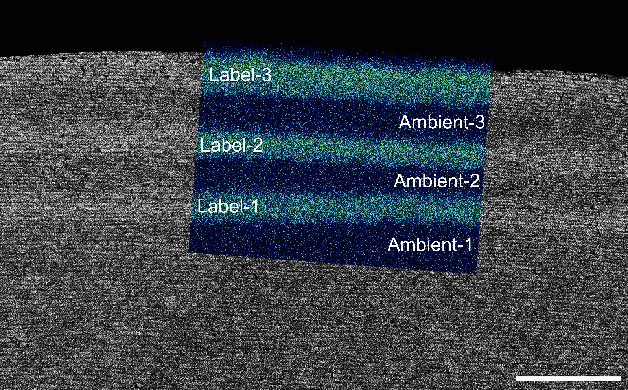
Supplementary Fig. 1. Representative SEM-EDS map (coloured) transecting the three Sr-labels in a M. galloprovincialis shell cross-section overlain on a grey-scale BSE image. Light blue areas (‘Label-1’ to ‘Label-3’) formed during Sr pulse-chase labelling intervals in seawater with elevated Sr concentrations while dark blue map areas (‘Ambient-1’ to ‘Ambient-3’) represent shell layers grown in ambient seawater. The three light blue Sr-labelled shell layers correspond to the brighter greyscales of the BSE image. The increased blurriness of the EDS map compared to the BSE image is due to the greater depth at which characteristic X-rays are produced compared to the backscattered electrons. Scale bar is 25 µm.

Supplementary Table 2: Element concentrations of the Sr-labelled and unlabelled M. galloprovincialis shell portions analysed by quantitative SEM-EDS (data derived from map shown in Supplementary Fig. 1). The data is presented as averages ± first standard deviations given in µg/g together with the number of spectra (n) for each shell portion as well as the Sr/Ca ratio in mmol/mol. The average Sr concentration, calculated from the three labelled shell portions, is 12,467 µg/g, (n_{Labelled}=4,744) while the average Sr concentrations, calculated from the three ambient shell portions, is 2,033 µg/g (n_{Ambient}=6,844).
Region of interest | Na  [µg/g] | S  [µg/g] | Ca  [µg/g] | Sr  [µg/g] | Sr/Ca  [mmol/mol]
Ambient-1 (n=2,272) | 3,400 ± 100 | 1,500 ± 100 | 447,200 ± 100 | 2,100 ± 100 | 2.15
Label-1 (n=1,043) | 3,700 ± 100 | 1,000 ± 100 | 441,300 ± 200 | 11,900 ± 100 | 12.33
Ambient-2 (n=1,337) | 3,600 ± 100 | 1,400 ± 100 | 448,500 ± 100 | 1,900 ± 100 | 1.94
Label-2 (n=1,163) | 3,700 ± 100 | 1,300 ± 100 | 437,500 ± 200 | 12,500 ± 100 | 13.07
Ambient-3 (n=3,235) | 3,400 ± 100 | 1,500 ± 100 | 447,200 ± 100 | 2,100 ± 100 | 2.15
Label-3 (n=2,538) | 3,200 ± 100 | 1,400 ± 100 | 439,600 ± 100 | 13,000 ± 100 | 13.53

NanoSIMS Sr/Ca ratio maps
Supplementary Fig. 2. NanoSIMS imaging of nacre growth visualised via Sr pulse chase labelling. Depicted are three additional magnified areas to those shown in Fig. 2 providing snapshots of dynamic nanoscale growth processes. All magnified regions show a stepped growth pattern of intercalated nacre tablets formed in seawater with normal Sr concentration (blue) and during Sr-labelling (magenta). Magnified regions of interest show sharp (i.e., within 100 nm) near-vertical transitions (white arrowheads) between labelled and unlabelled portions of nacre lamellae. The sizes of neighbouring labelled and unlabelled lamellae portions ranging between 3.0 to 4.2 µm demonstrate that these portions represent changes in Sr/Ca rations within individual tablets as the total length of a nacre tablet is 10-20 µm. Scale bar is 10 μm (large map) and 3 μm.

Supplementary Atom Probe Tomography details
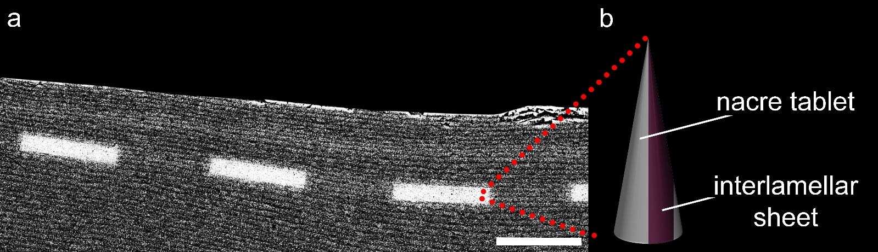
Supplementary Fig. 3: In situ FIB liftout from Sr-labelled nacre for APT analysis. a BSE image of the polished nacre cross-section at the umbo used for site-specific FIB-SEM lamellae extractions from within the Sr-labelled nacre. The selected areas contain the mineral-organic interface and the oganic interlamellar sheet. The protective platinum strips (white stripes in a) were deposited on the Sr-enriched nacre increments prior to wedge milling using a Xe ion beam. b schematic of a APT tip milled in this study with the organic interlamellar sheet (magenta) close to the tip’s apex. Scale bar is 25 μm.

Supplementary Fig. 4. APT Voltage evolution curve for the analysed nacre sample. Bivariate plot showing the voltage evolution during analysis as a function of ion counts for the APT tip. The voltage evolution obtained for nacre resembles a saw-tooth pattern due to the repeated encounter of the organic interlamellar sheet which caused change in the evaporation field. This is unlike to voltage curves observed for conductive samples where voltage would be observed to ramp up smoothly. We therefore chose to reconstruct the dataset as separate volumes (marked by red boxes and arrows pointing to the approximate location on a schematic APT tip) instead of one large reconstruction, to minimise potential artefacts. We selected three areas where the signal was relatively stable: area 1 to 3 are shown in Fig. 3, Supplementary Figs. 5 and 7, respectively.
Supplementary Fig. 5. 3D atom probe reconstruction for area 2 in the APT tip. a iso-concentration surface of Ca (50 at%, grey) and C (5.1 at%, magenta) for the nacre tablet and the organic interlamellar sheet. b iso-concentration surface of hydrogen (10 at%, yellow) is enriched in the organic interlamellar sheet. c iso-concentration surface of Sr (20 at%, red) shows an enriched cortex along the outermost part of the nacre tablet adjacent to the organic sheet. d volume rendering showing the distribution of Sr across the volume of the reconstruction showing Sr-enriched areas in warmer colours. e iso-concentration surface of Na (8 at%, green). f schematic representation of the APT reconstruction (red box) and its relative position within the tip as well as within the nacreous architecture more generally.
Supplementary Fig. 6. Qualitative compositional line profile across the nacre tablet and the mineral-organic interface associated with the interlamellar sheet (area 2 shown in Supplementary Fig. 5). The profile is divided by black dashed lines into three sections ‘tablet’, ‘cortex’ and ‘interlamellar sheet’. The tablet-cortex transition is defined by a significant increase in Sr, while the transition from cortex to interlamellar sheet is defined as the point of intersection between the Ca (grey) and the C (magenta) signals (see methods). The ‘tablet’ is characterized by high Ca concentrations indicative of CaCO₃, while the ‘cortex’ area is defined by high Sr (red) at intermediate Ca and the ‘interlamellar sheet’ by high C and H (yellow) counts indicative of organics. The Sr-enriched cortex appears within 4 nm of the mineralized nacre tablet adjacent to the organic sheet. The abundance of Na (green) increases steadily from the tablet into the organic sheet. Shaded error envelopes are calculated based on counting statistics.
Supplementary Fig. 7. 3D atom probe reconstruction for area 3. a iso-concentration surface of Ca (50 at%, grey) and C (5.1 at%, magenta) identifying the nacre tablet and the organic interlamellar sheet. b enriched iso-concentration surface of hydrogen (10 at%, yellow) in the organic interlamellar sheet. c iso-concentration surface of Sr (20 at%, red) shows an enriched cortex in the outermost part of the nacre tablet adjacent to the organic sheet. d volume rendering showing the distribution of Sr across the volume of the reconstruction showing Sr-enriched areas in warmer colours. e the iso-concentration surface of Na (8 at%, green). f schematic representation of the APT reconstruction (red box) and its relative position within the tip as well as within the nacreous architecture more generally.
Supplementary Fig. 8. Qualitative compositional line profile across the nacre tablet and the mineral-organic interface associated with the interlamellar sheet (area 3 shown in Supplementary Fig. 7). The profile is divided by black dashed lines into three sections ‘tablet’, ‘cortex’ and ‘interlamellar sheet’. The tablet-cortex transition is defined by a significant increase in Sr, while the transition from cortex to interlamellar sheet is defined as the point of intersection between the Ca (grey) and the C (magenta) signals (see methods). The ‘tablet’ is characterized by high Ca concentrations indicative of CaCO₃, while the ‘cortex’ area is defined by high Sr (red) at intermediate Ca and the ‘interlamellar sheet’ by high C and H (yellow) counts indicative of organics. The Sr-enriched cortex appears within 4 nm of the mineralized nacre tablet adjacent to the organic sheet. The abundance of Na (green) increases steadily from the tablet into the organic sheet. Shaded error envelopes are calculated based on counting statistics.

Photo-induced Force Microscopy mapping
Supplementary Fig. 9. Overview PiFM phase distribution map. a topographic AFM image with lighter and darker colour representing differences in topography (60 nm). b composite PiFM map showing aragonite (mapped using the band at 1470 cm⁻¹, green) and Sr-rich aragonite (mapped using the shoulder at 1444 cm⁻¹, red). The map was set up to cover the area showing the second Sr-labelled shell layer, which is clearly visible as a red band in the composite map (between the two dashed lines). c full spectra obtained from hyperspectral IR (hyPIR) mapping. Spectra are numbered with location indicated in the composite map as white crosses. The bands related to the aragonite and Sr-rich aragonite main peaks at 1470 and 1444 cm⁻¹ are clearly visible. The small, sharp bands at 1262 and 854 cm⁻¹ are associated with aragonite, while the remaining broad, peaks at 1262, 1101 cm⁻¹, 1024 cm⁻¹ and 809 cm⁻¹ are associated with organic phases. See methods for details and peak assignment. Scale bar is 5 µm (a and b).

