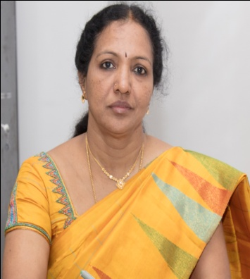
C. Gomathy acquired B.E. (Honors) degree in Electronics and Communication Engineering from Government College of Engineering, Tirunelveli, in the year 1986, and an M.S. degree in Electronics and Control Engineering from Birla Institute of Technology and Science, Pilani, in 1992. She also obtained an M.S. (by research) degree from Anna University in 2001. She obtained her Ph.D. in the area of Mobile Ad hoc networks from Department of Electronics and Communication Engineering, College of Engineering, Anna University, Chennai, India, in the year 2007. She has published over 95 research papers in National and International conferences and journals. She has received the Best Teacher Award for Four consecutive times from SRM University for her research publications. She has 33 Years of Teaching and Research Experience. She has Guided More than 65 UG Projects and more than 20 PG Projects. She is now Guiding 6 Ph.D Students. 5 candidates have completed Ph.D, under her guidance. She has Conducted Many International/National conferences, Symposiums and workshops. She also is a Life Member in ISTE, member in IEEE and IET, Joint Treasurer in IET-CLN. She has been acting as reviewer and Editor in many International journals. She has conducted many workshops and presented invited talks in many institutions. She has authored a text book on electronic devices. She has successfully completed a research project titled” Design and development of Fast response Electronics for Eddy current flow meter” for the FRTG Group of IGCAR, Kalpakkam. The project amount sanctioned is 7.86 Lakhs. She also acted as Co-Investigator for project on Meteorological Tower instrumented with sensors relocated in Sathyabama University.

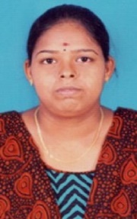 Sandhiyaa S received a B.E degree in Electronics and communication Engineering from the department of Electronics and Communication Engineering , Avinashi lingam university, Coimbatore in 2017, and a M.E degree in Applied electronics from the department of Electronics and communication Engineering, Vellalar institute of engineering technology, erode in 2019.Now I am pursuing Ph.D. research scholar in SRM institute of science and technology, Vadapalani. My research area under underwater wireless sensor network.

