Table 3: Analysis of different plant growth traits and yield of moong bean treated with different combinations and feather hydrolysate and commercial amino acid in pot trails to optimized dose and duration
Agronomic traits | Different treatments |  |  |  |  |  | Visual observation
Agronomic traits | Raw Feather hydrolysate (Gr-1) | Water:FH=2:1 (Gr-2) | Water:FH=1:2 (Gr-3) | Water:FH=1:1 (Gr-4) | Commercial Amino acid (Gr-5) | Water wetted with poultry litter (Gr-6) | Visual observation
Physiological observation |  |  |  |  |  | 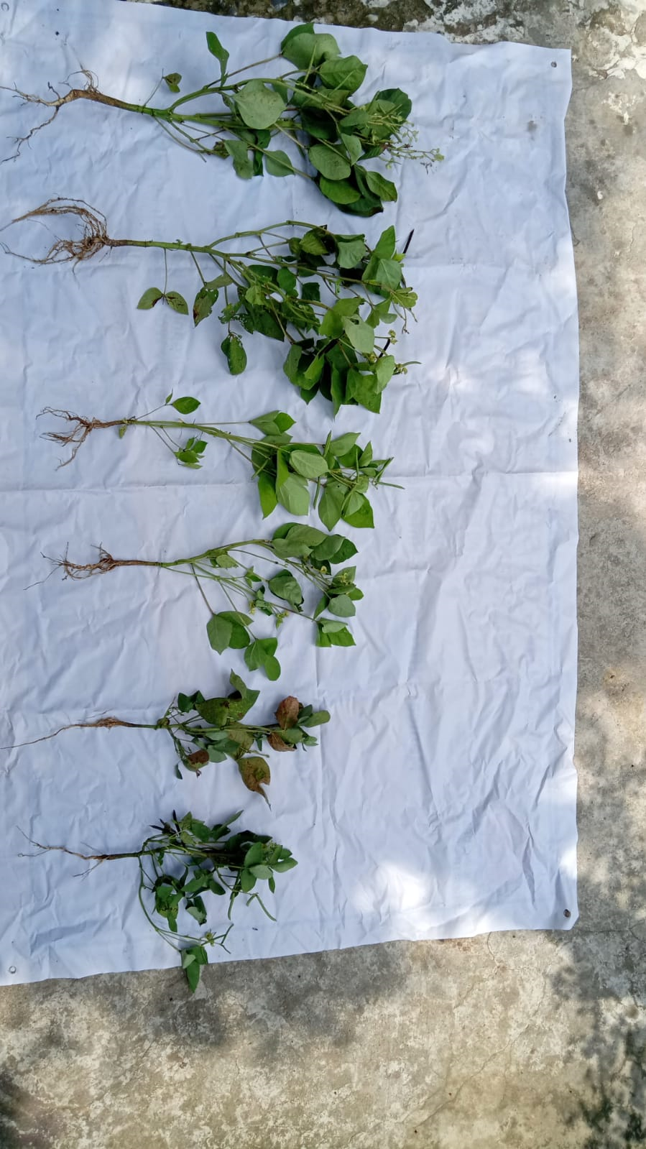  Gr. 1, Gr. 3, Gr. 5, Gr. 2, Gr. 4, Gr. 6
Shoot Length (cm) | 30.9 | 25.15 | 30.32 | 27.15 | 30.56 | 22.51
Shoot wet weight (g) | 19 | 10.7 | 19 | 12 | 18.6 | 10.8
Shoot dry weight (g) | 1.9 | 0.8 | 1.9 | 1.1 | 1.8 | 1.1
Branches (no.) | 6 | 3 | 7 | 5 | 6 | 4
Average leaf diameter (sq. cm) | 7.2 | 4.9 | 6.9 | 5.8 | 7 | 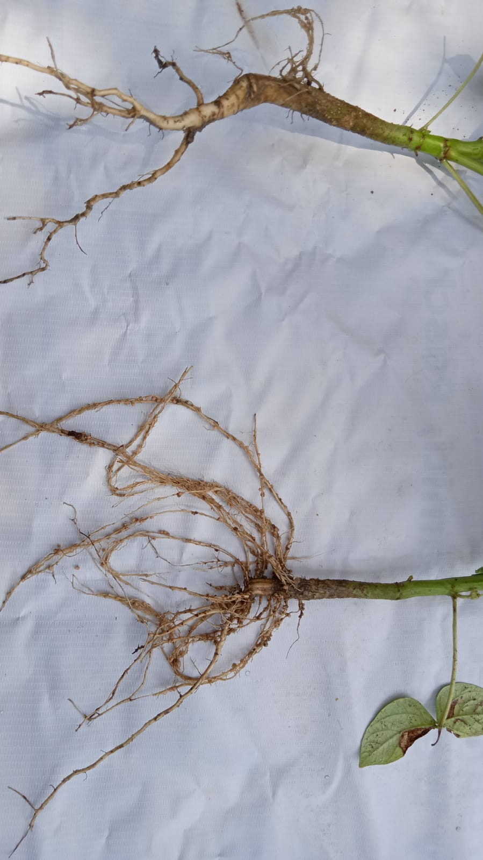  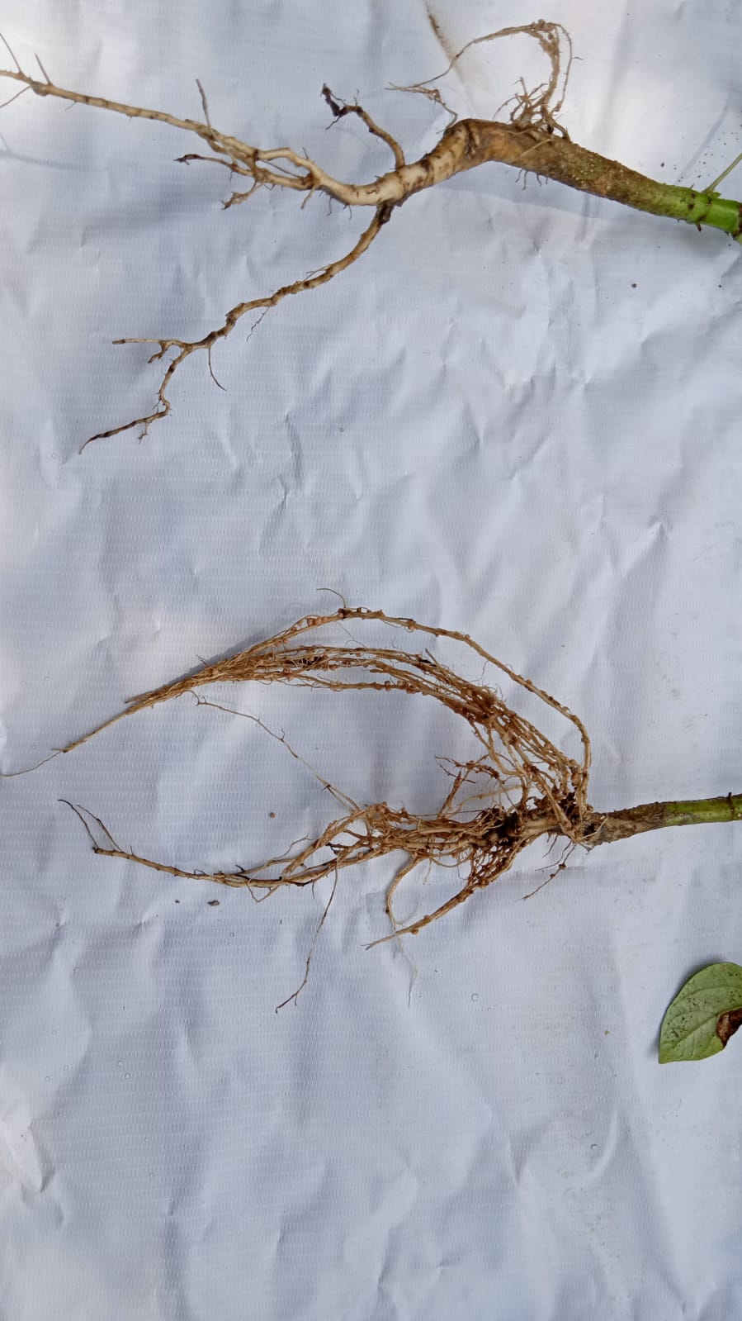  4.7  Gr. 1, Gr. 3, Gr. 5,
Pod number | 8 | 9 | 12 | 10 | 10 | 10
Flower number | 6 | 6 | 7 | 5 | 7 | 4
Average no of grain in mature pod | 7 | 5 | 7 | 5 | 7 | 4
Root length (cm) | 4.75 | 3.4 | 4.58 | 4.17 | 4.89 | 3.24
Root wet weight (g) | 4 | 2.2 | 3.8 | 2.4 | 3.5 | 1.7
Root dry weight | 0.38 | 0.31 | 0.37 | 0.25 | 0.34 | 0.16
No of nodule formation | 20 | 11 | 20 | 13 | 15 | 12
Overall appearance of grain (colour and texture) | Light green & shigning | Light green & shigning | Light green & shigning | Greenish yellow & shigning | Light green & shigning | Greenish yellow & shigning | 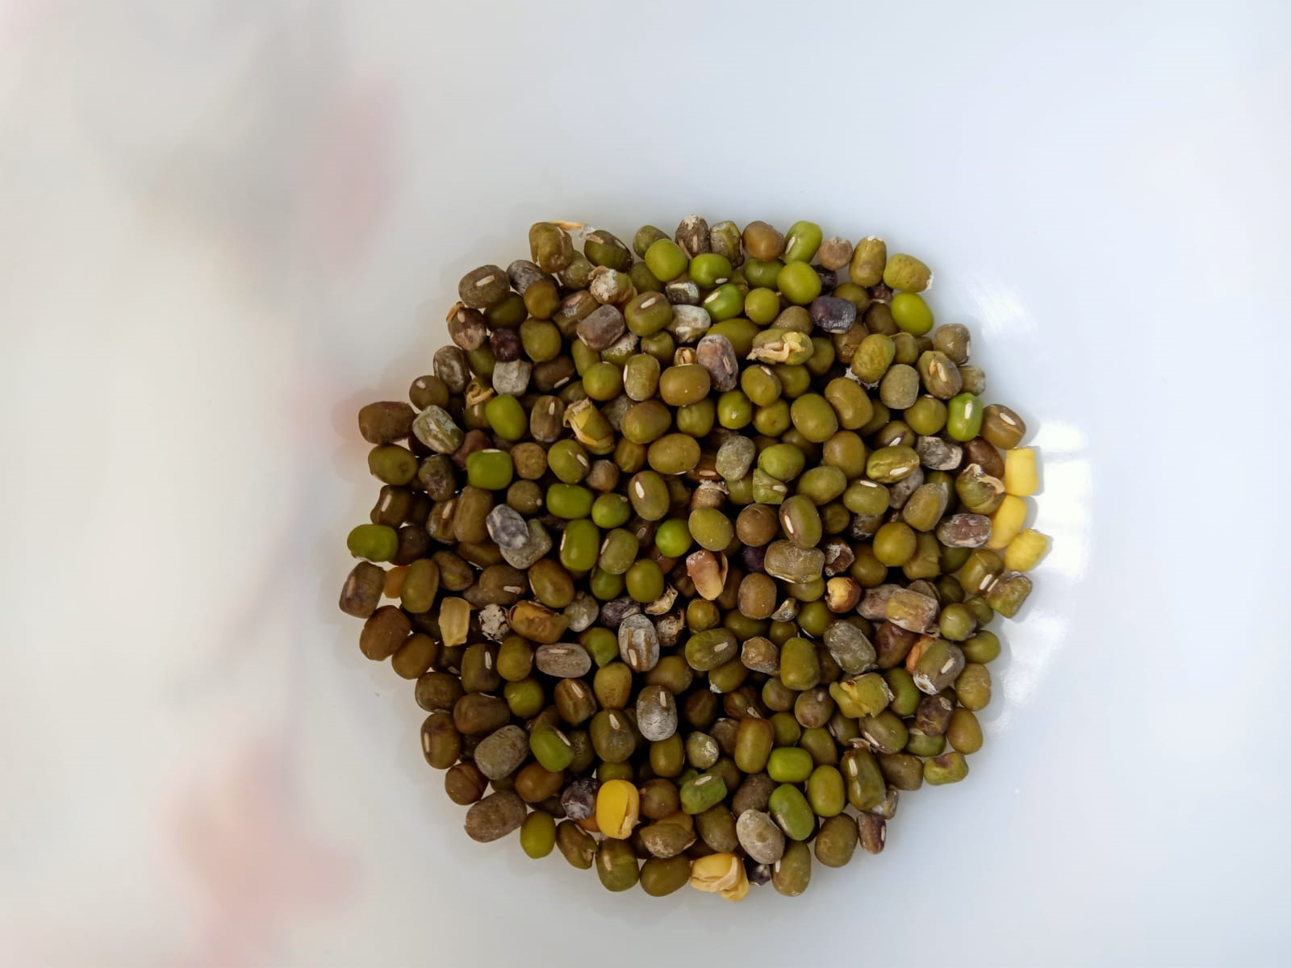  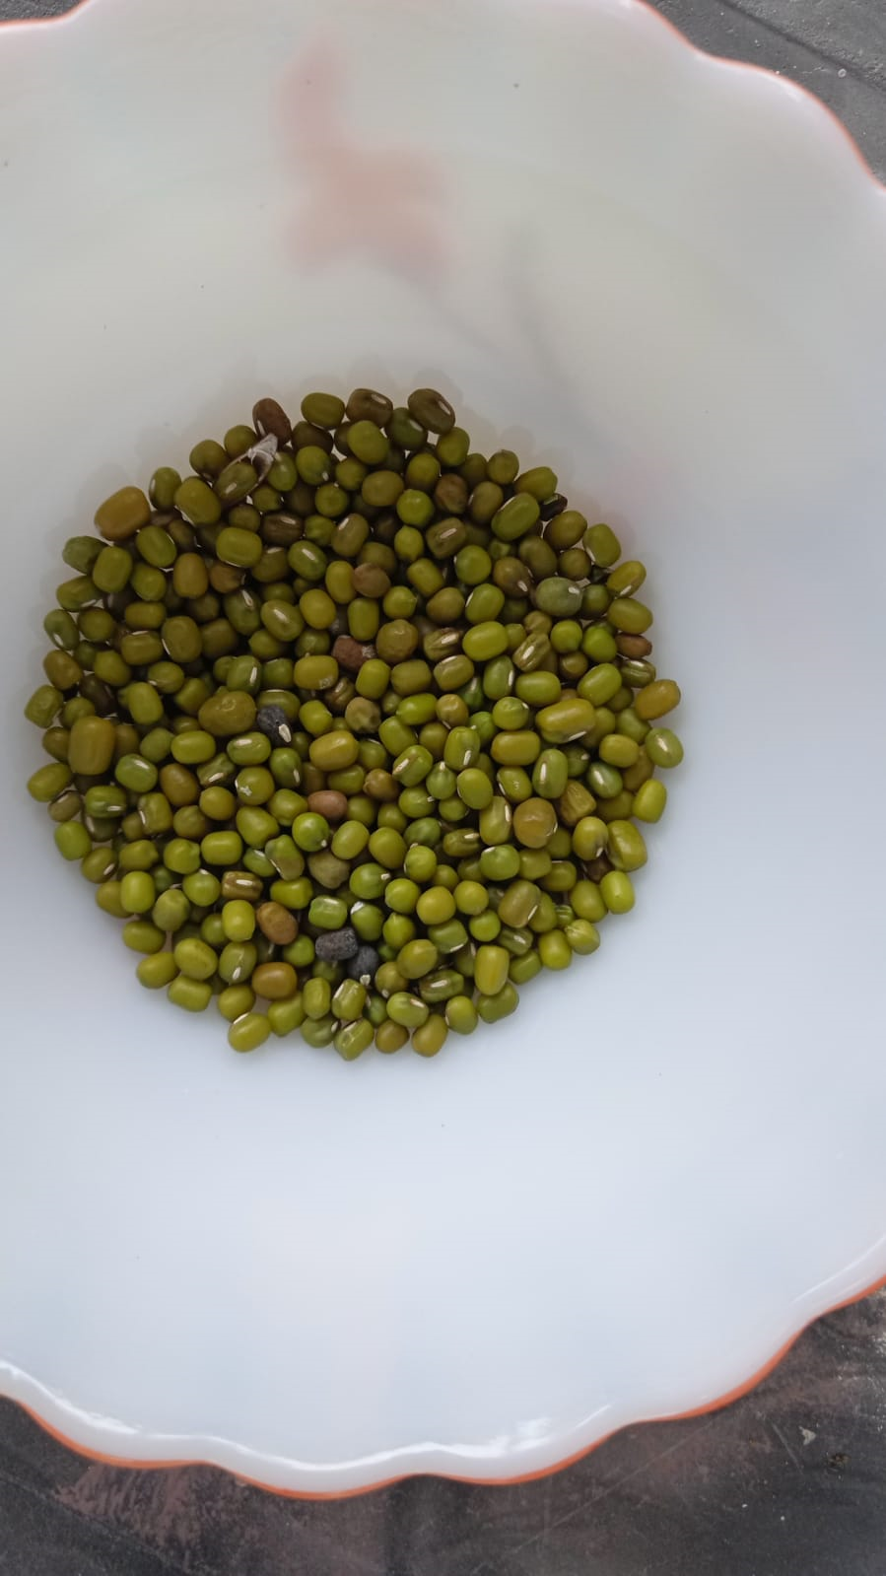  Gr. 6 Gr. 3
Overall grain weight (1st flash) | 14.8 | 11.23 | 14.77 | 12.3 | 14 | 5.6
Overall grain weight (2nd flash) | 10.85 | 7.2 | 10.58 | 8 | 9.78 | 4.31
Table 4: Analysis of different microscopic and biochemical properties related to plant growth and yield of moong bean treated with different combinations and feather hydrolysate and commercial amino acid in pot trails to optimized dose and duration

Agronomic traits | Different treatments |  |  |  |  |  | Visual observation
Agronomic traits | Raw Feather hydrolysate (Gr-1) | Water:FH=2:1 (Gr-2) | Water:FH=1:2 (Gr-3) | Water:FH=1:1 (Gr-4) | Commercial Amino acid (Gr-5) | Water wetted with poultry litter (Gr-6) | Visual observation
Microscopic observation |  |  |  |  |  |  | 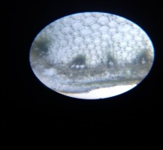  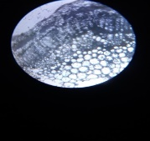  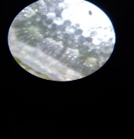  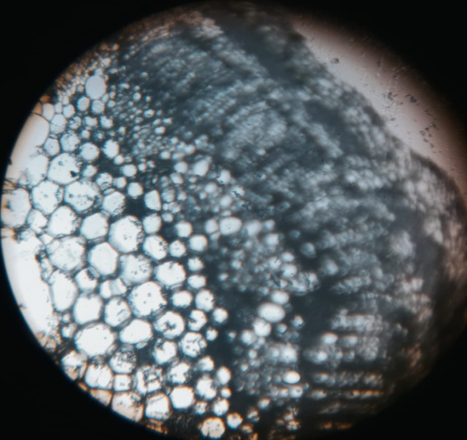  Gr. 1 Gr. 3  Gr. 5 Gr. 6
No of xylem in moong bean stem | 29 | 23 | 29 | 25 | 26 | 20
No of phloem in moong bean stem | 23 | 15 | 22 | 17 | 21 | 14
Size of root cortex and endodermis (µm) | 34.5 | 25.8 | 34.2 | 28.7 | 33.1 | 23.7
No of stomata present in leaf (per 100×200 µm area) | 7 | 6 | 8 | 7 | 7 | 5
Bio-Chemical analysis of plants
IAA content (mg/g) | 72 | 40 | 72 | 45 | 53 | 44
Chlorophyll content (mg/g) | 45.86 | 23.1 | 45.91 | 23.8 | 43 | 20.17
Proline content (mg/g) | 0.08 | 0.11 | 0.07 | 0.12 | 0.16 | 0.12
Bio-Chemical analysis of grain
Total Carbohydrate content (mg/g) | 29.41 | 20.9 | 29.25 | 21.74 | 26.04 | 20.13
Total Protein content (mg/g) | 16.87 | 10.35 | 16.75 | 10.25 | 15.57 | 13.52
Total flavonoid content (mg/g) | 29.8 | 21.8 | 29.5 | 23.5 | 36 | 23
Total phenolic content (mg/g) | 46 | 32.5 | 46 | 36 | 42 | 32
Total Amino Acid content (µg/g) | 74 | 34 | 72 | 40 | 69.5 | 35

