Comparative analysis of latex transcriptomes reveals the potential mechanisms underlying the rubber molecular weight variations among Hevea brasiliensis clones RRIM600 and Reyan7-33-97
Shichao Xin, Yuwei Hua, Ji Li, Xuemei Dai, Xianfeng Yang, Jinu Udayabhanu, Huasun Huang* and Tiandai Huang*

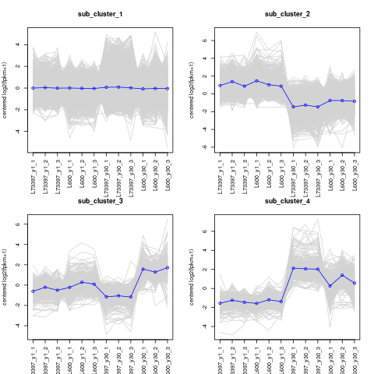

Fig. S1. Hierarchical cluster analysis indicated that the expression patterns of DEGs obtained from the transcriptome sequencing analysis could be divided into 4 sub-clusters.

