Electronic Supplementary Information

Development of a high-performance platinum-sensitized Co₂P/NF electrode for hydrogen production from water decomposition

Xiaoyan Dengª, Qiuyue Quª, Xiaoyang Jiª, Hongkai Bu^{b}, Yan Zhao^{b}, Chuanling Wang^{c}, Hongtao Gao^{b*}
ªCollege of Environment and Safety Engineering, State Key Laboratory Base of Eco-Chemical Engineering, Qingdao University of Science & Technology, Qingdao, 266042, P. R. China.
^{b}College of Chemistry and Molecular Engineering, State Key Laboratory Base of Eco-Chemical Engineering, Qingdao University of Science & Technology, Qingdao, 266042, P. R. China.
^{c}Shandong Fanpu Testing Co., Ltd, Jining,272200, P. R. China.

Figure S1. Cyclic voltammograms of Co₂P, Co₂P-5000, Co₂P-15000, Pt-Co₂P/NF at scan rates from 5 to 100 mV/s within 0.1 V potential window centered at the open-circuit potential.
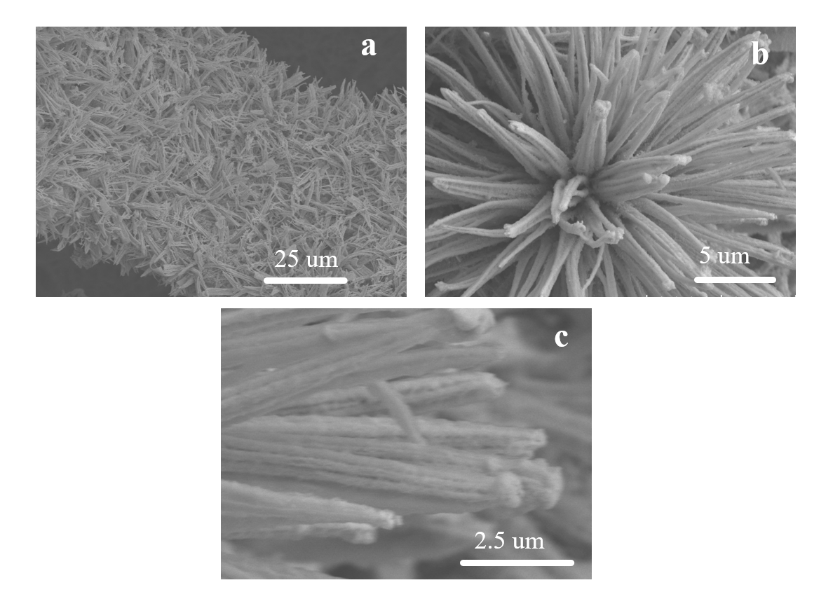
Figure S2. SEM images of Pt-Co₂P/NF that was evaluated by chronoamperometry method for at least 24 h

Table S1 The mass percentage of each element
a Co₂P
Elt. | Conc | Units
C | 3.245 | wt.%
O | 19.992 | wt.%
P | 32.215 | wt.%
Co | 44.549 | wt.%
 | 100.000 | wt.% | Total
b Pt-Co₂P/NF
Elt. | Conc | Units
C | 8.734 | wt.%
O | 4.920 | wt.%
P | 3.991 | wt.%
Co | 82.356 | wt.%
 | 100.000 | wt.% | Total

