Three-dimensional operando optical imaging of single particle and electrolyte heterogeneities inside Li-ion batteries

^{1,2}Raj Pandya✉, ¹Lorenzo Valzania#, ^{3,4}Florian Dorchies#, ¹Fei Xia#, ⁵Jeffrey Mc Hugh, ^{2,6}Angus Mathieson, ⁶Jien Hwee Tan, ⁷Thomas G. Parton, ⁶Michael De Volder, ^{3,4}Jean-Marie Tarascon, ¹Sylvain Gigan✉ ,¹Hilton B. de Aguiar✉, and ^{3,4}Alexis Grimaud✉

¹Laboratoire Kastler Brossel, ENS-Université PSL, CNRS, Sorbonne Université, Collège de France, 24 Rue Lhomond, Paris 75005, France
²Department of Physics, Cavendish Laboratory, University of Cambridge, JJ Thomson Avenue, Cambridge CB3 0HE, United Kingdom
³Chimie du Solide et de l’Energie, UMR 8260, Collège de France, Paris, France
⁴Réseau sur le stockage Electrochimique de l’Energie (RS2E), Amiens, France
⁵Neuroglial Interactions in Cerebral Physiology and Pathologies, Center for Interdisciplinary Research in Biology, Collège de France, CNRS, INSERM, Labex Memolife, Université PSL, 75005 Paris, France
⁶Department of Engineering, University of Cambridge, Cambridge CB3 0FS, U.K.
⁷Yusuf Hamied Department of Chemistry, University of Cambridge, Lensfield Road, Cambridge, CB2 1EW, United Kingdom

✉Correspondence to: rp558@cam.ac.uk, sylvain.gigan@lkb.ens.fr, h.aguiar@lkb.ens.fr alexis.grimaud@college-de-france.fr
#These authors contributed equally

Supporting Information

Table of contents
Supplementary note 1: Reflection spectrum of Li_{x}FePO₄ as a function of state-of-charge 3
Supplementary note 2: Extracting refractive index of LCO and NMC811 4
Supplementary note 3: Influence of defocus on spatial reflectivity from LCO 7
Supplementary note 4: Extraction of uncertainity on particle volume 8
Supplementary note 5: Modelling influence of defocus on size of imaged particles 11
Supplementary note 6: Attenuation and aberration correction of confocal z-stacks 13
Supplementary note 7: Extraction of velocity from depth-dependent reflectivity measurements 19
Supplementary note 8: Extraction and projection of particle surfaces 22
Supplementary note 9: Spatial inhomogeneities at core and surface of particles in LCO and NMC811 as a function of cycling-rate 23
Supplementary note 10: Imaging electrolyte concentration gradients around cycling LCO and NMC811 particles 26
Supplementary note 11: Assembly of operando half-cell 30

Supplementary note 1: Reflection spectrum of Li_{x}FePO₄ as a function of state-of-charge

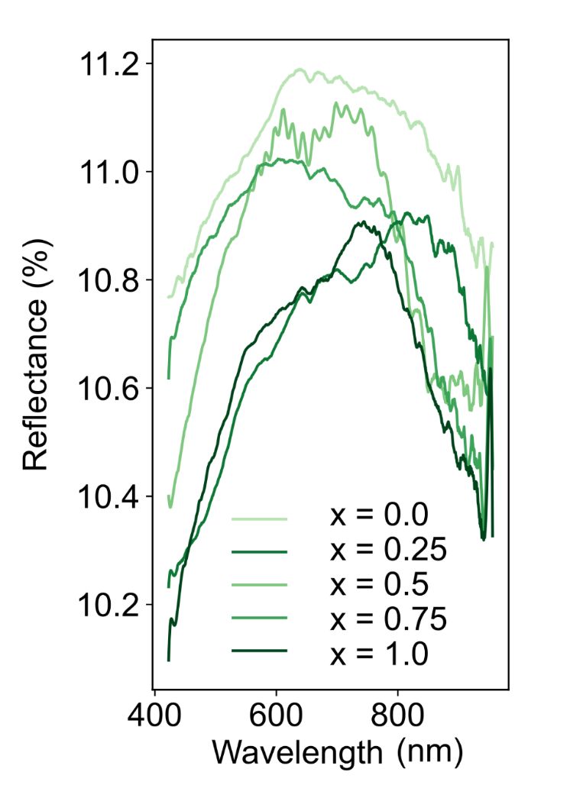
Supplementary Figure 1: Reflection (R) spectra as a function of lithium doping fraction (x) for Li_{x}FePO₄.

Supplementary note 2: Extracting refractive index of LCO and NMC811

The real (n) and imaginary (k) parts of the refractive of index of LCO and NMC were estimated by fitting their reflectivity spectra with the RefFit software¹. Here the normal incidence reflectivity, $(ω)$ , is taken to be ${\left|\frac{1-\sqrt{ϵ}}{1+\sqrt{ϵ}}\right|}^{2}$, where $ε(ω)$ is the dielectric function. For both LCO and NMC $ε(ω)$ is assumed to follow the Drude-Lorentz model. Three Drude peaks are used to fit the reflectivity spectra. For the third Drude peak the transverse frequency is confined to zero to account for the response of free charge carries. RefFit employs variational dielectric functions to transform the data such that the fit is performed with a large number of analytically Kramers-Kronig-constrained functions (such as Lorentzians) which constitute the dielectric function. Supplementary Figure 2 show the fitted n and k spectra.
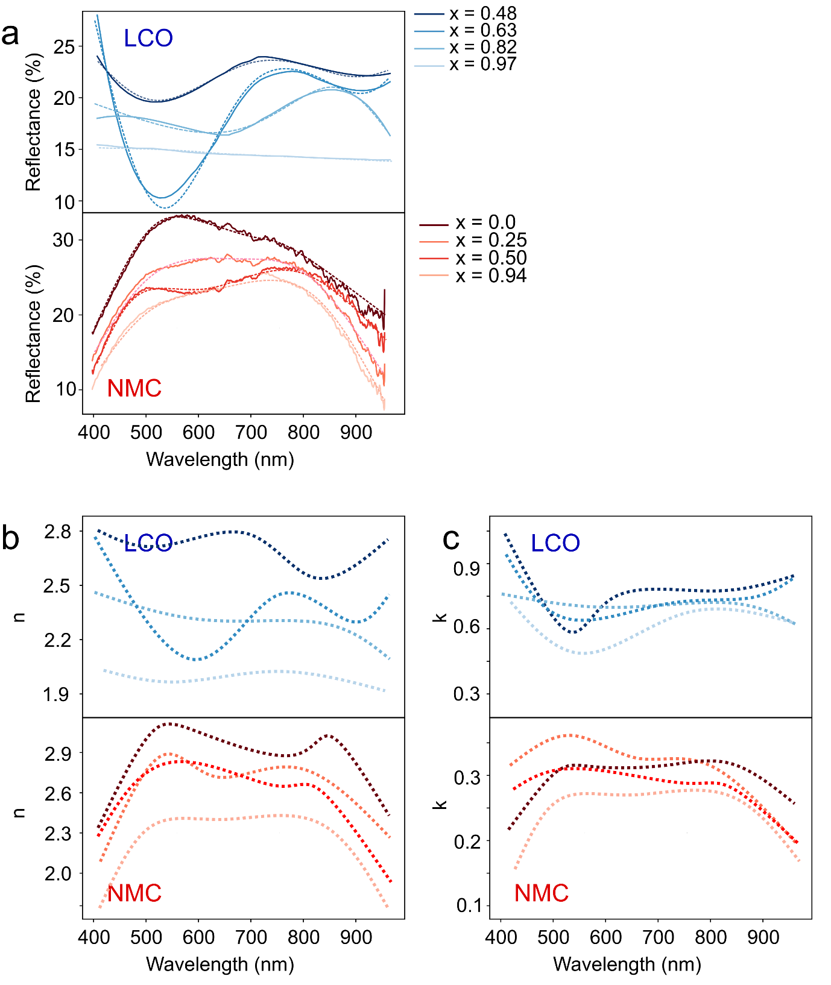

Supplementary Figure 2: a. Raw (solid lines) and fitted (dashed lines) reflectivity spectra of Li_{x}CoO₂ (LCO) and Li_{x}Ni_{0.8}Mn_{0.1}Co_{0.1}O₂ (NMC) as a function of doping (x). b-c. Real (n) and imaginary (k) parts of the refractive index of LCO and NMC extracted from fitting model.

We note that the un-normalised, but attenuation corrected, change in reflectivity is ~1.7 times larger for the surface as compared to inside the particle (Figure 1b and supplementary Figure 3). This is slightly smaller than what would be expected based on purely a difference in the real-part of the refractive index n (particle/electrolyte versus intraparticle n variation). The variation in the imaginary (absorptive) part of the refractive index (k) with lithiation state is small as shown in supplementary Figure 2, with a slight increase in k during delithiation. Absorptive (k) effects will play a more significant role when focussing inside the material. Attenuation correction (see supplementary note 6) should account for both the absorption and scattering that attenuates the signal when focussing inside the material. However, some imperfections in this correction and unaccounted for variations in k may additionally contribute to the difference between the direction of the ‘surface’ (S) and ‘inside’ (I) focussing changes; indeed, an increase in k during charging as is observed will decrease the reflected signal. Because we do not compare raw reflection intensities between different depths in this work any unaccounted k variation should not influence our observations.

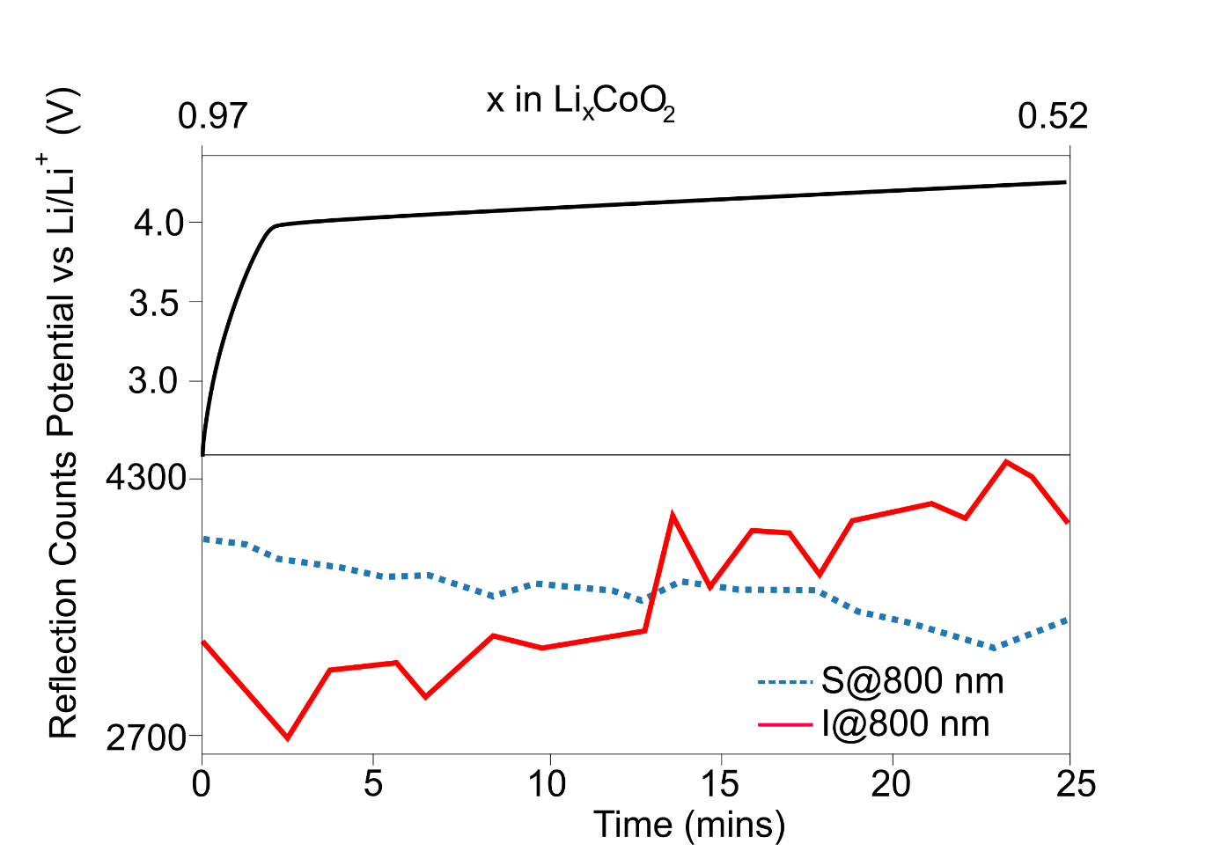
Supplementary Figure 3: Variation in (attenuation corrected) un-normalised reflection signal when focussing on the surface and inside of material at 800 nm as a function of state-of-charge.

Supplementary note 3: Influence of defocus on spatial reflectivity from LCO
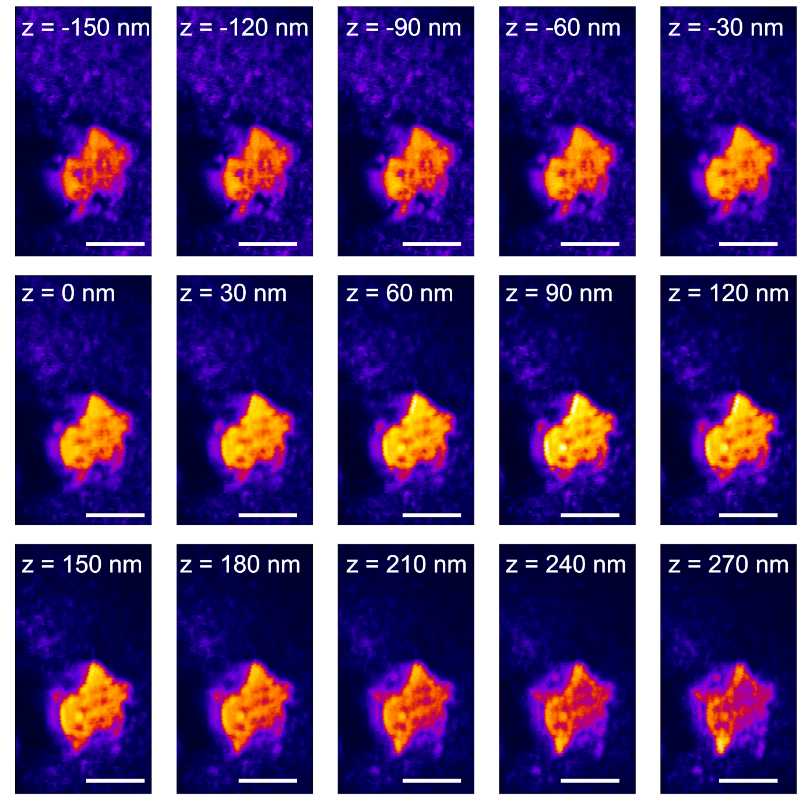
Supplementary Figure 4: Reflection images of particle whilst scanning focus (white label). A quasi-wide field imaging modality is used by increasing the pinhole size to 2.0 A.U.. Although at all focus positions the particle appears to remain nominally in focus (i.e. sharp outline), the spatial reflected intensity pattern changes. Scale bar is 5 μm.

Supplementary note 4: Extraction of uncertainity on particle volume
The refractive index, n, also plays a role on the imaged size of an object via the optical path length, (OPL) OPL = n · s, where s is the geometric path length. As n increases so will the OPL, meaning the true imaging plane of a reflection or transmission microscope (defocus) will be lower (higher) for larger (smaller) values of n. The impact of this is that if experimentally the defocus is not corrected by axial movement of the focal plane, the object will appear larger/smaller than it truly is both laterally and axially, i.e. particles will appear to falsely expand/contract when cycling simply due to a changing n. Consequently, before using optical microscopy to investigate any geometric particle size changes during cycling e.g. from a phase changes, cracking, etc, the impact of a varying n on the OPL must first be quantified and accounted for. We note the above OPL formula, although valid, is an oversimplification for normal incidence, with other interference terms in-reality also playing a role².
To estimate the particle size distortion introduced by the refractive index mismatch we extract the size of the object at a single focus position (F1) and compare it with the maximum intensity projection (MIP) obtained using time-gated optical coherence tomography as described in the methods section of the main text. From the mismatch in length between the MIP and single focus image we then estimate an uncertainty on the volume of the particle assuming cube and based on error propogation i.e. V = L_{x} · L_{y} · L_{z} ∴ ΔV = V · (ΔL_{x}/L_{x} + ΔL_{y}/L_{y} + ΔL_{z}/L_{z}).
In supplementary figures 5 – 8 we show the difference in MIP and F1 images for LCO particles in different doping states. We also show that for polystyrene beads of refractive ~1.59 the mismatch in size between the MIP and F1 image is negligible.

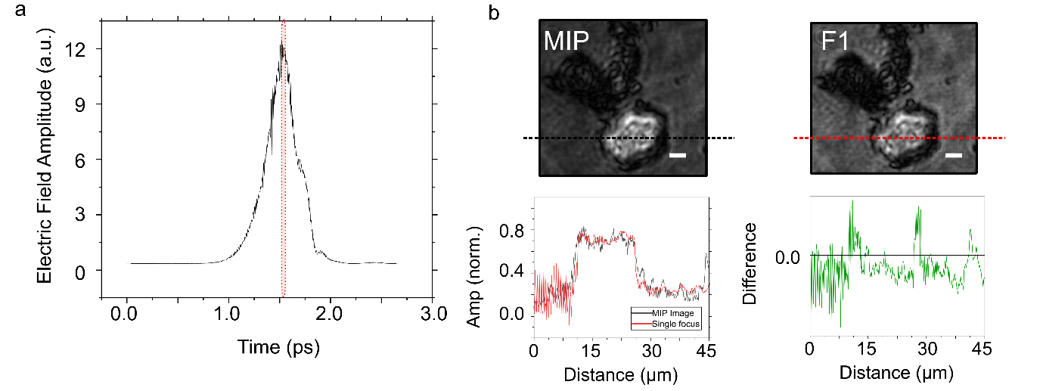
Supplementary Figure 5: a. Electric field amplitude from time-domain optical coherence tomography (TD-OCT) stack of Li_{0.63}CoO₂ particle. b. Maximum intensity projection (MIP) image of Li_{0.63}CoO₂ particle obtained from TD-OCT and image taken from a single time gate, F1 (marked with red shading in a. Scale bar 5 μm. (Bottom) Normalised line-cut through particle (dashed lines in image) for MIP (black) and F1 (red) images. Green line shows difference between two line-cuts.

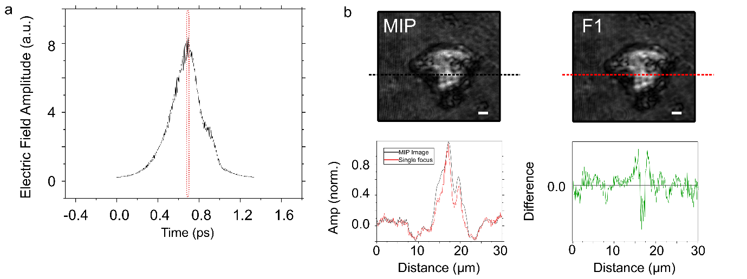
Supplementary Figure 6: a. Electric field amplitude from time-domain optical coherence tomography (TD-OCT) stack of Li_{0.82}CoO₂ particle. b. Maximum intensity projection (MIP) image of Li_{0.82}CoO₂ particle obtained from TD-OCT and image taken from a single time gate, F1 (marked with red shading in a. Scale bar 5 μm. (Bottom) Normalised line-cut through particle (dashed lines in image) for MIP (black) and F1 (red) images. Green line shows difference between two line-cuts.

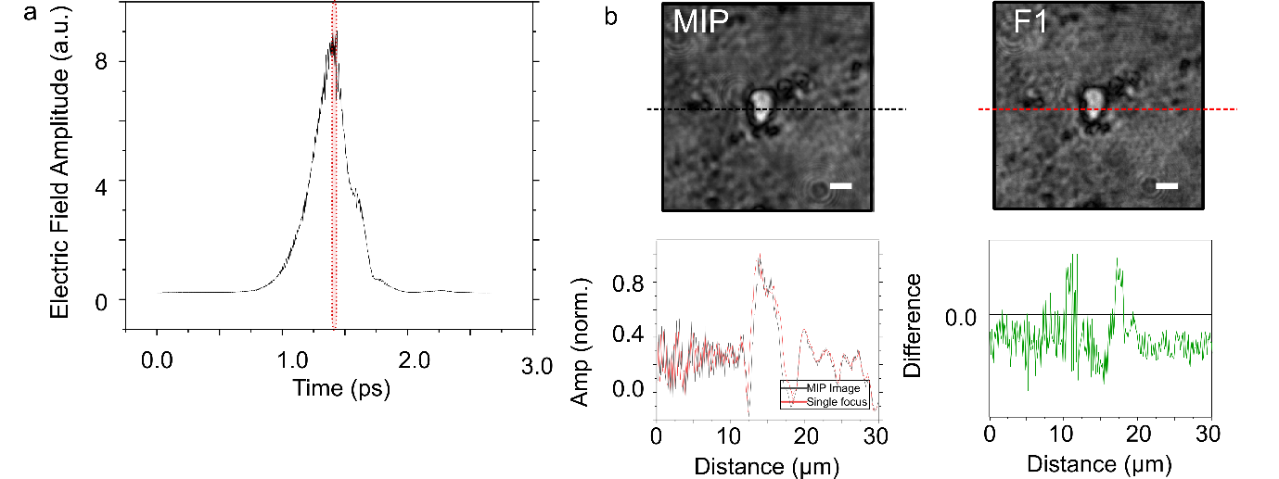

Supplementary Figure 7: a. Electric field amplitude from time-domain optical coherence tomography (TD-OCT) stack of Li_{0.97}CoO₂ particle. b. Maximum intensity projection (MIP) image of Li_{0.97}CoO₂ particle obtained from TD-OCT and image taken from a single time gate, F1 (marked with red shading in a. Scale bar 5 μm. (Bottom) Normalised line-cut through particle (dashed lines in image) for MIP (black) and F1 (red) images. Green line shows difference between two line-cuts.

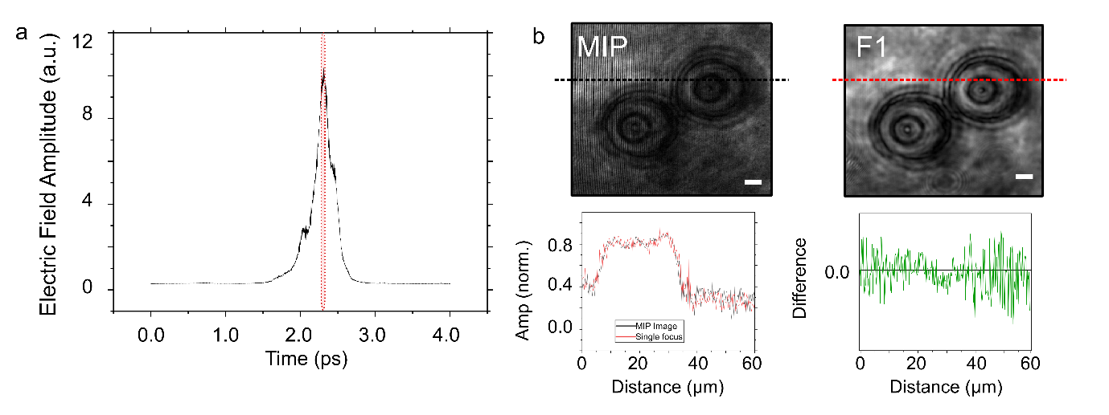

Supplementary Figure 8: a. Electric field amplitude from time-domain optical coherence tomography (TD-OCT) stack of 30 μm diameter polystyrene bead particle. b. Maximum intensity projection (MIP) image of 30 μm diameter polystyrene bead obtained from TD-OCT and image taken from a single time gate, F1 (marked with red shading in a. Scale bar 3 μm. (Bottom) Normalised line-cut through particle (dashed lines in image) for MIP (black) and F1 (red) images. Green line shows difference between two line-cuts.

Supplementary note 5: Modelling influence of defocus on size of imaged particles
To demonstrate the role of refractive index on the imaged size of an object via the optical path length finite-difference time-domain simulations (FDTD Solver; Lumerical Inc.) are used. In supplementary Figure 9 a rectangular rod shaped object with varying refractive index from 2.0 to 2.5 along the rod length (e.g. mimicking directional doping along a rod like battery particle) is shown. The physical width of the rod is uniform along its length, but in a fixed imaging plane, as is performed experimentally, the width of rod increases with refractive index. This is as a consequence of the increased OPL of light with greater n, meaning the true imaging plane (defocus) will be lower for greater n (see cartoon in right of supplementary Figure 9). This effect will be independent of the particle shape as shown in the bottom right panel of supplementary Figure 9 where the percentage difference between the input top face area of a hexagonally prismatic shaped object and area of the imaged object is plotted. As n increases the deviation between input and output areas increases due to the increasing OPL and defocus in the imaging plane.

Finite-difference time-domain simulations are performed using a FDTD solver (Lumerical Inc.) using the total-field scattered field method. Typically, a simulation volume of 30 μm × 30 μm × 30 μm with auto non-uniform meshing, set to accuracy of ‘4’, typically with an auto shut-off parameter of 1 × 10 ⁻⁹ was used. A 2D z-normal power (reflection) monitor whose xy dimensions spanned the entire simulation volume was used. The source was placed in-front of the monitor in contact with the top of the simulation object stack (electrolyte, battery particle and binder). The dimensions of the object stack were defined as shown in supplementary Figure 9, with objects set as custom n,k materials. Following simulation, the nearfield was decomposed into plane waves using far-field projection. A filter was applied for propagating through an aperture, an image plane defined and finally a chirp z-transform performed to calculate the image. In some cases, an additional far-field filter set at ~0.3 was used to remove ripples in the far field projection due to clipping of the near fields. Python scripts were developed for batch running and processing of simulations.

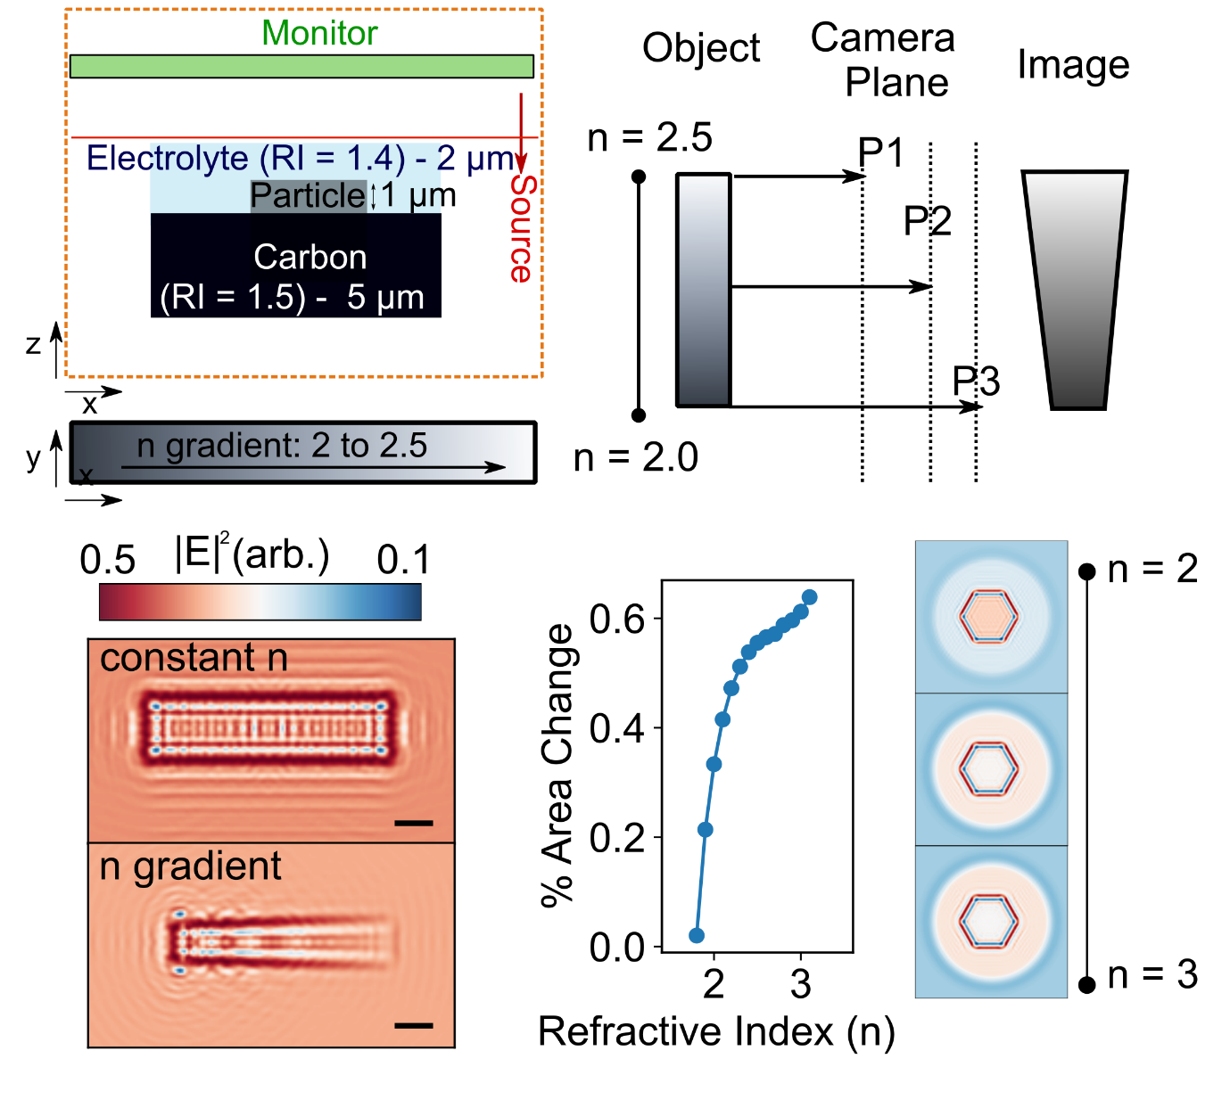

Supplementary Figure 9: Particle sizing with optical reflection microscopy (Top left) Cartoon schematic of simulated battery particles in carbon matrix (RI = 1.5) and embedded in electrolyte (RI =1.4). Red arrow indicates source direction with monitor behind; orange box indicates simulation area. (Bottom left) Simulated far-field electric field profile of particle with constant refractive index along length (top) and one with a refractive index gradient from 2 to 2.5). (Top right) Cartoon schematic highlighting defocus effect as refractive index of object increases. (Bottom right) Simulated differential area change (with respect to object of n = 1.6) of prismatic hexagonal shaped object (right) as a function of refractive index. Images show differential far field images with respect to n = 1.6 prismatic hexagon (indicated n is object refractive index). Circular halo arises from far-field filter used in simulation to remove ripples in the far field projection due to clipping of the near fields

Supplementary note 6: Attenuation and aberration correction of confocal z-stacks
In 3D confocal microscopy a number of corrections must be made to image stacks. The first is due to the attenuation of light with depth, such that the intensity (I) at a given plane (z) will in fact be I₀e^{-μz} where I₀ is the incident intensity and μ the attenuation coefficient. Generally, the attenuation can come from both absorption and scattering of ballistic photons, however in our case the former will dominate, resulting in a rapidly exponentially decay of the reflected intensity with depth. In order to correct for this a pixel wise attenuation image (AM) was measured for a given region of interest whilst the battery cell was at OCP, i.e. before cycling. To generate AM, each pixel in the z-stack at OCP was fit with an equation of the form I₀e^{-μz}. From AM each image $J\left(x,z\right)$ was then corrected as $R\left(x,y, z\right)= \frac{J(x,y,z)}{AM(x, y,z)}$ where $R\left(x,y, z\right)$ is the corrected image^{3,4}. In supplementary figures 10 and 11 we illustrate this for LCO and NMC. As emphasised in the main text although the attenuation coefficient due to absorption is smaller than the particle thickness, we remain able to extract information at 1 to 3 times this value due to their still being reflection intensity signal above the noise (see supplementary figures 10 and 11). We also note that although the attenuation map may change slightly during and between cycles. However, because we do not compare the raw intensity values between planes, only their rate of change, any systematic error introduced by this will have negligible effect on our interpretations. Hence the only requirement is that at each depth there is a resolvable level of reflected signal intensity from the particle.
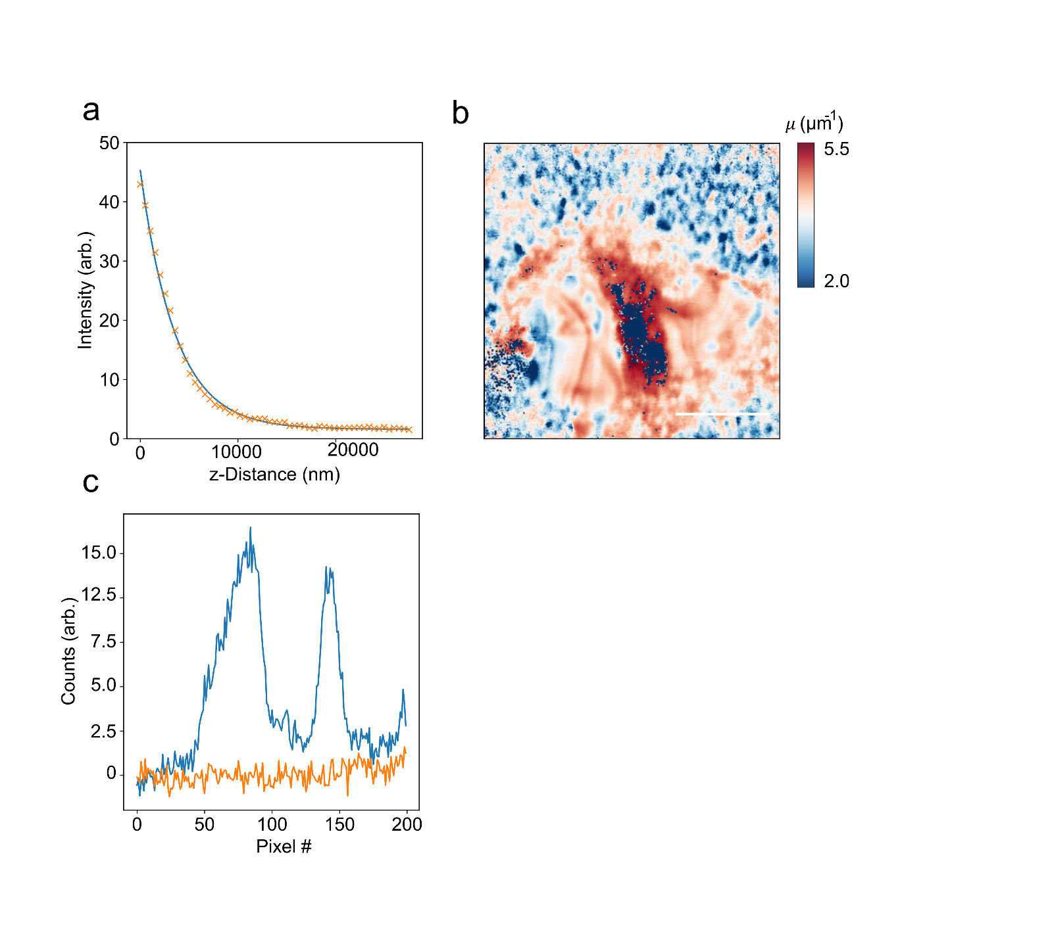
Supplementary Figure 10: a. Exponential decay of reflected intensity at centre of LCO particle. Orange crosses show raw data and blue line fit. b. Attenuation coefficient map image (AM) calculated by fitting exponential decay at pixel in region of interest. Scale bar is 5 μm. c. Horizontal line cuts through a particle 10 μm below the top surface. Although the signal in the particle remains low (blue lines) it lies above the background (orange line) allowing us to extract information from these planes deeper than one attenuation length. The two sharp peaks centred at pixel # ~60 and 146 indicate the edges of the particle, where due to a differing change in the refractive index as compared to the bulk the reflectivity increases.

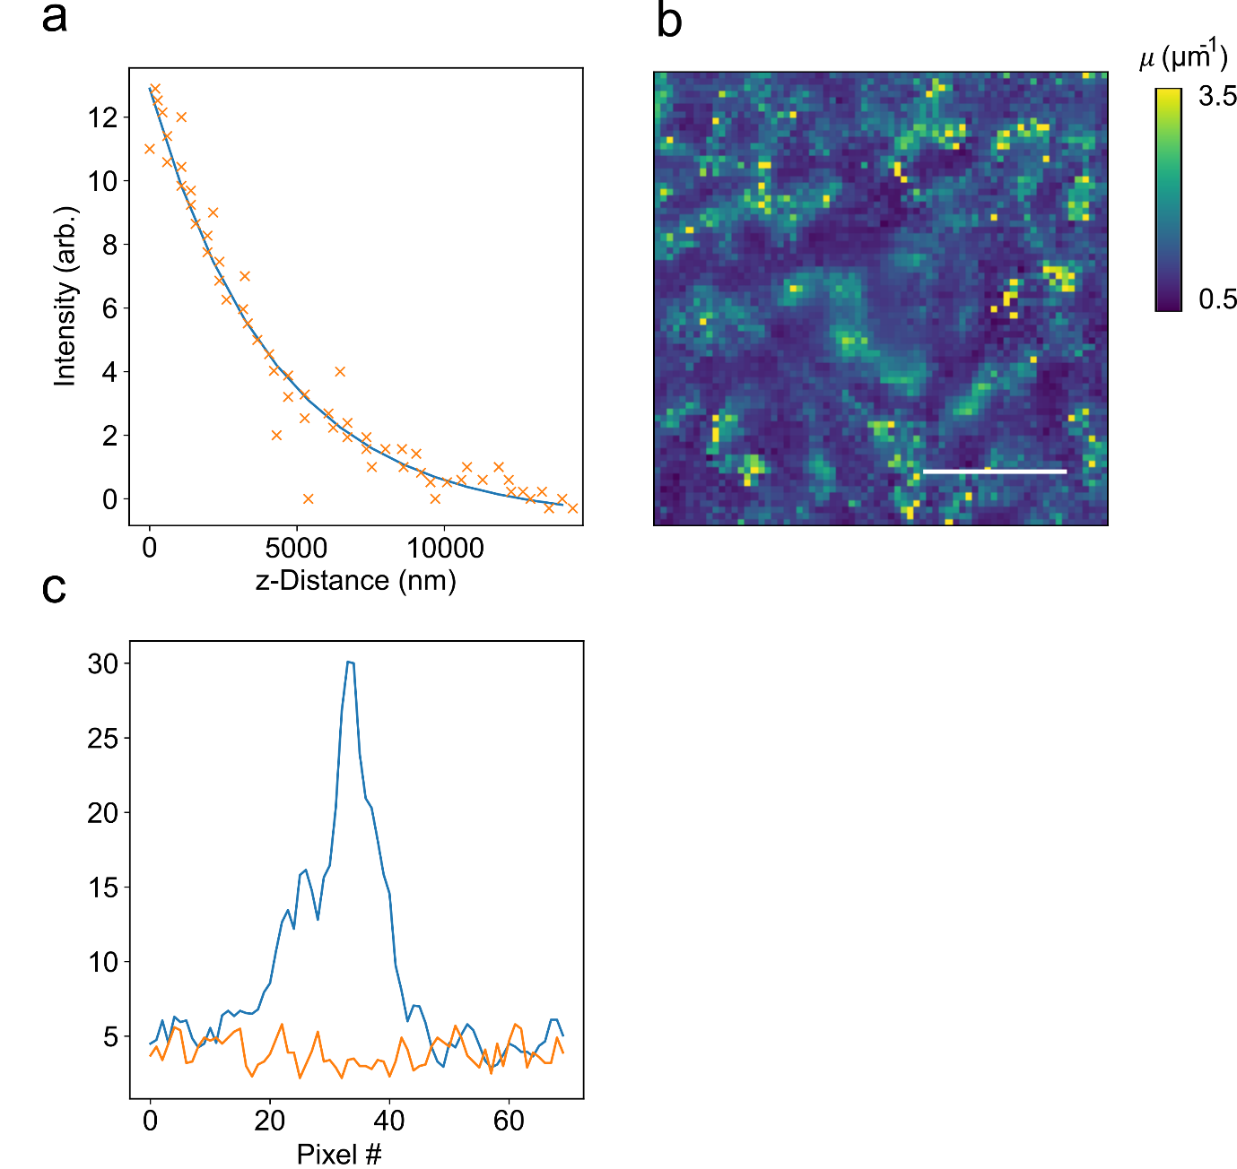
Supplementary Figure 11: a. Exponential decay of reflected intensity at centre of NMC particle. Orange crosses show raw data and blue line fit. b. Attenuation coefficient map image (AM) calculated by fitting exponential decay at pixel in region of interest. Scale bar in image is 5 μm. c. Horizontal line cuts through a particle 5 μm below the surface. Although the signal in the particle remains low (blue lines) it lies above the background (orange line) allowing us to extract information from these planes deeper than one attenuation length.

The second effect that must be accounted for is the well-known spherical aberrations introduced by the fact that the distance that an image plane moves in a sample is not the same as the distance travelled by the objective during the z-stack measurement. This gives rise to artificially compressed images, if, as in our case the objective is immersed in a medium with a lower refractive index than that of the imaged objects. In order to correct for this we can apply the formula, $\frac{d'}{d}= \frac{tan⁡(\sin^{-1}{\frac{0.5 NA}{n_{1}})}}{tan⁡(\sin^{-1}{\frac{0.5 NA}{n_{2}})}}$ where $\frac{d'}{d}$ is the correction factor relating the actual focal position (d’) to the one that is expected (d), N.A. the objective numerical aperture and n₁ and n₂ are the refractive index of a sample’s mounting medium and refractive index of the imaging objective’s immersion medium⁵.
Finally, the sampling rate (number of pixels) must be at least twice the theoretical resolution limit of the imaging system (referred to as Nyquist sampling). The theoretical resolution (axial PSF) is defined as $\frac{0.88 × λ}{n-\sqrt{n^{2}-{NA}^{2} }}$ where λ is the illumination wavelength, n is the refractive index of the immersion medium and NA is the numerical aperture of the imaging objective. In our case λ = 800 nm, NA = 1.4 and n = 1.59 giving a PSF of 841 nm. This is divided by 2.3 to account for Nyquist sampling and then further divided by the axial correction factor of 1.21, giving a sampling of 304 nm.
In order to separate the particles from the carbon background image thresholding was performed using the two-dimensional Otsu method⁶. This method was chosen as the histogram of intensities in a single frame showed a relatively sharp bimodal distribution (background and particle), with some noise at low depths. For further segmenting into shells, as was performed in Figure 5 of the main text, thresholded images were segmented into rings by first identifying contours along their boundary. The contour was then shrunk by 10% to define the inner shell surface. Performing this as a function of z-plane allowed for segmentation of volumes into shells of defined semi-major radii. The above thresholding and segmentations are illustrated in supplementary Figure 12. We note from the thresholded volumes a number of quantities can be directly and simply estimated e.g. total volume of a particle by counting the number of occupied voxels.

The key assumption of the Otsu method is that the distribution of image pixel intensities should follow a bi-modal histogram. Pixels can then be separated into foreground and background based on optimisation of the threshold value determined by minimization of the intra-class variance. To estimate an error bar for our extracted volume values we assume that the thresholding is the largest source of error. The ability of the algorithm to distinguish between foreground and background pixels will be determined by the signal (particle) to noise (background) ratio of the image. We estimate SNR as SNR = $\frac{μ_{particle}}{σ_{background}}$ where μ_{particle} is the mean pixel intensity on the particles and σ_{background} is the standard deviation of pixel intensity. Across our LCO data we achieve a SNR of ~100 giving a ~1% error. For NMC811 the SNR is lower ~80 giving a ~2% error.

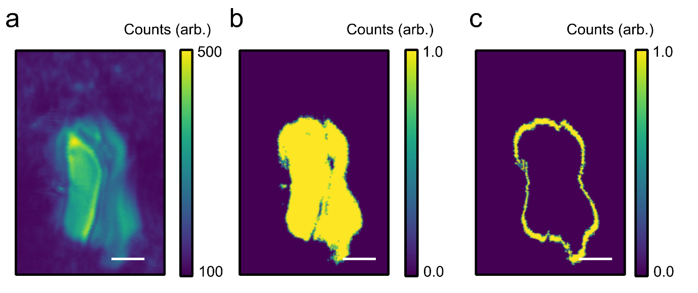

Supplementary Figure 12: a. Confocal reflection of single particle at single focal plane. b. Segmented image of particle using Otsu method as described in text above. c. Extraction of ring of approximately 10 pixels continuously in thickness around particle. Stacking the rings for each imaging plane allows a particle shell to be created. Scale bar is 3.5 μm.

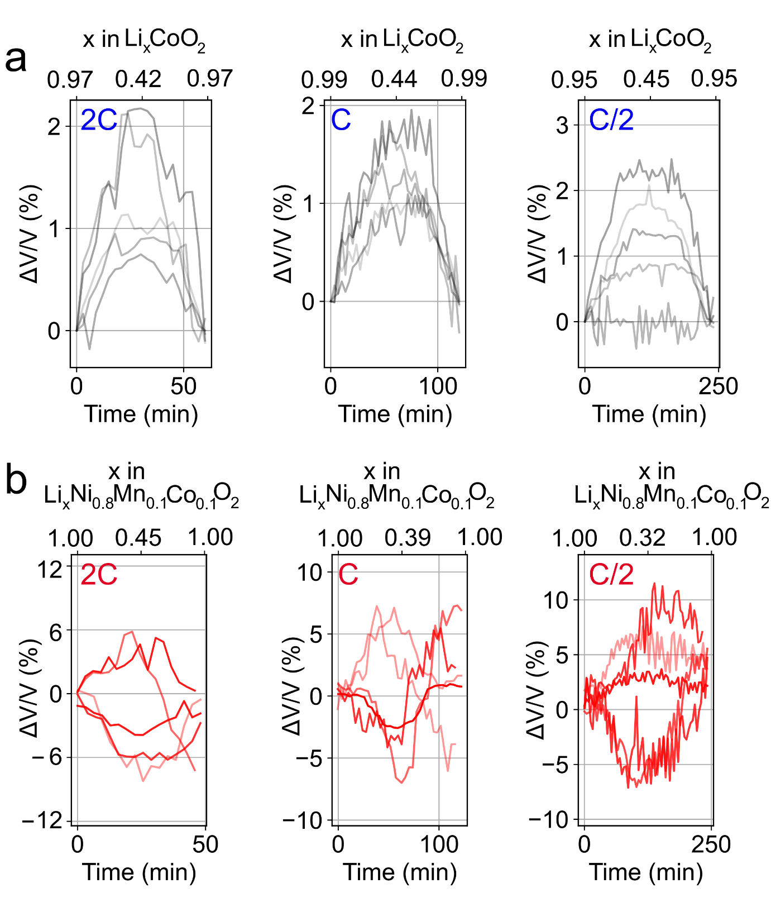
Supplementary Figure 13: a-b. Single particle volume change of 5 LCO and NMC811 particles in addition to those shown in the main text. Qualitatively a similar trend can be observed as compared to the main text.

We can use the volume of fitted ellipsoids to the particles (see supplementary note 8 and Figure 5a) to estimate the expansion in the x, y and z directions of particles; z is taken as into the depth of the electrode and x and y represent the 2D imaging plane. In both LCO and NMC811 the change in size (or more precisely ellipsoid axis length) mostly appears to be uniform across all three dimensions as shown in supplementary Figure 14.
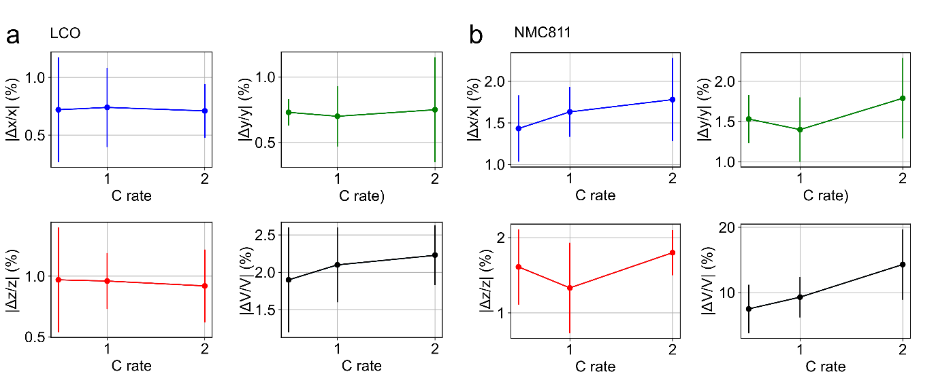

Supplementary Figure 14: a-b. Fitting an ellipsoid to the particle volume allows extraction of lateral (xy) and z (into the electrode) extent of the LCO (left) and NMC811 (right) particles. Plots show absolute change in these values as a function of C-rate as well as absolute volume change.

Supplementary note 7: Extraction of velocity from depth-dependent reflectivity measurements

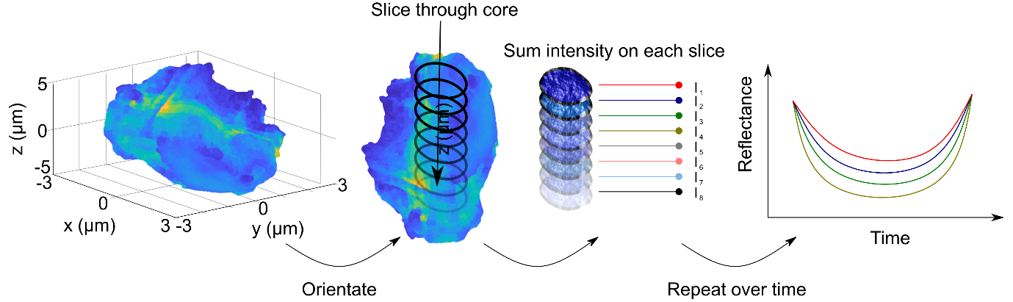
Supplementary Figure 15: Cartoon explaining extraction of plans from particles. The particle is first orientated and slices through the core of the particle extracted. For each slice the mean reflection intensity is calculated (after appropriate attenuation correction). This is then repeated over time (during the cycling) such that at depth and time varying reflectivity profile can be obtained.

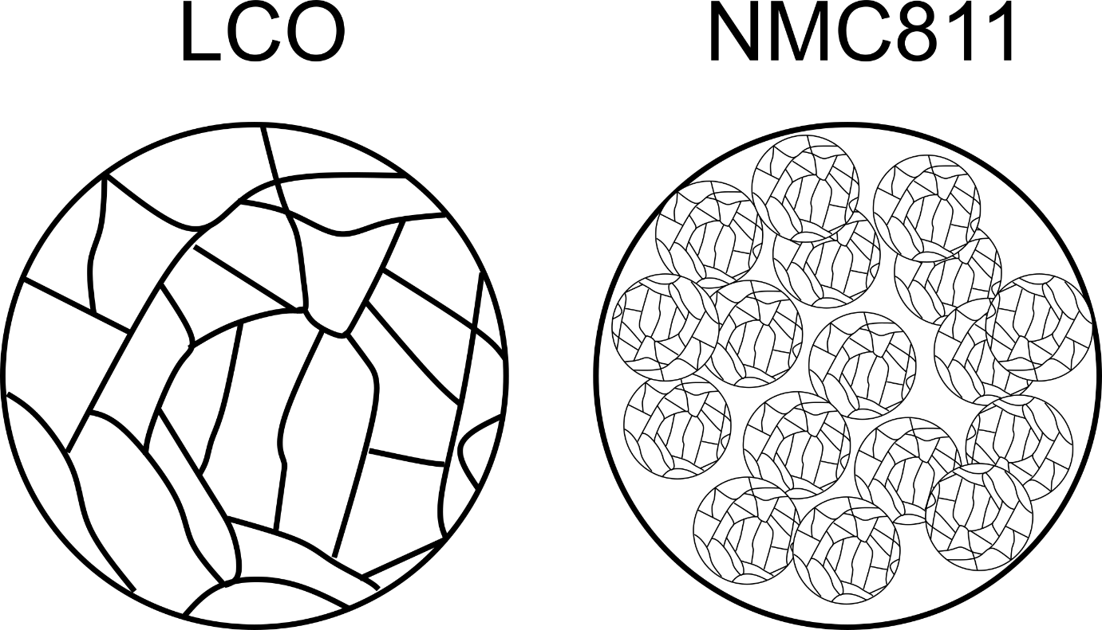

Supplementary Figure 16: Cartoon of LCO and NMC811 particles. LCO is polycrystalline with randomly orientated domains. NMC811 consists of randomly orientated primary particles which are polycrystalline and have randomly orientated domains.
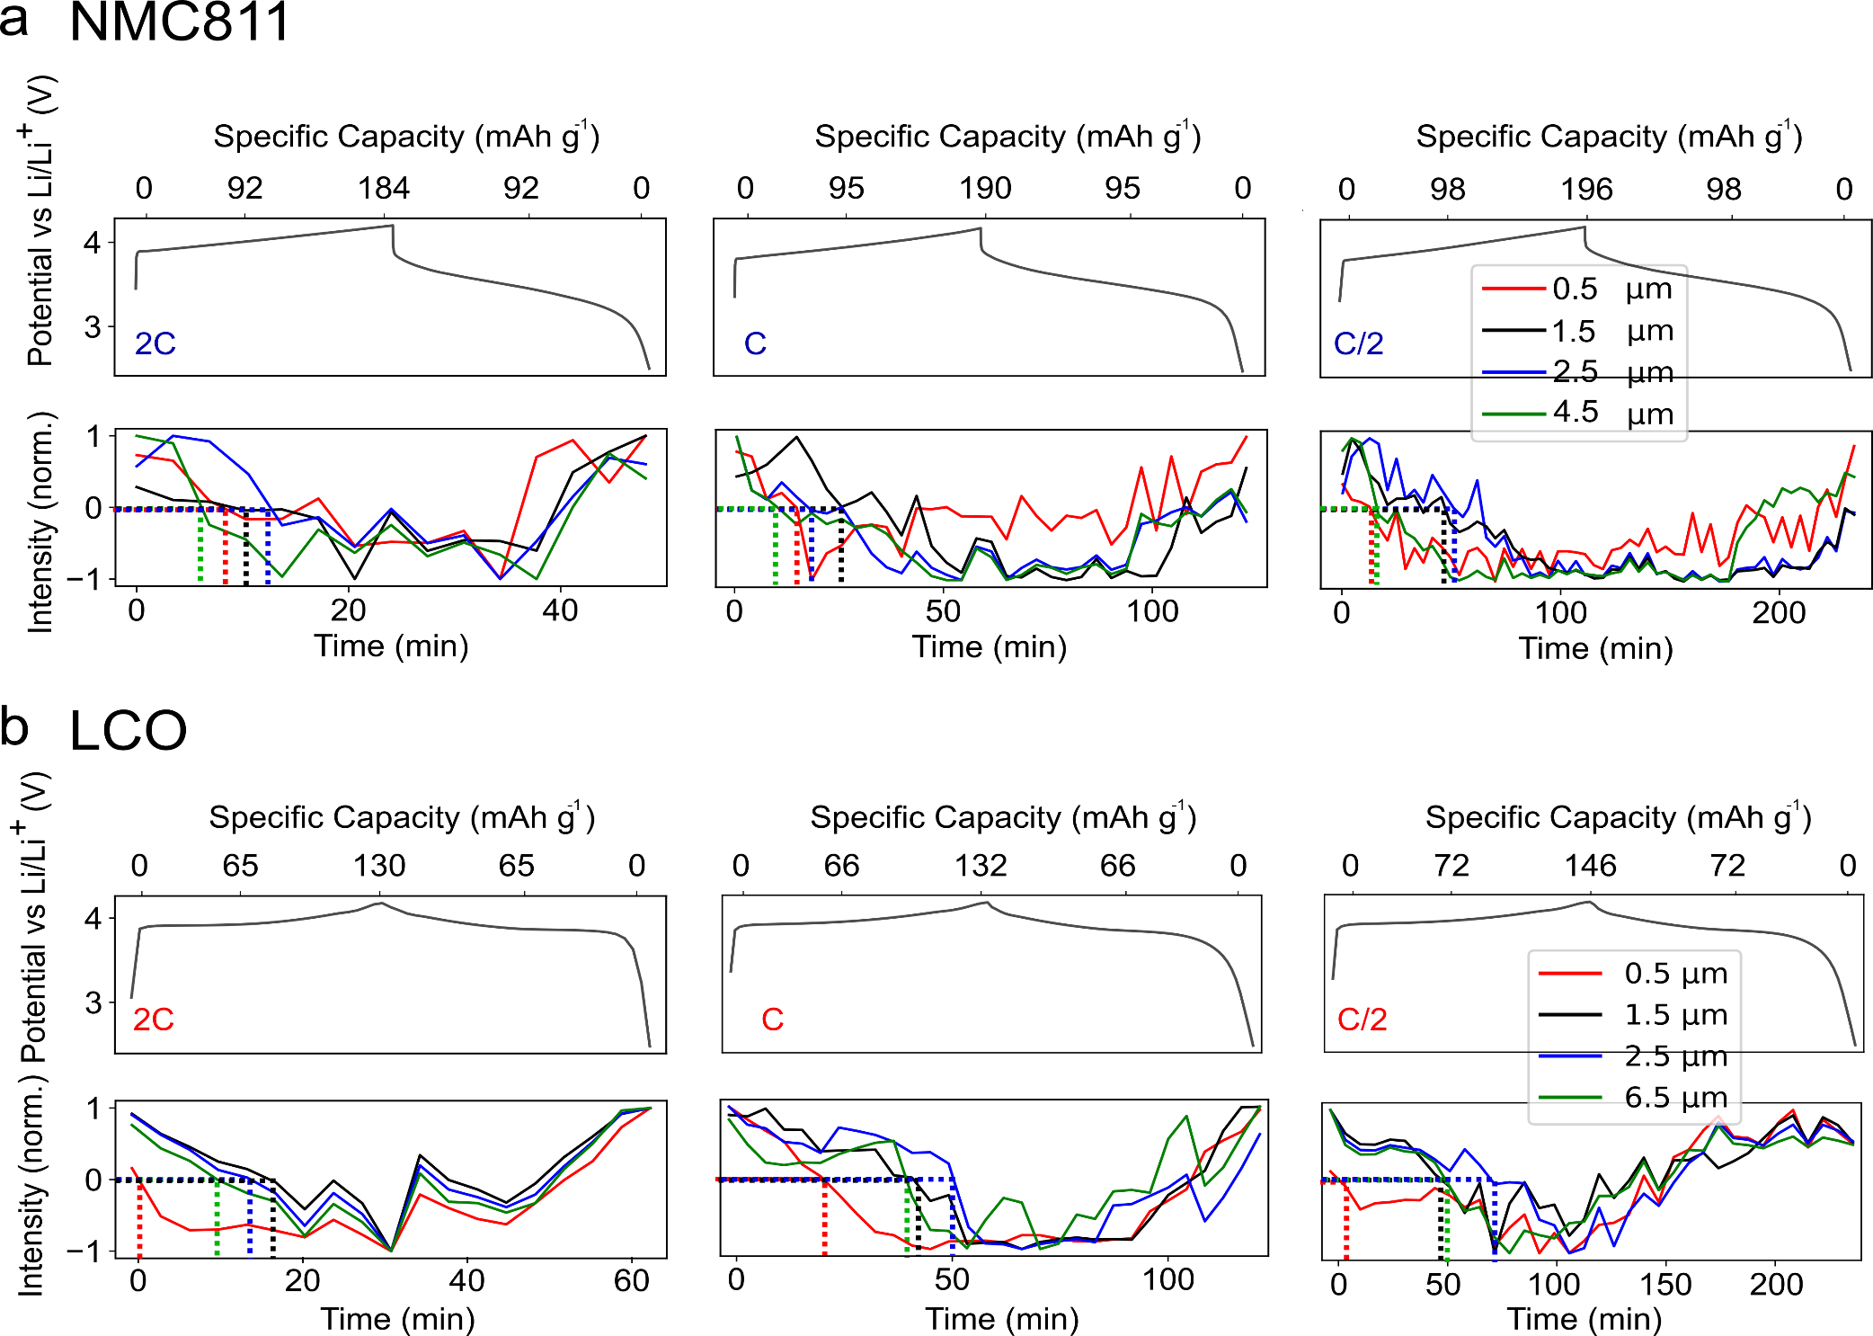
Supplementary Figure 17: a. Charge-discharge curves for NMC811 and LCO at 2C, C and C/2 with normalised reflectivity versus time plots for different z-planes as indicated in the legend. Dotted lines indicate when normalised reflectivity passes through zero, which varies for the different planes.

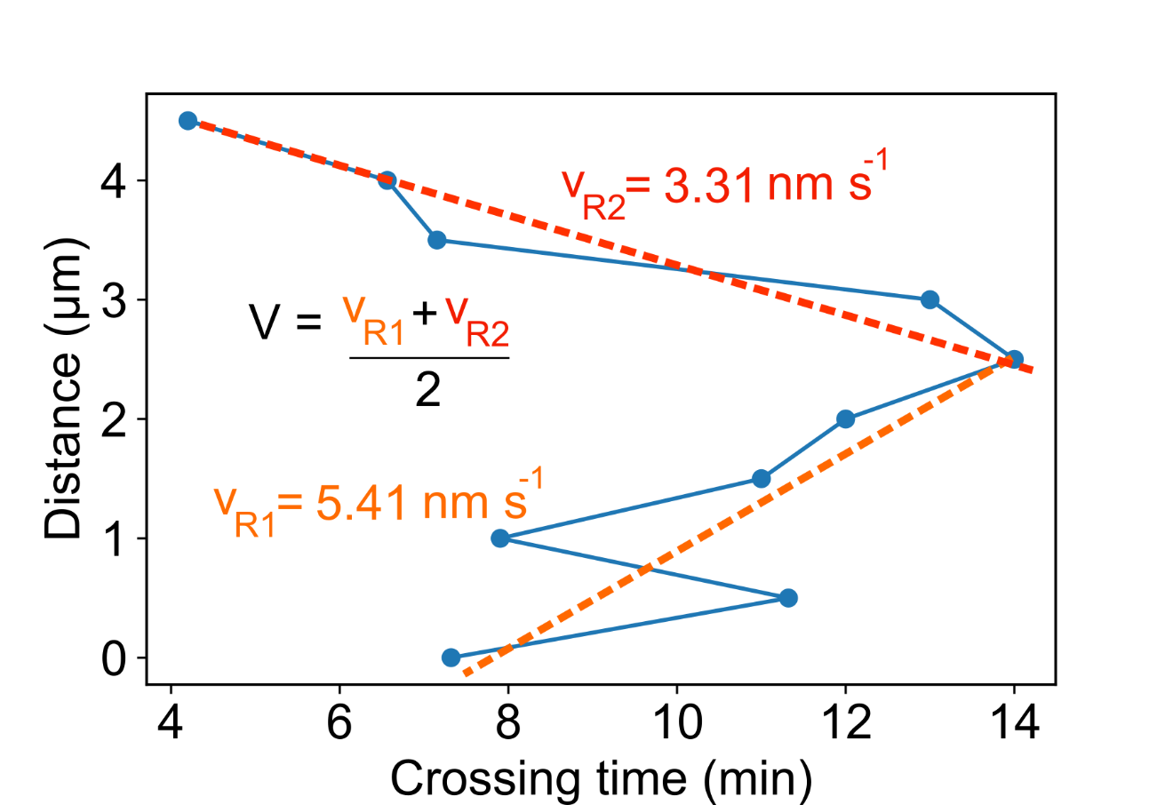

Supplementary Figure 18: Example of velocity estimation for data displayed in Figure 4 of the main text. From the time at which the [1,-1] normalised reflectivity of the particle at a given plane crosses zero a ‘crossing time’ can be estimated⁷. This can be somewhat asymmetric when considering transport from the top and bottom of particles. Fitting a straight line to the top to core (orange line) and bottom to core distance versus crossing time graphs allows an estimate of the phase transport velocity through the particle to be estimated from the average of the two velocities. Distance in this case represents the z-extent of the particle.

Supplementary note 8: Extraction and projection of particle surfaces
In order to project surfaces of the particles as shown in Figure 5 of the main text the following approach was taken. A 3D point cloud of reflected intensity was obtained from laser scanning confocal microscopy. The raw data were segmented as illustrated in supplementary Figure 12 to yield the point clouds of the intensity reflected by the individual battery particles.
We computed the minimum volume ellipsoid (often referred to as the Löwner-John ellipsoid⁸) enclosing each set of points of a battery particle. Note, that ellipsoids in 3D are defined as the set of points x ϵ ℝ³ satisfying (x – x₀)^{T} A (x – x₀) ≤ 1, where x₀ ϵ ℝ³ is the centre and A ϵ ℝ^{3×3} is a symmetric positive definite matrix. The corresponding volume is (4π/3) × det(A^{-1/2}). Obtaining the Löwner-John ellipsoid therefore entails solving the following optimization problem:
min_{A’} -log det(A’) , [Eq. 1]
subjected to the constraints
- A’ ϵ ℝ^{4×4} is a symmetric and positive definite matrix;
- q_{i}^{T} A’ q_{i} ≤ 1;
- q_{i} ≡ [p_{i} ; 1] ϵ ℝ⁴, i = 1, …, m and where p_{i} are the m cloud points.
The matrix describing the Löwner-John ellipsoid is finally given by the first 3 rows and the first 3 columns of A’. [Eq. 1] was solved via the iterative Khachiyan algorithm⁹, run until the error on the obtained volume dropped below 0.1%.
The intensity of the nearest data point was then assigned to each point of the ellipsoid. Finally, its surface was projected onto a 2D plane (x, y) through the Mercator projection¹⁰. After parametrizing the ellipsoid in terms of latitude φ and longitude θ of each of its points, the projection equations read (x, y) = (r_{x} × θ, r_{y} × ln |sec(φ) + tan(φ)|), where r_{x,y} is the average radius of the ellipsoid along x, y. Note, however, that such procedure is subject to deformations with increasing latitude. In addition to using this method to project the spatial distribution of intensities at different surfaces, from the semi-major radii of the fitted ellipsoids the distinct in and out of plane volume expansions were determined as well as the evolution of the particle surface area throughout a cycle (see supplementary note 8).
We note that for the both the exterior and core of particles, in Figure 5 of the main and below, the reflection contrast is derived from intraparticle refractive index changes. In the case of the particle exterior we focus ~100 nm into the particle such that interface giving rise to reflection contrast is within the particle but still close to the surface.

Supplementary note 9: Spatial inhomogeneities at core and surface of particles in LCO and NMC811 as a function of cycling-rate

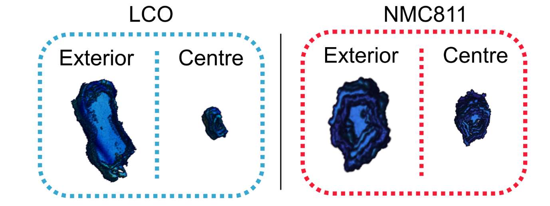
Supplementary Figure 19: Example of segmentation of particles into hollow shells at exterior (left) and centre (right) of LCO (blue box) and NMC811 (red box). For LCO the ellipsoidal shell that encloses the surface has semi-major axis radii of 6.5, 6.5 and 7.3 μm for the core it is 1, 1 and 1.8 μm. For NMC811 the semi-major axes of the surface ellipsoid are 4.5, 3.5 and 6 μm, for core it is 1.5, 1 and 2 μm.

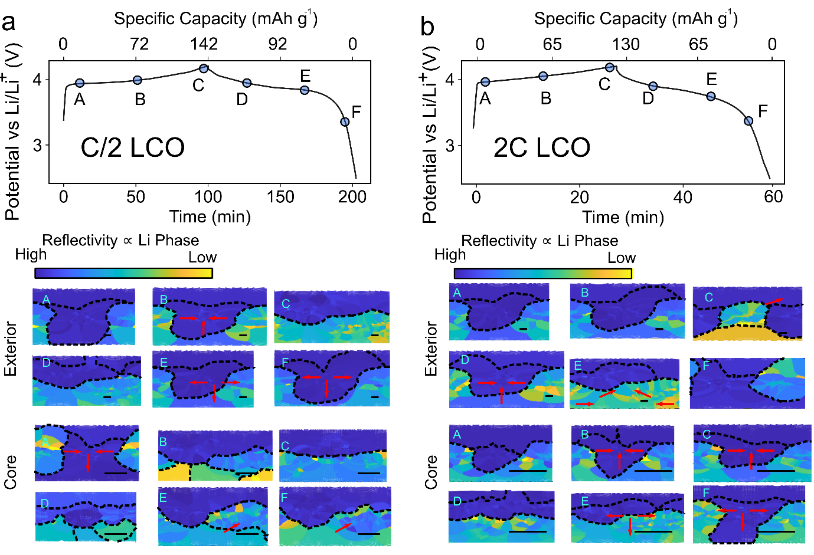

Supplementary Figure 20: Charge-discharge cycle of LCO at C/2 and 2C showing projections from shells at exterior and centre of particle at set points during the cycle (letters A to F) as shown in Figure 5 of the main text. Red arrows and dashed lines act as guide to eye to show motion of different Li-phases (colour scale) along the shell surface. Scale bar in each image is 5 μm. The ellipsoidal shell that encloses the exterior surface has semi-major axis radii of 6.5, 6.5 and 7.3 μm whereas for the core it is 1, 1 and 1.8 μm. For both C/2 and 2C, shells at the particle exterior and centre show a migration of lithiation domains (regions of different colour) away from the projection edges during delithiation. During lithiation, the phase fronts appear to have a preferential direction of motion towards one edge of the projection. These observations are consistent with shrinking-core and intercalation wave mechanisms for delithiation and lithiation of LCO^{11–13}. However as discussed in the main text extracting such data is non-trivial and relies heavily on data treatment, and hence more is needed to to understand the implication of these observation

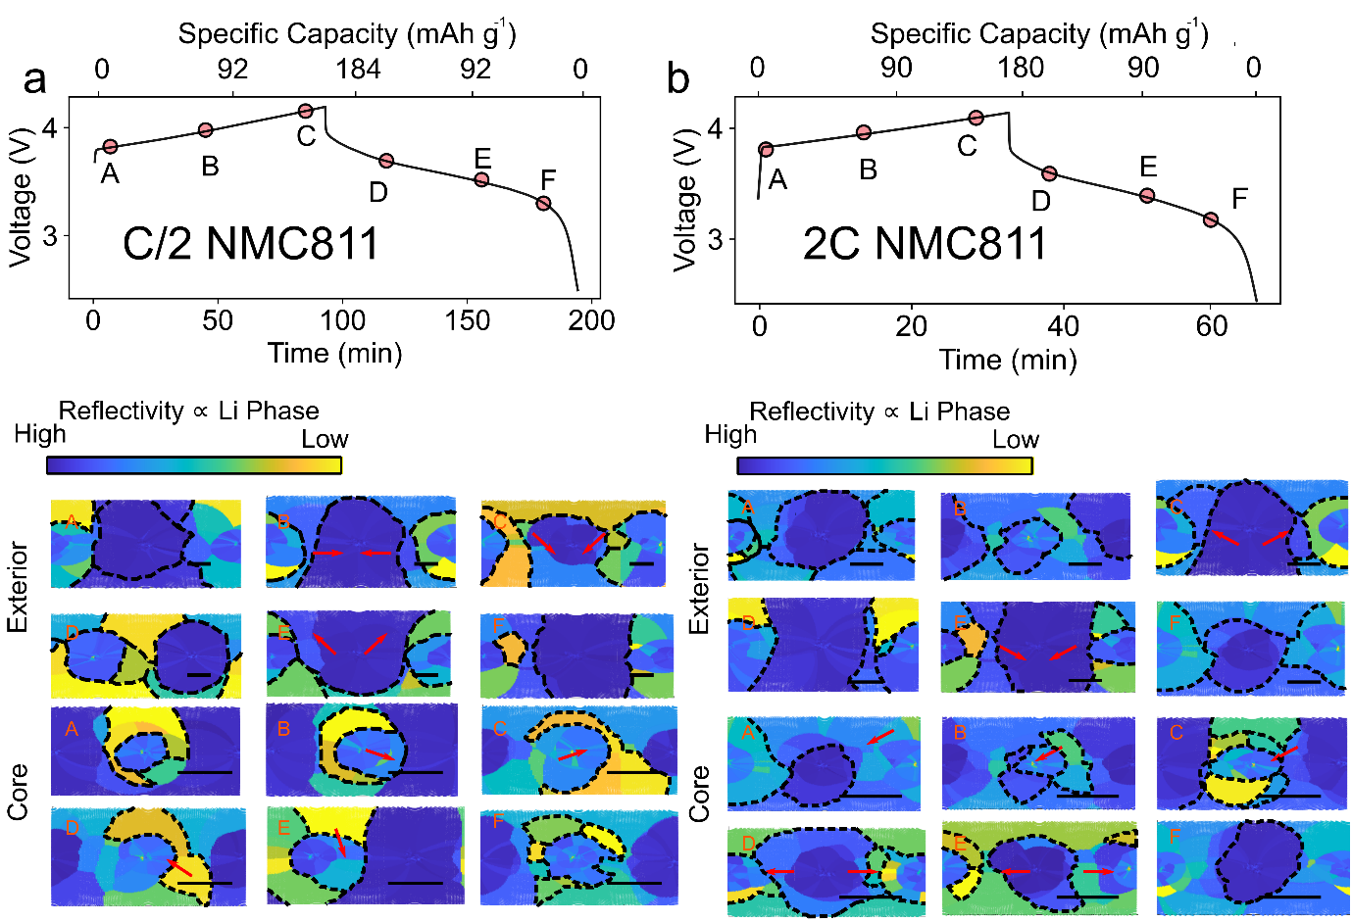

Supplementary Figure 21: Charge-discharge cycle of NMC811 at C/2 and 2C showing projections from shells at exterior and centre of particle at set points during the cycle (letters A to F). For NMC811 the semi-major axes of the surface ellipsoid are 3.5, 2.8 and 6.5 μm, for core it is 1.2, 1 and 1.8 μm. As for LCO some movement of intensity from the edges of the projection to the centre on delithiation and a reverse on lithiation can be observed, however the exact nature of the motion is unclear. For NMC811 there are a range of domains with different degrees of lithiation at the start of the charge, further complicating the analysis. Qualitatively it appears the overall difference in degree of lithiation within and between domains decreases on charge and increases once again on discharge. However, further work is required to fully interpret these observations.

Supplementary note 10: Imaging electrolyte concentration gradients around cycling LCO and NMC811 particles

In the main text we show in Figure 6b the two photon excited fluorescence of LP30 electrolyte to be proportional to the concentration of LiPF₆ in the electrolyte. The principal assumption here is that because of electro-neutrality the PF₆⁻ ions must bind to Li⁺ such that Li⁺ exchanged with particle during lithiation/delithiation is correlated with the 2PEF. We note however there are numerous ion complexes that can be present during battery cycling where anions are coordinating 0, 1 or 2 to Li⁺ ions¹⁴. As a result of this although we can confidently claim we are measuring the concentration of LiPF₆ and demonstrate how this can be used to track electrolyte concentration gradients in a cycle. We do not claim to be directly observing the total Li⁺ concentration^{15,16} and suggest there may be other non-fluorescent species in lower concentration than LiPF₆ which may also play a role in inhomogeneities we are unable to capture.

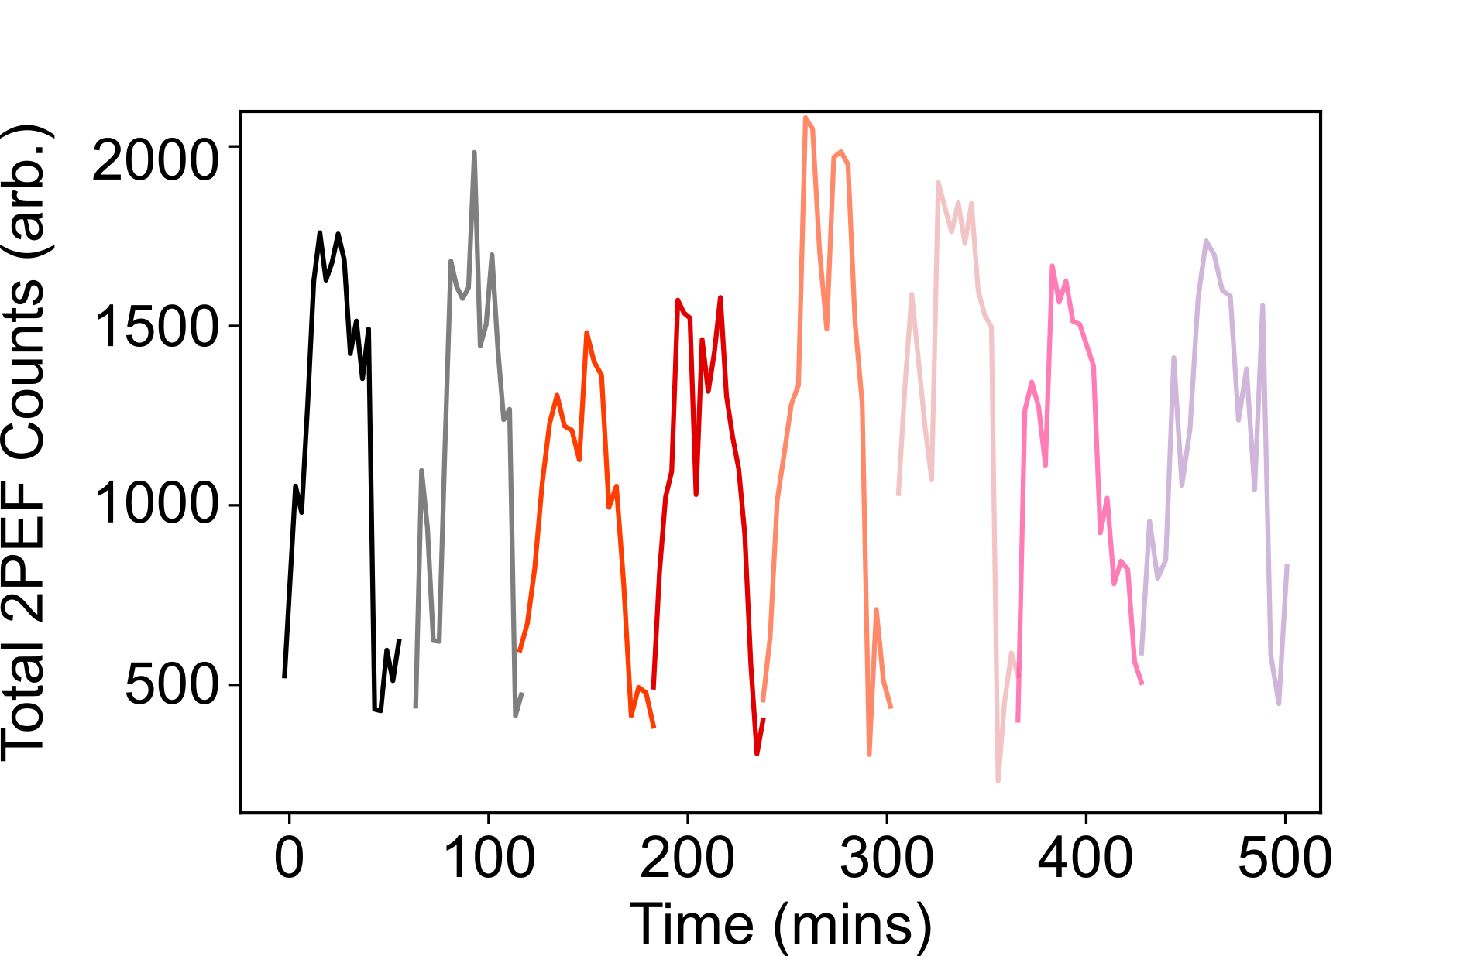

Supplementary Figure 22: Two-photon excited fluorescence (2PEF) from region displayed in Figure 6 of main text with repeated cycling of cell at 2C. Each plot colour represents the total 2PEF versus time from the region with different colours representing different cycle. The pattern of intensity is changes are reproducible both in magnitude and shape suggesting electrolyte degradation does not occur.

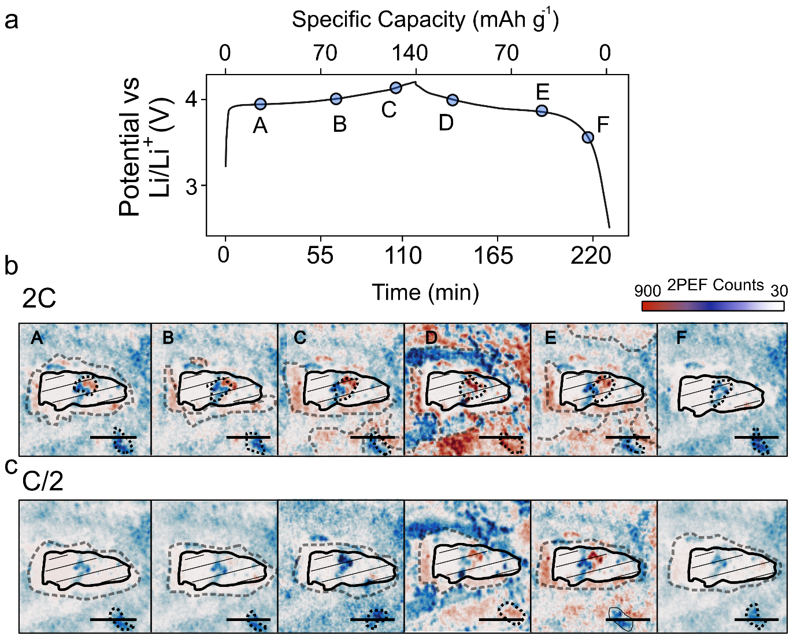

Supplementary Figure 23: Two-photon excited fluorescence (2PEF) from LP30 electrolyte during a C/2 and 2C cycle of LCO, around a different particle to that discussed in the main text. A qualitatively similar behaviour to that discussed in the main text (Figure 6) is observed. At C/2 a concentration gradient in the electrolyte is observed on charging above 4.0 V, this gradient disappears on discharging. At 2C there is a brightening around particles up to 3.9 V (panel A), with a homogenously decaying concentration gradient. Following this, the electrolyte distribution becomes inhomogeneous surrounding the particles (dotted black lines are guides to the eye). The reverse behaviour is followed on the discharged. The above observations again provide evidence that we image true concentration polarisation gradients due to mass transfer limitations at high C-rates. They further support the notion that at high C-rates the electrolyte transport is influenced by inhomogeneities in the self-standing electrodes. Scale bar is 5 μm.

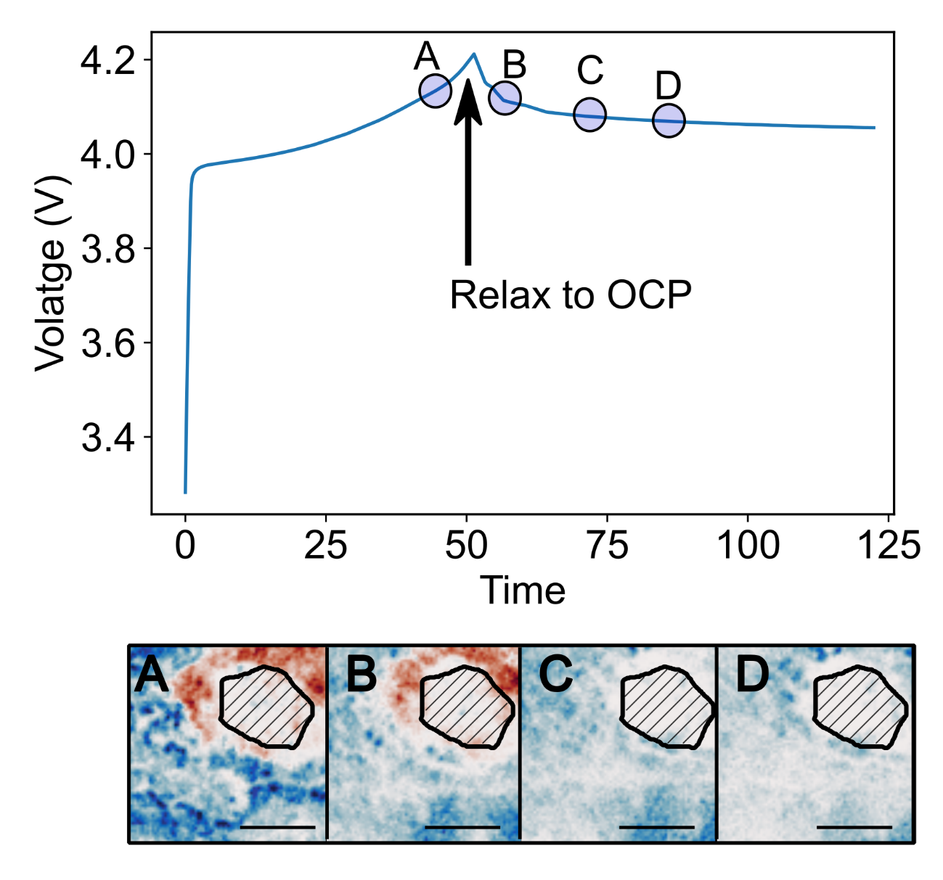
Supplementary Figure 24: Two-photon excited fluorescence (2PEF) from LP30 electrolyte during a C charge of LCO followed by relaxation to OCP. On relaxation to OCP the gradient in 2PEF density around the particles rapidly disappears, providing further evidence that the observed gradient does indeed arise from polarisation concentration.

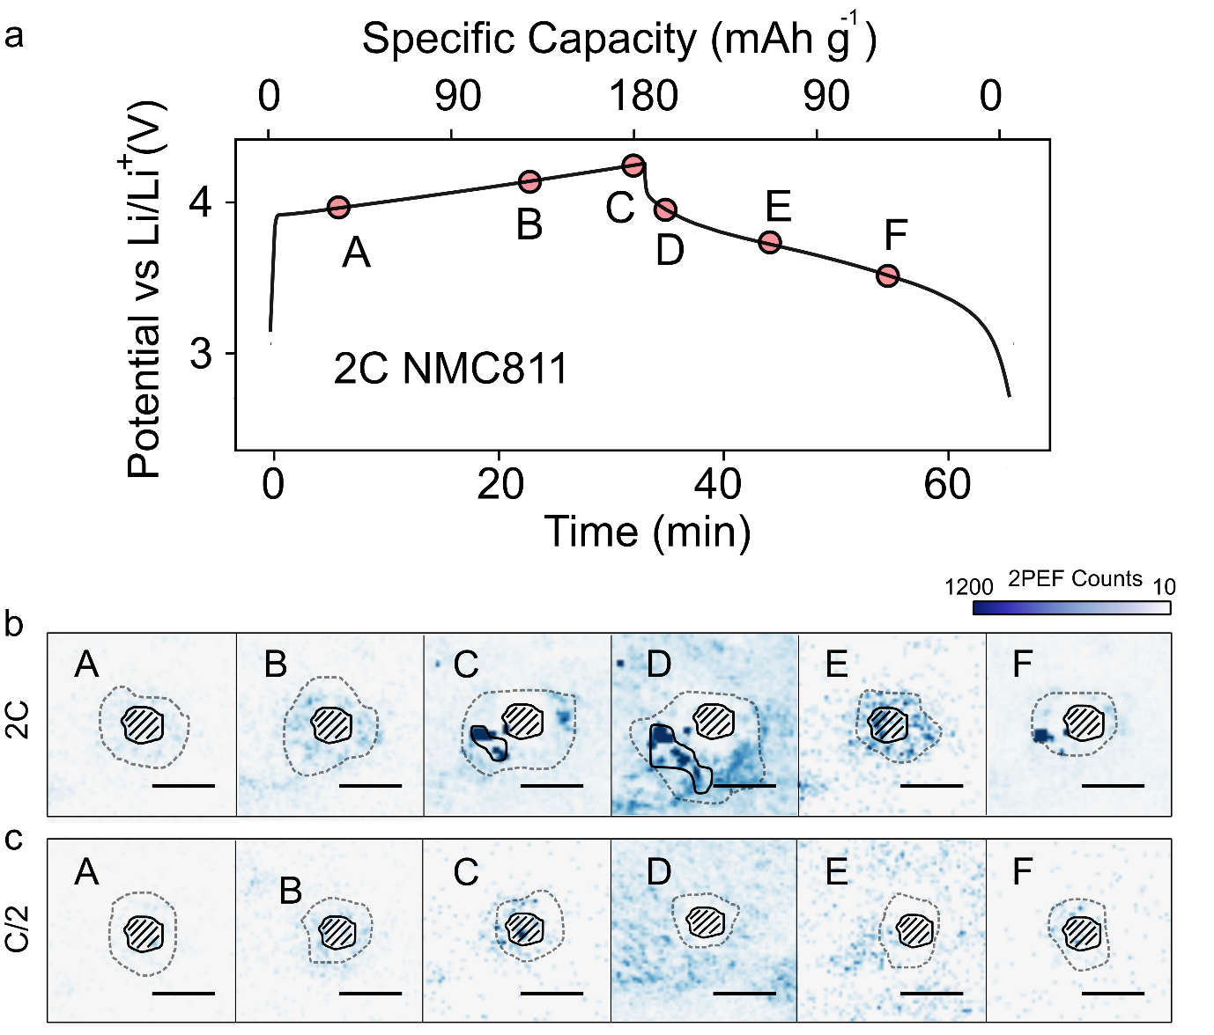

Supplementary Figure 25: Two-photon excited fluorescence (2PEF) from LP30 electrolyte during a 2C top and C/2 cycle of NMC811. In a similar manner to LCO there is brightening of the electrolyte 2PEF on charge and dimming on discharge. Around the particles (white outlines; red dashed lines are guides to the eye), the 2PEF is initially homogeneously distributed (panels A and B) before a concentration/2PEF gradients build-up at higher potentials above 4.0 V. The 2PEF concentration gradient is somewhat inhomogeneously distributed around particles above 4.0 V (panels C and D). At C/2 the onset of the 2PEF concentration gradient is at higher potentials as compared to 2C. Scale bar is 4 μm.

Supplementary note 11: Assembly of operando half-cell

The battery cell for operando measurements was purchased from EL-Cell GmbH. The stainless steel lid was modified such that a 0.15 mm thick glass coverslip could be accommodated. The assembly of the cell was performed in an Ar glovebox as can be found at https://el-cell.com/products/test-cells/optical-test-cells/ecc-opto-std/#1489590351680-30ae9365-4211.
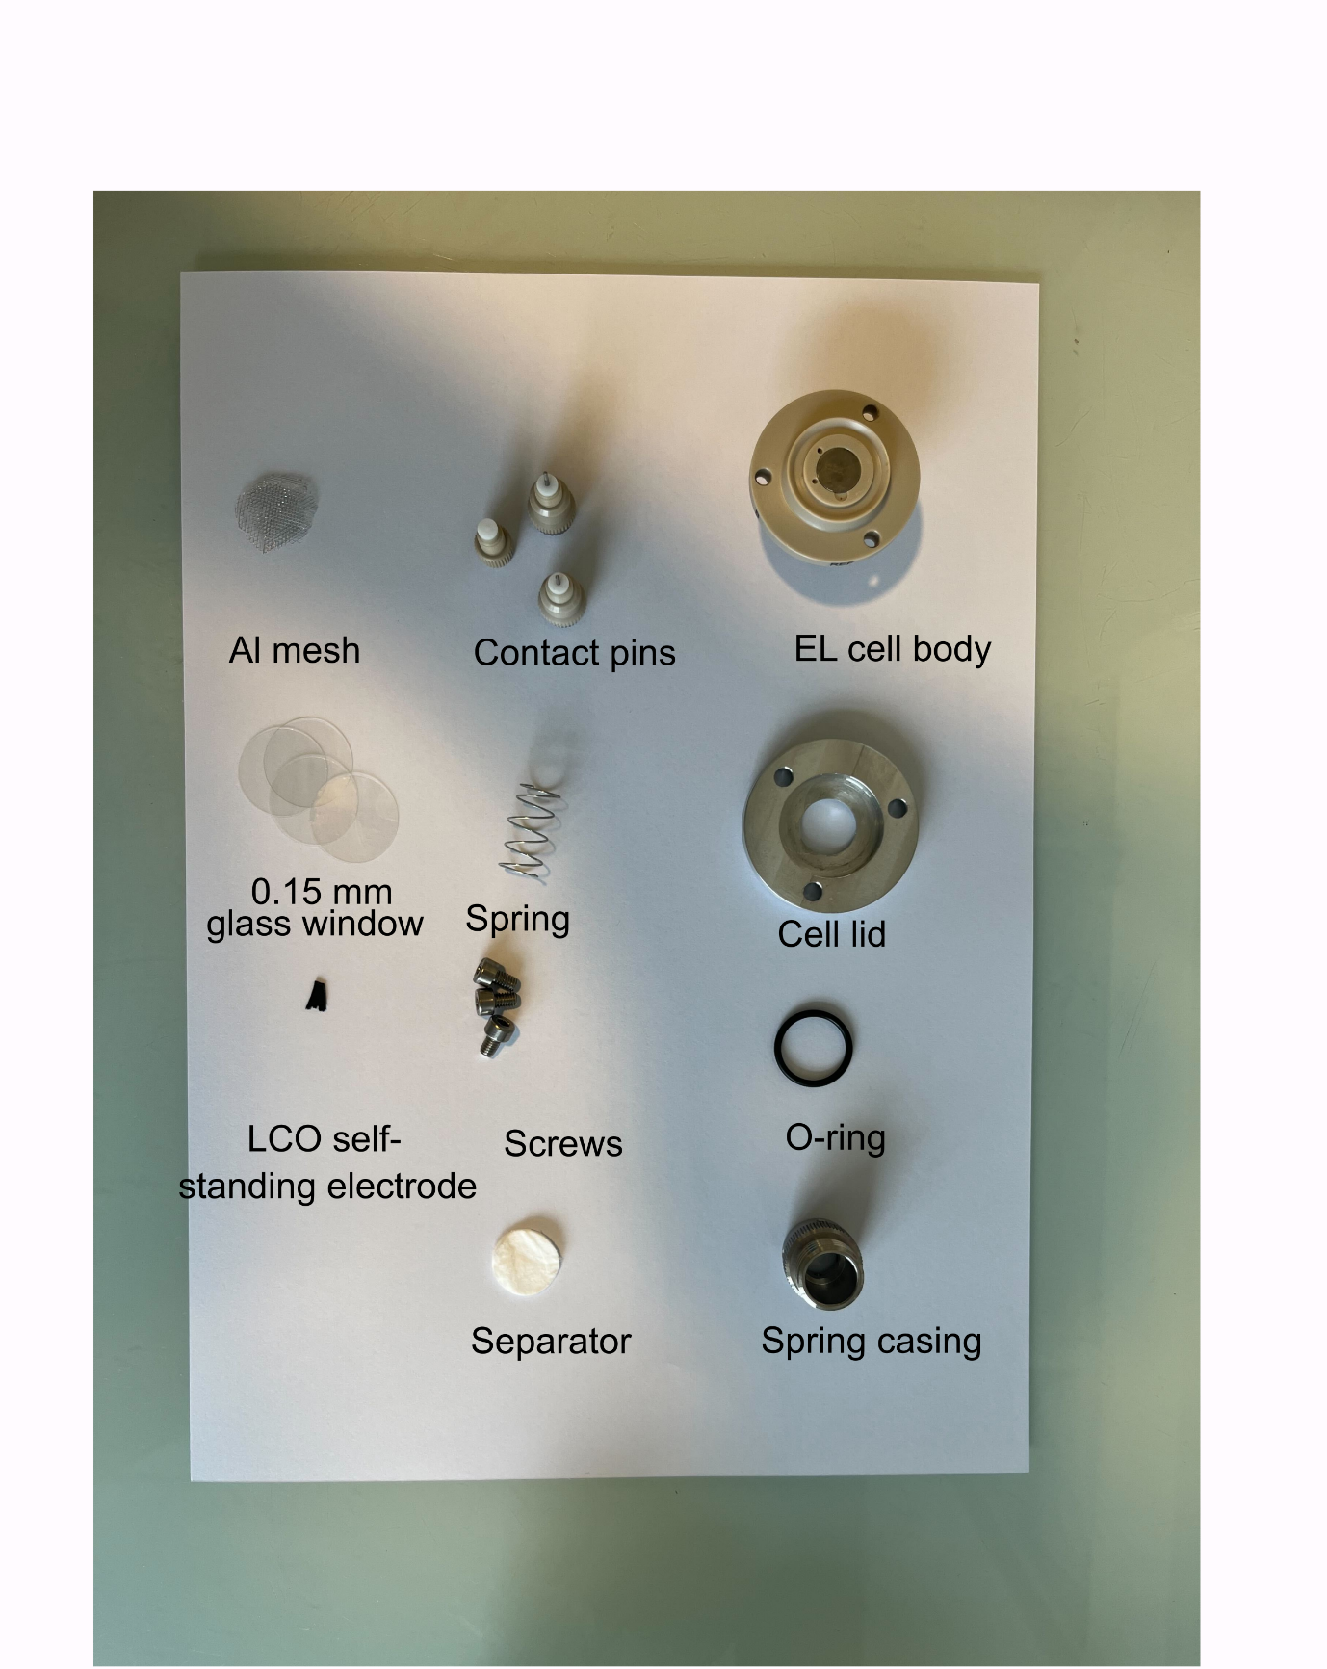
Supplementary Figure 26: Components of operando half-cell.
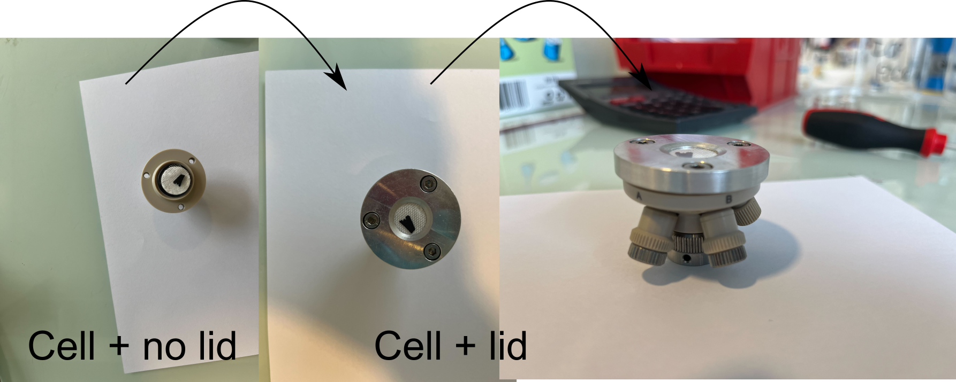
Supplementary Figure 27: Assembled operando half-cell with and without lid.

References

1. Kuzmenko, A. B. Kramers–Kronig constrained variational analysis of optical spectra. Rev. Sci. Instrum. 76, 083108 (2005).
2. Mahmoodabadi, R. G. et al. Point spread function in interferometric scattering microscopy (iSCAT). Part I: aberrations in defocusing and axial localization. Opt. Express, Vol. 28, Issue 18, pp. 25969-25988 28, 25969–25988 (2020).
3. Gong, P. et al. Parametric imaging of attenuation by optical coherence tomography: review of models, methods, and clinical translation. J. Biomed. Opt 25, 40901 (2020).
4. Ghosh, B., Mandal, M., Mitra, P. & Chatterjee, J. Attenuation corrected-optical coherence tomography for quantitative assessment of skin wound healing and scar morphology. J. Biomed. Opt 25, 40901 (2020).
5. Diel, E. E., Lichtman, J. W. & Richardson, D. S. Tutorial: avoiding and correcting sample-induced spherical aberration artifacts in 3D fluorescence microscopy. Nat. Protoc. 2020 159 15, 2773–2784 (2020).
6. Otsu, N. Threshold selection method from gray-level histograms. IEEE Trans Syst Man Cybern SMC-9, 62–66 (1979).
7. Rivnay, J. et al. Structural control of mixed ionic and electronic transport in conducting polymers. Nat. Commun. 2016 71 7, 1–9 (2016).
8. Todd, M. J. & Yildirim, E. A. On Khachiyan’s algorithm for the computation of minimum-volume enclosing ellipsoids. Discret. Appl. Math. 155, 1731–1744 (2007).
9. Khachiyan, L. G. Rounding of Polytopes in the Real Number Model of Computation. Math. Oper. Res. 21, 307–320 (1996).
10. Maling, D. H. Coordinate systems and map projections. (Pergamon Press, 1992).
11. Bazant, M. Z. Theory of chemical kinetics and charge transfer based on nonequilibrium thermodynamics. Acc. Chem. Res. 46, 1144–1160 (2013).
12. Fraggedakis, D. et al. A scaling law to determine phase morphologies during ion intercalation. Energy Environ. Sci 13, 2142 (2020).
13. Merryweather, A. J., Schnedermann, C., Jacquet, Q., Grey, C. P. & Rao, A. Operando optical tracking of single-particle ion dynamics in batteries. Nature 594, 522–528 (2021).
14. Seo, D. M., Borodin, O., Han, S.-D., Boyle, P. D. & Henderson, W. A. Electrolyte Solvation and Ionic Association II. Acetonitrile-Lithium Salt Mixtures: Highly Dissociated Salts. J. Electrochem. Soc. 159, A1489–A1500 (2012).
15. Cheng, Q. et al. Operando and three-dimensional visualization of anion depletion and lithium growth by stimulated Raman scattering microscopy. Nat. Commun. 2018 91 9, 1–10 (2018).
16. Fawdon, J., Ihli, J., Mantia, F. La & Pasta, M. Characterising lithium-ion electrolytes via operando Raman microspectroscopy. Nat. Commun. 2021 121 12, 1–9 (2021).

