Appendices
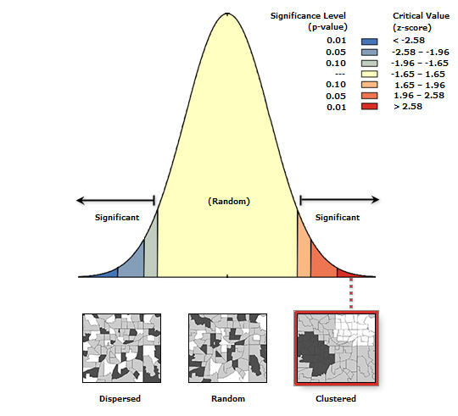
Appendix A: Spatial autocorrection of ANC
Source: Computed from 2017 Maternal Health Survey

