ESSENTIAL ELEMENTS IN PLANT-BASED BURGERS – VALIDATION OF A SIMPLE METHOD FOR ANALYSIS AND NUTRITIONAL EVALUATION

Gisele Marcondes Luz¹, Eduardo Adilson Orlando¹, Juliana Azevedo Lima Pallone¹

¹Department of Food Science and Nutrition, School of Food Engineering, State University of Campinas, Monteiro Lobato Street, 80, CEP: 13.083-862, Campinas, São Paulo, Brazil
*Corresponding author
E-mail: jpallone@unicamp.br

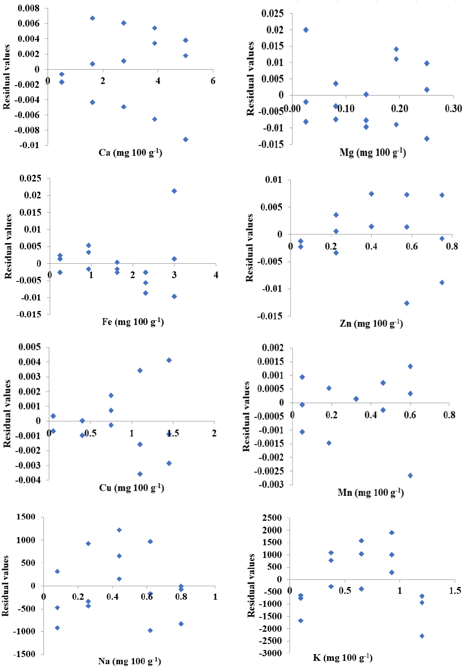
Fig. S1. Residual values plots for the essential elements.

Table S1. Nutritional composition of the label of different types of PBB.
Types | Brand | Energy value | Carbohydrates | Proteins | Total  fats | Saturated fats | Trans fat | Dietary fiber | Na | Fe | Zn
Mushroom | 1 | 197 | 16.4 | 15.5 | 8.0 | 0.6 | 0.0 | 3.3 | 446.4 | ND | ND
Mushroom | 2 | 85 | 15.0 | 4.0 | 1.3 | 0.2 | 0.0 | 3.6 | 198.3 | ND | ND
Pea | 1 | 210 | 2.2 | 14.0 | 16.0 | 9.2 | 0.0 | 5.8 | 441.0 | 1.0 | 0.5
Pea | 2 | 265 | 10.6 | 16.3 | 17.5 | 7.5 | 0.0 | 4.0 | 618.8 | 3.4 | ND
Chickpea | 1 | 225 | 29.9 | 6.6 | 9.0 | 3.6 | 0.0 | 4.7 | 381.3 | ND | ND
Chickpea | 2 | 159 | 28.0 | 7.0 | 2.2 | 0.4 | 0.0 | 6.4 | 383.0 | ND | ND
Soybean | 1 | 271 | 13.8 | 17.5 | 16.3 | 3.8 | 0.0 | 5.0 | 522.5 | 2.6 | ND
Soybean | 2 | 106 | 12.0 | 7.4 | 3.8 | 0.2 | 0.0 | 2.4 | 115.0 | ND | ND
The energy value is expressed in kcal 100 g⁻¹. Carbohydrates, proteins, total fats, saturated fats, trans fat, and dietary fiber are expressed in g 100 g⁻¹. Na, Fe, and Zn are expressed in mg 100 g⁻¹. Not detected (ND).

