Supplementary Table 1. Scoring of histological lesions of VBDS in the liver biopsy specimens
Histological lesions Score | 0 | 1 | 2 | 3 | 4
Cholangitis and regeneration
Vanishing bile duct | / | ≥1/2,＜3/4 | ≥3/4 | / | /
CK7⁺ hepatocyte | / | ＜1/3 portal tract | 1/3-2/3 portal tract | ＞2/3 portal tract | /
Ductular reaction, type Ⅱ | Absent | Periportal,  small | Periportal, branched | / | /
Cholestasis
Canalicular cholestasis | Absent | Obvious in high power microscopic view in zone 3 | Obvious in low power microscopic view in zone 3 | Obvious in low power microscopic view in zone 2,3 | Obvious in low power microscopic view in all zone
Hepatocellular cholestasis | Absent | Some in zone 3 | most in zone 3 | most in zone 2,3 | most in zone 1,2,3
Cholestasis in Kupffer cells | Absent | Scattered | Numerous | / | /
Cholate stasis | Absent | few | many | / | /
Foam cells | Absent | Minimal | Clusters | / | /
Inflammation
Portal inflammation | Absent | Mild, some or all portal areas | Moderate, some or all portal areas | Moderate/marked, all portal areas | Marked, all portal areas
Interface hepatitis | Absent | Mild | Mild-Moderate | Moderate | Severe
Lobular inflammation  (Assessment at X200) | Absent | ＜2 lesions | 2-4 lesions | ＞4 lesions | /
Fibrosis
Fibrosis (according to Ludwig) | Absent | portal inflammation with or without florid bile duct lesions | Periportal lesions | Septal fibrosis or bridging necrosis | Cirrhosis
Supplementary Table 2. Univariate and multivariable Cox regression analysis of clinical and biochemical characteristics associated with liver transplantation or liver-related deaths in patients with vanishing bile duct syndrome
Characteristics | Univariate analysis |  |  | Multivariate analysis
Characteristics | Hazard ratio (95% CI) | P value |  | Hazard ratio (95% CI) | P value
Female | 0.485 (0.258-0.913) | 0.025
Age | 1.002 (0.978-1.028) | 0.847
Etiology
Drug-induced injury  live injury | Reference
Primary biliary cholangitis | 1.084 (0.409-2.878) | 0.871
Others | 3.115 (1.139-8.517) | 0.027
AST (U/L) | 1.002 (0.999-1.006) | 0.172
ALP (U/L) | 1.001 (1.000-1.002) | 0.231
GGT (U/L) | 1.001 (1.000-1.002) | 0.091
ALB (g/L) | 0.839 (0.782-0.900) | <0.001
TBIL (umol/L) | 1.007 (1.005-1.009) | <0.001 |  | 1.017 (1.010-1.023) | <0.001
DBIL (umol/L) | 1.009 (1.006-1.012) | <0.001
IBIL (umol/L) | 1.018 (1.011-1.025) | <0.001

Supplementary Figure 1. Flowchart showing retrospective multicenter cohort of patients diagnosed with vanishing bile duct syndrome (VBDS) on liver biopsy. A final total of 183 patients were included, of which 42 succumbed to liver-related deaths or required liver transplantation.

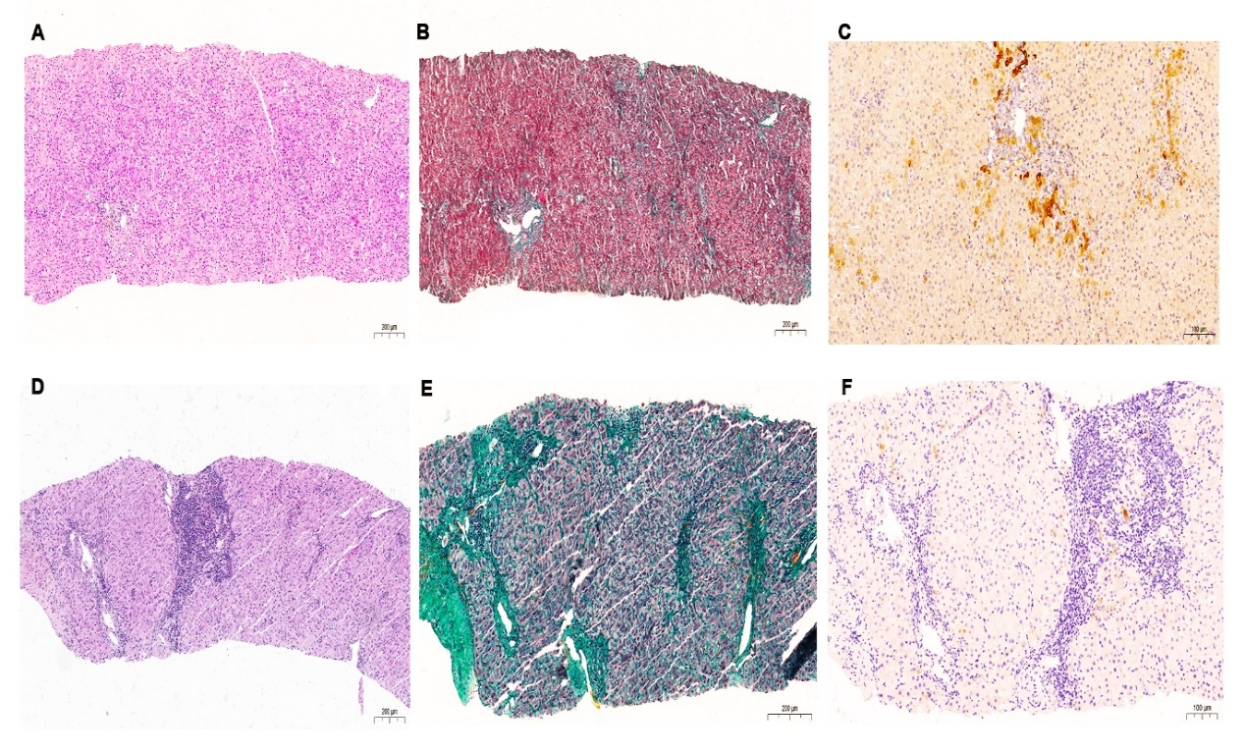
Supplementary Figure 2. Histological features of the two different forms of VBDS. (A-C) Patient with liver biopsy displaying “bland” ductopenia without obvious inflammation or significant fibrosis (A: Hematoxylin-eosin; B: Masson trichrome; C: Cytokeratin 7); (D-F) Patient with liver biopsy exhibiting ductopenia associated with portal-periportal inflammation and advanced fibrosis (D: Hematoxylin-eosin; E: Masson trichrome; F: Cytokeratin 7).

Supplementary Figure 3. Kaplan Meier plots for transplant-free survival in VBDS patients stratified by (A) Gender and (B) Etiology. A significant difference was observed in curves a (Log rank p < 0.05).

