Multiscale Optical Imaging with Real Time Projection of Cancer Risk and Biopsy Guidance Maps for Early Oral Cancer Diagnosis and Treatment: supplemental document

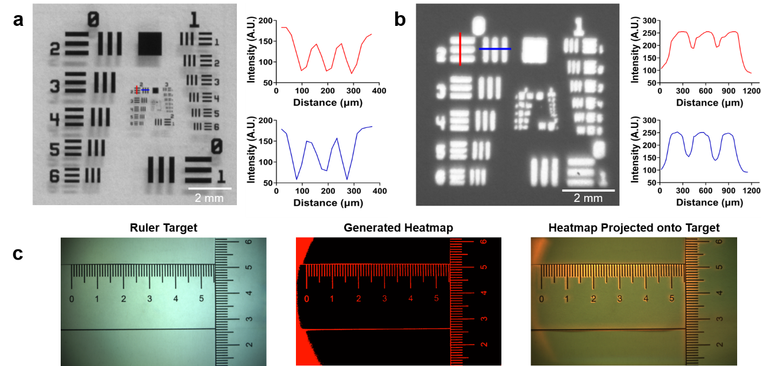
Supplemental Figure 1 | Evaluation of ABGS imaging and projection performance. The transverse optical resolution of the ABGS for imaging (110 µm) (A) and projection (400 µm) (B) measured by imaging a standard US Air Force calibration target and projecting the image of the calibration target onto a blank background. (C) The projection accuracy demonstrated by acquiring a white light image of a paper ruler target, generating a binary mask from the white light image, and projecting the binary mask back onto the ruler target.

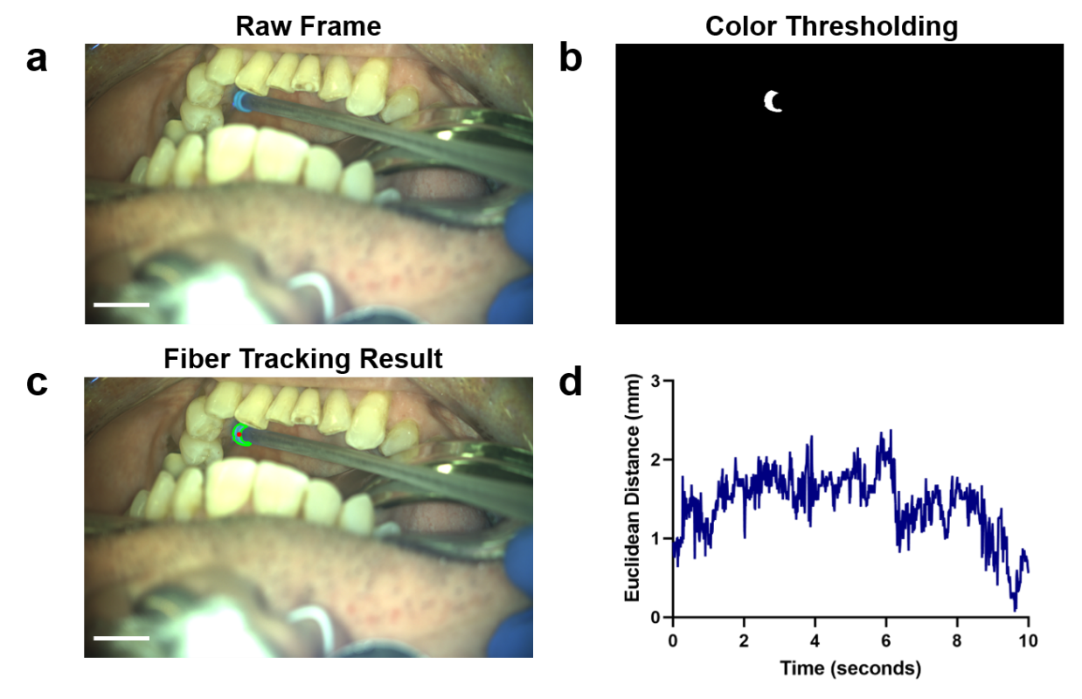
Supplemental Figure 2 | Evaluation of fiber tracking performance in a patient with a gingival lesion in the left mandible. a, A video sequence was acquired of the imaging probe being moved across the gingiva in the left mandible. b, Each image of the video sequence was processed using color thresholding to determine the location of the colored bands on the 3D printed fiber holder. c, Results of the color thresholding analysis were used to calculate the location of the tip of the fiber probe on the patient as designated by the red dot in the image. d, The fiber tracking algorithm shows good accuracy; the Euclidean distance between the pixel coordinates of the fiber tip calculated by the automated tracking algorithm and by hand annotations was <3 mm for all images in a nine second video sequence. Scale bars represent 1 cm.

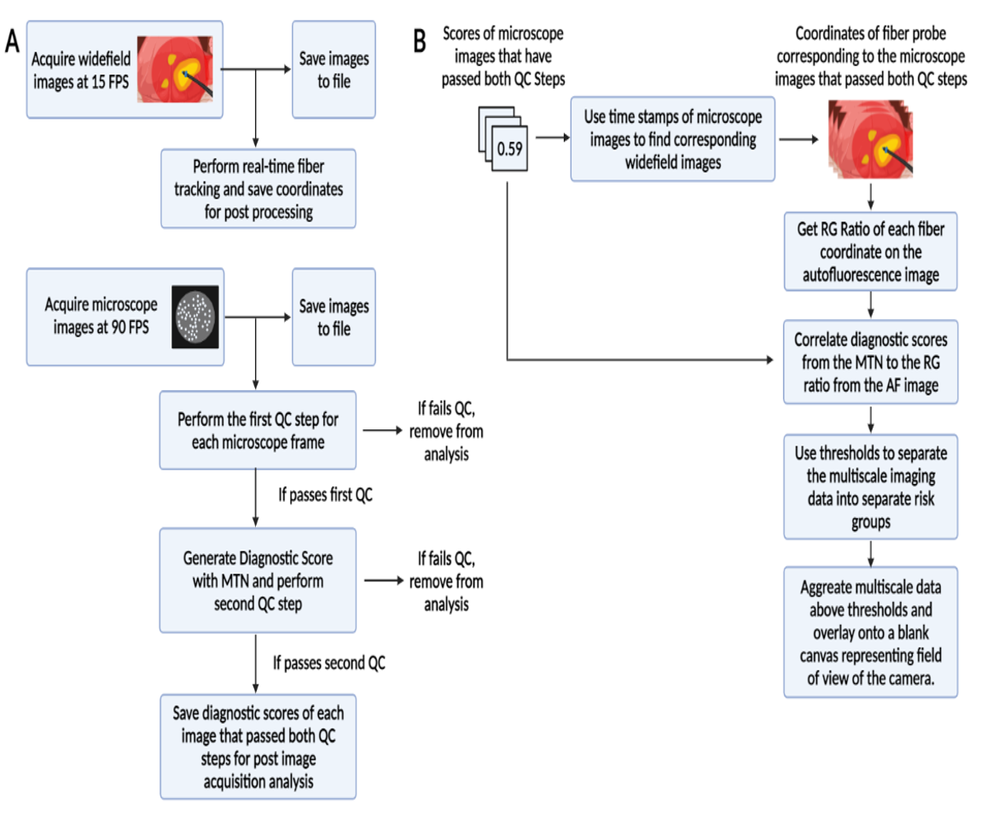
Supplemental Figure 3 | Overview of real-time multi-scale image processing and Biopsy Guidance Map generation. (a) Overview of real time analysis of widefield and high resolution microscope images during multiscale image acquisition (b) Overview of generation of the Biopsy Guidance Map immediately after multiscale image acquisition is finished. Acronyms: (FPS – Frames per second; QC – Quality Control; MTN – Multi-task Network; RG – Red to Green).

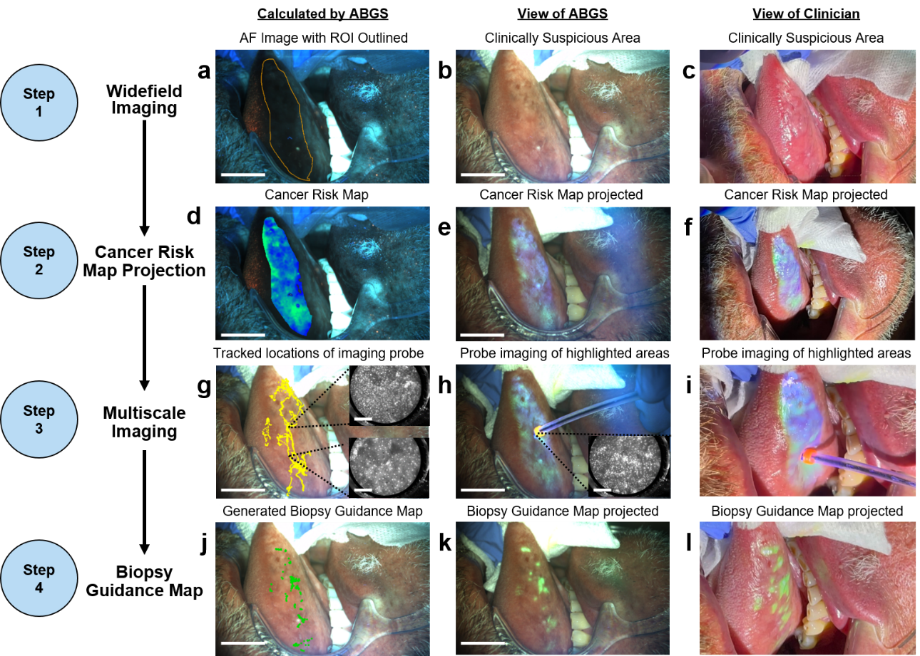

Supplemental Figure 4: Multiscale imaging and analysis from a lesion on the right lateral tongue. ABGS acquired (a) autofluorescence and (b) white light images of clinically suspicious area. (c) Clinician’s view as captured by a cell phone. (d) Cancer risk map overlaid on the AF image, (e) imaged by the ABGS, and (f) viewed by the clinician. (g) ABGS tracked locations of the high resolution probe overlaid on the white light image. (h) ABGS view of probe acquiring high resolution images from areas indicated by the projected cancer risk map and (i) as viewed by the clinician. (j) Biopsy guidance map overlaid on WL image, (k) biopsy guidance map projected on the tissue as viewed by the ABGS (l) and as viewed by the clinician. Scale bars on widefield images represent 1 cm while scale bars on the high-resolution images represent 200 um. Acronyms: (AF – Autofluorescence; ROI –Region of interest; ABGS – Active Biopsy Guidance System).

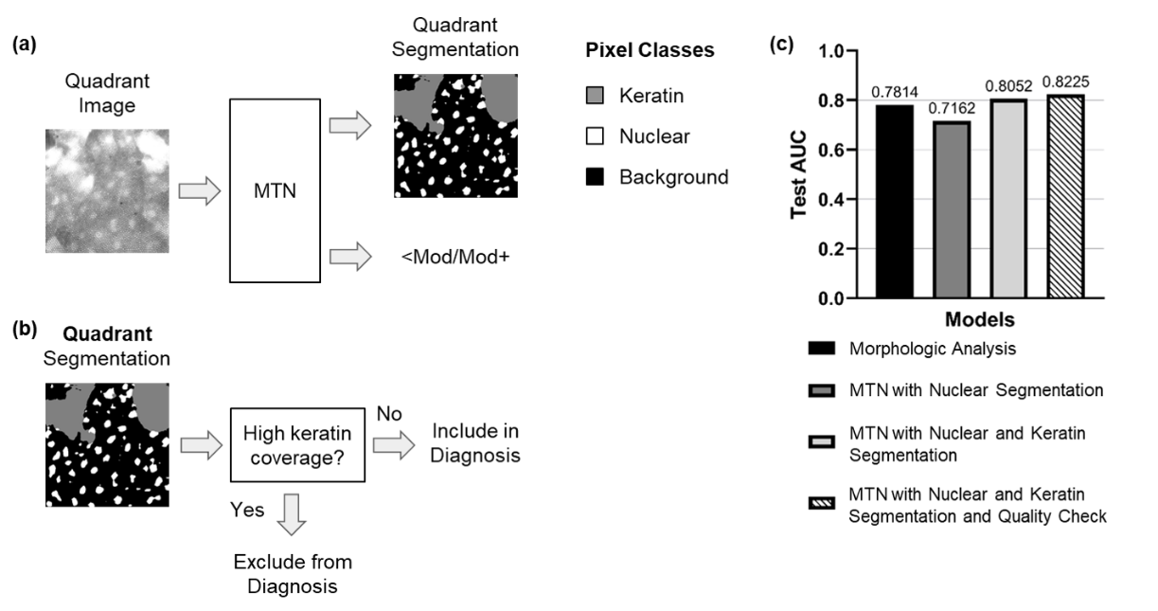
Supplemental Figure 5: High resolution image processing. (a) Oral HRME quadrant image is processed by the MTN to generate the 3-class quadrant segmentation (keratin, nuclear, and background segmentation) and predict pathology. (b) The generated segmentation mask is used to determine the degree of keratin coverage. Quadrants with a high keratin coverage are excluded from diagnosis. (c) Test set area under the receiver operating curve (AUC) for detection of Mod+ disease of the MTN model variants and the morphologic analysis algorithm. Tested MTN variants include MTN with nuclear segmentation only, MTN with nuclear and keratin segmentation, and a MTN with nuclear and keratin segmentation with quality check based on keratin coverage. Acronyms: (MTN – Multi-task Network; Mod - pathology grade moderate or more severe).

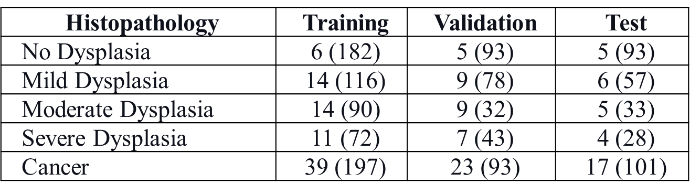
Supplemental Table 1: Number of patients and number of microscope images in the training, validation, and test sets of the oral MTN (Multi-Task Network) stratified by patient histopathologic diagnosis. Number of microscope images are in parentheses.

