Support information
Design, synthesis, in vitro, and in silico biological evaluations of new coumarin-indole hybrids as anti-α-glucosidase agents
Davood Rezapour Niri¹, Mohammad Hosein Sayahi², Somayeh Behrouz¹, Ali Moazzam³, Somayeh Mojtabavi⁴, Mohammad Ali Faramarzi⁴, Bagher Larijani³, Hossein Rastegar⁵, Maryam Mohammadi-Khanaposhtani^{6*}, Mohammad Mahdavi^{3*}
¹Medicinal Chemistry Research Laboratory, Department of Chemistry, Shiraz University of Technology, Shiraz, Iran. ²Department of Chemistry, Payame Noor University (PNU), Tehran, Iran. ³Endocrinology and Metabolism Research Center, Endocrinology and Metabolism Clinical Sciences Institute, Tehran University of Medical Sciences, Tehran, Iran. ⁴Department of Pharmaceutical Biotechnology, Faculty of Pharmacy, Tehran University of Medical Sciences, Tehran, Iran. ⁵Cosmetic products research center, Iranian food and drug administration, MOHE, Tehran, Iran. ⁶Cellular and Molecular Biology Research Center, Health Research Institute, Babol University of Medical Sciences, Babol, Iran.
*Correspondences:
maryammoha@gmail.com
Department of Pharmaceutical Biotechnology, Faculty of Pharmacy, Tehran University of Medical Sciences, Tehran, Iran
momahdavi@tums.ac.ir
Endocrinology and Metabolism Research Center, Endocrinology and Metabolism Clinical Sciences Institute, Tehran University of Medical Sciences, Tehran, Iran

3-((1H-indol-3-yl)(phenyl)methyl)-4-hydroxy-2H-chromen-2-one (4a)
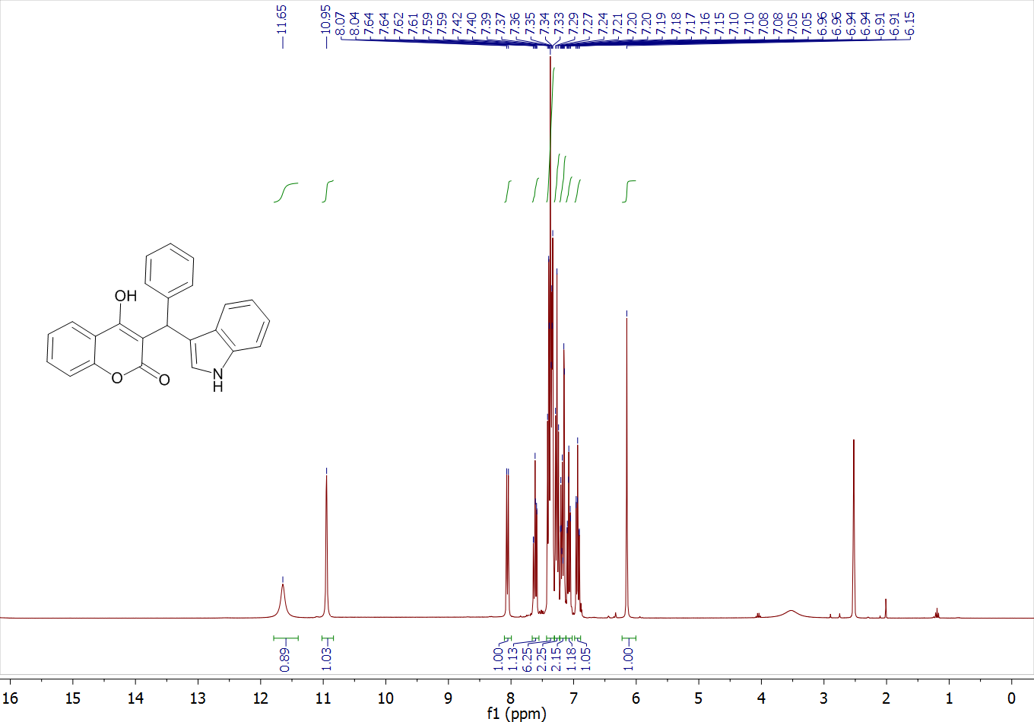

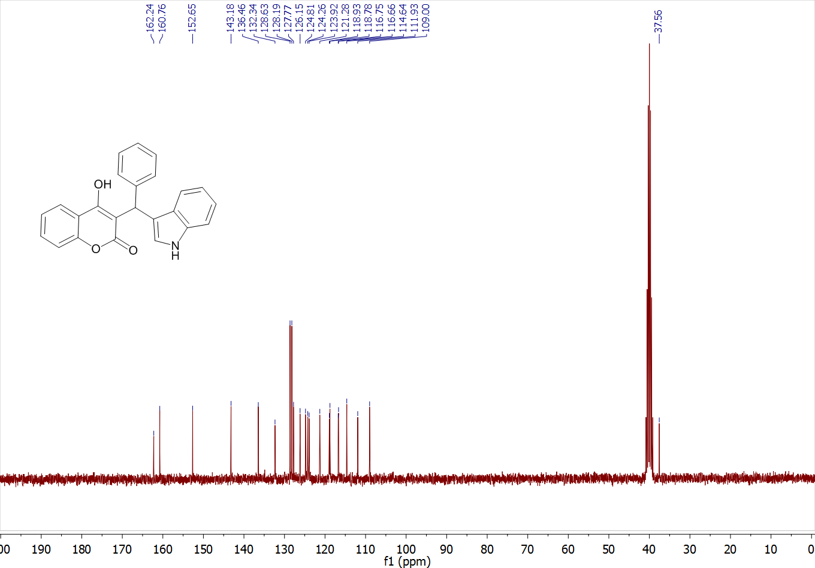

3-((1H-indol-3-yl)(p-tolyl)methyl)-4-hydroxy-2H-chromen-2-one (4b)

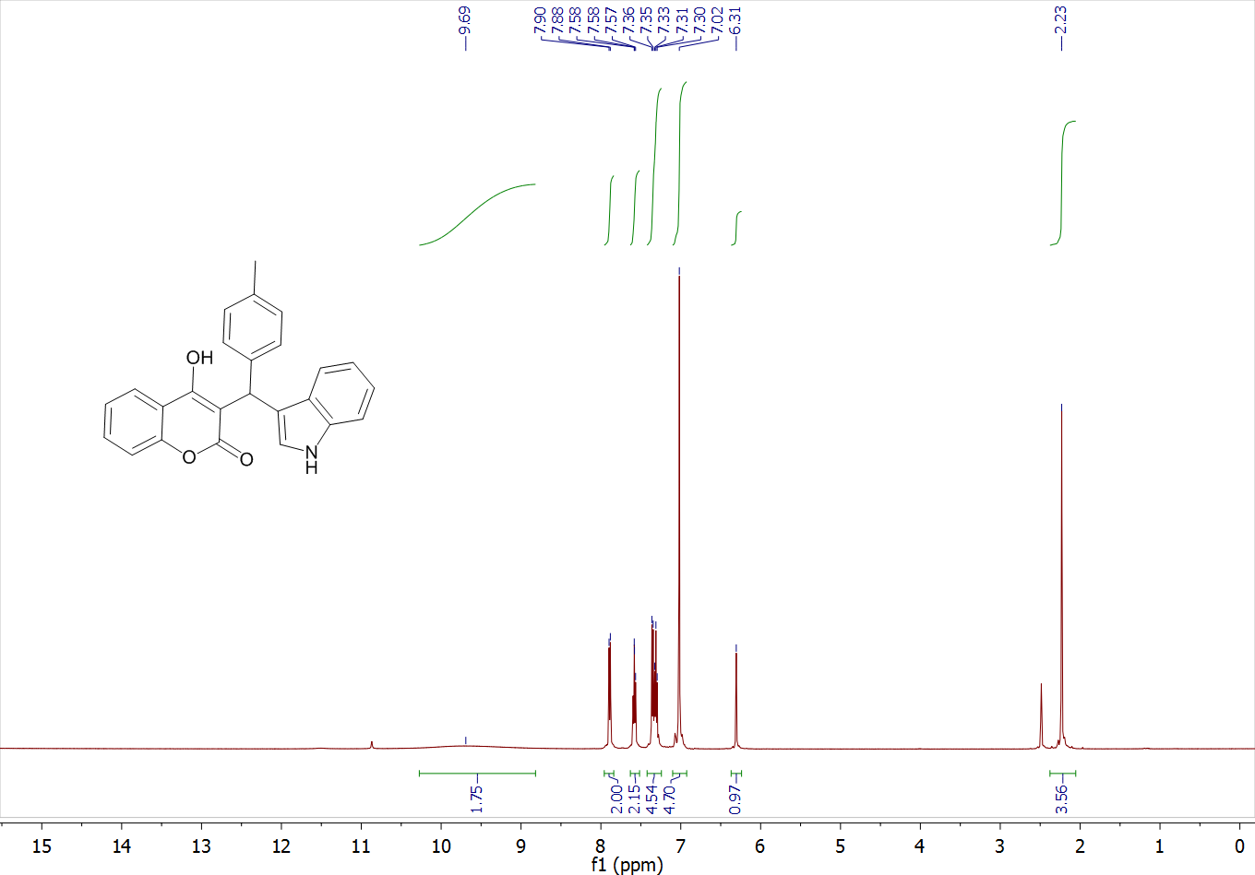
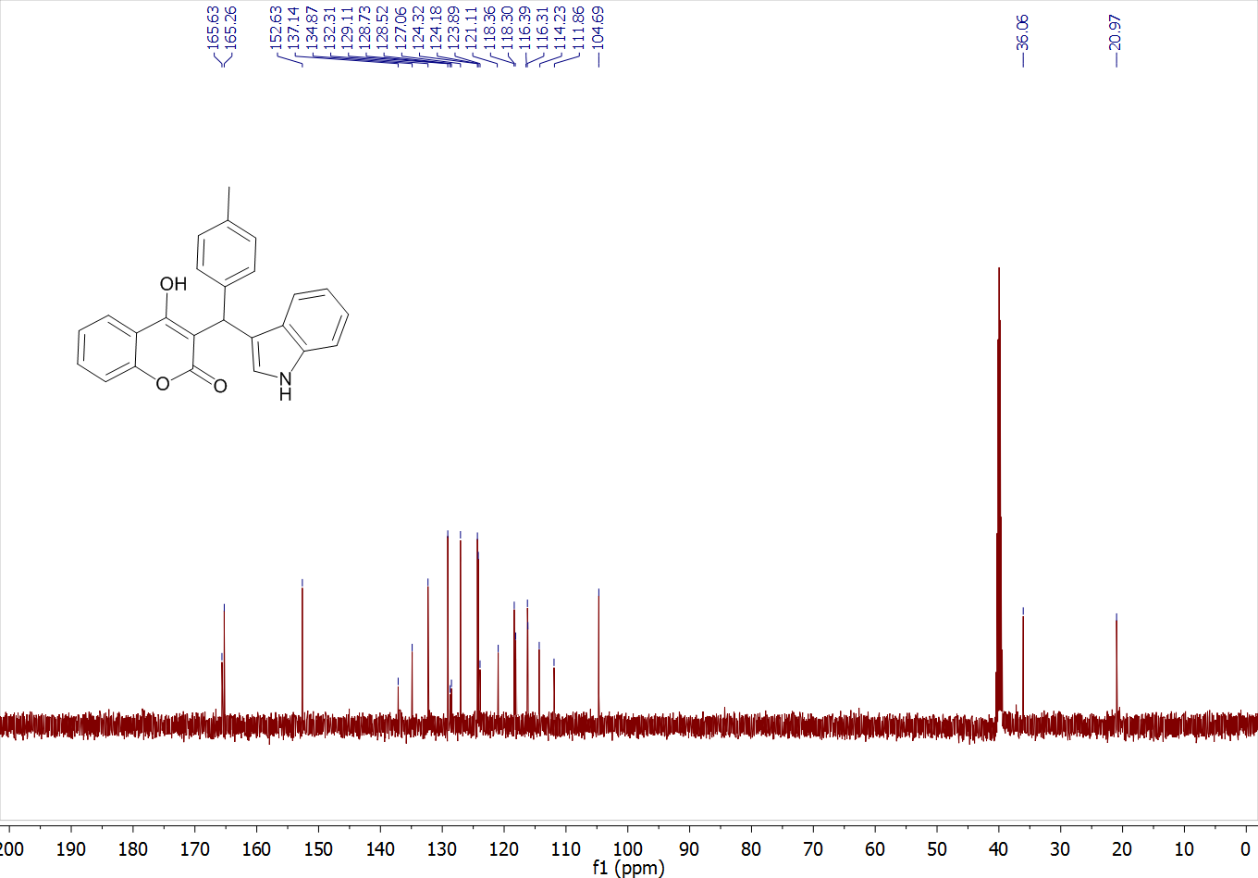
3-((1H-indol-3-yl)(4-methoxyphenyl)methyl)-4-hydroxy-2H-chromen-2-one (4c)
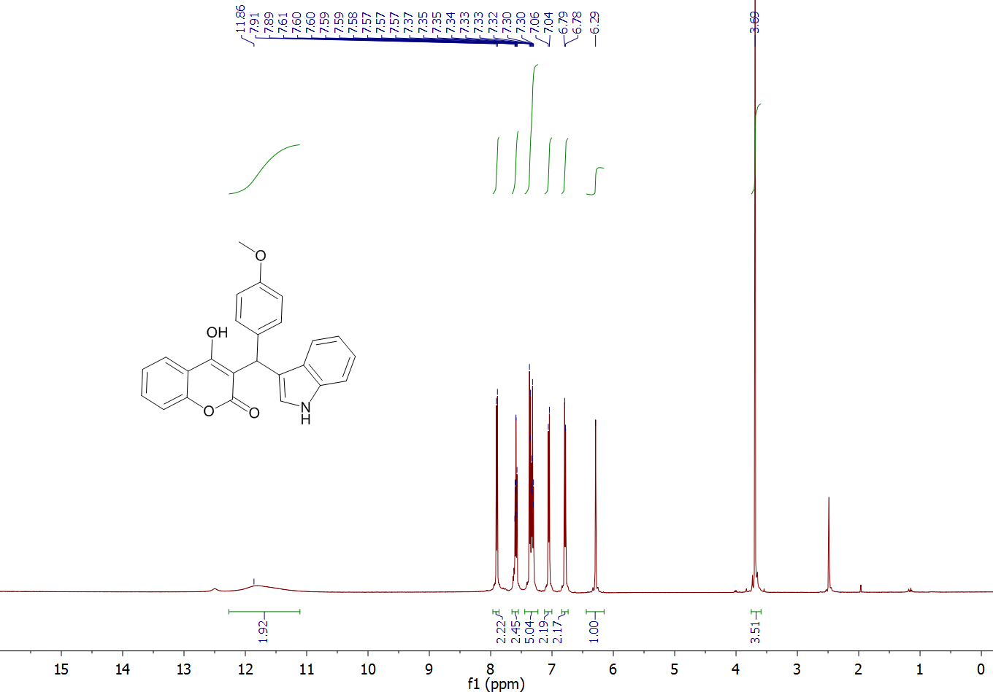
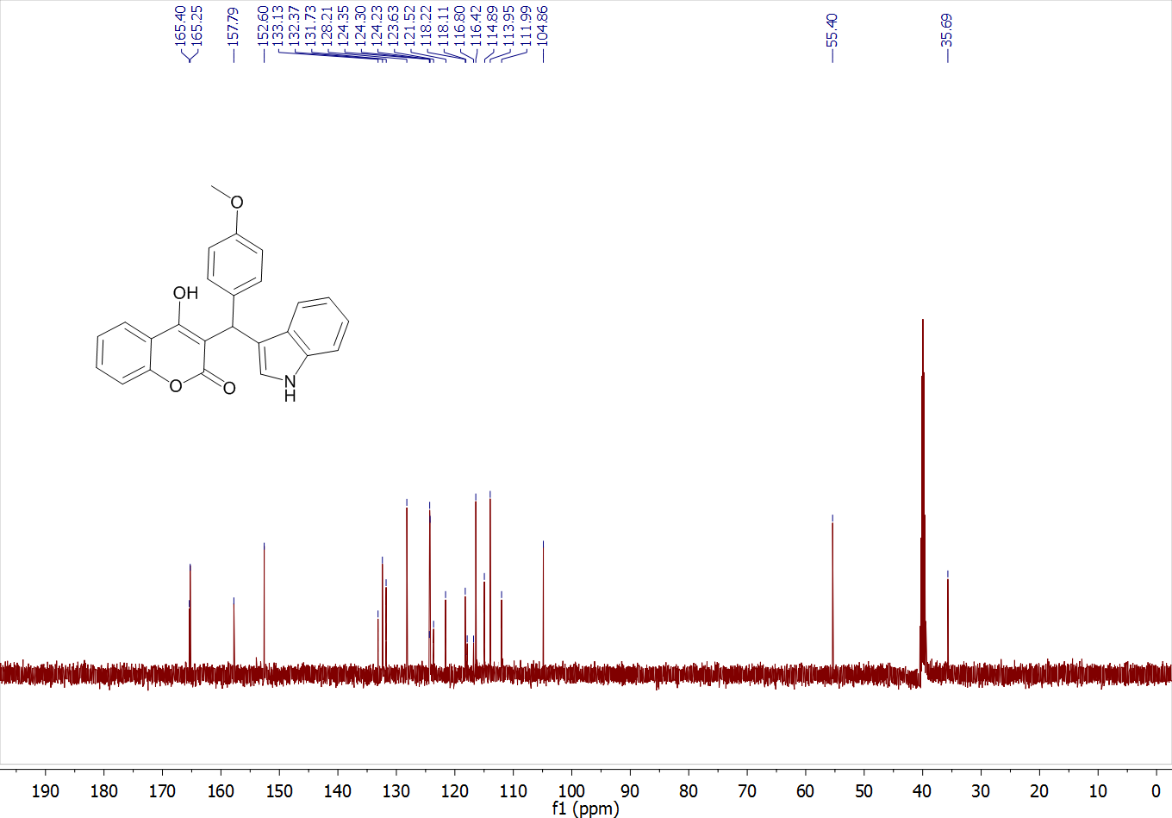

3-((1H-indol-3-yl)(3-phenoxyphenyl)methyl)-4-hydroxy-2H-chromen-2-one (4d)

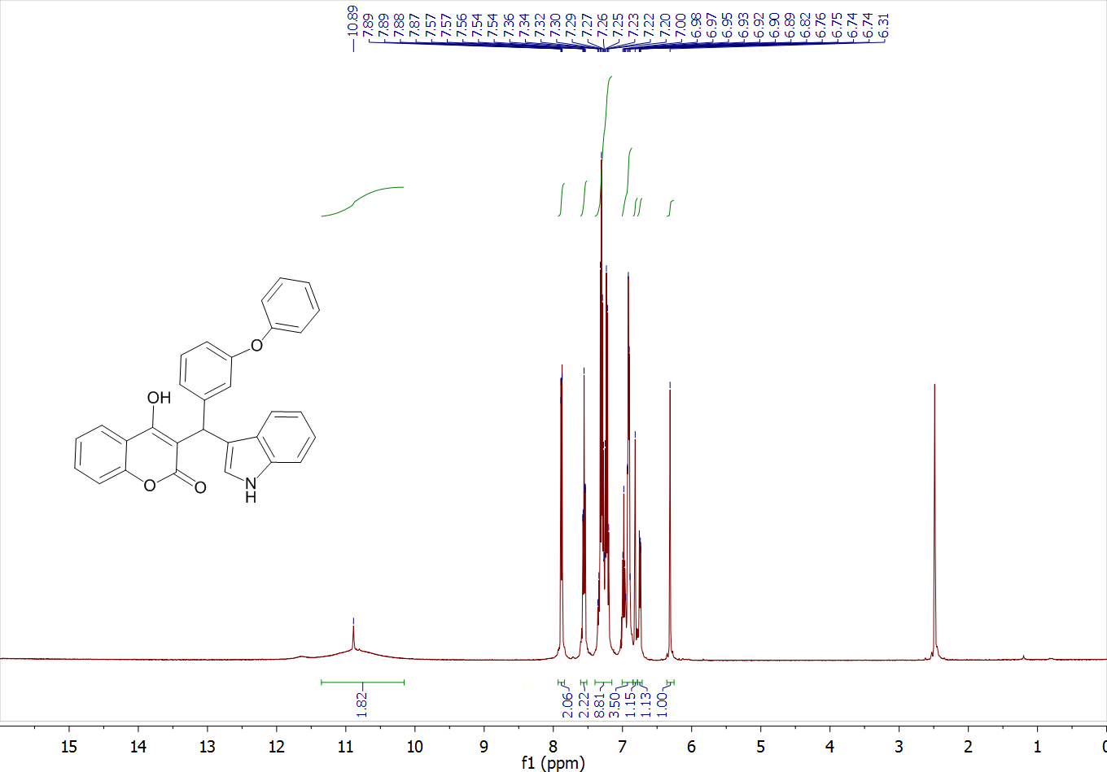

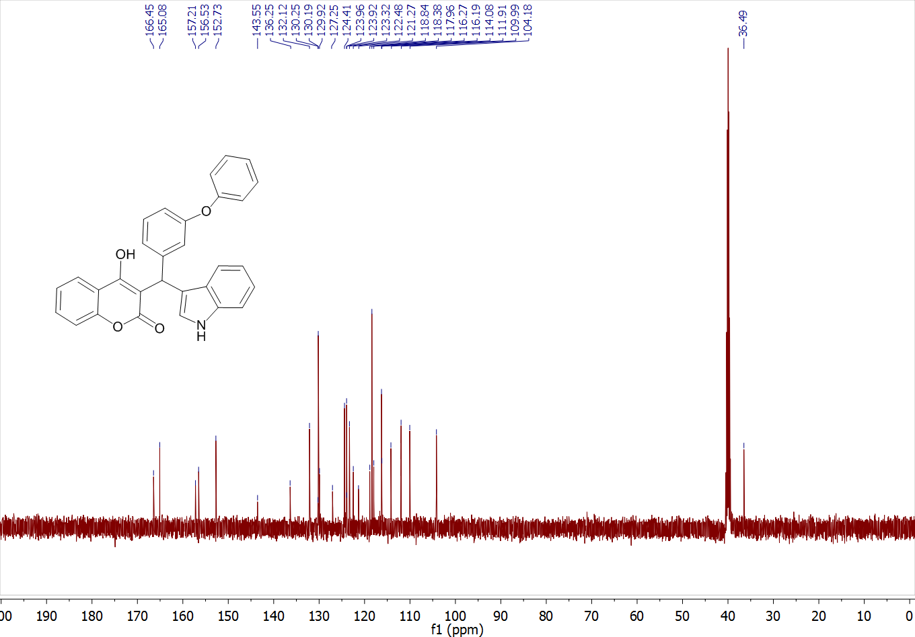
4-hydroxy-3-((3-hydroxyphenyl)(1H-indol-3-yl)methyl)-2H-chromen-2-one (4e)
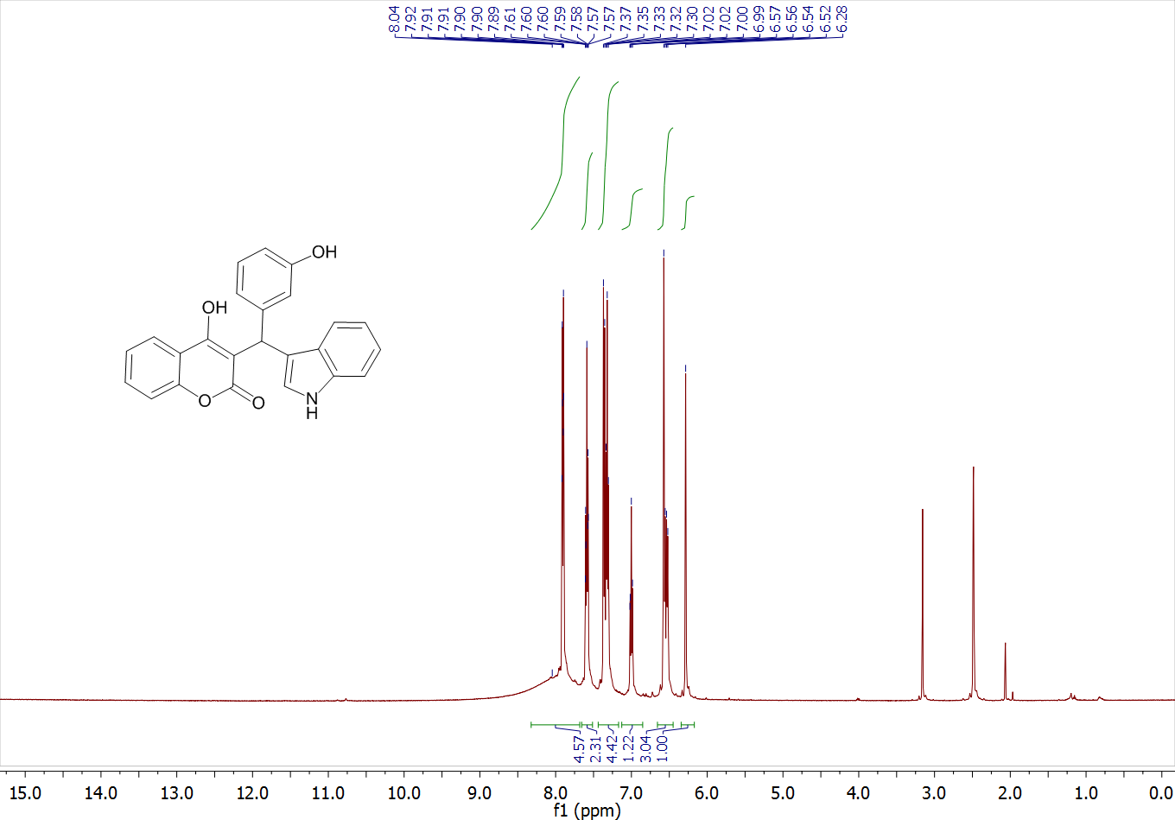
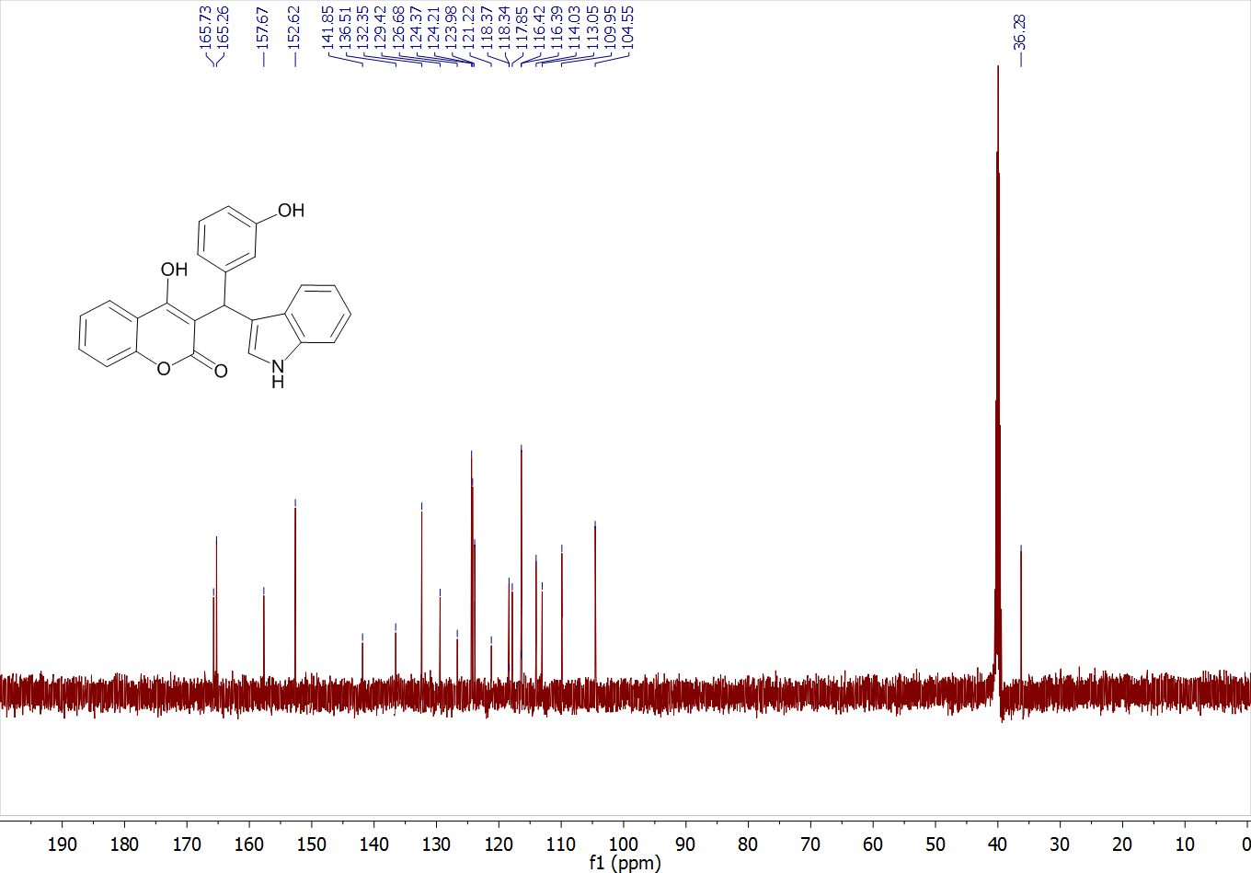
4-hydroxy-3-((4-hydroxyphenyl)(1H-indol-3-yl)methyl)-2H-chromen-2-one (4f)
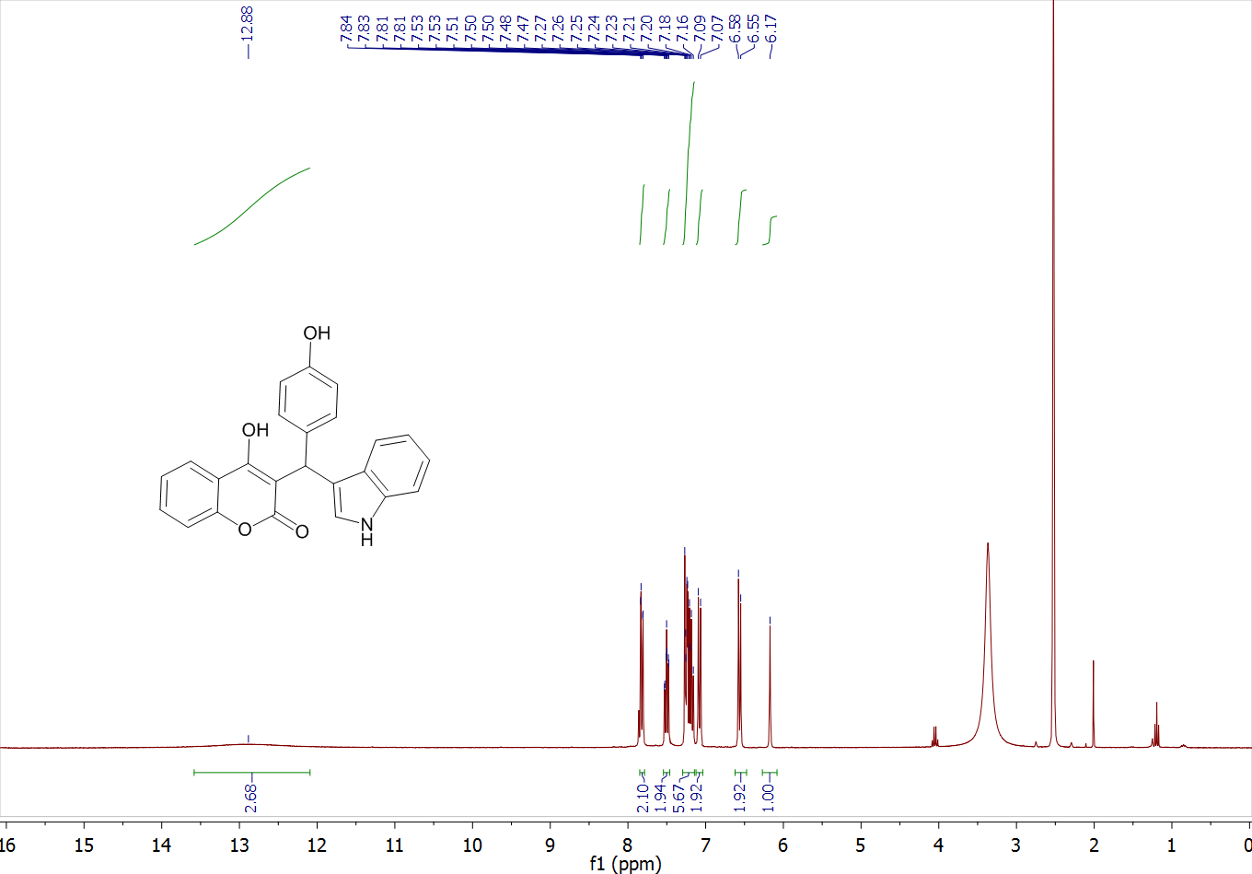
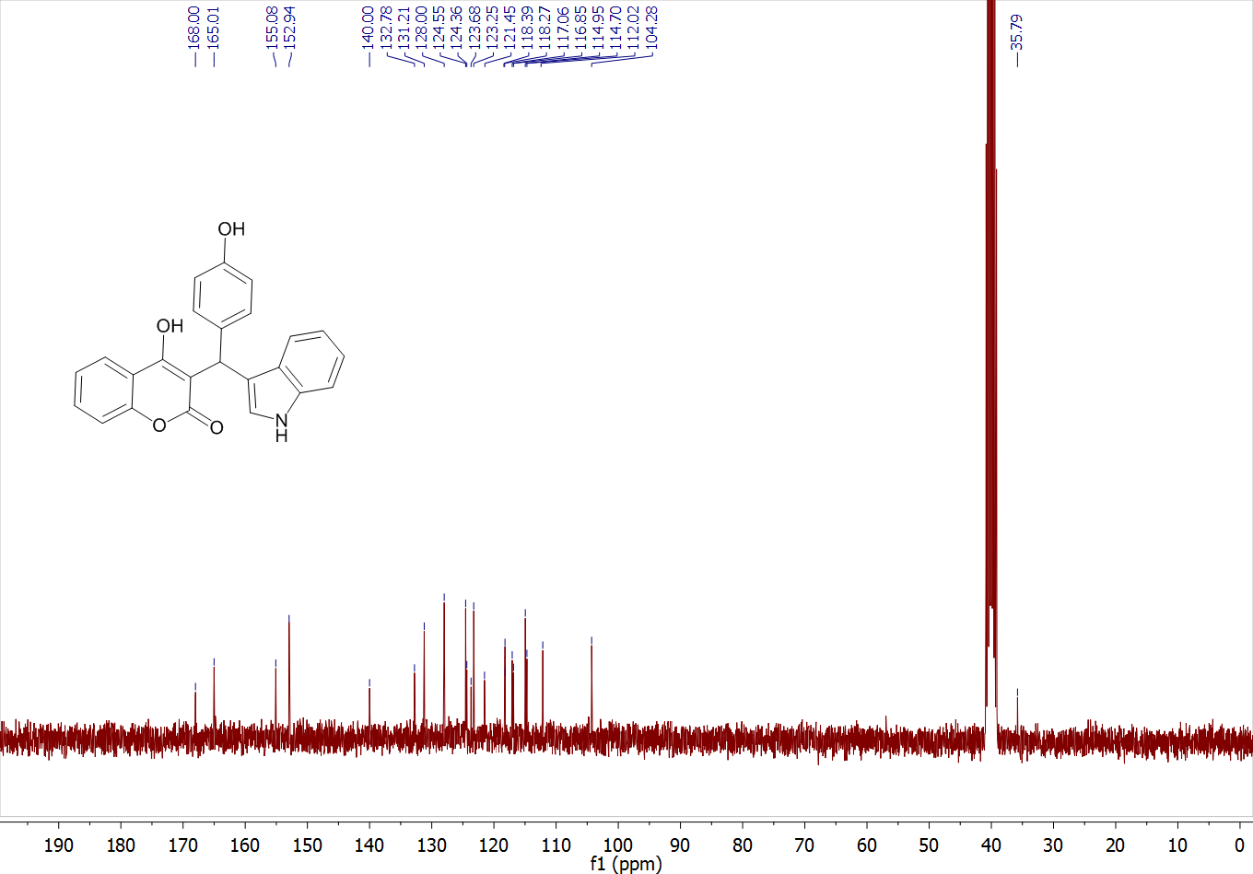
3-((3-fluorophenyl)(1H-indol-3-yl)methyl)-4-hydroxy-2H-chromen-2-one (4g)

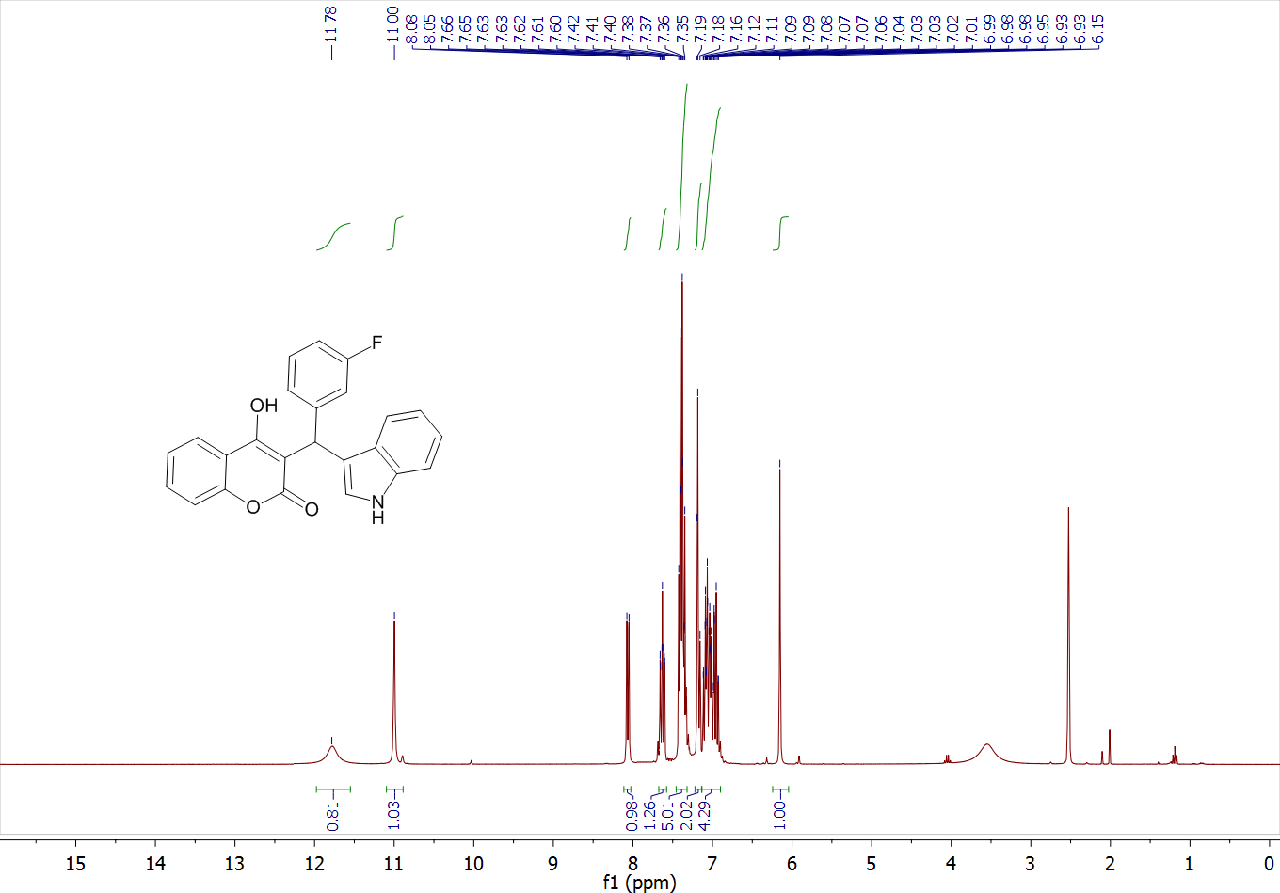
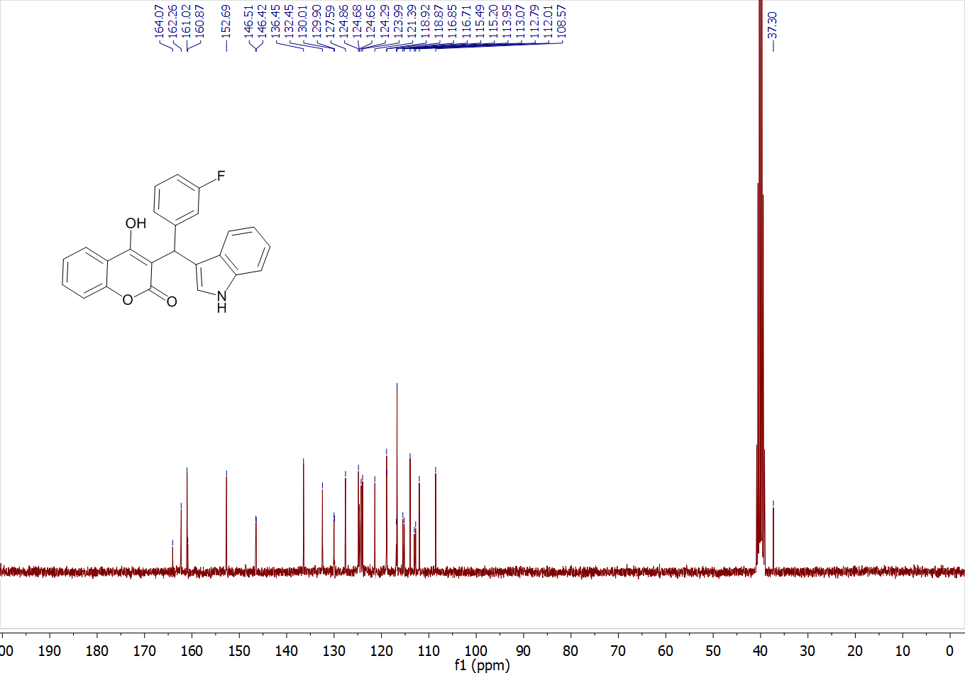

3-((4-fluorophenyl)(1H-indol-3-yl)methyl)-4-hydroxy-2H-chromen-2-one (4h)
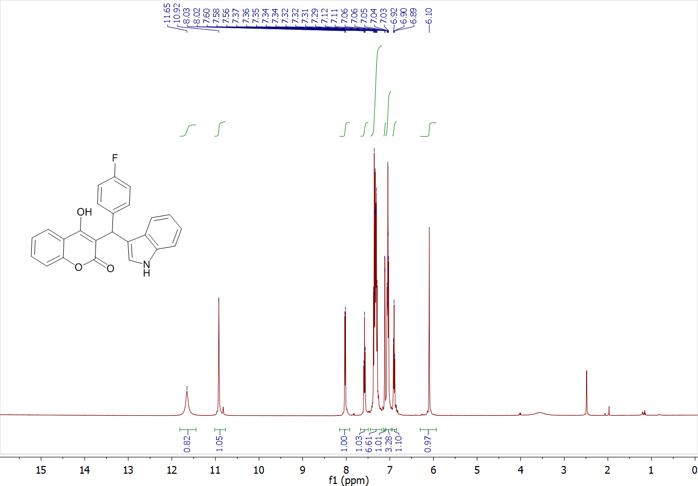
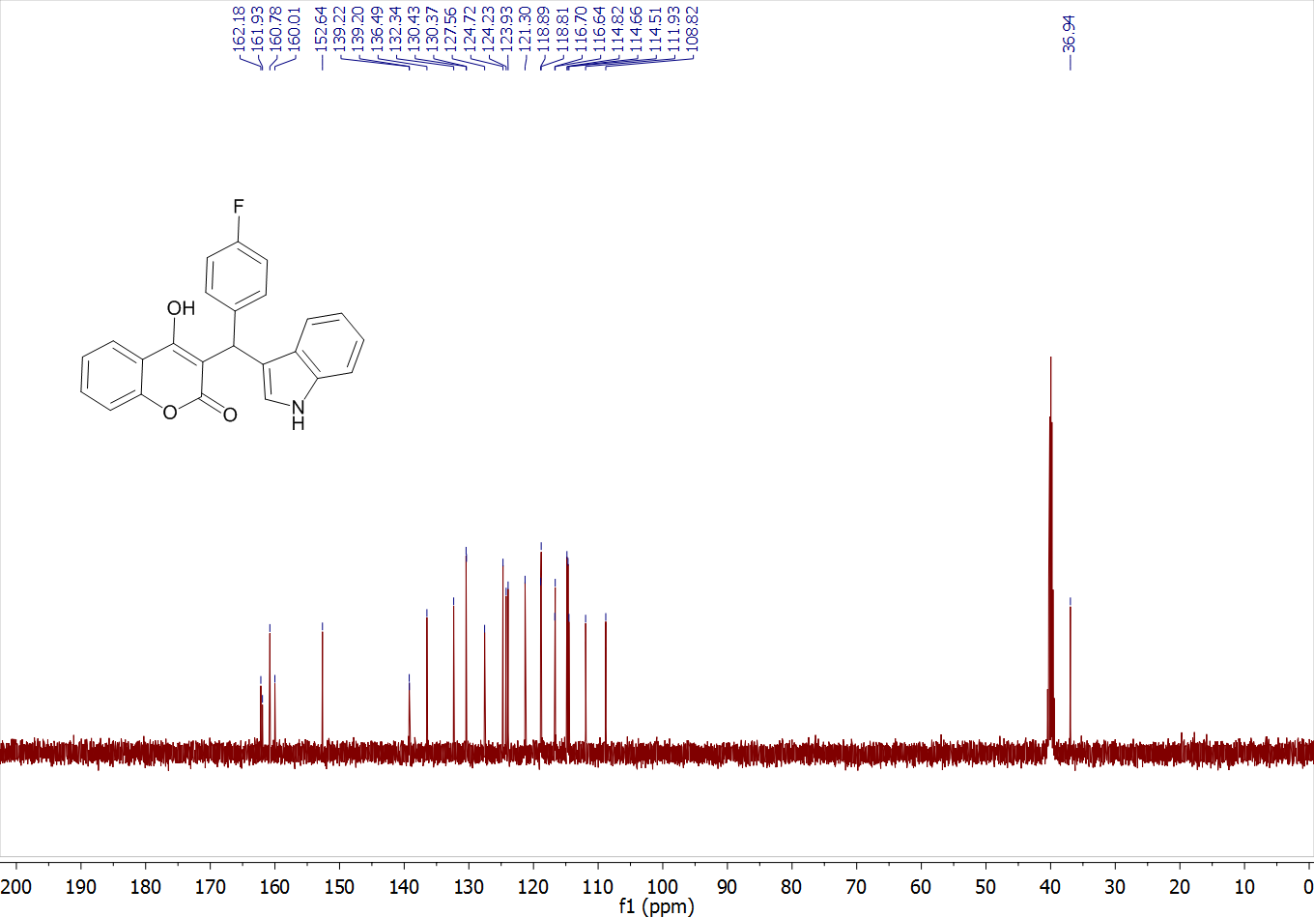
3-((3-Chlorophenyl)(1H-indol-3-yl)methyl)-4-hydroxy-2H-chromen-2-one (4i)
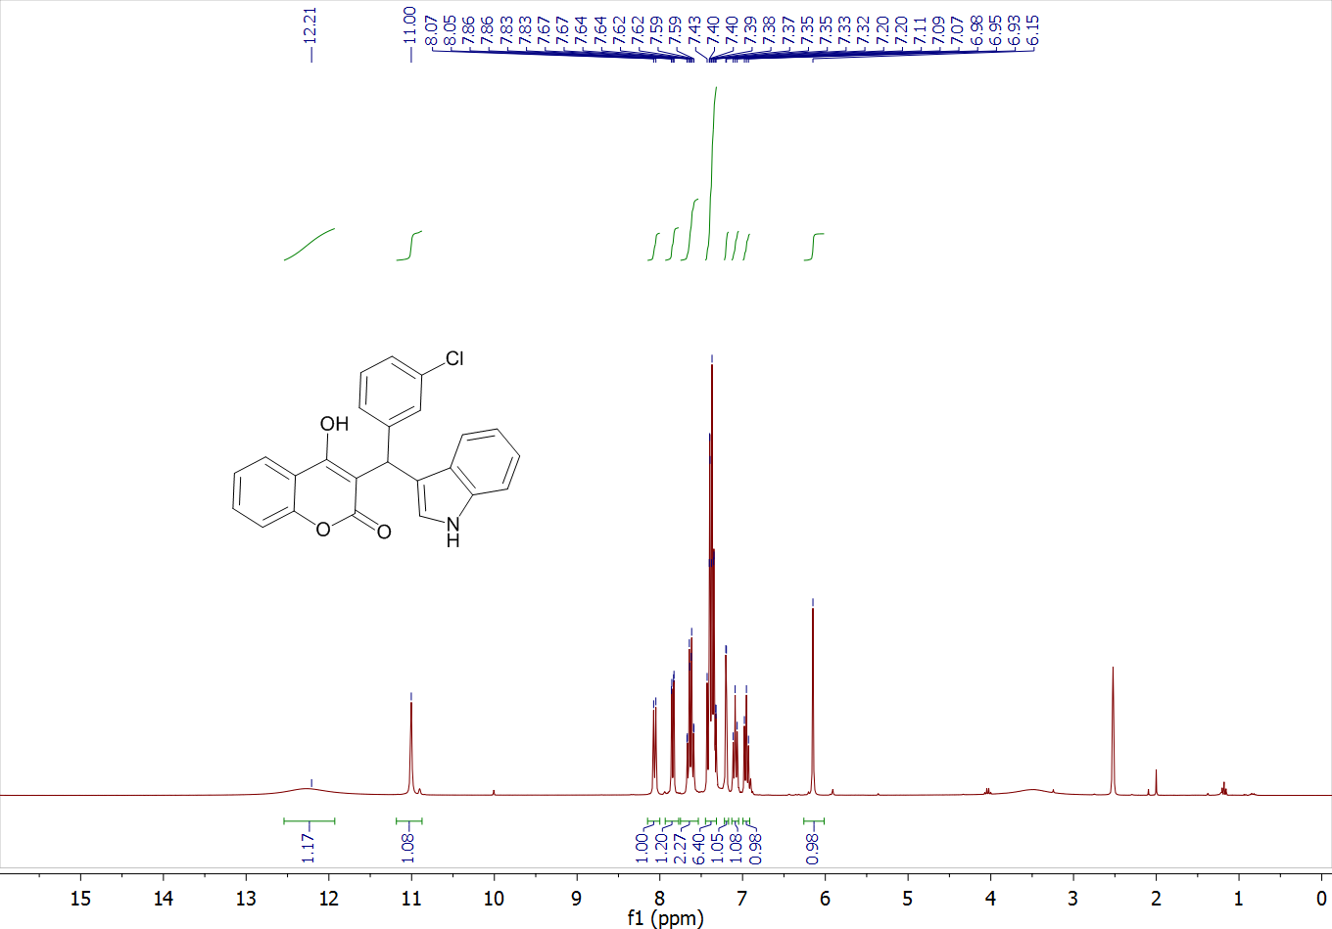
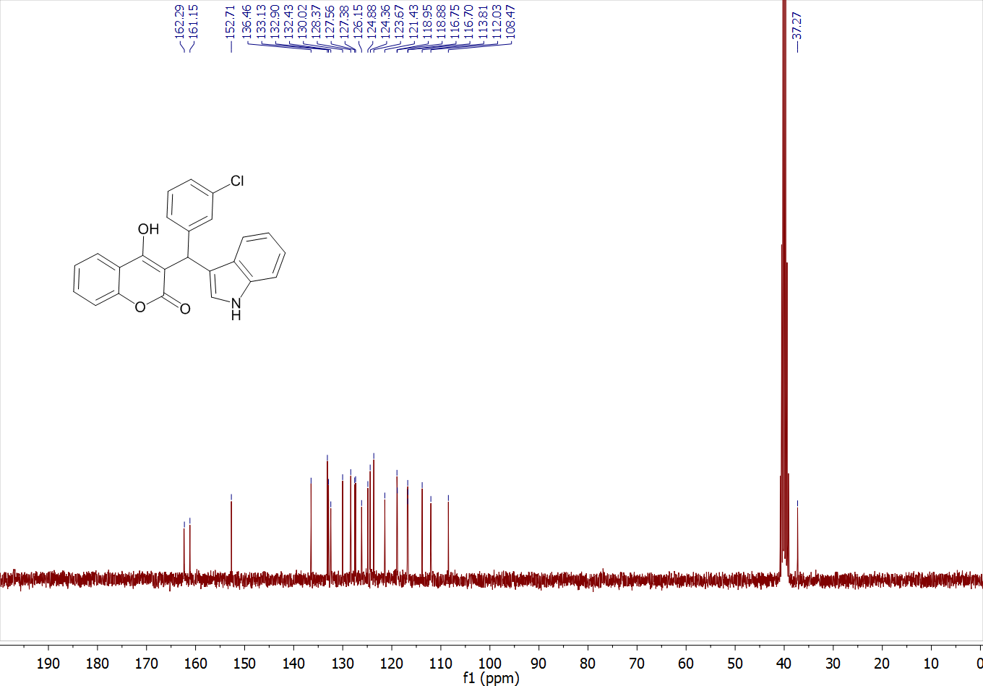
3-((4-chlorophenyl)(1H-indol-3-yl)methyl)-4-hydroxy-2H-chromen-2-one (4j)
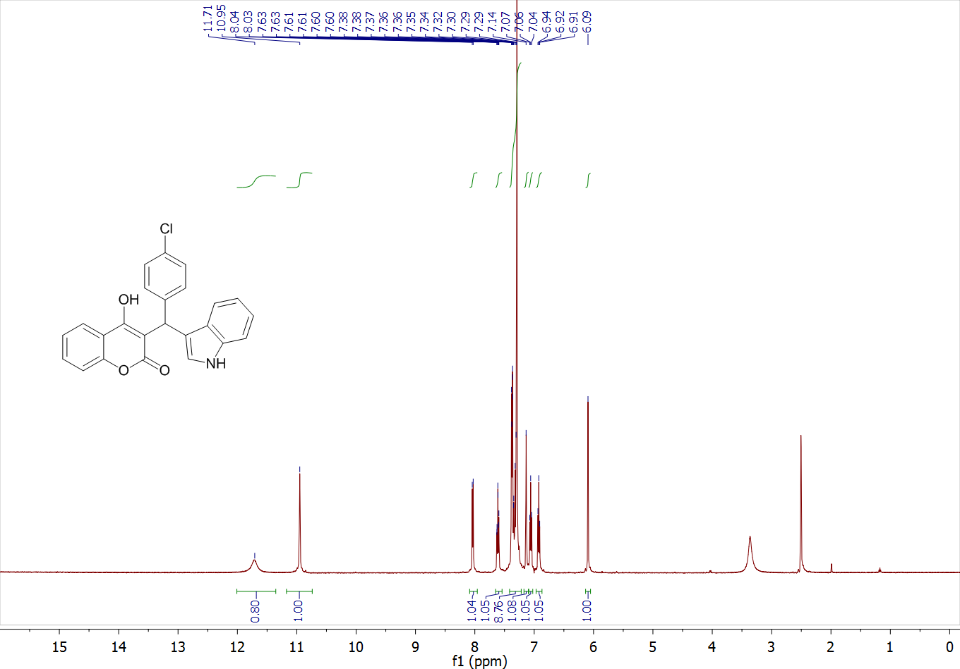
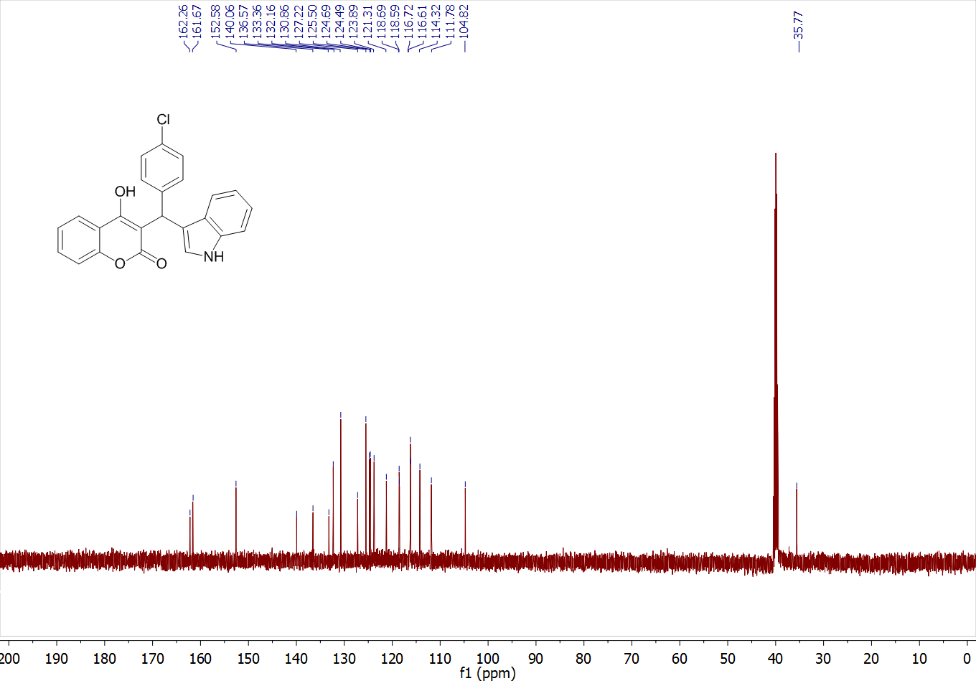

3-((3-bromophenyl)(1H-indol-3-yl)methyl)-4-hydroxy-2H-chromen-2-one (4k)

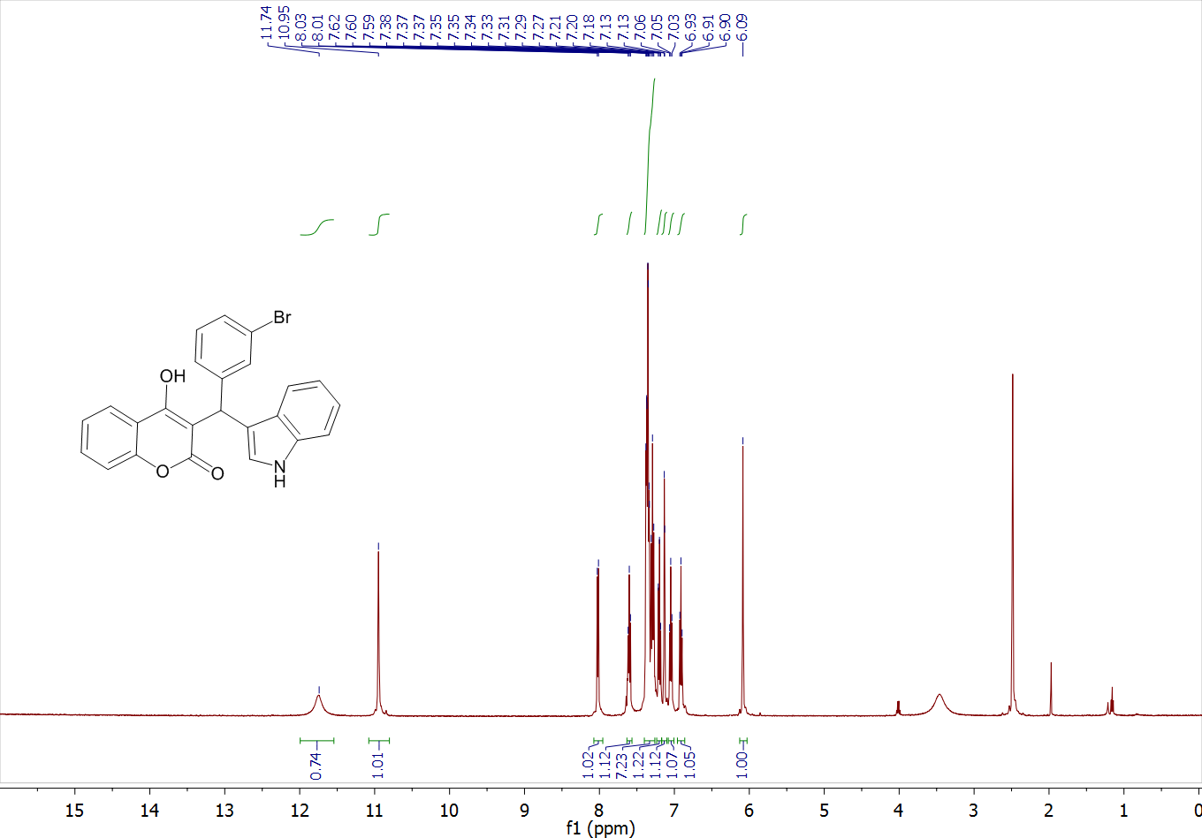
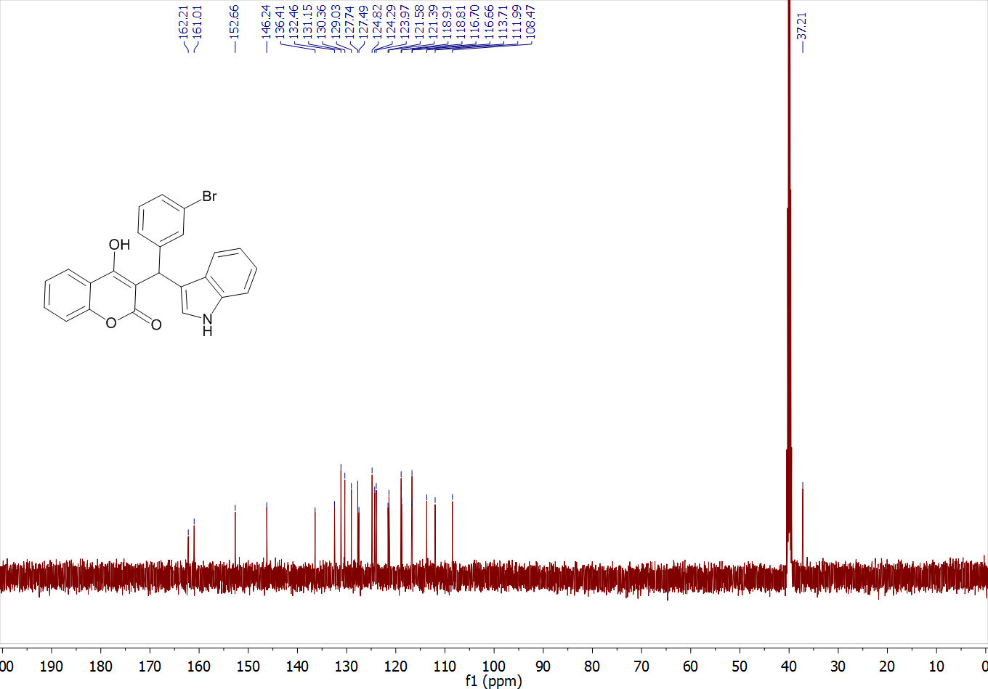
3-((1H-indol-3-yl)(2-nitrophenyl)methyl)-4-hydroxy-2H-chromen-2-one (4l)
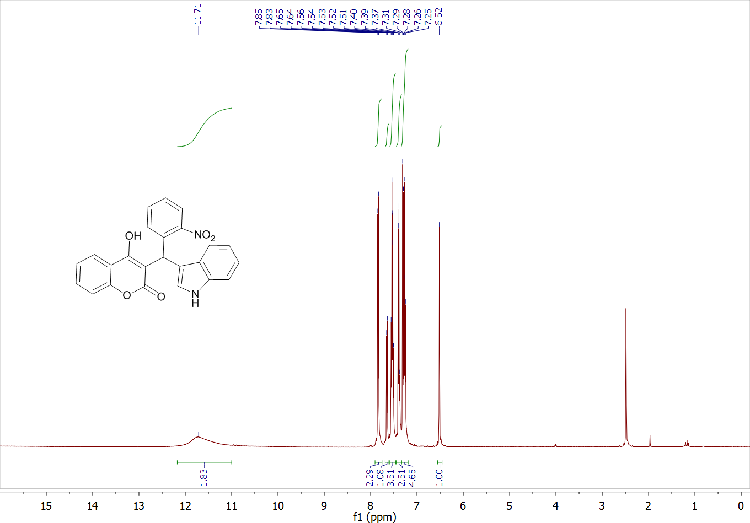
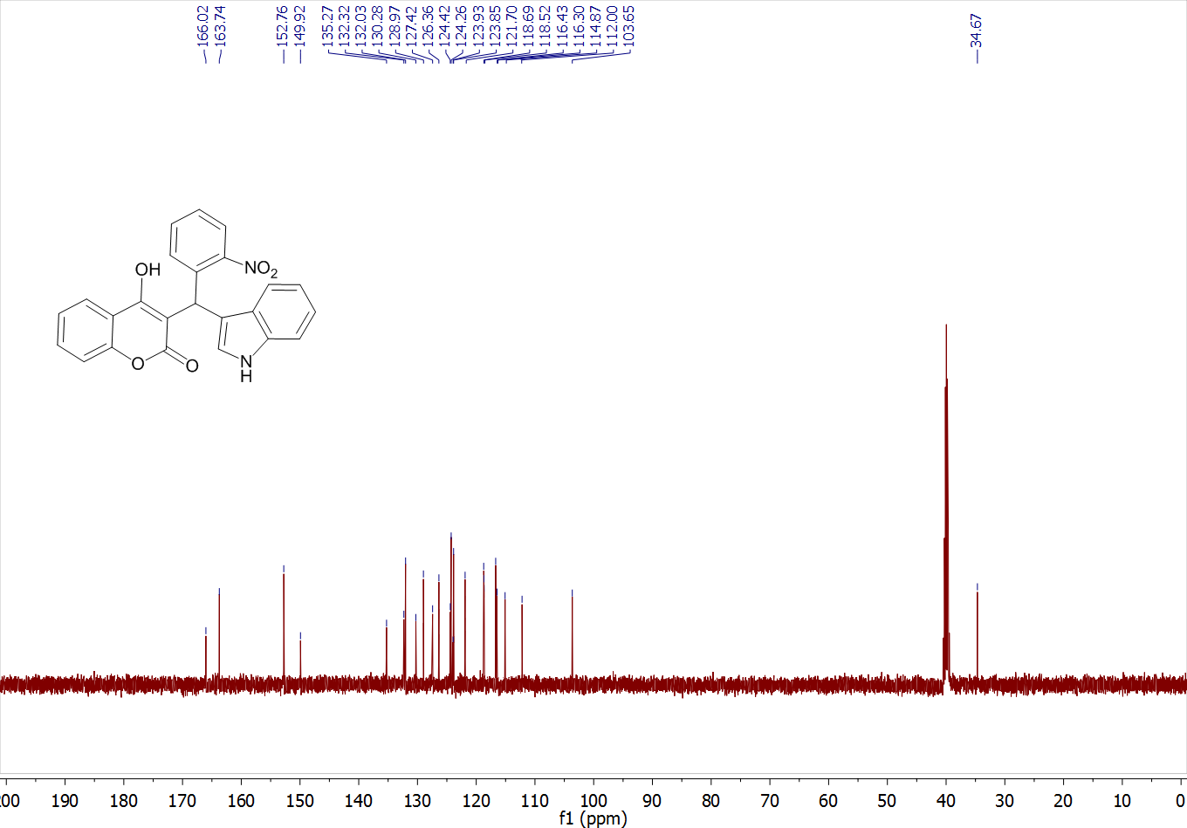

3-((1H-indol-3-yl)(3-nitrophenyl)methyl)-4-hydroxy-2H-chromen-2-one (4m)

