Borinane Boosted Bifunctional Organocatalysts for Ultrafast Ring-Opening Polymerization of Cyclic Ethers
Chao Chen, Yves Gnanou,* and Xiaoshuang Feng*

Physical Sciences and Engineering Division, King Abdullah University of Science and Technology (KAUST), Thuwal 23955, Saudi Arabia

Contents
Experimental section 4
Scheme S1. Synthetic procedure of borinane and its amplification reaction. 4
Scheme S2. Synthesis procedure for the ammonium salts with two and three vinyl groups. 4
Scheme S3. Synthesis procedure for the ammonium salts with four vinyl groups. 6
Figure S1. ¹H NMR of borinane in CDCl₃. 9
Figure S2. 13C NMR of borinane in CDCl3. 9
Figure S3. ¹¹B NMR of 9-BBN (top) and borinane (bottom) in CDCl₃. 10
Figure S4. ¹H NMR of ammonium salt precursor for initiator/catalyst B2 in CDCl₃. 11
Figure S5. ¹³C NMR of ammonium salt precursor for initiator/catalyst B2 in CDCl₃. 11
Figure S6. ¹H NMR of ammonium salt precursor for initiator/catalyst B3 in CDCl₃. 11
Figure S7. ¹³C NMR of ammonium salt precursor for initiator/catalyst B3 in CDCl₃. 12
Figure S8. ¹H NMR of ammonium salt precursor for initiator/catalyst B4 in CDCl₃. 12
Figure S9. ¹³C NMR of ammonium salt precursor for initiator/catalyst B4 in CDCl₃. 13
Figure S10. ¹H NMR of initiator/catalyst B2 in CDCl₃. 14
Figure S11. ¹³C NMR of initiator/catalyst B2 in CDCl₃. 14
Figure S12. ¹¹B NMR of initiator/catalyst B2 in CDCl₃. 14
Figure S13. ¹H NMR of initiator/catalyst B3 in CDCl₃. 15
Figure S14. ¹³C NMR of initiator/catalyst B3 in CDCl₃. 16
Figure S15. ¹¹B NMR of initiator/catalyst B3 in CDCl₃. 16
Figure S16. ¹H NMR of initiator/catalyst B4 in CDCl₃. 17
Figure S17. ¹³C NMR of initiator/catalyst B4 in CDCl₃. 18
Figure S18. ¹¹B NMR of initiator/catalyst B4 in CDCl₃. 18
Figure S19. ¹H NMR of PPO polyols synthesized using initiator/catalyst B4 in CDCl₃. 19
Table S1. Activity comparison of bifunctional borinane-bearing ammonium salts in the presence of CTAs.ª 20
Figure S20. ¹H NMR of PPO synthesized using BzOH as CTA (Table S1, entry 4). 21
Figure S21. ¹H NMR of PPO synthesized using TFE as CTA (Table S1, entry 5). 21
Figure S22. ¹⁹F NMR of PPO synthesized using TFE as CTA (Table S1, entry 5). 22
Figure S23. ¹H NMR of PPO synthesized using PA as CTA (Table S1, entry 6). 22
Figure S24. ¹H NMR of PPO synthesized using HEA as CTA (Table S1, entry 7). 23
Figure S25. ¹H NMR of PPO synthesized using H₂O as CTA (Table S1, entry 8). 23
Figure S26. ¹H NMR of PPO synthesized using PG as CTA (Table S1, entry 9). 24
Figure S27. ¹H NMR of PPO synthesized using DBzOH as CTA (Table S1, entry 10). 24
Figure S28. ¹H NMR of PPO synthesized using DBzSH as CTA (Table S1, entry 11). 25
Figure S29. ¹H NMR of PPO synthesized using PEG4OH as CTA (Table S1, entry 12). 25
Table S2. B4 catalyzed ROP of PO in the presence of BzOH as CTA.ª 26
Figure S30. SEC traces of PPO with different molar masses (Table S2, entry 1, 2, 3, 5). 27
Figure S31. ¹H NMR of PEO synthesized using DBzOH as CTA (Table 2, entry 6). 28
Figure S32. ¹H NMR of PEO synthesized using H₂O as CTA (Table 2, entry 7). 28
Figure S33. ¹H NMR of PEO synthesized using PEG4OH as CTA (Table 2, entry 9). 29
Figure S34. ¹H NMR of PBO synthesized using H₂O as CTA (Table 2, entry 10). 29
Figure S35. ¹H NMR of POO synthesized using H₂O as CTA (Table 2, entry 13). 30
Figure S36. ¹H NMR of PAGE synthesized using H₂O as CTA (Table 2, entry 12). 30
Figure S37. ¹H NMR of PPGE synthesized using H₂O as CTA (Table 2, entry 11). 31
Table S3. Comparison of catalysts B4 with other catalyst system for the ROP of oxetane.ª 32
Figure S38. MALDI-TOF spectra of PPO obtained using B4 as catalyst. 33
Figure S39. MALDI-TOF spectra of PTMO obtained using B4 as catalyst. 34
Figure S40. ¹³C NMR spectra of PPO synthesized by rac-PO (top) and chiral S-PO (bottom). 35
Figure S41. ¹¹B NMR of borane and borane-oxyanion complex in THF-d₈. 35
Figure S42. DFT computation optimized structures of intermediates and transition states for B2 mediated RD-ROP. 36
REFERENCES 37
Cartesian coordinates for the optimized structures 37

Experimental section
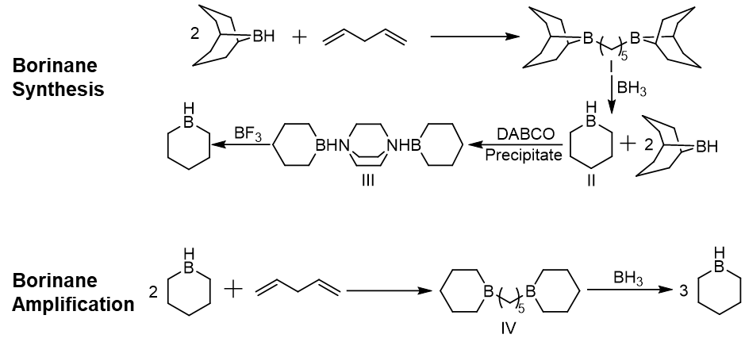

Scheme S1. Synthetic procedure of borinane and its amplification reaction.
Synthesis of ammonium salts.

Scheme S2. Synthesis procedure for the ammonium salts with two and three vinyl groups.

N,N-dibutyl-N-(pent-4-en-1-yl)pent-4-en-1-ammonium chloride
The detailed synthesis procedure was shown in Scheme S2. In a flame dried round bottom flask equipped with magnetic stir bar, anhydrous THF solution of butyl amine (1 eq., 10 g, 137 mmol) was added. Subsequently, two equivalent quantity of 5-bromo-1-pentene (2 eq., 40.8 g, 274 mmol) and potassium carbonate (2 eq., 38 g, 274 mmol) was added and stirred at 70 °C for 48 h. The solvent was removed via rotary evaporation to afford crude products as pale yellow liquid which was further purified by distillation (yield 95%). The purified tertiary amine was quaternized by one equivalent butyl bromide with yield up to 98 %. The above bromide salt (5 g) was dissolved in methanol and eluted through a column containing Amberlite IRA-402 (Cl form) ion-exchange resin (50.0 g) at a drop rate of 1 mL/min. Solvent was removed and product was dried in vacuo at 50 °C to yield a white solid (4.3 g, 100% yield).
N-butyl-N,N-di(pent-4-en-1-yl)pent-4-en-1-ammonium chloride
The above obtained tertiary amine was quaternized by one equivalent 5-bromo-1-pentene with yield up to 97 %. The corrsponding bromide salt (5 g) was dissolved in methanol and eluted through a column containing Amberlite IRA-402 (Cl form) ion-exchange resin (50.0 g) at a drop rate of 1 mL/min. Solvent was removed and product was dried in vacuo at 50 °C to yield a white solid (4.4 g, 100% yield).

Scheme S3. Synthesis procedure for the ammonium salts with four vinyl groups.

Tetra(pent-4-en-1-yl)ammonium chloride
The detailed synthesis procedure for quaternary vinyl ammonium salts was shown in Scheme S3. In a flame dried round bottom flask equipped with magnetic stir bar, an anhydrous THF solution of 4-penten-1-amine (1 eq., 5 g, 58.8 mmol) was added. Subsequently, two equivalent quantity of 5-bromo-1-pentene (2 eq., 17.6 g, 117.6 mmol) and potassium carbonate (2 eq., 16.3 g, 117.6 mmol) was added and stirred at 70 °C for 48 h. The solvent was removed via rotary evaporation to afford crude products as pale yellow liquid which was further purified by distillation (yield 96%). The purified tertiary amine was quaternized by one equivalent 5-bromo-1-pentene with yield up to 97 %. The above bromide salt (5 g) was dissolved in methanol and eluted through a column containing Amberlite IRA-402 (Cl form) ion-exchange resin (50.0 g) at a drop rate of 1 mL/min. Solvent was removed and product was dried in vacuo at 50 °C to yield a white solid (4.5 g, 100% yield).

Synthesis of catalysts
As shown in Scheme 1, all the bifunctional catalysts were synthesized via the direct hydroboration of borinane with vinyl groups. All the solvents utilized in this reaction were carefully dried to afford high yield and eliminate side reaction.

Catalyst B2
In a flame dried Schlenk tube, the anhydrous THF solution of above obtained ammonium salt, N,N-dibutyl-N-(pent-4-en-1-yl)pent-4-en-1-aminium chloride, (1 g, 3.31 mmol) was charged. An equivalent quantity of borinane (543 mg, 6.62 mmol) was added and stirred overnight in glovebox. Solvent was removed under reduced pressure to afford crude products as white solid (B2, 1.54 g, 100% yield).

Catalyst B3
In a flame dried Schlenk tube, the anhydrous THF solution of above obtained ammonium salt, N-butyl-N,N-di(pent-4-en-1-yl)pent-4-en-1-aminium chloride, (1 g, 3.18 mmol) was charged. An equivalent quantity of borinane (784 mg, 9.55 mmol) was added and stirred overnight in glovebox. Solvent was removed under reduced pressure to afford crude products as white solid (B3, 1.78 g, 100% yield).

Catalyst B4
In a flame dried Schlenk tube, the anhydrous THF solution of above obtained ammonium salt, tetra(pent-4-en-1-yl)ammonium chloride, (1 g, 3.07 mmol) was charged. An equivalent quantity of borinane (1.01 g, 12.27 mmol) was added and stirred overnight in glovebox. Solvent was removed under reduced pressure to afford crude products as white solid (B4, 2 g, 100% yield).
Computational Details
All calculations in this work were performed using Gaussian 09 program package.^{[1]} Full geometry optimizations were performed to locate all the stationary points, using the B3LYP method^{[2]} with the def2svp* basis^{[3]}, namely B3LYP/ def2svp*. Dispersion corrections were computed with Grimme's D3(BJ) method in optimization.^{[4]} The intrinsic reaction coordinate (IRC) path was traced to check the energy profiles connecting each transition state to two associated minima of the proposed mechanism.^{[5]}
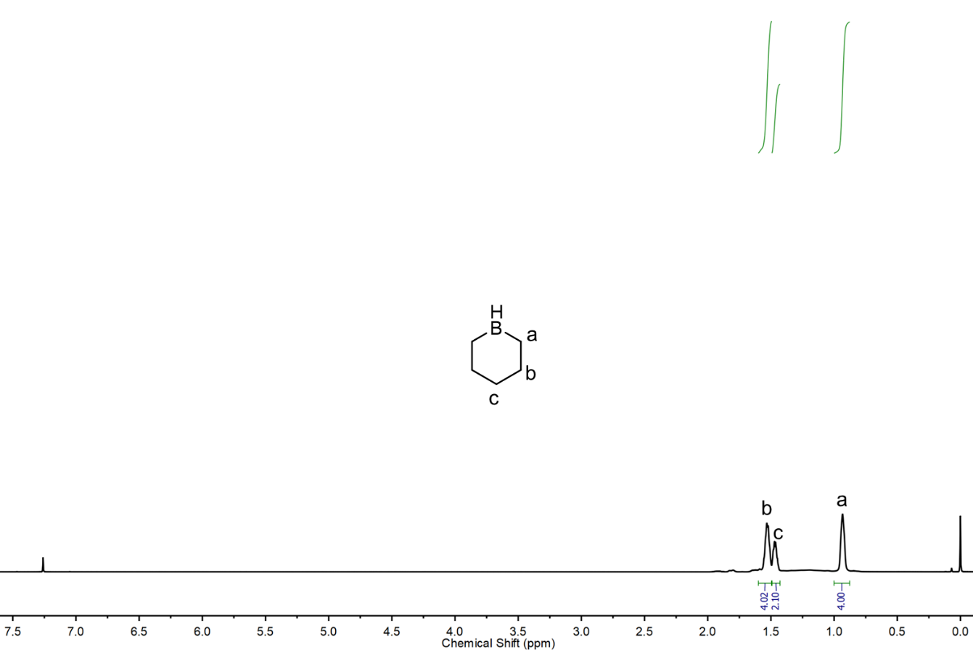

Figure S1. ¹H NMR of borinane in CDCl₃.

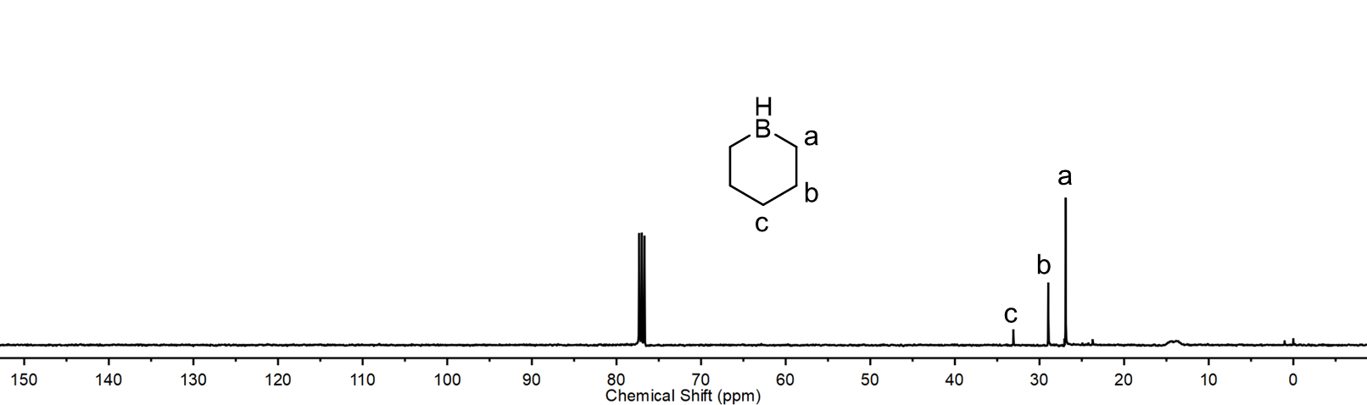

Figure S2. 13C NMR of borinane in CDCl3.

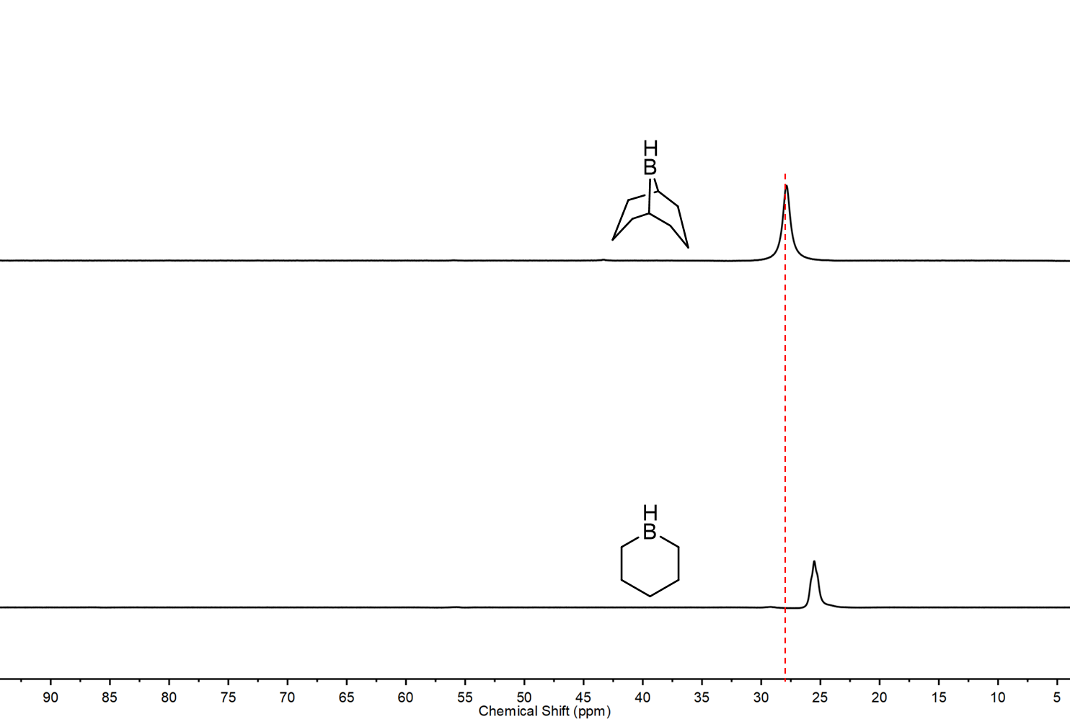

Figure S3. ¹¹B NMR of 9-BBN (top) and borinane (bottom) in CDCl₃.

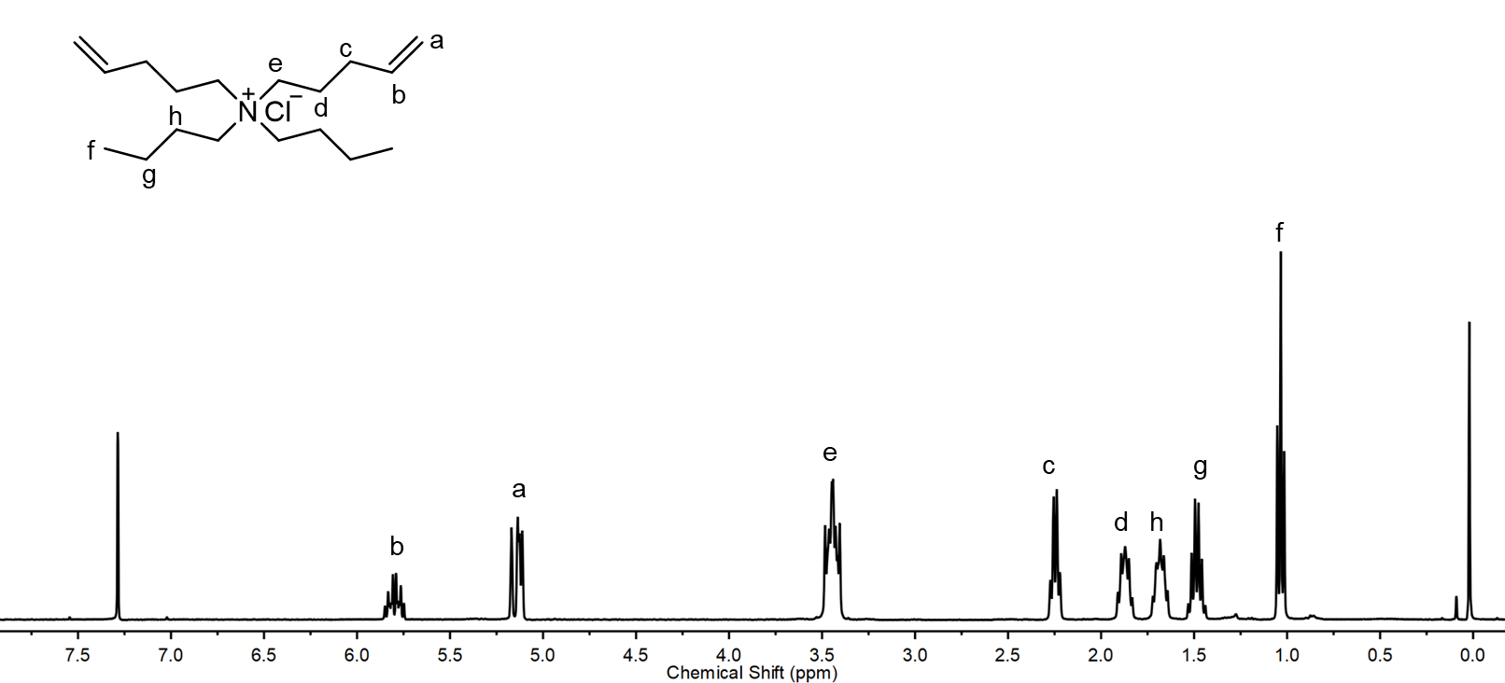

Figure S4. ¹H NMR of ammonium salt precursor for initiator/catalyst B2 in CDCl₃.

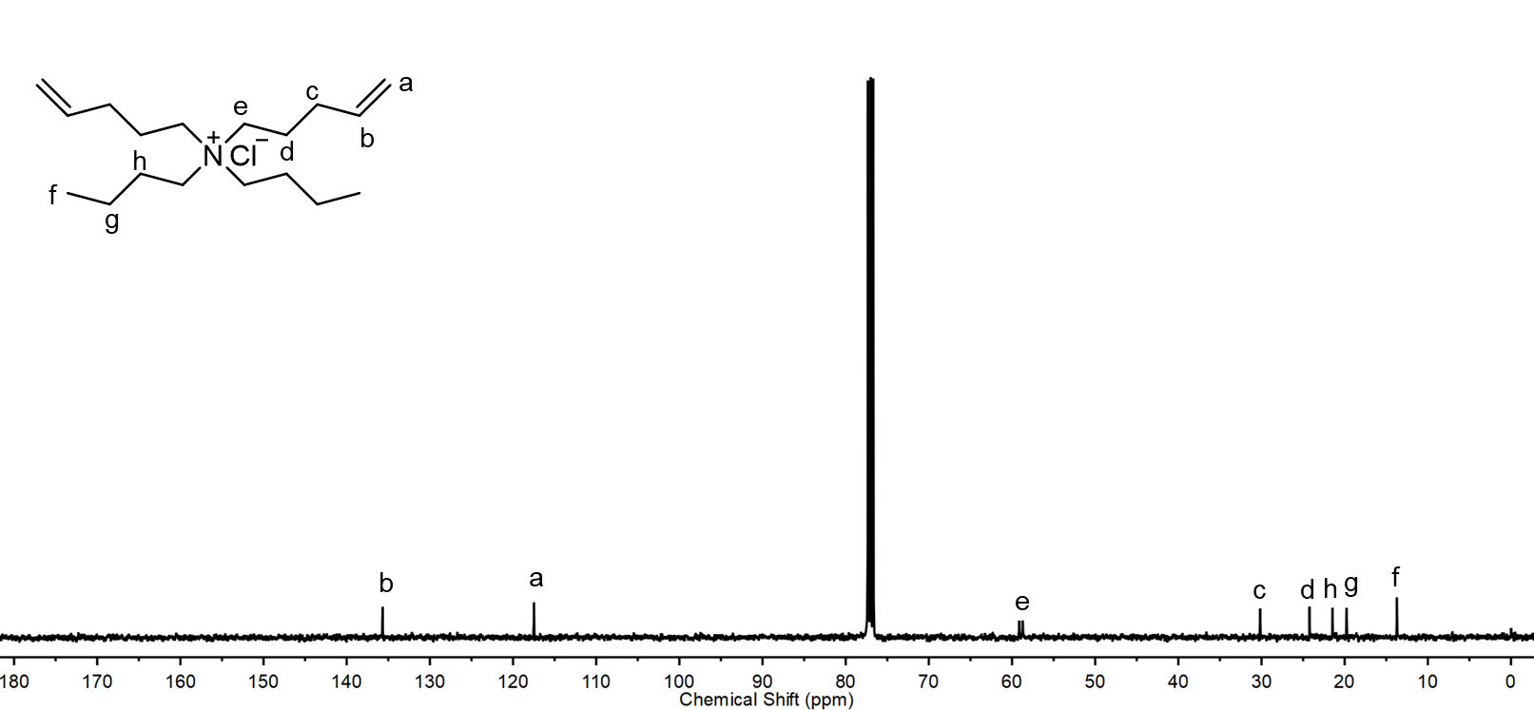

Figure S5. ¹³C NMR of ammonium salt precursor for initiator/catalyst B2 in CDCl₃.

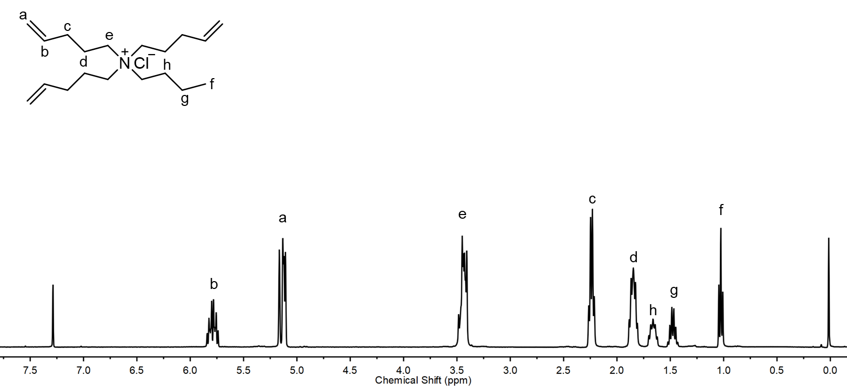

Figure S6. ¹H NMR of ammonium salt precursor for initiator/catalyst B3 in CDCl₃.

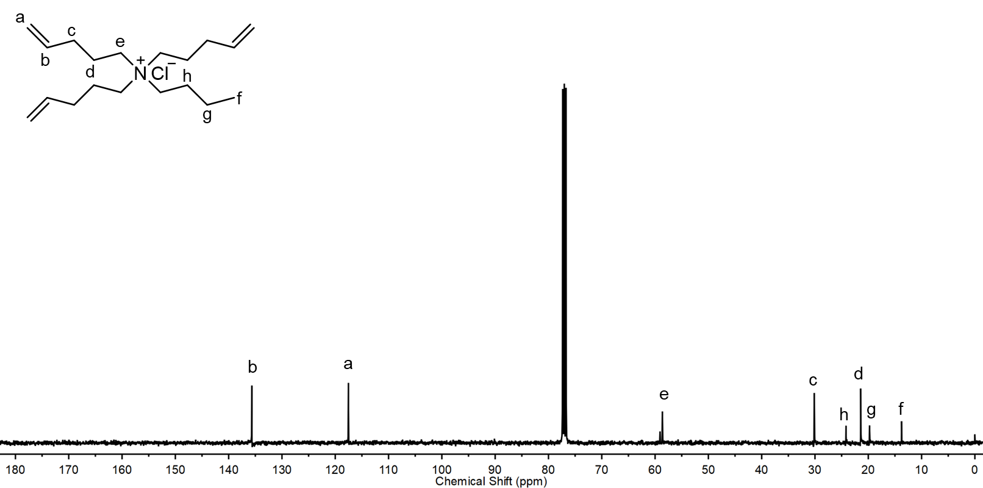

Figure S7. ¹³C NMR of ammonium salt precursor for initiator/catalyst B3 in CDCl₃.

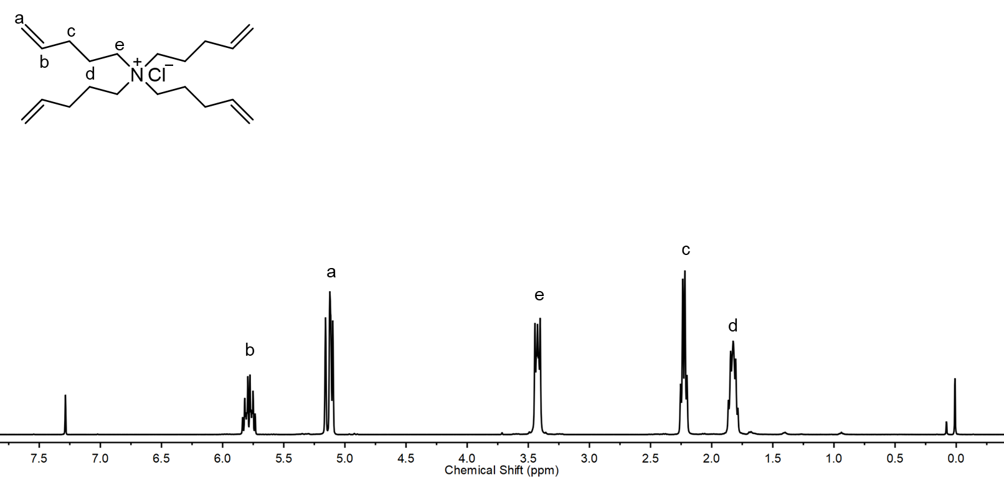

Figure S8. ¹H NMR of ammonium salt precursor for initiator/catalyst B4 in CDCl₃.

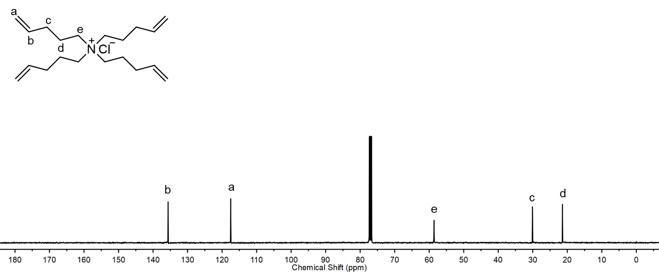

Figure S9. ¹³C NMR of ammonium salt precursor for initiator/catalyst B4 in CDCl₃.

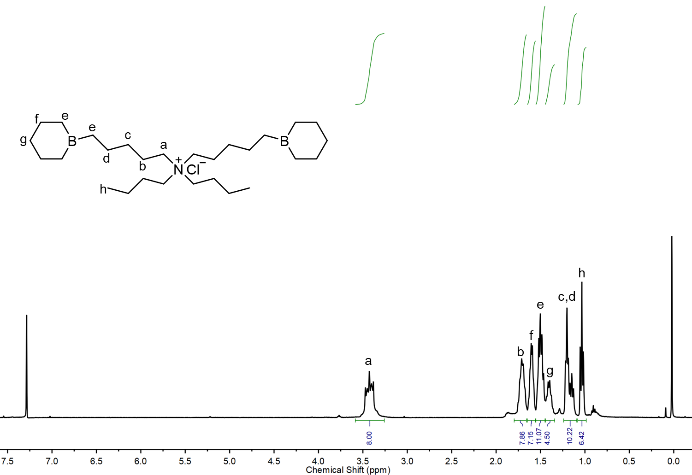

Figure S10. ¹H NMR of initiator/catalyst B2 in CDCl₃.

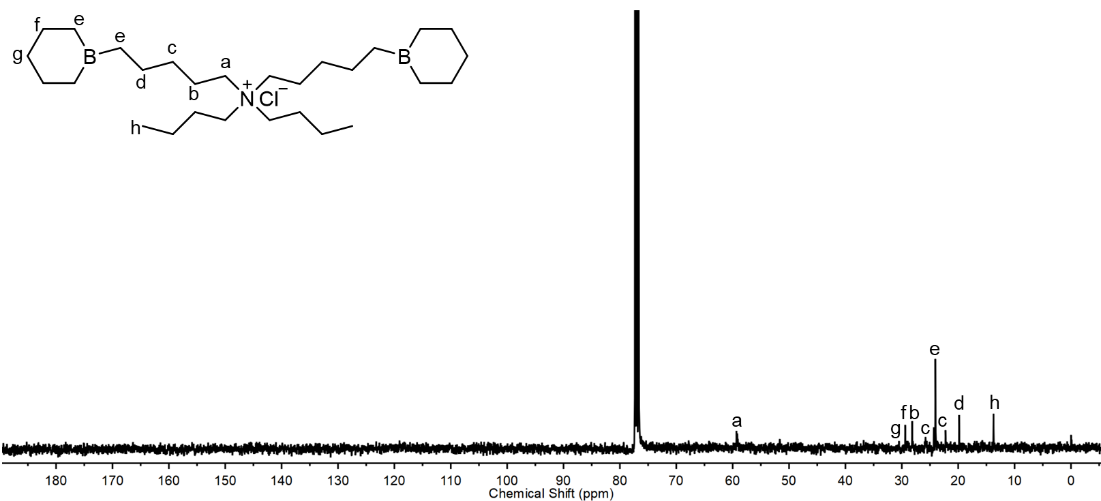

Figure S11. ¹³C NMR of initiator/catalyst B2 in CDCl₃.
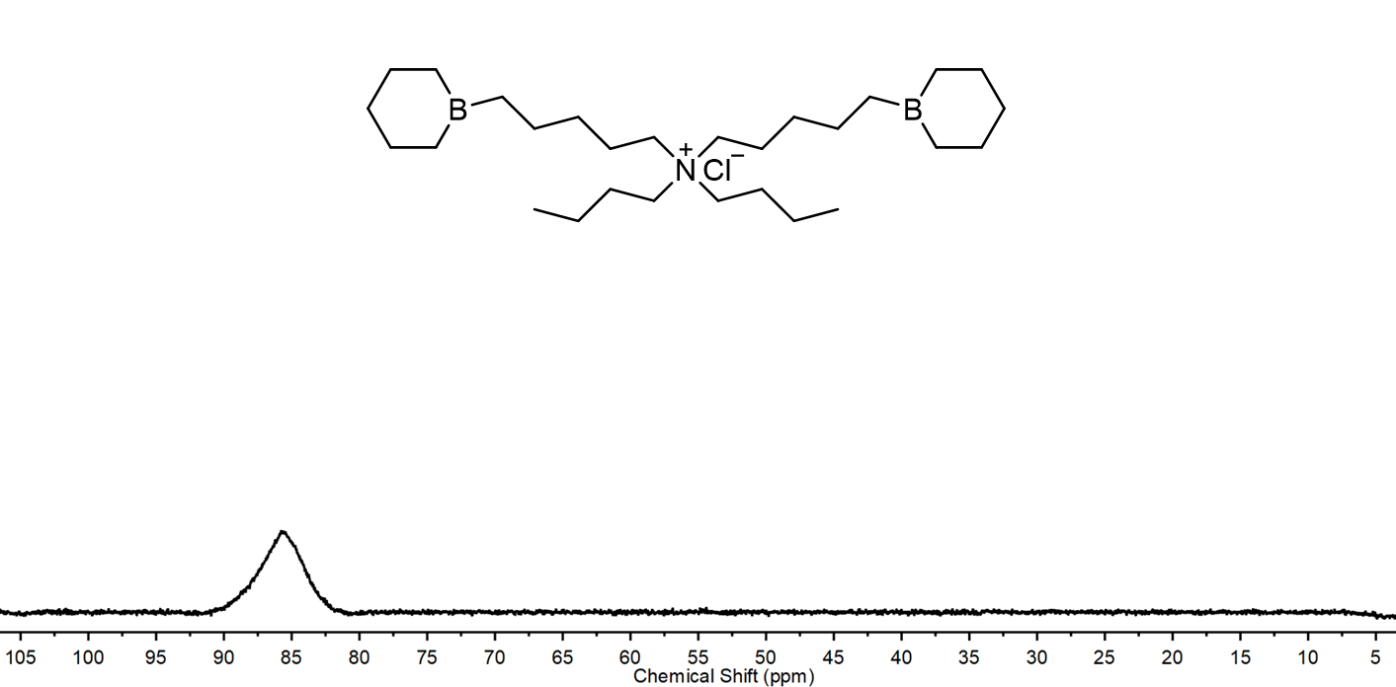

Figure S12. ¹¹B NMR of initiator/catalyst B2 in CDCl₃.

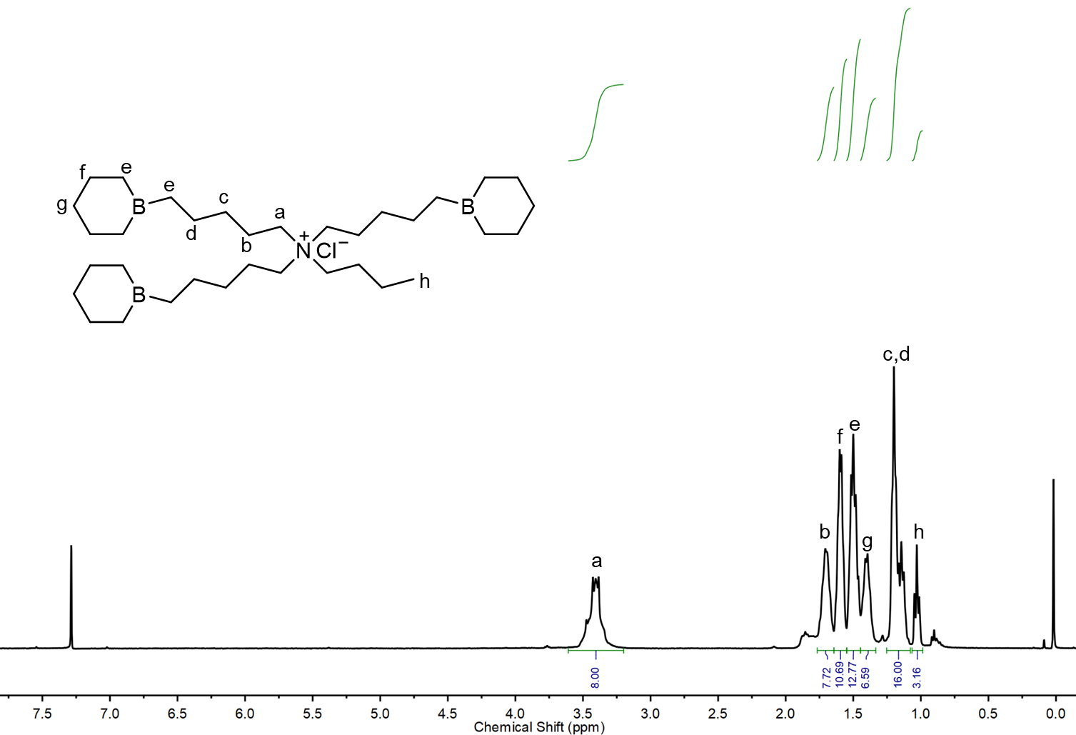

Figure S13. ¹H NMR of initiator/catalyst B3 in CDCl₃.

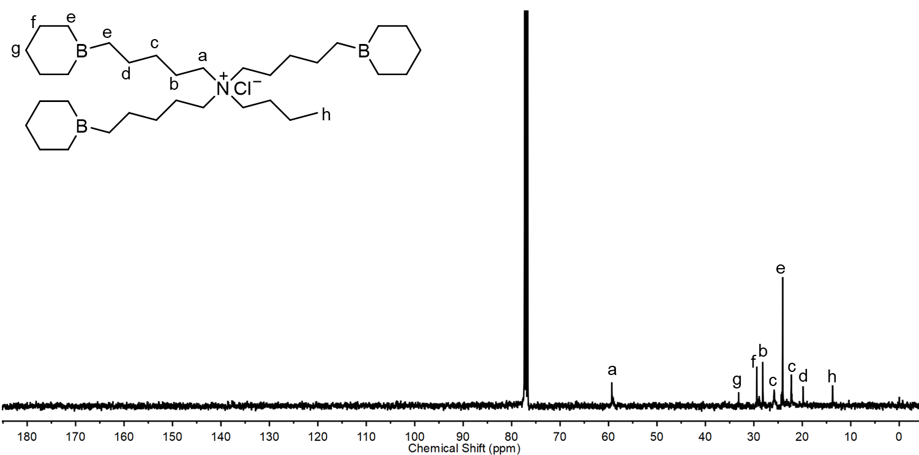

Figure S14. ¹³C NMR of initiator/catalyst B3 in CDCl₃.

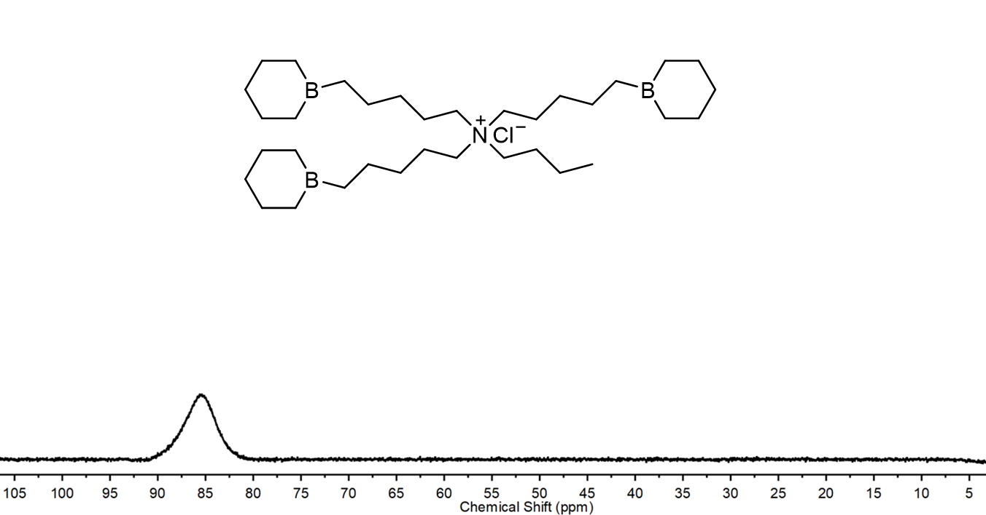

Figure S15. ¹¹B NMR of initiator/catalyst B3 in CDCl₃.

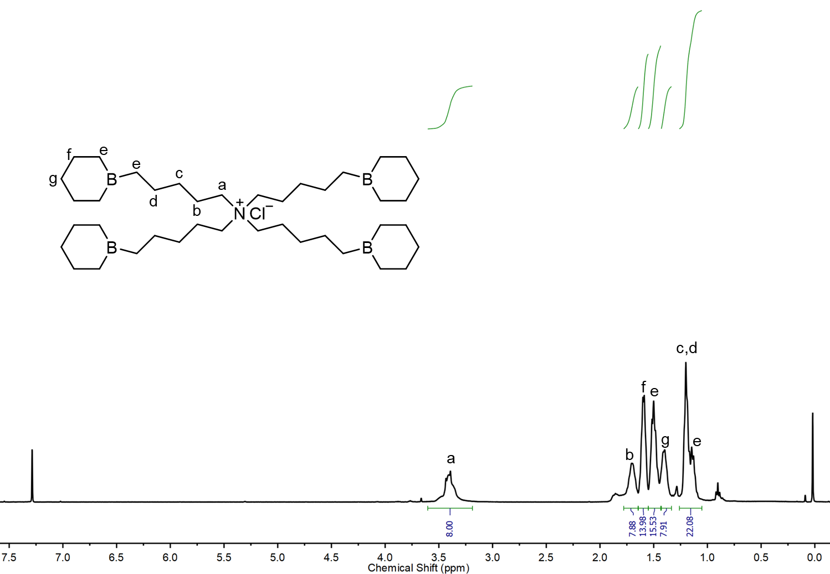

Figure S16. ¹H NMR of initiator/catalyst B4 in CDCl₃.

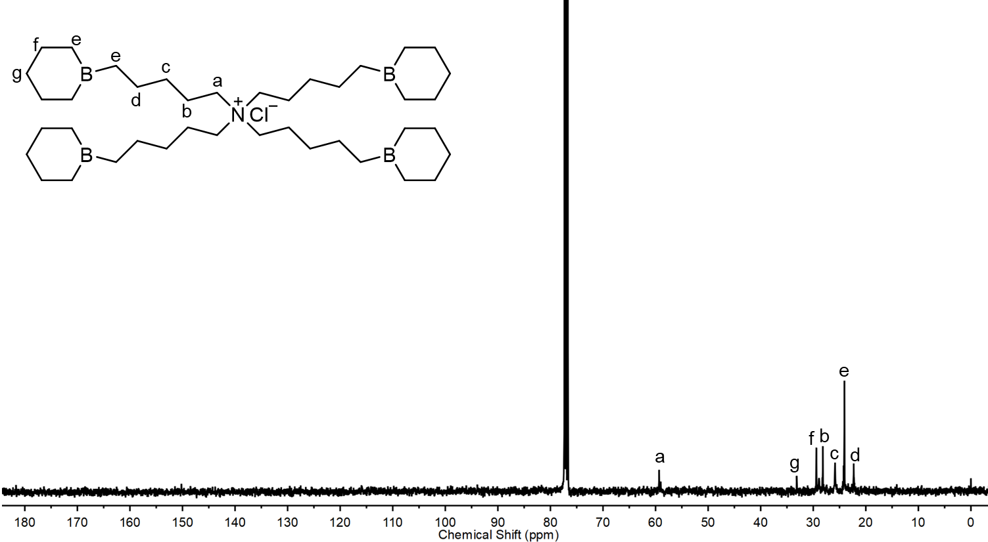

Figure S17. ¹³C NMR of initiator/catalyst B4 in CDCl₃.
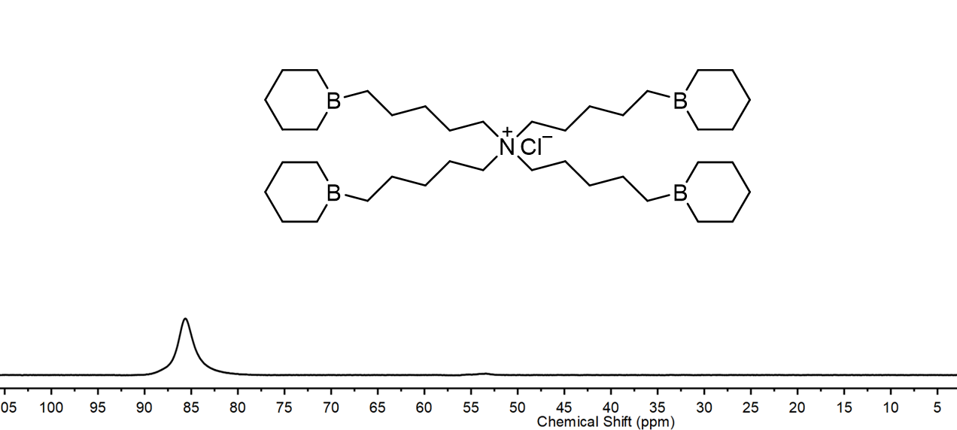

Figure S18. ¹¹B NMR of initiator/catalyst B4 in CDCl₃.

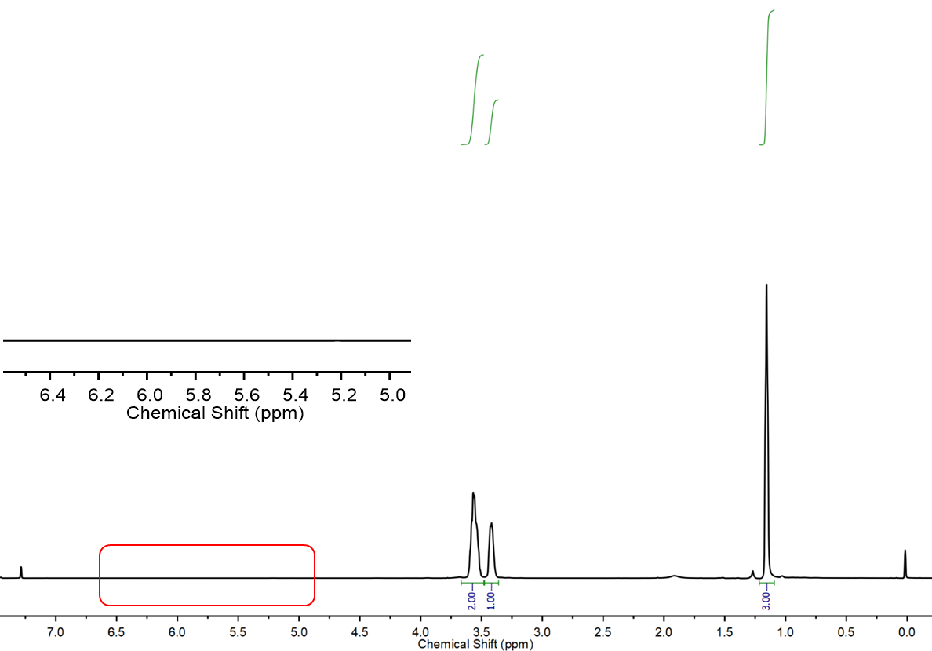

Figure S19. ¹H NMR of PPO polyols synthesized using initiator/catalyst B4 in CDCl₃.

Table S1. Activity comparison of bifunctional borinane-bearing ammonium salts in the presence of CTAs.ª
Entry | Catalyst | CTA | Time (min) | Conv. (%)^{b} | TOF (h⁻¹)^{c}
1 | TBACl+4TEB | BzOH | 10 | 5 | 6000
2 | B2 | BzOH | 10 | 17 | 33600
3 | B3 | BzOH | 10 | 50 | 62400
4 | B4 | BzOH | 10 | 88 | 105600
5 | B4 | TFE | 10 | 7 | 8400
6 | B4 | PA | 10 | 85 | 102000
7 | B4 | HEA | 10 | 10 | 12000
8 | B4 | H₂O | 10 | 6 | 7200
9 | B4 | PG | 10 | 9 | 10800
10 | B4 | DBzOH | 10 | 90 | 108000
11 | B4 | DBzSH | 10 | 7 | 8400
12 | B4 | PEG4OH | 10 | 8 | 9600
ª Polymerizations were run in neat PO condition at room temperature, catalyst: CTA: PO=1:1000:20000. ^{b} Conversion was determined by ¹H NMR. ^{c} Turnover frequency (TOF) = TON/ time (h).

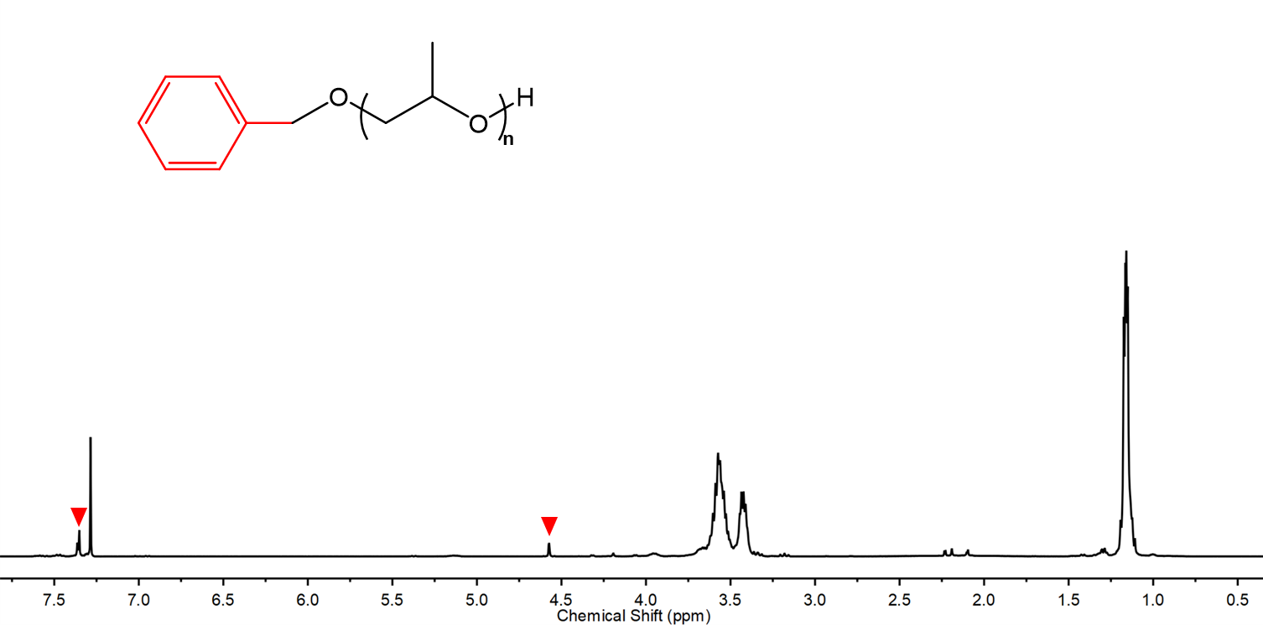

Figure S20. ¹H NMR of PPO synthesized using BzOH as CTA (Table S1, entry 4).

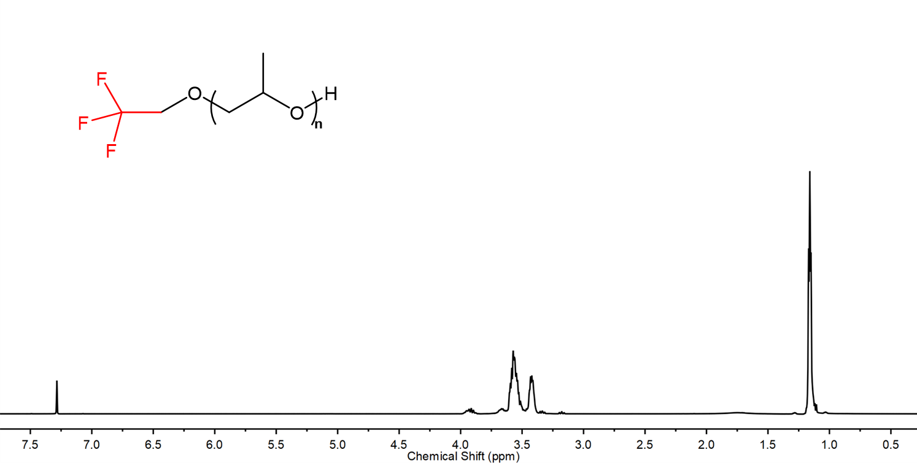

Figure S21. ¹H NMR of PPO synthesized using TFE as CTA (Table S1, entry 5).

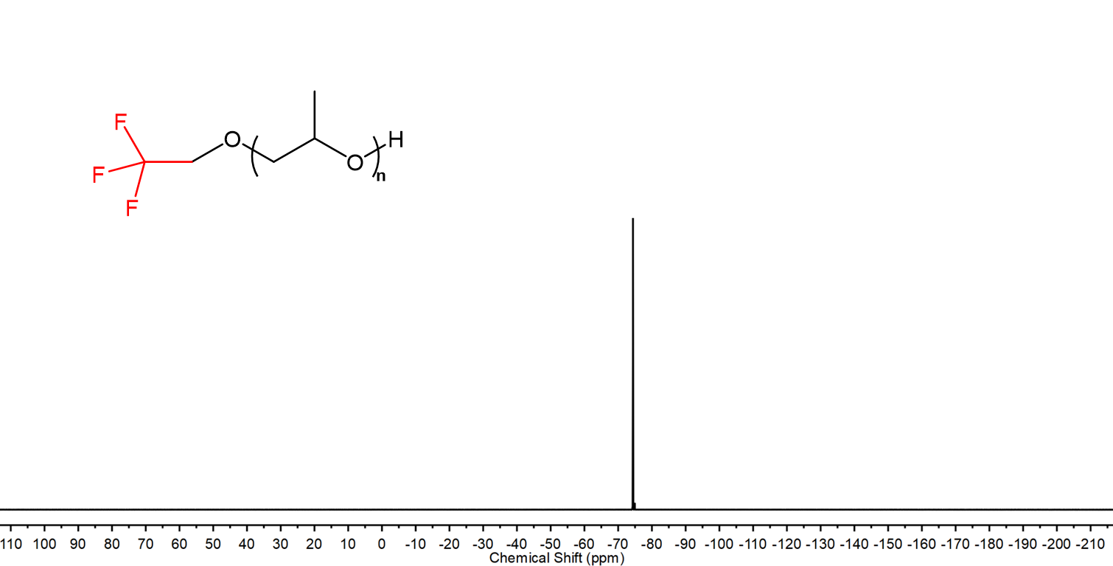

Figure S22. ¹⁹F NMR of PPO synthesized using TFE as CTA (Table S1, entry 5).

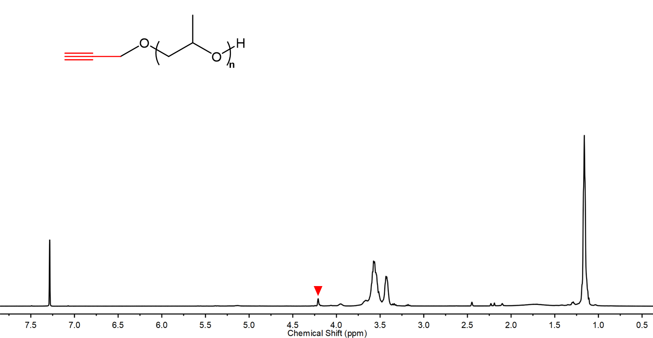

Figure S23. ¹H NMR of PPO synthesized using PA as CTA (Table S1, entry 6).

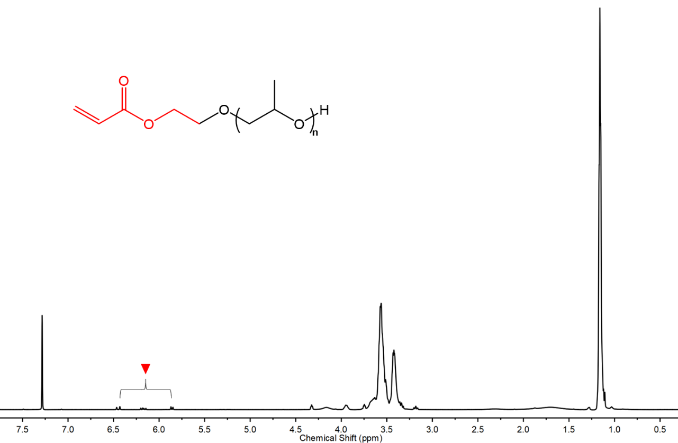

Figure S24. ¹H NMR of PPO synthesized using HEA as CTA (Table S1, entry 7).

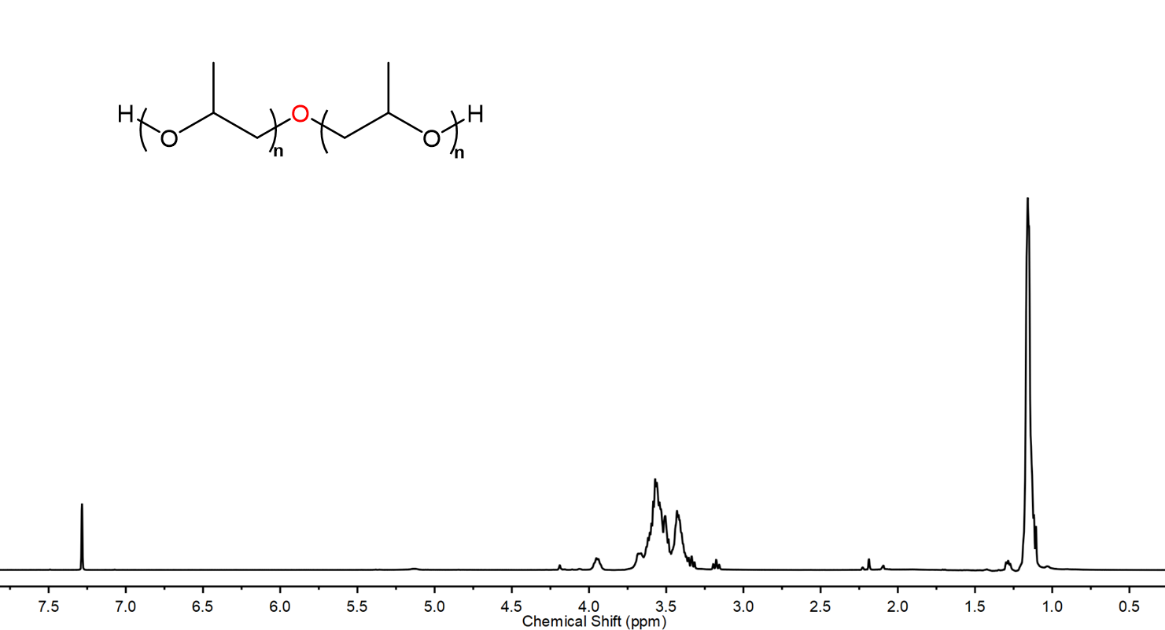

Figure S25. ¹H NMR of PPO synthesized using H₂O as CTA (Table S1, entry 8).

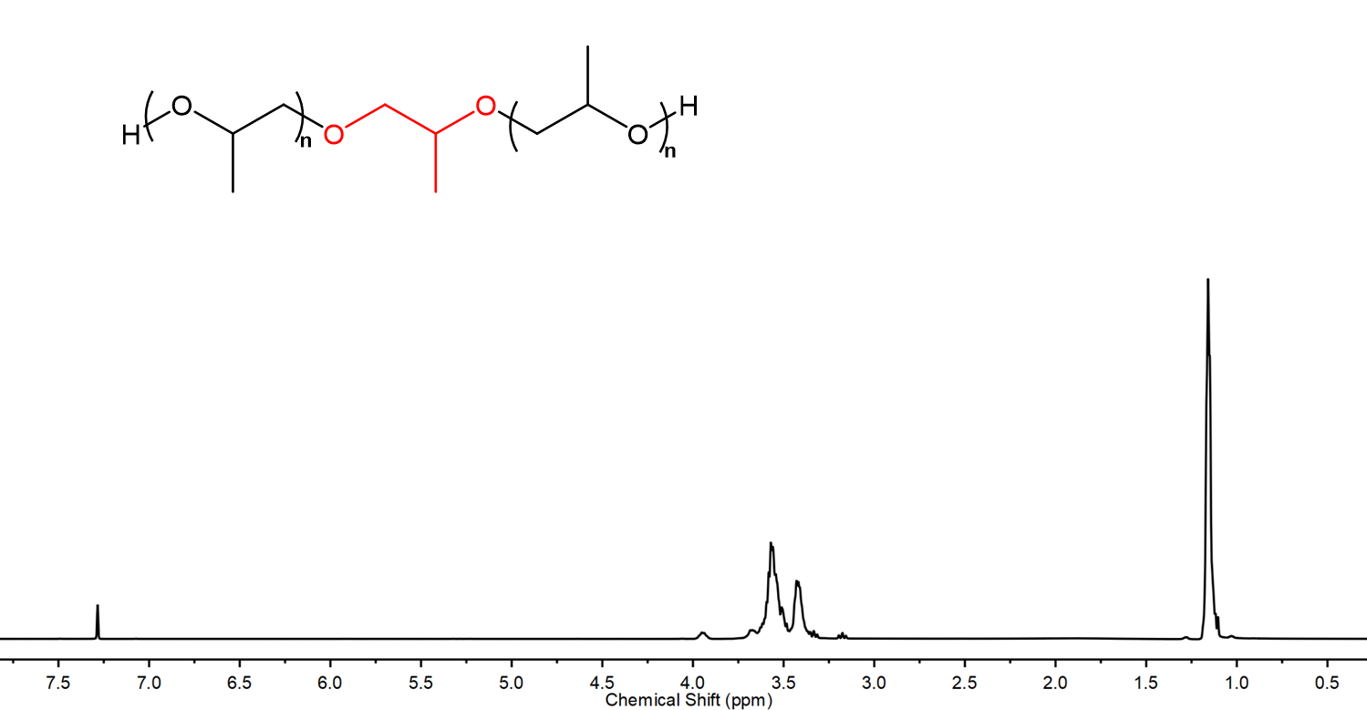

Figure S26. ¹H NMR of PPO synthesized using PG as CTA (Table S1, entry 9).
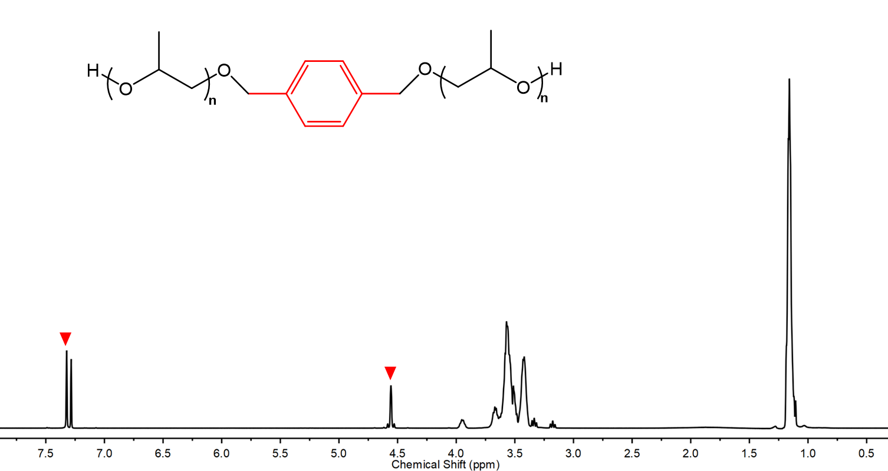

Figure S27. ¹H NMR of PPO synthesized using DBzOH as CTA (Table S1, entry 10).

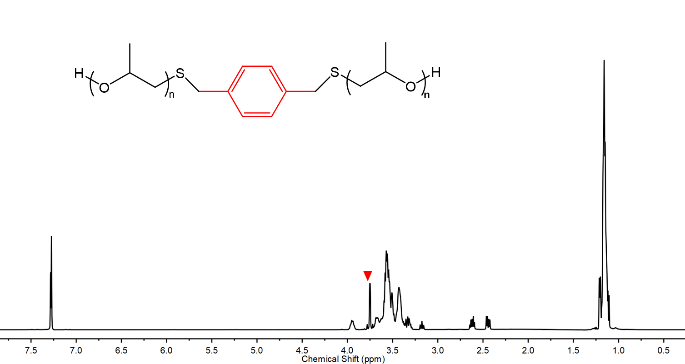

Figure S28. ¹H NMR of PPO synthesized using DBzSH as CTA (Table S1, entry 11).
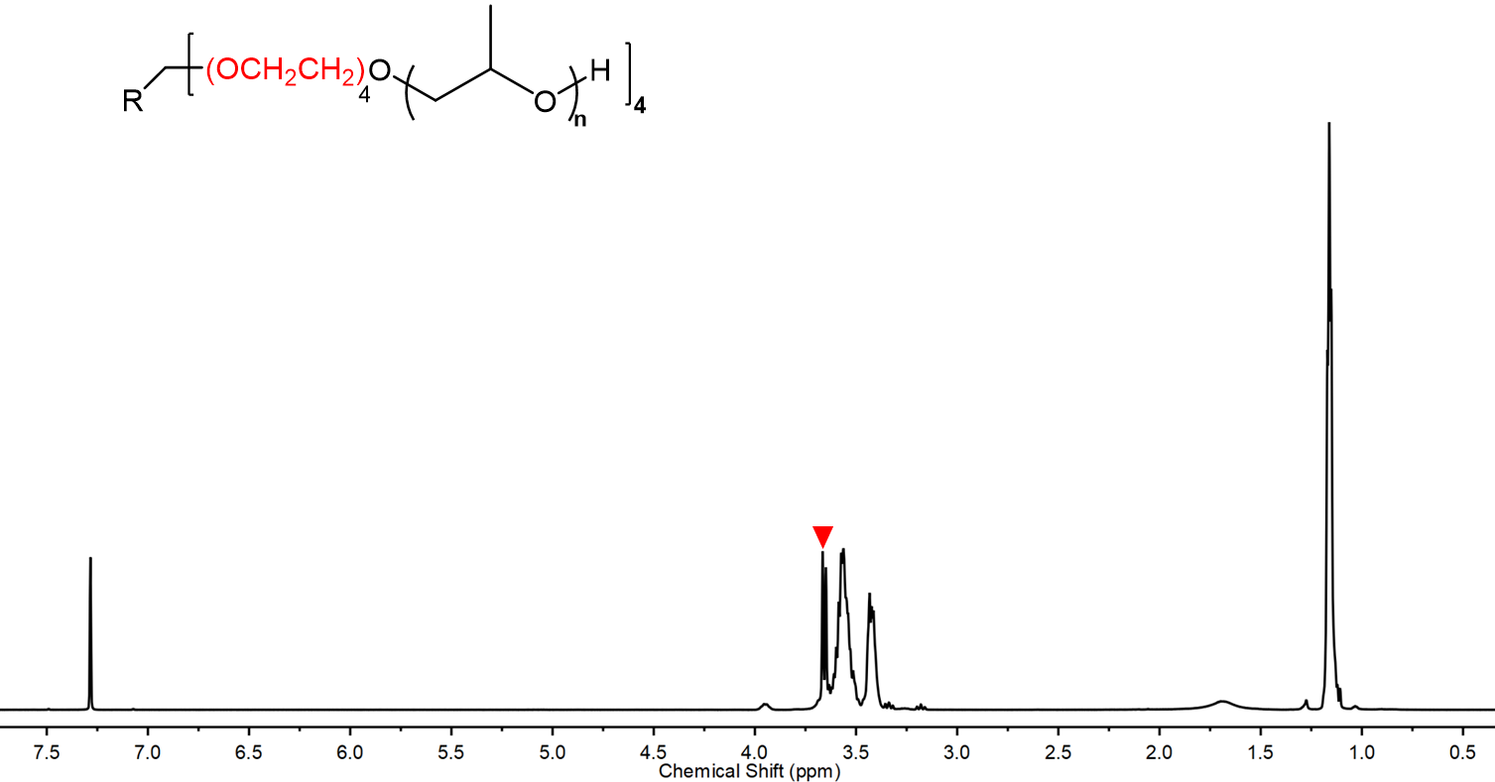

Figure S29. ¹H NMR of PPO synthesized using PEG4OH as CTA (Table S1, entry 12).

Table S2. B4 catalyzed ROP of PO in the presence of BzOH as CTA.ª
Entry | M:Cat:CTA | T  (℃) | Time (min) | Conv. (%)^{b} | TON^{c} | TOF  (h⁻¹)^{d} | M_{n,thero.}^{e}  (kg/mol) | M_{n,GPC}^{f}  (kg/mol) | Ð^{f}
1 | 20000:1:100 | 25 | 30 | 99 | 20000 | 40000 | 11.7 | 13.5 | 1.03
2 | 20000:1:250 | 25 | 30 | 99 | 20000 | 40000 | 4.8 | 5.0 | 1.02
3 | 20000:1:500 | 25 | 30 | 99 | 20000 | 40000 | 2.5 | 2.6 | 1.05
4 | 20000:1:750 | 25 | 30 | 99 | 20000 | 40000 | 1.7 | 1.7 | 1.04
5 | 20000:1:1000 | 25 | 30 | 99 | 20000 | 40000 | 1.3 | 1.4 | 1.04
6 | 20000:1:2000 | 25 | 30 | 99 | 20000 | 40000 | 0.7 | 0.8 | 1.06
7 | 20000:1:4000 | 25 | 30 | 99 | 20000 | 40000 | 0.4 | 0.5 | 1.08
8 | 1000:1:50 | 25 | 30 | 99 | 1000 | 2000 | 1.3 | 1.7 | 1.04
9 | 10000:1:500 | 25 | 30 | 99 | 10000 | 20000 | 1.3 | 1.5 | 1.04
10 | 50000:1:2500 | 25 | 30 | 80 | 40000 | 80000 | 1.1 | 1.2 | 1.05
11 | 100000:1:5000 | 40 | 120 | 86 | 86000 | 43000 | 1.1 | 1.3 | 1.04
12 | 200000:1:10000 | 40 | 120 | 71 | 142000 | 71000 | 1.0 | 1.1 | 1.05
13 | 500000:1:25000 | 60 | 1440 | 90 | 450000 | 18750 | 1.2 | 1.2 | 1.03
ª Polymerizations were run in neat PO condition using B4 as catalyst. ^{b} Conversion was determined by ¹H NMR. ^{c} Turnover number (TON) = moles of PO consumed/ moles of catalysts. ^{d} Turnover frequency (TOF) = TON/ time (h). ^{e} Determined by ¹H NMR. ^{f} Determined by GPC in THF using standard PEO as calibration.

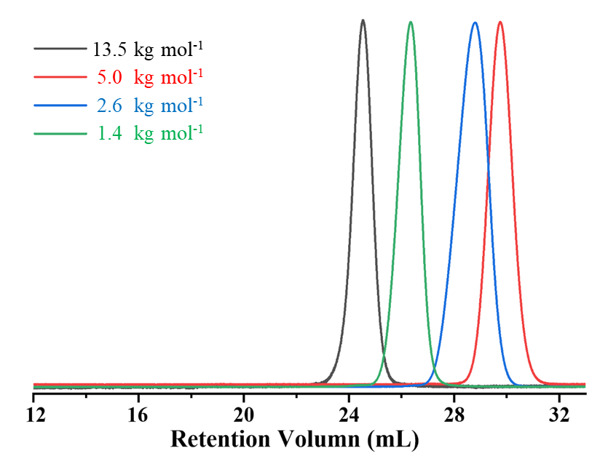

Figure S30. SEC traces of PPO with different molar masses (Table S2, entry 1, 2, 3, 5).

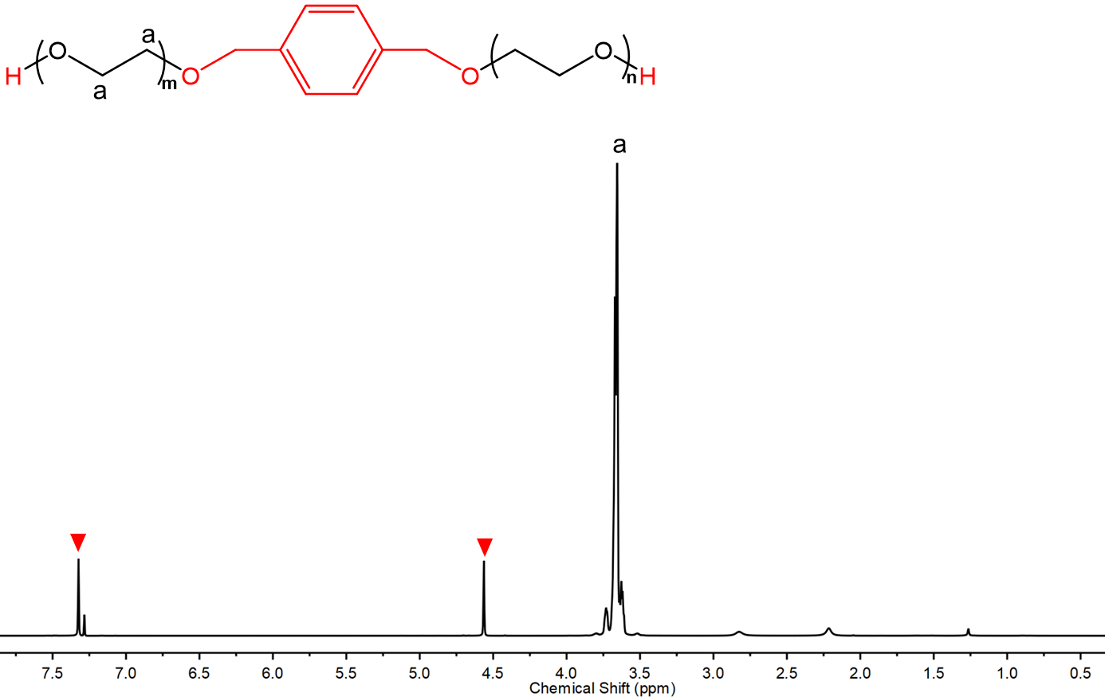

Figure S31. ¹H NMR of PEO synthesized using DBzOH as CTA (Table 2, entry 6).

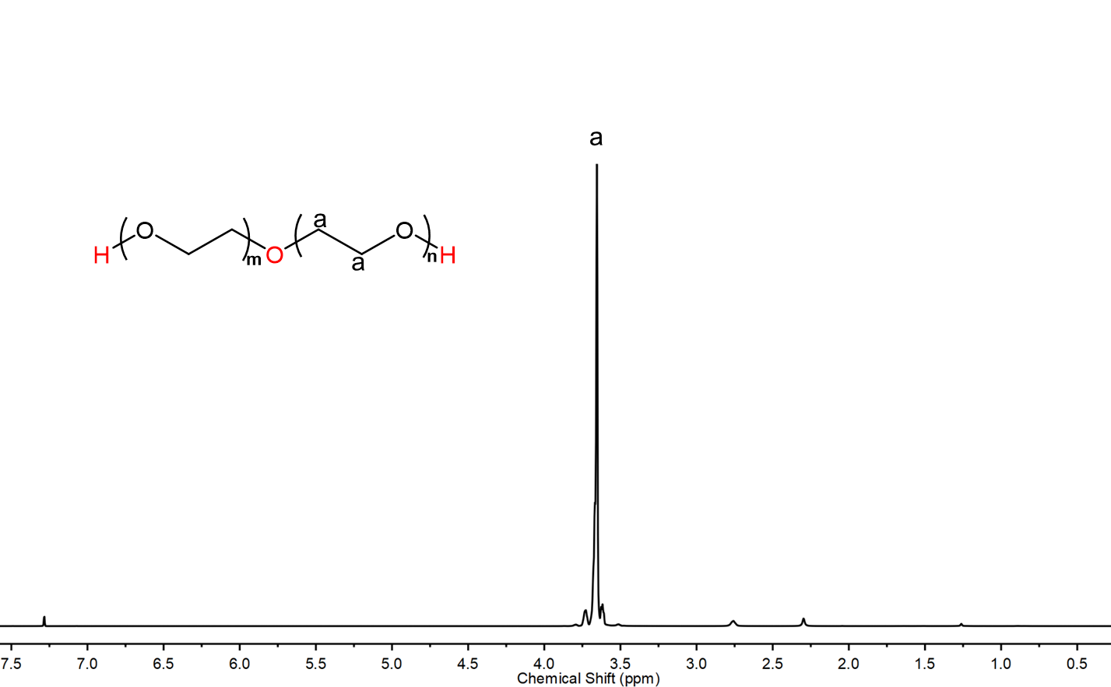

Figure S32. ¹H NMR of PEO synthesized using H₂O as CTA (Table 2, entry 7).

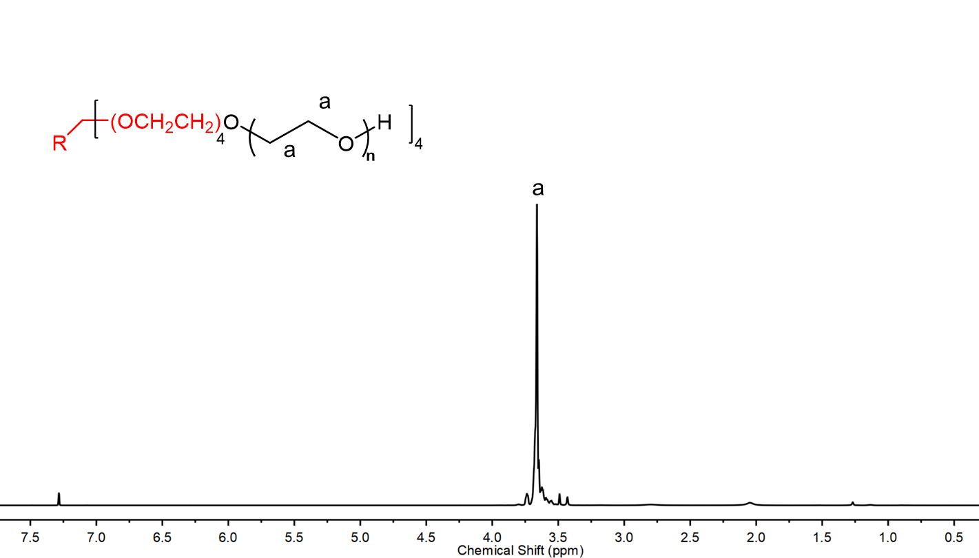

Figure S33. ¹H NMR of PEO synthesized using PEG4OH as CTA (Table 2, entry 9).

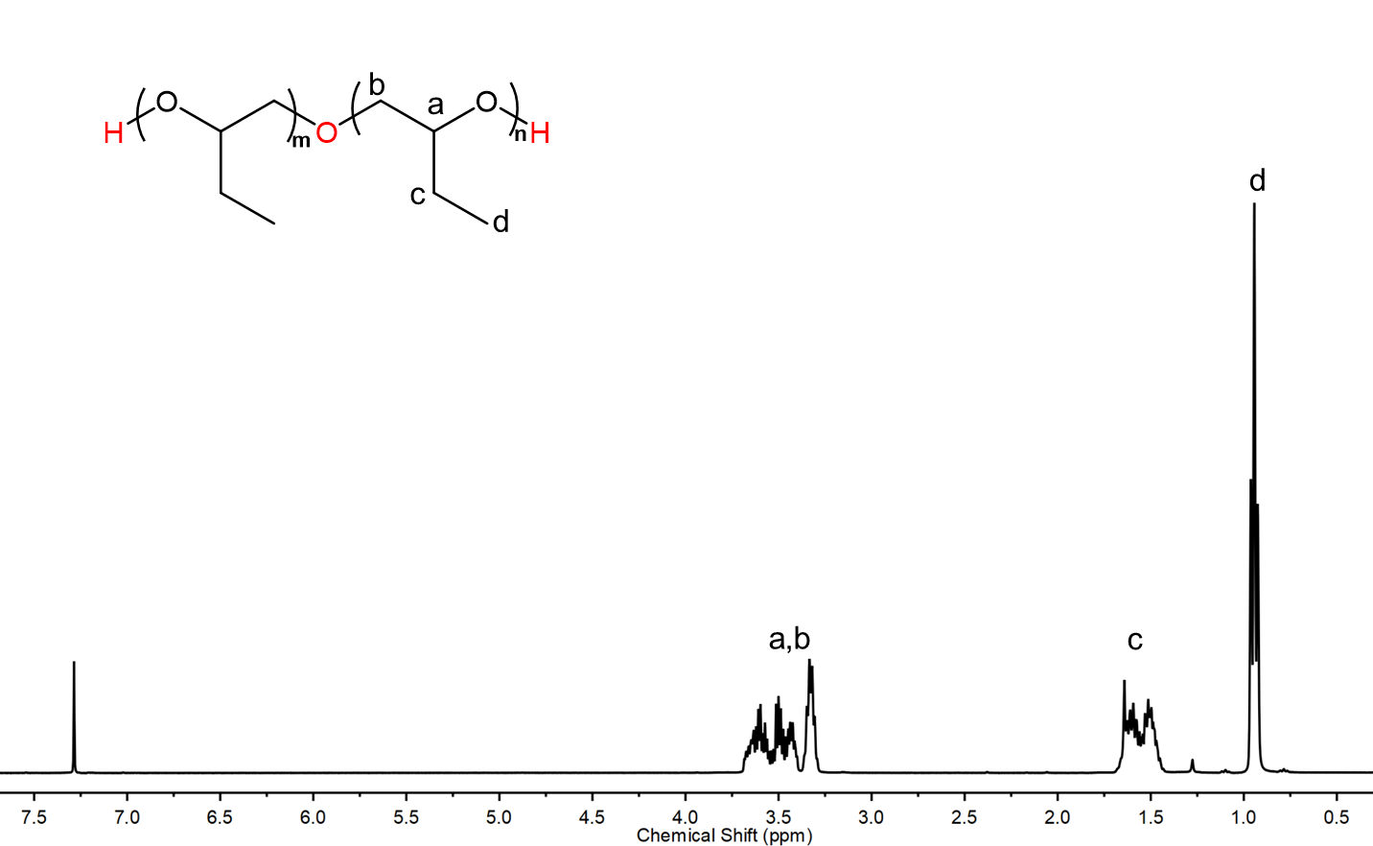

Figure S34. ¹H NMR of PBO synthesized using H₂O as CTA (Table 2, entry 10).

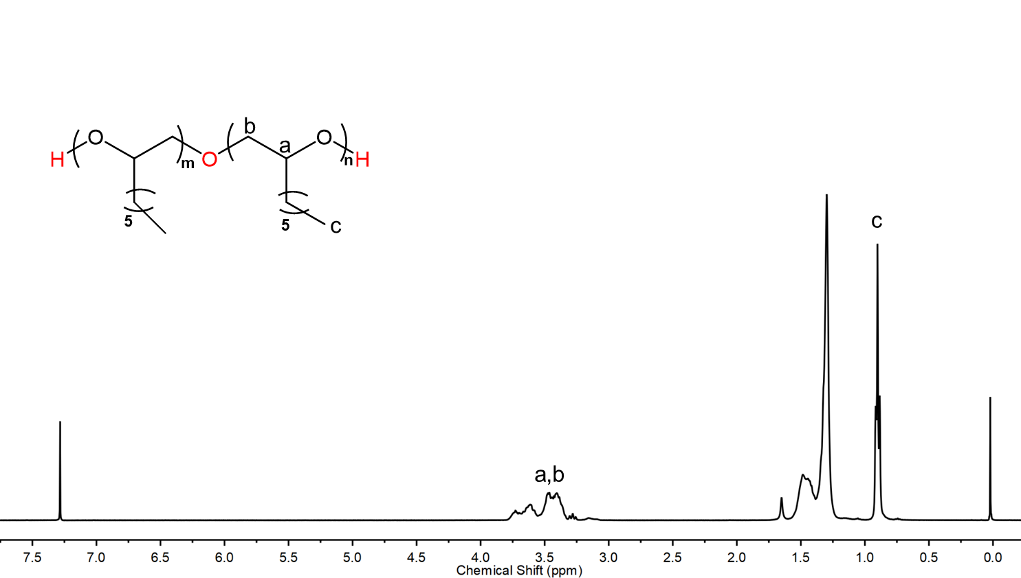

Figure S35. ¹H NMR of POO synthesized using H₂O as CTA (Table 2, entry 13).

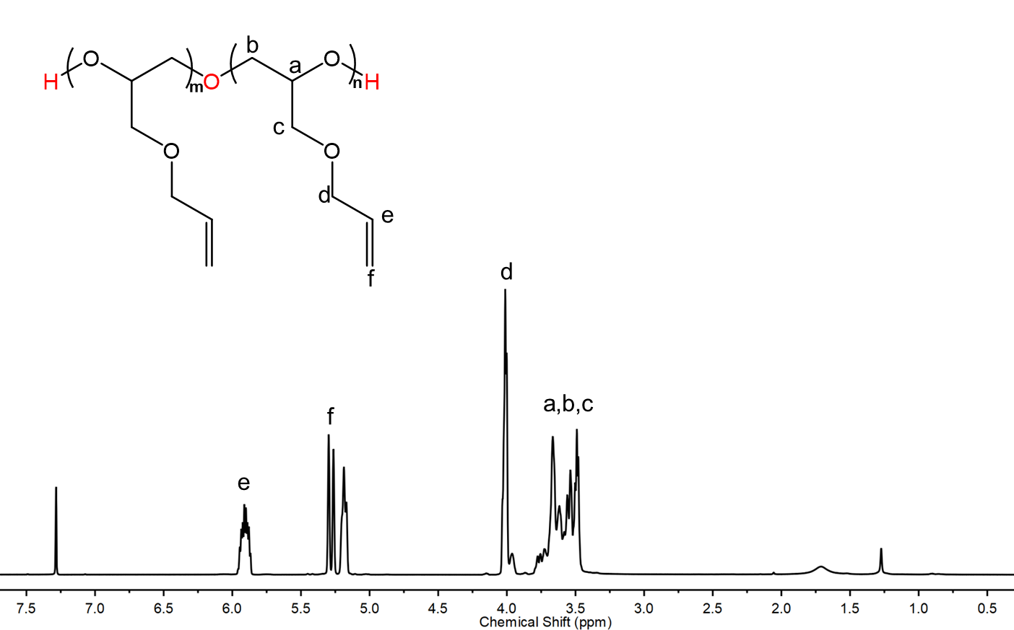

Figure S36. ¹H NMR of PAGE synthesized using H₂O as CTA (Table 2, entry 12).

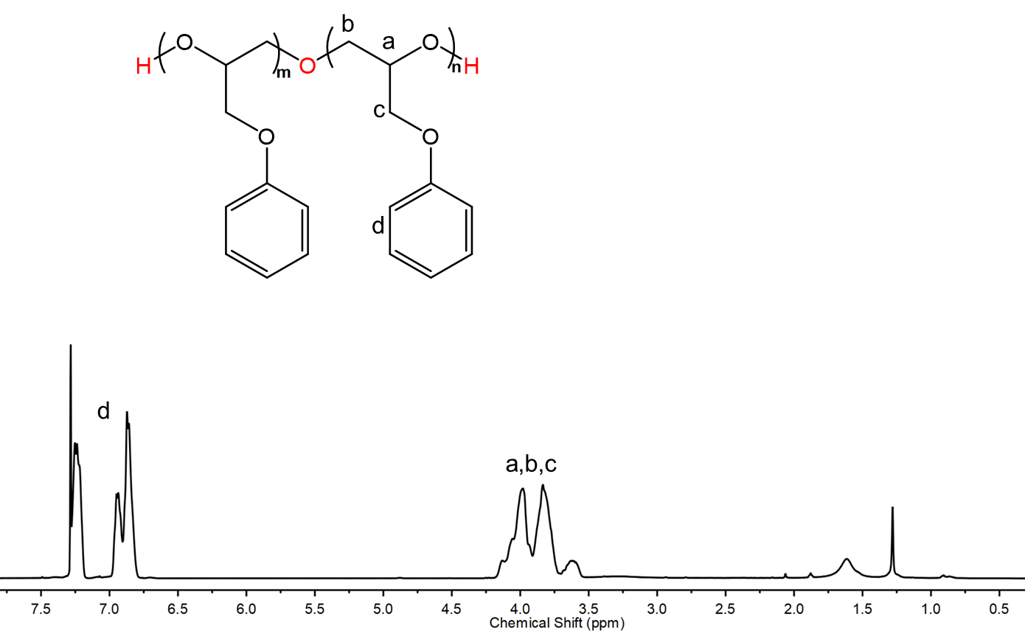

Figure S37. ¹H NMR of PPGE synthesized using H₂O as CTA (Table 2, entry 11).

Table S3. Comparison of catalysts B4 with other catalyst system for the ROP of oxetane.ª
Entry | Catalysts | M:Cat | T (℃) | Conv.  (%) | TOF^{b}  (h⁻¹) | M_{n,thero.}^{c}  (kg/mol) | M_{n,GPC}^{d}  (kg/mol) | Ð^{e}
1 | B4 | 4000:1 | r.t. | 75 | 750 | 174 | 181 | 1.17
2 | B4 | 10000:1 | r.t. | 98 | 1225 | 580 | 630 | 1.18
3 | B4 | 4000:1 | 60 | 97 | 3880 | 225 | 214 | 1.20
4^{f,[6]} | 3-PPOA | 819:1 | 35 | 100 | 205 | 48 | 120.6 | 1.23
5^{g,[7]} | Triisobutylaluminum | 207:1 | r.t. | 83 | 3.4 | 10 | 9.2 | 1.14
6^{h,[8]} | Organoaluminum | 400:1 | r.t. | 100 | 30 | 23 | 19 | 1.11
ª Polymerizations were run in neat TMO condition using B4 as catalyst for 4 h (entry 1); 8 h (entry 2); 1 h (entry 3). ^{b} Turnover frequency (TOF) = TON/ time (h).^{c} Determined by ¹H NMR. ^{d,e} Determined by GPC in THF using multidetectors corrected by the dn/dc value of PTMO. ^{f} 3-phenoxypropyl1-oxonia-4-oxacyclohexane hexafluoroantimonate (3-PPOA), with [oxetane]=1.125 M in dioxane via cationic mechanism. ^{g}triisobutylaluminum: tetraoctylammonium bromide=5:1, with [oxetane]= 5 M in toluene. ^{h}Organoaluminum Diphenolates, with [oxetane]= 0.12 M in dichloromethane.

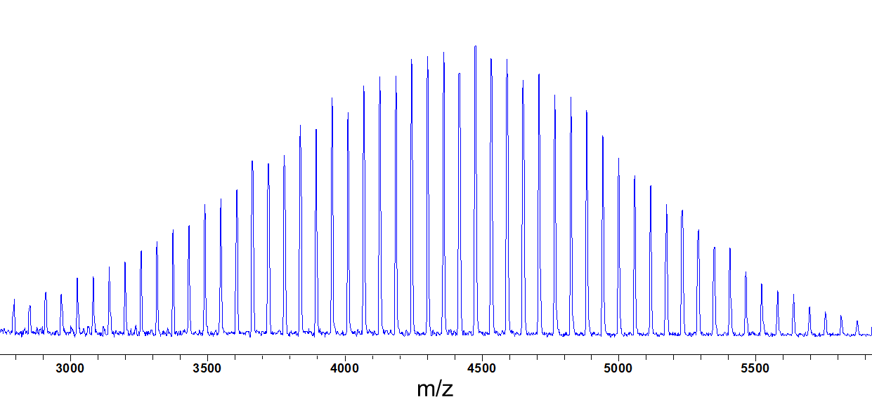
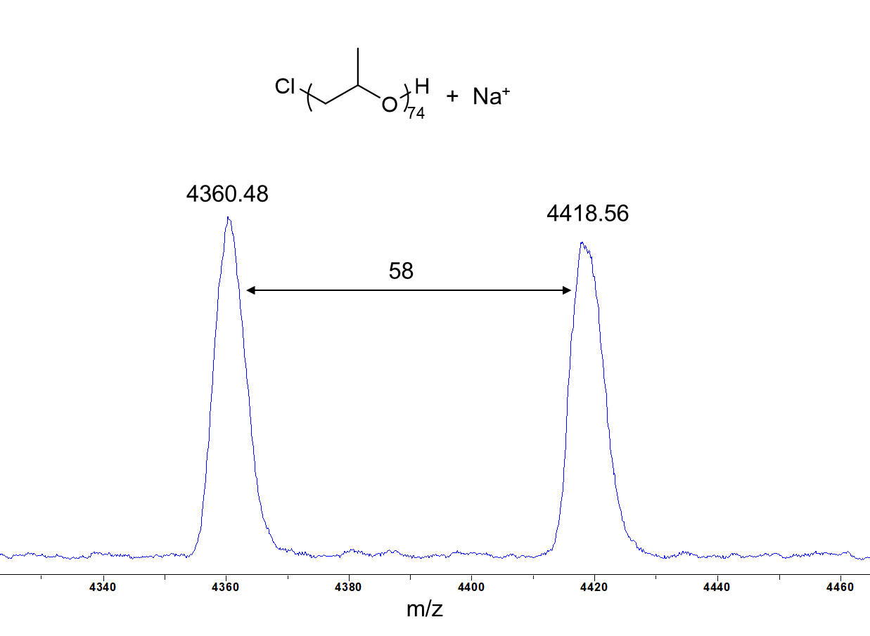

Figure S38. MALDI-TOF spectra of PPO obtained using B4 as catalyst.

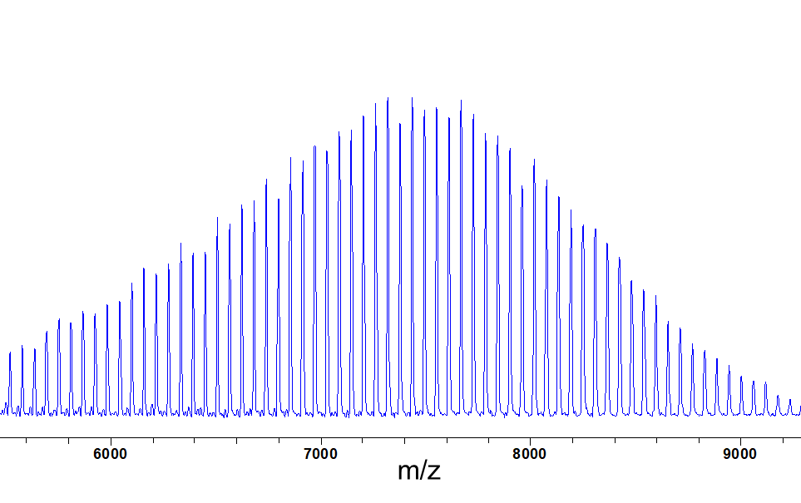
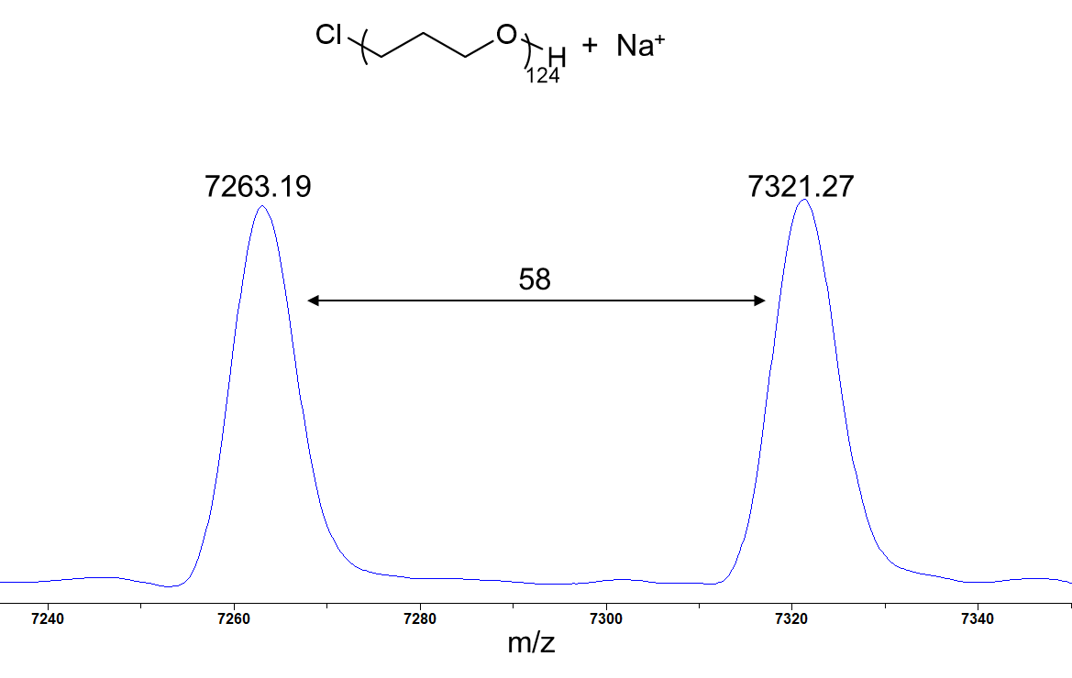

Figure S39. MALDI-TOF spectra of PTMO obtained using B4 as catalyst.

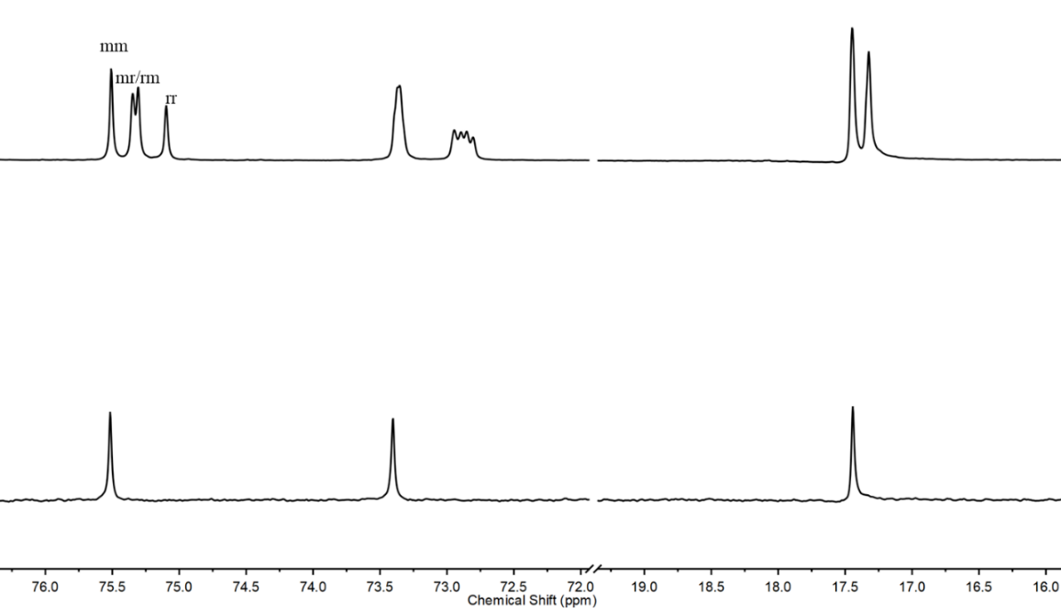

Figure S40. ¹³C NMR spectra of PPO synthesized by rac-PO (top) and chiral S-PO (bottom).

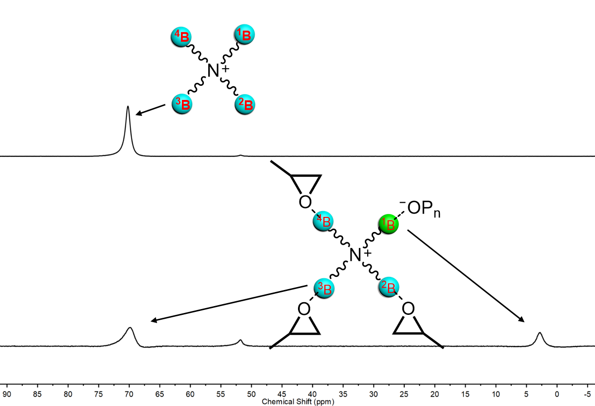

Figure S41. ¹¹B NMR of borane and borane-oxyanion complex in THF-d₈.

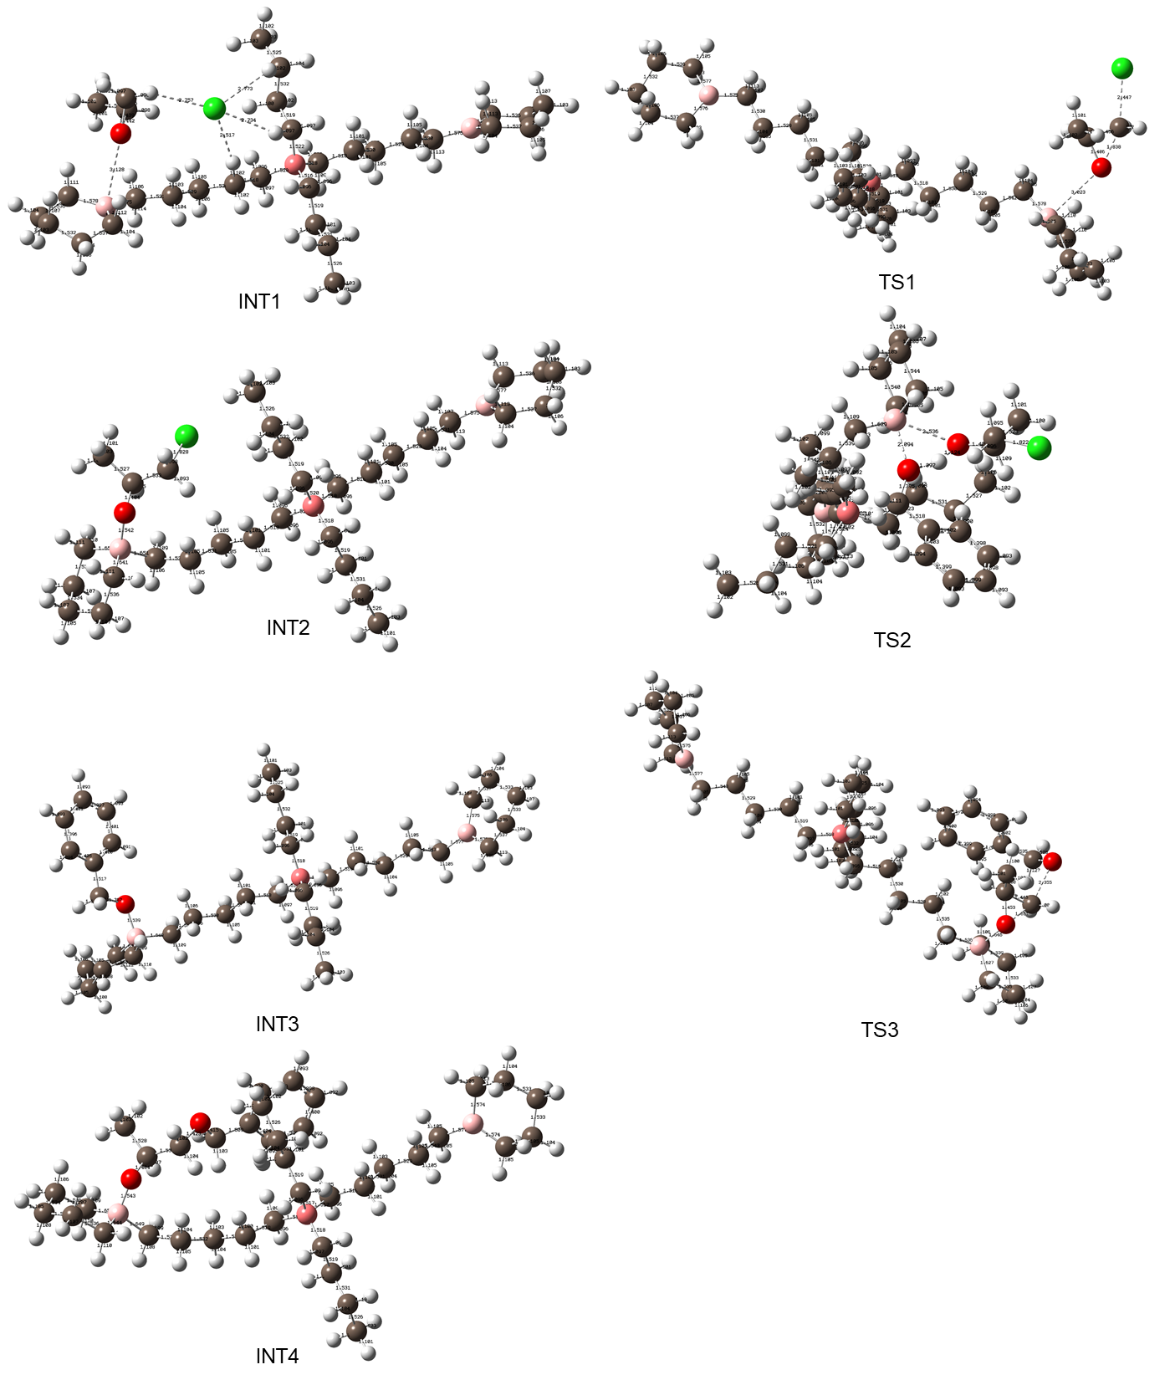

Figure S42. DFT computation optimized structures of intermediates and transition states for B2 mediated RD-ROP.

REFERENCES
[1] G. W. T. M.J. Frisch, H.B. Schlegel, G.E. Scuseria, M.A. Robb, J.R. Cheeseman, G. Scalmani, V. Barone, B. Mennucci, G.A. Petersson, H. Nakatsuji, M. Caricato, X. Li, H.P. Hratchian, A.F. Izmaylov, J. Bloino, G. Zheng, J.L. Sonnenberg, M. Hada, M. Ehara, K. Toyota, R. Fukuda, J. Hasegawa, M. Ishida, T. Nakajima, Y. Honda, O. Kitao, H. Nakai, T. Vreven, J.A. Montgomery, J.J.E. Peralta, F. Ogliaro, M. Bearpark, J.J. Heyd, E. Brothers, K.N. Kudin, V.N. Taroverov, T. Keith, R. Kobayashi, J. Normand, K. Raghavachari, A. Rendell, J.C. Burant, S.S. Iyengar, J. Tomasi, M. Cossi, N. Rega, J.M. Millam, M. Klene, J.E. Knox, J.B. Cross, V. Bakken, C. Adamo, J. Jaramillo, R. Gomperts, R.E. Stratmann, O. Yazyev, A. J. Austin, R. Cammi, C. Pomelli, J. W. Ochterski, R.L. Martin, K. Morokuma, V.G. Zakrzewski, G.A. Voth, P. Salvador, J.J. Dannenberg, S. Dapprich, A.D. Daniels, O. Farkas, J.B. Foresman, J.V. Ortiz, J. Cioslowski, D.J. Fox, Gaussian 09 (Revision D.01), I. Gaussian, Wallingford, CT 2013.
[2] R. Krishnan, J. S. Binkley, R. Seeger, J. A. Pople, J. Chem. Phys. 1980, 72, 650-654.
[3] F. Weigend, R. Ahlrichs, Phys. Chem. Chem. Phys. 2005, 7, 3297-3305.
[4] S. Grimme, J. Antony, S. Ehrlich, H. Krieg, J. Chem. Phys. 2010, 132, 154104.
[5] C. Gonzalez, H. B. Schlegel, J. Chem. Phys. 1989, 90, 2154-2161.
[6] M. I. P. Hassen Bouchékif, Eamon Colclough, and Allan J. Amass, Macromolecules 2008, 41, 1989-1995.
[7] M. Gervais, A. Forens, E. Ibarboure, S. Carlotti, Polym. Chem. 2018, 9, 2660–2668.
[8] Y. W. Daisuke Takeuchi, Takuzo Aida, and Shohei Inoue, Macromolecules 1995, 28, 651-652.

Cartesian coordinates for the optimized structures
Catalyst B2
C 0.11121000 1.82469200 -1.06811300
H 1.12512900 2.06297400 -1.41589700
H -0.41895400 1.36487300 -1.91098200
C 0.54243500 -0.55011600 -0.82168600
H 1.38090800 -0.30963300 -1.48768000
H -0.34821000 -0.71539300 -1.43881200
C -0.63264800 3.08170200 -0.63923100
H -0.21317800 3.50709100 0.28124400
H -1.68725600 2.84763000 -0.42852600
C -0.56952300 4.13185200 -1.75207300
H -0.98262200 3.70453100 -2.68263900
H 0.48712600 4.36931700 -1.96630800
C -1.32258500 5.40869500 -1.39138300
H -0.90622500 5.87392900 -0.48244100
H -1.26836300 6.15153200 -2.20289400
H -2.38838900 5.20203900 -1.19781000
C 1.54172900 0.96269600 0.81442100
H 1.48129500 0.23853500 1.63326000
H 2.37325300 0.67495800 0.16161600
C -0.90635100 0.58717700 0.88000900
H -0.62600100 -0.14152200 1.65016800
H -1.02928200 1.55361600 1.38172000
N 0.29302300 0.72678100 -0.02732400
C 0.87355900 -1.79433500 -0.01563500
H 0.02171800 -2.08920800 0.61846500
H 1.72915100 -1.61097600 0.64987400
C 1.24269200 -2.94225500 -0.95942900
H 0.39684300 -3.15464900 -1.63655300
H 2.08224600 -2.61135100 -1.59434900
C 1.64176100 -4.20890500 -0.20886000
H 1.90173500 -5.02338900 -0.90349800
H 2.51836500 -4.02482600 0.43482100
H 0.82412100 -4.56823600 0.43805400
C 1.79450500 2.34997600 1.37853200
H 0.95425500 2.68530100 2.00611600
H 1.90497800 3.07524600 0.55809300
C 3.09335200 2.36594800 2.20703300
H 2.94666600 1.79010400 3.13835800
H 3.26107900 3.41040600 2.51778800
C 4.32943800 1.82476700 1.45914000
H 5.22215800 2.38146900 1.79125200
H 4.21871400 2.06428100 0.38627900
C 4.59393100 0.31560900 1.62597300
H 3.64108600 -0.22105900 1.77665500
H 5.13846700 0.16380500 2.58120400
C -2.19518800 0.16001500 0.19303400
H -2.35696600 0.73277400 -0.73323400
H -2.13294300 -0.90053300 -0.09707000
C -3.39262100 0.36281600 1.12250700
H -3.20621700 -0.14721300 2.08439500
H -3.49182000 1.43729300 1.35773000
C -4.70370300 -0.14853100 0.52467800
H -4.86335100 0.33526200 -0.45574100
H -4.60303300 -1.22860700 0.31425900
C -5.92881900 0.09572200 1.43089900
H -5.74303200 -0.38006300 2.41096300
H -6.02663200 1.18266300 1.60530900
C -7.66219100 -1.98358500 0.99151100
C -8.07475800 0.37408800 -0.25394400
C -8.48860200 -2.63228400 -0.13010600
H -8.29861600 -1.86620800 1.89748700
H -6.83163900 -2.63312300 1.31973900
C -8.88184400 -0.40850600 -1.30194200
H -8.77673800 0.87354100 0.45130000
H -7.50307000 1.20192300 -0.70918100
C -9.52687000 -1.67008900 -0.71750700
H -8.98615500 -3.55071100 0.22694800
H -7.80808200 -2.95065400 -0.94106900
H -9.65555700 0.23101400 -1.76119600
H -8.20790000 -0.70941300 -2.12495100
H -10.11508300 -2.18394000 -1.49675700
H -10.24388900 -1.38057000 0.07396000
C 6.83897200 0.24911300 0.03912700
C 5.59861400 -2.02866900 0.69547400
C 7.61208800 -0.55099100 -1.01846000
H 7.45783200 0.30628900 0.96053700
H 6.71829300 1.29665500 -0.29458000
C 6.42453300 -2.72614700 -0.39356100
H 6.11696700 -2.16375500 1.66899800
H 4.61934700 -2.53144500 0.81444500
C 7.76928600 -2.02706800 -0.63099600
H 8.61065800 -0.11502300 -1.21139300
H 7.05999500 -0.49585700 -1.97399100
H 6.60281200 -3.79181500 -0.15475500
H 5.85035900 -2.71287800 -1.33730700
H 8.34068600 -2.56234000 -1.41058600
H 8.37570600 -2.09319300 0.29356000
B 5.42861200 -0.43308000 0.45744800
B -7.20010400 -0.50379800 0.71713300
Cl 4.22524300 -0.28205100 -1.26308900

INT1
C 0.79800100 -0.82880900 -0.90317800
H -0.08722700 -0.69706400 -1.53814600
H 1.67882500 -0.86929800 -1.55499000
C 1.03550200 1.58077400 -1.08697500
H 0.11829200 1.52334500 -1.68416200
H 1.86829000 1.33622900 -1.75682400
C 0.64369400 -2.11822000 -0.11575500
H -0.33903800 -2.12863100 0.37842700
H 1.41884200 -2.21836000 0.66063200
C 0.71541800 -3.31923200 -1.06352200
H 1.72143900 -3.37039800 -1.51646200
H -0.01090700 -3.15778500 -1.87629000
C 0.38823400 -4.63236000 -0.36002800
H -0.64985300 -4.62241000 0.01236400
H 0.48835900 -5.49190700 -1.04226300
H 1.05307300 -4.81034300 0.50212500
C -0.23087200 0.63624200 0.85361700
H -0.26029900 -0.26420700 1.47820000
H 0.03126800 1.47415000 1.51128800
C 2.18867800 0.39086000 0.78972000
H 2.21228300 1.33587600 1.34468000
H 2.01002800 -0.40505300 1.52228700
N 0.94989700 0.44592200 -0.08505400
C 1.20998700 2.97303700 -0.50575400
H 2.15730700 3.04548100 0.05123400
H 0.39929800 3.20322600 0.20334600
C 1.20720100 4.01837900 -1.62488000
H 2.01813800 3.78909000 -2.33818900
H 0.26478900 3.93734900 -2.19407400
C 1.37005700 5.44019900 -1.09661100
H 1.36881800 6.17726100 -1.91506400
H 0.55134600 5.70397400 -0.40656700
H 2.31760000 5.55385200 -0.54412900
C -1.57021700 0.86630700 0.17665300
H -1.73970600 0.12118100 -0.61722200
H -1.59900800 1.86743900 -0.28294200
C -2.72131400 0.73621800 1.17617700
H -2.59368000 1.45145500 2.00988300
H -2.68884800 -0.27139900 1.62925500
C -4.08631200 0.94252700 0.51833500
H -4.16704500 0.24480700 -0.33257800
H -4.12607800 1.95725800 0.08482500
C -5.26904000 0.73492600 1.46731900
H -5.19750900 1.45945800 2.31037700
H -5.19674900 -0.25217900 1.96095300
C 3.50482000 0.16761600 0.06625600
H 3.50000300 -0.80048900 -0.45809300
H 3.66426900 0.94662500 -0.69582600
C 4.67365700 0.19194200 1.05329900
H 4.68022000 1.15590200 1.59326900
H 4.52311800 -0.58763100 1.82159100
C 6.02618800 -0.01710500 0.37225500
H 6.00478400 -0.97567300 -0.17739000
H 6.16121100 0.76273300 -0.39727200
C 7.21461400 -0.00625200 1.33632600
H 7.25345600 0.97416400 1.86203000
H 7.05602600 -0.73639400 2.15298000
C 9.83392800 -0.68913200 1.66143100
C 8.98370900 0.10120300 -0.77820900
C 11.25623100 -0.35565100 1.18663100
H 9.68442100 -1.79141000 1.62018600
H 9.68287400 -0.43259300 2.72536100
C 10.45963000 0.36943700 -1.11322200
H 8.66287300 -0.85314000 -1.25341300
H 8.32193900 0.86162100 -1.22750400
C 11.41468000 -0.53454600 -0.32693500
H 12.00370400 -0.96848200 1.71983800
H 11.48787900 0.69519100 1.44007100
H 10.64226900 0.25997200 -2.19637100
H 10.69880400 1.42109700 -0.87076400
H 12.45676900 -0.32613400 -0.62321200
H 11.22099700 -1.59124500 -0.59202100
C -7.00617600 1.86687500 -0.35012600
C -7.95812100 0.26584500 1.60392900
C -8.42300700 2.45603600 -0.44327900
H -6.84722900 1.14941000 -1.18469100
H -6.23721700 2.64277200 -0.50634500
C -9.31246100 0.96506100 1.41050200
H -7.98085300 -0.71577600 1.08514200
H -7.76960500 0.01982000 2.66417800
C -9.50517900 1.45379500 -0.02894000
H -8.62616400 2.83084400 -1.46161900
H -8.49191800 3.33616100 0.22240400
H -10.14488700 0.29832700 1.69604200
H -9.37498000 1.83686800 2.08774700
H -10.50274200 1.91180900 -0.14101400
H -9.48239800 0.58554500 -0.71448700
B -6.72566400 0.97434300 0.91933500
B 8.66629400 -0.15995900 0.74306200
Cl -2.50265500 -1.94207000 -1.84057000
C -5.47823200 -2.62406700 0.02132100
C -5.87419800 -2.87757400 -1.36693400
O -6.14289100 -1.60479900 -0.75244200
H -4.41109200 -2.40974300 0.16507300
H -6.76311500 -3.48605700 -1.57572000
H -5.08903300 -2.85269400 -2.13154000
C -6.22762500 -3.17862400 1.19826800
H -5.76484400 -4.12459000 1.52408800
H -6.19377300 -2.47917100 2.04845700
H -7.28084500 -3.37405600 0.94534100

TS1
Cl 7.94583500 5.50413300 -0.55742900
C 7.15125400 2.44357000 0.00799700
C 8.25681400 3.08087800 -0.69387600
O 7.87729600 1.30804100 -0.39174000
H 6.17155600 2.55865800 -0.49699800
H 9.20742600 3.19384000 -0.17967100
H 8.23568500 3.14869100 -1.77775200
C 7.01499800 2.68113200 1.49675500
H 6.29882000 1.97432700 1.94521700
H 7.99006300 2.55069400 1.99426400
H 6.66385300 3.70893000 1.67851400
C -1.68406500 -2.00035600 -1.12537700
H -0.91047000 -2.75681300 -0.94925200
H -2.65147400 -2.48886300 -0.95857800
C -1.66573700 -1.75062600 1.28817300
H -0.91777500 -2.55107500 1.24394900
H -2.65017600 -2.23126300 1.25340400
C -1.59344700 -1.46538300 -2.54366100
H -0.61824400 -0.98354700 -2.71637500
H -2.36827600 -0.70395700 -2.72363800
C -1.77209000 -2.60587200 -3.55001100
H -2.75059900 -3.08837900 -3.38131900
H -1.00977200 -3.38147500 -3.35998900
C -1.67389200 -2.13077500 -4.99650800
H -0.69049300 -1.67571100 -5.20071400
H -1.81024500 -2.96474300 -5.70303900
H -2.44277800 -1.37277700 -5.22057800
C -0.19457400 -0.26759300 -0.09501500
H -0.20642600 0.29146800 -1.03769600
H -0.19550000 0.47215000 0.71450200
C -2.59290900 0.10562500 -0.11703200
H -2.37512800 0.82107300 0.68442700
H -2.40344400 0.62068700 -1.06618300
N -1.53332300 -0.97859500 -0.01210700
C -1.50704600 -0.94563800 2.56609100
H -2.20933900 -0.09771000 2.58594700
H -0.49070500 -0.52676000 2.63493500
C -1.76676100 -1.83705300 3.78387300
H -2.79244900 -2.24062600 3.72298000
H -1.09076000 -2.70918100 3.74721100
C -1.58089300 -1.09604200 5.10439800
H -1.77930300 -1.75413400 5.96510800
H -0.55203100 -0.71248600 5.20569600
H -2.26381300 -0.23337600 5.17792200
C 1.04003200 -1.14758500 -0.01213000
H 1.04847100 -1.88595800 -0.82908400
H 1.05410900 -1.70981000 0.93458800
C 2.29986000 -0.28343500 -0.10340000
H 2.28618600 0.47058700 0.70338700
H 2.28829300 0.28205800 -1.05194500
C 3.59582800 -1.09030800 -0.01460100
H 3.60001400 -1.85450500 -0.81251200
H 3.60541600 -1.64986600 0.93839300
C 4.86159700 -0.21613700 -0.12083600
H 4.82855700 0.54636300 0.67708400
H 4.83985600 0.31900700 -1.08737900
C -4.03624300 -0.35866400 -0.03828700
H -4.24797800 -1.10764500 -0.81715000
H -4.23792200 -0.83535700 0.93372300
C -4.98539600 0.82839700 -0.21852600
H -4.76308700 1.59679700 0.54374600
H -4.79339400 1.30403500 -1.19694700
C -6.45938300 0.43475900 -0.12371100
H -6.67145000 -0.34706300 -0.87553000
H -6.63999800 -0.03916300 0.85673900
C -7.42234500 1.60830400 -0.31800500
H -7.22153700 2.38140000 0.45729700
H -7.20625900 2.13014900 -1.26995500
C -9.99213700 2.34953000 -0.84580000
C -9.55208100 0.06705200 0.52653600
C -11.40989300 2.34272200 -0.25403200
H -10.03238100 1.97847600 -1.89445300
H -9.58715100 3.37365200 -0.93201100
C -10.99870800 0.19020500 1.03175200
H -9.50935700 -0.68994300 -0.28878600
H -8.88330100 -0.33563300 1.30633300
C -11.90674700 0.92301800 0.03882200
H -12.11880200 2.85985000 -0.92378600
H -11.41218400 2.91541800 0.69171200
H -11.41952500 -0.80354300 1.26393600
H -11.00062900 0.75081500 1.98459800
H -12.93760100 0.95914800 0.43044300
H -11.95319500 0.34944400 -0.90634400
C 6.75843100 -1.82036900 -1.27504200
C 6.81864500 -1.38921400 1.40213400
C 7.61499500 -3.06801400 -1.00598000
H 7.39692700 -1.01459800 -1.69425400
H 5.99939100 -2.00669300 -2.05612400
C 7.66450100 -2.66829900 1.50209800
H 7.48013800 -0.50341400 1.50396000
H 6.10239000 -1.30194600 2.23873700
C 8.49699300 -2.90915200 0.23765400
H 8.23937900 -3.31482700 -1.88235000
H 6.95198200 -3.93919300 -0.85113100
H 8.32349600 -2.63718000 2.38733500
H 6.99828100 -3.53823800 1.65017000
H 9.12666400 -3.80573800 0.36792500
H 9.18979000 -2.05951300 0.08842500
B 6.13927900 -1.13344000 0.00271800
B -8.97002200 1.34994400 -0.17928700

INT2
C 0.68476500 0.15266700 1.50887900
H -0.15396100 -0.19621300 2.12211500
H 1.58459100 0.08282500 2.13108000
C 1.07557600 -2.21077900 1.09311900
H 0.19567800 -2.37024000 1.72750600
H 1.93365200 -2.07394800 1.76186200
C 0.45703500 1.58700400 1.06284900
H -0.42400000 1.66366200 0.40759800
H 1.32163900 1.95588900 0.48847800
C 0.24741600 2.49059600 2.28209300
H 1.10274600 2.37707300 2.97106200
H -0.64289400 2.14659100 2.83712000
C 0.08186000 3.95945900 1.90254800
H -0.78406300 4.10018500 1.23634200
H -0.06949500 4.58923700 2.79354500
H 0.97373900 4.33539900 1.37385400
C -0.36550000 -0.92125000 -0.49675000
H -0.44182000 0.07466000 -0.94802800
H -0.12578500 -1.62129400 -1.30551100
C 2.03086300 -0.52168800 -0.49277100
H 2.06362700 -1.29506200 -1.26890800
H 1.76181800 0.41732900 -0.99067500
N 0.85787300 -0.87585400 0.40341400
C 1.30045000 -3.40340200 0.17977300
H 2.20013100 -3.25405700 -0.43756300
H 0.45174700 -3.53322500 -0.50997200
C 1.47179900 -4.68155200 1.00566500
H 2.29926800 -4.54216300 1.72310800
H 0.56401800 -4.84775700 1.61141200
C 1.74505200 -5.90532700 0.13653200
H 1.86082000 -6.81448600 0.74741300
H 0.92052100 -6.08238500 -0.57394200
H 2.66827800 -5.77694000 -0.45255800
C -1.67376200 -1.29469200 0.17681500
H -1.84396000 -0.65831500 1.05914500
H -1.65237500 -2.33755200 0.53019200
C -2.84660600 -1.09303600 -0.78506700
H -2.75502400 -1.77675100 -1.64799800
H -2.78281500 -0.07211800 -1.20215900
C -4.21484500 -1.25732000 -0.11717000
H -4.19126800 -0.68255900 0.82644800
H -4.34508200 -2.30934000 0.19572300
C -5.39959000 -0.78786300 -0.98071200
H -5.80752500 -1.64776600 -1.54420400
H -5.00857900 -0.11387700 -1.76920900
C 3.38059400 -0.39406900 0.19045200
H 3.35755400 0.40172600 0.95133500
H 3.64556000 -1.32965800 0.70723900
C 4.46340100 -0.06817500 -0.84085900
H 4.49213200 -0.86473600 -1.60597000
H 4.19090100 0.85897800 -1.37632100
C 5.85353500 0.09161400 -0.22600400
H 5.81670100 0.88404200 0.54340400
H 6.11509900 -0.83482000 0.31426700
C 6.94111100 0.41994300 -1.25182400
H 6.99615000 -0.39859800 -2.00392300
H 6.65035400 1.30460300 -1.85040300
C 9.46393800 1.36854400 -1.64324100
C 8.91768700 0.02861800 0.63681100
C 10.94450100 1.05133100 -1.38480200
H 9.25867500 2.42199900 -1.34838300
H 9.21611800 1.33269100 -2.71921200
C 10.43236300 -0.19907300 0.76676200
H 8.60580500 0.84528500 1.32624000
H 8.34499900 -0.84983300 0.98046500
C 11.25271600 0.91605600 0.11003100
H 11.59682900 1.81898800 -1.83629900
H 11.20551400 0.09945600 -1.88299300
H 10.72357300 -0.30738200 1.82598900
H 10.69529900 -1.15647700 0.28047900
H 12.32936500 0.72376800 0.25561100
H 11.03681400 1.87636800 0.61561300
C -7.25965400 -0.93001900 1.01261300
C -7.80954300 0.44329600 -1.20311300
C -8.10544900 -2.07878200 0.44427700
H -7.91352600 -0.30338900 1.65637700
H -6.48797400 -1.33813300 1.69659500
C -8.64350500 -0.75635600 -1.67921900
H -8.49195500 1.15387200 -0.68972700
H -7.42312100 0.99508500 -2.08472800
C -9.19907400 -1.57459600 -0.50636300
H -8.57221300 -2.68439000 1.24485300
H -7.45297100 -2.77754700 -0.11351200
H -9.48183800 -0.44561600 -2.33250500
H -8.01460800 -1.42060600 -2.30180600
H -9.79346100 -2.42533300 -0.88605100
H -9.90276200 -0.94106600 0.06797900
B -6.60283200 0.00018800 -0.16925100
B 8.43045800 0.56759200 -0.76107500
Cl -2.76242900 3.20983300 -0.67651900
C -5.32573500 2.19962100 -0.20176000
C -3.91551400 2.28030900 0.39454100
O -6.03144300 1.24225700 0.54380300
H -5.21467400 1.88447300 -1.25516000
H -3.91455100 2.78421400 1.37063700
H -3.47834500 1.28381200 0.49893500
C -6.03356100 3.55203300 -0.17383600
H -5.44788200 4.32491300 -0.69623700
H -7.01908800 3.47759800 -0.65849900
H -6.18645100 3.87708300 0.86895200

TS2
C 0.92848600 0.62522100 -1.08943400
H 0.19912300 1.36294900 -1.44894700
H 1.78530800 0.64775400 -1.77172200
C 1.74346000 2.64236300 0.00634400
H 0.77536200 3.15899600 0.04416200
H 2.11212500 2.71403300 -1.02456200
C 0.29463800 -0.75954100 -1.06449300
H -0.61412800 -0.75642700 -0.44850300
H 0.98374700 -1.50050800 -0.62715900
C -0.09107300 -1.18427000 -2.48420600
H 0.78343800 -1.08120600 -3.15018000
H -0.85592000 -0.48636000 -2.86845800
C -0.63152300 -2.61015600 -2.55710000
H -1.53726600 -2.74466300 -1.93701100
H -0.90920100 -2.86863500 -3.59212900
H 0.11804700 -3.34530800 -2.22066800
C 0.27588900 1.01571800 1.22681600
H -0.62236300 1.26948500 0.65591700
H 0.24075300 -0.05200800 1.45281900
C 2.61430200 0.39478000 0.76329300
H 2.95087700 0.91773700 1.66477300
H 2.23297400 -0.58145700 1.08654400
N 1.42236600 1.17159800 0.24637300
C 2.74140600 3.30507200 0.94341600
H 3.73565400 2.84709100 0.83066200
H 2.44739800 3.18395200 1.99519600
C 2.84272200 4.79814600 0.61868900
H 3.08815200 4.92226300 -0.45081500
H 1.85442000 5.26834100 0.76339100
C 3.88654200 5.51092800 1.47312800
H 3.93139400 6.58656100 1.23997400
H 3.65888100 5.40972800 2.54744800
H 4.89182200 5.08867900 1.30842700
C 0.28029400 1.78347100 2.54240700
H 0.19805100 2.86746800 2.36223600
H 1.21148500 1.61008700 3.10247600
C -0.92932400 1.29415100 3.36452800
H -0.84944500 1.68694800 4.39156700
H -0.85978500 0.20123900 3.45886800
C -2.28448500 1.69145300 2.74632400
H -2.14925900 1.85973700 1.67105800
H -2.56409500 2.68294300 3.14940600
C -3.44488400 0.69467100 2.91823900
H -4.37833600 1.21975900 2.65360800
H -3.54994500 0.45088100 3.99465800
C 3.76664400 0.21651200 -0.21146900
H 3.46547300 -0.43979900 -1.04224000
H 4.05914500 1.18160200 -0.65615500
C 4.97017000 -0.39956100 0.50364500
H 5.26179300 0.24815900 1.34991900
H 4.67343300 -1.36667300 0.94811000
C 6.17734800 -0.60908900 -0.41010200
H 5.87214100 -1.22821400 -1.27318400
H 6.48014000 0.36465000 -0.83228200
C 7.36678500 -1.26752400 0.29393300
H 7.64244200 -0.66012800 1.18693900
H 7.06886100 -2.24504900 0.71680400
C 9.76359700 -2.52086600 -0.12145200
C 9.17293500 -0.34761800 -1.58588300
C 11.24753900 -2.15979200 -0.29892500
H 9.49077900 -3.30128300 -0.86706500
H 9.57284500 -2.99163900 0.85901000
C 10.68742900 -0.08915500 -1.66578700
H 8.84543900 -0.85654800 -2.51990900
H 8.60284300 0.59648300 -1.56583600
C 11.50688300 -1.38127700 -1.59311800
H 11.87736600 -3.06621600 -0.27254000
H 11.57322000 -1.53787600 0.55523500
H 10.94135300 0.46573100 -2.58571500
H 10.98629500 0.56464800 -0.82564000
H 12.58184700 -1.14723200 -1.67840100
H 11.25771000 -2.02074700 -2.46091800
C -4.81521600 -1.54015800 2.37069600
C -2.19555900 -1.65284100 2.04847600
C -4.62066600 -2.24737100 3.72969900
H -5.01594100 -2.32542700 1.61914500
H -5.73162600 -0.92281700 2.41131300
C -2.08950400 -2.32846300 3.42806500
H -2.32539800 -2.45306400 1.29807100
H -1.24886700 -1.16047100 1.78735300
C -3.36066700 -3.12021300 3.75905800
H -5.50193200 -2.86684200 3.97860700
H -4.54646500 -1.49517200 4.53556200
H -1.21165300 -2.99899700 3.47519500
H -1.93186100 -1.56914000 4.21524100
H -3.26152100 -3.60682300 4.74550300
H -3.47344300 -3.93577000 3.01973000
B -3.48229900 -0.67787200 2.04191600
B 8.74450100 -1.36567900 -0.45951000
Cl -7.33104300 -2.21237900 -2.02115500
C -4.70205200 -2.17239700 -1.16193000
C -6.11897600 -1.78389800 -0.72978200
O -3.73683600 -1.60955200 -0.30334800
H -4.57737500 -1.73557200 -2.17359200
H -6.44544500 -2.28355500 0.18769600
H -6.19022500 -0.69924800 -0.58916400
C -4.49147500 -3.67453100 -1.30437300
H -5.15562600 -4.09125800 -2.07589500
H -3.44987900 -3.86189300 -1.61575400
H -4.67753200 -4.20772400 -0.35889100
C -4.99155700 1.29855300 -3.58994100
C -5.76460600 2.40954000 -3.94114500
C -6.05348700 3.37946100 -2.97542000
C -5.58256600 3.22941200 -1.66711500
C -4.81718400 2.11176700 -1.30122700
C -4.51796500 1.15560900 -2.28257900
H -4.75431800 0.53712700 -4.33758300
H -6.14067300 2.51910900 -4.96135800
H -6.65814400 4.25106400 -3.23915200
H -5.82427200 3.98412500 -0.91287600
H -3.90447400 0.29548700 -2.01580900
C -4.27876800 1.97704900 0.11179400
H -4.92949600 2.57093000 0.78851200
H -3.29678000 2.49720500 0.12923300
O -4.13312400 0.67036700 0.57764100
H -3.90280500 -0.51164700 -0.13004100

INT3
C 6.14871000 -4.27733100 0.19915100
C 7.02537200 -4.84873700 1.12467200
C 7.95531800 -4.03438500 1.78441400
C 8.00070900 -2.66494100 1.51802700
C 7.12294600 -2.08113400 0.58890700
C 6.19830700 -2.90316700 -0.06696300
H 5.41936300 -4.90377100 -0.32143400
H 6.98692700 -5.92078300 1.33310900
H 8.64555700 -4.47058100 2.51126900
H 8.72721000 -2.03286700 2.03813800
H 5.51605300 -2.45594700 -0.79083800
C 7.20388800 -0.59169500 0.31341900
H 8.21455200 -0.38452000 -0.10153700
H 7.18889200 -0.07145600 1.29447300
O 6.18923800 -0.15294900 -0.52507800
C -1.74973700 1.36673200 1.35908400
H -2.61803700 1.03238600 1.93902700
H -0.85942300 1.14450900 1.95880300
C -1.55250000 -0.95904400 0.69553800
H -2.41157000 -1.10263500 1.36149300
H -0.65560900 -0.96160600 1.32592100
C -1.84037700 2.85572400 1.07445300
H -2.72529900 3.08388100 0.45967700
H -0.95741900 3.19945300 0.51323700
C -1.92923600 3.63707600 2.38865500
H -1.05924400 3.38409900 3.01942700
H -2.82111500 3.30623100 2.94877500
C -1.98563800 5.14599900 2.17018200
H -2.86580400 5.43058400 1.56992100
H -2.04416200 5.68847800 3.12700900
H -1.09025600 5.50413100 1.63554700
C -2.91421200 0.59315300 -0.72037600
H -2.92988000 1.63590000 -1.05735200
H -2.73268300 -0.02665000 -1.60640000
C -0.49477600 0.80366100 -0.73758900
H -0.53659000 0.10932200 -1.58481900
H -0.70090900 1.80483200 -1.13464200
N -1.67746600 0.45165500 0.14899400
C -1.48602500 -2.07419500 -0.33300700
H -0.62722400 -1.93356500 -1.00779100
H -2.39235600 -2.08177100 -0.95855100
C -1.35233000 -3.42815600 0.37031700
H -0.43519900 -3.42840600 0.98470900
H -2.19337700 -3.55586600 1.07399000
C -1.31859400 -4.59645200 -0.60999700
H -1.21313000 -5.55897900 -0.08495500
H -2.24346200 -4.64120400 -1.20885000
H -0.47382100 -4.50409500 -1.31262700
C -4.23724700 0.21955500 -0.07431100
H -4.40143500 0.79716200 0.84855600
H -4.24385400 -0.84579600 0.20421500
C -5.38730400 0.49104000 -1.04697600
H -5.20069600 -0.04310900 -1.99543400
H -5.40786200 1.56603100 -1.29858400
C -6.75164000 0.07389200 -0.49647000
H -6.92755800 0.59363800 0.46251000
H -6.72587500 -1.00387700 -0.25489100
C -7.91410200 0.36367600 -1.46907400
H -7.71376900 -0.16097400 -2.42111400
H -7.92707100 1.44691600 -1.68812000
C 0.87329000 0.75777700 -0.08115800
H 0.92470900 1.46261600 0.76362600
H 1.07681100 -0.24632900 0.32274700
C 1.96187500 1.11516800 -1.09687300
H 1.90240100 0.41890800 -1.95321100
H 1.75978300 2.12063300 -1.50913300
C 3.37505500 1.07873600 -0.51130700
H 3.41631000 1.77431900 0.34774400
H 3.55164700 0.07470200 -0.08274100
C 4.49234600 1.41437400 -1.50296000
H 4.38952200 0.73981800 -2.38100800
H 4.30739100 2.43085600 -1.90713700
C 7.09256500 1.72985500 -2.12526300
C 6.24879900 2.34913700 0.35757600
C 8.50830900 2.10958900 -1.66443300
H 6.67942700 2.60112500 -2.67632100
H 7.14858500 0.91833200 -2.88053500
C 7.70608300 2.73219400 0.67384500
H 5.70301500 3.28837500 0.12860800
H 5.76382200 1.96306700 1.27729000
C 8.47920600 3.18319500 -0.57072200
H 9.13353100 2.46501100 -2.50686600
H 9.02849900 1.21909400 -1.26499300
H 7.75645700 3.53025000 1.44021900
H 8.23876400 1.86952000 1.11246200
H 9.50875900 3.47202100 -0.29192800
H 8.00454800 4.09662600 -0.98007700
C -10.14645500 0.87295200 0.03901300
C -9.80265600 -1.57795500 -1.04498000
C -11.11305300 0.20961400 1.03262700
H -10.72959300 1.40498600 -0.74609600
H -9.54489400 1.66600300 0.51776300
C -10.78590300 -2.09688400 0.01594900
H -10.33119500 -1.48066400 -2.02012500
H -8.99143400 -2.30068000 -1.24373000
C -11.79781900 -1.02724500 0.44084500
H -11.87266000 0.92874600 1.38508200
H -10.54964600 -0.10149800 1.93147900
H -11.31578200 -2.99613600 -0.34332200
H -10.21892700 -2.41528200 0.91002100
H -12.50504900 -1.45034200 1.17436700
H -12.40238900 -0.72706300 -0.43595900
B -9.26570200 -0.11613900 -0.81253800
B 6.03231200 1.32518500 -0.92300600

TS3
C -1.59845500 0.81776800 0.64478200
H -2.44838600 0.63824100 1.31291300
H -0.70048300 0.48202200 1.17557300
C -1.80304100 -1.53066300 0.07855400
H -2.57998400 -1.50965000 0.85198300
H -0.84415900 -1.65764100 0.59454900
C -1.49236700 2.29259900 0.30053200
H -2.41358600 2.64578200 -0.18910000
H -0.66248600 2.47127600 -0.40083900
C -1.25294800 3.11028600 1.57346300
H -0.32733300 2.75639700 2.06056200
H -2.07063800 2.91643400 2.28934100
C -1.15134200 4.60679200 1.29646400
H -2.07632100 4.99002900 0.83446900
H -0.97825700 5.17708000 2.22271800
H -0.32057800 4.82782500 0.60586800
C -3.04835000 0.15901000 -1.29244100
H -2.92753900 1.16650400 -1.70751800
H -3.05832700 -0.53753400 -2.13964800
C -0.63168800 0.00435200 -1.51967200
H -0.82207300 -0.73339600 -2.30758700
H -0.74472800 0.99579700 -1.97424900
N -1.77306300 -0.13602400 -0.52366800
C -2.04705200 -2.67648600 -0.88737000
H -1.29651200 -2.67815000 -1.69310500
H -3.03534000 -2.57926400 -1.36371000
C -1.98117000 -4.01336200 -0.14286000
H -0.97975700 -4.12901300 0.30702900
H -2.69606800 -3.99577200 0.69826200
C -2.28229400 -5.20369800 -1.04808600
H -2.22212800 -6.15384600 -0.49413600
H -3.29492700 -5.13017700 -1.47824600
H -1.56886100 -5.25886800 -1.88701900
C -4.34342800 0.06070500 -0.50528300
H -4.34054300 0.76786700 0.33880200
H -4.46764300 -0.94857100 -0.08293200
C -5.53638200 0.37207400 -1.41198800
H -5.54466200 -0.33043900 -2.26397700
H -5.41694700 1.38092800 -1.84489200
C -6.87474400 0.29198000 -0.67632300
H -6.85555900 0.99372300 0.17695200
H -6.98057700 -0.71538600 -0.23520800
C -8.09173700 0.59699900 -1.57444000
H -8.10482700 -0.12687200 -2.40943200
H -7.96542300 1.60450000 -2.01093300
C 0.75906900 -0.16167600 -0.94061400
H 0.94639000 0.60507100 -0.17504400
H 0.86034100 -1.13693900 -0.44071900
C 1.84396400 -0.04633400 -2.01374100
H 1.72240500 -0.85237500 -2.75984500
H 1.72655000 0.90496500 -2.56371800
C 3.23864600 -0.11126900 -1.38770500
H 3.31362700 0.70907000 -0.65264800
H 3.28805000 -1.03905700 -0.79440700
C 4.41595400 -0.03981700 -2.36955700
H 4.47416700 -0.99079100 -2.93746700
H 4.16840600 0.72348500 -3.13513600
C 6.98038400 0.53459600 -3.00890200
C 5.85814200 1.73622500 -0.87858700
C 8.30516900 1.17250600 -2.56938700
H 6.53897500 1.16959300 -3.80313800
H 7.16640100 -0.44517000 -3.49110500
C 7.22196900 2.40317300 -0.62461100
H 5.21734700 2.46521400 -1.41469100
H 5.34068400 1.57221500 0.08543100
C 8.07363300 2.52794100 -1.89262000
H 9.00004500 1.29732200 -3.42078700
H 8.82273900 0.50547200 -1.85333400
H 7.09617500 3.40122500 -0.16481800
H 7.79998500 1.81501000 0.11024300
H 9.03928600 3.00504600 -1.64855100
H 7.56726300 3.20278900 -2.60965800
C -9.97661600 1.76865300 0.03540900
C -10.17753700 -0.85954600 -0.55165000
C -10.85353600 1.48125600 1.26465900
H -10.60210100 2.22925500 -0.76229200
H -9.20262900 2.52660600 0.25015900
C -11.04048500 -0.99426100 0.71326100
H -10.83766700 -0.84742600 -1.44805500
H -9.52680800 -1.73912500 -0.70144400
C -11.79929200 0.29661200 1.03923600
H -11.43218200 2.37547300 1.55453100
H -10.20190700 1.24841500 2.12681500
H -11.75048900 -1.83425300 0.61976500
H -10.38835700 -1.24152600 1.57099500
H -12.42855800 0.14488100 1.93264800
H -12.49055300 0.53362100 0.20836200
B -9.39470600 0.49942800 -0.69173500
B 5.88989300 0.39669700 -1.80876700
C 5.73136800 -1.40505200 0.19034400
C 7.00217600 -0.85845100 0.61119600
O 6.46565100 -0.88374300 -0.94975800
H 4.86324300 -0.79517700 0.43921500
H 7.88978100 -1.48768100 0.64085500
H 7.07275800 0.17966400 0.90670100
C 5.46510900 -2.87975000 0.13582200
H 4.65281800 -3.09585200 -0.57534200
H 6.36591900 -3.43043000 -0.17387400
H 5.15622000 -3.23646200 1.12923900
C 2.66745700 -1.70394500 2.89549200
C 1.80398500 -0.65809200 2.55056700
C 2.31248000 0.64085500 2.43282500
C 3.67196900 0.88519500 2.65518300
C 4.54844600 -0.15627000 2.99845300
C 4.02487700 -1.45105900 3.11512200
H 2.28088000 -2.72294200 2.98596100
H 0.74502800 -0.85426400 2.36609700
H 1.64746200 1.46288100 2.15371700
H 4.06519400 1.90069600 2.54365900
H 4.71355500 -2.26341200 3.35690700
C 6.04761900 0.08633500 3.22120800
H 6.13208100 0.45464000 4.28399900
H 6.28741600 1.01200800 2.62415900
O 6.86441100 -0.97464600 2.95949600

INT4
C 1.16667100 -3.19815600 0.74439900
H 2.05337200 -3.13031700 1.38628100
H 0.34233900 -3.56274800 1.36893700
C 0.62530300 -1.02285300 1.67731500
H 1.56501900 -1.14096600 2.22901500
H -0.14257800 -1.57058400 2.23500700
C 1.41791700 -4.14821200 -0.41363900
H 2.22595100 -3.77035700 -1.05934000
H 0.51773000 -4.24081500 -1.04114600
C 1.80657400 -5.53547400 0.10544700
H 1.01467300 -5.90816100 0.77833500
H 2.71913100 -5.45112300 0.72094900
C 2.03620600 -6.53585000 -1.02347000
H 2.84261000 -6.20050600 -1.69667900
H 2.31786500 -7.52604000 -0.63174300
H 1.12703000 -6.66269300 -1.63428500
C 1.89188800 -1.12685800 -0.47310900
H 1.93194100 -1.69741900 -1.40844400
H 1.51892800 -0.12945000 -0.72630300
C -0.45786600 -1.72415300 -0.46759100
H -0.55759700 -0.68413300 -0.79831700
H -0.25522500 -2.32385000 -1.36248100
N 0.80818600 -1.77161400 0.37056600
C 0.25433400 0.44475100 1.55713500
H -0.65014000 0.57114300 0.94437500
H 1.05772800 1.01046800 1.06076200
C -0.00111400 1.03456000 2.94714100
H -0.81830800 0.47099900 3.43050100
H 0.89217600 0.88132300 3.57782200
C -0.35624800 2.51781800 2.90569400
H -0.54311700 2.91169400 3.91727500
H 0.45847100 3.11042900 2.45912500
H -1.25994500 2.69142100 2.30116000
C 3.26730400 -1.03074400 0.16135000
H 3.65323400 -2.02928400 0.42021400
H 3.22039600 -0.44861300 1.09478300
C 4.23874500 -0.34462500 -0.80198500
H 3.82542800 0.63360900 -1.10149500
H 4.32268500 -0.94032300 -1.72808800
C 5.62964800 -0.13722700 -0.20265900
H 6.03428100 -1.11241300 0.12255300
H 5.53414100 0.47084000 0.71507300
C 6.61654500 0.53853300 -1.17725200
H 6.17745900 1.49525700 -1.51441700
H 6.72616800 -0.10522000 -2.06891900
C -1.73644000 -2.17054600 0.21967000
H -1.66732700 -3.21445200 0.56320000
H -1.91627600 -1.54872900 1.10957400
C -2.92739200 -1.99364800 -0.73013700
H -2.78530900 -1.05505100 -1.29276100
H -2.93632400 -2.79653600 -1.48825300
C -4.27886900 -1.90325000 -0.01530800
H -4.52795600 -2.88129000 0.43552500
H -4.14441600 -1.21803400 0.84012500
C -5.43189700 -1.39199300 -0.89701900
H -4.99318900 -0.83031400 -1.74715000
H -5.94543900 -2.24838700 -1.37794700
C -7.68064300 0.09834700 -1.19578600
C -7.29430300 -1.21639800 1.09536300
C -8.83284100 0.84485800 -0.50808600
H -8.10575100 -0.77185600 -1.73897300
H -7.23949400 0.73878600 -1.98708800
C -8.45638300 -0.40449800 1.68733200
H -7.69613700 -2.18244500 0.72488200
H -6.58285300 -1.48715100 1.90209900
C -9.46896600 0.01585200 0.61517300
H -9.62019200 1.14895400 -1.22527000
H -8.45143800 1.78557500 -0.06883800
H -8.98436900 -0.95473100 2.49044500
H -8.05569500 0.50894300 2.16690800
H -10.30009900 0.57862000 1.07748000
H -9.92254200 -0.89472100 0.17656600
C 9.10968300 -0.35260300 -0.46661400
C 8.31096100 2.11426300 0.28972400
C 10.14269800 -0.27952500 0.66896800
H 9.61592700 -0.15237900 -1.43784800
H 8.69269800 -1.36903500 -0.58050000
C 9.39027600 2.04374000 1.38116500
H 8.67503500 2.74994000 -0.54884700
H 7.39845000 2.62570700 0.64431800
C 10.57369400 1.16015700 0.97131600
H 11.02797700 -0.89655200 0.43639100
H 9.70382400 -0.71217600 1.58674200
H 9.74791400 3.05348700 1.64755400
H 8.94588100 1.62584500 2.30313800
H 11.33599600 1.16267500 1.76883300
H 11.05935800 1.59185000 0.07571700
B 7.99308700 0.75672100 -0.44008500
B -6.53528500 -0.43268200 -0.13380000
C -5.00290000 1.62601000 -0.20292600
C -3.68210900 1.75543300 0.57280900
O -5.83163200 0.76605000 0.53565200
H -4.77157500 1.19232300 -1.19428400
H -3.88856000 2.21304500 1.55395000
H -3.26676000 0.74768900 0.75033800
C -5.64293000 2.99638800 -0.42272000
H -6.52994000 2.92106200 -1.06906700
H -5.95658900 3.42584100 0.54383500
H -4.93274700 3.69546100 -0.89308600
C 1.27736000 3.68892200 -0.75463400
C 2.05862400 2.97584900 -1.66830400
C 1.46637900 1.97353900 -2.44578300
C 0.10953900 1.68084700 -2.29636300
C -0.67802400 2.38567100 -1.37252500
C -0.08424600 3.39913800 -0.61130800
H 1.72947800 4.47462400 -0.14418400
H 3.12327600 3.19651900 -1.77486600
H 2.06933100 1.40554200 -3.15801200
H -0.34449500 0.88385000 -2.89146300
H -0.68709700 3.94911600 0.11103900
C -2.13259100 2.01284000 -1.21922100
H -2.21054100 0.91266500 -1.18809900
H -2.69639700 2.33992300 -2.11422900
O -2.69728200 2.57261400 -0.04869000

