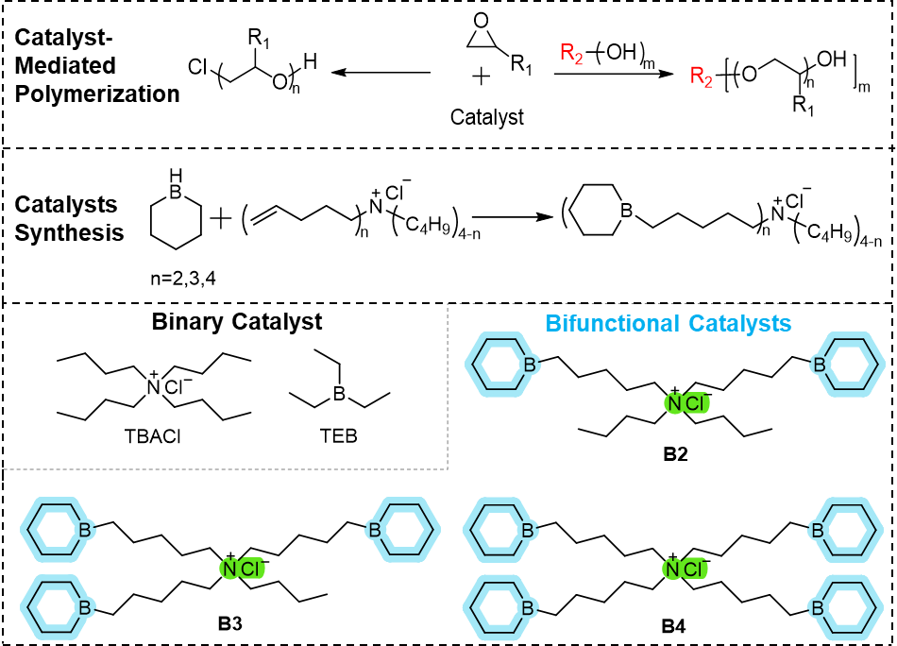
Scheme 1. Binary and bifunctional catalysts synthesized and screened in this study.

